SUPPORTING INFORMATION
Detection of Cu²⁺ Ions Through Colorimetric Methods Utilising a Schiff-Base Probe, Along with its Application in Actual Water Samples and Theoretical Insights.
Ram Kumar^{a, b}, Bholey Singh^{c}* Parveen Gahlyanª, Abhishek Verma^{d}, Tanya Goel^{e} Rita Kakkar^{f}, Balaram Pani^{b}*
ªDepartment of Chemistry, University of Delhi, Delhi 110007, India
^{b}Department of Chemistry, Bhaskaracharya College of Applied Sciences, University of Delhi, New Delhi 110075, India
^{c}Department of Chemistry, Swami Shraddhanand College, University of Delhi, Delhi 110036, India
^{d}Department of Chemistry, Kirori Mal College, University of Delhi, Delhi 110007, India
^{e}Dr. B.R. Ambedkar Center for Biomedical Research, University of Delhi, Delhi 110007, India
^{f}Computational Chemistry Group, Department of Chemistry, University of Delhi, Delhi 110007, India
* Corresponding author
Email: bholeysingh@ss.du.ac.in, balarampani63@gmail.com

Figure Caption
Figure S1. HRMS spectrum of L1 in methanol
Figure S2. FTIR spectrum of L1.
Figure S3. ¹H NMR of compound L1 in (DMSO-d_{6,} 400 MHz)
Figure S4. ¹³C NMR of compound L1 in (DMSO-d₆, 100 MHz)
Figure S5. Optimized geometry of ligand L1, showing atomic numbering
Figure S6. (a) Electron density (isovalue = 0.001 electrons/bohr³) (b) molecular electrostatic potential (ESP) (isovalue = -42.9541 kcal mol⁻¹) (c) Highest occupied molecular orbital (HOMO) and (d) Lowest unoccupied molecular orbital (LUMO) (isovalue = -0.05 au) of ligand L1
Figure S7. Optimized geometry of the copper complex
Figure S8. HOMOs and LUMOs for the two spin states of copper complex
Table S1. Excitation energies and oscillator strengths of ligand L1.
Figure S1. HRMS spectrum of L1 in methanol.
Figure S2. FTIR spectrum of L1.
Figure S3.¹H-NMR spectrum for L1 in DMSO.

Figure S4. ¹³C-NMR spectrum for L1 in DMSO.
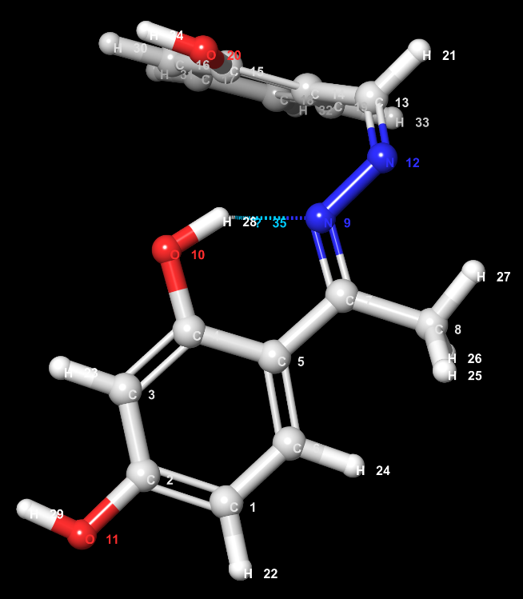
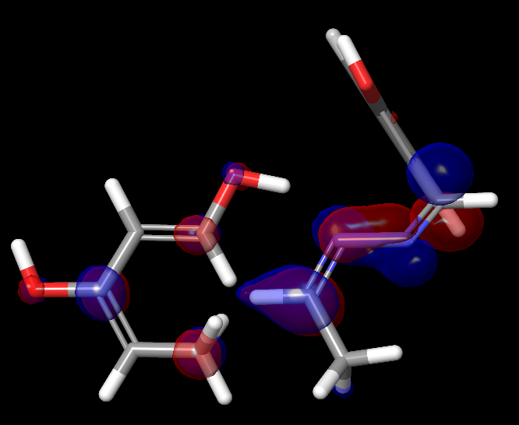
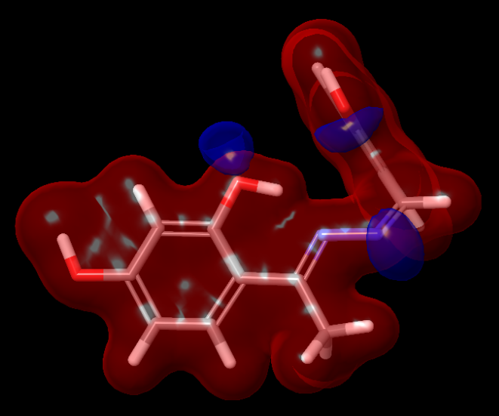
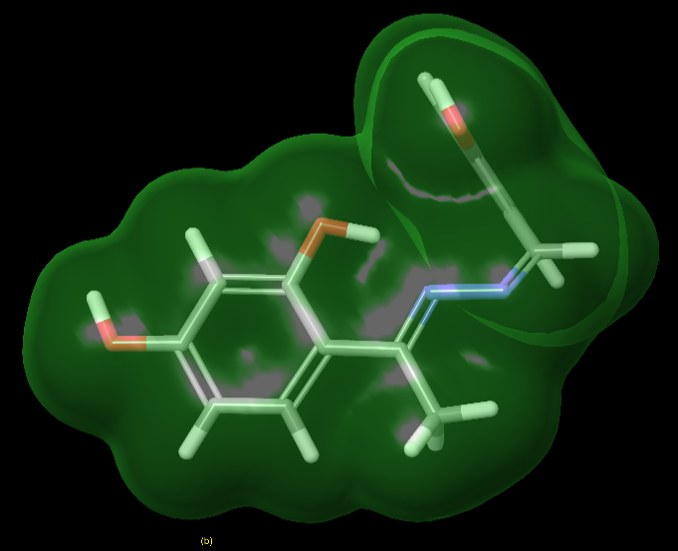
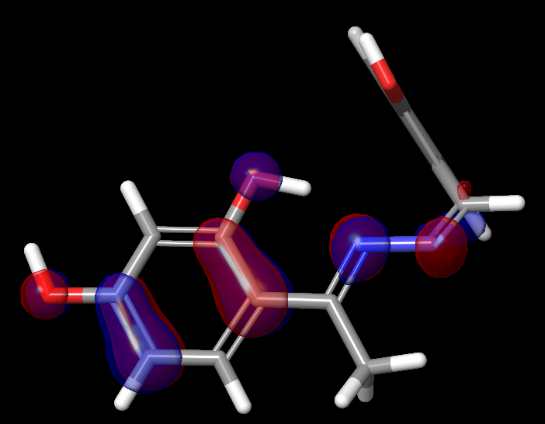
Figure S5. Optimized geometry of ligand L1, showing the atomic numbering.
d

c

b

a

ε_{HOMO} = -6.198 eV ε_{LUMO} = -1.906 eV
Figure S6. (a) Electron density (isovalue = 0.001 electrons/bohr³) (b) molecular electrostatic potential (ESP) (isovalue = -42.9541 kcal mol⁻¹) (c) Highest occupied molecular orbital (HOMO) and (d) Lowest unoccupied molecular orbital (LUMO) (isovalue = -0.05 au) of ligand L1.
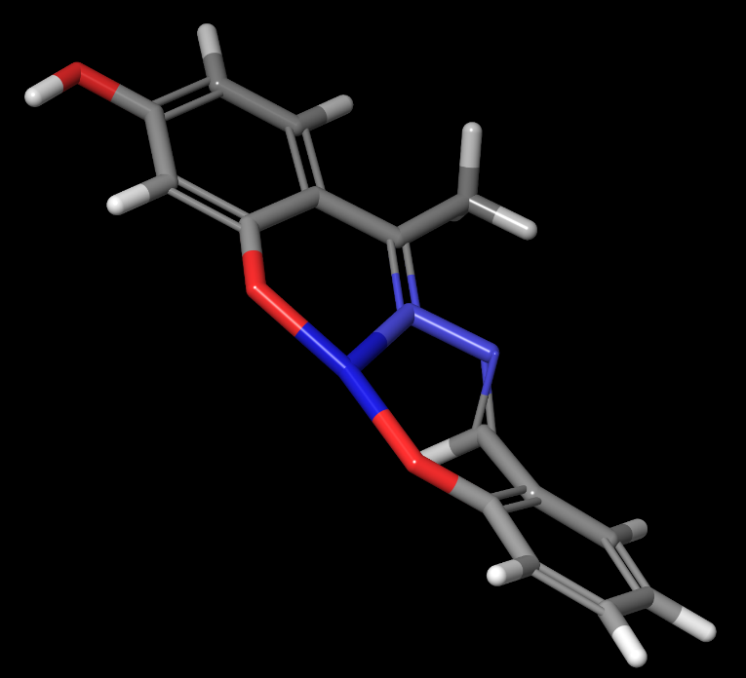
Figure S7. Optimized geometry of the copper complex.
α-orbitals
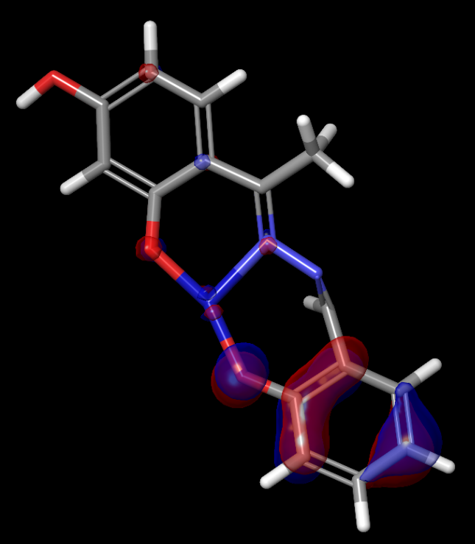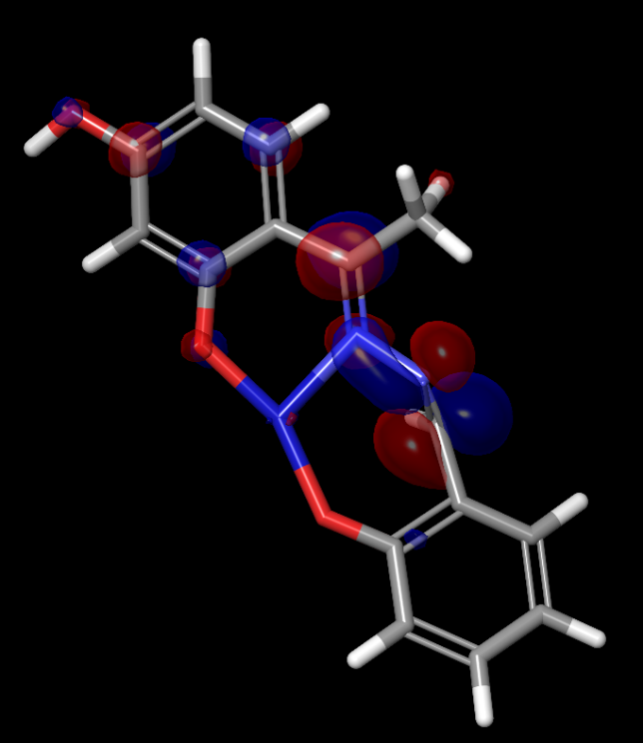
ε_{HOMO} = -6.023 eV ε_{LUMO} = -2.346 eV
β-orbitals
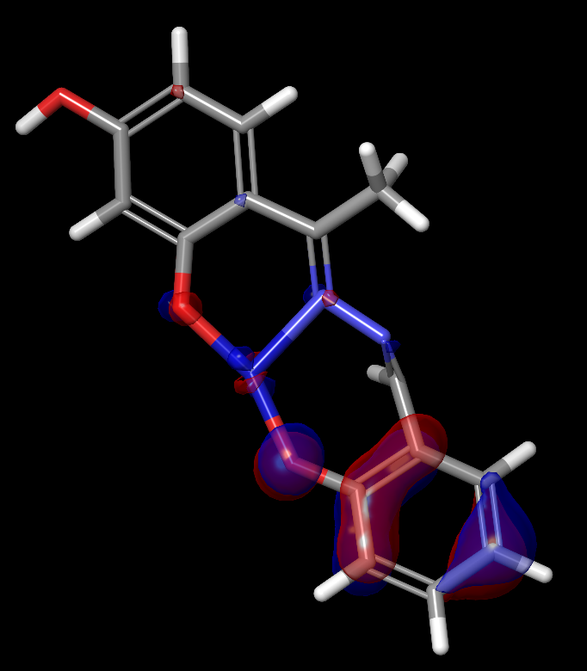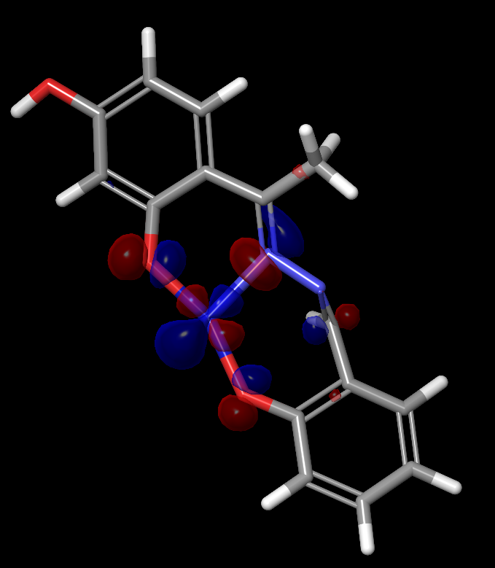
ε_{HOMO} = -5.991 eV ε_{LUMO} = -4.274 eV
Figure S8: HOMOs and LUMOs for the two spin states of copper complex .

Table S1. Excitation energies and oscillator strengths of ligand L1.
Excitation | Transition | Weight (%) | Excitation Energy (eV) | Wavelength (nm) | Oscillator Strength (f)
1 | HOMO→LUMO | 88 | 3.60 | 345 | 0.1290
2 | HOMO-1→LUMO | 78 | 3.94 | 314 | 0.2929
4 | HOMO-1→LUMO+1 | 39 | 4.41 | 281 | 0.0525
5 | HOMO-3→LUMO | 33 | 4.56 | 272 | 0.3128
6 | HOMO→LUMO+1 | 50 | 4.65 | 266 | 0.0591
7 | HOMO-4→LUMO | 57 | 4.92 | 252 | 0.1295
8 | HOMO-2→LUMO+1 | 36 | 4.96 | 250 | 0.0244
9 | HOMO-3→LUMO+1 | 50 | 5.17 | 240 | 0.0298
11 | HOMO-3→LUMO+1 | 26 | 5.45 | 227 | 0.0349

