Table S1a: Expression levels of NLA gene under B toxicity condition in Arabidopsis thaliana
 | C | 1B | 3B
Exression level | 1.04±0.28 | 1.6±0.05 | 4.2±0.6

Table S1b: primer list
NLA-F | TGATGGCTTGAAAACCGCAG
NLA-R | CAATAGTCTCTGCAGCTTCGC
PHO2-F | ACCGTTTCTCATCAAGGCGT
PHO2-R | GTGCCCGTCCACCATAAGAA
NRT1.7-F | CGCCACTCTCCTCGGACTAA
NRT1.7-R | CTGTTGCATGATGCTGGGTG
PHT1;1-F | AGTGTACGGTCTCACTTTGGTAA
PHT1;1-R | CCAAATCCCAACCAAAACCTGAA
PHT1;4-F | AGATCCCACATAAACTTTCTAGGAG
PHT1;4-R | AGAATCCCATTCCGGCGATT

Figure S1a. Quantitative real-time polymerase chain reaction (qRT-PCR) of randomly selected genes.
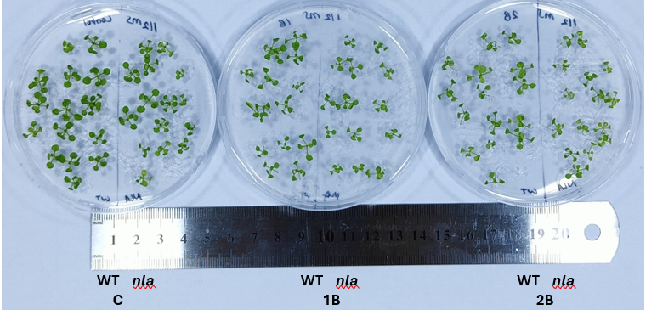
Figure S1b. Phenotypical view of nla mutant and WT Arabidopsis thaliana plants grown under C, 1B and 2B conditions for 2 weeks.

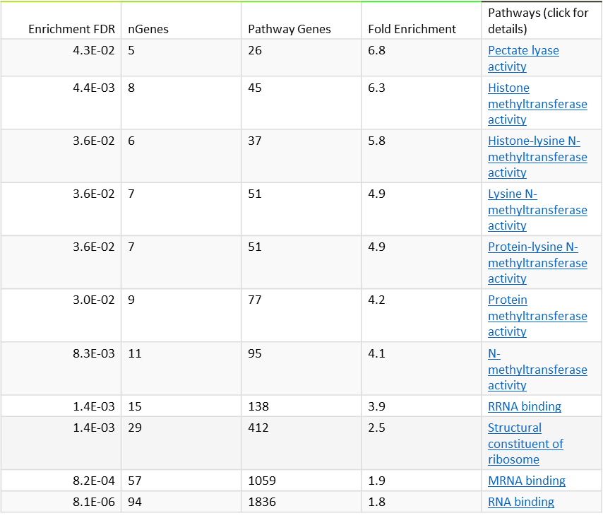
Figure S2. GO Molecular function analysis of upregulated genes in nla under C condition compared to WT-C

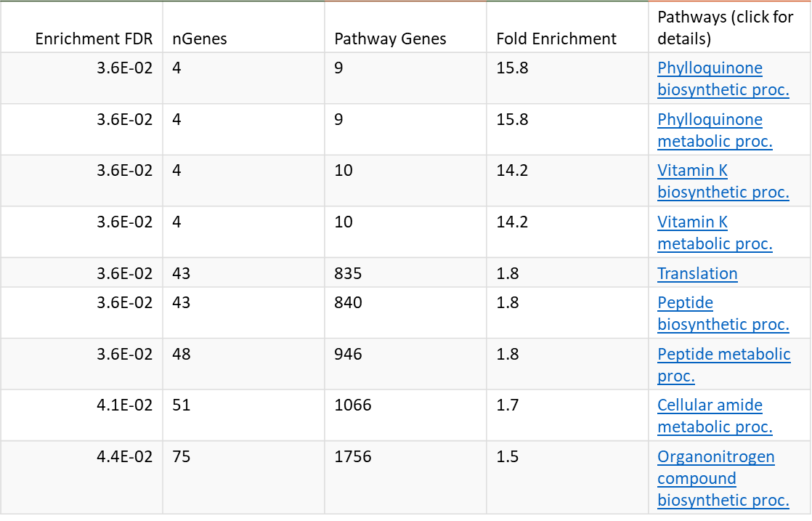
Figure S3. GO Biological process analysis of upregulated genes in nla under C condition compared to WT-C

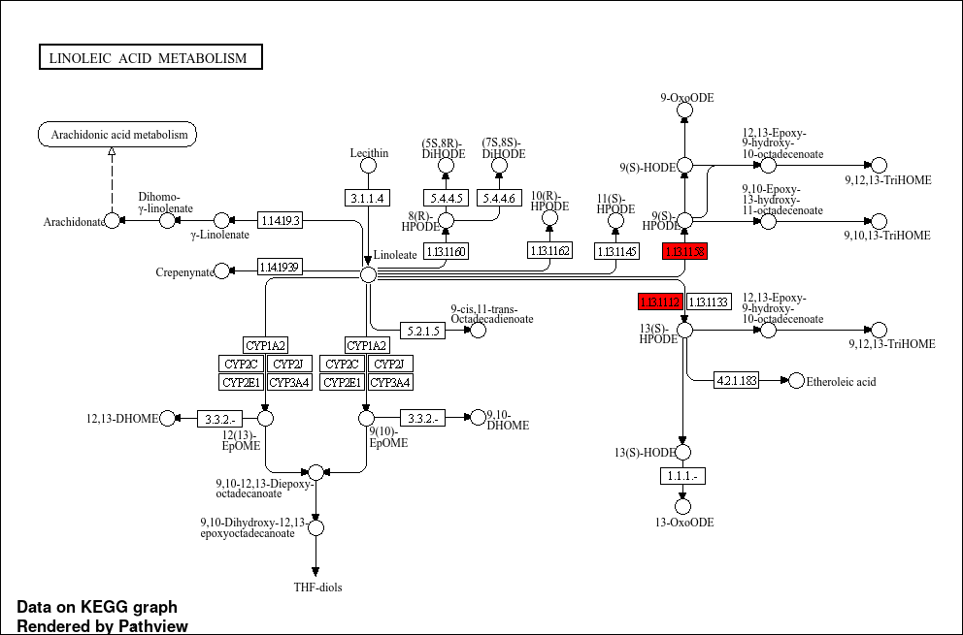
Figure S4. DEGs in linoleic acid metabolism pathway downregulated in nla under C condition compared to WT-C

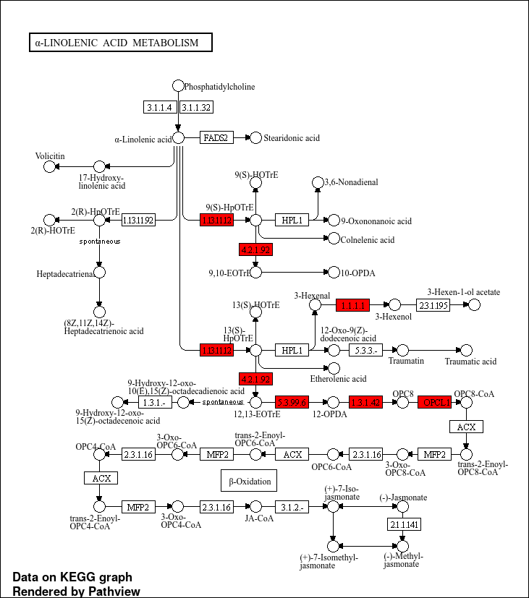
Figure S5. DEGs in alpha linolenic acid metabolism pathway downregulated in nla under C condition compared to WT-C

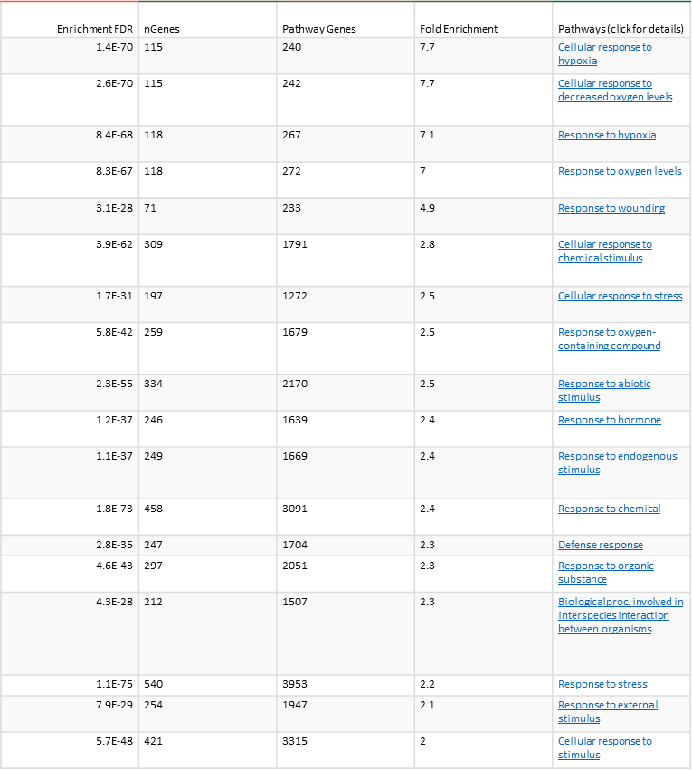
Figure S4. GO Biological process analysis of downregulated genes in nla under C condition compared to WT-C
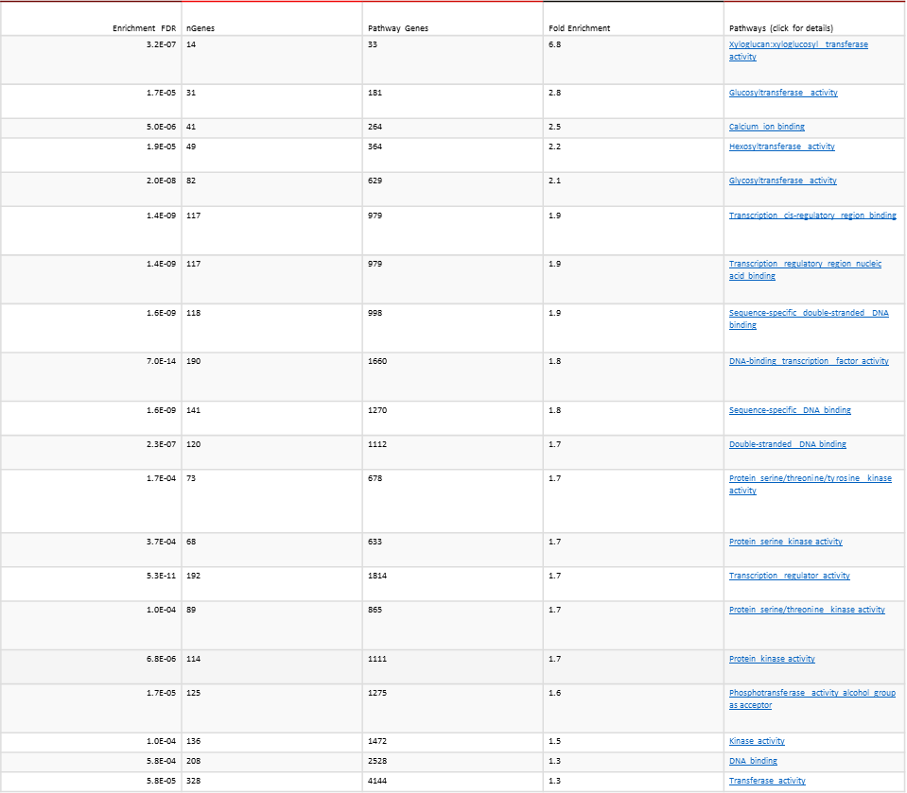
Figure S5. GO Molecular function analysis of downregulated genes in nla under C condition compared to WT-C
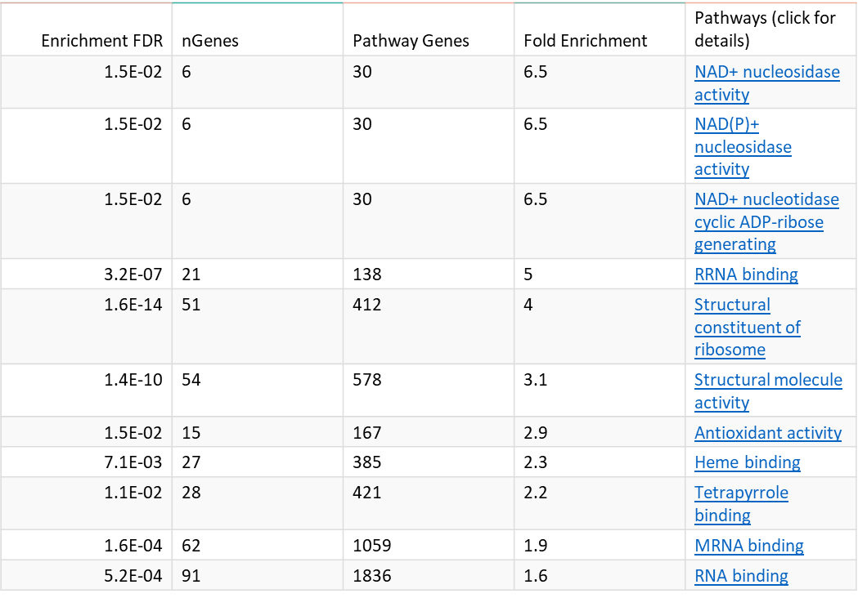
Figure S6. GO Molecular function analysis of upregulated genes in nla under 1B condition compared to WT-C

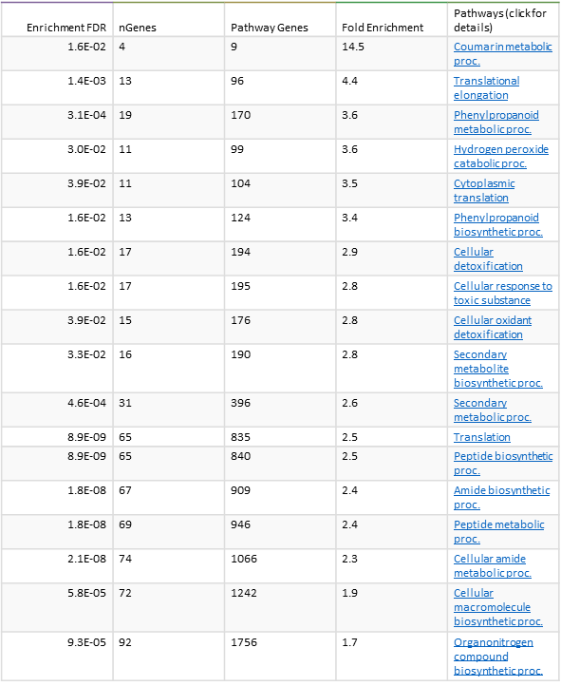
Figure S7. GO Biological process analysis of upregulated genes in nla under 1B condition compared to WT-C
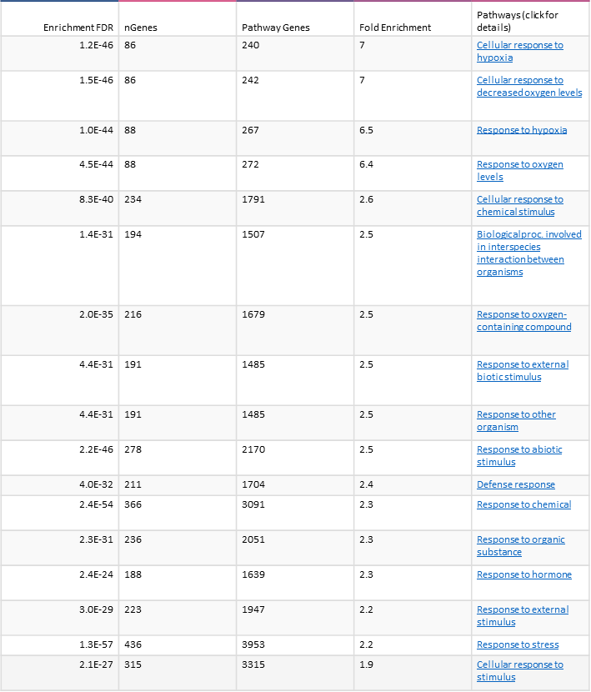
Figure S8. GO Biological process analysis of downregulated genes in nla under 1B condition compared to WT-C
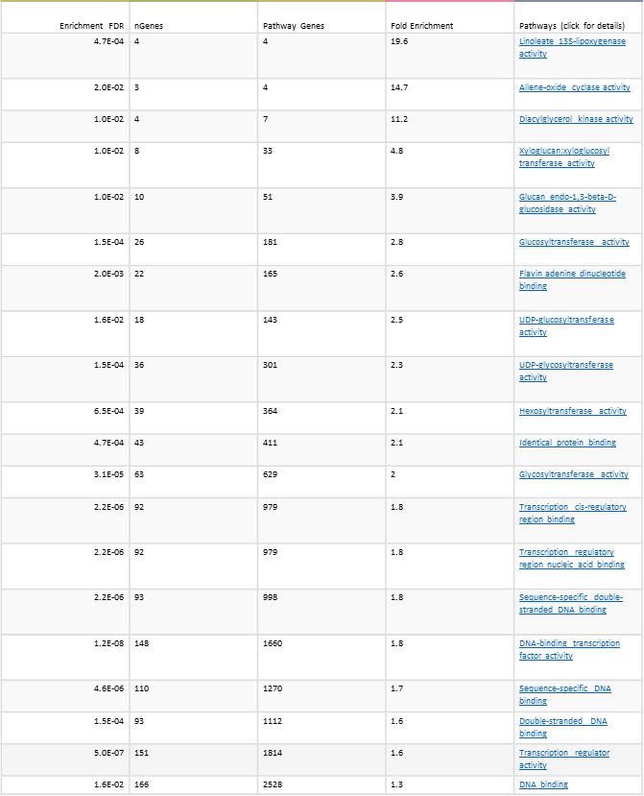
Figure S9. GO Molecular function analysis of downregulated genes in nla under 1B condition compared to WT-C
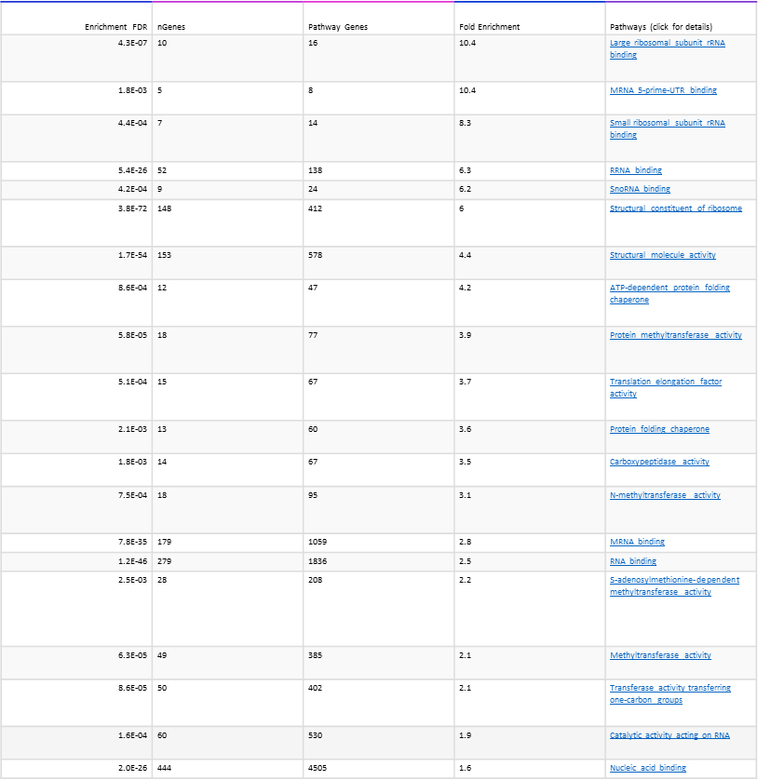
Figure S10. GO Molecular function analysis of upregulated genes in nla under 2B condition compared to WT-C

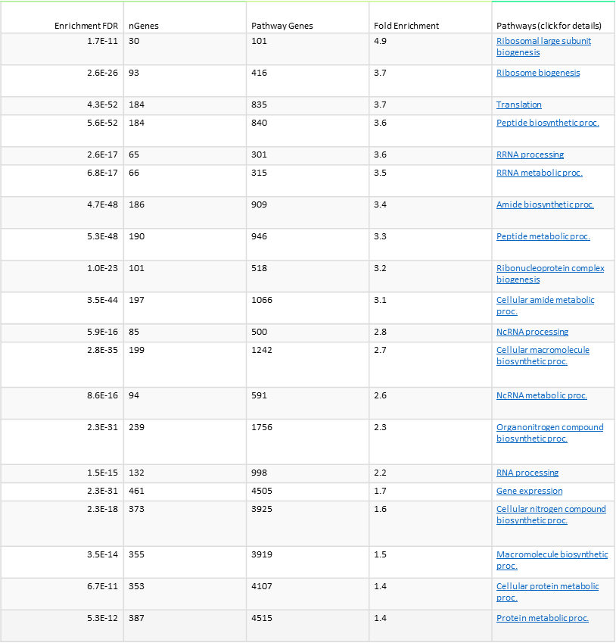
Figure S11. GO Biological process analysis of upregulated genes in nla under 2B condition compared to WT-C
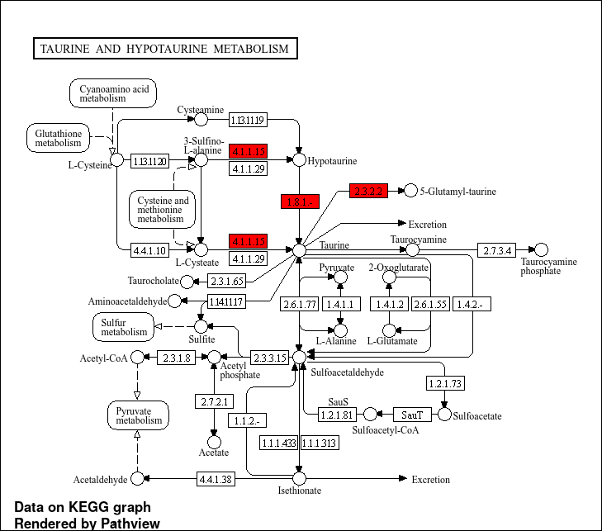
Figure S12. DEGs in taurine and hypotaurine metabolism pathway downregulated in nla under 2B condition compared to WT-C
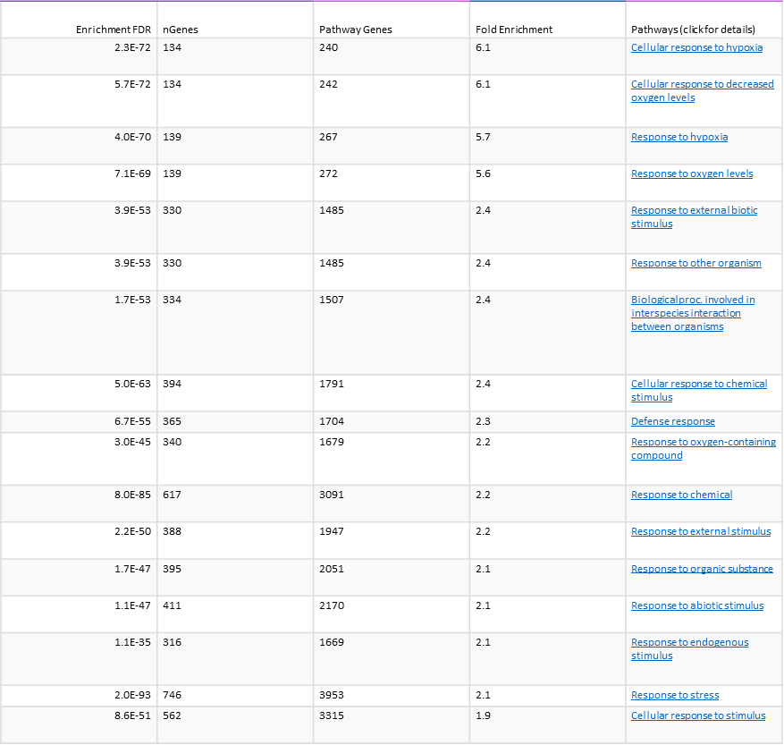
Figure S13. GO Biological process analysis of downregulated genes in nla under 2B condition compared to WT-C

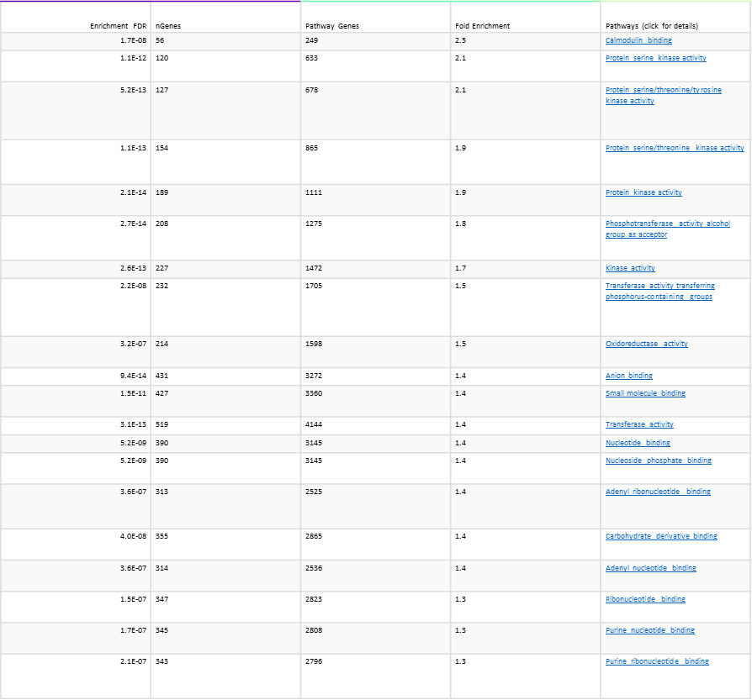
Figure S14. GO Molecular function analysis of downregulated genes in nla under 2B condition compared to WT-C
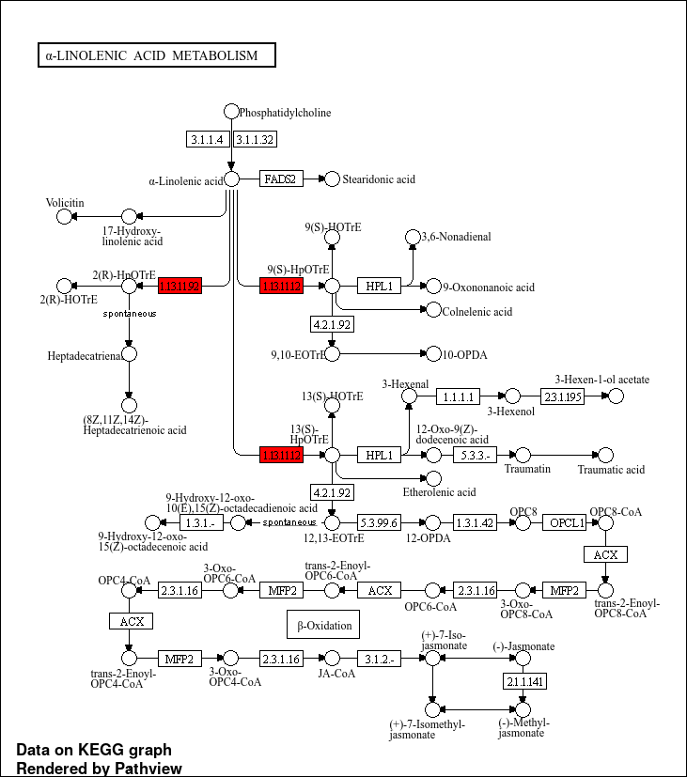
Figure S15. DEGs in alpha linolenic acid metabolism pathway upregulated in nla under 1B condition compared to nla-C

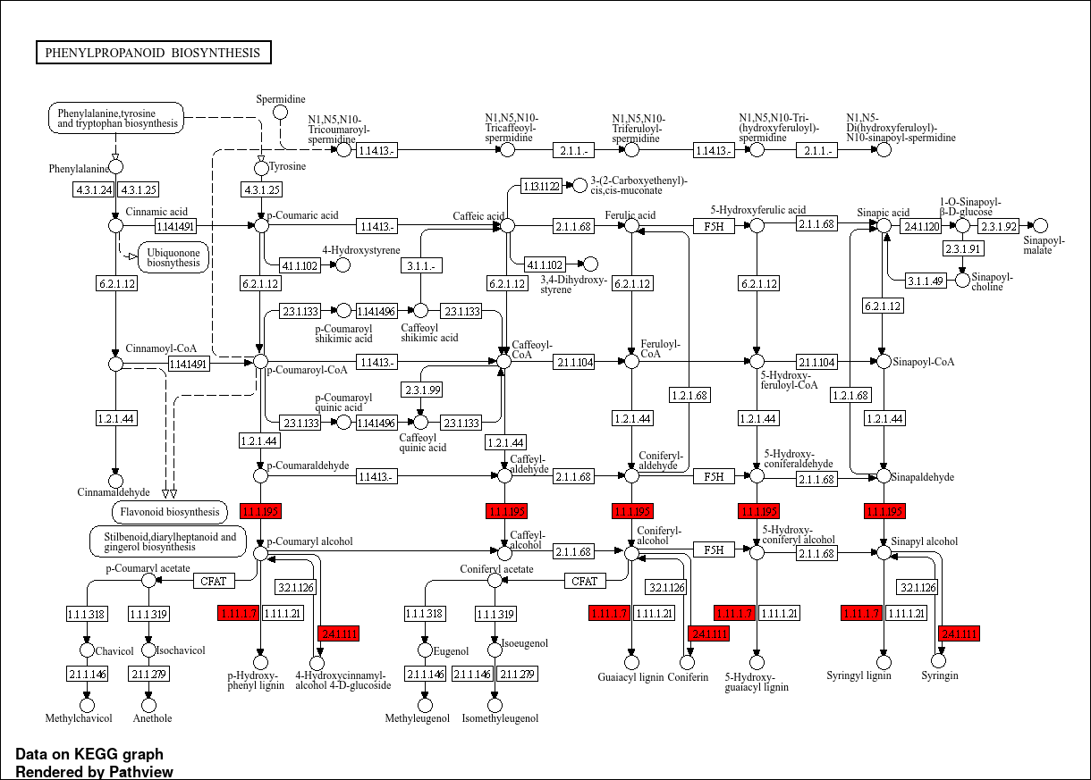
Figure S16. DEGs in phenylpropanoid biosynthesis pathway upregulated in nla under 1B condition compared to nla-C

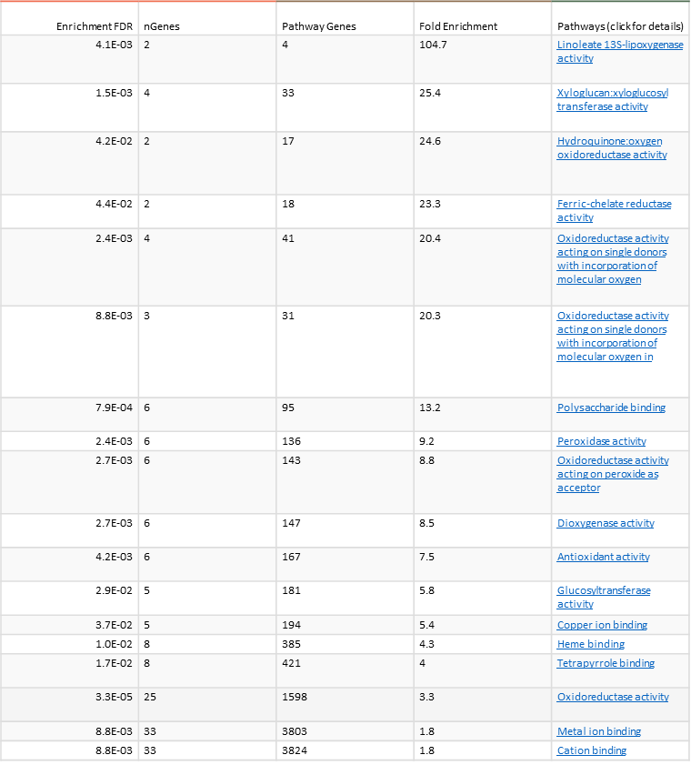

Figure S17. GO Molecular function analysis of upregulated genes in nla under 1B condition compared to nla-C
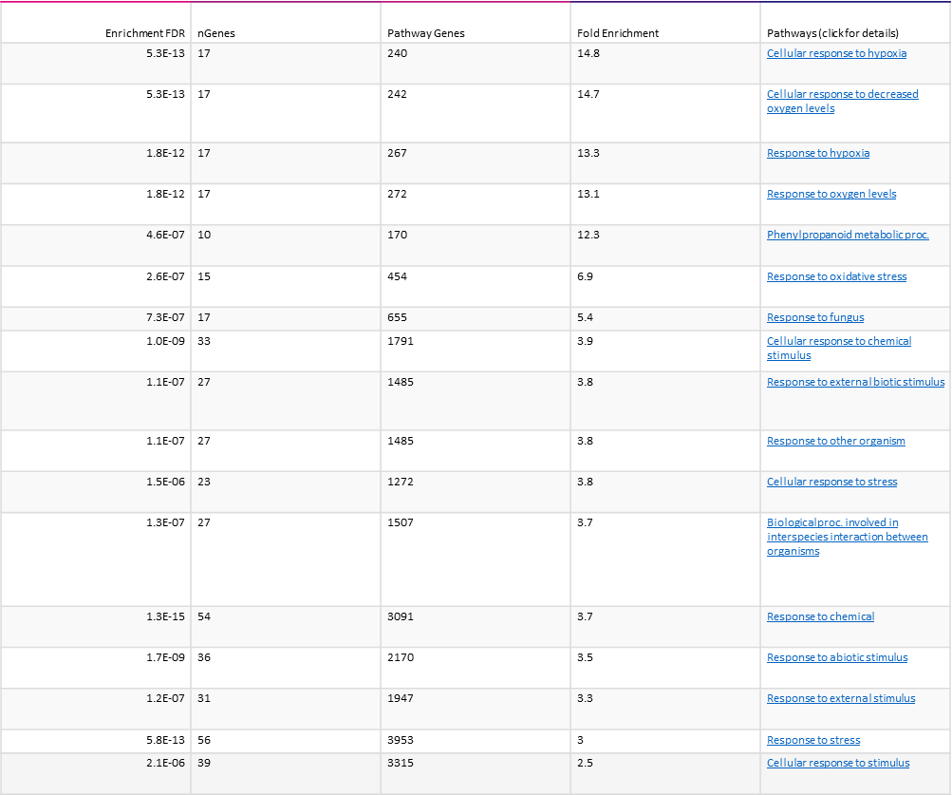
Figure S18. GO Biological process analysis of upregulated genes in nla under 1B condition compared to nla-C

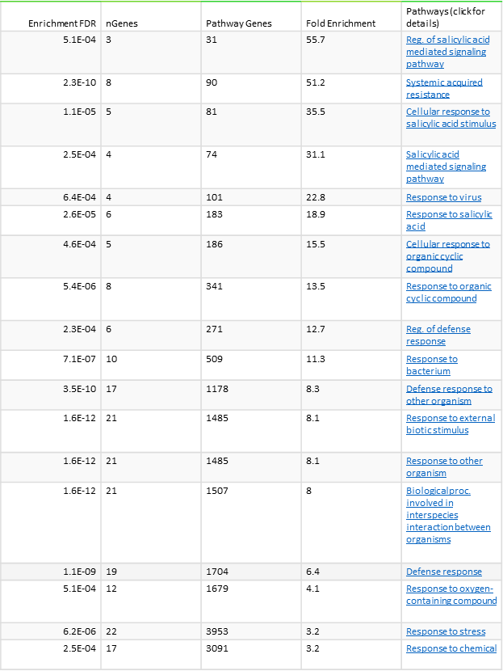
Figure S19. GO Biological process analysis of downregulated genes in nla under 1B condition compared to nla-C
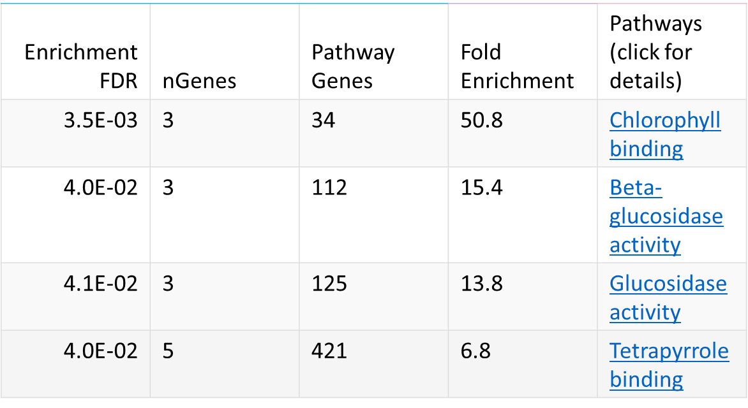
Figure S20. GO Molecular function analysis of downregulated genes in nla under 1B condition compared to nla-C

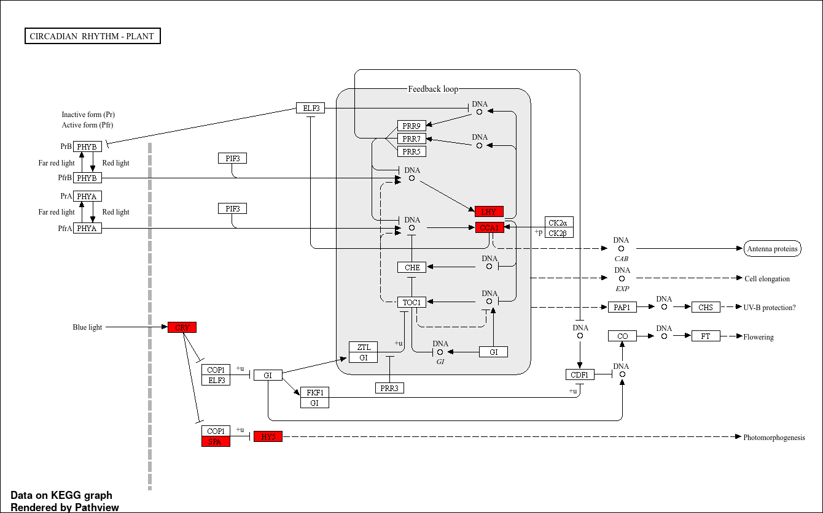
Figure S21. DEGs in circadian rhythm-plant pathway upregulated in nla under 2B condition compared to nla-C

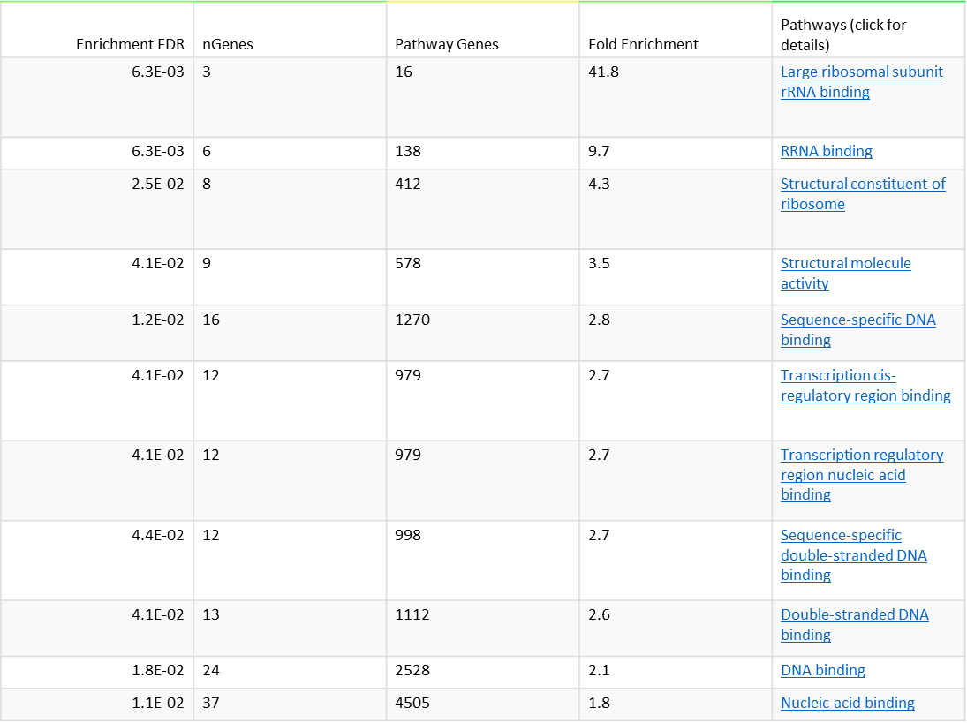
Figure S22. GO Molecular function analysis of upregulated genes in nla under 2B condition compared to nla-C
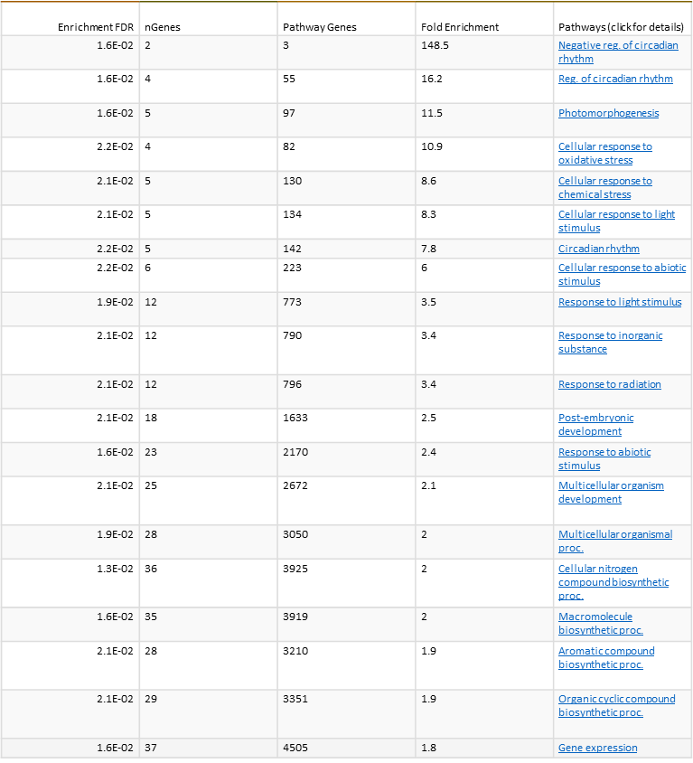
Figure S23. GO Biological process analysis of upregulated genes in nla under 2B condition compared to nla-C

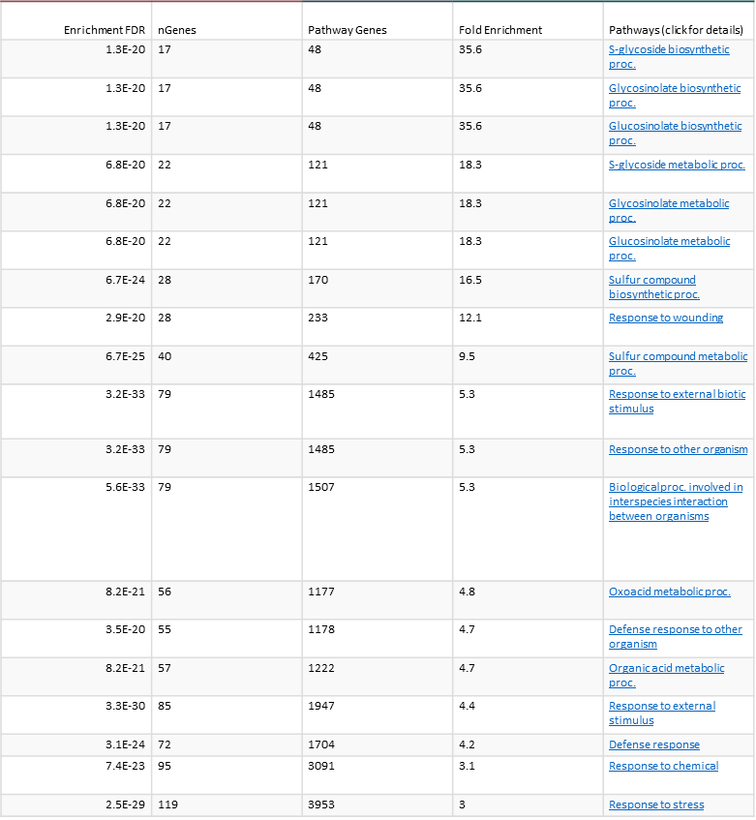
Figure S24. GO Biological process analysis of downregulated genes in nla under 2B condition compared to nla-C

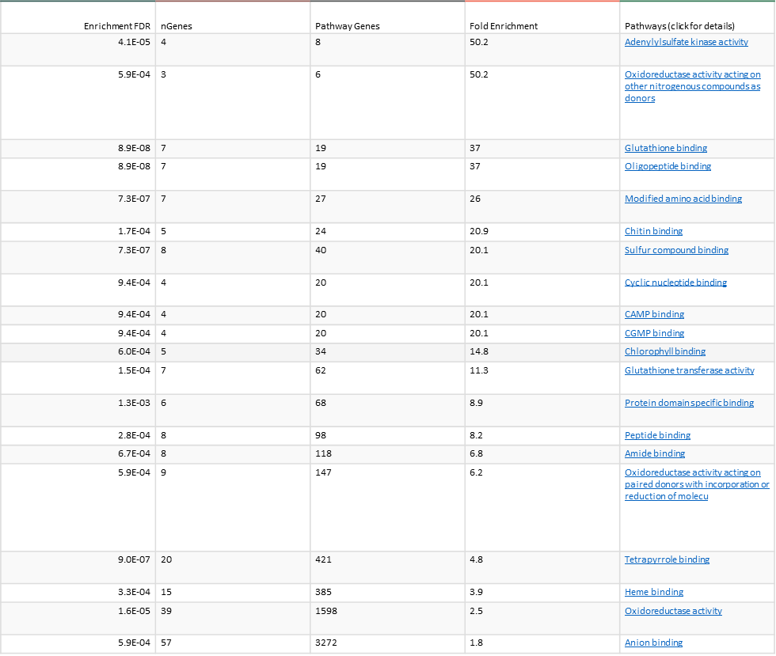
Figure S25. GO Molecular function analysis of downregulated genes in nla under 2B condition compared to nla-C

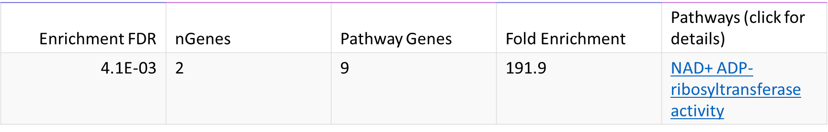
Figure S26. GO Molecular function analysis of upregulated genes in nla under 2B condition compared to nla-1B

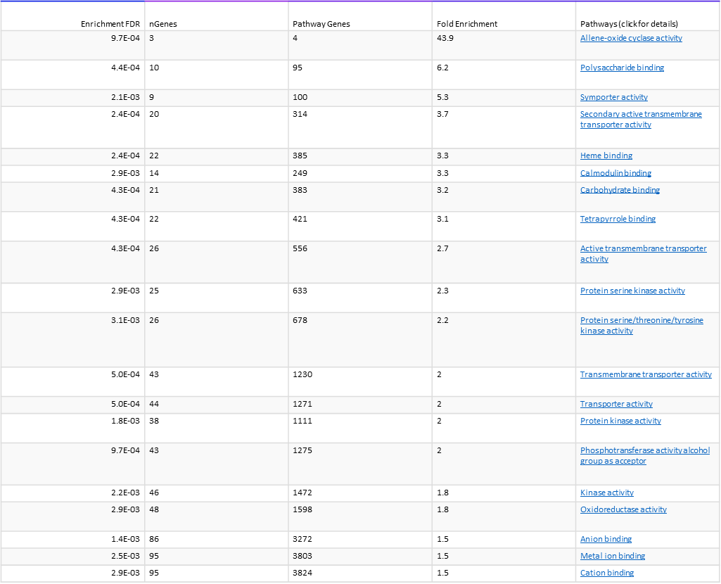
Figure S27. GO Molecular function analysis of downregulated genes in nla under 2B condition compared to nla-1B
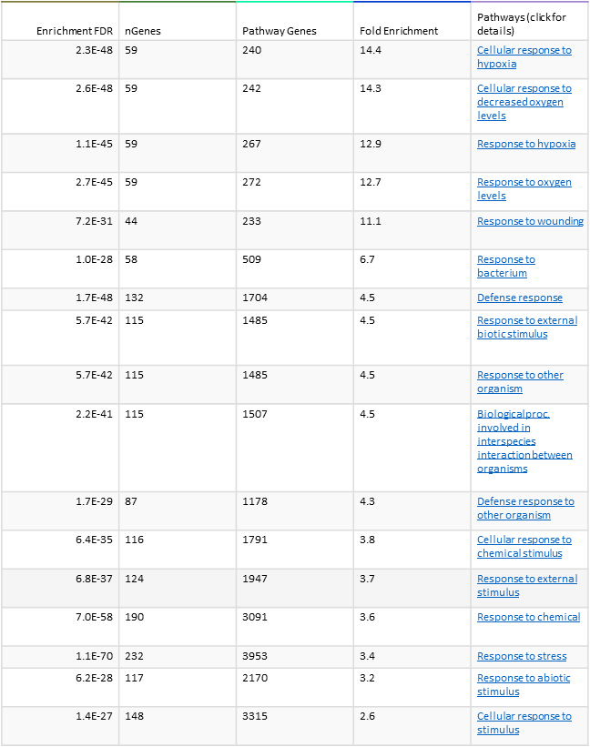
Figure S28. GO Biological process analysis of downregulated genes in nla under 2B condition compared to nla-1B

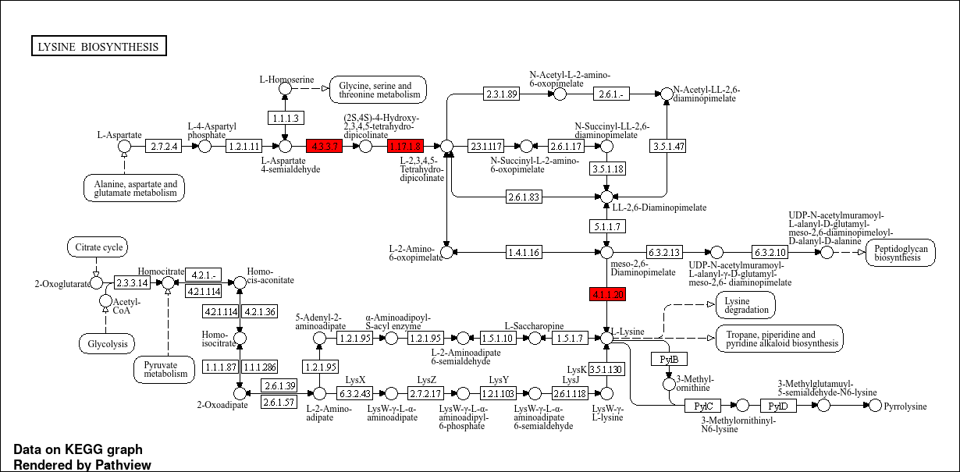
Figure S29. DEGs in lysine biosynthesis pathway specifically upregulated in nla under 2B condition compared to WT-C

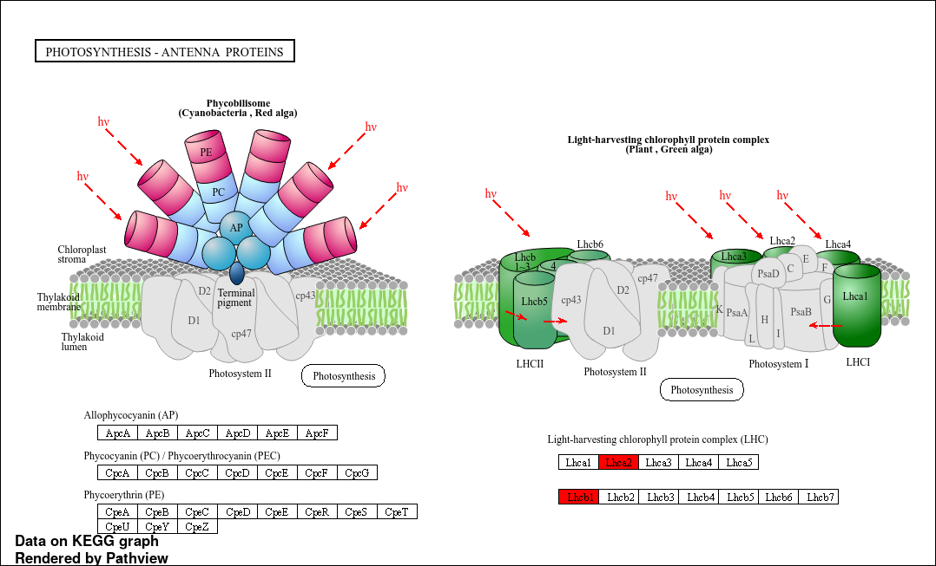
Figure S30. DEGs in photosynthesis-antenna proteins pathway commonly downregulated in nla plants under 1B and 2B conditions compared to nla-C

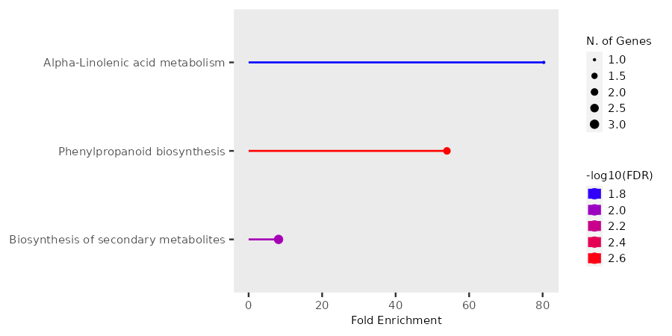
Figure S31. KEGG enrichment analysis of 8 commonly upregulated genes between nla under B toxicity vs WT-C and nla under B toxicity vs nla-C
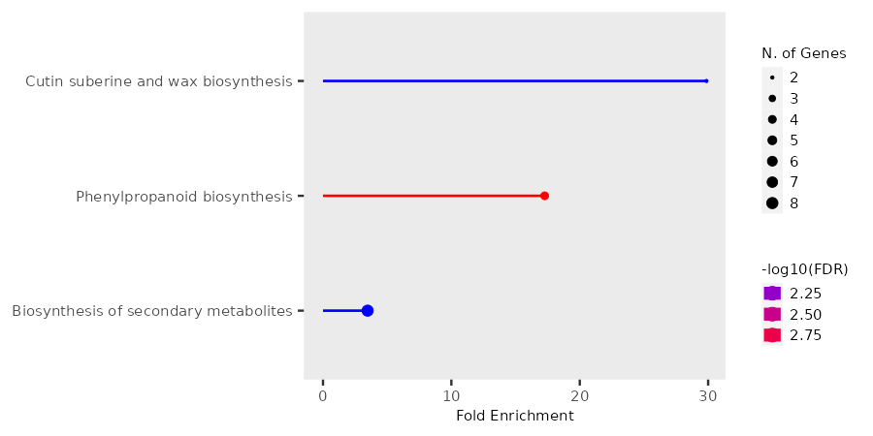
Figure S32. KEGG enrichment analysis of 50 commonly upregulated genes between nla under 1B vs WT-C and nla under 1B vs nla-C

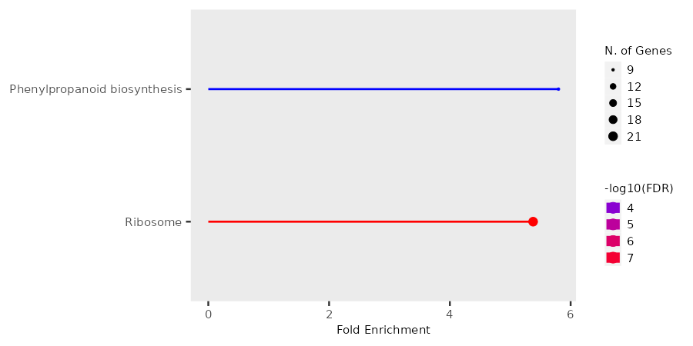
Figure S33. KEGG enrichment analysis of 345 specifically upregulated genes in nla under 1B vs WT-C

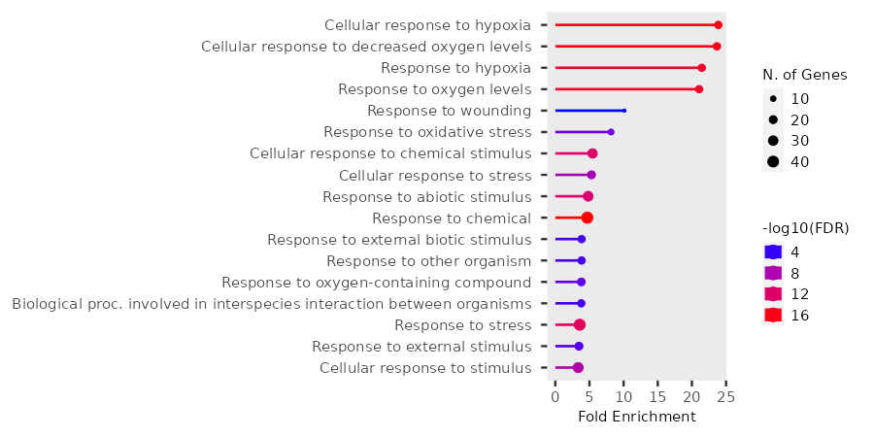
Figure S34. KEGG enrichment analysis of 82 specifically upregulated genes in nla under 1B vs nla-C

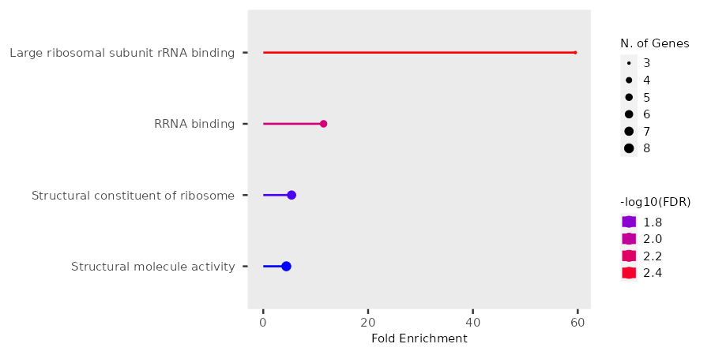
Figure S35. KEGG enrichment analysis of 89 commonly upregulated genes between nla under 2B vs WT-C and nla under 2B vs nla-C

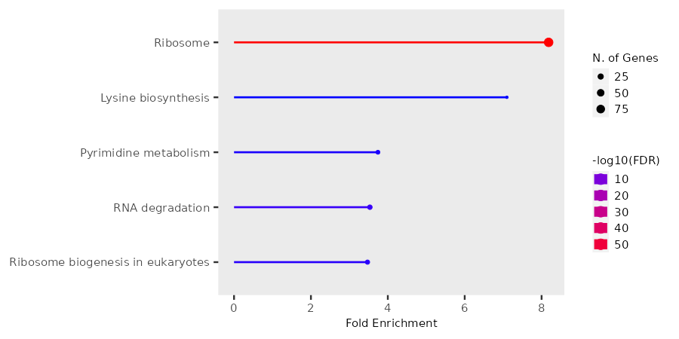
Figure S36. KEGG enrichment analysis of 1084 specifically upregulated genes in nla under 2B vs WT-C
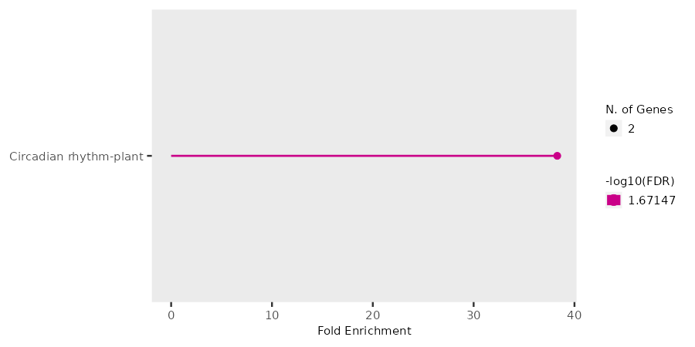
Figure S37. KEGG enrichment analysis of 38 specifically upregulated genes in nla under 2B vs nla-C

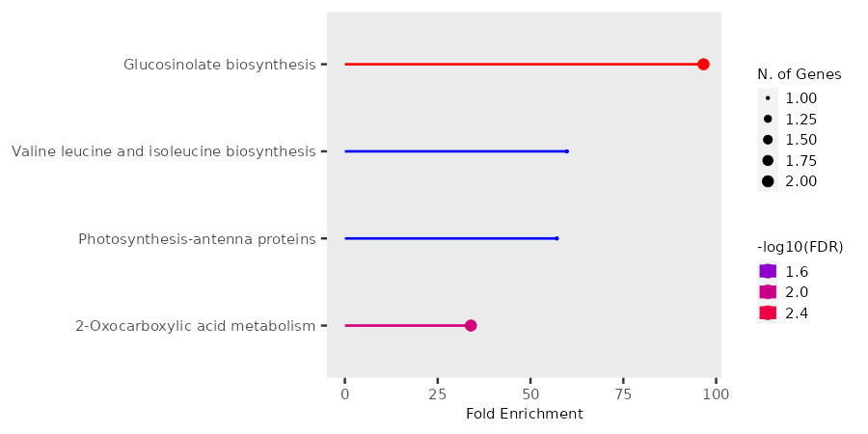
Figure S38. KEGG enrichment analysis of 22 commonly downregulated genes between nla under B toxicity vs WT-C and nla under B toxicity vs nla-C

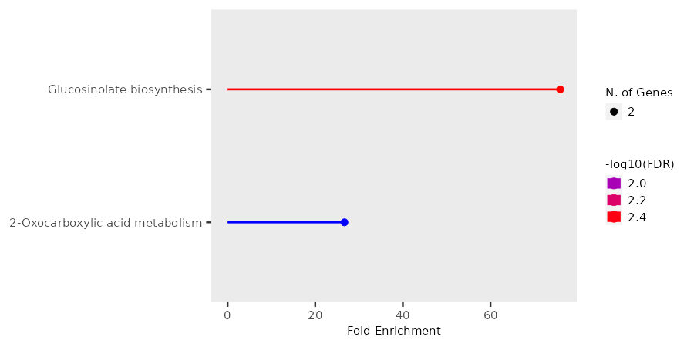
Figure S39. KEGG enrichment analysis of 28 commonly downregulated genes between nla under 1B vs WT-C and nla under 1B vs nla-C

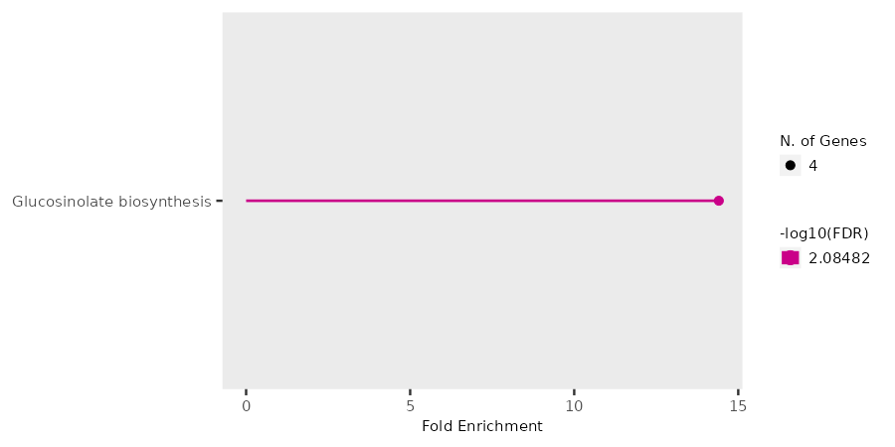
Figure S40. KEGG enrichment analysis of 299 specifically downregulated genes in nla under 1B vs WT-C

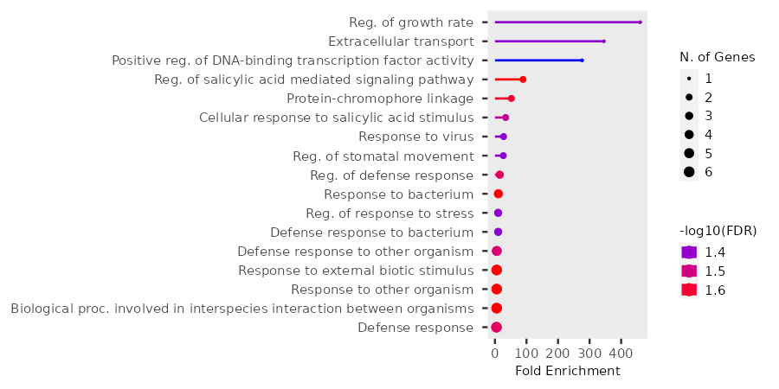
Figure S41. GO Biological Process analysis of 21 specifically downregulated genes in nla under 1B vs nla-C (too few genes for KEGG).

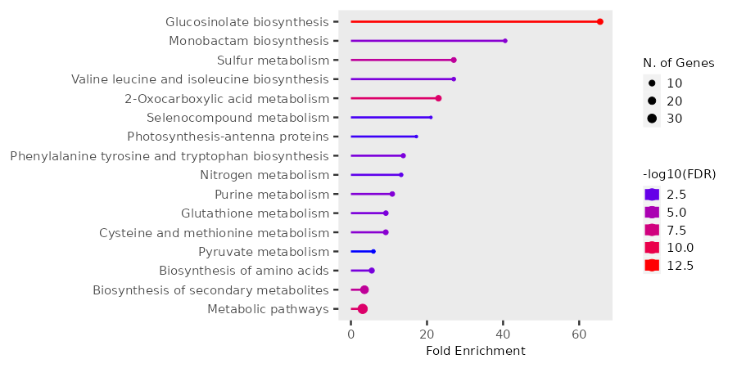
Figure S42. KEGG enrichment analysis of 147 commonly downregulated genes between nla under 2B vs WT-C and nla under 2B vs nla-C

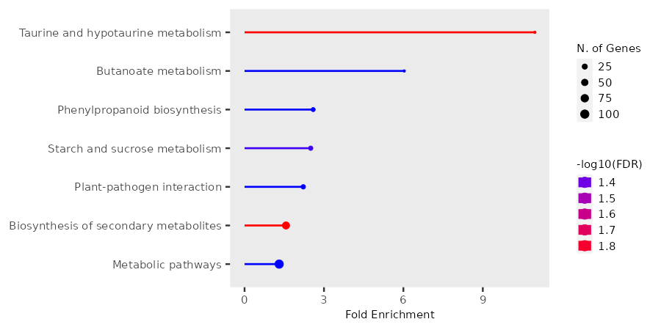
Figure S43. KEGG enrichment analysis of 945 specifically downregulated genes in nla under 2B vs WT-C

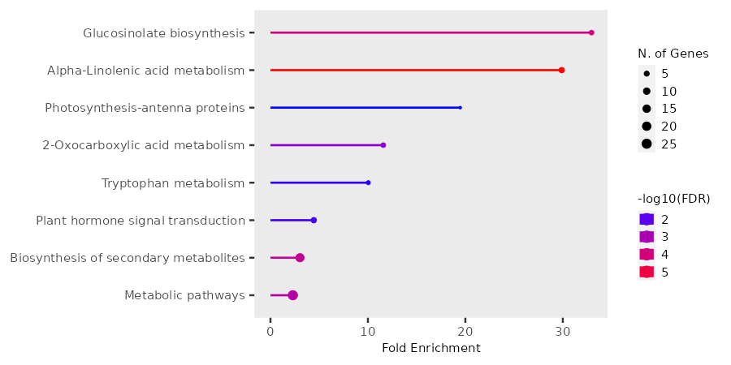
Figure S44. KEGG enrichment analysis of 129 specifically downregulated genes in nla under 2B vs nla-C


Figure S45: KEGG enrichment analysis of 180 downregulated TFs in nla under C condition compared to WT-C

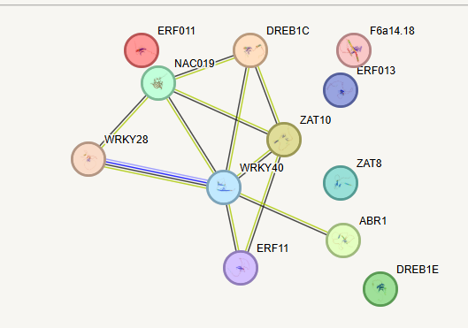
Figure S46. STRING analysis of upregulated 12 TFs in nla under 1B compared to nla-C

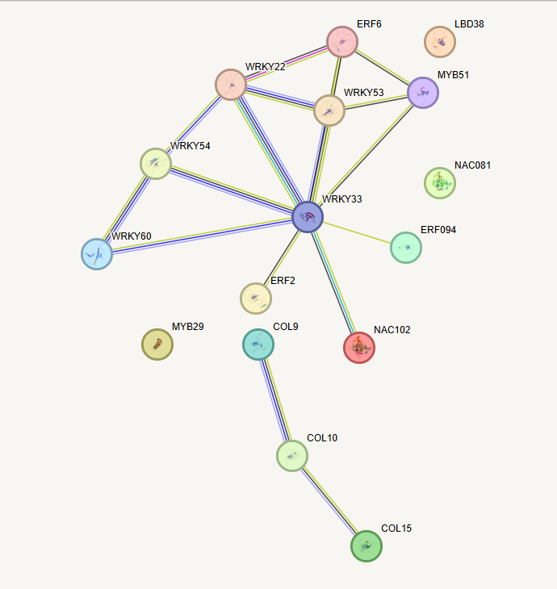
Figure S47. STRING analysis of downregulated 16 TFs in nla under 2B compared to nla-C
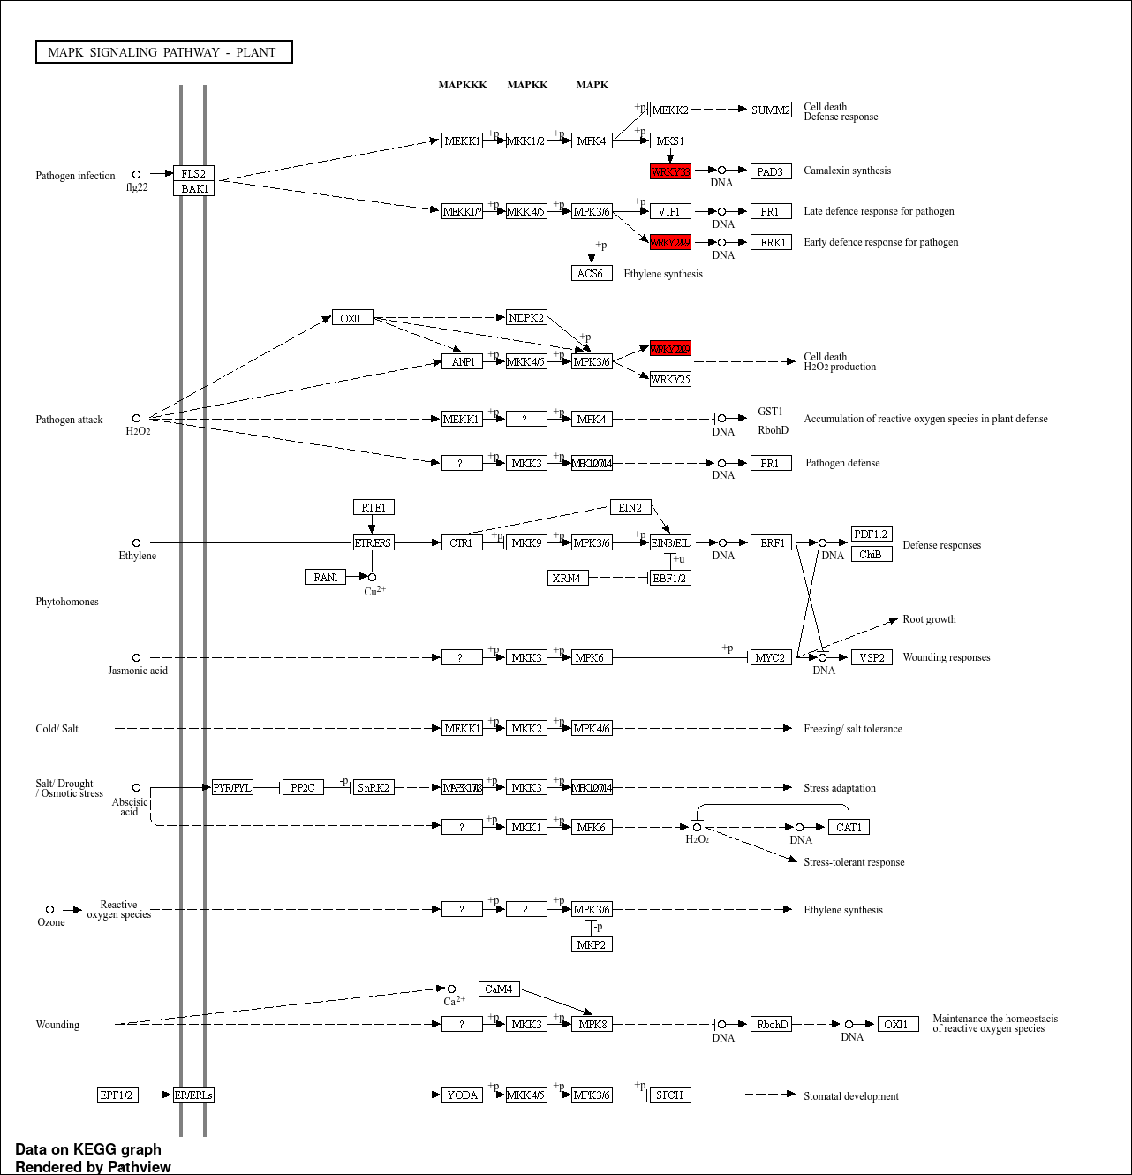
Figure S48. Downregulated TFs in MAPK signaling pathway-plant in nla under 2B compared to nla-C

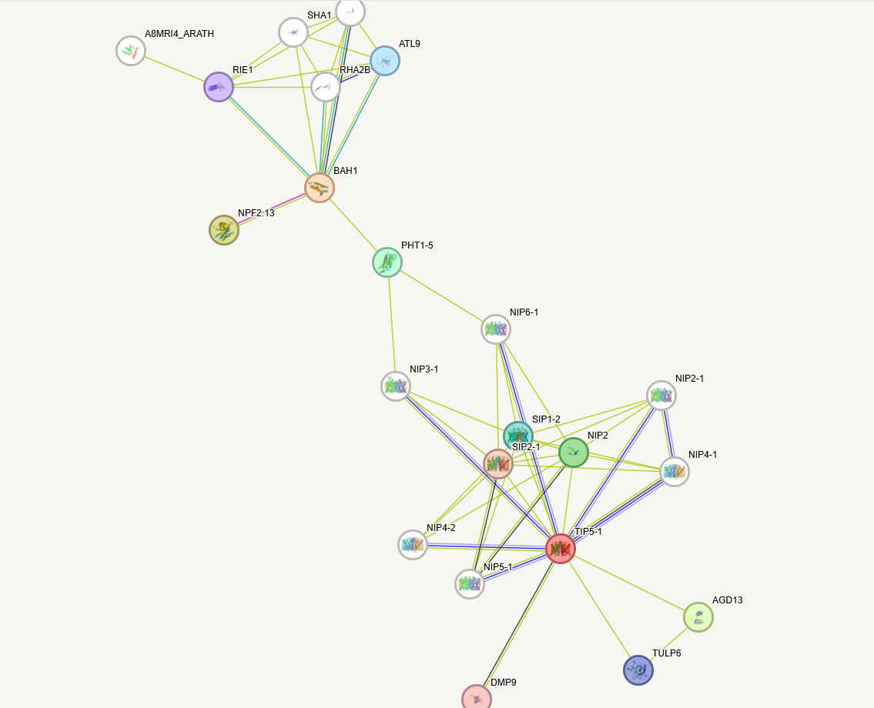
Figure S49. STRING analysis for NLA (represented by BAH1) and AtTIP5

