USP7 aggravates diabetic cardiomyopathy by stabilizing Keap1 to govern cardiac oxidative stress-induced pyroptosis

The western blot analysis of tissue protein USP7 shown in Figure 1A
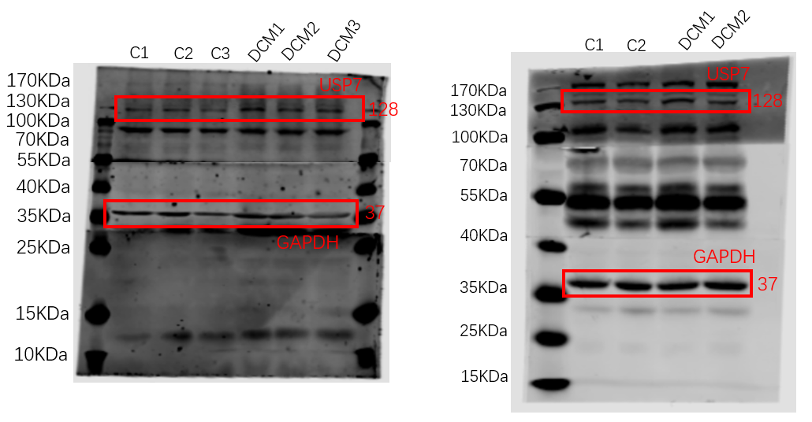
The western blot analysis of tissue protein NLRP3 shown in Figure 3A
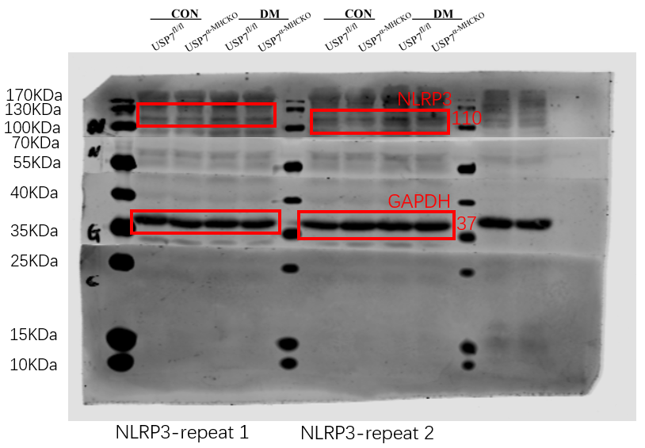
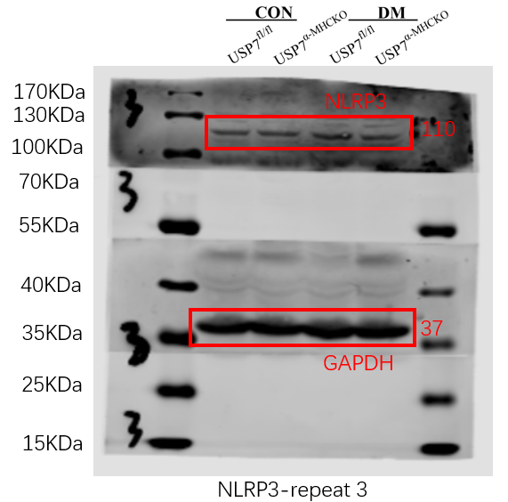
The western blot analysis of tissue protein Caspase1 shown in Figure 3A
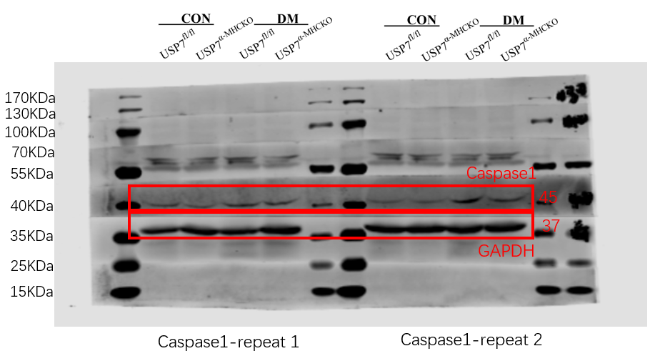
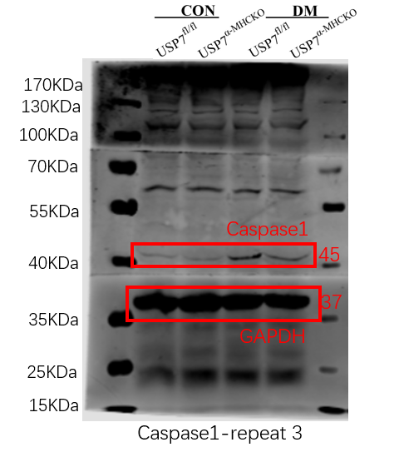
The western blot analysis of tissue protein GSDMD shown in Figure 3A
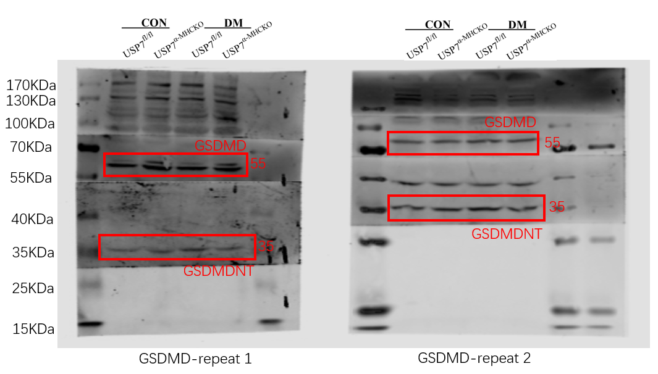
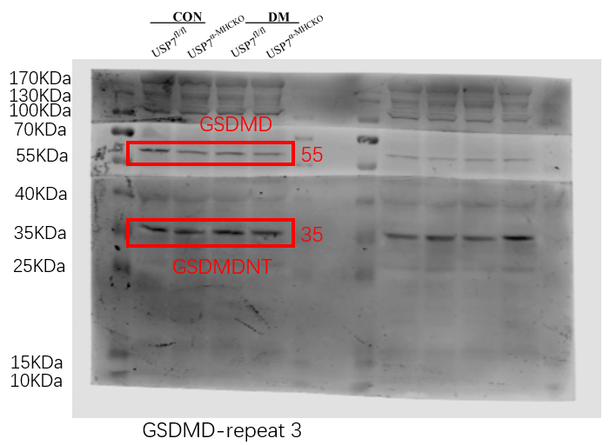
The western blot analysis of tissue protein NLRP3 shown in Figure 3C
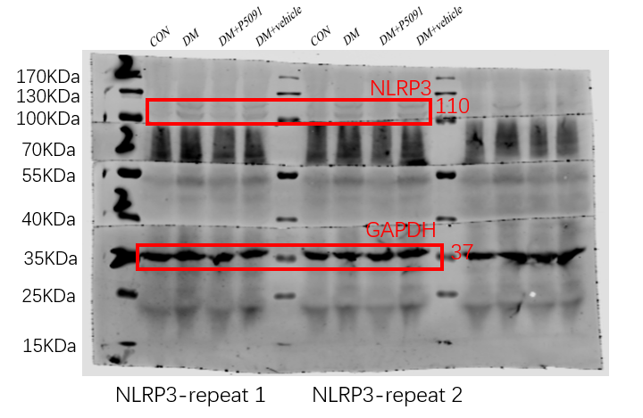
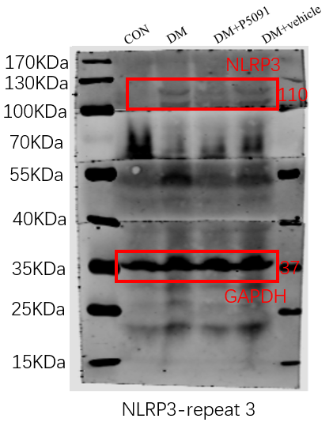
The western blot analysis of tissue protein Caspase1 shown in Figure 3C
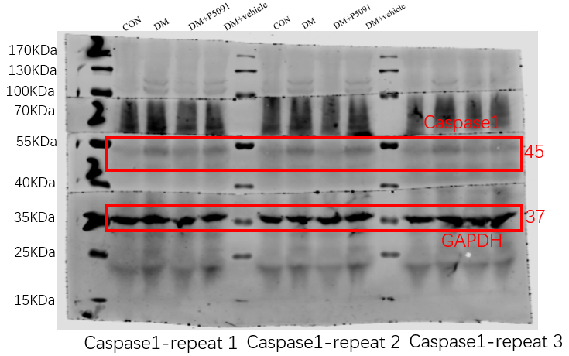

The western blot analysis of tissue protein GSDMD shown in Figure 3C
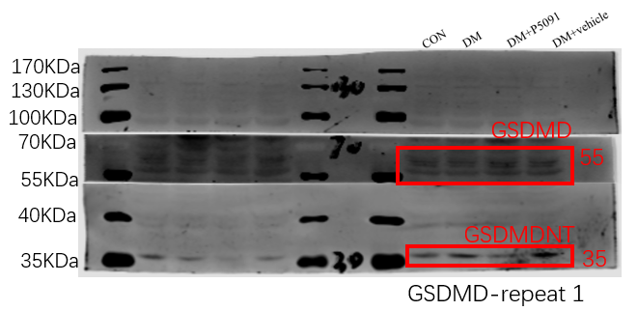
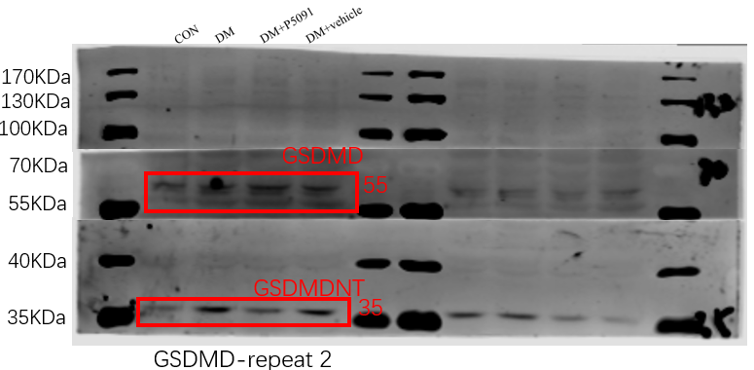
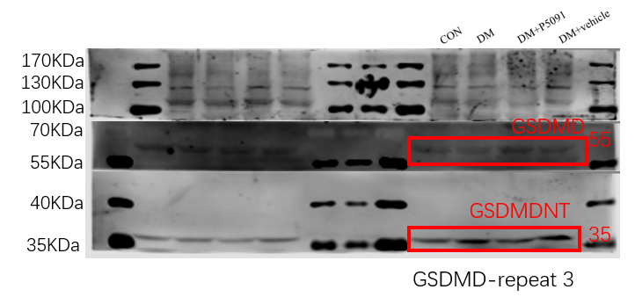
The western blot analysis of cell protein USP7 shown in Figure 4B
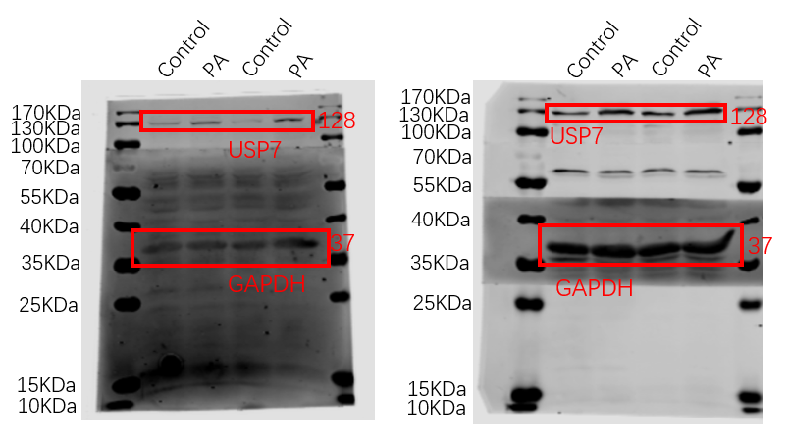
The western blot analysis of cell protein NLRP3 shown in Figure 4N
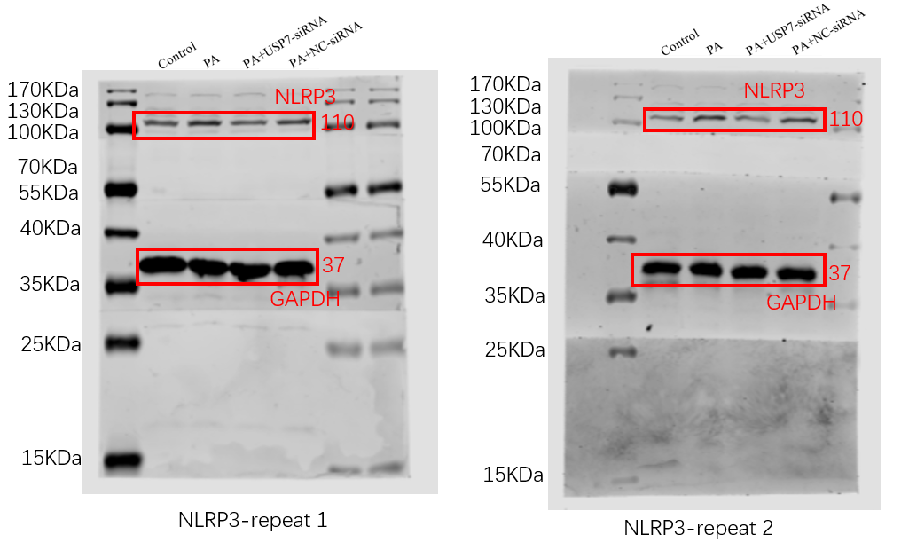
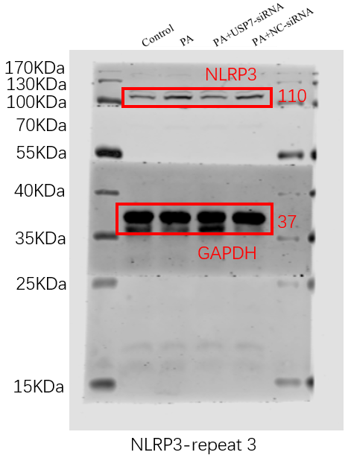
The western blot analysis of cell protein Caspase1 shown in Figure 4N
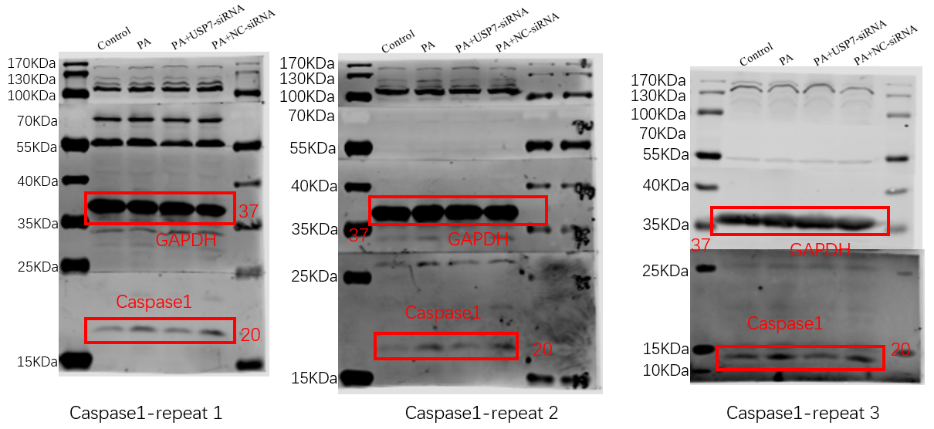
The western blot analysis of cell protein GSDMD shown in Figure 4N
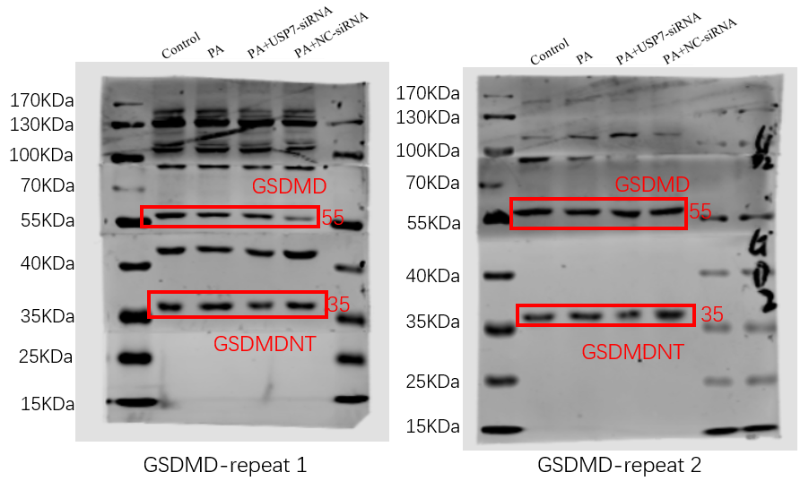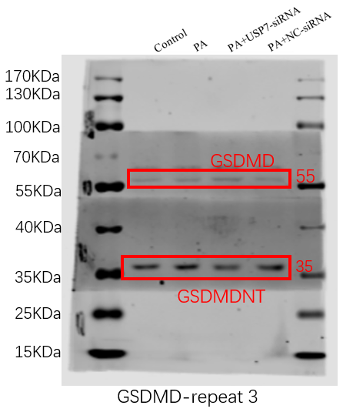
The western blot analysis of tissue protein Keap1 shown in Figure 5A
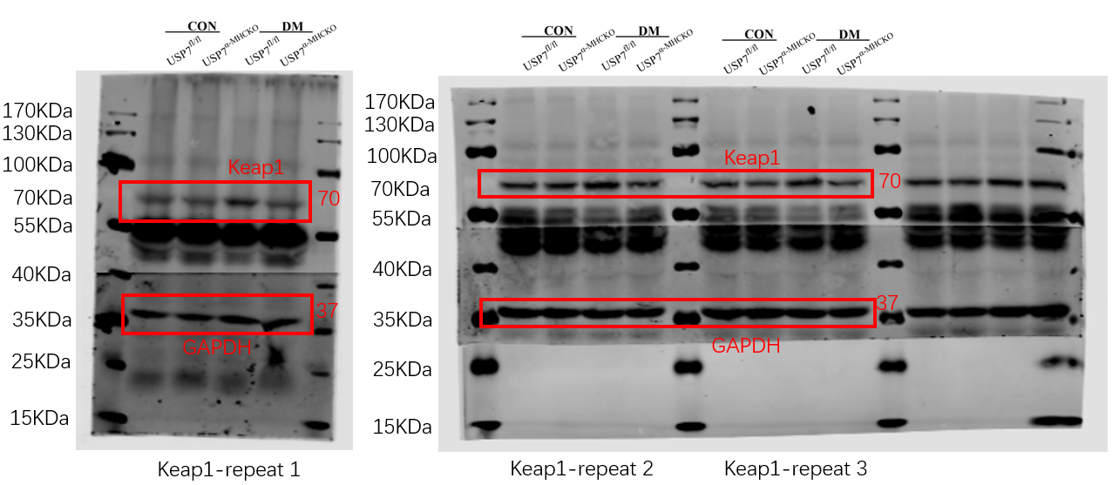
The western blot analysis of tissue protein Nrf2 shown in Figure 5A
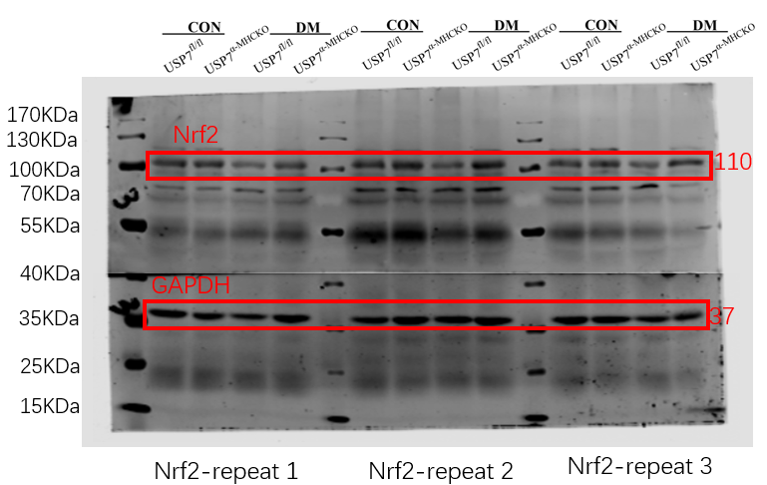
The western blot analysis of tissue protein Keap1 shown in Figure 5C
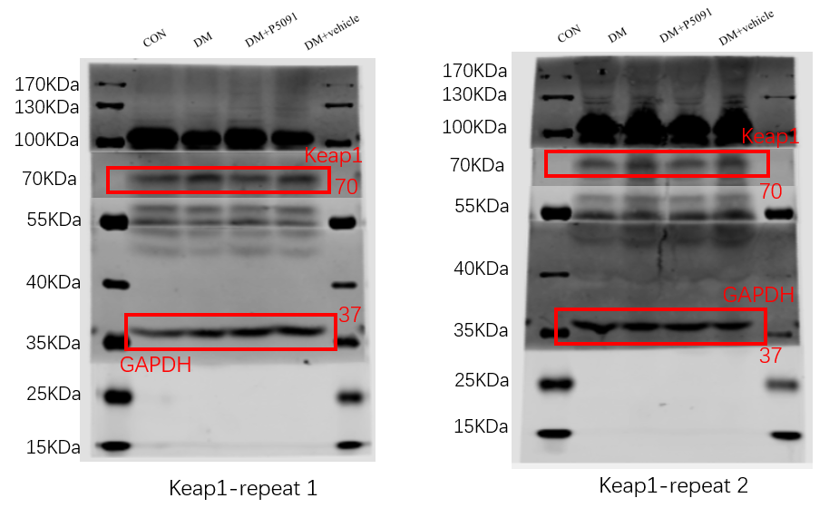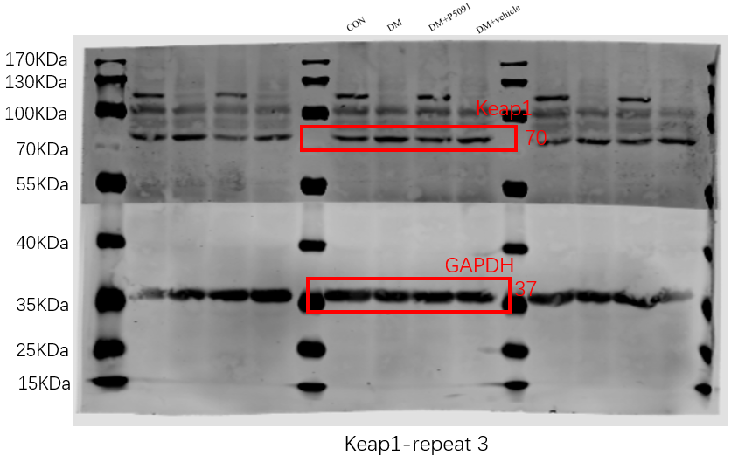
The western blot analysis of tissue protein Nrf2 shown in Figure 5C
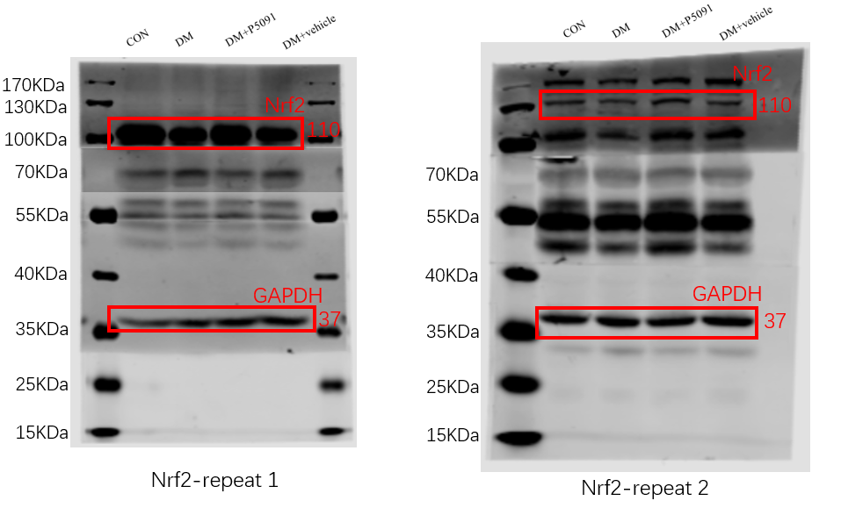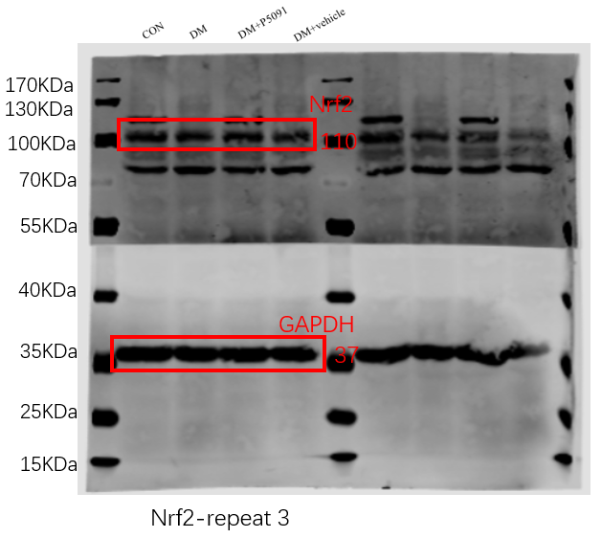
The western blot analysis of cell protein Keap1 shown in Figure 5E
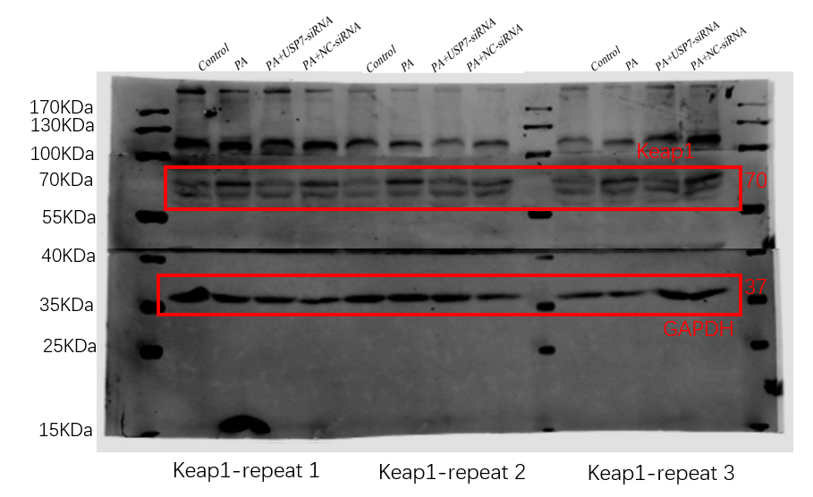
The western blot analysis of cell protein Nrf2 shown in Figure 5E
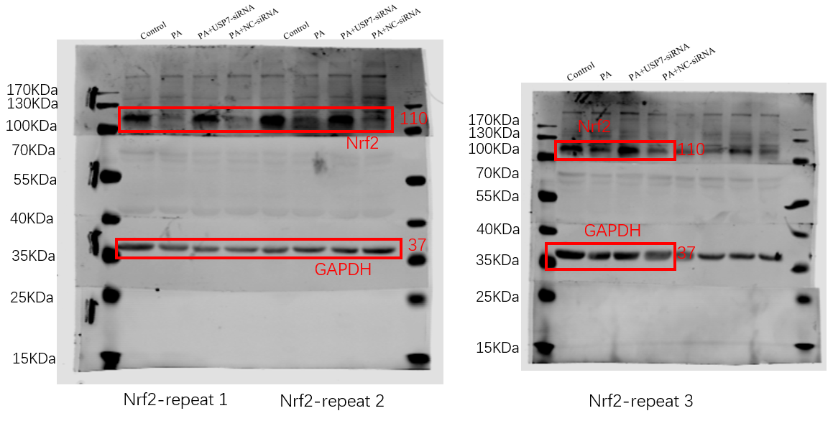
The western blot analysis of cell protein Keap1 shown in Figure 5G
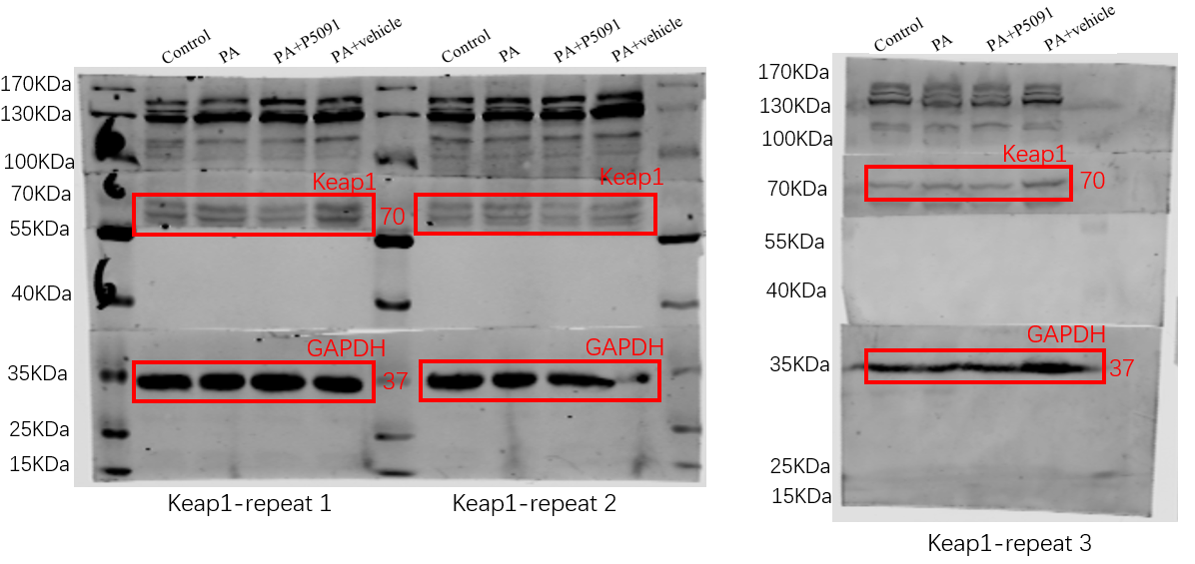
The western blot analysis of cell protein Nrf2 shown in Figure 5G
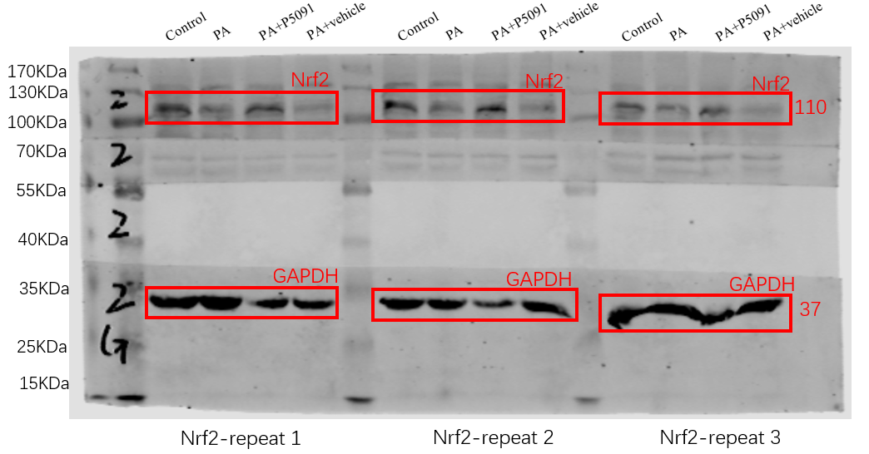
The western blot analysis of cell protein Nrf2 shown in Figure 5I
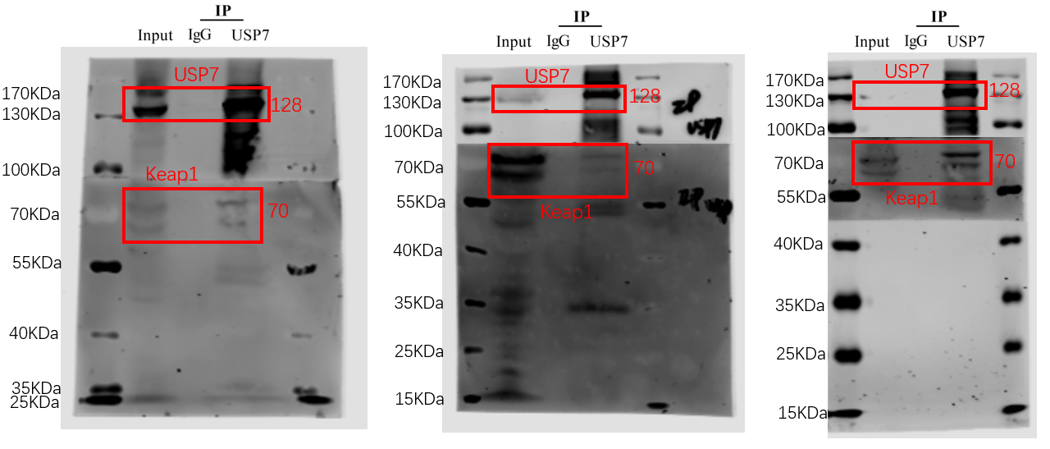
The western blot analysis of cell protein Nrf2 shown in Figure 5J
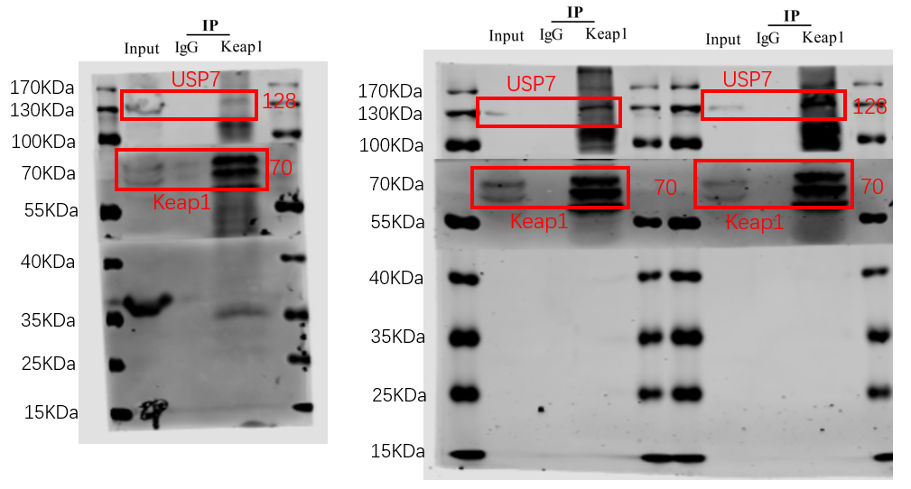
The western blot analysis of cell protein Nrf2 shown in Figure 5K
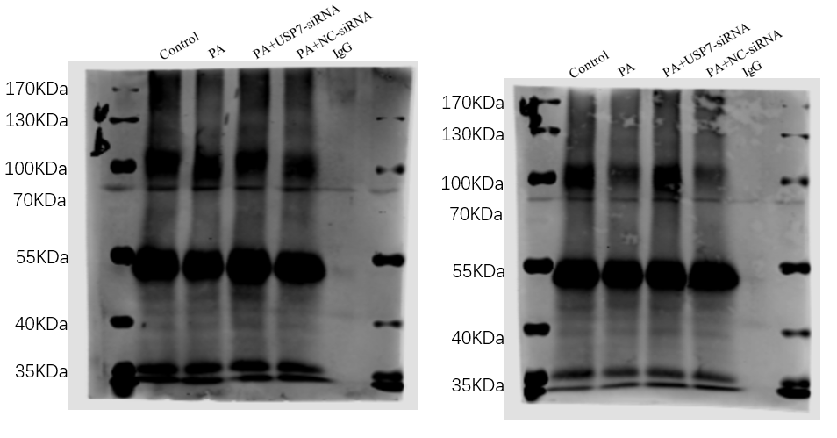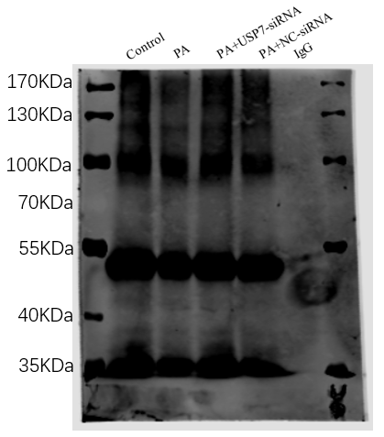

The western blot analysis of cell protein USP7 shown in Figure 6A
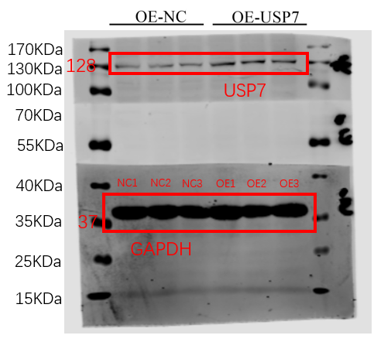
The western blot analysis of cell protein Keap1 shown in Figure 6B
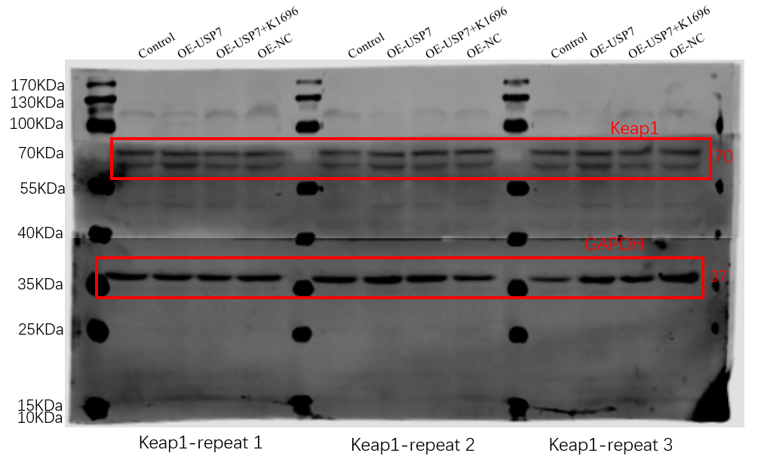
The western blot analysis of cell protein Nrf2 shown in Figure 6B
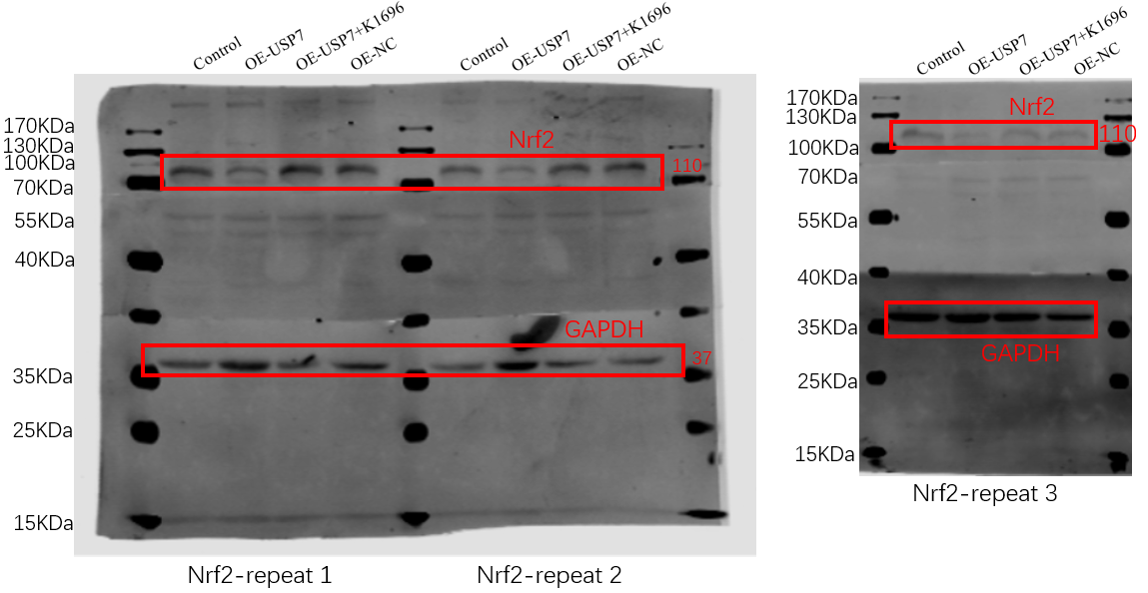
The western blot analysis of cell protein NLRP3 shown in Figure 6B
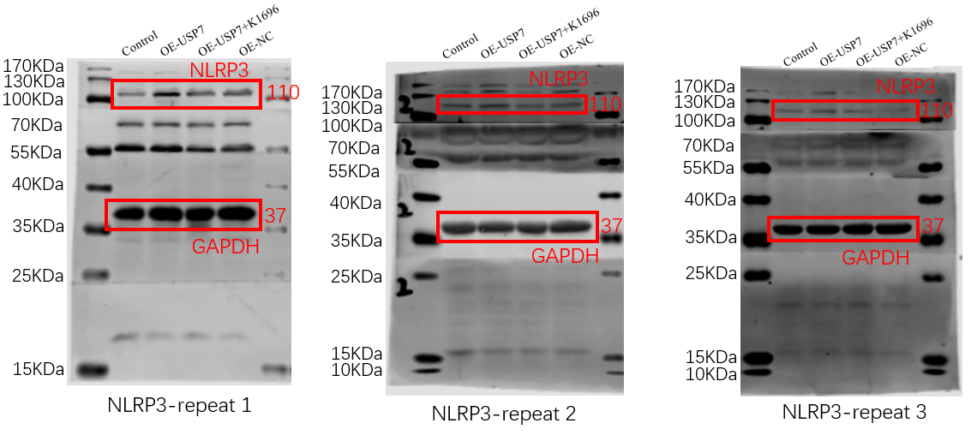
The western blot analysis of cell protein Caspase1 shown in Figure 6B
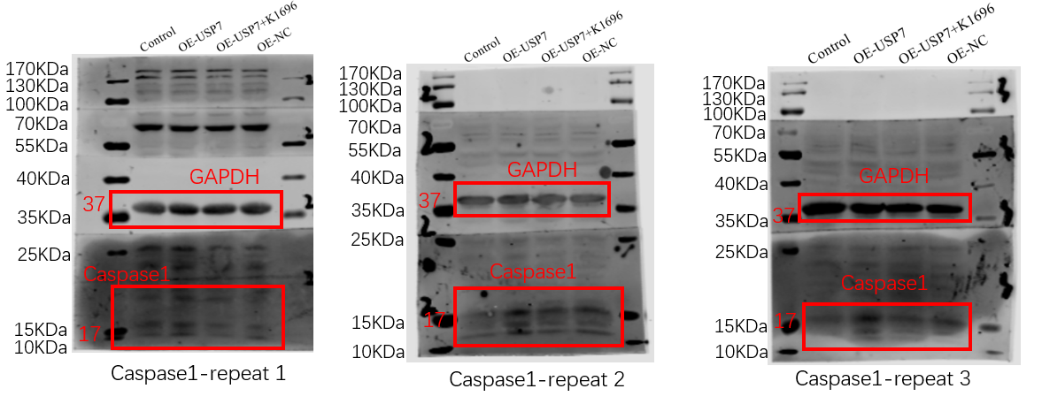
The western blot analysis of cell protein GSDMD shown in Figure 6B
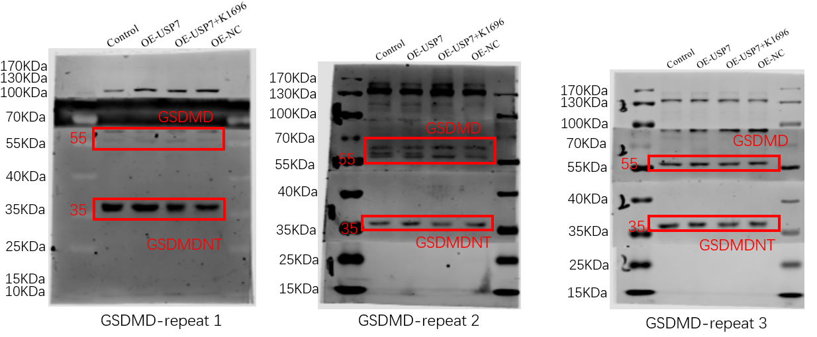
The western blot analysis of tissue protein USP7 shown in Figure S1C
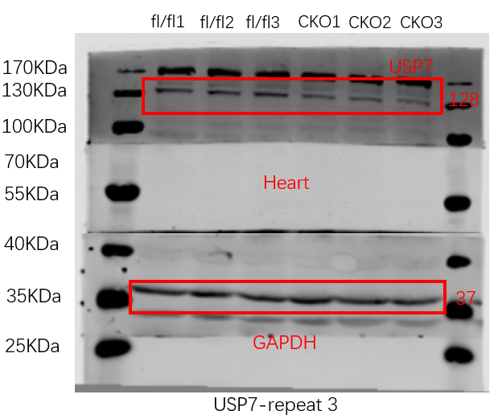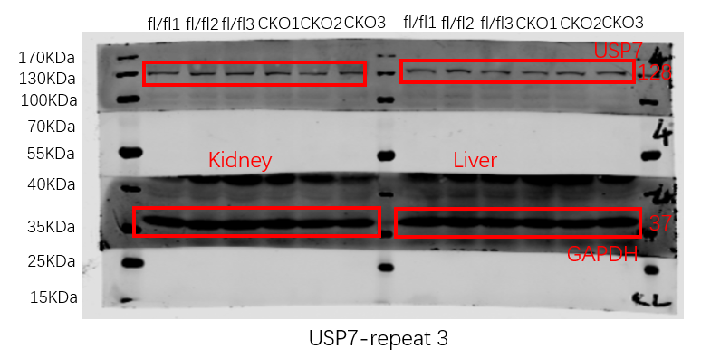

The western blot analysis of cell protein USP7 shown in Figure S1E
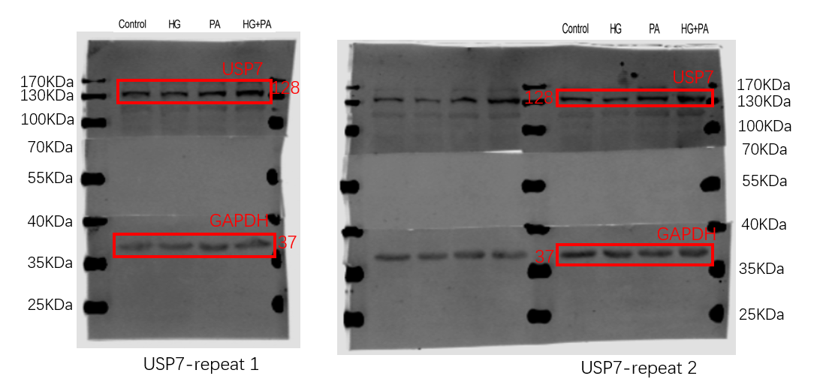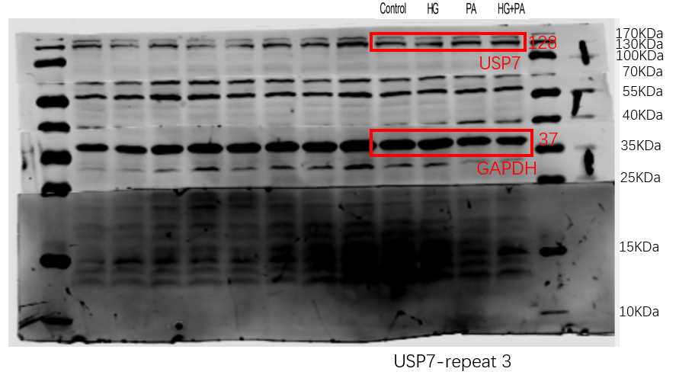
The western blot analysis of cell protein NLRP3 shown in Figure S2A
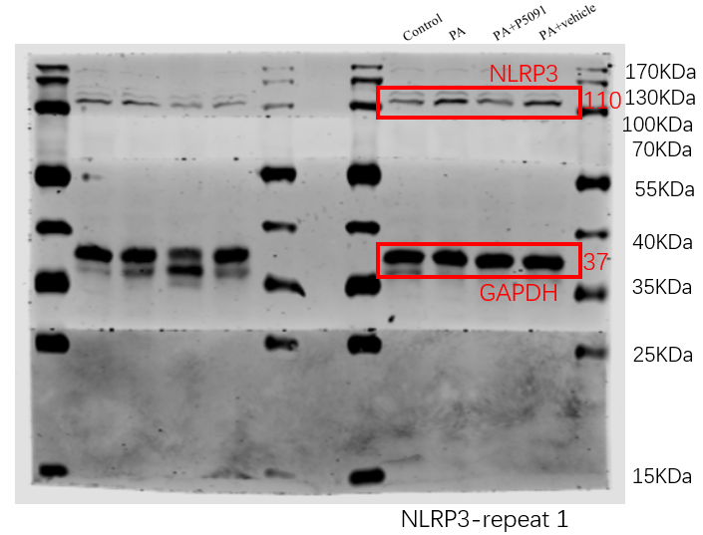
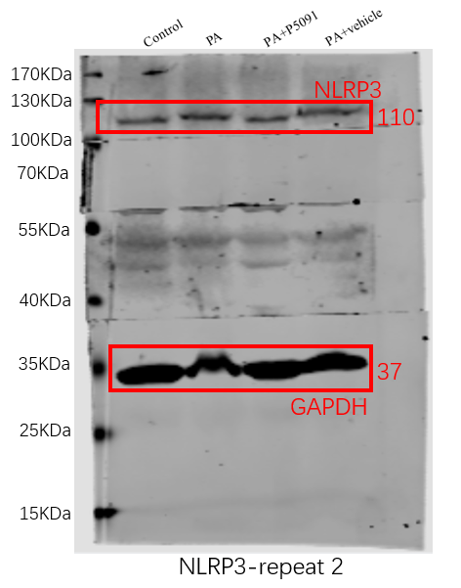
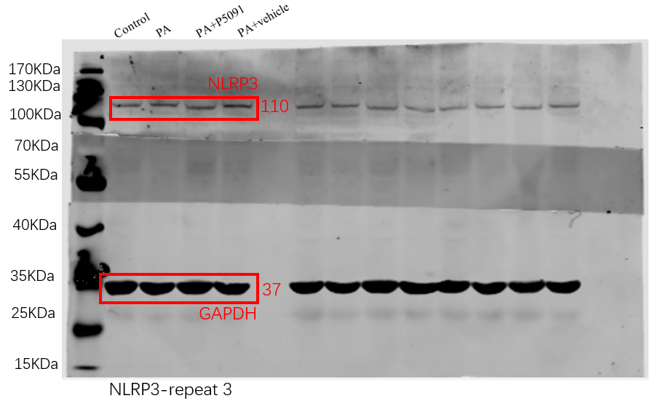
The western blot analysis of cell protein Caspase1 shown in Figure S2A
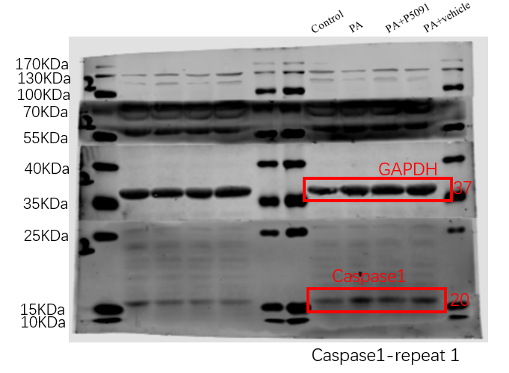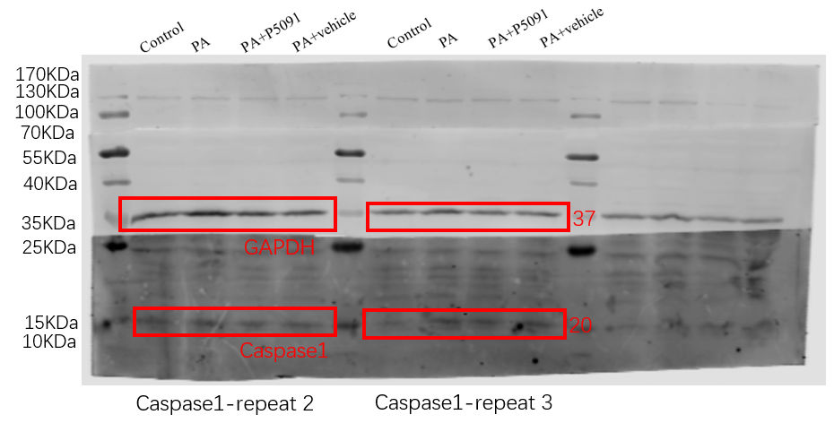

The western blot analysis of cell protein GSDMD shown in Figure S2A
