Table S1: Detailed information of MRI parameters.
 | Tangdu Hospital  (GE 3.0T/SIEMENS 1.5T) |  |  |  |  | Xi'an People's Hospital  (SIEMENS 3.0T/Philips 1.5T)
 | T1WI | T2WI | T1CE | FLAIR |  | T1WI | T2WI | T1CE | FLAIR
TR (ms) | 450-  1750 | 4247-  4300 | 450-  1750 | 8400-  9510 |  | 300-  500 | 2500-  5000 | 300-  500 | 7000-  8500
TE (ms) | 10-24 | 93-109 | 8.9-24 | 78-145 |  | 8-12 | 84-104 | 8-12 | 95-145
TI (ms) |  |  |  | 2100-  2200 |  |  |  |  | 2207-  2300
Slice thickness (mm) | 5-5.5 | 5-5.5 | 5-5.5 | 5-5.5 |  | 5.5-6 | 5.5-6 | 5.5-6 | 5.5-6
Spacing (mm) | 1-1.5 | 1-1.5 | 1-1.5 | 1-1.5 |  | 1-1.5 | 1-1.5 | 1-1.5 | 1-1.5
Note. —TR = repetition time, TE = echo time, TI = inversion time, T1CE = contrast-enhanced T1WI, FLAIR = fluid-attenuated inversion recovery.

S1. Fractal analysis by box counting method.
Fractal analysis is performed on boundary of the tumor region. Fractal dimension (FD) represents complexity or roughness of tumor morphology. FD is calculated using the box counting algorithm. Mathematically, FD is then obtained by:
$$FD = \lim_{∈→0}{\frac{\log\left(N\left(∈\right)\right)}{\log\left(1/∈\right)}}$$
where $ϵ$ is a box length and$N(ϵ)$ is the number of counted boxes.

Figure S1
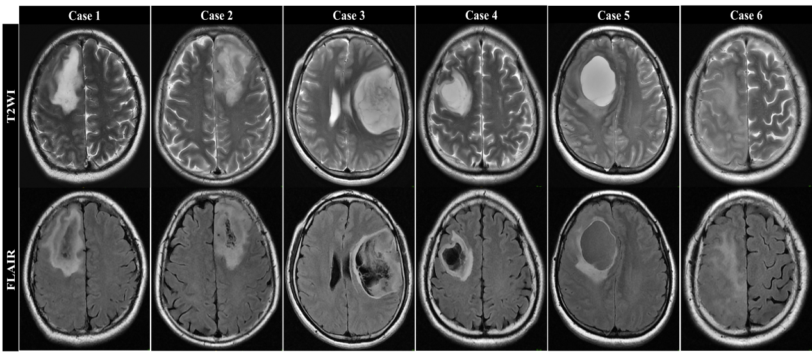
Figure S1. Representative positive and negative RT2FM cases. Cases 1-5 exemplify positive RT2FM in IDHmut gliomas. As shown in cases 1-4, mismatch regions neither require homogeneous T2WI signal nor necessarily involve the entire tumor. Case 5 (cystic glioma) was classified as RT2FM-positive. Case 6 shows negative RT2FM.
Abbreviations: IDH = isocitrate dehydrogenase, T2WI = T2 weighted imaging, FLAIR = fluid-attenuated inversion recovery, RT2FM = relaxed T2-FLAIR mismatch.

Figure S2
Figure S2. Bland-Altman plots of the inter-observer (A) and intra-observer agreement (B) for fractal dimension.

Figure S3
Figure S3. Intersectional feature selection using Boruta and LASSO algorithms.(A) Feature importance ranking based on the boruta algorithm. (B) Feature selection via LASSO regression with 10-fold cross-validation. (C) LASSO regression model screening variable trajectories. (D) Plot of LASSO selected predictors and corresponding coefficients. Abbreviations: T2WI = T2 weighted imaging, T1WI = T1 weighted imaging, FLAIR = fluid-attenuated inversion recovery, RT2FM = relaxed T2-FLAIR mismatch, FD = fractal dimension, Deep WM invasion = deep white matter invasion, SWITW = sinuous wave-like intratumoral-wall feature on T2WI, LASSO = least absolute shrinkage and selection operator.

