Supplementary Figures:

Figure S1: rGCL thickness in controls determined by SD-OCT
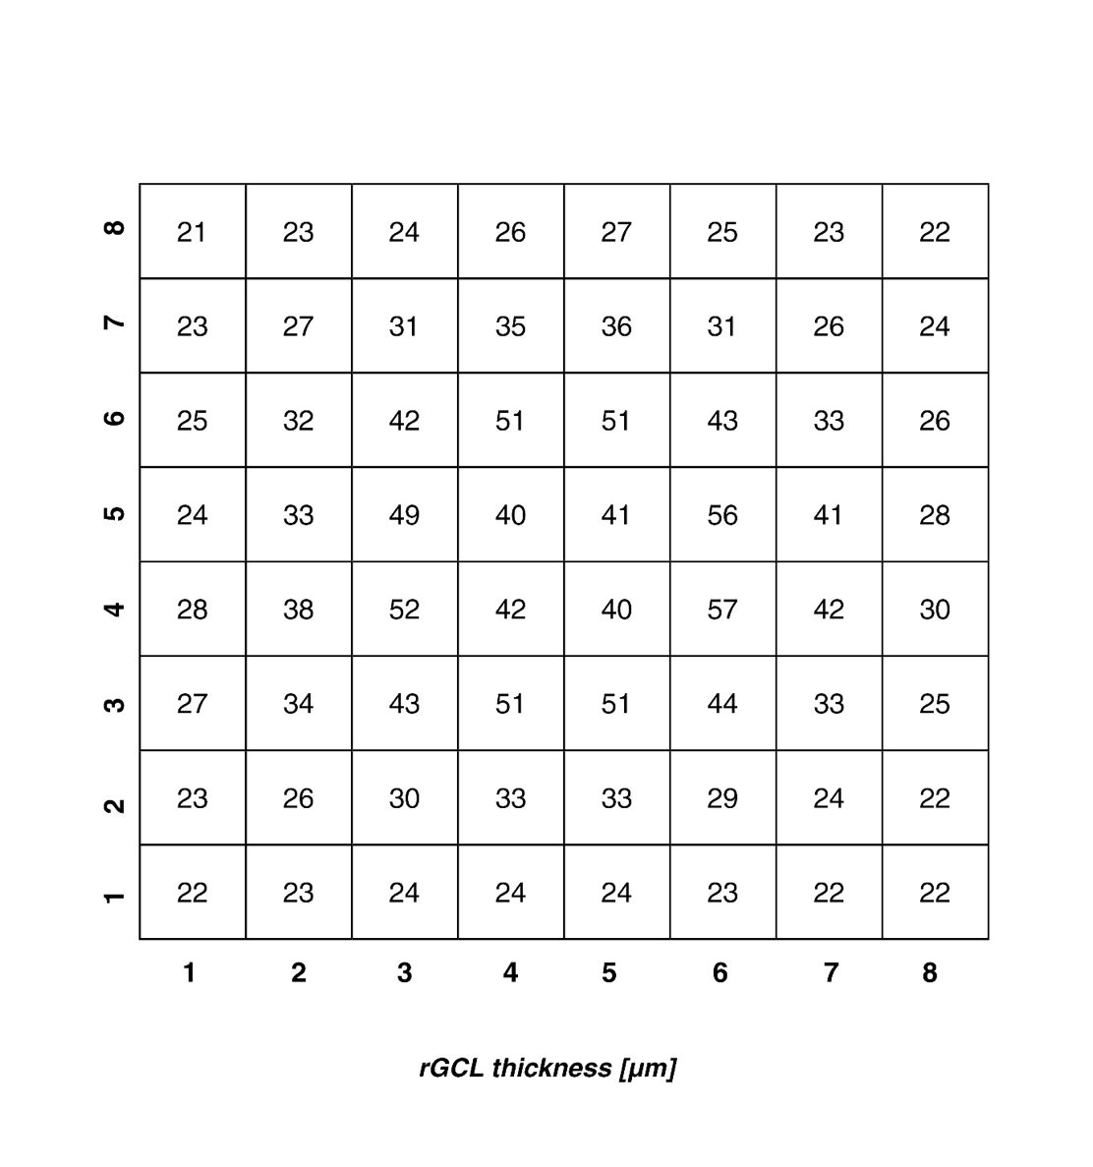
S1: rGCL thickness (rounded to whole numbers) at the posterior pole in normal subjects according to the presentation of Palazon-Cabanes. Numbers at the x and y axis ascend from temporal to nasal, and from inferior to superior, respectively [19].

Figure S2: Age-dependence of ODD location

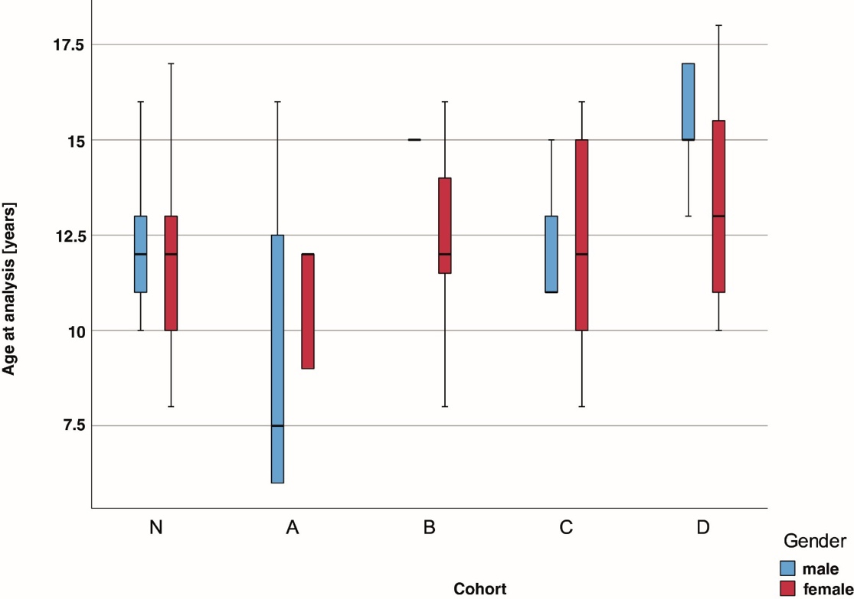
S2. Age-dependence of ODD location/ probands with superficial ODD are older than those with deep ODD. N; healthy controls. A, B, C, D, subgroups of the ODD population, respectively.

Figure S3.
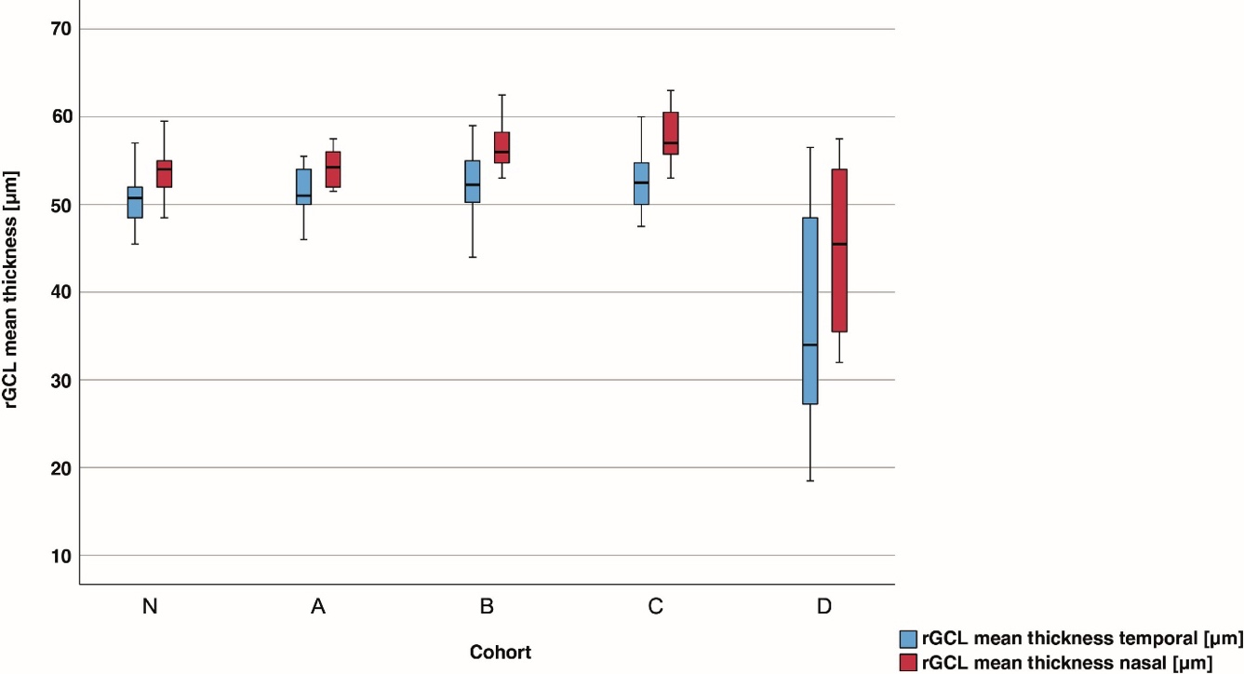

S3. Naso-temporal asymmetry of the rGCL. The decrease in rGCL thickness is larger temporally than nasally. The naso-temporal difference is significantly higher in group D versus controls (p<0,001, Mann Whitney Test). N; healthy controls. A, B, C, D, subgroups of the ODD population, respectively.

