Upgrading fiber-optic spectrometers to hyperspectral imagers
Yujin Liu#, Jingyang Xing#, Hao Wang, Hanyan Zhao, Hongling Wan, Yuncheng Xu, Zhong Ji*, Xueli Chen*
Guangzhou Institute of Technology, Xidian University, Guangzhou, Guangdong 510555, China
Center for Biomedical-Photonics and Molecular Imaging, Advanced Diagnostic-Therapy Technology and Equipment Key Laboratory of Higher Education Institutions in Shaanxi Province, School of Life Science and Technology, Xidian University, Xi’an 710126, China
*Corresponding authors: jizhong@xidian.edu.cn, xlchen@xidian.edu.cn
# These two authors contributed equally to this work.

Section 1. The architecture and imaging principles of the FHSPI system
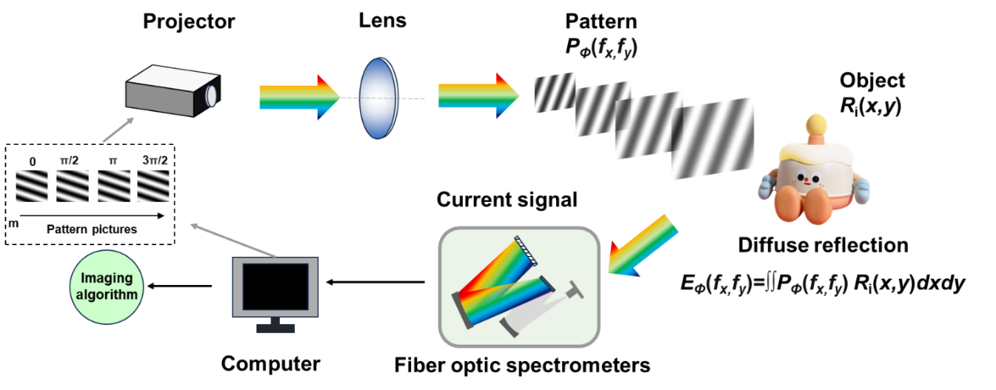
Fig. S1. Architecture of the FHSPI system

As demonstrated in Fig. S1, we use a DLP projector (CB-U05,EPSON) to generate Fourier basis patterns, the size of the Fourier basis patterns is 128 (W)× 128 (H) pixels, and we recover the object image with the same size. A fiber optic spectrometer (AMOS LBTEK) is used as a single-pixel detector to measure the intensity of back-reflected light from the object under the basis patterns’ illumination. The temporal signals of the structured light captured at different wavelengths by the spectrometer are algorithmically reconstructed, thereby achieving three-dimensional spectral imaging.

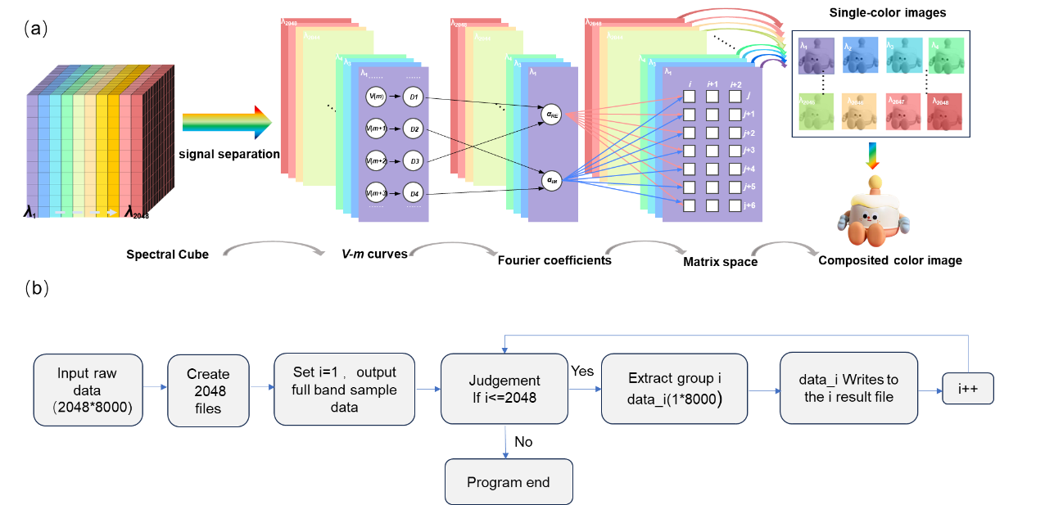
Fig. S2. Imaging principles of the FHSPI system

As demonstrated in Fig. S2, prior to the initiation of data processing, the spectral data acquired from the spectrometer must be subjected to a separation procedure. The procedure for processing the spectrometer data entails the following steps: Initially, the raw spectral data (2048×8000, where 2048 denotes the number of spectral channels and 8000 denotes the sequence of patterns) are input into the system. Subsequently, a result file is generated for each sample to store its full-spectral information. The process begins by setting the initial value i=1 and then looping through to extract 2048 sets of full-spectral sample data. When i is less than 2048, the i-th set of data (data_{i}, size 1×8000) is extracted and written to the i-th result file. Subsequently, i is incremented by 1, and the loop continues. The loop terminates when i exceeds 2048, marking the end of the procedure. Following the aforementioned procedures, each set of data extracted from the spectrometer (1×8000) will serve as the input for subsequent imaging processing. The subsequent processing employs a typical four-step phase-shifting Fourier algorithm, with Fig. S2 illustrating the detailed image reconstruction process. First, the obtained V-t curve can be averaged to V-m curve, where m refers to the sequence of patterns, according to the preset average times. Subsequently, the complex-valued Fourier coefficients (α) are calculated from the I-m curve using the four-step phase-shift method, α=α+j·α_{i} =[D₀-D_{π}]+j·[D_{π/2}–D_{3π/2}]. On this basis, the Fourier spectrum of the entire image is obtained by measuring each Fourier coefficient within the Fourier space. The reconstruction of the multispectral image is then achieved by applying the inverse Fourier transform (IFT) to the acquired Fourier spectrum of the object image.

Section 2. The photograph of the compound-eye fiber optics.
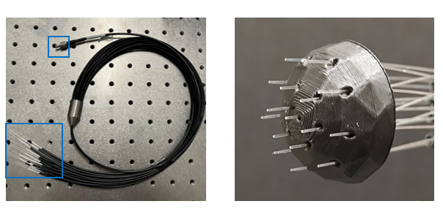
Fig. S3. Photograph of the FHSPI system

We took inspiration from the compound eyes of insects and designed a hemispherical fiber optic port with a compound-eye structure. This fiber optic port consists of a 1-to-16 fiber optic interface and a hemispherical shell, with 16 fibers evenly distributed across the shell. The physical prototype is manufactured using 3D printing technology. The hemispherical shell has a diameter of 2 centimeters, and each aperture has a diameter of 1 millimeter. The apertures are arranged in a 1-6-9 layout: one aperture in the innermost ring, six in the middle ring, and nine in the outermost ring. This design significantly expands the FOV of the fiber optics.

Section 3. The voltage curves (V-m curves) at different wavelengths
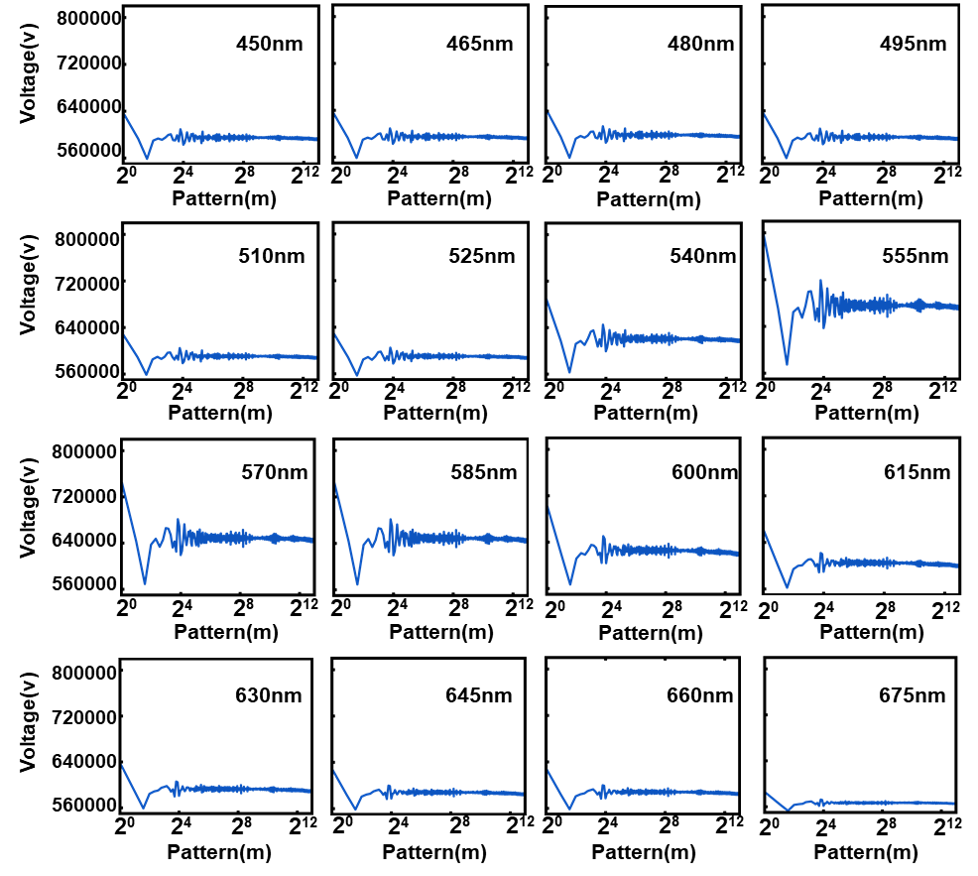
Fig. S4. V-m curves at different wavelengths

The curve in Fig. S2 represents the relationship between the projected pattern number and voltage (V-m), indicating that the measured voltage intensity varies with the change in the projected pattern.

Section 4. The calculation methods for image SNR
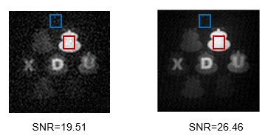
Fig. S5. SNR of the reconstructed images at different wavelengths

The SNR was calculated using the following formula in this study:
$$\begin{aligned}SNR=\frac{<I_{f}>-<I_{b}>}{σ_{b}}\#（1）\end{aligned}$$
In the formula, <I_{f}> represents the average measured signal of the feature region within the image (calculated from the white area enclosed by the red dashed line in Fig. S5); <I_{b}> represents the average measured signal of the background region within the image (calculated from the black area enclosed by the blue dashed line in Fig. S5); and 𝜎_{𝑏} is the standard deviation of the measured signal in the background.

Section 5. Spectral images at different sampling rates.
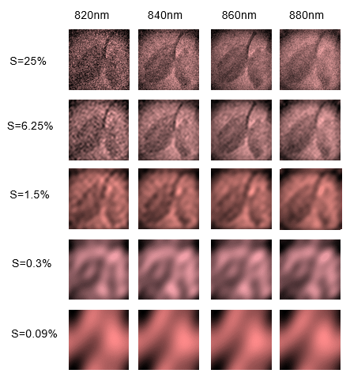
Fig. S6. As the measurement number (m) increases (from bottom to top), the corresponding reconstructed image.

As is well known, a 2D image can be converted to the frequency domain by Fourier transform. In the Fourier spectrum, the low-frequency information determines the general outline of the imaging target, and the high-frequency information determine the details. Consequently, when employing full sampling, the reconstructed image exhibits both a well-defined outline and abundant details, indicative of high resolution. In contrast, reduced sampling leads to a decline in resolution. Fig. S6 shows the reconstructed images as the number of measurements (m) increases, demonstrating that the resolution can be readily enhanced by increasing the number of measurements (m).

Section 6. Generalizability of Object Discrimination at Low Sampling Rates
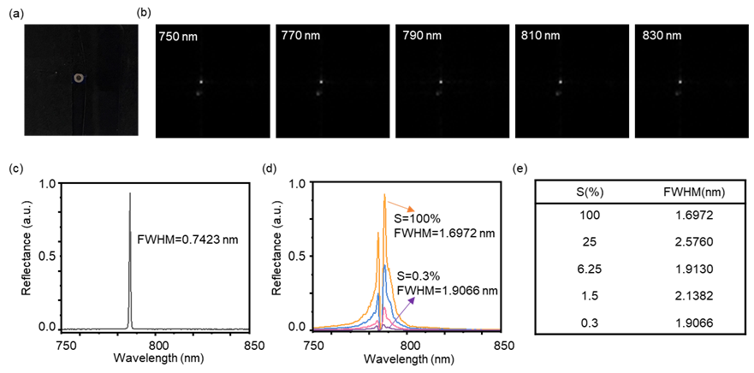
Fig. S7. Spectral resolution characterization under varying sampling rates (a) Image of the target object used for spectral measurements (b) Imaging results at different wavelengths (c) High-resolution spectral measurement of the 0.7 nm FWHM laser source (d) Reconstructed spectral curves under different sampling rates (e) FWHM distribution of reconstructed spectra across sampling rates

In conventional imaging systems, low sampling rates do compromise spatial resolution. However, our research primarily focuses on spectral resolution characteristics for target discrimination tasks. The experimental results confirm that spectral resolution remains largely unaffected by low sampling rates. We have systematically validated these findings through comprehensive experimental analyses. Fig.S7 (a) presents the imaging results of the target object, while Fig. S7 (b) shows the imaging results at different wavelengths. Fig. S7 (c) displays the high-precision spectral measurement of the 0.7 nm FWHM laser source. Most importantly, Fig. S7 (d) and (e) demonstrate that the reconstructed spectral data and their FWHM distributions maintain remarkable consistency across varying sampling rates, clearly indicating that reduced sampling rates do not substantially compromise spectral resolution capability. The observed minor broadening may be attributed to laser speckle effects and image formation quality in the optical system.

Section 7. The architecture and imaging principles of the FHSPI system
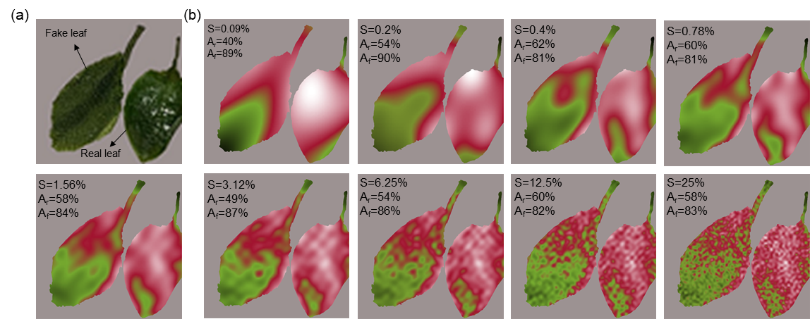
Fig. S8. Near-infrared spectral imaging (880 nm) of real and fake leaves at different sampling rates (a) Photoraph of real and fake leaves. (b) Image results and recognition accuracy at 880 nm

Based on probabilistic statistical methods, we established the following discrimination criteria: regions with pixel values below 0.55 were classified as genuine leaves, while those above 0.55 were identified as artificial leaves. As demonstrated in Fig. S8, at 25% sampling rate, the system achieved 58% recognition accuracy for genuine leaves and 83% for artificial leaves. When the sampling rate was reduced to 0.09%, the recognition rate for genuine leaves increased to 40%, while maintaining 89% for artificial leaves. This phenomenon may be attributed to the specific distribution characteristics of imaging noise under low sampling conditions - the noise actually enhances the signal-to-noise ratio in the characteristic spectral bands of genuine leaves.

Section 8. The performance comparison between our FHSPI and commercial spectrometers.
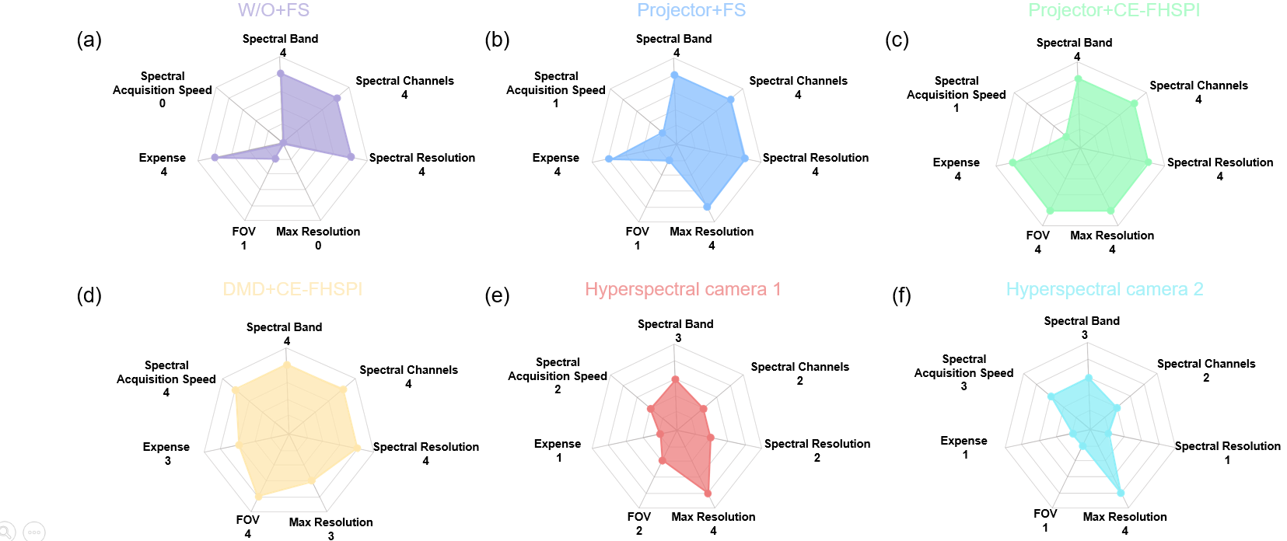
Fig. S9 The Radar Chart of Performance Comparison between Our FHSPI and Commercial Spectrometers.

To comprehensively evaluate the performance of our Fourier Hyperspectral Imaging (FHSPI) system in comparison to commercial spectrometers, we conducted a detailed comparative analysis across several critical parameters, including spectral range, number of spectral channels, spectral resolution, maximum resolution, field of view (FOV), and cost. To more accurately assess spectral recognition performance, we introduced a novel parameter—the spectral acquisition rate—defined as the number of spectra captured per unit time and expressed in "spectra per second" (sp/s). Our FHSPI system achieves an impressive spectral acquisition rate of 1250 sp/s, significantly surpassing many commercial alternatives. Furthermore, the FHSPI system demonstrates superior performance in multiple aspects: it offers a greater number of spectral channels, higher spectral resolution, and a wider FOV, all while maintaining a lower cost. This combination of advanced capabilities and cost-effectiveness positions FHSPI as a highly competitive solution in the field of hyperspectral imaging.

Section 9. Preliminary Biological Applications
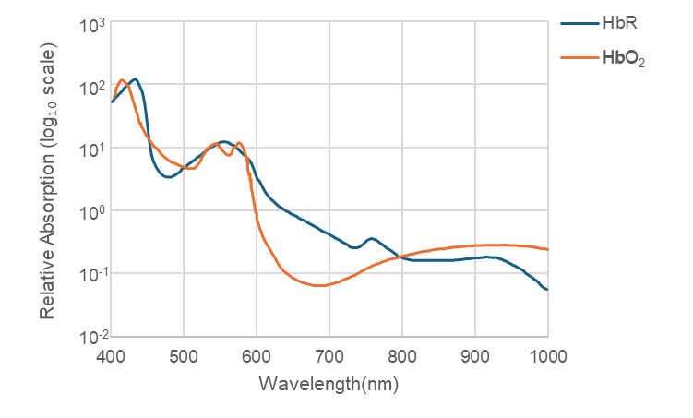
Fig. S10. The near-infrared range (650-950 nm) offers an "optical window" for deep tissue imaging due to the relatively low absorption of HbR (deoxyhemoglobin) and HbO₂ (oxyhemoglobin), enabling non-invasive monitoring of hemoglobin dynamics in tissues like the brain.

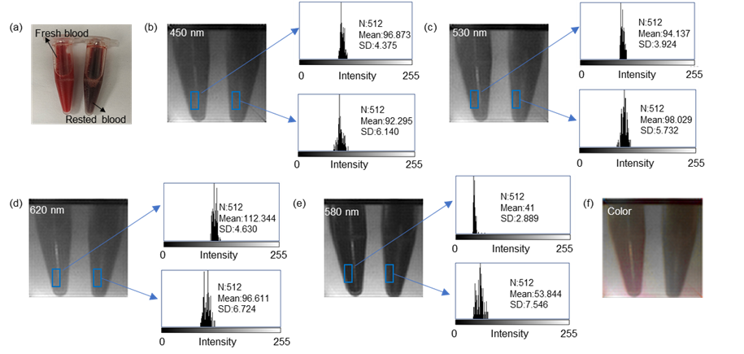
Fig. S11. Multi-wavelength imaging of fresh and rested blood samples. (a) Fresh blood (left) and rested blood (right). (b-e) Images and histograms at 450 nm, 530 nm, 580 nm, and 620 nm. (f) Composite color image.

We have expanded the biological applications of our system in this study. Due to time constraints, the current work focused on preliminary experiments with two fundamental blood sample types (fresh anticoagulated bovine blood and sedimented static blood), while systematic in vivo imaging validations are still underway. As shown in Fig. S11, we systematically investigated the imaging contrasts at four characteristic wavelengths (450 nm, 530 nm, 580 nm, and 620 nm) selected based on the distinct extinction coefficients of oxyhemoglobin and deoxyhemoglobin (Fig. S10), and generated composite color images for analysis. Through multispectral data fusion, the composite images reveal distinct contrasts between oxygenated states and sedimentation characteristics of blood sample.
Currently, in vivo imaging experiments are being actively pursued. Although the experimental results presented here are preliminary in scope, the blood sample experiments have preliminarily verified the system's capability in biofluid discrimination and the appropriateness of our wavelength selection, thereby establishing a foundation for subsequent in vivo studies. We anticipate that further development of in vivo experiments will enable more comprehensive evaluation of the system's potential for biomedical applications. These forthcoming results will be systematically reported in future work.

