Supplementary Information for

Hydrogels with Gigantic Thermopower for Low-grade Heat Harvesting

Yongjie He¹†, Qi Zhang¹†, Hanlin Cheng²†, Yang Liu¹, Yue Shu¹, Yang Geng¹, Yujie Zheng¹, Bo Qin³, Yongli Zhou¹, Shanshan Chen¹, Jing Li¹, Meng Li¹, George Omololu Odunmbaku¹, Jianyong Ouyang²*, Kuan Sun¹*

This PDF file includes:
Materials
Further Notes
Supplementary Figs. 1 to 18
References
Other Supplementary Materials for this manuscript include the following:
Supplementary Videos S1 to S2

Materials
Flocculent PVA (average degree of polymerization of 1750, MW ≈ 77000) was purchased from Tianjin Dingshengxin Chemical Industry Co., Ltd. (Tianjin, China). CsI (M_{w} = 259.81 g/mol, >99.9%), NaI (M_{w} = 149.89 g/mol, >99.0%), KI (M_{w} = 166.00 g/mol, >99.0%), KBr (M_{w} = 119.00 g/mol, >99.0%), KNO₃ (M_{w} = 101.1 g/mol 0, >99.99%) were purchased from Adamas Reagent. KCl (M_{w} = 74.55 g/mol, >99.0%), KOH (M_{w} = 56.11 g/mol, >99.0%) were purchased from General Reagent. All materials were used without further purification. The copper electrode was purchased from Wuhan Zhanchuchayou Electronic Commerce Co., Ltd.

Further Notes
Note 1: Reproducibility of Results
The same PVA/CsI hydrogel system delivers a Seebeck coefficient of 51.8 mV K⁻¹ (Supplementary Fig. 3) at National University of Singapore.

Note 2: Elimination of Possible Factors Affecting Observed Seebeck Coefficient
The Seebeck coefficient of five kinds of hydrogels is measured using either copper electrode or silver electrode respectively. No obvious difference is noticed (Supplementary Fig. 6), implying the result is independent on the type of metal electrodes. Cyclic voltammetry (CV) is performed on the hydrogel and no redox peak is observed (Supplementary Fig. 7), thereby indicating no redox reaction takes place and the valence state of the ions is unchanged. As shown in Supplementary Fig. 8, the thermal voltage exhibits a peak and then declines slowly during the measurement. This is due to the evaporation of water from the hydrogel during the test. When the relative humidity of the test is increased, the voltage curve gradually becomes flat, with peak value slightly decreased (Supplementary Fig. 9). At the same time, the evaporation of water has an insignificant influence on the ionic conductivity (Supplementary Fig. 10) when the peak value is reached. Besides, the Seebeck coefficients obtained in our hydrogels are all positive, suggesting that cations are the majority charge carriers.

Note 3: Further Details Regarding Water Retention Experiments
In order to further prove that I⁻ ions are able to liberate more hydroxyl groups in PVA hydrogels, a water retention experiment was conceived. The hydrogels containing different potassium compounds are kept at 70 ºC and a constant humidity of 50%. Their weight is measured every half an hour to derive the water content of each hydrogel.

a
b

Supplementary Figure 1. a, Nyquist plots and (b) the calculated ionic conductivity of the i-TE hydrogels with 0.1 M of inorganic salts or alkalis (KI, KBr, KCl, KNO₃ or KOH). The error bars (1 s.d. from five measured samples) were obtained from five measured samples with standard deviations of 0.63, 0.46, 0.33, 0.25 and 0.25 mS cm⁻¹
a
b

Supplementary Figure 2. The Seebeck coefficient of PVA/CsI hydrogel (a) with a CsI concentration of 0.1 M, (b) with a NaI concentration of 1 M determined by the linear fit of the open circuit voltage vs. temperature difference.

Supplementary Figure 3. The Seebeck coefficient of PVA/CsI hydrogel measured at National University of Singapore. The concentration of CsI is 0.1 M.
b
a
c
Supplementary Figure 4. a, The Seebeck coefficient, (b) ionic conductivity, and (c) power factor of PVA/NaI and PVA/KI hydrogel at different concentrations.

Thermal conductivity measurement
The thermal conductivity of hydrogels was measured by hot-wire method. The principle is shown in Supplementary Fig. 5a. The hot wire is arranged inside the hydrogel and the logarithmic relationship between temperature rise and time is recorded. The thermal conductivity is calculated by the formula
$$∆T_{id}\left(r_{0},t\right)=\frac{q}{4πλ}lnt+\frac{q}{4πλ}ln⁡(\frac{4α}{r_{0}^{2}C})$$
Where λis the thermal conductivity, r_{o} is the radius of the insulated wire, C is a constant, q is the heat generation per unit length of the wire. A plot of temperature rise against time for thermal conductivity measurement of PVA/NaI hydrogel is shown in Supplementary Fig. 5b.

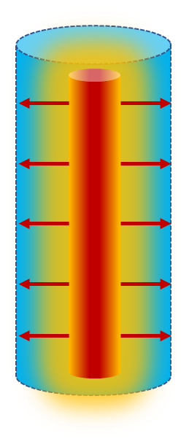
a
b
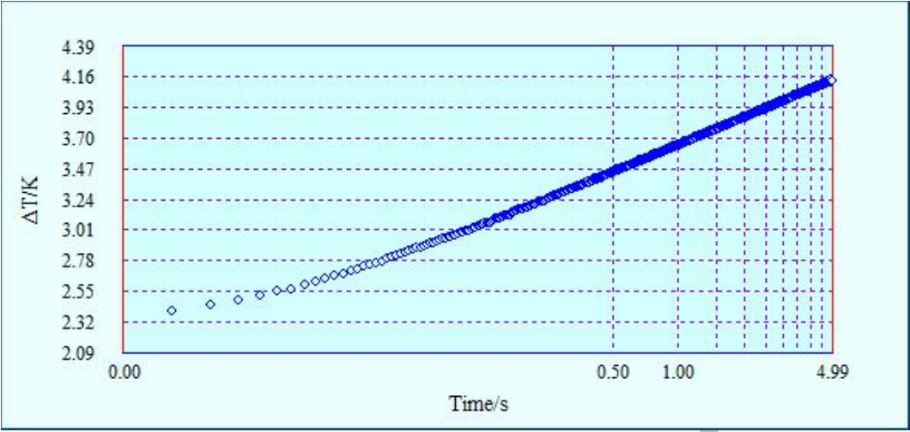

Supplementary Figure 5. a, Schematic illustration of the transient hot wire method. b, Semi-logarithmic plot of temperature rises with time for PVA/NaI hydrogel with a NaI concentration of 1M.

b
a

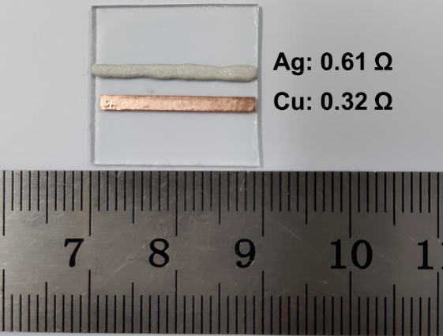

Supplementary Figure 6. a, The Seebeck coefficients of the PVA/x hydrogels with an x concentration of 0.1 M measured by Ag and Cu electrodes (x = KI, KBr, KCl, KNO₃ and KOH). b, The used Ag and Cu electrodes in this work.

Supplementary Figure 7. Cyclic voltammetry (CV) of the PVA/NaI hydrogel with a NaI concentration of 1 M.

Supplementary Figure 8. The voltage dependence of time during charging. The voltage curve of the charging process shows a peak, indicating that the thermal voltage generated by the simultaneous thermo diffusion of anion and cation species towards the cold side.

b
a
c
Supplementary Figure 9. The voltage dependence of time of the 1 M PVA/NaI hydrogel at the RH of (a) 57%, (b) 78%, and (c)94%.

a
b

Supplementary Figure 10. The conductivity dependence of water loss in the hydrogels. The conductivity exhibits a small difference because the evaporation of water also leads to an increase in the concentration of NaI. The error bars (1 s.d. from five measured samples) were obtained from three measured samples with standard deviations of 0.59, 2.74, 1.01 and 1.67 mS cm⁻¹.

Geometry optimizations and frequency analyses were implemented by Gaussian 09 program¹ using B3LYP functional² in conjunction with def2-TZVP basis set.³ Integral equation formalism variant polarizable continuum model (IEF-PCM)⁴ was used to reflect the impact of water solvent environment and the dispersion correction was considered by DFT-D3.^{5,6} All optimized structures are the minimum points on the potential energy surface with no imaginary frequencies.
In order to obtain accurate binding energies, double hybrid functional PWPB95⁷ in combination with def2-QZVPP basis set³ were employed in the single point calculations. Continuum solvation model SMD⁸ and dispersion correction of DFT-D3 were considered in these calculations. The ORCA 4.2 program⁹ was employed for this part of investigation, and the RIJCOSX technique¹⁰ was enabled for accelerating the calculations.
$$\begin{aligned}BE=E\left(PVA\right)+E\left(cation\right)-E\left(PVA+cation\right)\#\end{aligned}$$
All structures are visualized by VMD¹¹
a
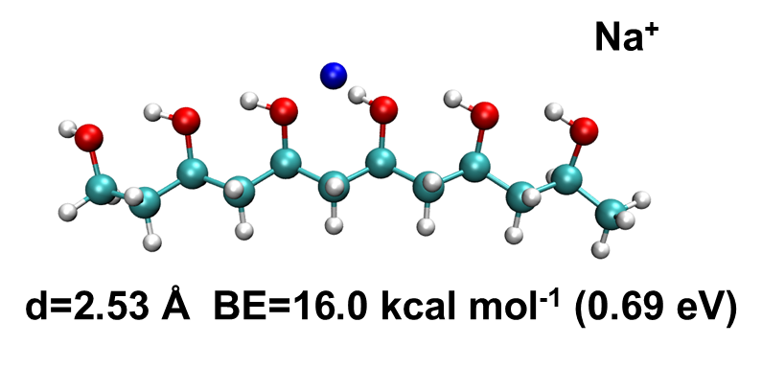

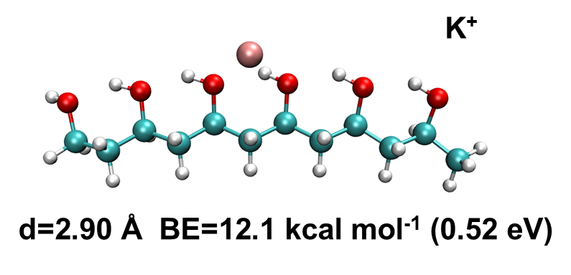
b

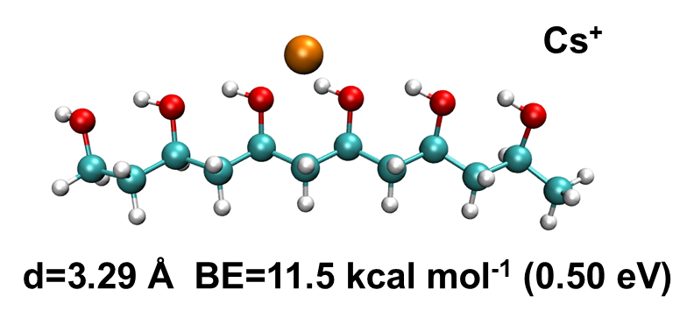
c

Supplementary Figure 11. The distance between the metal cation and the oxygen atom on PVA, and binding energy (BE) between the metal cation and the PVA. The distances between PVA oxygen atom and (a) sodium, (b) potassium and (c) cesium are 2.53 Å, 2.90 Å and 3.29 Å, respectively. And the corresponding binding energies are 16.0 kcal mol⁻¹, 12.1 kcal mol⁻¹ and 11.5 kcal mol⁻¹, respectively.

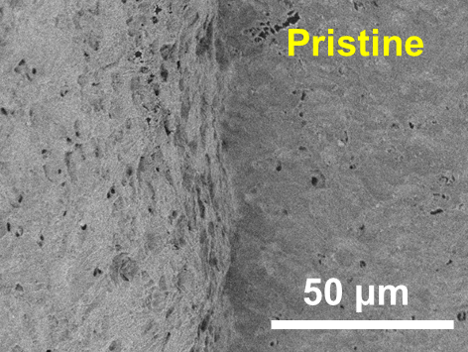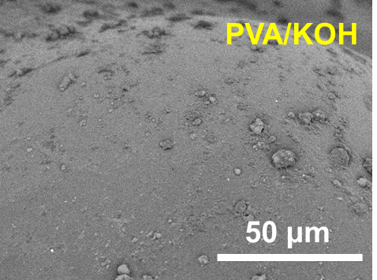
a
b
c
d
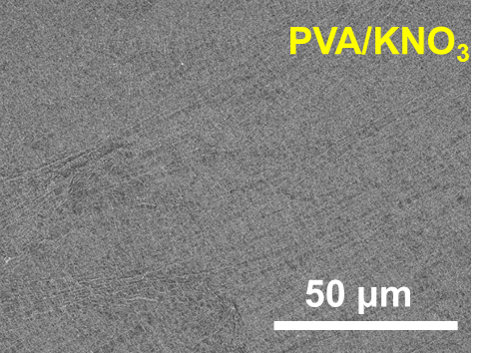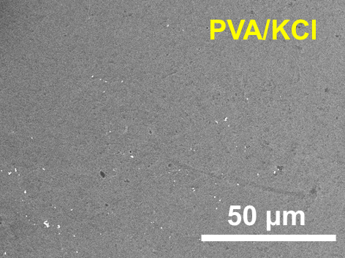
f
e
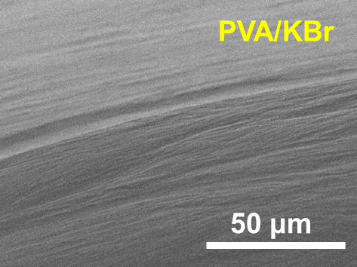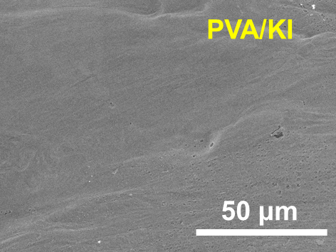

Supplementary Figure 12. The SEM images of (a) PVA hydrogel, (b) PVA/KOH, (c) PVA/KNO₃, (d) PVA/KCl, (e) PVA/KBr and (f) PVA/KI. The scale bar is 50 μm.

Atomic force microscopic (AFM) images were acquired using multifunctional scanning probe microscope (MicroNano D-5A) in tapping mode. The film surface morphology of the PVA hydrogel is very rough and showed a R_{q} value of 61.9 nm (Supplementary Fig. 13a). When different inorganic ions are added to PVA hydrogels, the roughness decreases and the film uniformity is significantly improved. It shows that the addition of inorganic ions facilitates homogeneous PVA dispersion in the solvent. The PVA/KOH Rq roughness of 2.8 (Supplementary Fig. 13a) and the PVA/KI (Supplementary Fig. 13b) Rq roughness of 1.0 prove that iodide ions are superior to hydroxide ions in making the polymer evenly dispersed, which is determined by degree of the structure breaker.

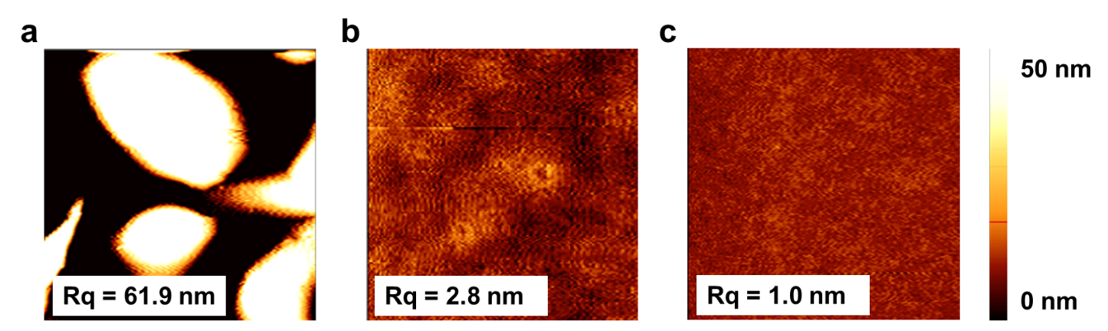

Supplementary Figure 13. AFM images of pristine (a) PVA hydrogel, (b) PVA/KOH and (c) PVA/KI. The image size is 5 x 5 µm.

Supplementary Figure 14. The normalized water content of the hydrogels at ~343K and a RH of ~50%. Hydrogels with strong water retention demonstrated greater exposure of hydroxyl groups.

Seebeck coefficient test system and calibration
The ionic Seebeck coefficient was measured using a home-made experimental platform (Supplementary Fig. 15a). It consists of two Peltier cooling devices fixed unto a radiating aluminum sheet and a fan. The thermocouple is attached on the underside of the glass substrate directly below the electrodes (Supplementary Fig. 15b). To avoid temperature measurement errors resulting from imprecise positioning of the thermocouple beneath the electrodes, the Seebeck coefficient was determined by the following equation:
$$S=\frac{∆V}{∆T}\frac{d_{2}}{d_{1}}$$
Where ∆V is the open circuit voltage, ∆T is the temperature difference. The distance between the electrodes and the distance between the thermocouple are d₁ and d₂ respectively. According to previous reports, the system had a test error of about 6 %.¹² The PSSH films was tested as a standard sample. The Seebeck coefficient of PSSH films with 1 wt% by drop-casting on glass was about 8.6m V K⁻¹ at the relative humidity of 75% (Supplementary Fig. 15c & Supplementary Fig. 15d). This is consistent with the value reported in the literature.¹³
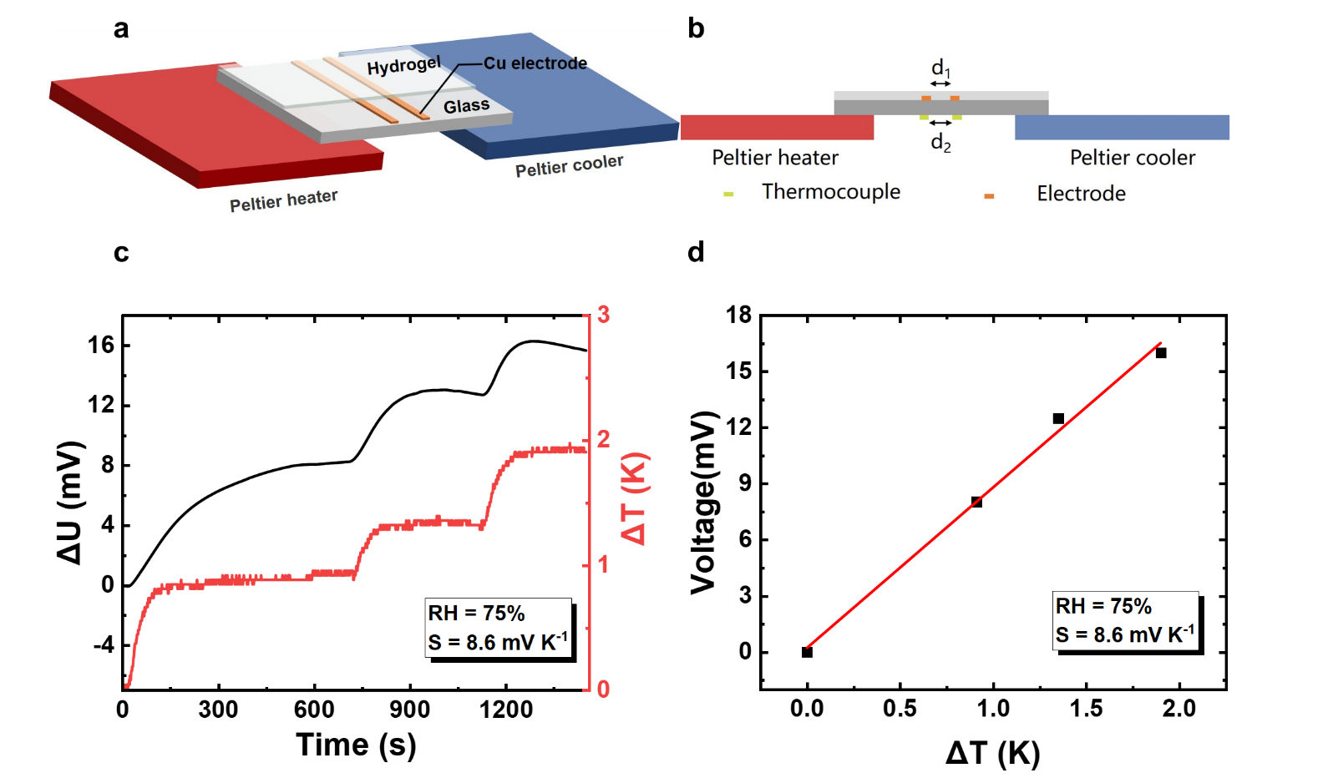

Supplementary Figure 15. a, Schematic illustration of the Seebeck coefficient test system. The hydrogel was evenly spread on a glass substrate containing electrodes with a width of 1mm and a spacing of 2 mm. b, Side view of the Seebeck coefficient test system showing the thermocouple under the glass substrate. c, The Seebeck coefficient was about 8.6 mV K⁻¹ at a humidity of ~75% using the PSSH film. d, Thermo-voltage vs. temperature difference for PSSH films exhibiting a linear fit.

Capacitance performance test measurement
We chose 1 M PVA/NaI hydrogel for capacitance performance test because it shows the best overall TE properties. The hydrogel was applied onto two smooth and clean copper electrodes (13×1 mm in length and width separated by of 2 mm, as shown in Supplementary Fig. 15a and Supplementary Fig. 15b) and a temperature difference of about 1.1 K was applied at room temperature to measure the thermal voltage properties of the PVA/NaI hydrogel. To obtain the power density, the converted electric energy can be estimated from the following equation:
$E=\int_{0}^{t}{(\frac{V^{2}}{R})dt}$

where V is the voltage, R is the resistance of the load, t is the discharging time.
a
b

Supplementary Figure 16. Charging time of hydrogels at a temperature difference of ~1.1 K with different thicknesses of (a) 300 μm, (b) 1000 μm. The Seebeck coefficient is ~42.8 mV K⁻¹.

a
b
Supplementary Figure 17. a, The discharge time curve, and (b) energy density of PVA/NaI hydrogels with different thickness.

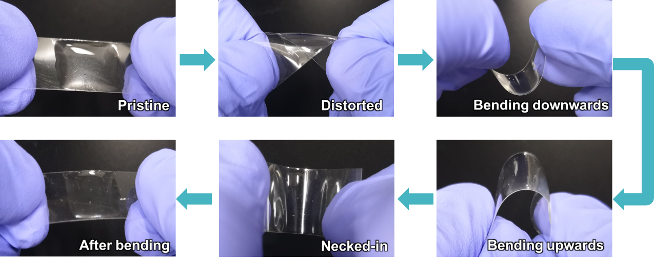

Supplementary Figure 18. The deformability and adhesion of PVA/NaI hydrogel on the PET substrate.

Supplementary Video S1.
Charging/Discharging of the PVA/NaI i-TE capacitor.

Supplementary Video S2.
Demonstration of mechanical properties of the PVA/NaI hydrogel.

References
- M. J. Frisch, G. W. Trucks, H. B. Schlegel, G. E. Scuseria, M. A. Robb, J. R. Cheeseman, G. Scalmani, V. Barone, G. A. Petersson, H. Nakatsuji, X. Li, M. Caricato, A. V. Marenich, J. Bloino, B. G. Janesko, R. Gomperts, B. Mennucci, H. P. Hratchian, J. V. Ortiz, A. F. Izmaylov, J. L. Sonnenberg, D. Williams-Young, F. Ding, F. Lipparini, F. Egidi, J. Goings, B. Peng, A. Petrone, T. Henderson, D. Ranasinghe, V. G. Zakrzewski, J. Gao, N. Rega, G. Zheng, W. Liang, M. Hada, M. Ehara, K. Toyota, R. Fukuda, J. Hasegawa, M. Ishida, T. Nakajima, Y. Honda, O. Kitao, H. Nakai, T. Vreven, K. Throssell, J. A. Montgomery, Jr., J. E. Peralta, F. Ogliaro, M. J. Bearpark, J. J. Heyd, E. N. Brothers, K. N. Kudin, V. N. Staroverov, T. A. Keith, R. Kobayashi, J. Normand, K. Raghavachari, A. P. Rendell, J. C. Burant, S. S. Iyengar, J. Tomasi, M. Cossi, J. M. Millam, M. Klene, C. Adamo, R. Cammi, J. W. Ochterski, R. L. Martin, K. Morokuma, O. Farkas, J. B. Foresman, and D. J. Fox, Gaussian 09, Revision D.01, Gaussian, Inc., Wallingford CT, 2016.
- P. J. Stephens et al., Ab initio calculation of vibrational absorption and circular dichroism spectra using density functional force fields Journal of Physical Chemistry 98, 11623-11627 (1994). doi:10.1021/j100096a001
- F. Weigend et al., Balanced basis sets of split valence, triple zeta valence and quadruple zeta valence quality for H to Rn: Design and assessment of accuracy. Physical Chemistry Chemical Physics 7, 3297-3305 (2005). doi:10.1039/b508541a
- J. Tomasi et al., Quantum mechanical continuum solvation models. Chemical Reviews 105, 2999-3093 (2005). doi:10.1021/cr9904009
- S. Grimme et al., A consistent and accurate ab initio parametrization of density functional dispersion correction (DFT-D) for the 94 elements H-Pu. Journal of Chemical Physics 132, (2010). doi:10.1063/1.3382344
- S. Grimme et al., Effect of the damping function in dispersion corrected density functional theory. Journal of Computational Chemistry 32, 1456-1465 (2011). doi:10.1002/jcc.21759
- L. Goerigk et al., Efficient and accurate double-hybrid-meta-GGA density functionals-evaluation with the extended GMTKN30 database for general main group thermochemistry, kinetics, and noncovalent interactions. J Comput Chem. 7, 291-309 (2011). doi:10.1021/ct100466k
- A. V. Marenich et al., Universal solvation model based on solute electron density and on a continuum model of the solvent defined by the bulk dielectric constant and atomic surface tensions. Journal of Physical Chemistry B 113, 6378-6396 (2009). doi:10.1021/jp810292n
- F. Neese, Software update: the ORCA program system, version 4.0. Wiley Interdisciplinary Reviews-Computational Molecular Science 8, (2018). doi:10.1002/wcms.1327
- S. Kossmann et al., Comparison of two efficient approximate Hartee-Fock approaches. Chemical Physics Letters 481, 240-243 (2009). doi:10.1016/j.cplett.2009.09.073
- W. Humphrey et al., VMD: Visual molecular dynamics. J. Mol. Graph. 14, 33-38 (1996). doi:10.1016/0263-7855(96)00018-5
- S. v. Reenen et al., Correcting for contact geometry in Seebeck coefficient measurements of thin film devices. Organic Electronics 15, 2250-2255 (2014). doi:10.1016/j.orgel.2014.06.018
- S. L. Kim et al., Thermally chargeable solid-state supercapacitor. Adv. Energy Mater. 6, (2016). doi:10.1002/aenm.201600546

