Month 1 to month 42 (each month), and months 45, 48, 51, 54, 57, 60, 63, and 66)
Medical outcomes
in pre-intervention, measurement 2 (10-day post intervention), measurement 3 (three-month post measurement 2), and ten following ups includes six three-month periods (6, 9, 12, 15, 18, 21), four six-month periods (27, 33, 39, 45), and two twelve-month period (57, and 69) after intervention by deploying FCEM and CCM questionnaires.
Instruments:Quality-of-life (SF-36), Percieved stress (PSQ-14), State and Trait Anxiety Basthel Index (BI)Kessler Psychological Distress Scale (K10)Six-minute walk test (6MWT)
Medical measures: Physical examination, Pulmonary-function testing (PFT), Posterior-anterior and lateral (PA-Lat) chest radiography (CXR), Resting oximetry, A standardized 6MWT with continuous oximetry, Free walking test as long as the stamina and capability of patient, Laboratory tests as indicated
xx group sessions
xx patients
xxx hours
Stage 4: Evaluation
xx group sessions
xx patients
xxx hours
Stage 3: Acceptance
xx group sessions
3-5 patients
3-5 hours
Stage 2: Expectations
3-5 group sessions
3-5 patients
45-50 min
Stage 1: Awareness and cognition

POST INTERVENTION
INTERVENTION
PRE INTERVENTION
Visit with phycologist, psychiatrist and neurologist
4. Control(n=35)
3. Researcher at trainer with CCM (n=35)
2. Intimate friend as trainer with FCEM (n=35)
1. Family-centered empowerment model and Continuous care model (n=35)
Random Allocation Software ©
(n=286)
Consulted with a nurse and specialists
(1) Age ≥18 years
(2) informed consent
(3) willingness of designated family member or friend to participate
(4) has basic health literacy and can fill out questionnaire
(5) admitted to the ICU
(6) full code status (7) met ARDS criteria
Acute Respiratory Distress Symptom
Intensive Care Units (n=2)
2016
2007

Measures:

Figure 1: Three phases of study design

Table1: Multiple Cox survival analysis of better scores of Barthel index (BI) and Kessler psychological distress scale (KPDS) over five years
 | Measurement | HR | P value | Lower | Upper
Barthe Index | Group 4 | Reference
Barthe Index | Group 1 | 87.652 | <0.0001 | 20.575 | 373.406
Barthe Index | Group 2 | 28.462 | <0.0001 | 6.770 | 119.654
Barthe Index | Group 3 | 29.226 | <0.0001 | 6.983 | 122.317
Barthe Index | Coexisting Illness First year, (No) | Reference
Barthe Index | Coexisting Illness First year, (One) | 2.045 | 0.017 | 1.139 | 3.672
Barthe Index | Coexisting Illness First year, (Two) | 1.062 | 0.856 | 0.555 | 2.030
Barthe Index | Coexisting Illness First year, (>Two) | 1.070 | 0.803 | 0.628 | 1.825
KPDS Index | Group 4 | Reference
KPDS Index | Group 1 | 2.179 | 0.048 | 1.103 | 4.454
KPDS Index | Group 2 | 2.409 | 0.009 | 1.196 | 4.364
KPDS Index | Group 3 | 0.615 | 0.264 | 0.258 | 1.416
KPDS Index | Gender | 1.322 | 0.233 | 0.824 | 2.061
KPDS Index | BMI | 0.845 | 0.139 | 0.896 | 1.071
KPDS Index | Returned to work first year | 0.684 | 0.170 | 0.418 | 1.232

A
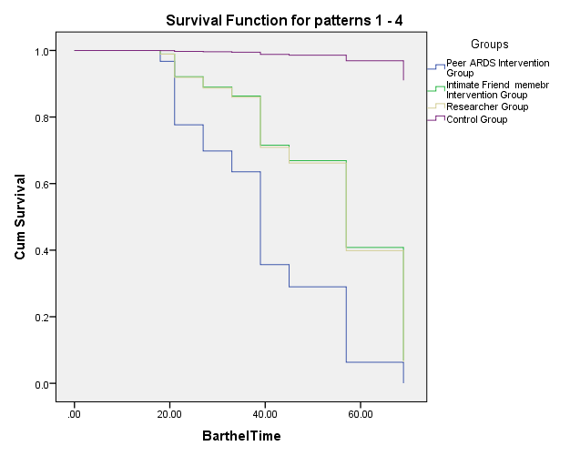
B
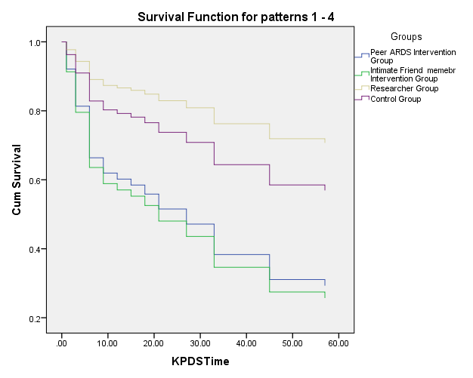

Figure 2: Multiple Cox survival analyses according to (A) Barthel index time and (B) Kessler Psychological Distress Scale (K10) time in four groups of study

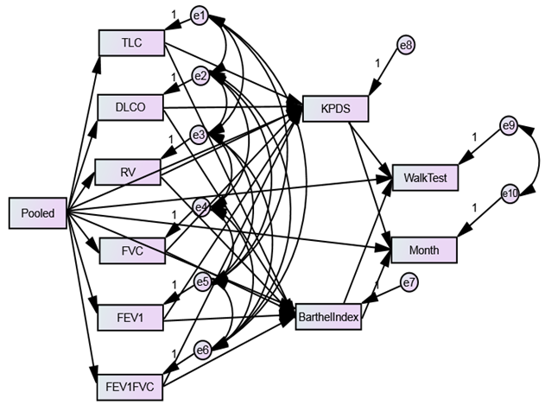

Figure 3:The Structural Education Modeling (SEM) for relationship between variables and waking index (WI) and Month as outcomes

