Extended Data Figures
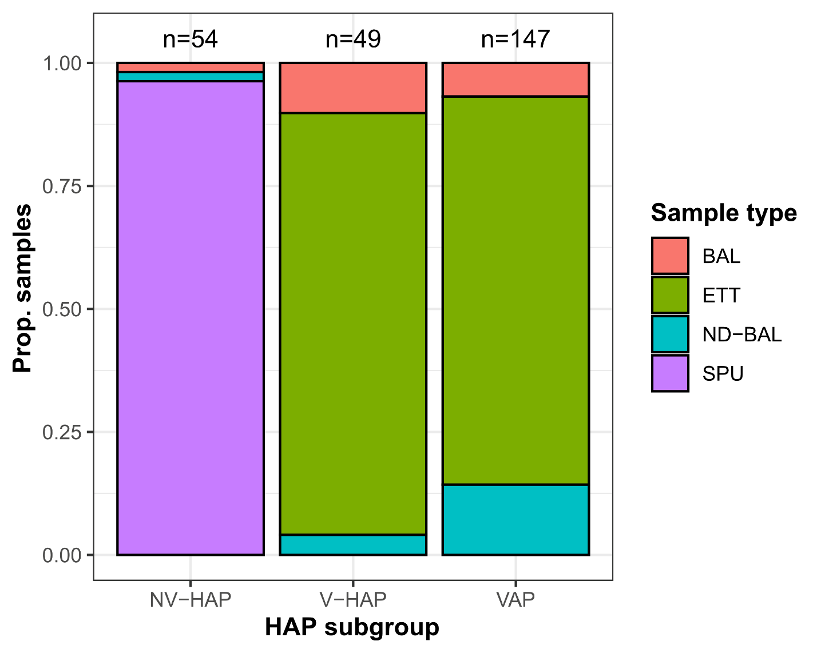

Extended Data Figure 1. Summary of sample types represented in this dataset stratified by HAP subgroup.
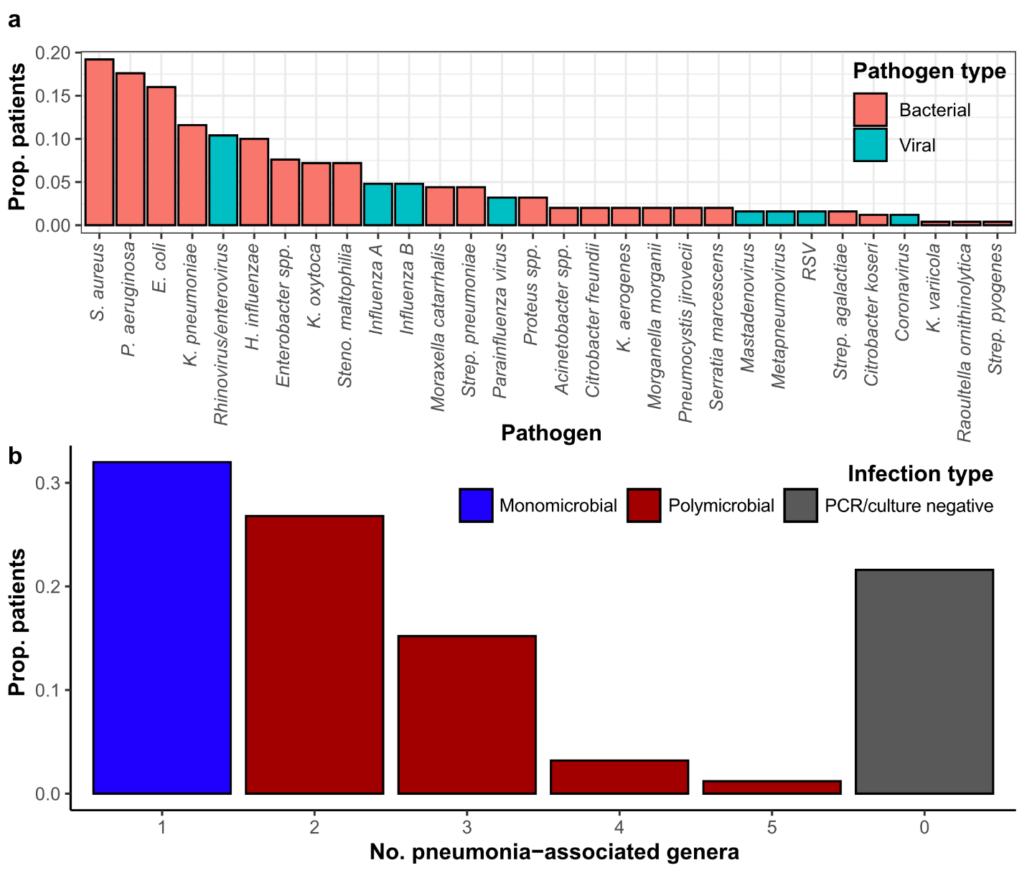

Extended Data Figure 2. Microbial characteristics of samples as assessed by PCR/culture. (a) Proportion of patients (n=250) testing positive for each of the 30 most common pathogens detected through PCR and/or culture. (b) Barplot providing the number of infections found to harbour pneumonia-associated genera. Polymicrobial infections are defined by the detection of more than one pneumonia-associated genus by PCR and/or culture.
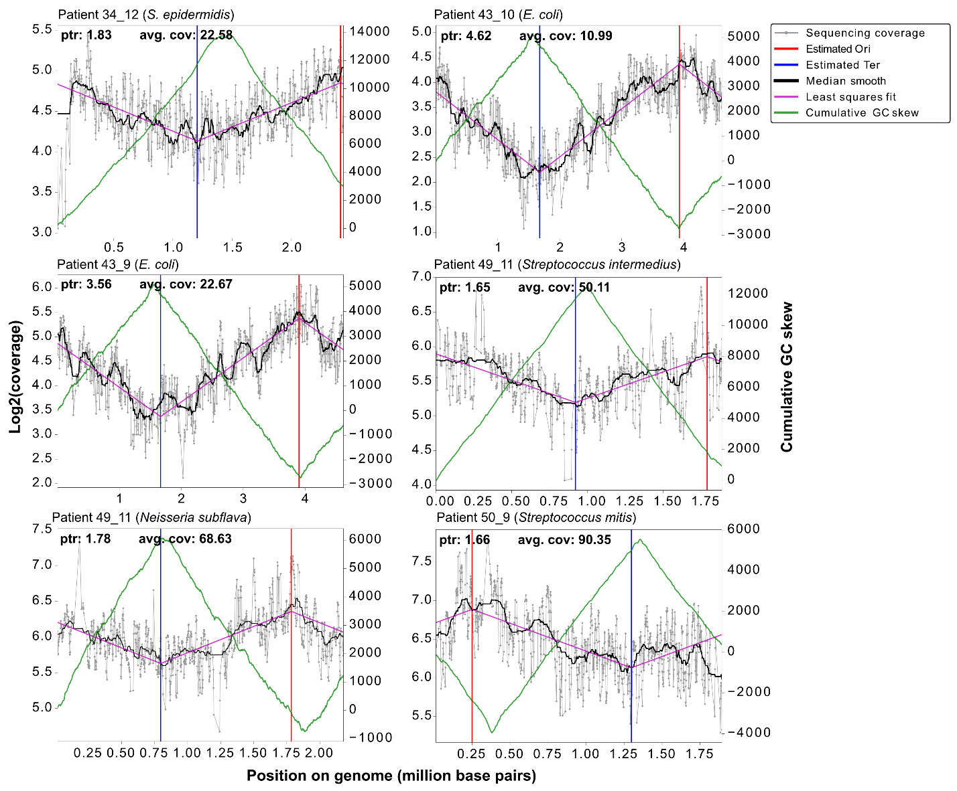

Extended Data Figure 3. Molecular signatures of replicating bacteria in PCR/culture-negative HAP patients. Replication rate analyses²⁹ were performed for all bacterial species that were assigned at least 10,000 reads by Kraken2 in the 49 HAP samples that were PCR/culture negative. Six bacterial species in five patient samples showed sequencing coverage patterns characteristic of replicating bacterial populations in microbial cultures²⁸ (see Methods). In growing bacterial populations, sequencing coverage is higher nearer to the origin of replication (Ori) and lower nearer to the terminus (Ter) of the bacterial chromosome. Each plot shows this characteristic sinusoidal shape of sequencing coverage across the bacterial genome for each of these species. The Ori and Ter positions inferred from these coverage plots were concordant with those inferred using an orthogonal method based on GC skew across the genome^{29,76}.
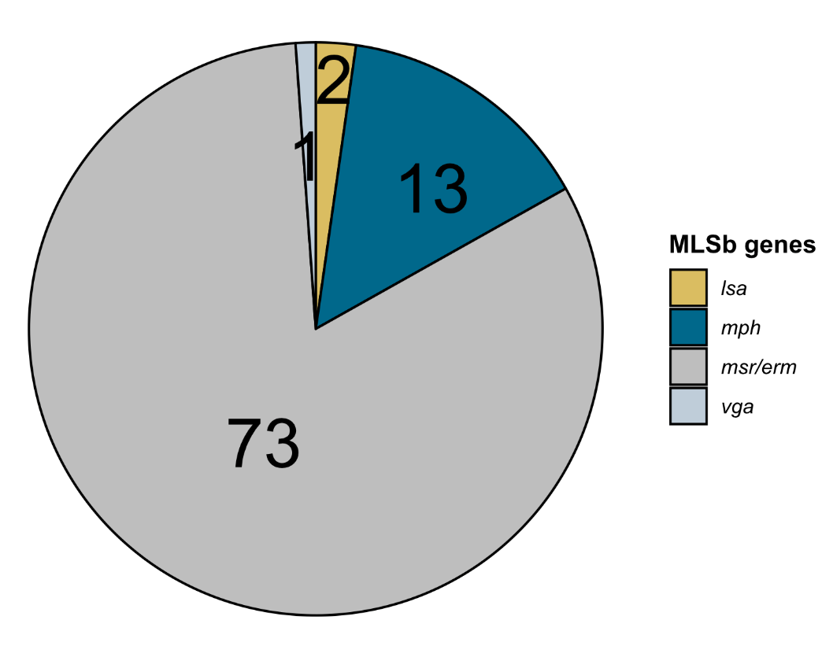
Extended Data Figure 4. Frequency of detected AMR genes associated with resistance to some or all macrolide, lincosamide or streptogramin B antibiotics, as determined by ResFinder⁴¹ across the dataset.
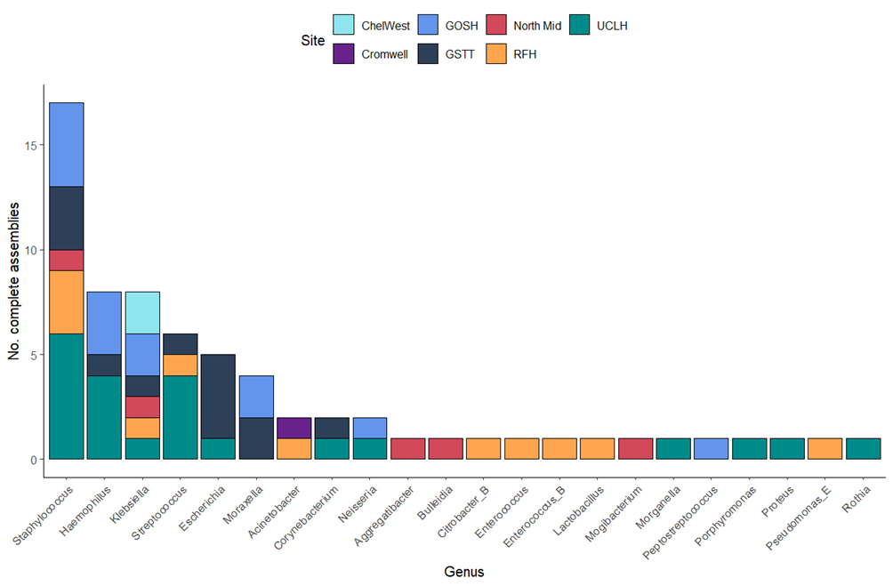

Extended Data Figure 5. Summary of high-quality complete bacterial assemblies recovered. Barplot providing the number of bacterial assemblies assessed by CheckM2⁴⁵ to be at least 90% complete and of high quality, stratified by bacterial genus. The 66 assemblies recovered were assigned GTDB-harmonised genus names using GTDB-tk⁷⁷.
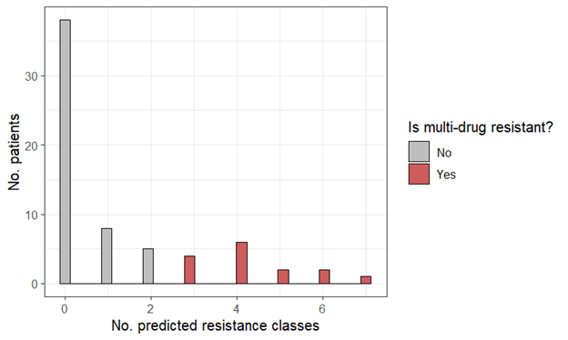

Extended Data Figure 6. High prevalence of predicted drug resistance in recovered bacterial assemblies. Histogram showing the number of predicted AMR resistance classes recovered per patient sample. Chromosomal genes conferring intrinsic resistance were removed (Supplementary Table 5). The antibiotic classes considered are listed in Supplementary Table 6.

