Graphical abstract

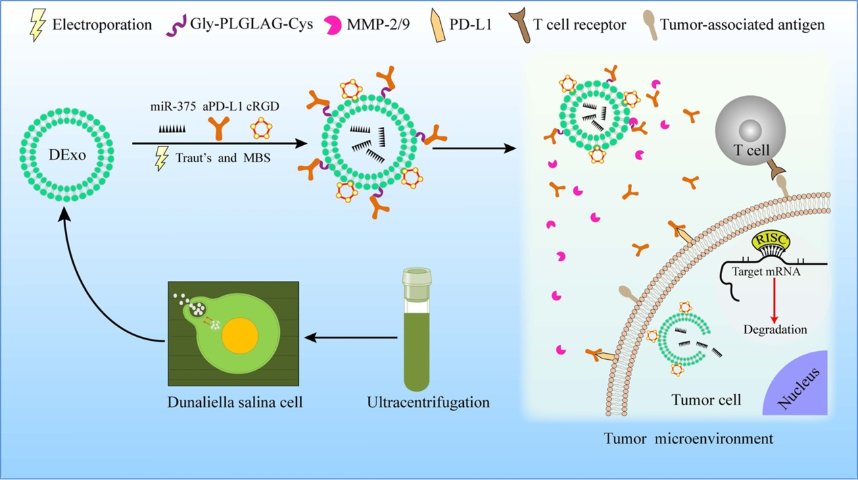
We develop a novel targeted drug delivery system based on exosome-like nanovesicle using natural marine single-celled Dunaliella salina (DENV). The c(RGDyK) peptide has been conjugated to DENV surface to achieve the targeted delivery, miR-375 has been loaded into the cRGD-DENV through electroporation, and aPD-L1 has been conjugated onto its surface via Gly-PLGLAG-Cys peptide, a matrix metalloproteinase-2 (MMP-2)-cleavable peptide, which facilitates the release of aPD-L1 in tumor environment to achieve the high-efficiency combination of gene therapy and immunotherapy. Results demonstrated the engineered cRGD-DENV was effective, promoted selective delivery of cargoes to the target site, and reduced nonspecific uptake, consequently, significantly inhibit tumor growth in vitro and in vivo.

