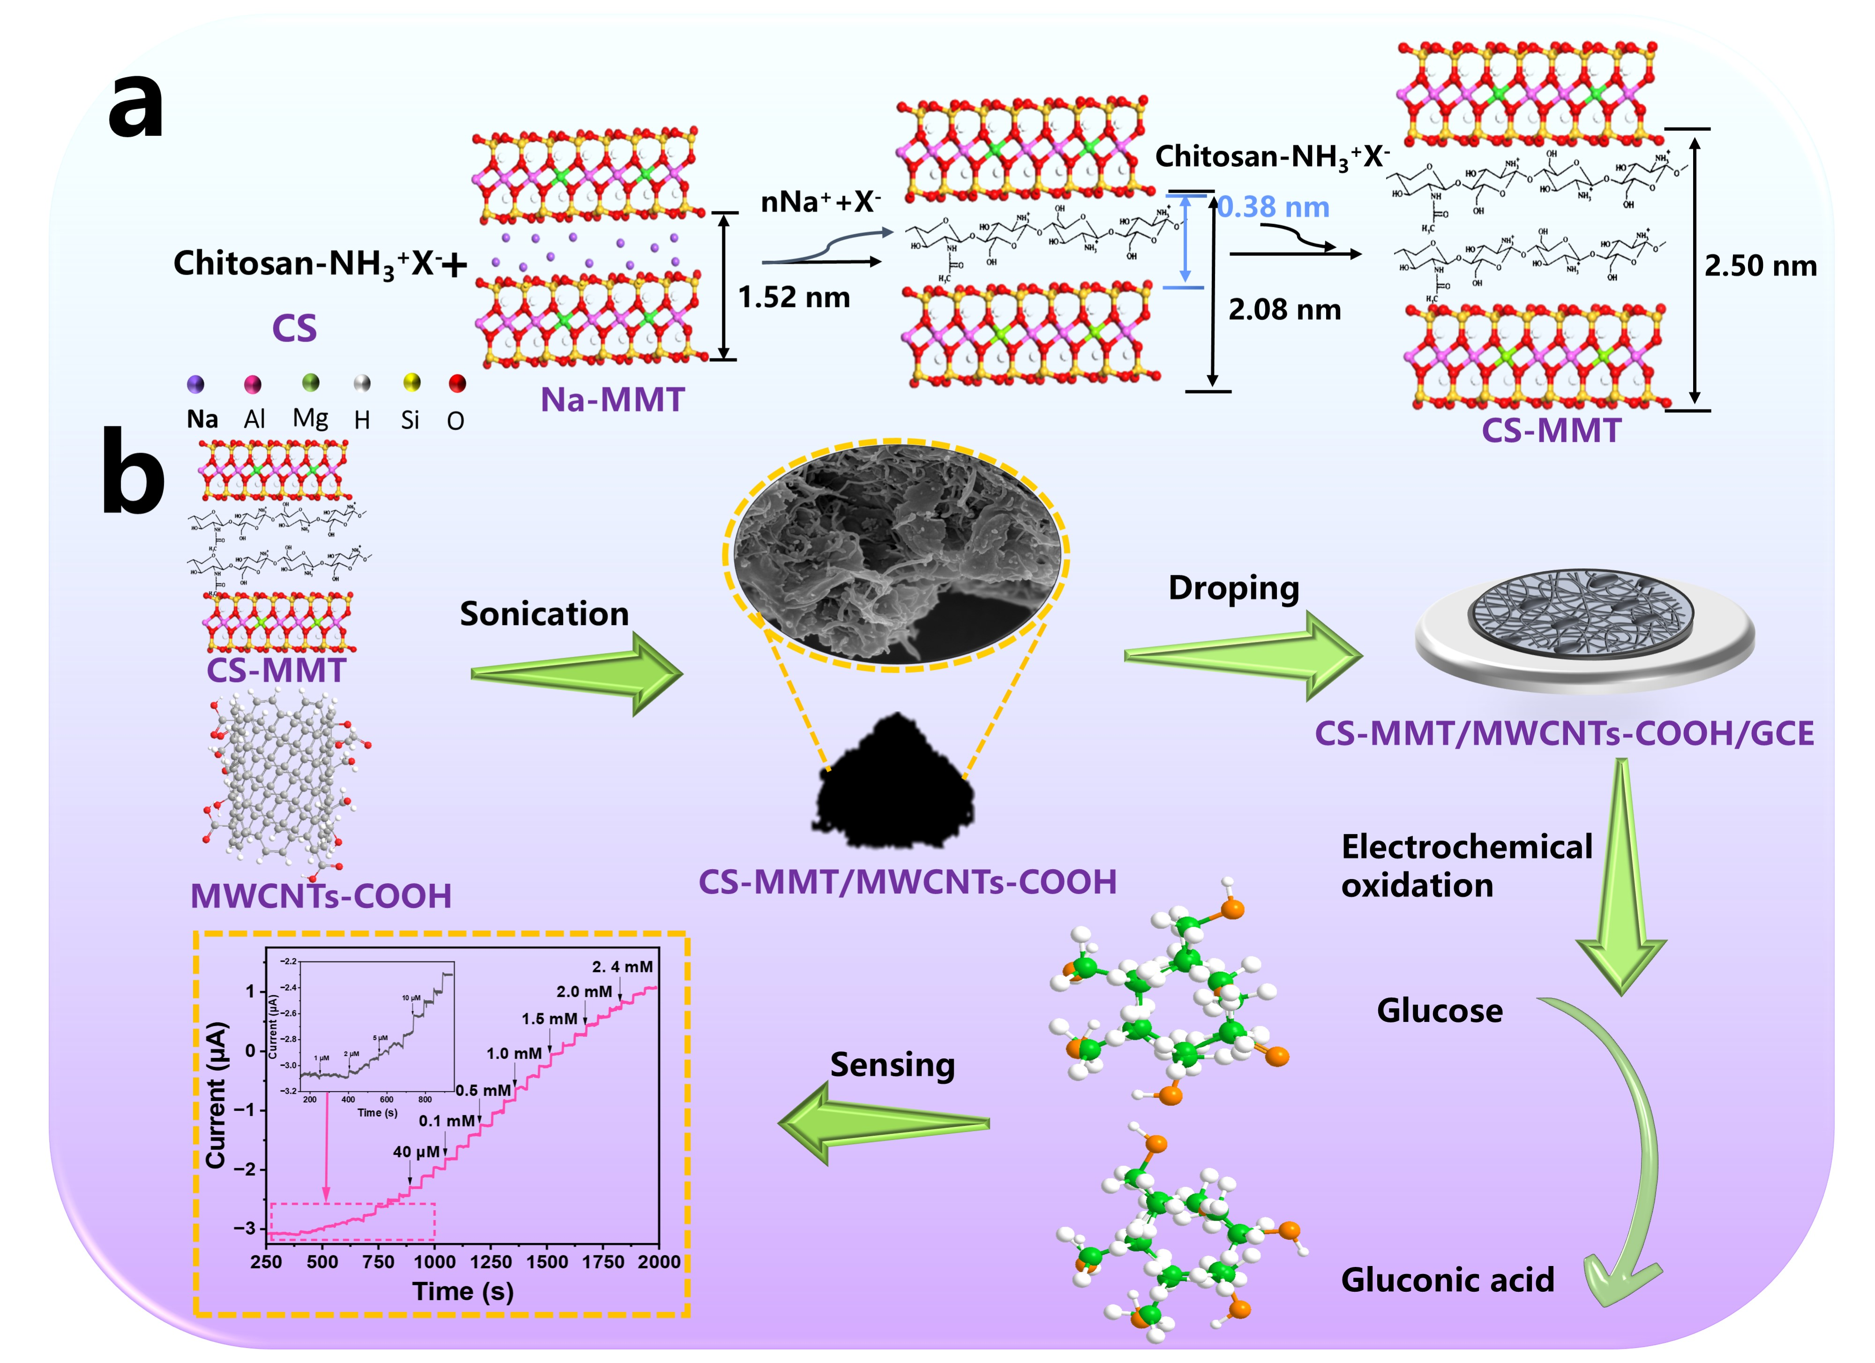
Scheme 1 Diagram showing the fabrication process of CS-MMT and CS-MMT/MWCNTs-COOH/GCE for glucose detection.

