Supporting Information
A hierarchical chitosan-intercalated montmorillonite/carboxylated MWCNTs composites for highly-Performance non-invasive glucose sensing via salivary analysis
Jie Deng,ª Yanqi Xu,^{a, b, ⁎} Cunjun Li,^{a, b} and Linjiang Wang^{a, b}
ª College of Materials Science and Engineering, Key Laboratory of New Processing Technology for Nonferrous Metals and Materials, Ministry of Education, Guilin University of Technology, Guilin 541004, China
^{b} Collaborative Innovation Center for Exploration of Nonferrous Metal Deposits and Efficient Utilization of Resources, Guilin University of Technology, Guilin 541004, China
Corresponding author: xuyanqi@glut.edu.cn

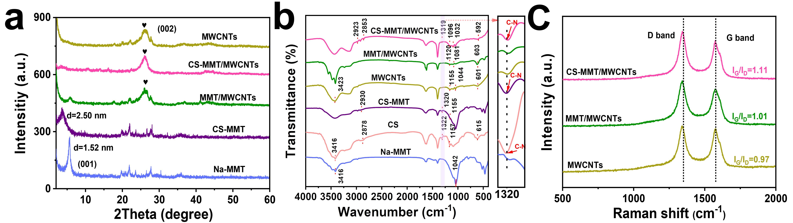
Fig. S1 (a) XRD patterns of Na-MMT, CS-MMT, MWCNTs, MMT/MWCNTs and CS-MMT/MWCNTs; (b) FT-IR spectra of Na-MMT, CS, CS-MMT, MWCNTs, MMT/MWCNTs and CS-MMT/MWCNTs; (c) Raman spectra of MWCNTs, MMT/MWCNTs, and CS-MMT/MWCNTs.

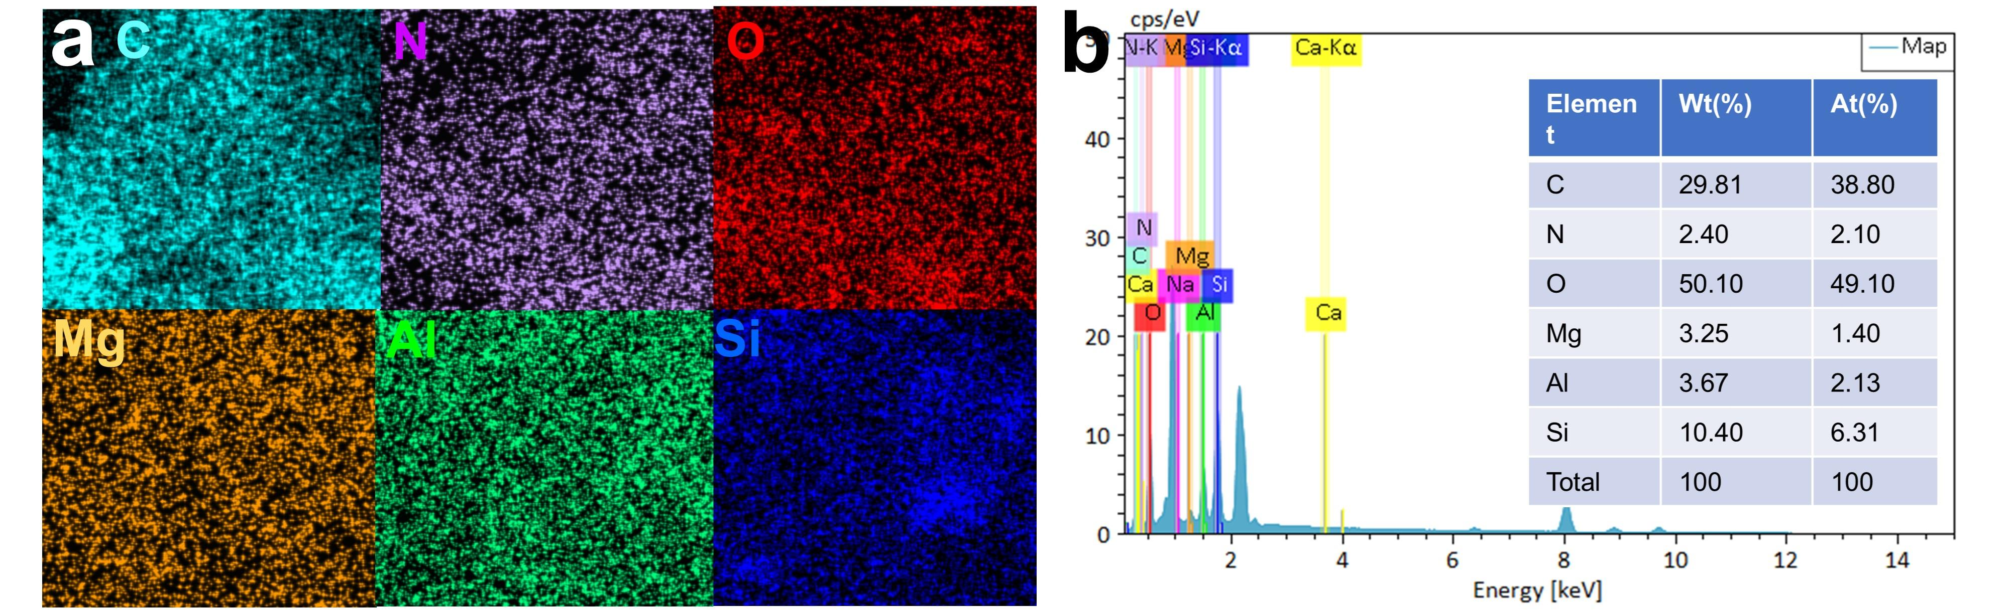
Fig. S2 (a) Elemental distribution of CS-MMT; (b) EDX spectra of CS-MMT.

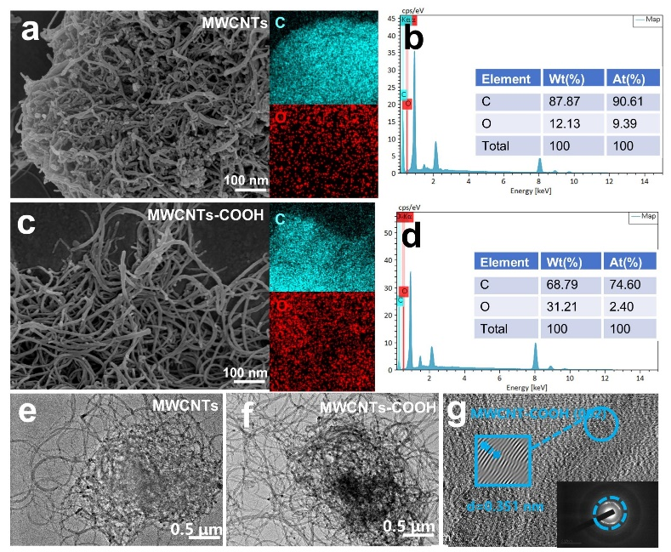
Fig. S3 (a) MWCNTs SEM images; (c) MWCNTs-COOH SEM images; (b) EDX spectra of MWCNTs; (d) EDX spectra of MWCNTs-COOH (e) TEM image of MWCNTs; (f) TEM images of MWCNTs-COOH; (g) HRTEM image of MWCNTs-COOH with an inset electron diffraction pattern of a selected region.

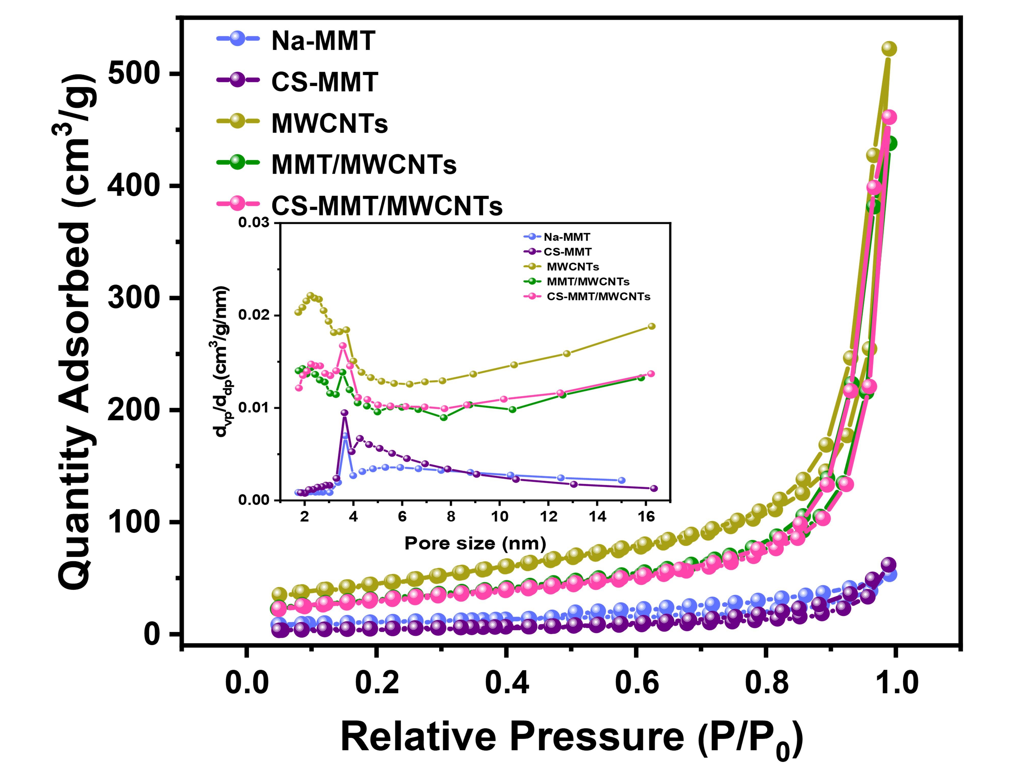
Fig. S4 Nitrogen adsorption-desorption isotherms and pore size distribution curves of Na-MMT, CS-MMT, MWCNTs, MMT/MWCNTs, and CS-MMT/MWCNTs.

Table S1 Specific surface area, pore size, and pore volume data of samples
Samples | Surface area (m²/g) | Pore size (nm) | Pore volume (cm^{3/}g)
Na-MMT | 36.69 | 5.60 | 0.06
CS-MMT | 18.16 | 7.09 | 0.04
MWCNTs | 161.94 | 6.03 | 0.27
MMT/MWCNTs | 108.25 | 5.69 | 0.20
CS-MMT/MWCNTs | 110.76 | 5.56 | 0.21

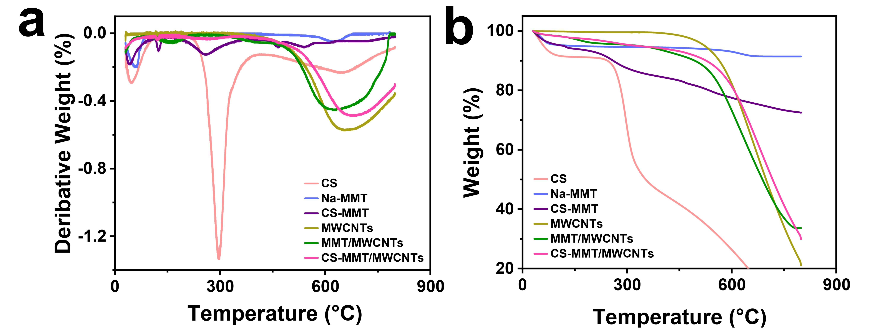
Fig. S5 TGA curves of (a) CS, Na-MMT, CS-MMT and (b) MWCNTs, MMT/MWCNTs and CS-MMT/MWCNTs.
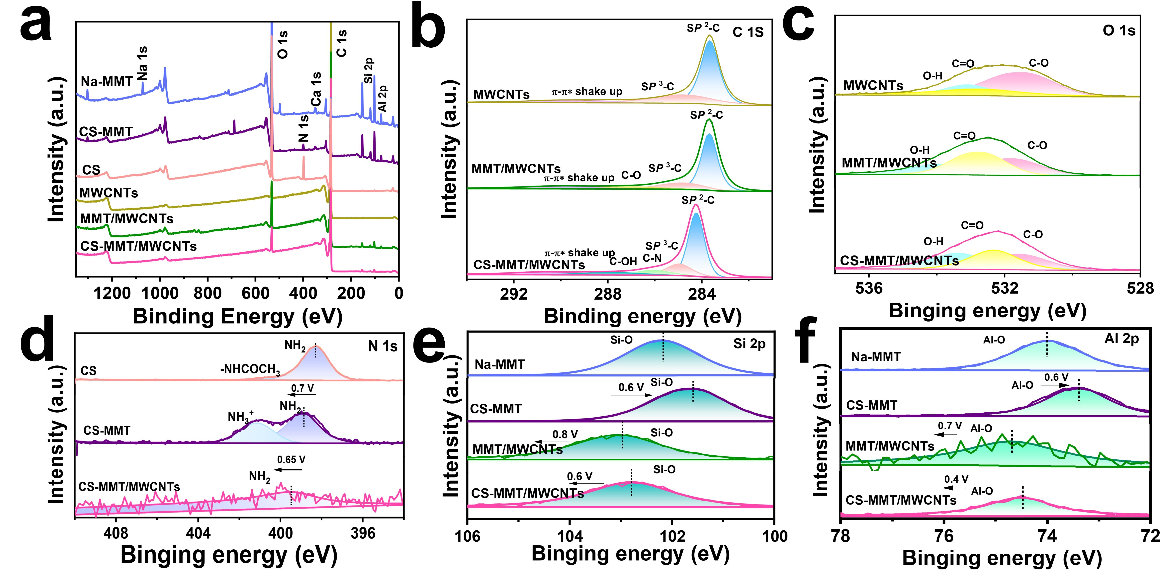
Fig. S6 (a) XPS spectra of Na-MMT, CS, CS-MMT, MWCNTs, MMT/MWCNTs, and CS-MMT/MWCNTs; (b) C 1s and (c) O 1s spectra of MWCNTs, MMT/MWCNTs, and CS-MMT/MWCNTs; (d) N 1s spectra of CS, CS-MMT and CS-MMT/MWCNTs; (e) Si 2p and (f) Al 2p spectra of Na-MMT, CS-MMT, MMT/MWCNTs and CS-MMT/MWCNTs.
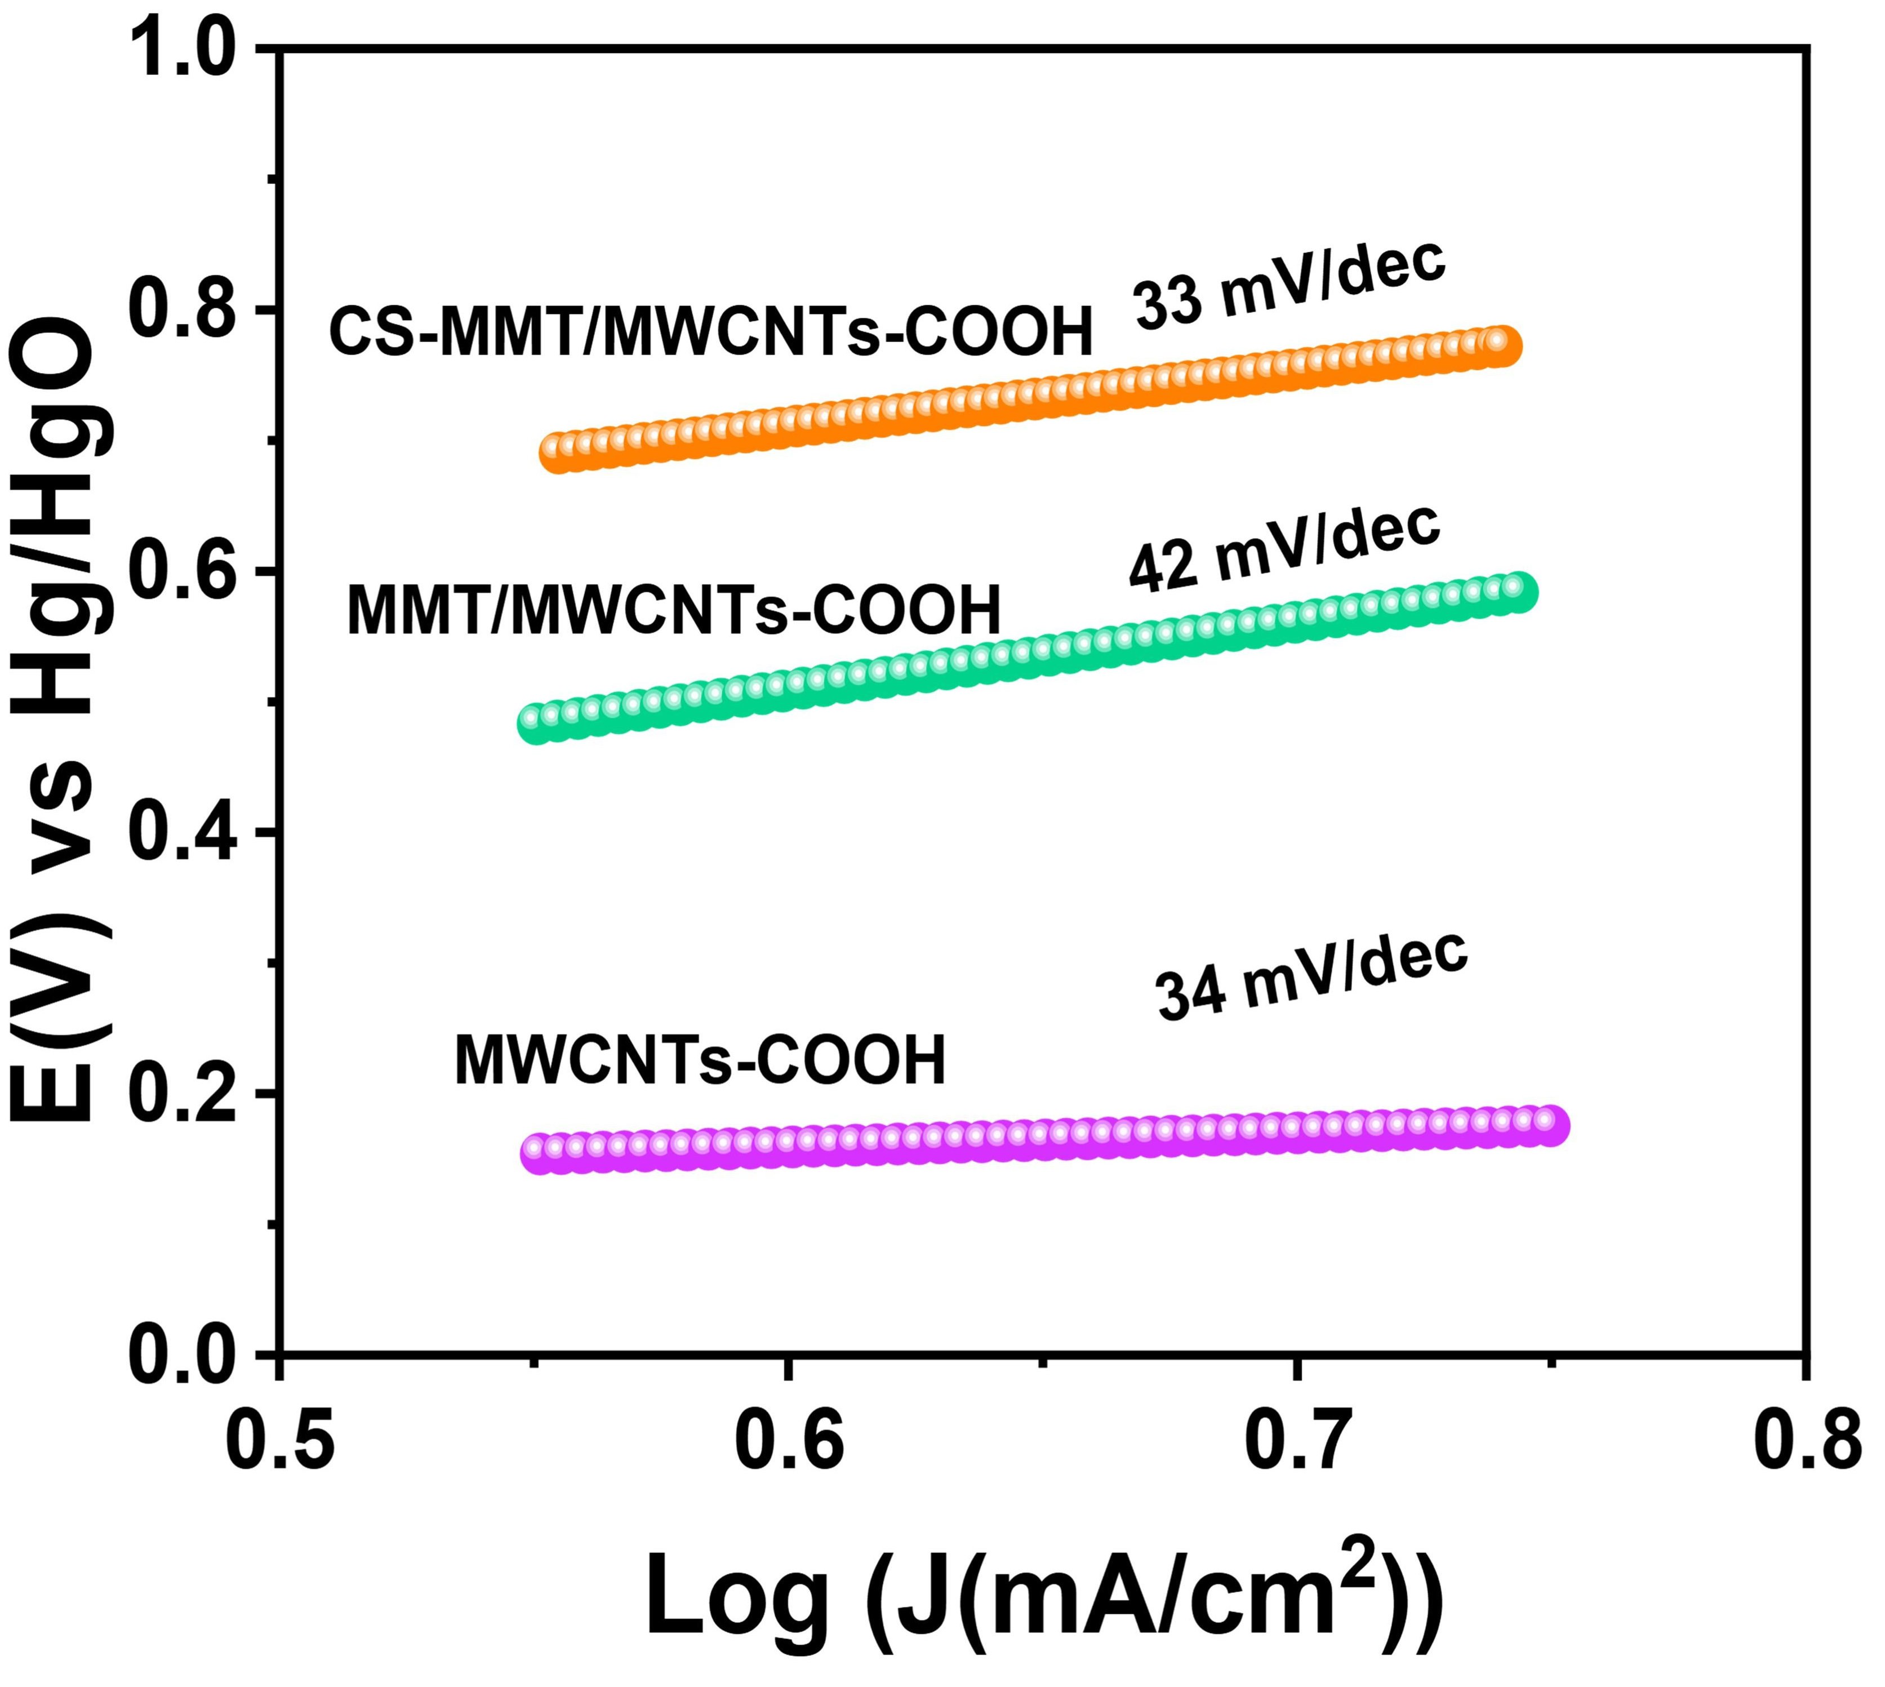
Fig. S7 The Tafel slopes obtained by fitting the LSV curves showed that CS-MMT/MWCNTs-COOH ， MMT/MWCNTs-COOH and MWCNTs-COOH

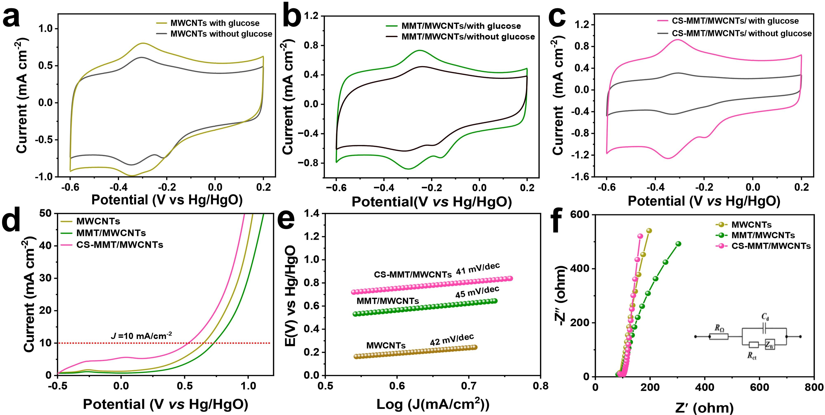
Fig. S8 CV curves of (a) MMT/MWCNTs, (b) CS-MMT/MWCNTs, and (c) MWCNTs with or without glucose; (d) LSV curves, (e) Tafel slopes, and (f) EIS spectra of MWCNTs, MMT/MWCNTs and CS-MMT/MWCNTs.

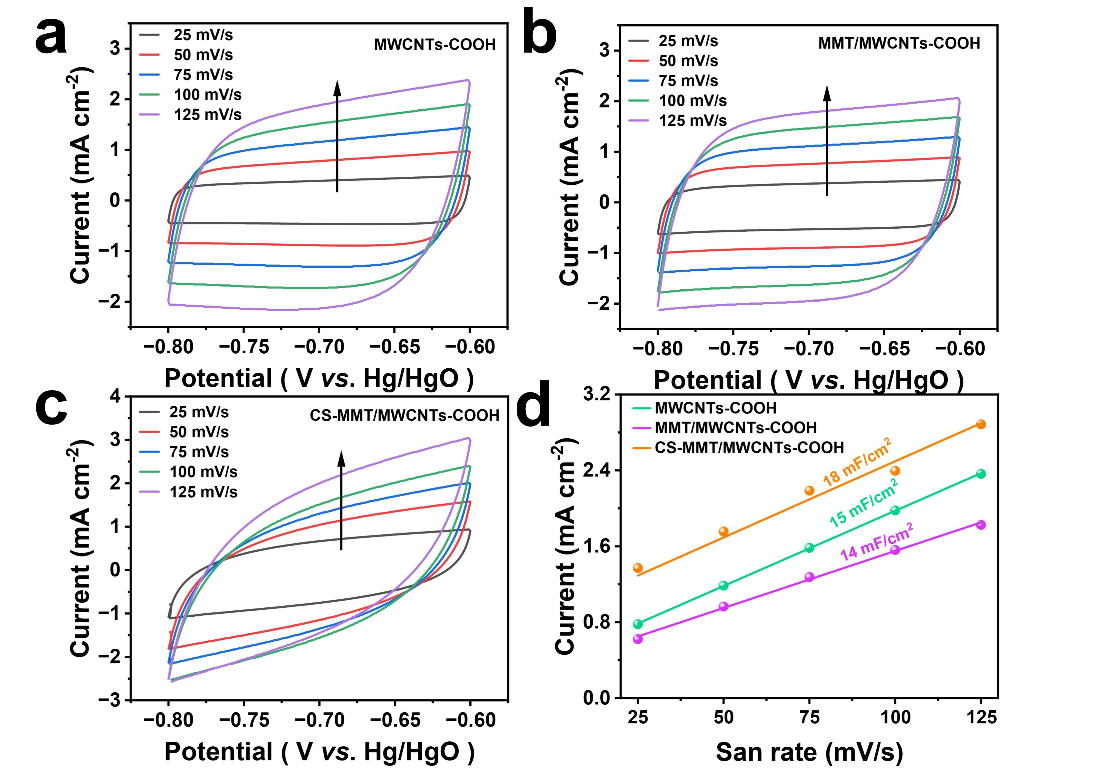
Fig. S9 CV curves of (a) MWCNTs-COOH, (b) MMT/MWCNTs-COOH, and (c) CS-MMT/MWCNTs-COOH measured at scan rates of 25, 50, 75, 100, and 125 mV/s; (d) double-layer capacitance values of MWCNTs-COOH, MMT/MWCNTs-COOH, and CS-MMT/MWCNTs-COOH.

Table S2 Comparison of non-enzymatic electrochemical glucose sensors in 0.1 M NaOH solution.
Electrodes | Sensitivity  (μA μM⁻¹ cm⁻²) | Linear range  (μM) | LOD  (μM) | Ref.
NiCo-LDH/MWCNTs  Cu-MOF/MWNTs | 1.15  3878 | 3000-9231.8  5×10⁻⁴-2.34  2.34-11.84 | 0.03  0.40 | ^{[1]}  ^{[2]}
CuO/MWCNTs  CuNPs/HD-CNTs  NiCo-LDH /CCCH/CuF | 1211  1942  10.78 | 4×10⁻³-14.5  4774  0.001-1500 | 4.00  2.80  0.68 | ^{[3]}  ^{[4]}  ^{[5]}
Ni-MOF/MWCNTs-COOH | 38.20 | 0.28-5.88 | 0.0021 | ^{[6]}
PdNPs-GNPs/MWCNTs  ª CNTs/MWCNTs/PDMS  CS-MMT/MWCNTs-COOH | 5290  71.62  3.89 | 0.025-10000  20-1100  1.0-67  67-5780 | 8.00  6.78  1.09 | ^{[7]}  ^{[8]}  This work

Experimental design Actual saliva samples were collected from two fasting healthy volunteers in our laboratory, and saliva samples were collected at 30, 60, and 120 min after a meal.
Informed Consent Form The volunteer understands the content of this study and is willing to participate, having checked and signed below on the informed consent form.
Name | Gender | Age | Literacy | Agree | Disagree
   | Male  Female | 23  26 | Master  Master | 

References
1. Zhu Y, Qian J, Xu K, et al (2024) Hollow nanocages heterostructured NiCo-LDH/MWCNTs electrocatalyst for highly sensitive and non-invasive detection of saliva glucose. Chemical Engineering Journal 485: 149795. http://dx.doi.org/10.1016/j.cej.2024.149795
2. Wu L, Lu Z, Ye J (2019) Enzyme-free glucose sensor based on layer-by-layer electrodeposition of multilayer films of multi-walled carbon nanotubes and Cu-based metal framework modified glassy carbon electrode. Biosensors and Bioelectronics 135: 45-49. http://dx.doi.org/10.1016/j.bios.2019.03.064
3. Liu X-W, Pan P, Zhang Z-M, et al (2016) Ordered self-assembly of screen-printed flower-like CuO and CuO/MWCNTs modified graphite electrodes and applications in non-enzymatic glucose sensor. Journal of Electroanalytical Chemistry 763: 37-44. http://dx.doi.org/10.1016/j.jelechem.2015.12.039
4. Pankaj G, Vandna K G, Artur H, et al (2021) Highly sensitive non-enzymatic glucose sensor based on carbon nanotube microelectrode set. Sensors and Actuators B: Chemical 348:130688. http://dx.doi.org/10.1016/j.snb.2021.130688
5. Zhao Z, Sun Y, Song J, et al (2020) Highly sensitive nonenzymetic glucose sensing based on multicomponent hierarchical NiCo-LDH/CCCH/CuF nanostructures. Sensors and Actuators B: Chemical 326: 128811. http://dx.doi.org/10.1016/j.snb.2020.128811
6. Li Y, Wang F, Huang F, et al (2012) Direct electrochemistry of glucose oxidase and its biosensing to glucose based on the Chit-MWCNTs-AuNRs modified gold electrode. Journal of Electroanalytical Chemistry 685:86-90. http://dx.doi.org/10.1016/j.jelechem.2012.08.028
7. Promsuwan K, Kachatong N, Limbut W (2019) Simple flow injection system for non-enzymatic glucose sensing based on an electrode modified with palladium nanoparticles-graphene nanoplatelets/mullti-walled carbon nanotubes. Electrochimica Acta 320: 134621. http://dx.doi.org/10.1016/j.electacta.2019.134621
8. Xia Y, Su T, Mi Z, et al (2023) Warable electrochemical sensor based on bimetallic MOF coated CNT/PDMS film electrode via a dual-stamping method for real-time sweat glucose analysis. Analytica Chimica Acta 1278: 341754. http://dx.doi.org/10.1016/j.aca.2023.341754

