Supplementary Material
The chlorination mechanism of arsenic during the arsenopyrite decomposition: Experimental and theoretical study
Chan Zou¹, Rui Liang¹, Huimin Liu²*, Zhong Lin³*, Chunbo Wang⁴
(¹ School of Safety Science and Emergency Management, Wuhan University of Technology, Wuhan 430070, China;
² School of Naval Architecture, Ocean and Energy Power Engineering, Wuhan University of Technology, Wuhan 430070, China;
³ Faculty of Chemistry and Environmental Science, Guangdong Ocean University, Zhanjiang 524088, China;
⁴ Department of Energy, Power & Mechanical Engineering, North China Electric Power University, Baoding 071003, China)

Total number of pages: 4
Total number of table and figures: 2

Figure and Table captions
Fig. S1. The stable optimized structures of arsenic formation on FeS2 (100) surface.
Table S1 The formation energy and some geometric parameters for arsenic formation on FeS2 (100) surface

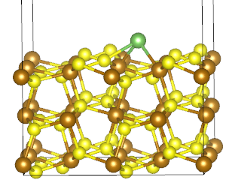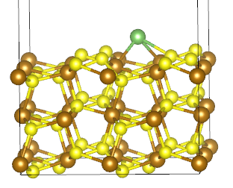
2.517
2.414
2.460
2.467
2.405
2.520
3
1
2
1
1-1. FeS₂-superficial As 1-2. FeS₂-superficial As
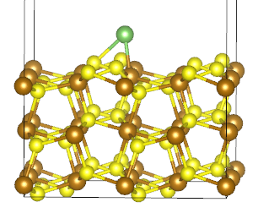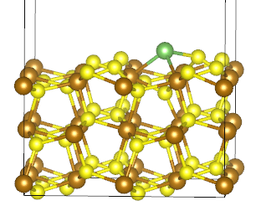
2.368
2.600
2.498
2.295
2.285
1
2
1
1-3. FeS₂-superficial As 1-4. FeS₂-superficial As
Fig. S1. The stable optimized structures of arsenic formation on FeS₂ (100) surface. As atom is green.

Table S1. The formation energy and some geometric parameters for arsenic formation on FeS₂ (100) surface.
Structure | ΔE(kJ/mol) | R_{Fe-As}(Å) | R_{S-As}(Å)
1-1 | -223.40 | 2.520/2.467 | 2.405
1-2 | -223.44 | 2.460/2.414 | 2.517
1-3 | -180.42 | 2.295 | 2.285
1-4 | -234.14 | 2.498/2.600 | 2.368

