Supplementary Online Contents

Dose-Dependent Association of Adolescent Breakfast Consumption with Mental Health and Changes Over Time: an International Observational Study

Supplementary Table S1. Associations of Total Breakfast Days Categories with Psychosomatic ﻿Complaints Stratiﬁed by Gender
Total Breakfast days | Male |  | Female
Total Breakfast days | β (95% CI) | P | β (95% CI) | P
0 days | 2.19 (2.06-2.31) | <0.001 | 3.53 (3.40-3.65) | <0.001
1 days | 2.06 (1.94-2.17) | <0.001 | 3.08 (2.97-3.18) | <0.001
2 days | 1.21 (1.14-1.29) | <0.001 | 1.84 (1.77-1.91) | <0.001
3 days | 1.41 (1.30-1.52) | <0.001 | 1.76 (1.65-1.86) | <0.001
4 days | 1.18 (1.08-1.28) | <0.001 | 1.74 (1.64-1.83) | <0.001
5 days | 1.05 (0.97-1.13) | <0.001 | 1.42 (1.33-1.50) | <0.001
6 days | 0.83 (0.76-0.90) | <0.001 | 1.05 (0.97-1.13) | <0.001
7 days | Ref. |  | Ref.
Abbreviations: CI, confidence interval; Ref, reference.
The βs and 95% CIs were extracted from multilevel generalized additive model, with psychosomatic complaints as the outcome and variable of total breakfast days categories as the exposure, as well as controlling for ﻿survey year (only for overall participants), school grade, physical activity, Family Affluence Scale, academic pressure, having experienced bullying, and smooth term of age and BMI.

Supplementary Table S2. Associations of Total Breakfast Days Categories with Psychosomatic ﻿Complaints Stratiﬁed by School Grade
Total Breakfast days | School Grade 5 |  | School Grade 7 |  | School Grade 9
Total Breakfast days | β (95% CI) | P | β (95% CI) | P | β (95% CI) | P
0 days | 2.23 (2.02-2.43) | <0.001 | 3.01 (2.88-3.14) | <0.001 | 3.15 (2.99-3.31) | <0.001
1 days | 2.32 (2.14-2.49) | <0.001 | 2.71 (2.60-2.83) | <0.001 | 2.82 (2.69-2.95) | <0.001
2 days | 1.24 (1.14-1.34) | <0.001 | 1.64 (1.56-1.72) | <0.001 | 1.71 (1.63-1.79) | <0.001
3 days | 1.26 (1.12-1.40) | <0.001 | 1.79 (1.67-1.92) | <0.001 | 1.66 (1.53-1.79) | <0.001
4 days | 1.22 (1.08-1.35) | <0.001 | 1.66 (1.55-1.77) | <0.001 | 1.50 (1.38-1.61) | <0.001
5 days | 0.99 (0.89-1.10) | <0.001 | 1.33 (1.24-1.42) | <0.001 | 1.35 (1.25-1.44) | <0.001
6 days | 0.89 (0.79-0.99) | <0.001 | 0.93 (0.84-1.02) | <0.001 | 1.01 (0.91-1.10) | <0.001
7 days | Ref. |  | Ref. |  | Ref.
Abbreviations: CI, confidence interval; Ref, reference.
The βs and 95% CIs were extracted from multilevel generalized additive model, with psychosomatic complaints as the outcome and variable of total breakfast days categories as the exposure, as well as controlling for ﻿survey year (only for overall participants), gender, physical activity, Family Affluence Scale, academic pressure, having experienced bullying, and smooth term of age and BMI.

Supplementary Table S3. Associations of Total Breakfast Days Categories with Psychosomatic ﻿Complaints adopted a cross-validation approach by dividing the dataset into 5 folds
Total Breakfast days | Sub dataset 1 |  | Sub dataset 2 |  | Sub dataset 3 |  | Sub dataset 4 |  | Sub dataset 5
Total Breakfast days | β (95% CI) | P | β (95% CI) | P | β (95% CI) | P | β (95% CI) | P | β (95% CI) | P
0 days | 2.92 (2.81-3.02) | <0.001 | 2.95 (2.85-3.06) | <0.001 | 2.94 (2.84-3.04) | <0.001 | 2.91 (2.81-3.01) | <0.001 | 3.01 (2.91-3.11) | <0.001
1 days | 2.68 (2.59-2.77) | <0.001 | 2.74 (2.65-2.83) | <0.001 | 2.76 (2.67-2.85) | <0.001 | 2.70 (2.61-2.78) | <0.001 | 2.71 (2.63-2.80) | <0.001
2 days | 1.57 (1.52-1.63) | <0.001 | 1.57 (1.52-1.63) | <0.001 | 1.58 (1.52-1.64) | <0.001 | 1.59 (1.54-1.65) | <0.001 | 1.59 (1.53-1.64) | <0.001
3 days | 1.62 (1.53-1.70) | <0.001 | 1.64 (1.56-1.73) | <0.001 | 1.64 (1.55-1.72) | <0.001 | 1.61 (1.52-1.69) | <0.001 | 1.64 (1.55-1.73) | <0.001
4 days | 1.52 (1.44-1.60) | <0.001 | 1.52 (1.44-1.60) | <0.001 | 1.47 (1.39-1.55) | <0.001 | 1.47 (1.39-1.55) | <0.001 | 1.51 (1.43-1.59) | <0.001
5 days | 1.26 (1.20-1.33) | <0.001 | 1.24 (1.18-1.31) | <0.001 | 1.25 (1.18-1.31) | <0.001 | 1.24 (1.18-1.31) | <0.001 | 1.28 (1.21-1.34) | <0.001
6 days | 0.96 (0.90-1.02) | <0.001 | 0.97 (0.91-1.03) | <0.001 | 0.94 (0.88-1.00) | <0.001 | 0.93 (0.87-1.00) | <0.001 | 0.96 (0.90-1.02) | <0.001
7 days | Ref. |  | Ref. |  | Ref. |  | Ref. |  | Ref.
Abbreviations: CI, confidence interval; Ref, reference.
The βs and 95% CIs were extracted from multilevel generalized additive model, with psychosomatic complaints as the outcome and variable of total breakfast days categories as the exposure, as well as controlling for ﻿survey year (only for overall participants), gender, school grade, physical activity, Family Affluence Scale, academic pressure, having experienced bullying, and smooth term of age and BMI.

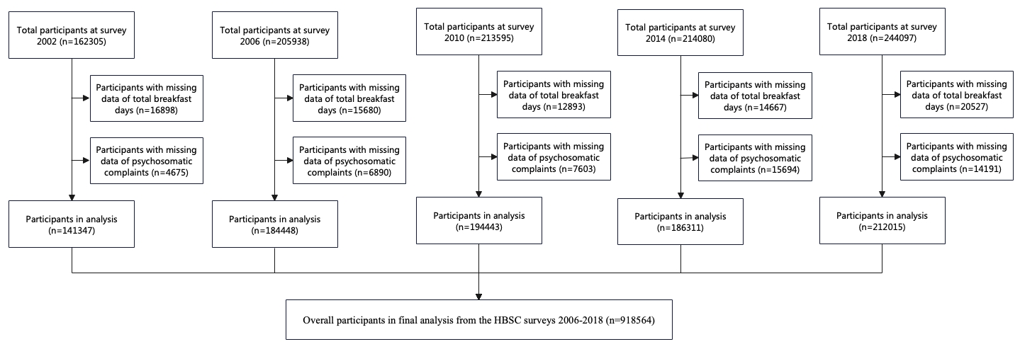
Supplementary Figure S1. Flowchart of the participants in the present study.

