Supplementary Information

pH-dependent Interaction of Interfacial Water with Pt in Electrocatalytic Hydrogen Oxidation Reaction

Wen-xuan Liang^{#a,b}, De-quan Cao^{#a}, Ze-Tong Jia^{#b}, Zhi-You Zhou^{b}, Chun-Hua Zhenª, Yao Zhou^{*a}, Jun-Tao Li^{*a}, Tao Wang^{*b}, Shi-Gang Sun^{*a,b}

^{a.} College of Energy, Xiamen University, Xiamen 361005, Fujian, China;
^{b.} College of Chemistry and Chemical Engineering, Xiamen University, Xiamen 361005, Fujian, China;
#. These authors contribute equally

The PDF file includes:
Supplementary methods
Supplementary Notes 1-5
Supplementary Figures 1-28
Supplementary Tables 1-2
Supplementary References

Supplementary Methods
Reagents
Potassium hydroxide (99.99%, GR) and sodium hydroxide (99.99%, GR) were purchased from Sigma Aldrich, sulfuric acid (95-98%, GR) and perchloric acid (95-98%, GR) were purchased from Sinopharm, acetone (99.55%, GR) was purchased from Sinopharm. All chemicals were used as received without further purification. Argon (99.999%), nitrogen (99.999%), hydrogen (99.999%) and deuterium (99.999%) were purchased from Best Gas. Ultra-pure Milli-Q water (~18.2 MΩ cm) was used throughout the study.
Characterizations
The morphology and nanostructure of the polycrystalline Pt quartz crystal chip were studied by scanning electron microscopy (SEM, Gemini SEM 500) coupled with energy dispersive X-ray (EDX) spectroscopy and high-resolution transmission electron microscopy (TEM, JEOL JEM-F200). X-ray powder diffraction (XRD) patterns were taken on a Rigaku Ultima IV diffractometer (Rigaku, Japan) with Cu Ka X-ray source. The surface morphology of the polycrystalline Pt quartz wafer was studied by atomic force microscope (AFM, Cypher ES).
Introduction on the EQCM system
- Setup for EQCM measurement: Cyclic-voltammetry (CV) and mass variation (MV) measurements were performed using a 440C Quartz Crystal Microbalance (CHI) with 7.995 MHz titanium/platinum coated quartz crystal electrodes (Renluxcrystal, Supplementary Fig. 1g) as the working electrodes (which is referred as Pt working electrode thereafter). Saturated calomel electrode (SCE, saturated KCl solution, in acid) / Hg/HgO (1 M KOH, in base) was used as the reference electrode (Gaoss Union) and Pt wire as the counter electrode. All potential was referenced versus the reversible hydrogen electrode (RHE). The whole setup was placed on an anti-vibration table, and the experiment was carried out under constant room temperature (298 ± 1 K) and humidity (45 ± 2%).

- Home-made electrochemical cell for EQCM measurement: All EQCM tests were performed in a home-made alkaline-resistant PTFE electrical cell, as shown in Supplementary Fig. 1.
To purge the electrolyte with different gas, the cell was integrated with high-precision pressure control system, which included inlet pipe, inlet valve, a manometer that can display the pressure in the upper chamber of the electrical cell, the inlet mass flow controller, outlet pipe and outlet valve, as shown in supplementary Fig. 2.
As shown in supplementary Fig. 3, the base line of frequency can remain stable with or without purging.

- Polishing and activation of the Pt working electrode: Prior to electrochemical testing, the EQCM working electrodes were freshly polished by successive sonication in acetone and deionized water for 5 minutes each in a plastic beaker; throughout the process, the electrodes were placed in a face-up manner. Afterward, it was vacuum dried at 25℃ for 1 h and then installed in the electrical cell as the working electrode. For installing the electrical cell, 15 mL of the freshly prepared electrolyte was loaded into the electrical cell, which then was tightened and placed in a home-build Faraday Cage. Before collecting the data, the Pt electrode was electrochemically polished and activated; during the process Ar was purged into the solution, with Ar flow rate of 15 mL min⁻¹ and the outlet valve in an open status. After Ar purging for 30 mins, the Pt working electrode was activated through repetitive CV scan at a scan rate of 50 mV s⁻¹ between 0 - 1.4 V (non-iR corrected) at least 1000 times in order to release any mechanical stress from the near-surface region¹, until a highly stable CV curve was obtained. Note that to thoroughly clean the polycrystalline Pt working electrode, electrolyte can be changed several times during the activation process.

- Data collection:
Measurement in Ar: After activation, instead of purging into the solution, Ar was passed above the electrolyte surface continuously with a flow rate of 5 mL min⁻¹, to expel any traces of air that might creep into the cell via joints. Before the test, the whole setup was left standing for more than 10 minutes; subsequently, CV and mass variation (MV) were carried out within 0-1.4 V, with a scan rate of 50 mV s⁻¹.

Hydrogen and/or deuterium stripping experiment (corresponding to Figure 2 in the main text): The polycrystalline Pt working electrode was polished and activated in the same way as described above before purging with H₂ or D₂. Afterward, the solution was purged with H₂ or D₂ at 15 mL min⁻¹ for 10 minutes; during the process no external potential was applied to the electrode. Then the solution was purged with Ar with a flow rate of 15 mL min⁻¹ for another 10 minutes. Afterwards, the valves for the inlet and outlet were both switched off. After letting the cell sit for one minute, linear voltametric profile (LSV) and MV were recorded within 0-0.2 V for base and 0-0.4 V for acid, with a scan rate of 50 mV s⁻¹.

Alkaline Hydrogen and/or deuterium oxidation experiment (corresponding to Figure 3 in the main text): The polycrystalline Pt working electrode was polished and activated in the same way as described above before purging with H₂ or D₂. Afterward, the solution was purged with H₂ or D₂ at 15 mL min⁻¹ for 30 minutes; during the process no external potential was applied to the electrode. Then H₂ or D₂ was passed above the electrolyte surface continuously with a flow rate of 5 mL min⁻¹, to expel any traces of air that might creep into the cell via joints. After standing for another 10 minutes, the LSV and MV were recorded repetitively within 0-0.2 V for base, with a scan rate of 50 mV s⁻¹.
Preparation of PtRu electrode
Au quartz wafer was used for electrodeposition of PtRu. The Au quartz wafers was activated and polished using CV at a scan rate of 100 mV s⁻¹ between 0.6 - 1.65 V vs. RHE (non-iR corrected) in 0.1 M H₂SO₄ with Ar purging. The PtRu coating layer was electrodeposited in two steps. Firstly, in an Ar-saturated 0.1 M H₂SO₄ solution (15 mL, which consists of 4 mg RuCl₃), the electrode was conditioned under a constant current density of 1.0 mA cm⁻² with a duration of 900 s. Subsequently, the electrolyte was replaced by 15 mL Ar-saturated H₂SO₄ solution (which consists of 6 mg H₂PtCl₆, 4 mg RuCl₃ and 1.49 g Na₂HPO₄); the same electrode was conditioned at constant current density of 1.0 mA cm⁻² with a duration of 120 s.
Electrified Interface Models
The Pt (111)/water interface was modeled using a four-layer 4×4 orthogonal Pt (111) slab (surface area: 1.10 nm²) with 60 water molecules adsorbed. A vacuum layer of ~2.4 nm and water film thickness of ~1.6 nm were maintained. Simulations used a 1.0 fs timestep, sampling only the Γ-point without symmetry constraints. Temperature was regulated at 298 K using a Nosé-Hoover thermostat. Systems were equilibrated for ≥10 ps, with configurations from the final 5 ps utilized for data analysis.
Computational Details
In acidic conditions, explicit H₃O⁺ ions were placed within the water film and explicit Na⁺ were inserted in alkaline conditions: Ions were initially positioned ~3-4 Å from the Pt surface, representing the compact Helmholtz layer. The Gouy-Chapman diffuse layer was omitted due to the high ionic concentrations relevant to experimental conditions. Co-ions were neglected as electrode charging at HOR potentials would expel them from the Helmholtz plane. System charge neutrality was preserved by adjusting the metal slab's electron count to match inserted ions, enabling control over surface charge density and electrode potential within the hydrogen oxidation regime. The electrode potential is calculated based on the work function relative to the absolute hydrogen electrode potential. For details, please refer to Supplementary Methods. The electrode potential versus the RHE was determined via
$$U_{SHE} =U_{RHE}+0.0592*pH$$
Slow-growth approach
The free-energy profile along a geometric parameter ξ can be scanned by an approximate slow-growth approach². In this method, the value of ξ is linearly changed from the value characteristic for the initial state (1) to that for the final state (2) with a velocity of transformation ξ˙. The resulting work needed to perform a transformation 1→2 can be computed as:
（S1）
In the limit of infinitesimally small ξ the work $ω_{1→2}^{irrev}$ corresponds to the free-energy difference between the the final and initial state. In the general case, $ω_{1→2}^{irrev}$ is the irreversible work related to the free energy via Jarzynski's identity³
（S2）
Note that calculation of the free-energy via this equation requires averaging of the term $〈\exp^{-\frac{w_{1→2}^{irrev}}{k_{B}T}}〉$ over many realizations of the transformation. Detailed description of the simulation protocol that employs Jarzynski's identity can be found in reference[4]⁴.
Constant Potential Energy Correction
In density functional theory (DFT) simulations of electrochemical reactions, computations are typically performed at constant charge conditions due to finite cell sizes, while real electrochemical systems operate under constant potential. To correct for this mismatch, we apply the charge-extrapolation method to convert reaction energies and activation barriers from constant charge to constant potential conditions^{5,6}.
This approach assumes that the total reaction energy can be decomposed into chemical and electrostatic components, where the electrostatic component follows a classical capacitor model. The interfacial charge differences between states (initial, transition, final) and the work function differences are used to perform the correction.
The corrected reaction energy ΔE at a reference potential Φ_ref is given by:

$ΔE(Φ_ref)=ΔE(Φ_calc)-Δq×(Φ_calc-Φ_ref)$ (S3)

where Δq = q_final − q_initial represents the change in Bader charge between the two states, Φ_calc is the work function of the DFT-calculated state, and Φ_ref is typically chosen as the standard hydrogen electrode (SHE) work function (~4.4 eV).
The same expression applies to activation energies, using the transition state in place of the final state. The slope ΔE vs. Φ provides the electrochemical transfer coefficient β = -Δq, consistent with Butler–Volmer kinetics to implement this correction computationally.
After the calculations complete, extract the total energies, Bader charges, and work functions. Apply the correction formula to obtain potential-dependent free energies or barriers suitable for constructing electrochemical energy diagrams.
Work Function Calculation
Work function (Φ) determinations for metal/electrolyte interfaces followed an established computational protocol. ∅ was derived from the energy separation between the system’s Fermi level (E_{F}) and the local vacuum level (E_{vac}).
The E_{vac} value was obtained from planar-averaged electrostatic potential profiles. A threshold electron density of 10⁻⁵ e⁻ Å⁻³ defined the location of E_{vac}, consistent with methodologies employed in implicit solvation/electrolyte models where charge density cutoffs delineate dielectric boundaries⁷.
The computed work function Φ was subsequently converted to the potential of zero charge (PZC) versus the standard hydrogen electrode (SHE) using the relationship:

$USHE=Φ-ΦSHE$ （S4）

where Φ_{SHE} = 4.44 V denotes the absolute SHE work function⁸.
Application of this approach to the Pt(111)/water interface yielded a PZC of ∼0.21 V⁹⁻¹¹. This value aligns closely with prior experimental observations and independent molecular dynamics simulations.
Supplementary Note 1
Characterizations of polycrystalline Pt working electrode
The polycrystalline Pt working electrode was characterized before electrochemical tests. Supplementary Fig. 4a is a digital photo of the electrode, which shows that the surface of the titanium/platinum coated quartz crystal electrodes is free of scratches and peeling warped edges, the position of the Pt metal layer is in the center. Further shown in Supplementary Fig. 4b, XRD analysis of the electrode reveals a dominating diffraction peak at 39.8°, corresponding to the Pt (1 1 1) (refer to PDF#04-0802). Transmission electron microscopy observation showed that the lattice fringes of the surface Pt could be seen in the high-resolution image, and the calculated crystal face spacing was 0.227 nm, corresponding to the Pt (1 1 1). Supplementary Fig. 4d is the scanning electron microscopy and EDS spectrum analysis, which shows that the surface layer is covered by a layer of Pt metal, surrounded by SiO₂, excluding contamination of impurity phases.
During the electrochemical reaction, the surface Pt metal layer may undergo electrochemical corrosion, which could interfere with the measured frequency change. Supplementary Fig. 4e and 4f shows the atomic force microscope images of the Pt coating layer on the surface of the quartz wafer before and after the electrochemical test. The comparison of the images shows that the roughness of the Pt metal layer before and after the electrochemical test and the surface morphology were similar, indicating that the Pt coating layer on the quartz wafer were well maintained before and after the electrochemical test; this thus ensure that the frequency change measured by EQCM was not from the mass change of the polycrystalline Pt metal layer itself, but from electrochemical process on the surface of the polycrystalline Pt metal layer in solution.
Supplementary Note 2
Calculation of ∆m from ∆f
- The Sauerbrey equation
The relationship between the frequency change, Δf, and mass change, Δm, is described by the Sauerbrey equation^{12,13}:
$∆m=-\frac{A\sqrt{ρμ}}{2f_{0}^{2}}Δf$ (S5)
Where f₀ is the nominal frequency of the crystal (7.995 MHz), A is the area of the piezo active region (0.26 cm²), and ρ and μ are the density (2.648 g cm⁻³) and shear modulus (2.947×10¹¹ g cm⁻¹ s⁻²) of an AT-cut quart crystal. In particular, as shown in Supplementary Fig. 3, it shall be mentioned that steady f₀ can be maintained within a period of time with/without purging, proving that the noise signal in Δf can be well controlled in our EQCM system, which is the pre-requisite for reliable measurement of the Δf.
For a standardized EQCM electrode, Equation S5 can be simplified as the linear equation S6 where $C_{f}$is the so-called Sauerbrey constant:
$∆m=-C_{f}Δf$ (S6)
$C_{f}$ is the characteristic constant containing all of the above properties of the quartz crystal and required to obtain Δm from Δf.
- The protocol for calibration of $C_{f}$
A Ag stripping/plating experiment was employed in this study for calibration of $C_{f}$.
To this end, calibration of $C_{f}$ involves the usage of the concept mpe, which represents the mass change for per mole of electrons transferred, as shown in equation S7:
$mpe=\frac{FΔm}{Q}$ (S7)
where F is the Faraday constant, Q is the accumulated charge. Ideally, for 1 mol Ag atoms deposited, there will be transfer of 1 mol electrons, which corresponds to a theoretically constant mpe_{Ag} of 107.87 g/mol.
On this basis, integrating equation S6 and S7 together generates equation S8 which shows the relationship between Δf and Q.
$Δf=-\frac{1}{FC_{f}}*mpe*Q$ (S8)
Equation S8 shows that, for a process with constant mpe, there is a linear relationship between Δf and Q, and the relevant slope r is shown in equation (S9)
$r=-\frac{{mpe}_{Ag}}{FC_{f}}$ (S9)
Hence, to calibrate $C_{f}$, one just need to know the linear slope r, which can be obtained by fitting Δf against the relevant Q.
- The calibration process and the conversion of ∆f to ∆m
As shown in Supplementary Fig. 5a, the Ag plating/stripping was conducted with currents of ± 10 µA in 0.5 M HNO₃ electrolyte with 0.025 M AgNO₃ (Supplementary Fig. 5a); the relevant frequency change of the electrode during alternating plating and stripping was measured. Then, as shown in Supplementary Fig. 5b, the frequency change Δf was plotted against the accumulated charge Q, from which the slope r of the linear section was calculated, which was found to be 827.64 (Hz/mC).
Subsequently, using equation S9, the $C_{f}$was calculated to be 1.34 ± 0.02 ng Hz⁻¹, where the error represents the single standard deviation of 5 repetitive plating/stripping experiments (Supplementary Fig. 5c).
After obtaining $C_{f}$, the Δm can be calculated accordingly using equation S6 and reported simultaneously with Δf in each scenario (Supplementary Fig. 5d).
Supplementary Note 3
Calculation of mpe
To calculate the mpe of the H_{upd} process in Figure 1 in the main text, as shown in Supplementary Fig. 10, for the potential range of concern, taking the range of 0-0.4 V for instance, the relevant charge change Q was obtained by calculating the integral charge of the shaded area shown in Supplementary Fig. 10a.
Then the relevant Δm (which was obtained from Δf as discussed in Supplementary Note 2) was plotted against Q. For the linear region which has a constant mpe, accordingly to equation S7, the relationship between Δm and Q is described as equation S10, where r is the slope which can be calculated by piecewise linear fitting the plot obtained each time.
$∆m=mpe*\frac{Q}{F}=r*Q$ (S10)
After obtained the slope r, the mpe can be obtained immediately using equation S11 where F is the Faraday constant.
$mpe=r*F$ (S11)

Supplementary Note 4
Determination of the potential of zero free charge (PZFC) at different pH values
Ex-situ immersion i-t curves were used to measure the PZFC, following the method reported¹⁴. Current transients during potential-controlled immersion experiments were first recorded using a CHI 760E potentiostat with Pt wire and SCE (in acid) / Hg/HgO (in base) as the counter and reference electrodes, respectively.
The PZFC measurement process is as follows¹⁴. Firstly, the polycrystalline Pt electrode was rinsed with plenty of deionized water, and dried in a gentle N₂ stream. Then, the excess charge on the electrode surface was removed by contacting the electrodes to the ground. Finally, immersion i-t curves were measured at different potentials. The above rinsing and grounding operations need to be repeated before different potentials i-t tests.
For evaluation of PZFC in acid, as shown in Supplementary Fig. 17, the current transients were recorded during immersion of a dry polycrystalline Pt electrode in a 0.1 M H₂SO₄ solution at 0.075 V (s. RHE, similarly thereafter, Supplementary Fig. 17a), 0.1 V (Supplementary Fig. 17b), 0.125 V (Supplementary Fig. 17c), 0.15 V (Supplementary Fig. 17d), 0.175 V (Supplementary Fig. 17e), 0.2 V (Supplementary Fig. 17f), 0.225 V (Supplementary Fig. 17g), and 0.25 V (Supplementary Fig. 17h), respectively. The relevant surface-area-normalized charge obtained by integration of the current transients under each potential are given in Supplementary Fig. 18, the extrapolated surface-area-normalized charge vs. potential curve crosses through zero at 0.39 V vs. RHE, which is the PZFC in 0.1 M H₂SO₄.
For evaluation of PZFC in base, as shown in Supplementary Fig. 19, the current transients were recorded during immersion of a dry polycrystalline Pt electrode in a 0.1 M KOH solution at 0.268 V (Supplementary Fig. 19a), 0.293 V (Supplementary Fig. 19b), 0.318 V (Supplementary Fig. 19c), 0.343 V (Supplementary Fig. 19d), 0.368 V (Supplementary Fig. 19e), 0.393 V (Supplementary Fig. 19f), 0.418 V (Supplementary Fig. 19g), and 0.443 V (Supplementary Fig. 19h), respectively. The relevant surface-area-normalized charge obtained by integration of the current transients under each potential are given in Supplementary Fig. 20, the extrapolated surface-area-normalized charge vs. potential curve crosses through zero at 0.99 V vs. RHE, which is the PZFC in 0.1 M KOH.
The determination of the potentials of zero total and free charge, PZTC and PZFC respectively, were made in a wide pH range by using the CO displacement method¹⁵ and the same calculation assumptions used previously for Pt(1 1 1) electrodes in contact with non-specifically adsorbing anions (Supplementary Table 1 and 2)¹⁶, which is close to the result of our study.

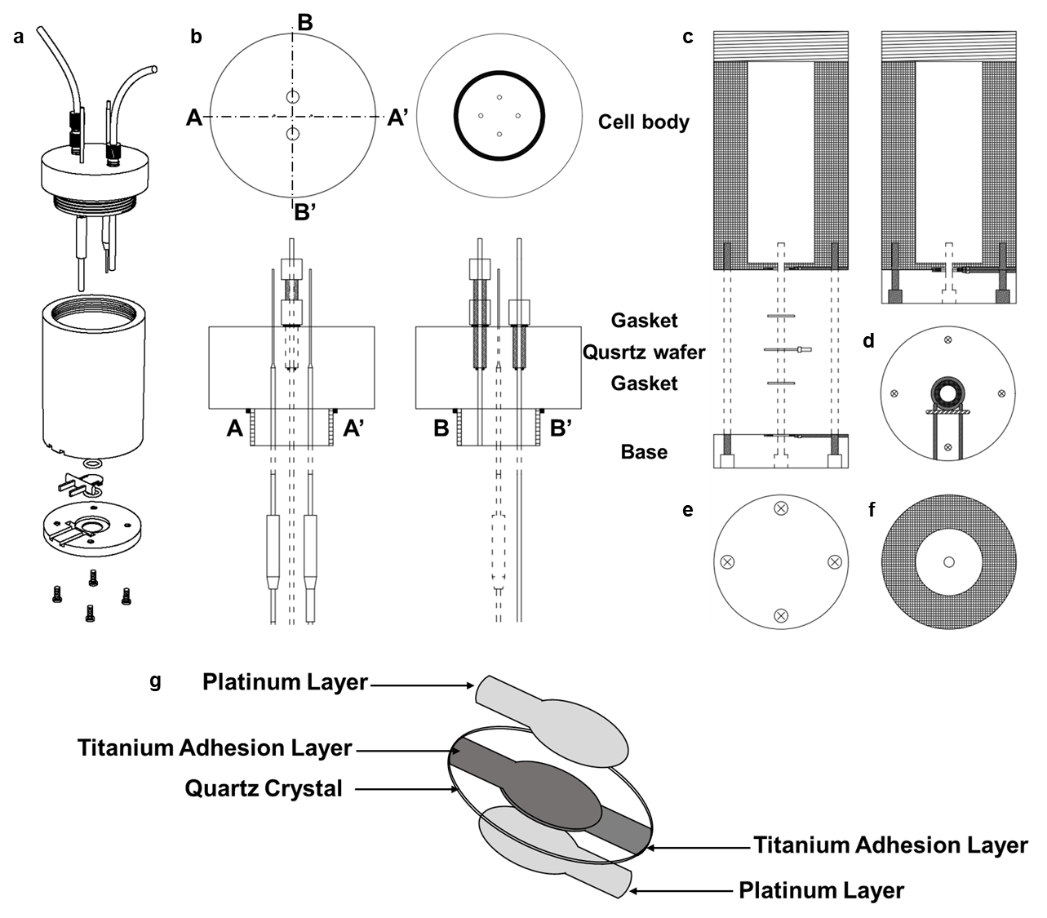
Supplementary Fig. 1| a) A scheme of the self-designed EQCM electrical cell, b) top view, bottom view and details of the electrical cell cover, c) electrical cell body profile, d) top view of electrical cell base, e) bottom view of electrical cell, f) top view of electrical cell body and g) schematic diagram of Pt-coated quartz wafer structure.
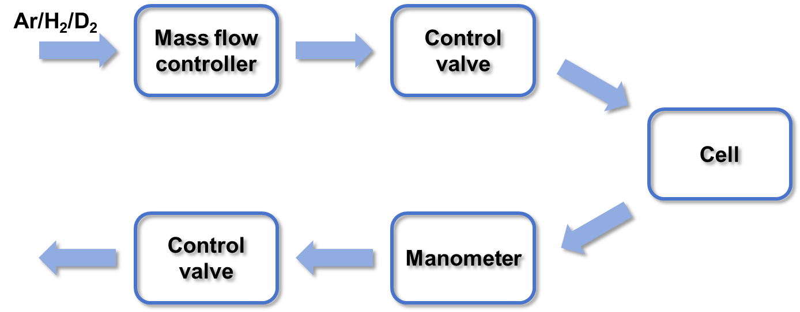
Supplementary Fig. 2| The diagram of EQCM cell with pressure control.

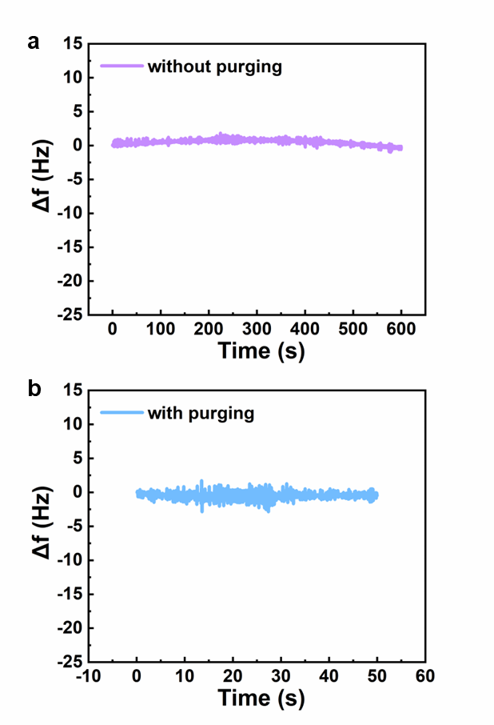
Supplementary Fig. 3| Base line of frequency Δf a) without purging and b) with purging in the home-made EQCM electrical cell.
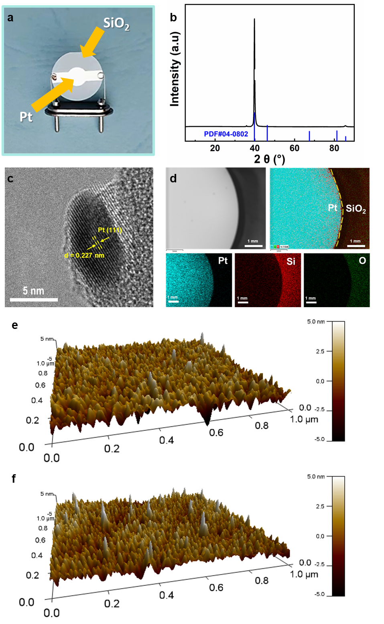
Supplementary Fig. 4| a) Optical picture; b) XRD pattern; c) TEM image and d) EDS Mapping images of titanium/platinum coated quartz crystal electrode; AFM images of the titanium/platinum coated quartz crystal electrodes e) before and f) after electrochemical test.

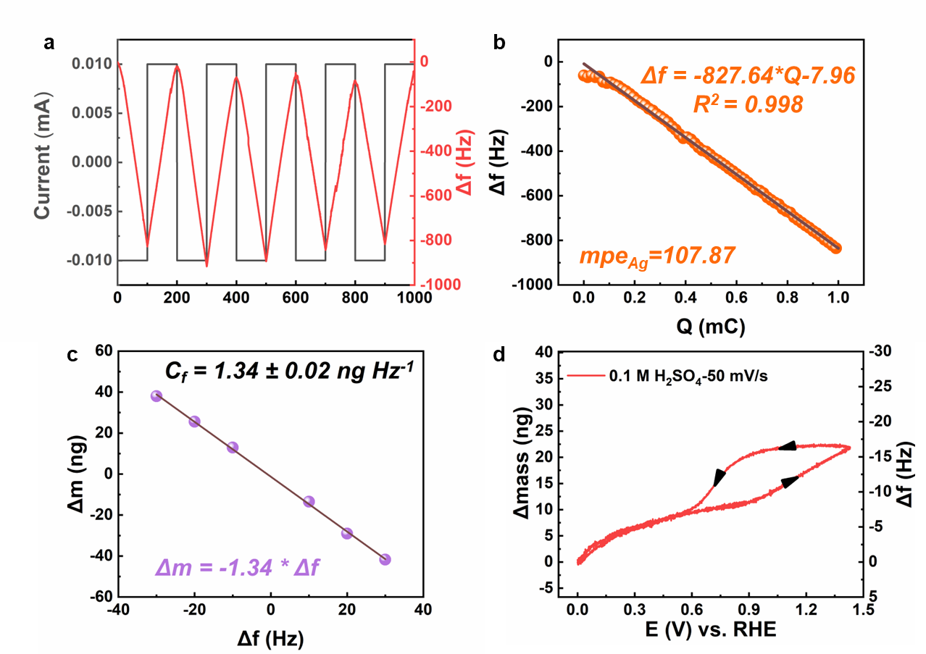 Supplementary Fig. 5| Calibration of the $C_{f}$ through galvanostatic Ag deposition/stripping using current of ± 10 µA and electrolyte 0.025 M AgNO₃ in 0.5 M HNO₃ and T = 298 K. The measured Sauerbrey constant $C_{f}$ of the 7.995 MHz titanium/platinum coated quartz crystal electrodes was 1.34 ± 0.02 ng Hz⁻¹. a) i vs t curve and Δf of the Ag deposition/stripping, b) Δf with the charge quantity of the Ag deposition, c) Δm vs Δf of the Ag deposition/stripping, and d) the Δf and the relevant Δm vs E on Pt in Ar-purged 0.1 M H₂SO₄.

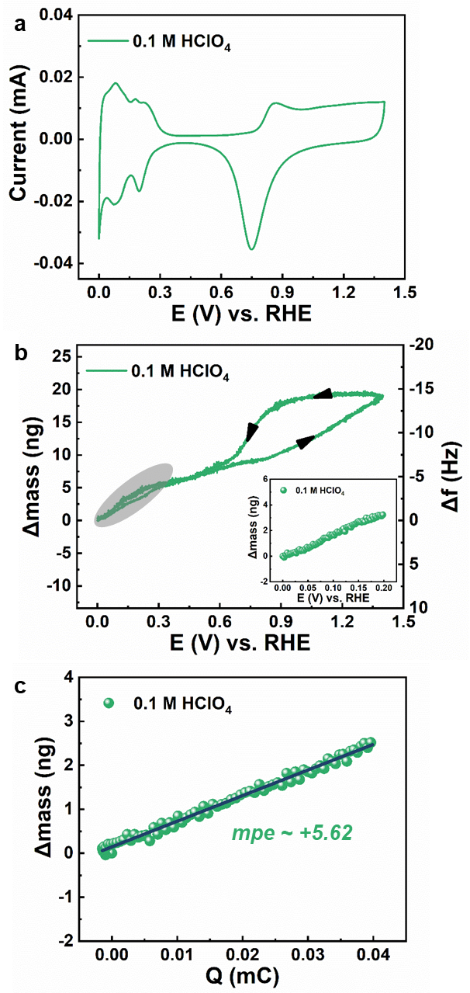
Supplementary Fig. 6| a) i vs E, b) Δm vs E, and c) the relevant Δm vs accumulative charge Q on Pt in HClO₄ purged Ar.
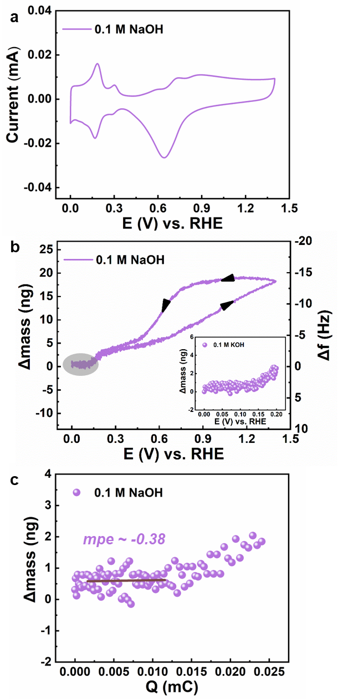
Supplementary Fig. 7| a) a) i vs E, b) Δm vs E, and c) the relevant Δm vs accumulative charge Q on Pt in NaOH purged Ar.
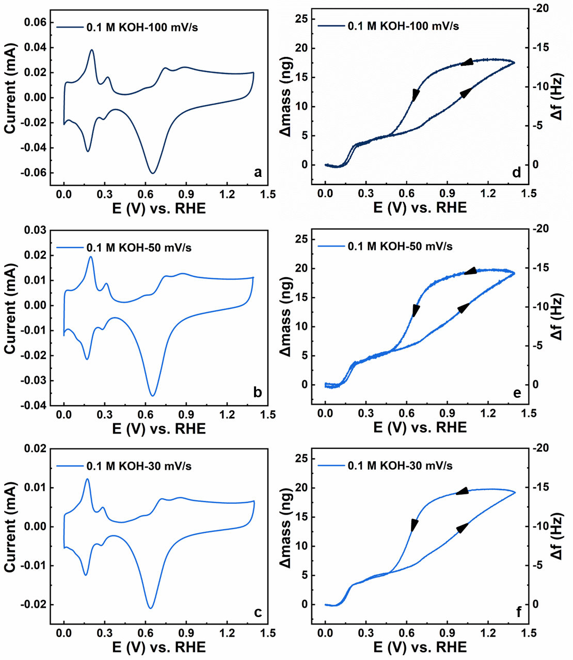
Supplementary Fig. 8| a-c) i vs E and d-f) Δm and Δf vs E on Pt in 0.1 M KOH with different scan rates（100 mV/s, 50 mV/s and 30 mV/s).
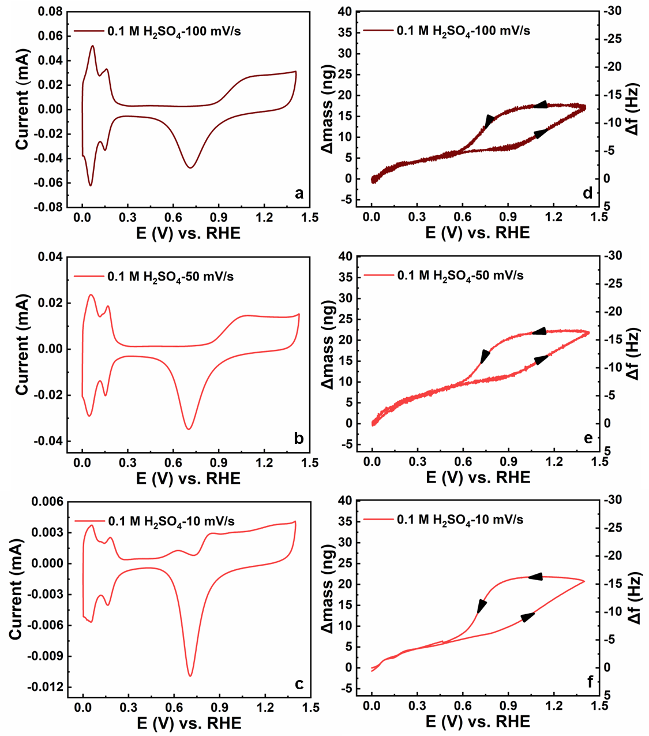
Supplementary Fig. 9| a-c) i vs E and d-f) Δm and Δf vs E on Pt in 0.1 M H₂SO₄ with different scan rates（100 mV/s, 50 mV/s and 10 mV/s).

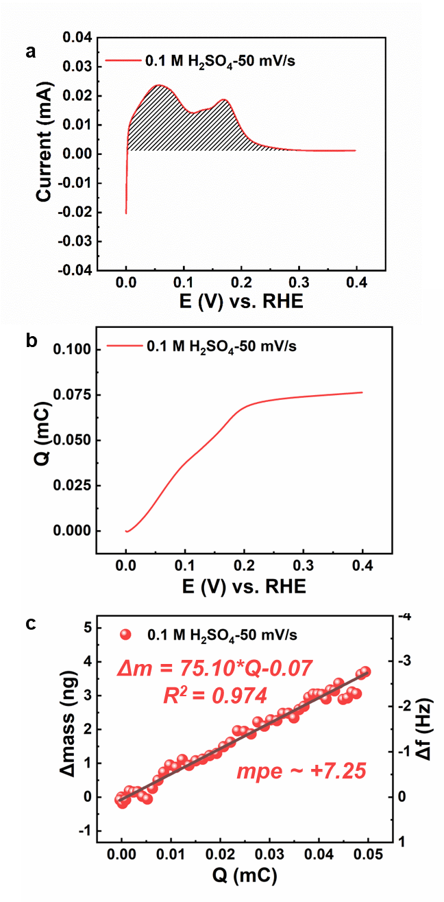
Supplementary Fig. 10| Procedures to calculate the mpe value from the i vs E and Δm vs E profiles.

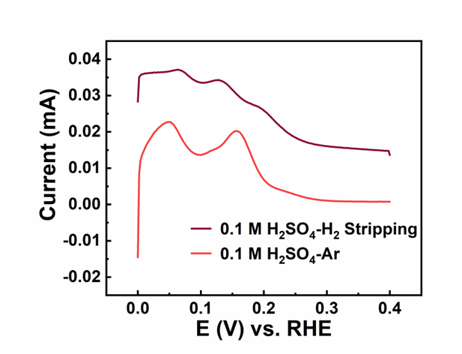
Supplementary Fig. 11| Comparison of the current obtained in Ar and H/H₂ Stripping in acid.

Supplementary Fig. 12| Comparison of the current obtained in Ar and H/H₂ Stripping in base.

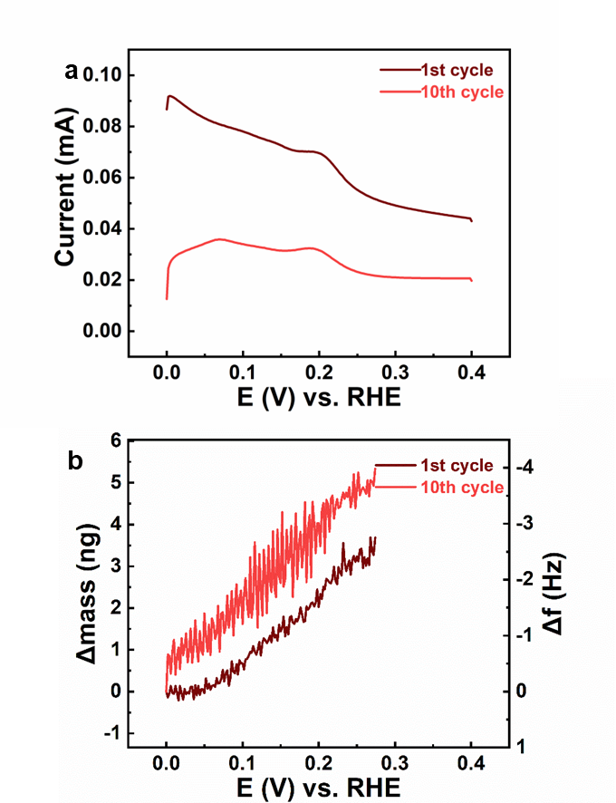
Supplementary Fig. 13| a) i vs E, b) Δm and Δf vs E on Pt in H₂SO₄ with different H₂ saturation. Net mass increase was observed in the acid case, indicating the oxidation desorption of pre-adsorbed H/H₂ in acid is accompanied by adsorption of water.
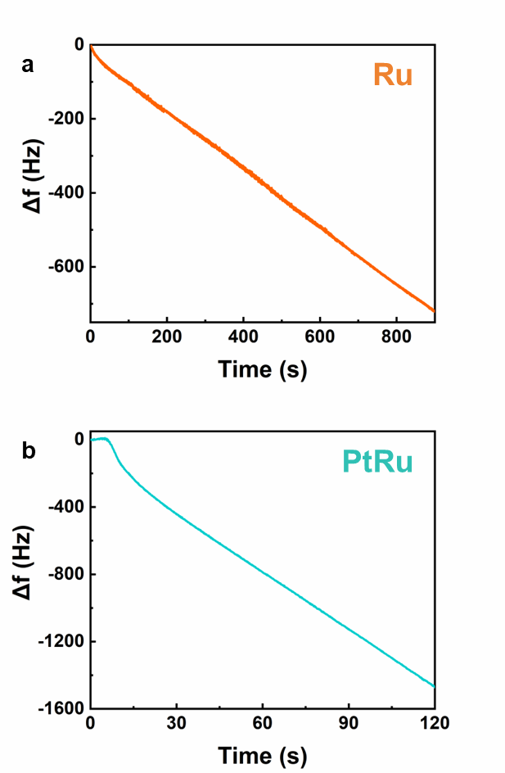
Supplementary Fig. 14| Frequency change during electrodeposition of Ru (a) and PtRu (b).
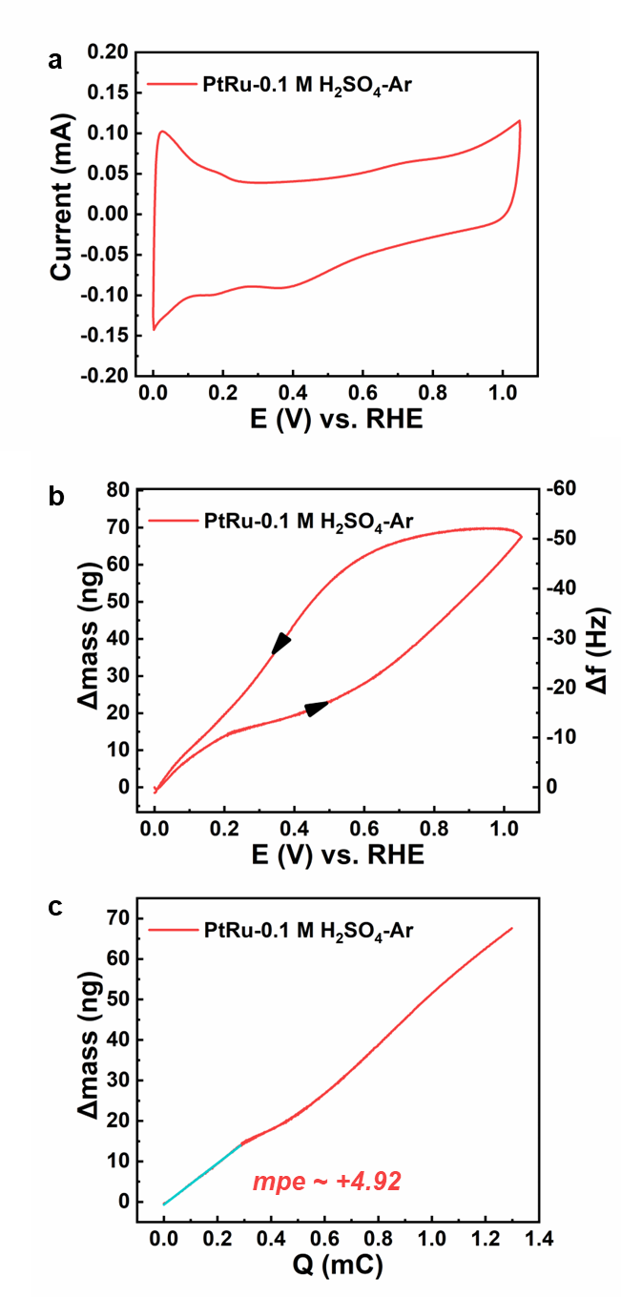
Supplementary Fig. 15| a) i vs E, b) Δf and the relevant Δm vs E, c) the Δm vs Q on PtRu in Ar-purged H₂SO₄.

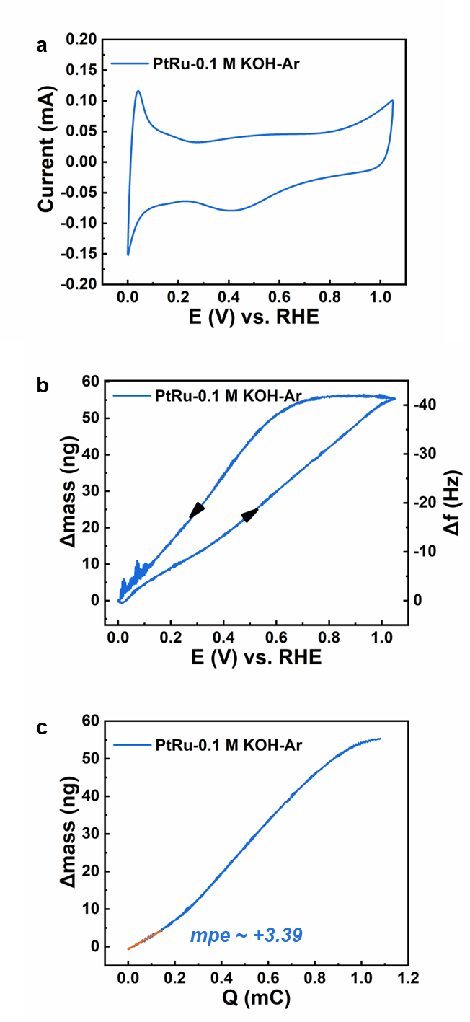
Supplementary Fig. 16| a) i vs E, b) Δf and the relevant Δm vs E, c) the Δm vs Q on PtRu in Ar-purged KOH.

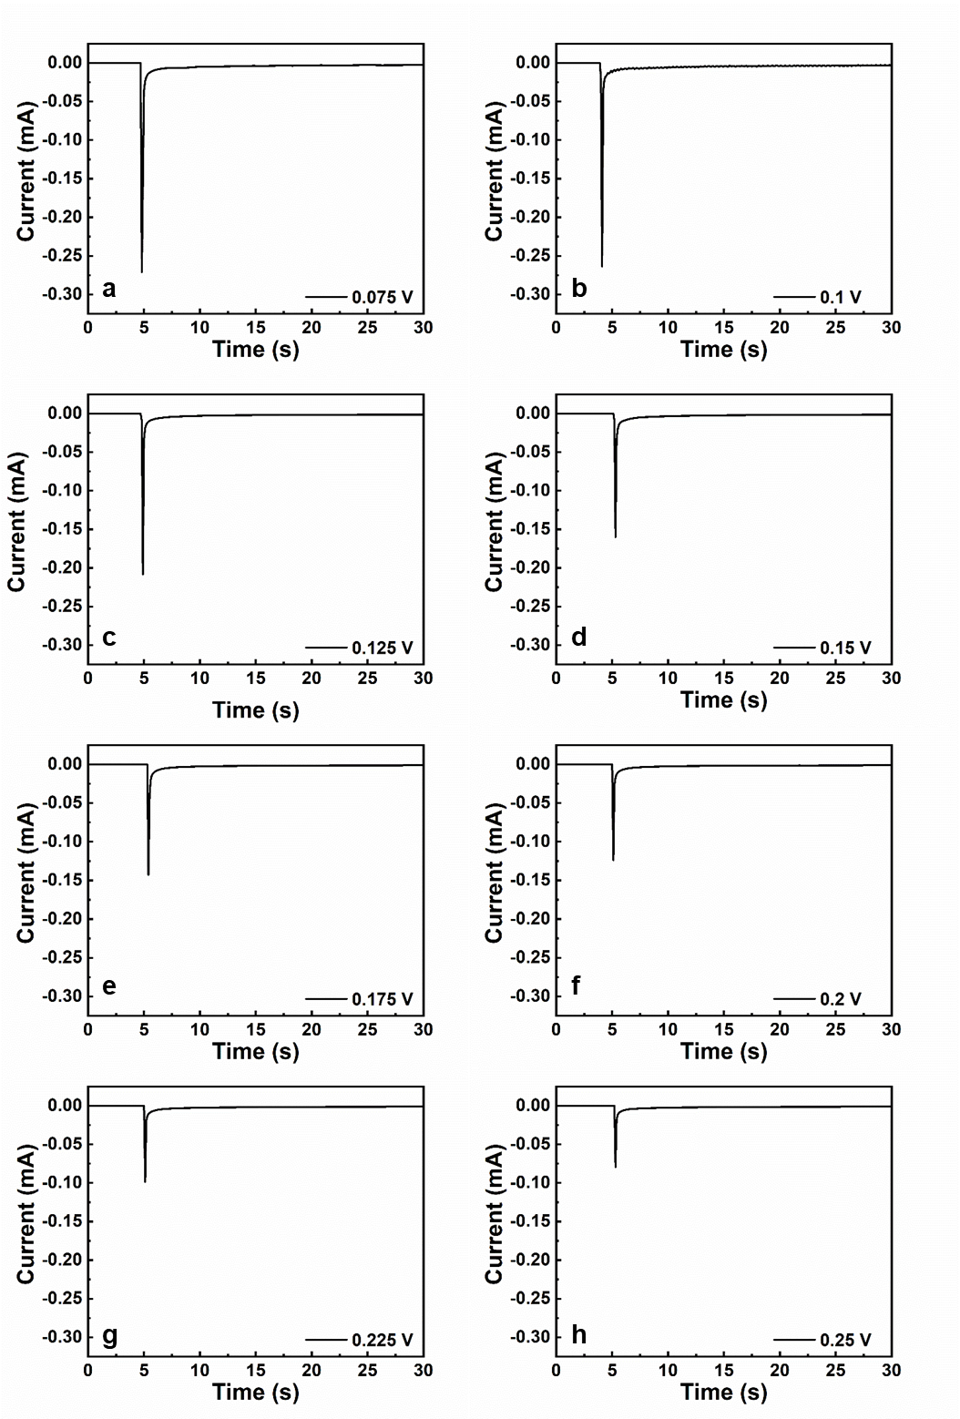
Supplementary Fig. 17| Current transients measured during the potentiostatic immersion of polycrystalline Pt electrode, prepared according to the procedure described in the text, in 0.1 M H₂SO₄. E = 0.075 V (a), 0.1 V (b), 0.125 V (c), 0.15 V (d), 0.175 V (e), 0.2 V (f), 0.225 V (g), 0.25 V (h) vs. RHE.

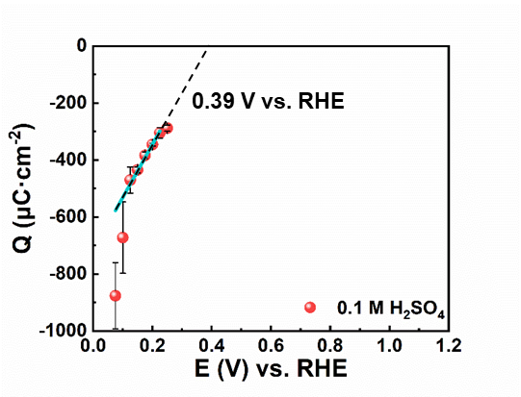
Supplementary Fig. 18| Charge density vs. potential curves of polycrystalline Pt electrode in 0.1 M H₂SO₄. Error bars represent s.d. for each data point (n = 3 independent experiments), and points are average values.
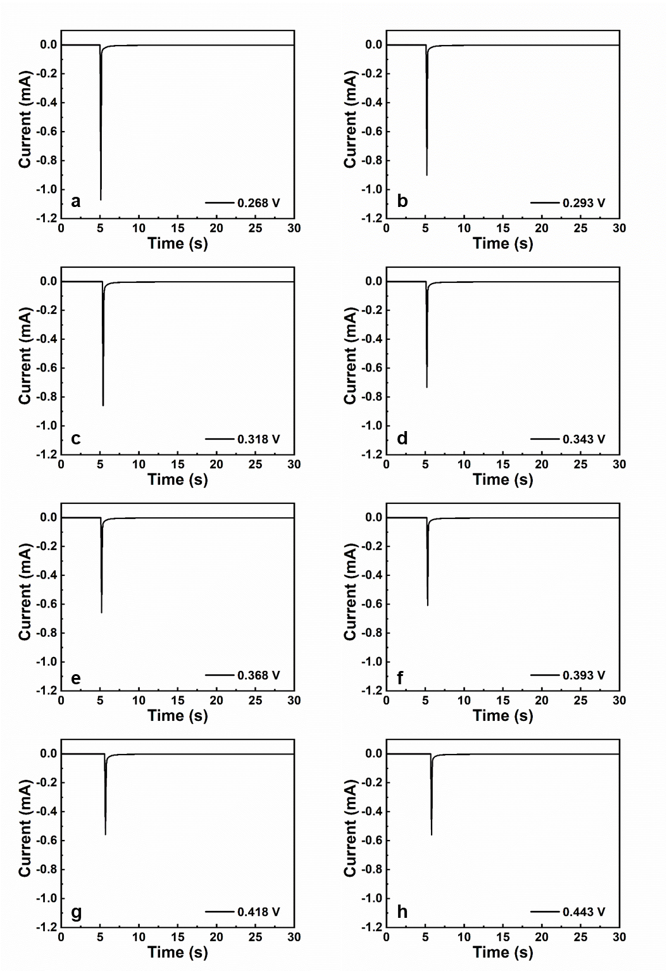
Supplementary Fig. 19| a) Current transients measured during the potentiostatic immersion of polycrystalline Pt electrode, prepared according to the procedure described in the text, in 0.1 M KOH. E = 0.268 V (a), 0.293 V (b), 0.318 V (c), 0.343 V (d), 0.368 V (e), 0.393 V (f), 0.418 V (g), 0.443 V (h) vs. RHE.
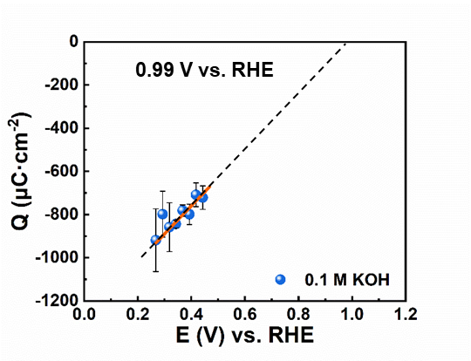
Supplementary Fig. 20| Charge density vs. potential curves of polycrystalline Pt electrode in 0.1 M KOH. Error bars represent s.d. for each data point (n = 3 independent experiments), and points are average values.

Supplementary Fig. 21| Whole snapshot of Acid or alkaline interface a) Alkaline Pt(111) - water interface, hydrogen coverage is 0.25, b) Alkaline Pt(111) - water interface,The hydrogen coverage is 0 at PZC , c) Acid Pt(111) - water interface, hydrogen coverage is 0.88, d).Acid Pt(111) - water interface,The hydrogen coverage is 0 at PZC.

Supplementary Fig. 22| Snapshots of the acid Pt(111)-water interface with different hydrogen coverage θ, a) θ = 0; b) θ = 0.25; c) θ = 0.5; d) θ = 0.75; e) θ = 0.88; f) θ = 1.

Supplementary Fig. 23| Snapshots of the alkaline Pt(111)-water interface with different hydrogen coverage θ, a) θ = 0, 2K⁺; b) θ = 0, 3K⁺; c) θ = 0.25, 3K⁺.

Supplementary Fig. 24| The distribution of water molecule concentration along the Z-axis interface.

Supplementary Fig. 25| The distribution of hydrogen bond concentration along the Z-axis interface.

Supplementary Fig. 26| Definitions of collective variables (CVs) at acid interface. a) Acid surface; b) Alkaline Surface; (Pt, gray; H, white; O, red and yellow; Na, purple. Other water molecules are represented by line models, while Pt, Na, the water molecules and the H atoms involved in the reaction are depicted using ball-and-stick models).
Supplementary Fig. 27| Potential of mean force derived from the slow-growth simulation a) Acid interface b) Alkaline interface.

Supplementary Fig. 28| O-H bond distance; a) Acid Interface; b) Alkaine Interface; (Pt, gray; H, white; O, red and yellow; Na, purple Other water molecules are represented by line models, while Pt, Na, the water molecules and the H atoms involved in the reaction are depicted using ball-and-stick models).
Supplementary Table 1| Values of the pztc and pzfc at the RHE scale. Corrected values are those obtained after consideration of the remaining charge on the CO covered surface¹⁶.

pH | RHE scale
pH | Pztc uncorrected | Pztc corrected | Pzfc uncorrected | Pzfc corrected
13.1 | 0.462 | 0.699 | 0.458 | 1.054
12.3 | 0.406 | 0.679 | 0.406 | 1.013
11.1 | 0.408 | 0.685 | 0.443 | 0.941
8.4 | 0.375 | 0.617 | 0.325 | 0.779
3.4 | 0.363 | 0.483 | 0.284 | 0.483
2.3 | 0.348 | 0.436 | 0.227 | 0.422
1.2 | 0.338 | 0.389 | 0.160 | 0.343

Supplementary Table 2| Values of the pztc and pzfc at the SHE scale. Corrected values are those obtained after consideration of the remaining charge on the CO covered surface¹⁶.

pH | SHE scale
 | Pztc uncorrected | Pztc corrected | Pzfc uncorrected | Pzfc corrected
13.1 | -0.313 | -0.076 | -0.317 | 0.279
12.3 | -0.326 | -0.049 | -0.326 | 0.285
11.1 | -0.249 | 0.028 | -0.214 | 0.284
8.4 | -0.120 | 0.122 | -0.170 | 0.282
3.4 | 0.162 | 0.282 | 0.083 | 0.282
2.3 | 0.211 | 0.299 | 0.090 | 0.285
1.2 | 0.267 | 0.318 | 0.098 | 0.272

Supplementary Table 3| The interface potential and work function of models.

Model | Work Function (eV) | Potential (V vs SHE)
Pt(111)-water | 4.60 | 0.16
Pt(111)-water-H | 4.53 | 0.09
Pt(111)-water-3K | 3.79 | -0.65
Pt(111)-water-3K-H | 4.03 | -0.41

Reference

- Jerkiewicz, G., Vatankhah, G., Tanaka, S.-i. & Lessard, J. Discovery of the Potential of Minimum Mass for Platinum Electrodes. Langmuir 27, 4220-4226 (2011). https://doi.org/10.1021/la200153n
- Woo, T. K., Margl, P. M., Blöchl, P. E. & Ziegler, T. A Combined Car−Parrinello QM/MM Implementation for ab Initio Molecular Dynamics Simulations of Extended Systems: Application to Transition Metal Catalysis. J. Phys. Chem. B 101, 7877-7880 (1997). https://doi.org/10.1021/jp9717296
- Jarzynski, C. Nonequilibrium Equality for Free Energy Differences. Phys. Rev. Lett. 78, 2690-2693 (1997). https://doi.org/10.1103/PhysRevLett.78.2690
- Oberhofer, H., Dellago, C. & Geissler, P. L. Biased Sampling of Nonequilibrium Trajectories: Can Fast Switching Simulations Outperform Conventional Free Energy Calculation Methods? J. Phys. Chem. B 109, 6902-6915 (2005). https://doi.org/10.1021/jp044556a
- Chan, K. & Nørskov, J. K. Electrochemical Barriers Made Simple. J. Phys. Chem. Lett. 6, 2663-2668 (2015). https://doi.org/10.1021/acs.jpclett.5b01043
- Chan, K. & Nørskov, J. K. Potential Dependence of Electrochemical Barriers from ab Initio Calculations. J. Phys. Chem. Lett. 7, 1686-1690 (2016). https://doi.org/10.1021/acs.jpclett.6b00382
- Mathew, K., Kolluru, V. S. C., Mula, S., Steinmann, S. N. & Hennig, R. G. Implicit self-consistent electrolyte model in plane-wave density-functional theory. J. Chem. Phys. 151, 234101 (2019). https://doi.org/10.1063/1.5132354
- Trasatti, S. The absolute electrode potential: an explanatory note (Recommendations 1986). J. Electroanal. Chem. 58, 955-966 (1986). https://doi.org/doi:10.1351/pac198658070955
- Li, P., Huang, J., Hu, Y. & Chen, S. Establishment of the Potential of Zero Charge of Metals in Aqueous Solutions: Different Faces of Water Revealed by Ab Initio Molecular Dynamics Simulations. J. Phys. Chem. C 125, 3972-3979 (2021). https://doi.org/10.1021/acs.jpcc.0c11089
- Li, P., Liu, Y. & Chen, S. Microscopic EDL structures and charge–potential relation on stepped platinum surface: Insights from the ab initio molecular dynamics simulations. J. Chem. Phys. 156, 104701 (2022). https://doi.org/10.1063/5.0080104
- Le, J., Iannuzzi, M., Cuesta, A. & Cheng, J. Determining Potentials of Zero Charge of Metal Electrodes versus the Standard Hydrogen Electrode from Density-Functional-Theory-Based Molecular Dynamics. Phys. Rev. Lett. 119, 016801 (2017). https://doi.org/10.1103/PhysRevLett.119.016801
- Ji, Y. et al. From bulk to interface: electrochemical phenomena and mechanism studies in batteries via electrochemical quartz crystal microbalance. Chem. Soc. Rev. 50, 10743-10763 (2021). https://doi.org/10.1039/D1CS00629K
- Mefford, J. T. et al. Correlative operando microscopy of oxygen evolution electrocatalysts. Nature 593, 67-73 (2021). https://doi.org/10.1038/s41586-021-03454-x
- Wang, Y.-H. et al. In situ Raman spectroscopy reveals the structure and dissociation of interfacial water. Nature 600, 81-85 (2021). https://doi.org/10.1038/s41586-021-04068-z
- Climent, V. c., Gómez, R. & Feliu, J. M. Effect of increasing amount of steps on the potential of zero total charge of Pt(111) electrodes. Electrochim. Acta 45, 629-637 (1999). https://doi.org/https://doi.org/10.1016/S0013-4686(99)00241-8
- Rizo, R., Sitta, E., Herrero, E., Climent, V. & Feliu, J. M. Towards the understanding of the interfacial pH scale at Pt(111) electrodes. Electrochim. Acta 162, 138-145 (2015). https://doi.org/https://doi.org/10.1016/j.electacta.2015.01.069

