Table 1. Sample and Feature Information: Control Group vs. Osteoporosis Group
 |  | Normal Bone Density Group  (n = 684) | Osteoporosis Group  (n = 1874)
Categorical Feature Level |  | Sample size (Proportion)
Gender | Male | 140 (20.5%) | 579 (30.9%)
Gender | Female | 544 (79.5%) | 1295 (69.1%)
Exercise | No | 92 (13.5%) | 316 (16.9%)
Exercise | Sometimes | 222 (32.5%) | 506 (27.0%)
Exercise | Everyday | 193 (28.2%) | 508 (27.1%)
Exercise | Other | 177 (25.9%) | 544 (29.0%)
Diet | Balanced | 665 (97.2%) | 1819 (97.1%)
Diet | Meat-Based | 15 (2.2%) | 33 (1.8%)
Diet | Vegetarian | 3 (0.4%) | 16 (0.9%)
Diet | Other | 1 (0.1%) | 6 (0.3%)
Smoke | No | 633 (92.5%) | 1643 (87.7%)
Smoke | Quit | 15 (2.2%) | 61 (3.3%)
Smoke | Current | 36 (5.3%) | 167 (8.9%)
Smoke | Other | 0 (0.0%) | 3 (0.2%)
Drink | No | 597 (87.3%) | 1617 (86.3%)
Drink | Quit | 4 (0.6%) | 26 (1.4%)
Drink | Occasional | 62 (9.1%) | 139 (7.4%)
Drink | Frequent | 20 (2.9%) | 60 (3.2%)
Drink | Other | 1 (0.1%) | 32 (1.7%)
Disease History | No | 479 (70.0%) | 1051 (56.1%)
Disease History | Yes | 195 (28.5%) | 761 (40.6%)
Disease History | Other | 10 (1.5%) | 62 (3.3%)
Continuous Features |  | Mean (SD)
Age (years) |  | 52.92 (8.56） | 65.26（9.96）
Body Mass Index (BMI) |  | 24.53（3.24） | 22.79（3.12）
Blood Pressure | SBP（mmHg） | 126.1（11.94） | 128.6（13.55）
Blood Pressure | DBP（mmHg） | 78.15（7.49） | 78.15（8.21）
Smoking Duration (years) |  | 1.881（8.33） | 3.559（12.02）
OSTA |  | 1.895（2.46） | -1.742（3.05）
Postmenopausal (years)  (only female) |  | 2.56（5.32） | 14.26（10.41）
Bone Density Measurements |  | Mean (SD)
L2 Bone Density (g/cm²) |  | 1.120（0.145） | 0.755（0.398）
L3 Bone Density (g/cm²) |  | 1.166（0.156） | 0.784（0.371）
L4 Bone Density (g/cm²) |  | 1.176（0.462） | 0.801（0.283）
Tem.Neck Bone Density (g/cm²) |  | 0.9065（0.116） | 0.637（0.168）
Trochanter Bone Density (g/cm²) |  | 0.756（0.093） | 0.537（0.151）
Table 2. Osteoporosis Risk Factors: Univariate Analysis
feature | FC | p_value | change
All Sample
age | 1.233 | 1.951e-118 | Up
gender | 0.858 | 1.691e-08 | Down
sbp | 1.017 | 1.040e-03 | Up
dbp | 0.998 | 7.002e-01 | Non
BMI | 0.928 | 1.895e-22 | Down
OSTA | 0.266 | 2.694e-119 | Down
smoke_age | 2.257 | 3.115e-04 | Up
exercise | 0.947 | 1.135e-01 | Non
diet | 0.996 | 6.663e-01 | Non
smoke | 2.018 | 1.517e-03 | Up
drink | 1.098 | 5.811e-01 | Non
disease | 1.4206 | 1.851e-06 | Up
Male
age | 1.105 | 6.133e-09 | Up
sbp | 1.019 | 3.388e-02 | Up
dbp | 0.994 | 5.163e-01 | Non
BMI | 0.916 | 1.267e-13 | Down
OSTA | 0.232 | 3.847e-17 | Down
smoke_age | 1.206 | 2.367e-01 | Non
exercise | 0.857 | 1.818e-02 | Down
diet | 0.981 | 2.723e-01 | Non
smoke | 1.077 | 5.636e-01 | Non
drink | 0.749 | 2.007e-02 | Down
disease | 1.058 | 6.196e-01 | Non
Female
age | 1.276 | 2.166e-182 | Up
sbp | 1.0178 | 5.118e-04 | Up
dbp | 0.998 | 7.164e-01 | Non
BMI | 0.931 | 5.074e-23 | Down
OSTA | 0.117 | 1.022e-185 | Down
smoke_age | 1.049 | 4.979e-02 | Up
exercise | 0.980 | 5.971e-01 | Non
diet | 0.992 | 3.084e-01 | Non
smoke | 1.002 | 2.899e-02 | Up
drink | 0.490 | 3.056e-02 | Down
disease | 1.603 | 4.005e-11 | Up
postmenopausal | 5.573 | 1.369e-175 | Up

Table 3. Performance Metrics of Models for Osteoporosis Risk Factors Analysis
Learners | Auc | Sensitivity | Specificity | FNR | FPR
classif.log_reg | 0.874 | 0.653 | 0.915 | 0.347 | 0.085
classif.naive_bayes | 0.845 | 0.785 | 0.777 | 0.215 | 0.223
classif.kknn | 0.818 | 0.604 | 0.887 | 0.396 | 0.113
classif.rpart | 0.840 | 0.599 | 0.929 | 0.401 | 0.071
classif.ranger | 0.872 | 0.629 | 0.928 | 0.371 | 0.072

Table 4. Osteoporosis Risk Factors: Multivariate Analysis
 | Features | Estimate | Std.Error | Z value | Pr(>|z|)
Male | the First Set of Factors
Male | age | 0.058 | 0.015 | 3.931 | 8.46e-05***
Male | sbp | 0.017 | 0.012 | 1.458 | 0.14473
Male | BMI | -0.246 | 0.049 | -5.075 | 3.87e-07***
Male | exercise | -0.601 | 0.200 | -3.007 | 0.00263**
Male | diet | 1.268 | 1.108 | 1.145 | 0.25214
Male | smoke | 0.135 | 0.176 | 0.768 | 0.44224
Male | drink | -0.023 | 0.139 | -0.167 | 0.86726
Male | disease | 0.056 | 0.303 | 0.184 | 0.85428
Male | the Second Set of Factors
Male | sbp | 0.014 | 0.012 | 1.200 | 0.2299
Male | OSTA | -0.356 | 0.053 | -6.759 | 1.39e-11***
Male | exercise | -0.603 | 0.202 | -2.989 | 0.0028**
Male | diet | 1.110 | 1.101 | 1.008 | 0.3135
Male | smoke | 0.158 | 0.177 | 0.894 | 0.3714
Male | drink | -0.0004 | 0.140 | -0.003 | 0.9979
Male | disease | -0.081 | 0.303 | -0.268 | 0.7885
Female | the First Set of Factors
Female | age | 0.165 | 0.015 | 10.843 | < 2e-16***
Female | sbp | -0.014 | 0.007 | -2.067 | 0.0387*
Female | BMI | -0.211 | 0.027 | -7.894 | 2.92e-15***
Female | exercise | -0.177 | 0.110 | -1.605 | 0.109
Female | diet | -0.230 | 0.494 | -0.466 | 0.641
Female | smoke | 7.606 | 214.76 | 0.035 | 0.972
Female | drink | -0.382 | 0.209 | -1.827 | 0.068
Female | disease | -0.333 | 0.195 | -1.711 | 0.087
Female | postmenopasual | 0.087 | 0.018 | 4.848 | 1.25e-06***
Female | the Second Set of Factors
Female | sbp | -0.011 | 0.007 | -1.651 | 0.099
Female | OSTA | -0.589 | 0.046 | -12.814 | < 2e-16***
Female | exercise | -0.146 | 0.110 | -1.322 | 0.186
Female | diet | -0.347 | 0.498 | -0.696 | 0.486
Female | smoke | 8.015 | 215.27 | 0.037 | 0.970
Female | drink | -0.393 | 0.206 | -1.904 | 0.057
Female | disease | -0.214 | 0.193 | -1.108 | 0.268
Female | postmenopausal | 0.117 | 0.015 | 7.637 | 2.22e-14***

Table 5. Multivariate Analysis of Osteoporosis Risk in the Full Sample Based on Logistic Regression
Feature | Estimate | Std.Error | Z value | Pr(>|z|)
age | 0.067 | 0.012 | 5.705 | 1.17e-08***
gender | -1.933 | 0.206 | -9.400 | < 2e-16***
sbp | -0.007 | 0.006 | -1.225 | 0.22
OSTA | -0.459 | 0.043 | -10.724 | < 2e-16***
exercise | -0.248 | 0.093 | -2.665 | 0.008**
diet | -0.149 | 0.415 | -0.360 | 0.719
disease | -0.143 | 0.157 | -0.911 | 0.362

Table 6. Performance of Machine Learning Classification Models Over 50 Repetitions
learner.id | Accuracy  Mean(SD) | AUC  Mean(SD)
classif.bart | 0.9742（0.0022） | 0.9971（0.0003）
classif.ctree | 0.9705（0.0045） | 0.9864（0.0028）
classif.cv_glmnet | 0.9243（0.0047） | 0.9755（0.0024）
classif.debug | 0.5016（0.0115） | 0.5005（0.0158）
classif.earth | 0.9732（0.0043） | 0.9934（0.0039）
classif.featureless | 0.4751（0.0082） | 0.5000（0.0000）
classif.gam | 0.9355（0.0017） | 0.9778（0.0014）
classif.gamboost | 0.9672（0.0015） | 0.9929（0.0010）
classif.gbm | 0.9754（0.0021） | 0.9970（0.0003）
classif.glmboost | 0.9236（0.0042） | 0.9757（0.0023）
classif.glmnet | 0.9275（0.0019） | 0.9767（0.0012）
classif.ksvm | 0.9706（0.0028） | 0.9953（0.0004）
classif.lda | 0.9361（0.0031） | 0.9788（0.0012）
classif.log_reg | 0.9367（0.0026） | 0.9759（0.0030）
classif.multinom | 0.9342（0.0026） | 0.9776（0.0012）
classif.naive_bayes | 0.9413（0.0022） | 0.9829（0.0014）
classif.nnet | 0.9561（0.0353） | 0.9699（0.0640）
classif.qda | 0.9428（0.0048） | 0.9785（0.0027）
classif.randomForest | 0.9829（0.0015） | 0.9976（0.0003）
classif.ranger | 0.9816（0.0017） | 0.9974（0.0002）
classif.rpart | 0.9736（0.0032） | 0.9781（0.0012）
classif.svm | 0.9683（0.0011） | 0.9959（0.0003）
classif.xgboost | 0.9715（0.0029） | 0.9908（0.0018）

Table 7. Performance of Machine Learning Regression Models Over 50 Repetitions
learner | Correlation  Mean（SD） | R square  Mean（SD） | MAE  Mean（SD）
regr.abess | 0.1473（0.0179） | 0.0220（0.0054） | 6.4587（0.0294）
regr.bart | 0.2405（0.0219） | 0.0583（0.0101） | 6.3205（0.0501）
regr.ctree | 0.0691（0.0421） | 0.0065（0.0059） | 6.5661（0.0488）
regr.cubist | 0.1035（0.0295） | 0.0116（0.0061） | 6.4307（0.0763）
regr.cv_glmnet | -0.0743（0.0285） | 0.0063（0.0045） | 6.5675（0.0099）
regr.debug | -0.0799（0.0287） | 0.0072（0.0049） | 6.5687（0.0109）
regr.earth | 0.0960（0.0363） | 0.0105（0.0078） | 6.7281（0.1756）
regr.featureless | -0.0819（0.0316） | 0.0077（0.0061） | 6.5690（0.0129）
regr.gausspr | 0.2264（0.0226） | 0.0517（0.0101） | 6.3428（0.0584）
regr.gbm | 0.2402（0.0179） | 0.0580（0.0085） | 6.3192（0.0450）
regr.glm | 0.1566（0.0178） | 0.0248（0.0057） | 6.4359（0.036）
regr.glmboost | 0.1576（0.0196） | 0.0252（0.0061） | 6.4376（0.0265）
regr.glmnet | 0.1550（0.0155） | 0.0243（0.0048） | 6.4389（0.0311）
regr.kknn | 0.1093（0.0271） | 0.0127（0.0058） | 6.8648（0.1018）
regr.ksvm | 0.2696（0.0193） | 0.0731（0.0104） | 6.1774（0.0618）
regr.lm | 0.1589（0.0201） | 0.0256（0.0064） | 6.4308（0.0381）
regr.ranger | 0.2314（0.0211） | 0.0540（0.0100） | 6.3752（0.0650）
regr.rpart | 0.1242（0.0379） | 0.0169（0.0097） | 6.9625（0.1494）
regr.svm | 0.3016（0.0159） | 0.0913（0.0098） | 6.0259（0.0538）
regr.xgboost | -0.0906（0.0302） | 0.0091（0.0055） | 36.7430（0.0000）

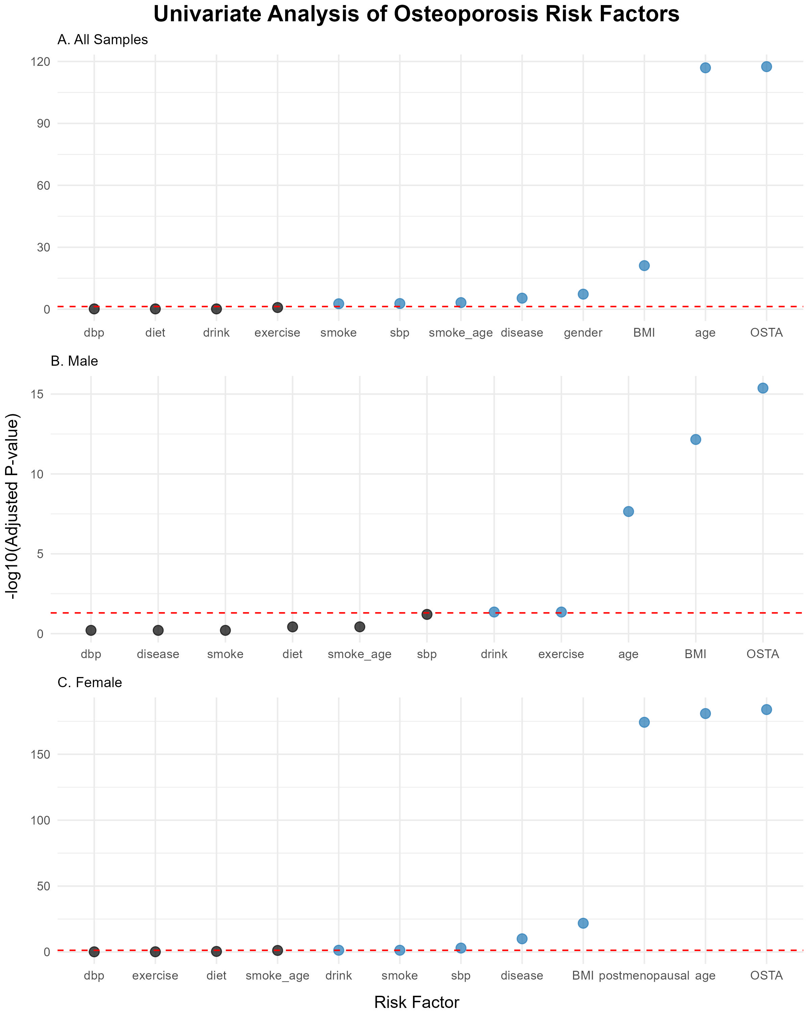
Fig 1. Univariate Analysis of Osteoporosis Risk Factors. This figure presents Manhattan plots illustrating the univariate analysis results of osteoporosis risk factors. Panel A shows the analysis for all samples, Panel B for male samples, and Panel C for female samples. Each point represents a variable, plotted based on its -log10-transformed adjusted p-value. The horizontal dashed red line indicates the significance threshold of 0.05. Points colored in blue represent variables that are statistically significant (adjusted p-value < 0.05), while black points represent non-significant variables.

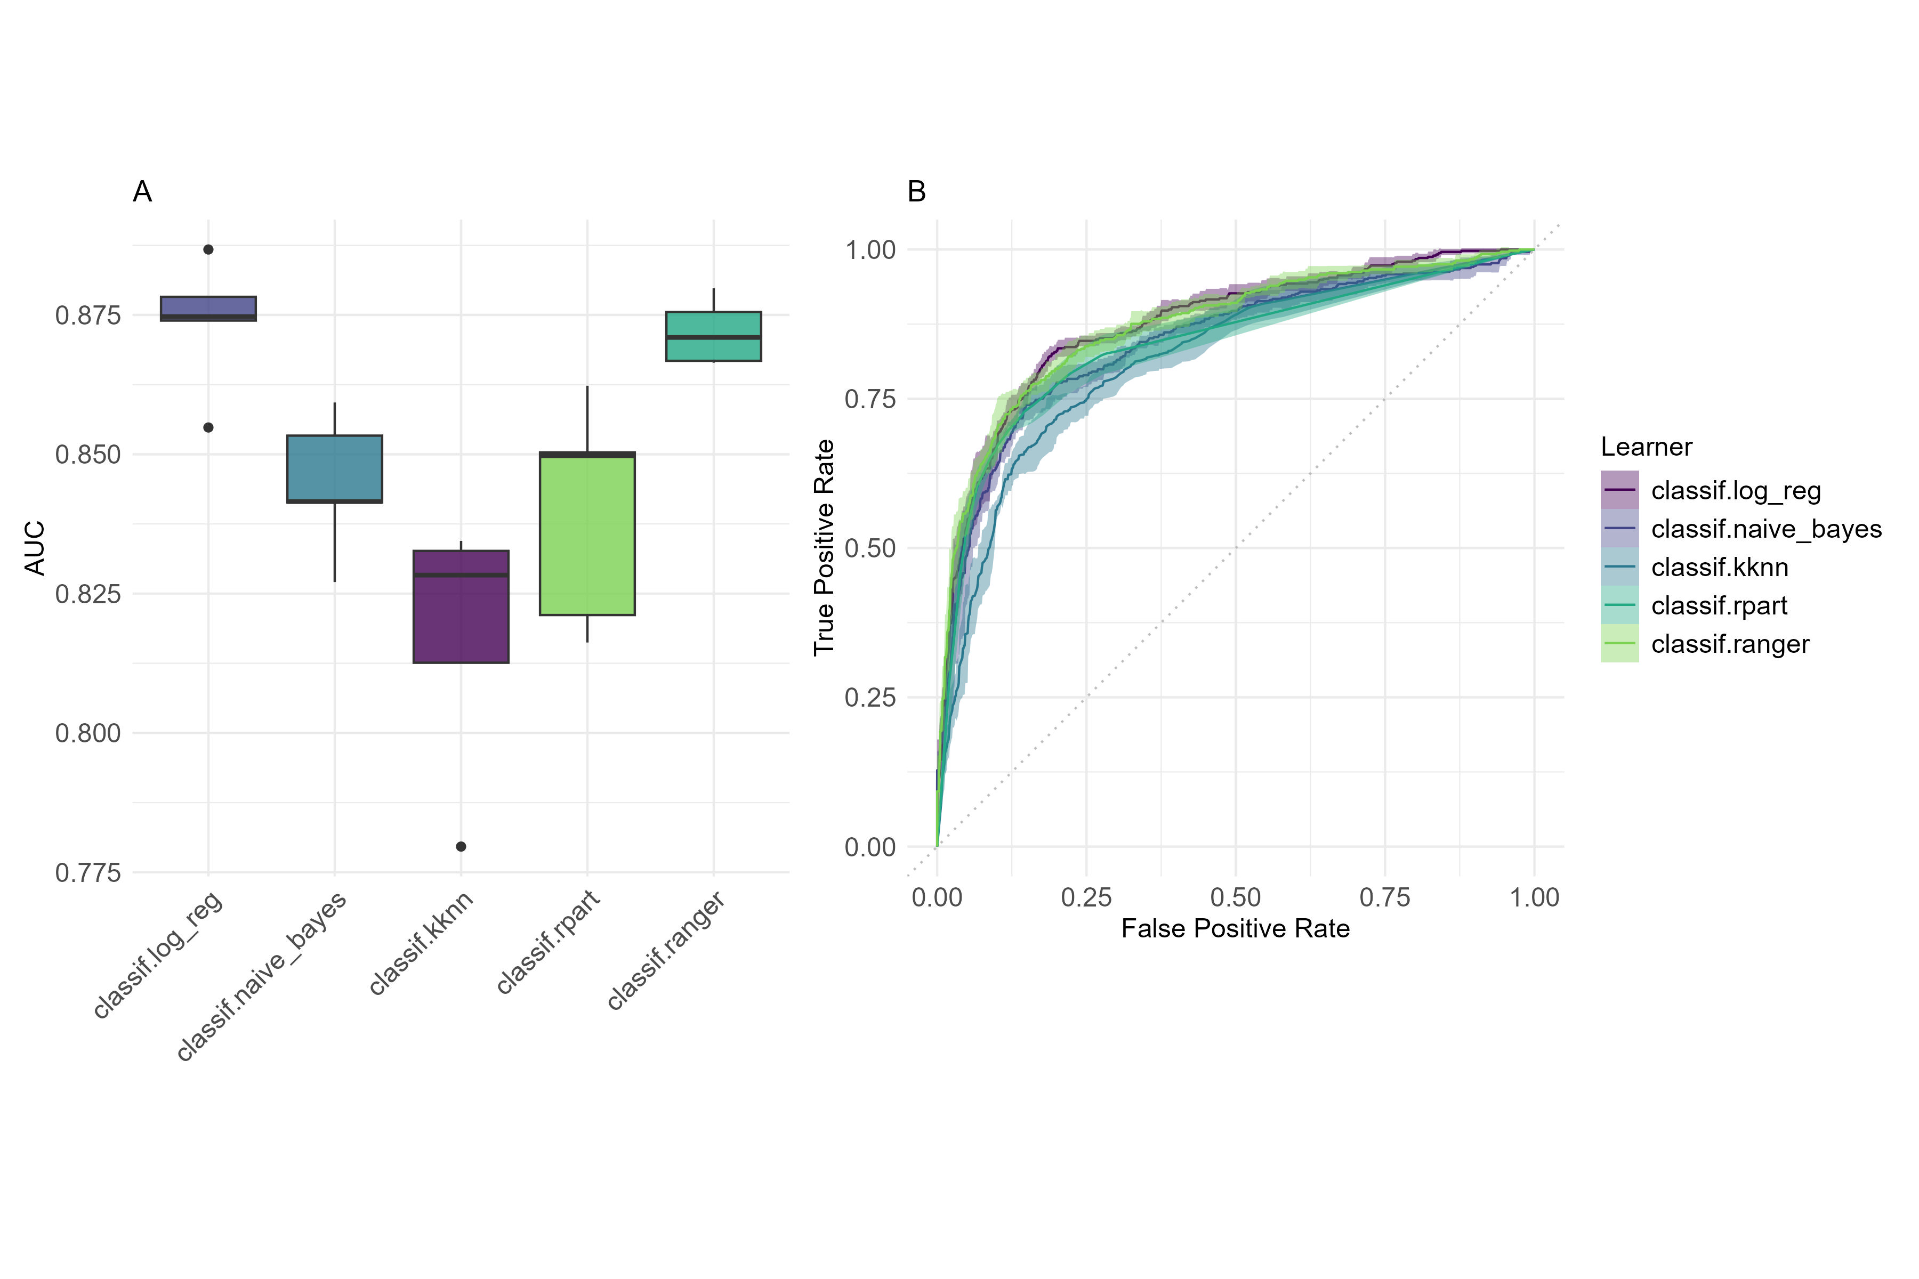
Fig 2. Performance Comparison of Different Learners. Panel A presents the AUC Boxplot, highlighting the distribution and central tendency of AUC scores across learners. Panel B shows ROC Curves, depicting the trade-off between True Positive Rate (TPR) and False Positive Rate (FPR) for each learner. Together, these plots offer a comprehensive comparison of classifier performance.

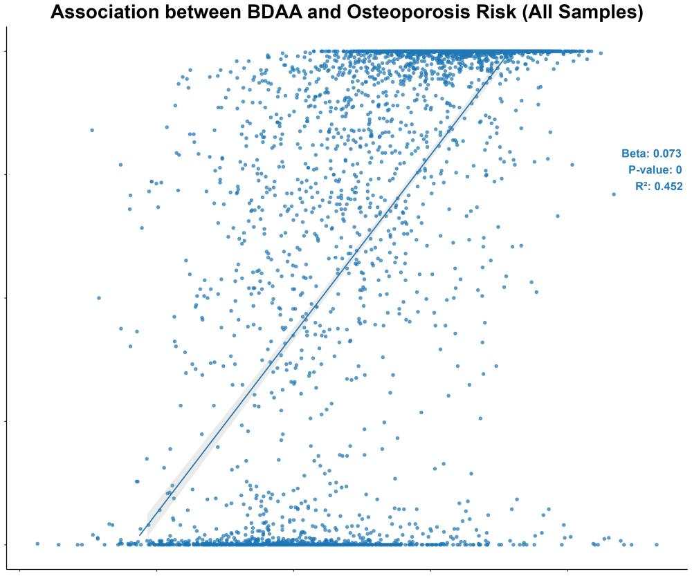
Fig 3. Association Between BDAA and Predicted Osteoporosis Risk for All Samples. This figure illustrates a scatter plot showing the association between Bone Density Age Acceleration (BDAA) and the predicted risk of osteoporosis for all samples combined. The x-axis represents BDAA, while the y-axis indicates the predicted osteoporosis risk. The annotation within the plot displays the regression slope (Beta), the p-value, and the coefficient of determination (R²), reflecting the strength and significance of the association between BDAA and osteoporosis risk.

