Supplementary Figure 1. Genome-wide association results for estimated MME opioid dose following knee arthroplasty in EUR individuals. The Manhattan plot displays the –log₁₀(P) values of SNP associations across the genome. The red horizontal line indicates the genome-wide significance threshold (P = 5 × 10⁻⁸), and the blue line marks the suggestive significance threshold (P = 1 × 10⁻⁶). SNPs exceeding the suggestive threshold are labeled with rsIDs. The plot in the upper right corner shows the quantile–quantile (QQ) plot of observed versus expected P-values.

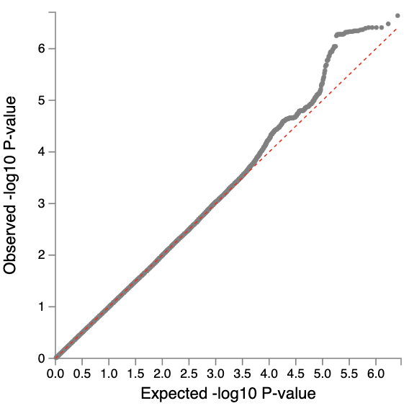

Supplementary Figure 2. Genome-wide association results for estimated MME opioid dose following hip arthroplasty in EUR individuals. The Manhattan plot displays the –log₁₀(P) values of SNP associations across the genome. The red horizontal line indicates the genome-wide significance threshold (P = 5 × 10⁻⁸), and the blue line marks the suggestive significance threshold (P = 1 × 10⁻⁶). SNPs exceeding the suggestive threshold are labeled with rsIDs. The plot in the upper right corner shows the quantile–quantile (QQ) plot of observed versus expected P-values.

Supplementary Figure 3. Genome-wide association results for estimated MME opioid dose following knee arthroplasty in AFR individuals. The Manhattan plot displays the –log₁₀(P) values of SNP associations across the genome. The red horizontal line indicates the genome-wide significance threshold (P = 5 × 10⁻⁸), and the blue line marks the suggestive significance threshold (P = 1 × 10⁻⁶). SNPs exceeding the suggestive threshold are labeled with rsIDs. The plot in the upper right corner shows the quantile–quantile (QQ) plot of observed versus expected P-values.

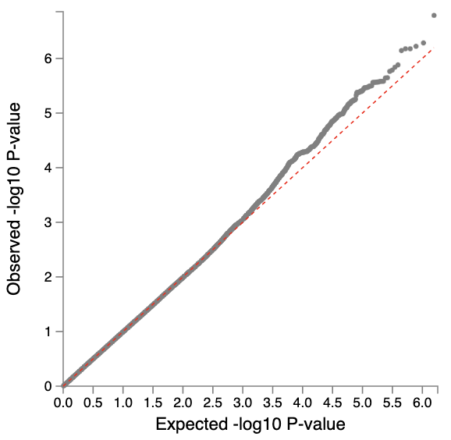

Supplementary Figure 4. Genome-wide association results for estimated MME opioid dose following hip arthroplasty in AFR individuals. The Manhattan plot displays the –log₁₀(P) values of SNP associations across the genome. The red horizontal line indicates the genome-wide significance threshold (P = 5 × 10⁻⁸), and the blue line marks the suggestive significance threshold (P = 1 × 10⁻⁶). SNPs exceeding the suggestive threshold are labeled with rsIDs. The plot in the upper right corner shows the quantile–quantile (QQ) plot of observed versus expected P-values.

Supplementary Figure 5. Genome-wide association results for estimated MME opioid dose following knee arthroplasty in AMR individuals. The Manhattan plot displays the -log₁₀(P) values of SNP associations across the genome. The red horizontal line indicates the genome-wide significance threshold (P = 5 × 10⁻⁸), and the blue line marks the suggestive significance threshold (P = 1 × 10⁻⁶). SNPs exceeding the suggestive threshold are labeled with rsIDs. The plot in the upper right corner shows the quantile–quantile (QQ) plot of observed versus expected P-values.

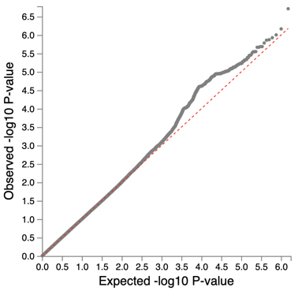

Supplementary Figure 6. Genome-wide association results for estimated MME opioid dose following hip arthroplasty in AMR individuals. The Manhattan plot displays the –log₁₀(P) values of SNP associations across the genome. The red horizontal line indicates the genome-wide significance threshold (P = 5 × 10⁻⁸), and the blue line marks the suggestive significance threshold (P = 1 × 10⁻⁶). SNPs exceeding the suggestive threshold are labeled with rsIDs. The plot in the upper right corner shows the quantile–quantile (QQ) plot of observed versus expected P-values.

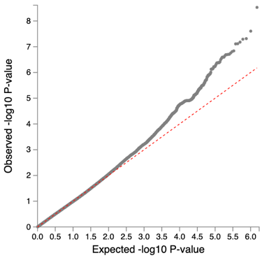

Supplementary Figure 7. Tissue expression enrichment results from MAGMA gene-property analysis.
Panels (a–d) show the relationship between tissue-specific gene expression and gene-level association signals derived from MAGMA. SNP-level p-values from the GWAS were used to compute gene-level statistics, and expression specificity was tested as a continuous variable. (a) BrainSpan dataset across 29 different post-conception and post-natal brain developmental timepoints. (b) BrainSpan dataset grouped into 11 broad developmental stages. (c) GTEx v8 dataset spanning 53 individual tissue types. (d) GTEx v8 dataset aggregated into 30 general tissue categories. Results indicate tissues in which gene expression is significantly associated with genetic association signals, suggesting relevant biological context for trait architecture

Supplementary Figure 8. Phenome-wide association study (PheWAS) of polygenic scores in the Penn Medicine Biobank using estimated MME opioid dose for knee (top panel) and hip (bottom panel) arthroplasty. A) EUR individuals B) AFR individuals. Each point represents the association –log₁₀(P) value between the genetic exposure and a clinical phenotype. Phenotypes are grouped by category along the x-axis. The red dashed line indicates the threshold for significance after multiple testing correction, while the blue line corresponds to the nominal significance level (P = 0.05). The top association within each phenotype category is labeled.
A)
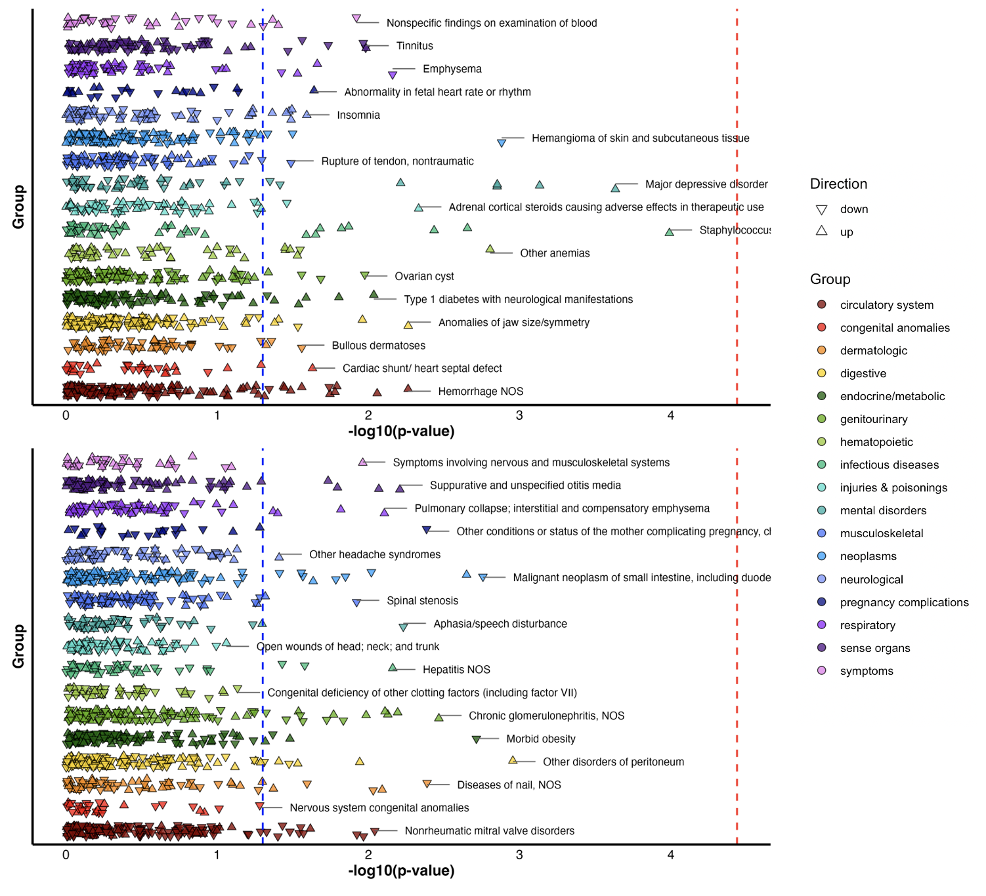

B)
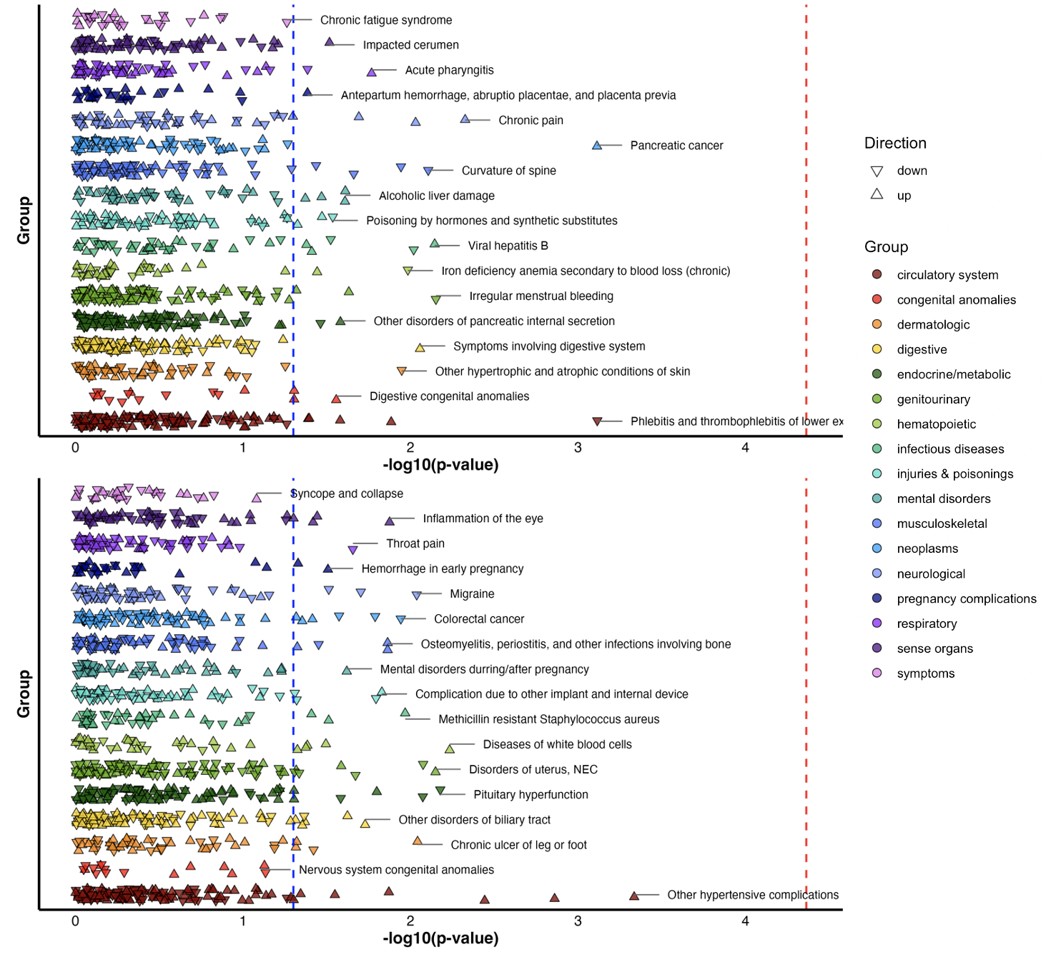

Supplementary Figure 9. Phenome-wide association study (PheWAS) of polygenic scores in the Yale-Penn sample using estimated MME opioid dose for knee (top panel) and hip (bottom panel) arthroplasty. A) EUR ancestry B) AFR ancestry (knee(top) and hip (bottom)). Each point represents the association –log₁₀(P) value between the genetic exposure and a clinical phenotype. Phenotypes are grouped by category along the x-axis. The red dashed line indicates the threshold for significance after multiple testing correction, while the blue line corresponds to the nominal significance level (P = 0.05). The top association within each phenotype category is labeled.
A)
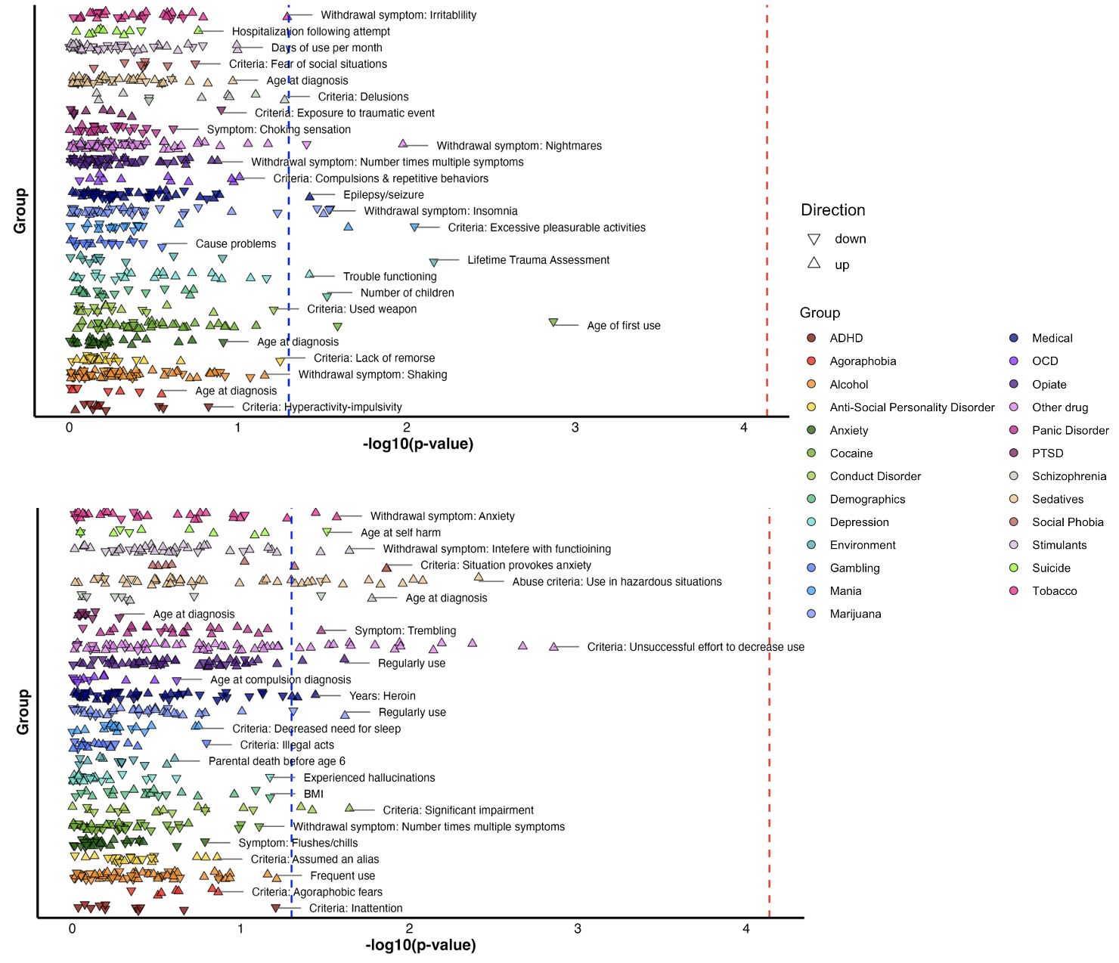
B)
