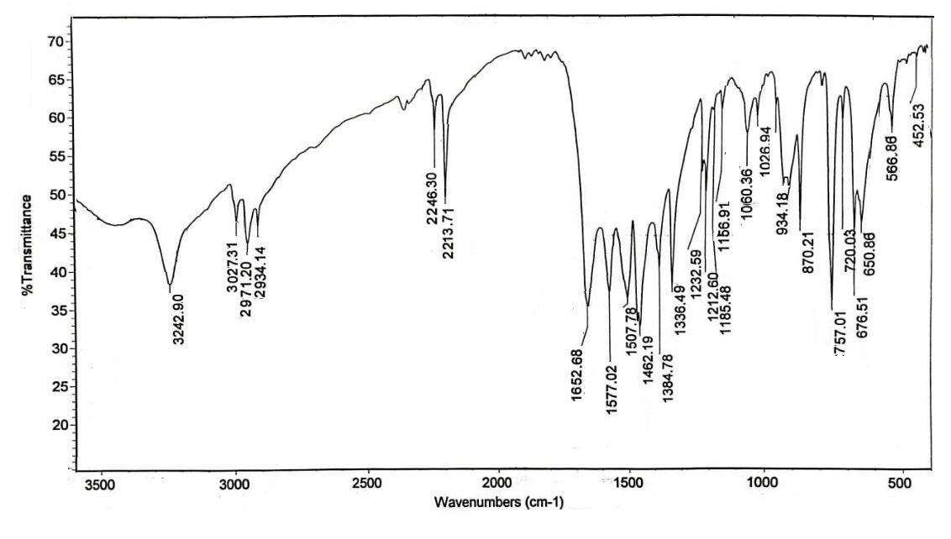
a

b
Figure S1: (a) Experimental and (b) Calculated IR spectra of compound 3 (CCPC) at B3LYP/6-311++G(d,p).

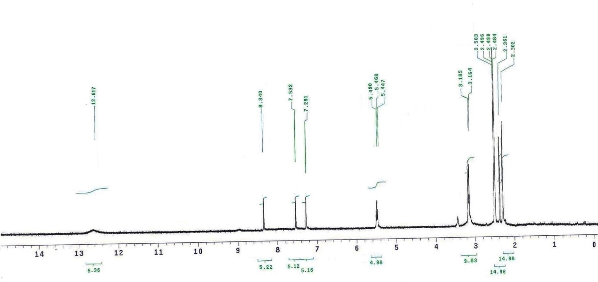
a

b
Figure S2: (a) Experimental and (b) Calculated ¹H NMR spectra of compound 3 (CCPC) at B3LYP/6-311++G(d,p).
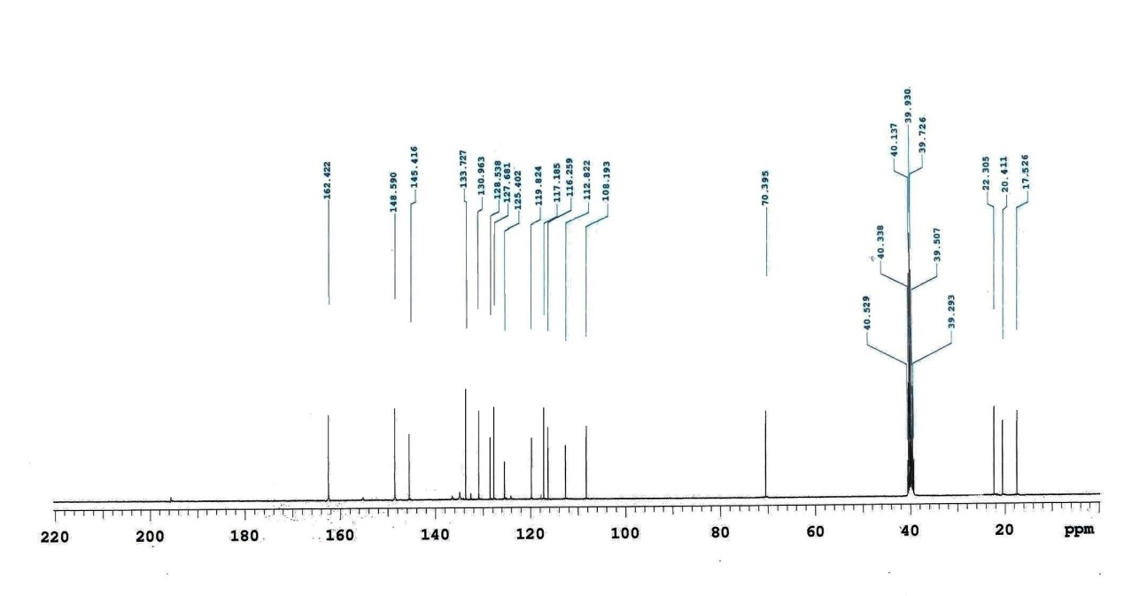
a
b
Figure S3: (a) Experimental and (b) Calculated ¹³C NMR spectra of compound 3 (CCPC) at B3LYP/6-311++G(d,p).

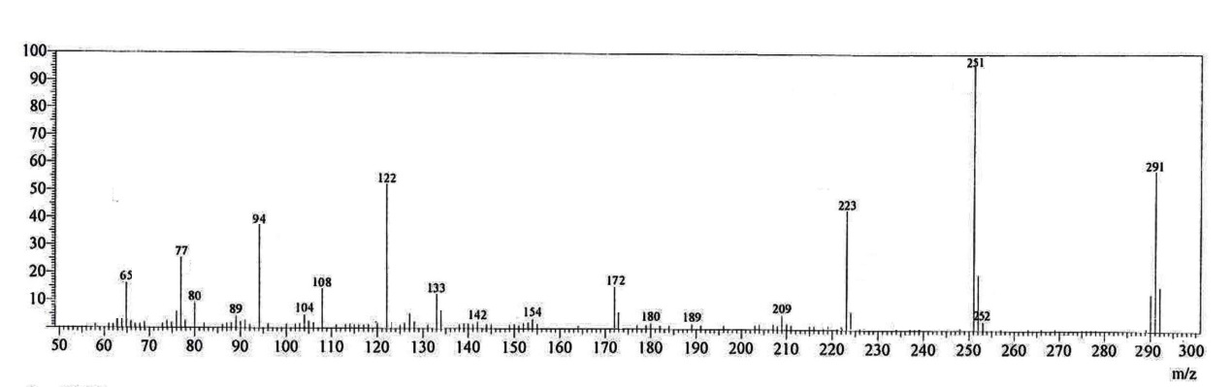
Figure S4: Mass spectrum of compound 3 (CCPC)

