Supplementary Information

Eco-Engineered Alginate Zr/Mn Hydrogel for Ultra-Efficient Cr(VI) Removal: Insights into Mechanism and Performance
Laila S. Alqarni¹, Jari S. Algethami², Faisal K. Algethami¹, Rachid EL Kaim Billah³, Lahoucine Bahsis⁴*, Vaishnavi Gomase⁵, Eder lima⁶*, Ravin Jugade⁵*

¹Department of Chemistry, College of Science, Imam Mohammad Ibn Saud Islamic University (IMSIU), Riyadh, 11623, Saudi Arabia.
²Department of Chemistry, College of Science and Arts, Najran University, P.O. Box 1988, Najran 11001, Saudi Arabia.
³Science Engineer Laboratory for Energy, ENSAJ, Chouaïb Doukkali University, El Jadida, Morocco
⁴ Faculté Poly-Disciplinaire, Université Cadi Ayyad, BP 4162, 46000 Safi, Morocco.
⁵Department of Chemistry, R.T.M. Nagpur University, Nagpur-440033, India
⁶Institute of Chemistry, Federal University of Rio Grande do Sul (UFRGS), Porto Alegre, RS, 91501-970, Brazil

Equilibrium Models
The Langmuir, Freundlich, and Liu isotherm models were applied to evaluate the adsorption equilibrium data. Equations 1, 2, and 3 represent the respective expressions for the Langmuir, Freundlich, and Liu models:
$$q_{e}=\frac{q_{max}bC_{e}}{\left(1+bC_{e}\right)} (1)$$$q_{e}=K_{F}C_{e}^{\frac{1}{n}}$ (2)

$q_{e}=\frac{Q_{max}.{{(K}_{g}.C_{e})}^{nL} }{1+{{(K}_{g}.C_{e})}^{nL}}$ (3)
Where:
- q_{e}​ is the amount of adsorbate adsorbed at equilibrium (mg·g⁻¹),
- C_{e}​ is the equilibrium concentration of the adsorbate (mg·L⁻¹),
- Qmax​ is the maximum adsorption capacity of the adsorbent (mg·g⁻¹),
- K_{L}​ is the Langmuir equilibrium constant (L·mg⁻¹),
- K_{F}​ is the Freundlich constant [mg·g⁻¹·(mg·L⁻¹)⁻¹⁄ⁿ_F],
- K_{g}​ is the Liu equilibrium constant (L·mg⁻¹),
- n_{F}​ and n_{L}​ are the dimensionless exponents of the Freundlich and Liu models, respectively.
Kinetic Adsorption Models

To better understand the adsorption behavior, four nonlinear kinetic models were applied to analyze the experimental data: the pseudo-first-order (PFO) , pseudo-second-order (PSO) , fractal-like pseudo-first-order (FL-PFO) , and fractal-like pseudo-second-order (FL-PSO) models. The corresponding mathematical expressions for each model are given by Equations 4–7:

$q_{t}= (q_{e}-e^{-k_{1}t})$ (4)

$q_{t}=\frac{k_{2}q_{e}^{2}t}{1+k_{2}q_{e}t}$ (5)

$q_{t}= qe\left(1-e^{-k_{1}t^{n}}\right)$ (6)

$q_{t}=\frac{k_{2}q_{e}^{2}t^{n}}{1+k_{2}q_{e}t^{n}}$ (7)

In these equations, t represents the contact time (min); qₜ and qₑ denote the adsorption capacities at time t and at equilibrium, respectively (mg·g⁻¹). k₁ is the pseudo-first-order rate constant (min⁻¹), while k₂ corresponds to the pseudo-second-order rate constant (g·mg⁻¹·min⁻¹). k₁.₀ and k₂.₀ are the rate constants for the fractal-like pseudo-first-order and pseudo-second-order models, respectively. The exponent n (> 0) reflects the degree of fractality, accounting for deviations from ideal kinetics due to surface heterogeneities or diffusion limitations

Adsorption thermodynamics
Thermodynamic studies for the adsorption of Na-ALG@ZrO₂/MnO₂ material were performed at temperatures ranging from 14°C to 45°C (287 to 318 K).
The Gibbs free energy change (ΔG°, kJ·mol⁻¹), enthalpy change (ΔH°, kJ·mol⁻¹), and entropy change (ΔS°, J·mol⁻¹·K⁻¹) were evaluated with the aid of Equations 8–12, respectively :

$$∆G°=∆H°-T. ∆S° (8)$$

$∆G°=-RT.$ln K_{e}⁰ (9)

$$K\text{e}°=\frac{\left(1000.k\text{g}.Mωadsorbate\right)°}{γ} (10)$$
$lnK\text{e}°=\frac{∆s°}{R}-\left(\frac{∆H°}{R}∙\frac{1}{T}\right)$ (11)
$K\text{e}°=e^{\left(\frac{∆s°}{R}-\left(\frac{∆H°}{R}∙\frac{1}{T}\right)\right)}$ (12)
Where R is the universal gas constant (8.314 J·K⁻¹·mol⁻¹); T is the absolute temperature (Kelvin);K_{e}⁰ is the thermodynamic equilibrium constant, which was calculated according to Equation 10.
Ke⁰ ​ is calculated by converting the values of Kg ​ (Liu equilibrium constant) or K_{L} (Langmuir equilibrium constant), which is expressed in L·mg⁻¹ into L·mol⁻¹. Firstly, the value Kg or K_{L}is multiplied by 1000 (mg·g⁻¹), and then multiplied by the molecular weight of the adsorbate (g·mol⁻¹), and by the standard concentration of the adsorbate (1 mol·L⁻¹), and divided by the activity coefficient of the adsorbate (dimensionless) . The solution is assumed to be sufficiently diluted to consider that the activity coefficient is unitary. Making these calculations, Ke⁰ becomes dimensionless .
Equation 11 was used for calculating ΔH° and ΔS°, and Equation 9 was used for calculating ΔG°.

Source |  | DF | Adj SS | Adj MS |  | F-Value | P-Value
Model |  | 12 | 683543 | 56962 |  | 79.18 | 0.000
Linear |  | 5 | 153688 | 30738 |  | 42.73 | 0.000
pH |  | 1 | 2514 | 2514 |  | 3.50 | 0.065
Dose (g/L) |  | 1 | 888 | 888 |  | 1.23 | 0.269
Time (min) |  | 1 | 14189 | 14189 |  | 19.72 | 0.000
Concentration (mg/L) |  | 1 | 125072 | 125072 |  | 173.86 | 0.000
Temperature (K) |  | 1 | 12848 | 12848 |  | 17.86 | 0.000
Square |  | 5 | 53457 | 10691 |  | 14.86 | 0.000
pH*pH |  | 1 | 494 | 494 |  | 0.69 | 0.410
Dose (g/L)*Dose (g/L) |  | 1 | 1003 | 1003 |  | 1.39 | 0.241
Time (min)*Time (min) |  | 1 | 42333 | 42333 |  | 58.85 | 0.000
Concentration (mg/L)*Concentration (mg/L) |  | 1 | 15 | 15 |  | 0.02 | 0.884
Temperature (K)*Temperature (K) |  | 1 | 3074 | 3074 |  | 4.27 | 0.042
2-Way Interaction |  | 2 | 11774 | 5887 |  | 8.18 | 0.001
Time (min)*Concentration (mg/L) |  | 1 | 2678 | 2678 |  | 3.72 | 0.057
Concentration (mg/L)*Temperature (K) |  | 1 | 9250 | 9250 |  | 12.86 | 0.001
Error |  | 90 | 64743 | 719
Lack-of-Fit |  | 85 | 62320 | 733 |  | 1.51 | 0.346
Pure Error |  | 5 | 2423 | 485
Total |  | 102 | 748286
Model summary
R² | R²_{adjusted} |  |  |  | R²_{predicted}
0.9135 | 0.9019 |  |  |  | 0.8730
Table S1: Analysis of variance

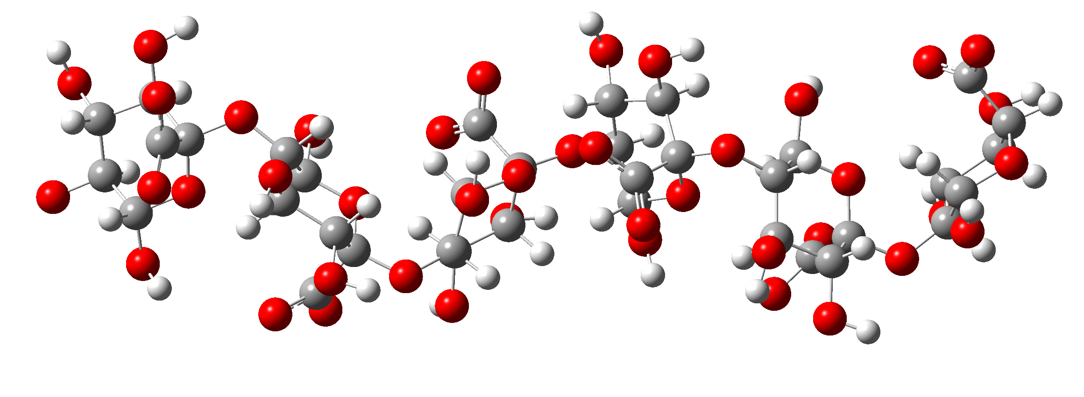
Alginate (ALG)
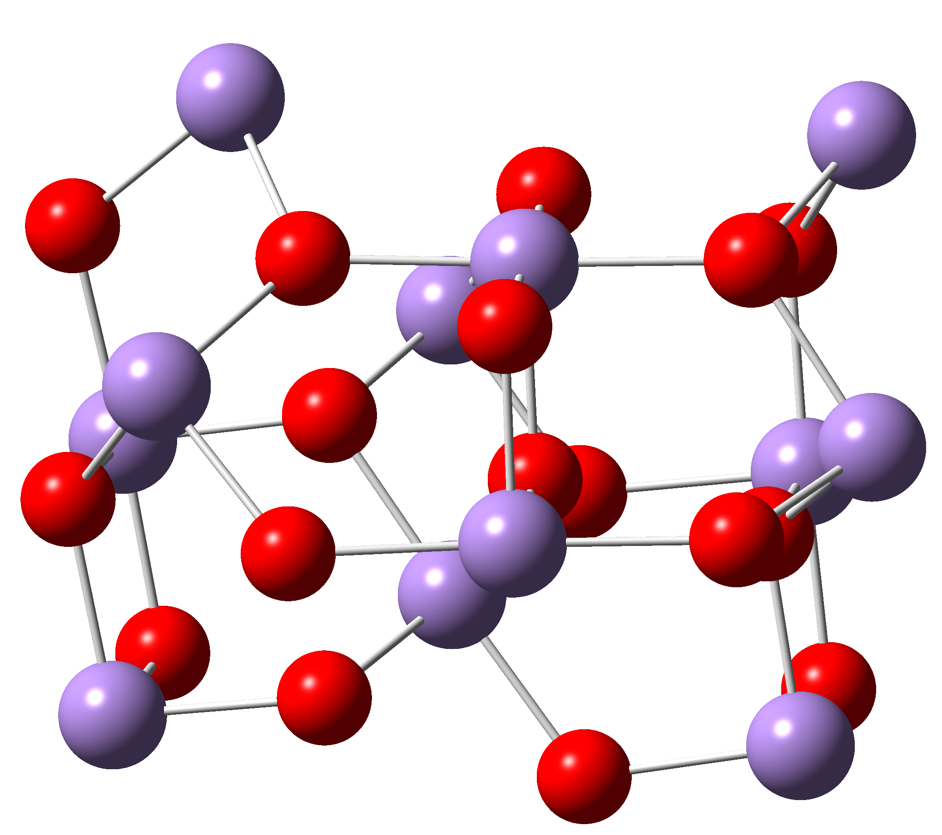 | 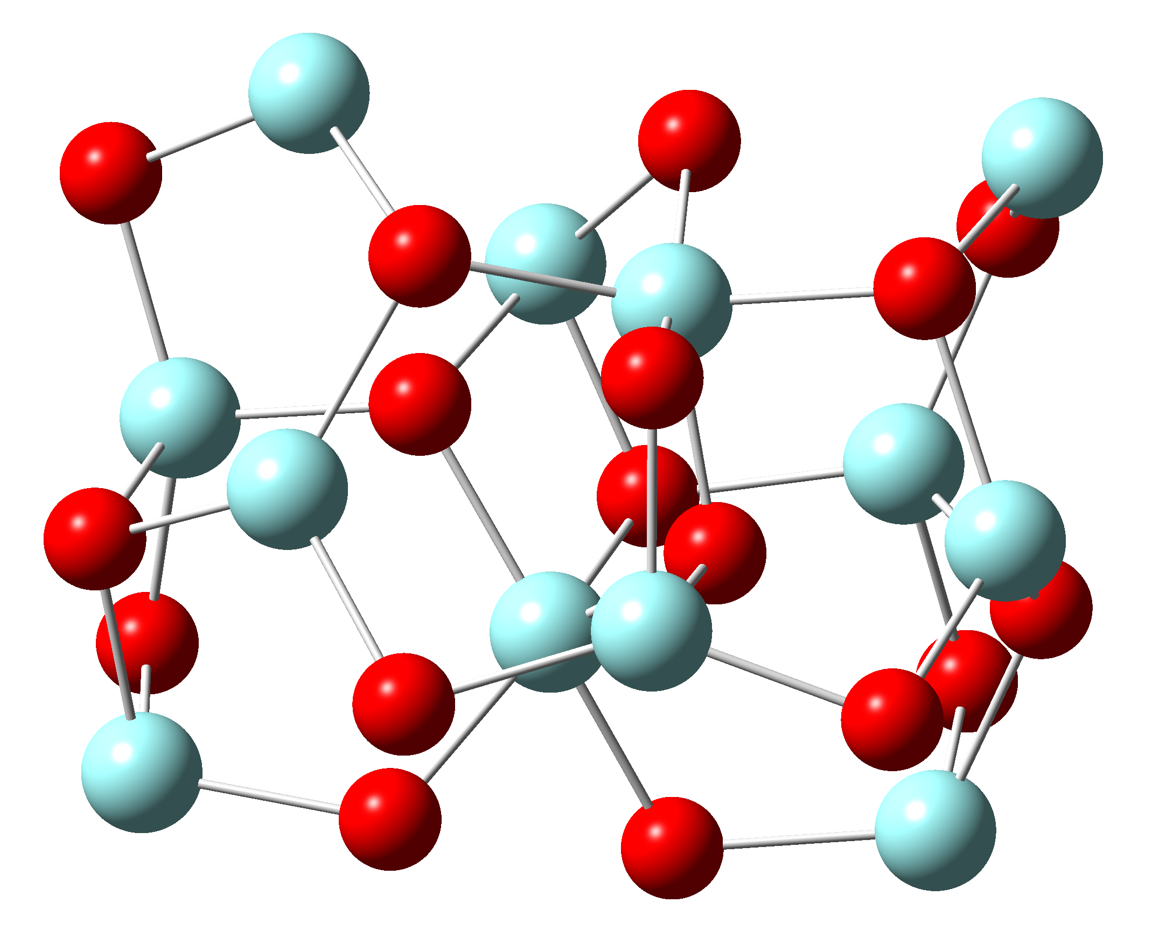
MnO₂ surface | ZrO₂ surface
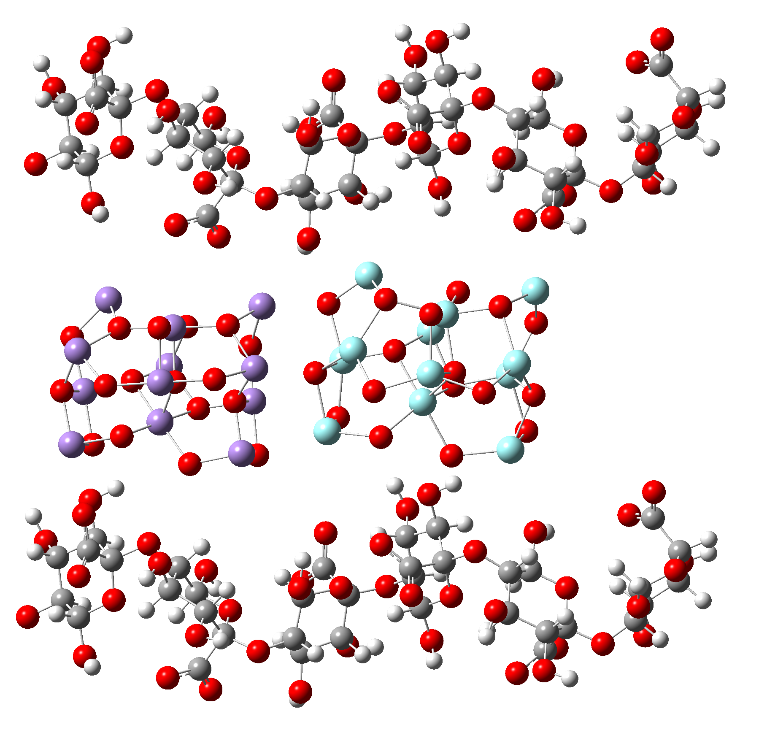 |  | 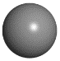
 |  | Carbon
 |  | 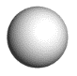
 |  | Hydrogen
 |  | 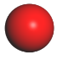
 |  | Oxygen
 |  | 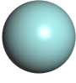
 |  | Zirconium
 |  | 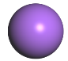
 |  | Manganese
ALG@Zr/Mn surface
Fig. S1. Optimized molecular structure of a) Na-ALG, b) MnO₂, c) ZrO₂ and d) ALG@Zr/Mn surface model at B3LYP/6-311G(d,p) level.

