The European Coal Curse Revisited: Human Capital Deficit or Institutional Dysfunction? Evidence from Spain

This supplementary document accompanies the main manuscript and presents detailed figures and tables referenced in the analysis. It is organized as follows:
• Section A: Figures
• Section B: Tables
All figures and tables are numbered sequentially as Figure A1, A2... and Table B1, B2..., and include explanatory captions.

Section A: Figures

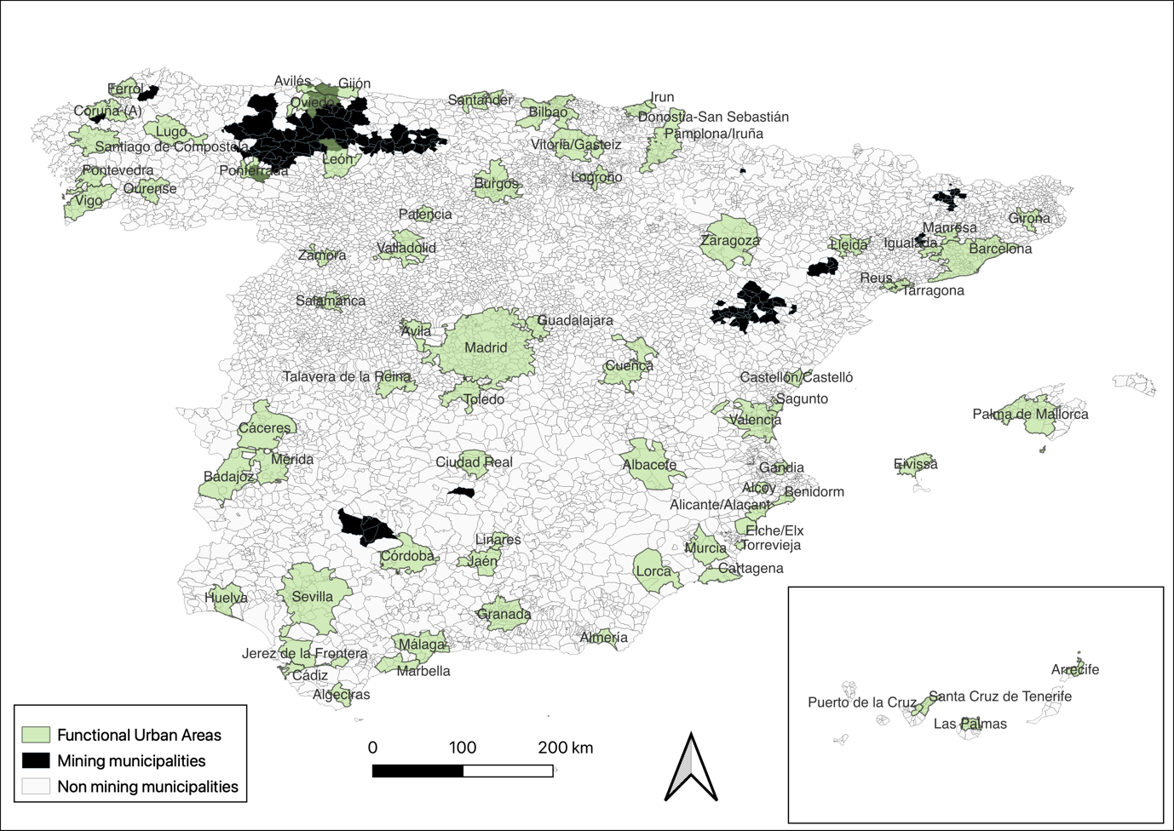
Figure A1. Map of coal mining municipalities and FUA boundaries in Spain
Source: Own elaboration based on a list of municipalities benefiting from aid for the restructuring of mining areas, Ministry for Ecological Transition and Demographic Challenge (Spanish Government 2007). Name of the mining municipalities (those listed in the 1890 register in bold): Pobla de Lillet (La) (Barcelona), Cercs (Barcelona), Puertollano (Ciudad Real), Belmez (Córdoba), Espiel (Córdoba), Matallana de Torío (León), Vegacervera (León), Seròs (Lleida), Langreo (Asturias), Laviana (Asturias), Mieres (Asturias), Quirós (Asturias), San Martín del Rey Aurelio (Asturias), Barruelo de Santullán (Palencia), San Cebrián de Mudá (Palencia), Aliaga (Teruel), Escucha (Teruel), Montalbán (Teruel), Utrillas (Teruel), Avià (Barcelona), Bagà (Barcelona), Berga (Barcelona), Calonge de Segarra (Barcelona), Fígols (Barcelona), Guardiola de Berguedà (Barcelona), Pujalt (Barcelona), Saldes (Barcelona), Vallcebre (Barcelona), Veciana (Barcelona), Fuente Obejuna (Córdoba), Peñarroya-Pueblonuevo (Córdoba), Villanueva del Rey (Córdoba), Cerceda (A Coruña), Pontes de García Rodríguez (As) (A Coruña), Santa Cruz de la Serós (Huesca), Barrios de Luna (Los) (León), Bembibre (León), Berlanga del Bierzo (León), Boca de Huérgano (León), Boñar (León), Cabrillanes (León), Cármenes (León), Carrocera (León), Cistierna (León), Crémenes (León), Ercina (La) (León), Fabero (León), Folgoso de la Ribera (León), Igüeña (León), Murias de Paredes (León), Noceda (León), Palacios del Sil (León), Páramo del Sil (León), Prado de la Guzpeña (León), Prioro (León), Riello (León), Sabero (León), San Emiliano (León), Sena de Luna (León), Soto y Amío (León), Toreno (León), Torre del Bierzo (León), Valdelugueros (León), Valdepiélago (León), Valderrueda (León), Valdesamario (León), Vega de Espinareda (León), Villablino (León), Villagatón (León), Villamanín (León), Almatret (Lleida), Gósol (Lleida), Granja d'Escarp (La) (Lleida), Massalcoreig (Lleida), Prats i Sansor (Lleida), Aller (Asturias), Bimenes (Asturias), Cangas del Narcea (Asturias), Caso (Asturias), Degaña (Asturias), Ibias (Asturias), Lena (Asturias), Piloña (Asturias), Sobrescobio (Asturias), Teverga (Asturias), Tineo (Asturias), Castrejón de la Peña (Palencia), Cervera de Pisuerga (Palencia), Dehesa de Montejo (Palencia), Guardo (Palencia), Mudá (Palencia), Santibáñez de la Peña (Palencia), Velilla del Río Carrión (Palencia), Pernía (La) (Palencia), Alacón (Teruel), Albalate del Arzobispo (Teruel), Alcorisa (Teruel), Alloza (Teruel), Andorra (Teruel), Ariño (Teruel), Belmonte de San José (Teruel), Berge (Teruel), Calanda (Teruel), Cañada Vellida (Teruel), Cañizar del Olivar (Teruel), Castel de Cabra (Teruel), Castellote (Teruel), Cerollera (La) (Teruel), Crivillén (Teruel), Ejulve (Teruel), Estercuel (Teruel), Foz-Calanda (Teruel), Gargallo (Teruel), Hinojosa de Jarque (Teruel), Jarque de la Val (Teruel), Martín del Río (Teruel), Oliete (Teruel), Olmos (Los) (Teruel), Palomar de Arroyos (Teruel), Pancrudo (Teruel), Rillo (Teruel), Segura de los Baños (Teruel), Seno (Teruel), Torre de las Arcas (Teruel), Zoma (La) (Teruel), Mequinenza (Zaragoza).
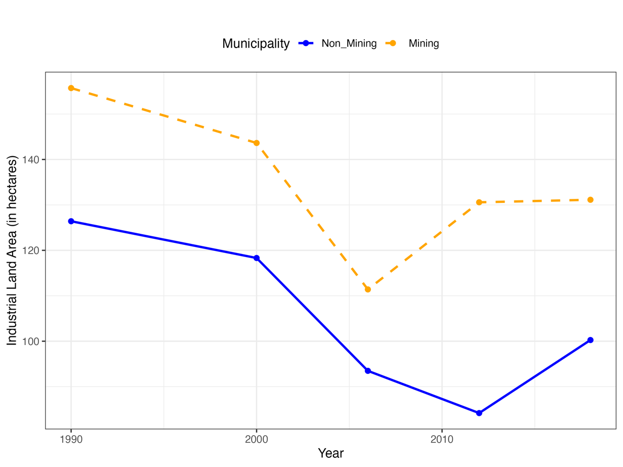
Figure A2. Area of industrial land (1990–2018), hectares (ha)
Source: Own elaboration based on data extracted from the CORINE Land Cover project
Section B: Tables

Table B1. Aggregated Historical and Modern Mining and Logged Income per Capita
Dependent variable: Log of income per capita
Ln(Income Per Capita) | OLS (Full Sample) | SAR (Full Sample) | OLS (ALP Cluster) | SAR (ALP Cluster) | OLS (Rest of Spain) | SAR (Rest of Spain)
Historical/Modern Mining (dummy) | 0.0782*** (0.0117) [p = 2.93e-11] | 0.0604*** (0.0107) [p = 1.77e-08] | 0.0912*** (0.0169) [p = 1.05e-07] | 0.0717*** (0.0162) [p = 9.99e-06] | 0.0737*** (0.0168) [p = 1.25e-05] | 0.0626*** (0.0152) [p = 4.03e-05]
Controls | Y | Y | Y | Y | Y | Y
Spatial lag (Rho) | – | 0.453*** (0.0273) [p < 0.01] | – | 0.332*** (0.0609) [p < 0.01] | – | 0.472*** (0.0308) [p < 0.01]
Observations | 1758 | 1758 | 432 | 432 | 1326 | 1326
Adjusted R² / Log-Likelihood | 0.555 / – | – / 1390.3 | 0.350 / – | – / 425.8 | 0.579 / – | – / 985.0
Residual SD (σ) | 0.118 | 0.108 | 0.094 | 0.089 | 0.125 | 0.113
Number of clusters (provinces) | 11 | 11 | 3 | 3 | 8 | 8
Number of mining municipalities | 126 | 126 | 63 | 63 | 63 | 63
Notes: The dependent variable is the natural logarithm of income per capita. The mining dummy captures both historical and modern mining municipalities. Controls include mean elevation, elevation standard deviation, log distance to urban areas, log population size, and province fixed effects. Standard errors are in parentheses. All SAR models are estimated with spatial weights based on 5 nearest neighbors (k = 5).
Source: Institution Nacional de Estadística www.ine.es

Table B2. Historical Coal Mining and the Municipal Share of Pension Income
 | Dependent variable: Percentage of total income per capita derived from pensions
Variable | OLS (50 km) | SAR (50 km)
Historical mining (dummy) | 0.3338*** (0.04687) [p = 1.74e-12] | 0.2636*** (0.04404) [p = 2.18e-09]
Controls | Y | Y
Province fixed effects | Y | Y
Spatial lag (Rho) | – | 0.3925*** (0.0335) [p < 0.001]
Observations | 1344 | 1344
Adjusted R² / Log-Likelihood | 0.505 | – / 344.2
Residual SD (σ) | 0.197 | 0.185
Number of clusters (provinces) | 8 | 8
Number of mining municipalities | 19 | 19
Notes: OLS and Spatial Lag Model (SAR) estimates. The dependent variable is the percentage of total income per capita derived from pensions at the municipal level. Historical mining (dummy) is a binary variable equal to 1 if the municipality had historical coal mining activity. All models include province fixed effects and control for elevation, elevation variability, log population, and log distance to urban areas. SAR models include a spatial lag term (ρ) to account for spatial autocorrelation using a k-nearest neighbors spatial weights matrix (k = 5). P-values are reported in brackets. The unit of observation is the municipality.
Source: Institution Nacional de Estadística www.ine.es

Table B3. Historical Coal Mining municipalities which mines closed before 1990 and Income per Capita
 | Dependent variable: Log of income per capita
Variable | OLS (Full Sample) | SAR (Full Sample) | OLS (ALP Cluster) | SAR (ALP Cluster) | OLS (Rest of Spain) | SAR (Rest of Spain)
Historical Mining (dummy) | -0.0126 (0.0539) [p = 0.816] | -0.0269 (0.0492) [p = 0.584] | 0.0170 (0.0507) [p = 0.738] | 0.0115 (0.0487) [p = 0.813] | -0.1484 (0.1239) [p = 0.231] | -0.1815 (0.1115) [p = 0.104]
Controls | Y | Y | Y | Y | Y | Y
Spatial lag (Rho) | – | 0.448*** (0.0283) [p < 0.01] | – | 0.293*** (0.0691) [p < 0.01] | – | 0.470*** (0.0314) [p < 0.01]
Observations | 1632 | 1632 | 369 | 369 | 1263 | 1263
Adjusted R² / Log-Likelihood | 0.566 / – | – / 1291.7 | 0.343 / – | – / 347.3 | 0.592 / – | – / 957.3
Residual SD (σ) | 0.118 | 0.108 | 0.097 | 0.094 | 0.123 | 0.111
Number of clusters (provinces) | 3 | 3 | 2 | 2 | 1 | 1
Number of mining municipalities | 5 | 5 | 4 | 4 | 1 | 1
Note: This table reports the results of OLS and spatial autoregressive (SAR) regressions using historical coal mining municipalities which mines closed before 1990 (i.e. those listed in the extractive statistics of the XIX but not in the recent list of municipalities affected by mine closure in the 1990s) as the key independent variable. The dependent variable is the natural logarithm of income per capita in 2010. All models control for mean elevation, elevation standard deviation, log distance to urban areas, log population (2021 census), and province fixed effects. SAR models account for spatial autocorrelation using a spatial lag with k-nearest neighbors (k = 5). Standard errors are in parentheses. P-values are shown in square brackets.
Source: Institution Nacional de Estadística www.ine.es

Table B4. Historical Mining and Higher Education Levels Among Population Aged Over 16
 | Dependent variable: percent of population over 16 with high education
Higher Education (%) | OLS (No Buffer) | SAR (No Buffer) | OLS (25 km) | SAR (25 km) | OLS (50 km) | SAR (50 km)
Historical mining (dummy) | -0.121 (2.089) [p = 0.954] | 0.254 (1.937) [p = 0.896] | -0.779 (1.783) [p = 0.662] | -0.526 (1.656) [p = 0.751] | -1.884 (1.582) [p = 0.234] | -1.155 (1.468) [p = 0.431]
Controls | Y | Y | Y | Y | Y | Y
Province fixed effects | Y | Y | Y | Y | Y | Y
Spatial lag (Rho) | – | 0.425*** (0.030) [p < 0.01] | – | 0.422*** (0.030) [p < 0.01] | – | 0.423 ***(0.030) [p < 0.01]
Observations | 1639 | 1639 | 1643 | 1643 | 1647 | 1647
Adjusted R² / Log-Likelihood | 0.410 / – | – / -5338.0 | 0.407 / – | – / -5355.7 | 0.401 / – | – / -5367.7
Residual SD (σ) | 6.66 | 6.18 | 6.67 | 6.20 | 6.67 | 6.19
Number of clusters (provinces) | 8 | 8 | 7 | 7 | 4 | 4
Number of mining municipalities | 8 | 8 | 7 | 7 | 4 | 4
Note: This table reports the results of OLS and spatial autoregressive (SAR) regressions where the dependent variable is the percentage of population over 16 years old with higher education. The key independent variable is a historical coal mining dummy, defined based on municipalities listed in 19th-century extractive statistics but not appearing in the official list of mining-affected municipalities during the 1990s restructuring period. The models are estimated using three spatial samples: (i) all municipalities without any distance restriction (“No Buffer”), (ii) municipalities located within a 25 km radius of any historical coal mining municipality (“25 km Buffer”), and (iii) those within 50 km (“50 km Buffer”). All models include controls for mean elevation, elevation standard deviation, log distance to urban areas, log population (2021 census), and province fixed effects. SAR models address spatial autocorrelation by incorporating a spatial lag structure based on k-nearest neighbors (k = 5). Standard errors are reported in parentheses. P-values are shown in square brackets.
Source: Institution Nacional de Estadística www.ine.es

Table B5. Difference in Urbanization per Hectare of Industrial Land Across mining and non-mining Municipalities in different periods
 | Non mining municipalities |  | Mining municipalities
Variable | N | Mean | N | Mean | W
Percent of change industrial land 2006-2012 | 57 | 7,69 | 38 | 19,1 | 957
Percent of change industrial land 2006-2018 | 57 | 10,2 | 38 | 20,7 | 918
Level of urbanization of industrial land | 52 | 17,9 | 40 | 13,8 | 1258.
Source: Own elaboration based on data extracted from the CORINE Land Cover project https://land.copernicus.eu/en/products/corine-land-cover

Table B6. Spatial Autoregressive (SAR) Model Results Using the Normalized Difference Vegetation Index (NDVI, 2020) as a proxy of environmental degradation.
 | Dependent variable: mean of NDVI
Variable | SAR (Full Sample) | SAR (ALP Cluster) | SAR (Rest of Spain)
Historical mining (dummy) | -9.91 (83.48) [p = 0.905] | 64.60 (127.43) [p = 0.612] | -136.87 (114.77) [p = 0.233]
Controls | Y | Y | Y
Province fixed effects | Y | Y | Y
Observations | 942 | 374 | 568
Spatial lag (Rho) | 0.835 [p < 0.001] | 0.770 [p < 0.001] | 0.856 [p < 0.001]
Log-likelihood | -6887.1 | -2736.8 | -4138.0
Residual SD (σ) | 329.1 | 338.8 | 317.8
Number of clusters (provinces) | 7 | 3 | 4
Number of mining municipalities | 17 | 9 | 8

Table B7. SAR Model Estimates for Electoral Participation in the 2023 Spanish Local Elections
 | Dependent variable: Voter Turnout
Variable | SAR (Full Sample) | SAR (ALP Cluster) | SAR (Rest of Spain)
Historical mining (dummy) | 0.4156 (1.7711) [p = 0.814] | -2.3449 (2.7550) [p = 0.395] | 1.0586 (2.4034) [p = 0.660]
Controls | Y | Y | Y
Province fixed effects | Y | Y | Y
Observations | 1646 | 374 | 1272
Spatial lag (Rho) | 0.089* [p = 0.010] | 0.016** [p = 0.844] | 0.098* [p = 0.012]
Log-likelihood | -5646.2 | -1274.3 | -4366.0
Residual SD (σ) | 7.47 | 7.30 | 7.48
Number of clusters (provinces) | 8 | 3 | 5
Number of mining municipalities | 19 | 9 | 10
Source: Spanish Ministry of the Interior (Ministerio del Interior), electoral results data. Available at: https://www.interior.gob.es

Table B8. Spatial Autoregressive (SAR) Model Estimates for Electoral Support for anti-establishment political party VOX
 | Dependent variable: percent of votes for VOX
Variable | SAR (Full Sample) | SAR (ALP Cluster) | SAR (Rest of Spain)
Historical mining (dummy) | -0.5640 (1.2538) [p = 0.653] | -0.1467 (2.7725) [p = 0.958] | -0.8816 (1.4319) [p = 0.538]
Controls | Y | Y | Y
Province fixed effects | Y | Y | Y
Observations | 1646 | 374 | 1272
Spatial lag (Rho) | 0.014 [p = 0.726] | -0.104 [p = 0.241] | 0.078* [p = 0.080]
Log-likelihood | -5076.7 | -1278.3 | -3708.1
Residual SD (σ) | 5.287 | 7.374 | 4.463
Number of clusters (provinces) | 8 | 3 | 5
Number of mining municipalities | 19 | 9 | 10
Source: Spanish Ministry of the Interior (Ministerio del Interior), electoral results data. Available at: https://www.interior.gob.es

Table B9. SAR Estimates: Average Number of Children per Mother (Fertility)
 | Dependent variable: average number of children per mother
Variable | SAR (Full Sample) | SAR (ALP Cluster) | SAR (Rest of Spain)
Historical mining (dummy) | -0.0798 (0.0648) [p = 0.218] | -0.1163 (0.1148) [p = 0.311] | 0.0195 (0.0836) [p = 0.816]
Controls | Y | Y | Y
Province fixed effects | Y | Y | Y
Observations | 1647 | 374 | 1273
Spatial lag (Rho) | 0.429*** [p < 0.001] | 0.425*** [p < 0.001] | 0.408*** [p < 0.001]
Log-likelihood | -229.4 | -92.6 | -114.8
Residual SD (σ) | 0.273 | 0.305 | 0.261
Number of clusters (provinces) | 8 | 3 | 5
Number of mining municipalities | 19 | 9 | 10
Source: Institution Nacional de Estadística www.ine.es

Table B10. Spatial Lag Model Estimates: Historical Coal Mining and Unemployment (2021)
 | Dependent variable: unemployment rate in 2021
Dependent Variable: Unemployment Rate (%) | SAR (Full Sample) | SAR (ALP Cluster) | SAR (Rest of Spain)
Historical mining (dummy) | 3.14*** (1.12) [p=0.005] | 2.86 (1.86) [p=0.124] | 2.52* (1.49) [p=0.090]
Controls | Yes | Yes | Yes
Province fixed effects | Yes | Yes | Yes
Observations | 1647 | 374 | 1273
Spatial lag (Rho) | 0.330*** [<0.001] | 0.260*** [<0.001] | 0.340*** [<0.001]
Log-likelihood | -4915.2 | -1129.4 | -3775.0
Residual SD (σ) | 4.74 | 4.93 | 4.65
Number of clusters (provinces) | 8 | 3 | 5
Number of mining municipalities | 19 | 9 | 10

