 | Patients, No. (%)
Characteristic | Non-Myopes | Myopes | High Myopes | Severe Myopes | P value
Characteristic | n = 1412 | n = 1198 | n = 376 | n = 64 | P value
Age, y
20 - 29 | 12 (0.85) | 17 (1.42) | 10 (2.66) | 1 (1.56) | <0.001
30 - 39 | 12 (0.85) | 21 (1.75) | 14 (3.72) | 5 (7.81) | <0.001
40 - 49 | 24 (1.7) | 38 (3.17) | 15 (3.99) | 5 (7.81) | <0.001
50 - 59 | 87 (6.16) | 91 (7.6) | 54 (14.36) | 8 (12.5) | <0.001
60 - 69 | 249 (17.63) | 279 (23.29) | 119 (31.65) | 19 (29.69) | <0.001
70 - 79 | 491 (34.77) | 464 (38.73) | 111 (29.52) | 23 (35.94) | <0.001
80 - 89 | 412 (29.18) | 219 (18.28) | 34 (9.04) | 2 (3.13) | <0.001
≥90 | 125 (8.85) | 55 (4.59) | 6 (1.6) | 1 (1.56) | <0.001
Unknown | 0 (0) | 14 (1.17) | 13 (3.46) | 0 (0)
Sex
Male | 489 (34.63) | 692 (57.76) | 214 (56.91) | 29 (45.31) | <0.001
Female | 923 (65.37) | 506 (42.24) | 162 (43.09) | 35 (54.69) | <0.001
Unknown | 0 (0) | 0 (0) | 0 (0) | 0 (0) | <0.001
Race
White | 468 (33.14) | 529 (44.16) | 127 (33.78) | 15 (23.44) | <0.001
Unknown | 16 (1.13) | 18 (1.5) | 9 (2.39) | 1 (1.56) | <0.001
Asian | 367 (25.99) | 327 (27.3) | 169 (44.95) | 32 (50) | <0.001
Black or African | 32 (2.27) | 33 (2.75) | 7 (1.86) | 0 (0) | <0.001
American Indians | 4 (0.28) | 5 (0.42) | 0 (0) | 0 (0) | <0.001
Native Hawaiians | 21 (1.49) | 15 (1.25) | 0 (0) | 0 (0) | <0.001
Other race | 504 (35.69) | 271 (22.62) | 64 (17.02) | 16 (25)
Ethnicity
Hispanic or Latino | 312 (22.1) | 172 (14.36) | 28 (7.45) | 12 (18.75) | <0.001
Not Hispanic or Latino | 1081 (76.56) | 1010 (84.31) | 336 (89.36) | 51 (79.69) | <0.001
Unknown | 19 (1.35) | 16 (1.34) | 12 (3.19) | 1 (1.56) | <0.001
Sequelae
CNV | 13 (0.92) | 20 (1.67) | 7 (1.86) | 7 (10.94) | 0.002
FRD | 0 (0) | 0 (0) | 2 (0.53) | 0 (0) | 0.002
Foveoschisis | 0 (0) | 0 (0) | 1 (0.27) | 0 (0) | 0.002
MH | 46 (3.26) | 51 (4.26) | 34 (9.04) | 15 (23.44) | 0.002
MMD | 0 (0) | 3 (0.25) | 7 (1.86) | 4 (6.25) | 0.002
RRD | 99 (7.01) | 166 (13.86) | 116 (30.85) | 23 (35.94) | 0.002
CNV: choroidal neovascularization; FRD: foveal retinal detachment; MH: macular hole; MMD: myopic macular degeneration; RRD: rhegmatogenous retinal detachment

Supplemental Table 1. Baseline Characteristics of Patients in STARR by Myopic Status as Determined by Axial Lengths

Retina Sequelae | Myopia Severity | Odds ratio (95% CI)* | 99% CI
Any | Non-Myope | 1 (Reference) | Reference
Any | Myope | 1.25 (1.01 - 1.53) | 0.95 - 1.63
Any | High Myope | 2.99 (2.33 - 3.84) | 2.15 - 4.15
Any | Severe Myope | 5.01 (2.94 - 8.51) | 2.49 - 10.06
CNV | Non-Myope | 1 (Reference) | Reference
CNV | Myope | 0.91 (0.51 - 1.63) | 0.42 - 1.96
CNV | High Myope | 0.46 (0.20 - 1.08) | 0.15 - 1.41
CNV | Severe Myope | 6.95 (2.77 - 17.41) | 2.08 - 23.24
MMD | Non-Myope | 1 (Reference) | Reference
MMD | Myope | 0.31 (0.09 - 1.07) | 0.06 - 1.58
MMD | High Myope | 1.51 (0.56 - 4.06) | 0.41 - 5.54
MMD | Severe Myope | 5.73 (1.58 - 20.69) | 1.06 - 30.99
Foveoschisis | Non-Myope | 1 (Reference) | Reference
Foveoschisis | Myope | did not converge | did not converge
Foveoschisis | High Myope | did not converge | did not converge
Foveoschisis | Severe Myope | did not converge | did not converge
MH | Non-Myope | 1 (Reference) | Reference
MH | Myope | 0.74 (0.52 - 1.05) | 0.47 - 1.18
MH | High Myope | 1.30 (0.86 - 1.96) | 0.75 - 2.23
MH | Severe Myope | 4.35 (2.29 - 8.25) | 1.88 - 10.09
FRD | Non-Myope | 1 (Reference) | Reference
FRD | Myope | 0.00 (0.00 - inf) | 0.00 - inf
FRD | High Myope | 1.14 (0.13 - 10.32) | 0.06 - 20.62
FRD | Severe Myope | 0.00 (0.00 - inf) | 0.00 - inf
RRD | Non-Myope | 1 (Reference) | Reference
RRD | Myope | 1.32 (1.05 - 1.67) | 0.97 - 1.80
RRD | High Myope | 3.16 (2.42 - 4.14) | 2.22 - 4.50
RRD | Severe Myope | 3.22 (1.83 - 5.65) | 1.53 - 6.75
CNV: choroidal neovascularization; FRD: foveal retinal detachment; MH: macular hole; MMD: myopic macular degeneration; RRD: rhegmatogenous retinal detachment
* Models examine odds of MMD, MTM, and retinal detachments in patients with and without varying levels of myopia. Models adjusted for age, sex, race, and ethnicity.

Supplemental Table 2. Odds of Myopic Macular Degeneration (MMD), Myopic Traction Maculopathy (MTM), and Retinal Detachments by Myopia Status determined by Axial Length

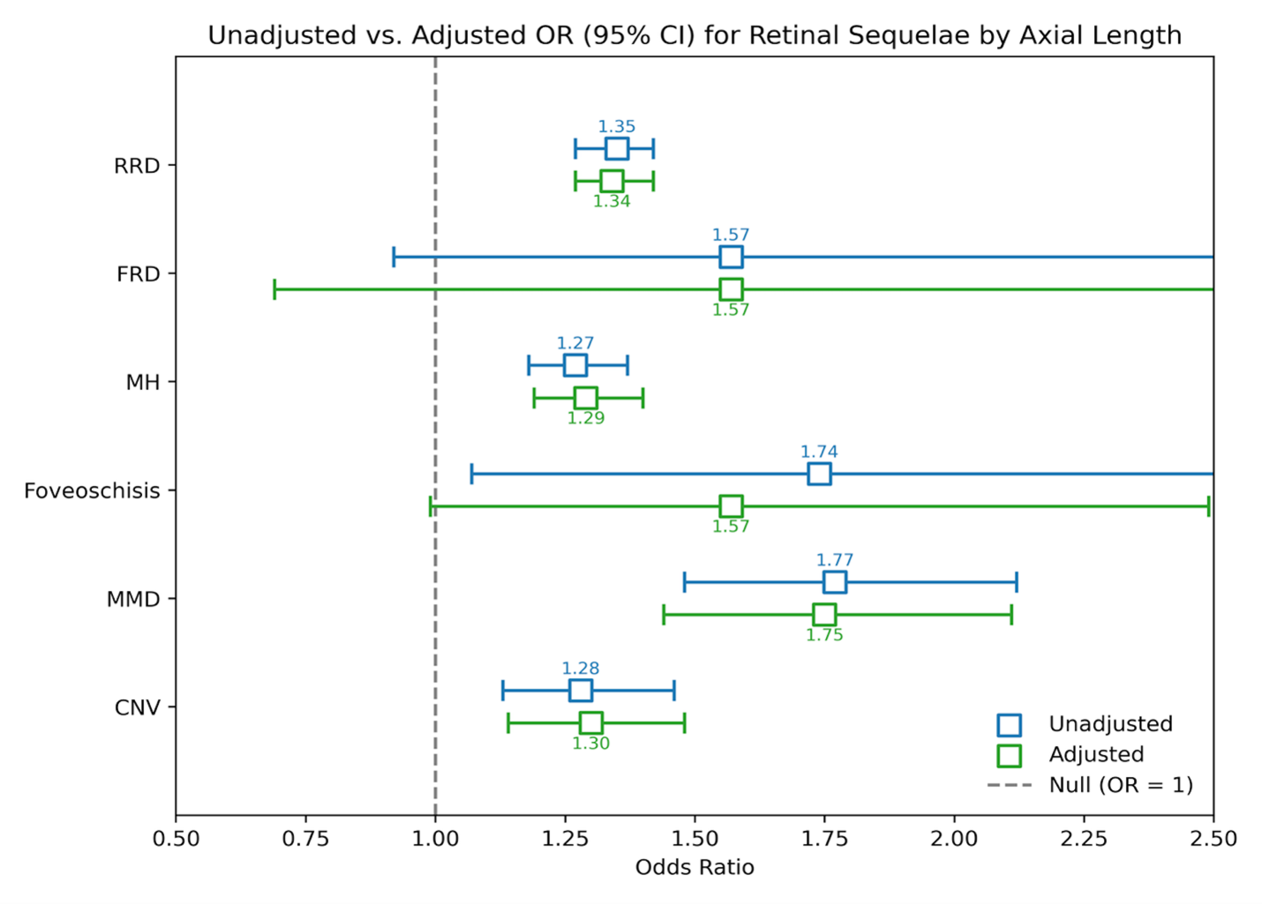
Supplemental Figure 1. Association between axial length and each retinal sequelae

G
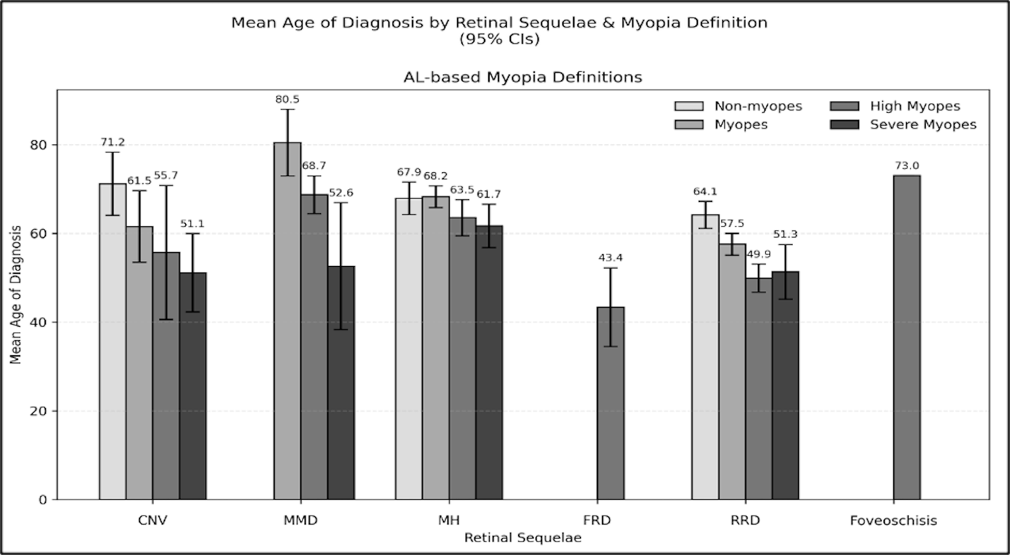
Supplemental Figure 2. Mean age of diagnosis for retina sequelae stratified by myopia status determined by axial lengths

