Supporting Information
Prolonged sleep deprivation induces cardiac dysfunction via microglia-neural circuit coupling

Fan ZHANG,^{1,5,6} Wen-jing SHAO,^{2,5} Nai-xuan WEI, ² Wei-LIU,² Zhi-hao XU, ² Zheng-jie LUO,² Yan-WU, ² Jian-qing YU, ² Qi SHU, ² Xiang ZHOU, ² Ling HU,^{2, 3} Guo-ming SHEN, ^{1, *} Qing YU,^{2, 3, *} Rong-lin CAI,^{2,3,4,7,*}
¹College of Integrated Chinese and Western Medicine, Anhui University of Chinese Medicine, Hefei, Anhui Province, China
²College of Acupuncture and moxibustion, Anhui University of Chinese Medicine, Hefei, Anhui Province, China
³Anhui Provincial Key Laboratory of Meridian-Viscera Correlation, Hefei, Anhui Province, China
⁴Key Laboratory of Xin’an Medicine, Ministry of Education, Anhui University of Chinese Medicine, Hefei, China
⁵These authors contributed equally to this work
⁶Technical contact
⁷Lead contact
*Correspondence:
shengm_66@163.com(G. S.)
yuqingtcm@126.com (Q.Y.)
ronglincai@ahtcm.edu.cn (R.C.)

This file includes
Supplementary information
Supplementary Figures 1-3
Supplementary Table 1
Supplementary Table 2

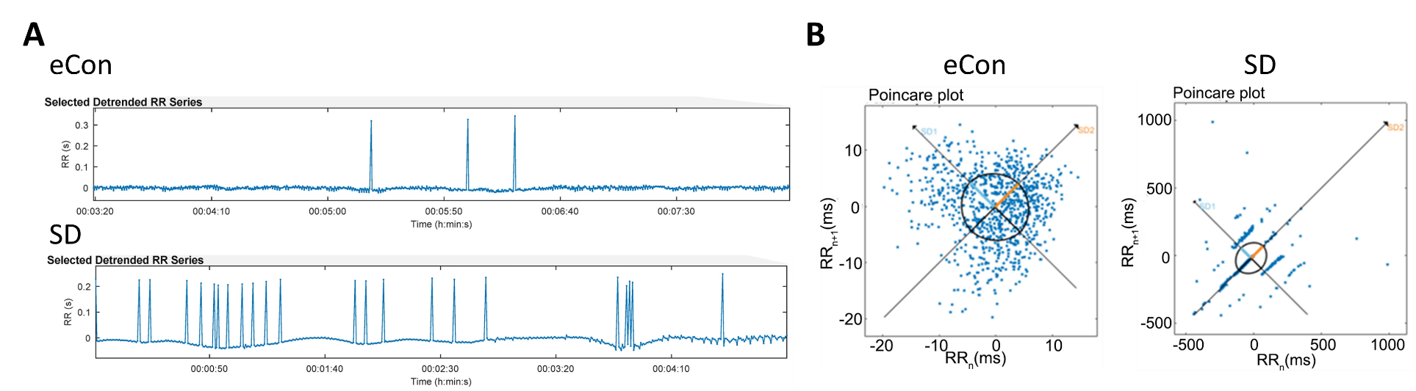
Figure S1. The HRV Analysis of sleep-deprived mice. (A) Typical RR tracks of severe cardiac arrhythmias in SD mice. (B) HRV Poincaré Plot Analysis in SD mice.

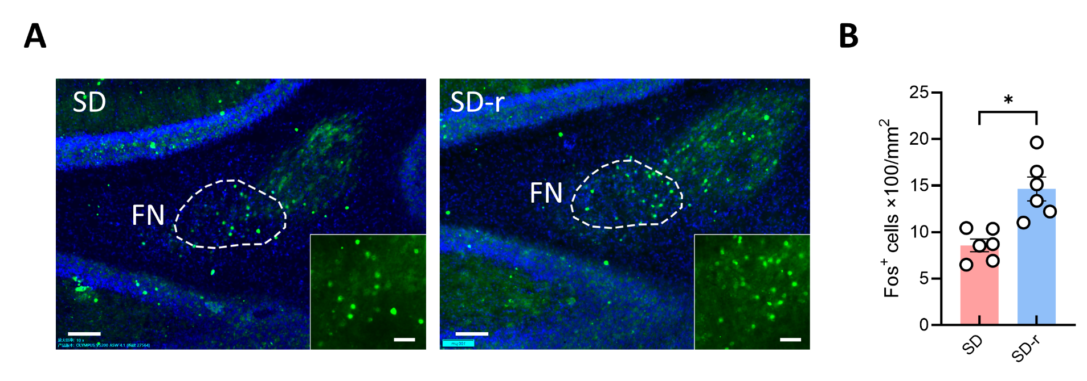
Figure S2. The expression of c-Fos signaling in the frontal neocortex (FN) of sleep-deprived recover mice. (A) Images showing the distribution of c-Fos-positive neurons in the FN in SD or SD-r mice. Scale bars, 200 μm. FN: The images depicting the area shown in the White dashed line. Scale bars, 50 μm. (B) Statistic data showing the distribution of c-Fos-positive neurons in the FN in SD or SD-r mice.

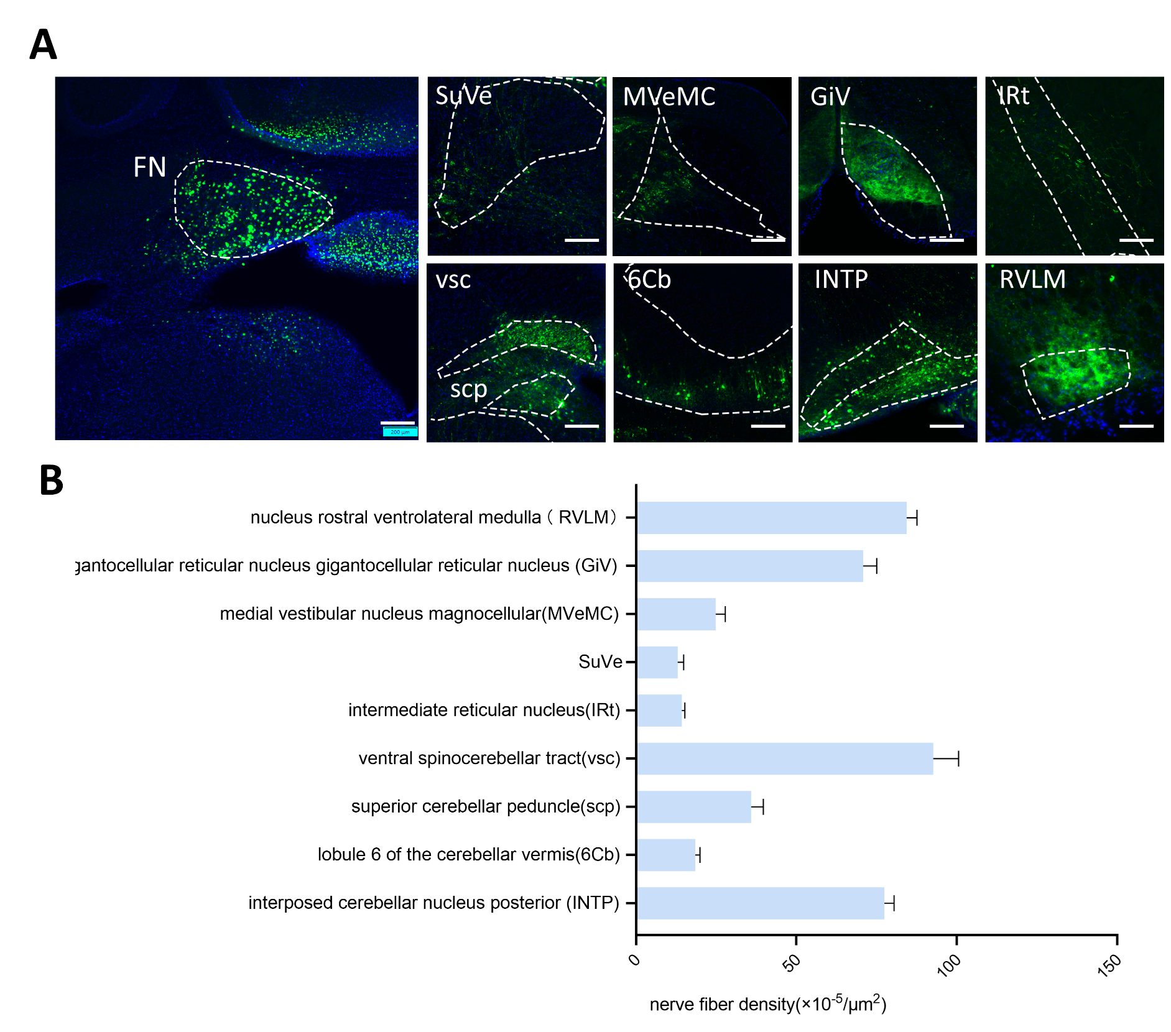
Figure S3. (A, B) Representative image(A) and data(B) of virals-labeled output eGFP-fibers across different brain areas to the FN infusion virus(rAAV- -DIO-eGFP) of vgat-mice. (Scale bars, 100 μm (overview) and 20 μm (zoom), n=4 mice ).

KEY RESOURCES TABLE
REAGENT or RESOURCE | SOURCE | IDENTIFIER
Antibodies
rabbit Anti-Glutamate | Sigma | Cat. No. G6642
rabbit Anti-GABA | Sigma | Cat. No. A2052
rabbit Anti-Iba-1 | Wako | Cat. No. 019-19741
mouse Anti-CD68 | abcam | Cat. No. ab955
goat Anti-PSD95 | abcam | Cat. No. ab317793
Alexa Fluor™ 488, donkey anti-rabbit | abcam | Cat. No. ab150061
Alexa Fluor™ 594, donkey anti-goat | abcam | Cat. No. ab150132
Alexa Fluor™ 647, and donkey anti-mouse | abcam | Cat. No. ab150107
Alexa Fluor® 488，goat anti-Guinea pig IgG H&L | abcam | ab150185
Anti-c-Fos antibody -BSA free | abcam | AB190289
Chemicals, peptides, and recombinant proteins
SDS-PAGE protein loading buffer | Solarbio | S8010,723T033
PVDF membrane | Millipore | IPVH00010
ECL luminescent kit | Thermo Fisher | VC298015
rAAV/11-hSyn-EGFP | braincase | BC230901-0020-11
rAAV/9-TRE-tight-hM4D(Gi)-mCherry (titer: 3.12E+12 vg/mL) | braincase | BC221104-0151-9
rAAV/9-cFos-tTA-NLS-FLAG (titer: 5.01E+12 vg/mL) | braincase | BC221104-0151-9
rAAV2/9-EF1a-DIO-Ypet-2A-mGFP-WPRE-pA (titer: 5.13E+12 vg/mL) | brainvta | 9-593-K240830
rAAV2/9-mVGAT1-Cre(titer: 3.75E+12 vg/mL) | braincase | BC-230106-1723-9
rAAV2/9-EF1a-DIO-hM3D(Gq)-mCherry-WPREs (titer: 5.04E+12 vg/mL) | brainvta | 9-42-S240304
rAAV2/9-EF1a-DIO-Hm4D(Gi)-mCherry-WPREs (titer: 5.32E+12 vg/mL) | brainvta | 9KC-43-Z240319A
rAAV/9-EF1a-DIO-GCaMP6m (titer: 5.22E+12 vg/mL) | braincase | BC230119-0087-9
rAAV2/MG1.2-Iba1-EGFP-WPREs (titer:5.31E+12 vg/mL) | brainvta | MG1.2-9623-K240112
rAAV/11-mIBA1-EGFP-WPRE-4XmiR9T(titer:1.01E+13 vg/mL） | braincase | BC240726-ZA0182-11
rAAV2/R-hSyn-CRE-WPRE-hGH（titer: 5.27E+12 vg/mL） | brainvta | 9-136-S240804
rAAV2/9-EF1a-DIO-hChR2(H134R)-EYFP-WPRE-hGH（titer: 6.08E+12 vg/mL） | brainvta | 9-1-S241029
AAV/9-CaMKIIa-FCSSP-EYFP-5E4(titer: 5.07E+12 vg/mL） | braincase | BC240719-SL014-9
rAAV2/9-hSyn-DIO-EGFP-WPRE-Hgh(titer:5.90E+12 vg/mL) | brainvta | 9-1103-K240625
Clozapine N-oxide(CNO) | brainvta | CNO-240429
Software and algorithms
Imaris | BITPLANE | 9.0.1(Sep 5 2017)
GrapePad Prism | GraphPad Software，Inc | 8.0
Kubios HRV Standard | Kubios | 3.5.0
IBM SPSS Statistics | International Business Machines Corp | 23
MATLAB | MathWorks | R2018a（9.4.0.813654）
LabChart | ADINSTRUMENTS | V8.1.19
Other
Confocal microscope | Olympus | FV1000
Fiber photometric recording system | ThinkerTech Co., Ltd | N/A
In vivo electrophysiological recording system | Plexon | N/A
ML118 Animal Bio Amp | AD Instruments, Sydney, Australia | N/A
Electronic acupuncture instrument | Suzhou Medical supplies Factory Co., Ltd, Suzhou, China | SDZ- III type
Minocycline hydrochloride(Mino) | SparkJade | SJ-MA0143
Lipopolysaccharide（ LPS） | WOCAS | L2880
Artificial Cerebrospinal Solution（(aCSF) | WOCAS | PH1851
Doxycycline Hyclate(Dox) | SparkJade | SJ-MA0058B

RESOURCE AVAILABILITY
Lead contact
Further information and requests for resources and reagents should be directed to and will be fulfilled by the lead contact, Rong-lin CAI (ronglincai@ahtcm.edu.cn).
Materials availability
This study did not generate unique reagents.
Data and code availability
All data are available in the main text or the supplementary materials. This paper does not report original code. Any additional information required to reanalyse the data reported in this paper is available from the lead contact upon request.

Supplementary Table 2. Statistical analyses related to Figures 1-6 and Supplementary Figures 1.

Figure | Conditions (sample size) | Analysis | P value | t or F value
Figure 1H | eCon(6) vs. hCon(6) | One-way ANOVA | 0.9986
Figure 1H | hCon(6) vs. SD(6) | One-way ANOVA | 0.0059
Figure 1H | eCon(6) vs. SD(6) | One-way ANOVA | 0.0065
Figure 1I | eCon(6) vs. hCon(6) | One-way ANOVA | 0.9960
Figure 1I | hCon(6) vs. SD(6) | One-way ANOVA | 0.0336
Figure 1I | eCon(6) vs. SD(6) | One-way ANOVA | 0.0396
Figure 1K | eCon(6) vs. hCon(6) | One-way ANOVA | 0.9765
Figure 1K | hCon(6) vs. SD(6) | One-way ANOVA | 0.9526
Figure 1K | eCon(6) vs. SD(6) | One-way ANOVA | 0.8699
Figure 1L | eCon(6) vs. hCon(6) | One-way ANOVA | 0.8876
Figure 1L | hCon(6) vs. SD(6) | One-way ANOVA | 0.0424
Figure 1L | eCon(6) vs. SD(6) | One-way ANOVA | 0.0171
Figure 1M | eCon(6) vs. hCon(6) | One-way ANOVA | 0.9991
Figure 1M | hCon(6) vs. SD(6) | One-way ANOVA | 0.9822
Figure 1M | eCon(6) vs. SD(6) | One-way ANOVA | 0.9893
Figure 1O | eCon(24) vs. hCon(24) | One-way ANOVA | 0.9982
Figure 1O | hCon(24) vs. SD(24) | One-way ANOVA | 0.0025
Figure 1O | eCon(24) vs. SD(24) | One-way ANOVA | 0.0030
Figure 1P | eCon(24) vs. hCon(24) | One-way ANOVA | 0.9384
Figure 1P | hCon(24) vs. SD(24) | One-way ANOVA | 0.0001
Figure 1P | eCon(24) vs. SD(24) | One-way ANOVA | 0.0003
Figure 1Q | eCon(24) vs. hCon(24) | One-way ANOVA | 0.9983
Figure 1Q | hCon(24) vs. SD(24) | One-way ANOVA | <0.0001
Figure 1Q | eCon(24) vs. SD(24) | One-way ANOVA | <0.0001
Figure 1R | eCon(24) vs. hCon(24) | One-way ANOVA | 0.9946
Figure 1R | hCon(24) vs. SD(24) | One-way ANOVA | 0.0049
Figure 1R | eCon(24) vs. SD(24) | One-way ANOVA | 0.0065
Figure 2F(1) | Con(34) vs. SD(9) | Unpaired t-test | 0.8240 | t=0.2239, df=42
Figure 2F(2) | Con(46) vs. SD(23) | Unpaired t-test | 0.0007 | t=3.559, df=67
Figure 2F(3) | Con(24) vs. SD(11) | Unpaired t-test | 0.5345 | t=0.6278, df=33
Figure 2K | Control+mCherry(6) vs. SD+mCherry(6) | One-way ANOVA | 0.0158
Figure 2K | SD+mCherry (6) vs. SD+ChR2+mCherry (6) | One-way ANOVA | 0.0451
Figure 2L | Control+mCherry(6) vs. SD+mCherry(6) | One-way ANOVA | 0.0012
Figure 2L | SD+mCherry (6) vs. SD+ChR2+mCherry (6) | One-way ANOVA | 0.0108
Figure 2M | Control+mCherry(6) vs. SD+mCherry(6) | One-way ANOVA | 0.0127
Figure 2M | SD+mCherry (6) vs. SD+ChR2+mCherry (6) | One-way ANOVA | 0.0420
Figure 2N | Control+mCherry(6) vs. SD+mCherry(6) | One-way ANOVA | 0.0032
Figure 2N | SD+mCherry (6) vs. SD+ChR2+mCherry (6) | One-way ANOVA | 0.0140
Figure 2O | Control+mCherry(6) vs. SD+mCherry(6) | One-way ANOVA | 0.0165
Figure 2O | SD+mCherry (6) vs. SD+ChR2+mCherry (6) | One-way ANOVA | 0.0288
Figure 2P | Control+mCherry(6) vs. SD+mCherry(6) | One-way ANOVA | 0.0011
Figure 2P | SD+mCherry (6) vs. SD+ChR2+mCherry (6) | One-way ANOVA | 0.0042
Figure 3E | Control(6) vs. SD (6) | paired t-test | 0.0010 | t=6.865, df=5
Figure 3E | SD (6) vs. SD-r (6) | paired t-test | 0.0458 | t=2.643, df=5
Figure 3F | Control(6) vs. SD (6) | paired t-test | 0.0137 | t=3.724, df=5
Figure 3F | SD (6) vs. SD-r (6) | paired t-test | 0.0264 | t=3.114, df=5
Figure 3J | SD+mCherry (11) vs. SD+hM3Dq+mCherry (16) | paired t-test | 0.0400 | t=2.208, df=18.65
Figure 3K | Control+mCherry(6) vs. SD+mCherry(6) | One-way ANOVA | 0.0486
Figure 3K | SD+mCherry (6) vs. SD+ hM3Dq+mCherry (6) | One-way ANOVA | 0.0179
Figure 3L | Control+mCherry(6) vs. SD+mCherry(6) | One-way ANOVA | 0.0010
Figure 3L | SD+mCherry (6) vs. SD+ hM3Dq+mCherry (6) | One-way ANOVA | 0.0351
Figure 3M | Control+mCherry(6) vs. SD+mCherry(6) | One-way ANOVA | 0.0007
Figure 3M | SD+mCherry (6) vs. SD+ hM3Dq+mCherry (6) | One-way ANOVA | 0.0194
Figure 3N | Control+mCherry(6) vs. SD+mCherry(6) | One-way ANOVA | 0.0040
Figure 3N | SD+mCherry (6) vs. SD+ hM3Dq+mCherry (6) | One-way ANOVA | 0.0258
Figure 3O | Control+mCherry(6) vs. SD+mCherry(6) | One-way ANOVA | 0.0471
Figure 3O | SD+mCherry (6) vs. SD+ hM3Dq+mCherry (6) | One-way ANOVA | 0.0015
Figure 3O | Control+mCherry(6) vs. SD+mCherry(6) | One-way ANOVA | 0.0020
Figure 3O | SD+mCherry (6) vs. SD+ hM3Dq+mCherry (6) | One-way ANOVA | 0.0107
Figure 3R | Control+mCherry(6) vs. SD+mCherry(6) | One-way ANOVA | 0.0438
Figure 3R | SD+mCherry (6) vs. SD+ hM3Dq+mCherry (6) | One-way ANOVA | 0.0278
Figure 3S | Control+mCherry(6) vs. SD+mCherry(6) | One-way ANOVA | 0.0184
Figure 3S | SD+mCherry (6) vs. SD+ hM3Dq+mCherry (6) | One-way ANOVA | 0.1868
Figure 3T | Control+mCherry(6) vs. SD+mCherry(6) | One-way ANOVA | 0.0003
Figure 3T | SD+mCherry (6) vs. SD+ hM3Dq+mCherry (6) | One-way ANOVA | 0.0470
Figure 4B | Control(6) vs. SD12h(6) | One-way ANOVA | 0.0436
Figure 4B | SD12h(6) vs. SD24h(6) | One-way ANOVA | 0.0013
Figure 4C | Control(6) vs. SD12h(6) | One-way ANOVA | 0.0356
Figure 4C | SD12h(6) vs. SD24h(6) | One-way ANOVA | 0.0057
Figure 4D | Control(6) vs. SD12h(6) | One-way ANOVA | 0.3706
Figure 4D | SD12h(6) vs. SD24h(6) | One-way ANOVA | 0.0040
Figure 4E | Control(6) vs. SD12h(6) | One-way ANOVA | 0.0240
Figure 4E | SD12h(6) vs. SD24h(6) | One-way ANOVA | 0.0324
Figure 4G | SD+ACSF(6) vs. SD+Mino(6) | Unpaired t-test | 0.0284 | t=2.559, df=10
Figure 4H | SD+ACSF(6) vs. SD+Mino(6) | Unpaired t-test | 0.6307 | t=0.4959, df=10
Figure 4I | SD+ACSF(6) vs. SD+Mino(6) | Unpaired t-test | 0.0291 | t=2.545, df=10
Figure 4J | SD+ACSF(6) vs. SD+Mino(6) | Unpaired t-test | 0.0225 | t=2.696, df=10
Figure 4K | SD+ACSF(6) vs. SD+Mino(6) | Unpaired t-test | 0.0024 | t=4.041, df=10
Figure 4M | SD+ACSF(24) vs. SD+Mino(24) | Unpaired t-test | <0.0001 | t=8.512, df=46
Figure 4N | SD+ACSF(24) vs. SD+Mino(24) | Unpaired t-test | <0.0001 | t=7.642, df=46
Figure 4O | SD+ACSF(24) vs. SD+Mino(24) | Unpaired t-test | 0.1000 | t=1.679, df=46
Figure 4P | SD+ACSF(24) vs. SD+Mino(24) | Unpaired t-test | <0.0001 | t=9.129, df=46
Figure 4R | SD+ACSF(12) vs. SD+Mino(19) | Unpaired t-test | 0.1131 | t=1.634, df=29
Figure 4S | SD+ACSF(6) vs. SD+Mino(6) | Unpaired t-test | 0.0254 | t=2.625, df=10
Figure 5C | Control(6) vs. SD(6) | Unpaired t-test | 0.0328 | t=2.475, df=10
Figure 5E | Control(6) vs. SD(6) | Unpaired t-test | 0.0061 | t=3.462, df=10
Figure 5G | Control(48) vs. SD(48) | Unpaired t-test | <0.0001 | t=4.318, df=94
Figure 5J | Control(6) vs. SD(6) | Unpaired t-test | 0.0166 | t=2.872, df=10
Figure 5L | SD+ACSF(12) vs. SD+Mino(19) | Unpaired t-test | 0.1131 | t=1.634, df=29
Figure 5N | SD+Saline(6) vs. SD+Mino(6) | Unpaired t-test | 0.1247 | t=1.676, df=10
Figure 6G | Control(6) vs. SD(6) | Unpaired t-test | 0.0427 | t=2.321, df=10
Figure 6K | Control+mCherry(6) vs. SD+mCherry(6) | One-way ANOVA | 0.0082
Figure 6K | SD+mCherry (6) vs. SD+ ChR2+mCherry (6) | One-way ANOVA | 0.0344
Figure 6L | Control+mCherry(6) vs. SD+mCherry(6) | One-way ANOVA | 0.0017
Figure 6L | SD+mCherry (6) vs. SD+ ChR2+mCherry (6) | One-way ANOVA | 0.0349
Figure 6M | Control+mCherry(6) vs. SD+mCherry(6) | One-way ANOVA | 0.0129
Figure 6M | SD+mCherry (6) vs. SD+ ChR2+mCherry (6) | One-way ANOVA | 0.0078
Figure 6N | Control+mCherry(6) vs. SD+mCherry(6) | One-way ANOVA | 0.0081
Figure 6N | SD+mCherry (6) vs. SD+ ChR2+mCherry (6) | One-way ANOVA | 0.0309
Figure 6O | Control+mCherry(6) vs. SD+mCherry(6) | One-way ANOVA | 0.0138
Figure 6O | SD+mCherry (6) vs. SD+ ChR2+mCherry (6) | One-way ANOVA | 0.0140
Figure 6P | Control+mCherry(6) vs. SD+mCherry(6) | One-way ANOVA | 0.0052
Figure 6P | SD+mCherry (6) vs. SD+ ChR2+mCherry (6) | One-way ANOVA | 0.0500
S Figure 1B | Control(6) vs. SD(6) | Unpaired t-test | 0.0026
S Figure 1C | Control(6) vs. SD(6) | Unpaired t-test | 0.4750
S Figure 1D | Control(6) vs. SD(6) | Unpaired t-test | 0.1445

