Supplemental Data
Posttransplant B cell development and function in patients with B cell positive SCID caused by pathogenic variants in IL2RG and JAK3

Authors: Eva-Maria Jacobsen^{1,2}, Abdallah Khazaleh^{1,2}, Kerstin Felgentreff¹, Ingrid Furlan¹, Katharina Wustrau¹, Mehtap Sirin¹, Ulrich Pannicke^{1,3}, Klaus Schwarz^{3,4}, Klaus-Michael Debatin¹, Wilhelm Friedrich¹, Ansgar S. Schulz¹, Manfred Hoenig¹

Institutions:
¹University Medical Center Ulm, Department of Pediatrics, Eythstrasse 24, 89075 Ulm, Germany;
²these authors have contributed equally
³ Institute for Transfusion Medicine, University of Ulm, Helmholzstrasse 10, 89081 Ulm, Germany
⁴Institute for Clinical Transfusion Medicine and Immunogenetics Ulm, German Red Cross Blood Transfusion Service Baden-Wuerttemberg-Hessen and University Hospital Ulm, Helmholtzstrass 10, 89081 Ulm, Germany

Corresponding Author: Eva-Maria Jacobsen, University Medical Center Ulm, Department of Pediatrics, Eythstrasse 24, 89075 Ulm, Germany. Phone: 49 731 500 57262.
e-mail: eva-maria.jacobsen@uniklinik-ulm.de

Supplemental Tables
Table S1 Patient Data
Table S1A: Patient Data B cell Immunotyping
UPN | genetic variant | age at Tx [mo] | conditioning | regimen | Sero  therapy | Serum IgM (g/l) | Serum IgA (g/l) | IVIG | CD27+/IgM-  >/= 4,65% of CD27+ | B-phenotype on day+ after Tx | method of Chim Analysis | *Donor B cells  / Non-T cells | Donor T cells | evidence of stem cell chimerism
15^{b} | IL2RG | 3 | n |  |  | 0.72 | 0.18 | n | n | 233 | HLA | 14 | 100 | y (1)
88 | IL2RG | 1 | n |  |  | 3.46 | Below detection level | y | n | 127 | HLA | 0 | 100 | n (1) (2)
246 | JAK3 | 8 | n |  |  | 1.9 | 0.57 | y | n | 141 | HLA | 0 | 100 | n (1)
250 | JAK3 | 6 | n |  |  | 4.06 | 0.1 | y | n | 182 | HLA | 0 | 97 | n (1)
289^{b} | IL2RG | 16 | n |  |  | 0.1 | 0.1 | n | y | 163 | HLA | 73 | 100 | y (1)
346^{b} | IL2RG | 3 | y | Bu8 |  | 1.85 | 0.62 | y | y | 140 | HLA | 30 | 100 | y (1)
349 | IL2RG | 141 | n |  |  | 2.53 | 2.2 | n | y | 100 | HLA | 100 | 100 | y (3)
358 | JAK3 | 5 | y | Bu8 | ATG  20 | 0.1 | 0.1 | y | n | 103 | HLA | 1 | 100 | y (1)
368 | JAK3 | 1 | n |  |  | 1.36 | 0.64 | n | y | 224 | - | n.a. | n.a. | n.a.
400 | IL2RG | 84 | y | Bu12.8 Cy200 | ATG  5 | 12.4 | 2.96 | n | y | 107 | STR | 100 | 100 | y (3)
402 | IL2RG | 4 | y | Bu8 |  | 0.33 | 0.06 | y | n | 154 | HLA | 15 | 100 | n (1)
446 | IL2RG | 5 | y | Bu12.8 Cy200 |  | 0.66 | 0.14 | n | y | 160 | HLA | 100 | 100 | y (3)
454^{b} | IL2RG | 9 | y | Bu12.8 Cy200 |  | 3.3 | 0.28 | n | y | 212 | HLA | 41 | 100 | y (1)
469^{b} | IL2RG | 2 | y | Bu12.8 Cy200 |  | 0.41 | 0.06 | n | y | 160 | HLA | 33 | 100 | y (1)
485 | IL2RG | 8 | n |  |  | 0.21 | 0.06 | y | n | 120 | HLA | 2.5 | 100 | n (1)
506 | JAK3 | 16 | n |  |  | 0.38 | 0.21 | y | n | 185 | HLA | 7.3 | 100 | n (1)
522 | IL2RG | 10 | n |  |  | 0.32 | 0.08 | y | n | 107 | HLA | 0 | 100 | n (1)
537 | IL2RG | 7 | y | Bu12.8 Cy200 |  | 5.39 | 0.09 | n | y | 97 | HLA | 96 | 100 | y (1)
558 | JAK3 | 11 | y | Bu16 Flu160 |  | 1.49 | 0.46 | n | y | 136 | HLA | 100 | 100 | y (1)
589^{b} | IL2RG | 6 | y | Bu16 Cy120 Flu160 | ATG  10 | 0.06 | 0.06 | n | y | 239 | HLA | 90 | 100 | y (1)
619 | JAK3 | 7 | n |  |  | 0.21 | 0.25 | n | y | 126 | STR | Don >  Rec | 100 | n (1) (2)
782 | JAK3 | 2 | n |  |  | 0.05 | 0.14 | n | y | 162 | XY-FISH | 0 | 100 | n (1)
839 | IL2RG | 8 | y |  | ATG  10 | 0.65 | 0.23 | n | y | 133 | XY-FISH | 96 | 100 | y (1)
856^{b} | IL2RG | 6 | y | Treo36 Flu160 | ATG  10 | 0.26 | 0.14 | n | y | 181 | HLA | 55 | 100 | n (1)
875 | JAK3 | 2 | n |  |  | 0.6 | 0.29 | n | y | 146 | STR | Rec >>>  Don | 100 | n (1)

Table S1 B Patient Data Chimerism Analysis
UPN | gene | age at Tx [mo] | conditioning | regimen | Sero  therapie | Serum IgM (g/l) | Serum IgA (g/l) | IVIG | CD27+/IgM- >/= 4,65% of donor CD27+ | B-phenotype  year+ after Tx | method of Chim Analysis | *Donor B cells | Donor T cells | evidence of stem cell chimerism
14 | IL2RG | 10 | n |  |  | 4.2 | 1,34 | n | y | 34.2 | HLA | 1,6 | 99,7 | n (1)
84 | IL2RG | 1 | y | Cy120  Thio20 |  | 6.2 | ND | n | y | 29.7 | HLA | 81 | 100 | y (1)
74 | IL2RG | 4 | y | Bu16 Cy200 | ATG14 | 12.7 | 2,76 | n | y | 30.1 | HLA | 17 | 100 | y (1)
192 | IL2RG | 9 | y | Bu8 Cy100 |  | 6.3 | 1,73 | n | y | 21.2 | HLA | 10 | 100 | n (1)
580 | IL2RG | 3 | y | Bu16 Flu160 |  | 7.7 | 0,96 | n | y | 9.9 | HLA | 76 | 100 | y (1)
15^{b} | Il2RG | 3 | n |  |  | 11.4 | <0,05 | n | y | 33.1 | HLA | 5 | 100 | n (1)
289^{b} | IL2RG | 16 | n |  |  | 9.3 | 1,92 | n | y | 18.8 | HLA | 73 | 100 | y (1)
346^{b} | IL2RG | 3 | y | Bu8 |  | 7.6 | <0,05 | n | y | 17.9 | HLA | 21 | 100 | y (1)
454^{b} | IL2RG | 9 | y | Bu12.8 Cy200 |  | 8 | ND | n | y | 14.3 | HLA | 22 | 100 | y (1)
469^{b} | IL2RG | 2 | y | Bu12.8 Cy200 |  | 6.3 | 0,97 | n | y | 13.4 | HLA | 28 | 100 | y (1)
589^{b} | IL2RG | 6 | y | Bu16 Cy120 Flu160 |  | 7.7 | 0,81 | n | y | 12.3 | HLA | 90 | 100 | y (1)
856^{b} | IL2RG | 6 | y | Treo36 Flu160 |  | 3.4 | 0,26 | n | y | 1.0 | HLA | 26 | 100 | n (1)

Table S1. Key information on the study participants. A: study participants for B cell immunotyping in flow cytometry. B: study participants for chimerism studies based on HLA-antigen mismatches in flow cytometry. Patients analysed for both purposes are indicated (^{b}).
UPN 289 and 349 were retransplanted after graft failure, B cell phenotyping was performed after second BMT. For the conditioning regimen, medication and cumulative dose (Busulfan (Bu) mg/kg; Fludarabin (Flu) mg/m²; Cyclophosphamide (Cy) mg/kg; Treosulfan (Treo) g/m²; Antithymoglobulin (ATG) mg/kg and Thiotepa (Thio) mg/kg) is given. The time point of denoted chimerism-data was chosen closest to the sample date for B cell phenotyping (0-0.6 y). Of 4 patients, only chimerism results at later time points (UPN15: 6.3y UPN88: 12.7y UPN 246: 1.1y UPN782: 2.2y) were available. For chimerism studies based on HLA-antigen mismatches (table S1B), time points of chimerism-analyses and B cell phenotyping were identical. *Donor Chimerism of B cells is given, if HLA-chimerism analysis was performed, for other chimerism methods, donor chimerism of non-T cells is denoted. Evidence of stem cell chimerism was classified as positive (y) if at least one of the following 3 criteria was fulfilled: (1): monocytes or granulocytes: donor present in STR or > 5% donor in HLA/XY FISH analysis, (2): CD34+ stem cells: donor present in STR or > 5% donor in HLA/XY FISH analysis, (3): full blood: 100% donor. Abbreviations: [mo]: months; HLA: human leucocyte antigen / flow cytometric chimerism analysis by using anti-HLA antibodies; XY-FISH: chimerism analysis by fluorescence-in-situ hybridization of X and Y chromosomes; STR: chimerism analysis by short tandem repeat analysis; Rec: recipient; Don: donor.

Table S2 Antibodies used for immunophenotyping
Specificity | Fluorochrome | Clone | Isotype | Company
CD3 | APC | UCHT1 | IgG1 mouse | Beckman Coulter,  Krefeld Germany
CD14 | FITC | TÜK4 | IgG2a mouse | Dako/ Agilent, Santa  Clara, CA, USA
CD16 | ECD | 3G8 | IgG1 mouse | Beckman Coulter,  Krefeld Germany
CD19 | APC-Alexa Fluor 700 | J3-119 | IgG1 mouse | Beckman Coulter,  Krefeld Germany
CD27 | Horizon V450 | M-T271 | IgG1 mouse | Becton Dickinson,  San José, CA, USA
CD45 | Krome-Orange | J.33 | IgG1 mouse | Beckman Coulter,  Krefeld Germany
CD56 | ECD | N901 (NKH1) | IgG1 mouse | Beckman Coulter,  Krefeld Germany
IgA | PE | polyclonal | F(ab`)2 goat | Southern Biotech,  Birmingham, AL, USA
IgD | FITC | polyclonal | F(ab`)2 Rabbit | Dako/ Agilent, Santa  Clara, CA, USA
IgD | PE-Cy7 | IAG-2 | IgG1 mouse | Biolegend, San Diego,  CA, USA
IgG | PE-Cy7 | G18-145 | IgG1 mouse | Becton Dickinson,  San José, CA, USA
IgM | Alexa Fluor 647 | polyclonal | F(ab`)2 Goat | Jackson ImmunoResearch, Cambridgeshire, UK
HLA-antibodies
A1,11,26 | unconjugated | monoclonal | IgM mouse | One Lambda INC,  Kittridge, CA, USA
A2 | unconjugated | monoclonal | IgM mouse | One Lambda INC,  Kittridge, CA, USA
A3 | unconjugated | monoclonal | IgM mouse | One Lambda INC,  Kittridge, CA, USA
A 11 (+/-A3) | unconjugated | monoclonal | IgG mouse | One Lambda INC,  Kittridge, CA, USA
A23/24 | unconjugated | monoclonal | IgG2b mouse | One Lambda INC,  Kittridge, CA, USA
A 29 | unconjugated | monoclonal | IgM mouse | One Lambda INC,  Kittridge, CA, USA
A 30/31 | unconjugated | monoclonal | IgM mouse | One Lambda INC,  Kittridge, CA, USA
B8 | unconjugated | monoclonal | IgM mouse | One Lambda INC,  Kittridge, CA, USA
B8,14 | unconjugated | monoclonal | IgM mouse | One Lambda INC,  Kittridge, CA, USA
B13,62,15 | unconjugated | monoclonal | IgG mouse | One Lambda INC,  Kittridge, CA, USA
secondary antibodies
Goat anti Mouse IgG (H+L) | FITC | polyclonal | F(ab`)2 goat | Southern Biotech,  Birmingham, AL, USA
Goat anti Mouse-IgM | FITC | polyclonal | F(ab`)2 goat | Southern Biotech,  Birmingham, AL, USA

Table S2 Definition of B cell subpopulations
Definition of B cell subpopulations (gated on CD19+ B cells)
naïve | CD27-IgD+(IgM+)
memory | CD27+
non-switched memory | CD27+IgM+
IgM-only | CD27+IgM+IgD-
Marginal Zone-like | CD27+IgM+IgD+
class-switched memory | CD27+IgM-
atypical memory | CD27-IgM-

Supplemental Figures
Supplemental Figure S1: Complementary HLA-staining

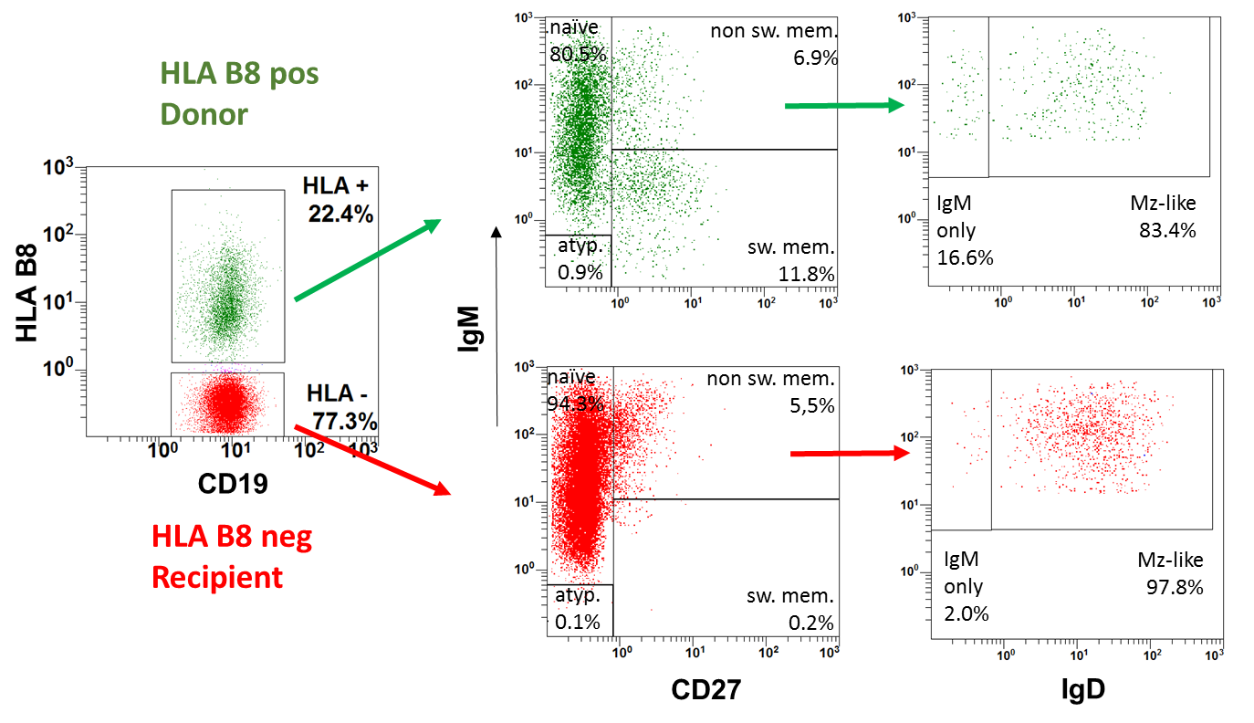

Figure S1. Staining with donor specific antibodies of the same sample obtained from patient UPN 454 confirms the results produced with a recipient specific antibody shown in Fig 2. This complementary staining excludes potential artefacts by false positive or false negative binding of HLA-specific antibodies. Patient peripheral blood MNC (14 years post SCT) were stained with HLA-B8 (donor). After staining with the HLA-specific antibody, MNCs were subsequently stained with anti-CD19, anti-CD27, anti-IgM and anti IgD. Donor B cells (green: CD19+ and HLA-B8 pos., upper row) are able to switch to IgM-CD27+CD19+ B cells while recipient B cells (red: CD19+ and HLA-B8 neg., lower row) are IgM+. Donor CD27+IgM+ (non switched mem) B cells show a substantial proportion of IgD- (IgM only) B cells while most of the IgM+CD27+ autologous B cells are IgD+.
Definition of B cell subpopulations: IgD+CD27-: naïve; IgM+CD27+: non switched memory; IgM-/CD27+: switched memory (sw mem); IgM+IgD+ (gate IgM+CD27+): Marginal Zone-like (MZ-like); IgM+IgD- (gate IgM+CD27+): IgM only

Supplemental Figure S2: Distribution of donor and recipient B cell subpopulations
A.
CD27+IgD+(IgM+)
Naïve B cells
CD27+IgM-
Class-switched memory B cells
CD27+
Memory B cells
CD27+IgM+
Non-switched memory B cells

B. C.
CD27+IgM-
Class-switched memory B cells
CD27+IgM+IgD-
IgM only B cells
CD27+IgM+IgD+
Marginal Zone-like B cells

Figure S2 A. Distribution of donor and recipient B cell subpopulations of CD19+ B cells. Distribution of naïve, CD27+, switched memory (CD27+/IgM-) and non switched memory (CD27+IgM+) B cells gated on donor (D, filled circles) and recipient (R, open circles) CD19+ B cells: switched memory B cells are only present in the donor-cell population while naïve, CD27+, and non switched MZ-like B cells are present in both recipient and donor B cells. B. Distribution of donor and recipient B cell subpopulations of CD27+IgM+ B cells. Proportion of IgM only B cells within the CD27+IgM+ population: in the donor cell population 5-25% of the CD27% were identified as IgM only and 75-94% as Marginal Zone like B cells, while the recipient CD27+ B cells only showed very low percentages (0-2,7%) of IgM only and >95% of Marginal Zone-like B cells. C. Proportion of switched memory B cells within the CD27+ population: in the donor-cell population 19-70% of the CD27% were IgM negative switched memory cells, while the recipient CD27+ B cells showed no or very low proportions of switched memory B cells. The Wilcocon matched-pairs signed rank test was used for comparing median black values (black lines) between donor and recipient populations. p-values and statistical significance are indicated. ns: non significant.

Supplemental Figure S3: Normal distribution of autologous B cell subpopulations in patients with ADA-deficiency or IL7R-Deficiency after HLA-haploidentical transplantation.
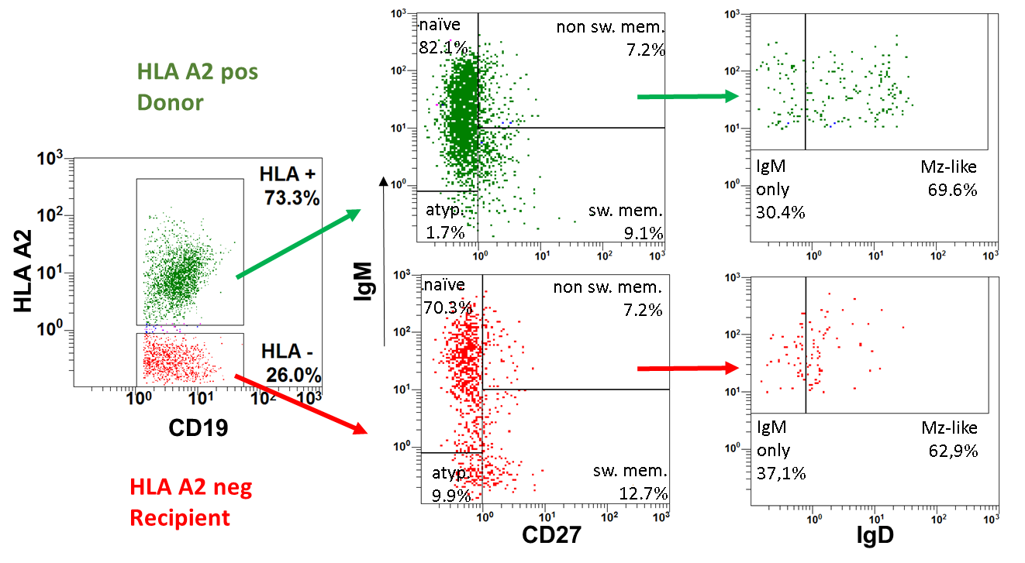
A.

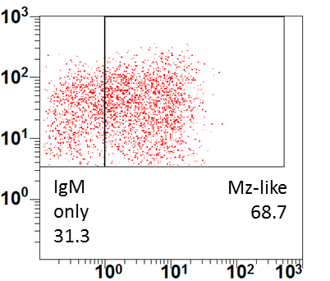
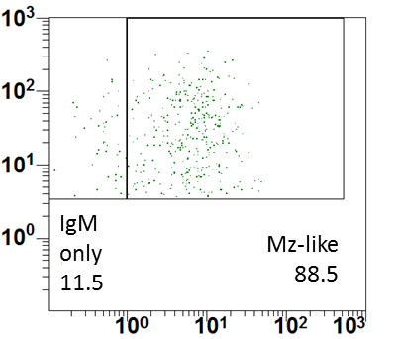
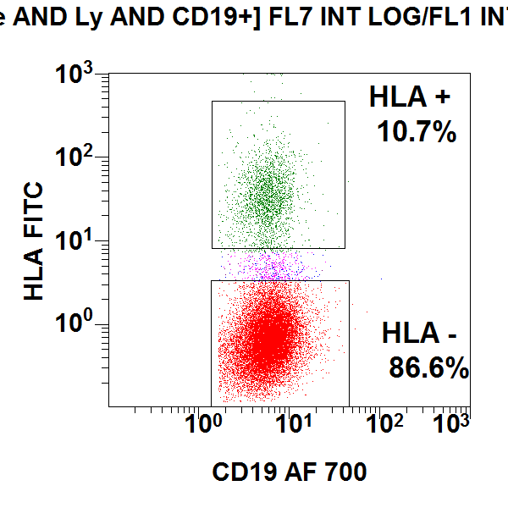
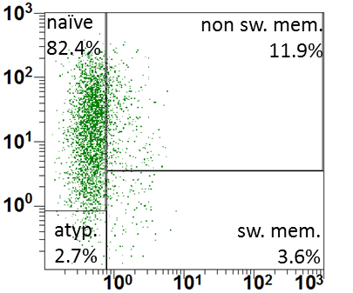
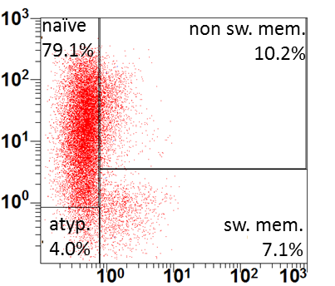
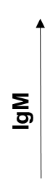

B.

HLA A32 pos Donor
HLA A32 neg Recipient
HLA A32
CD19
IgD
CD27

Figure S3 In ADA deficiency (A. patient UPN 683) and in IL7R deficiency (B. patient UPN 569), autologous B cells show a normal differentiation indicating that the atypical distribution of B cell subpopulations described in Fig 1, 3, suppl. Fig 1 and suppl. Fig 2 are specific for patients with B-positive SCID caused by pathogenic variants in IL2RG or JAK3. Peripheral blood MNCs of the patients (A. 9 years post SCT, B. 12 years post SCT) were stained with donor specific anti-HLA- A2 (A. patient UPN 683) or anti-HLA-A32 (B. patient UPN 569), followed by staining with anti-CD19, anti-CD27, anti-IgM and anti IgD. Donor B cells (green: CD19+ and donor HLA pos.) and recipient B cells (red: CD19+ and donor HLA neg.) are equally able to switch to IgM-CD27+CD19+ B cells and show a considerable proportion of IgD-negative B cells.
Supplemental Figure S4: Switched memory B cells in relation of the donor B cell proportion
A. B.
reference values

Figure S4 A. Patients with low proportions (<20%, dotted line) of donor B cells show high percentages of switched memory B cells in their donor B cell population. Donor B cells of 12 patients (s. Fig 3) with IL2RG deficiency after haploidentical stem cell transplantation were detected by HLA-antibodies. The proportion of switched memory B cells (CD27+IgM-) within the donor B cell population (y-axis) is plotted against the proportion of donor B cells of CD19+ B cells (x-axis). Error bars indicate age-related reference values. B. Longitudinal B cell chimerism analysis (donor cells of CD19+ B cells) with increasing proportions of switched memory B cells within the donor B cell population of patient UPN856 while donor-B cells declined (26% one year post SCT to 8.9% 10y post SCT). Age-related reference values are indicated as grey area.

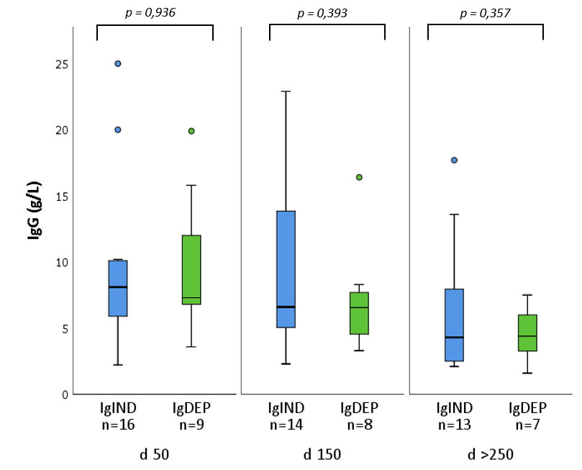
Supplemental Figure S5: Immunoglobulin levels in patients after hematopoietic stem cell transplantation (HSCT)
A.

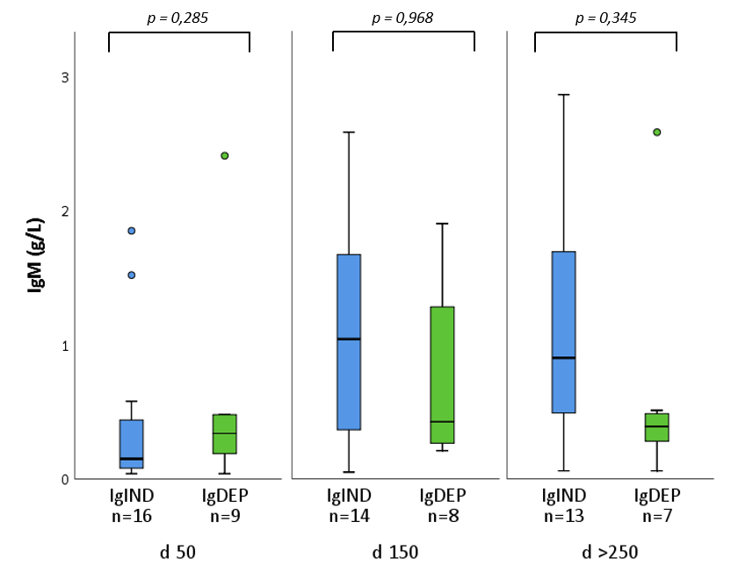
B.

Figure S5 A. There is no significant difference in the serum IgG-levels after hematopoietic stem cell Transplantation (HSCT) in patients independent (IgIND) or dependent (IgDEP) of immunoglobulin substitution. Because of the substitution of IgG it is not possible to distinguish between self-produced and substituted immoglobulin. B. Also for serum-IgM, no statistically significant difference between IgIND and IgDEP patients could be observered.
Supplemental Figure S6: Definition of cut off by ROC-analysis
​ | ​ | CD27+IgM-/CD27+​ |  | ​
​ | ​ | < 4.7 %​ | > 4.7 %​ | ​
Ig -substitution​ | IgIND​ | 1​ | 17​ | 18​
Ig -substitution​ | IgDEP​ | 11​ | 1​ | 12​
​ | ​ | 12​ | 18​ | ​

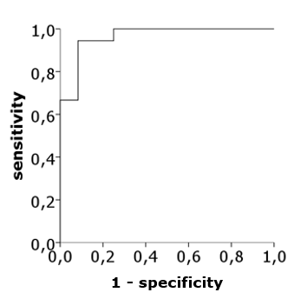

Figure S6. A ROC-analysis was used to determine the optimum cut-off value between the IgIND and IgDEP groups. A percentage of more than 4.7% class-switched memory B cells within the CD27+ population with a sensitivity of 94.4% and a specificity of 91.7% was found to be the optimal cut-off value in our cohort.

