Supplementary Table 1
Full search query terms
EMBASE
('nurse'/exp OR 'nurses' OR 'nursing'/exp) AND ('mindfulness'/exp OR 'mindfulness' OR 'meditation'/exp OR 'meditation' OR 'mindfulness-based stress reduction'/exp OR 'mbsr intervention' OR 'mbsr therapy' OR 'mbsr treatment' OR 'mindfulness stress reduction course' OR 'mindfulness stress reduction program' OR 'mindfulness stress reduction training' OR 'mindfulness stress reduction training program' OR 'mindfulness-based stress reduction' OR 'mindfulness-based stress reduction (mbsr)' OR 'mindfulness-based stress reduction (mbsr) therapy' OR 'mindfulness-based stress reduction technique' OR 'mindfulness-based stress reduction therapy' OR 'mindfulness-based stress reduction therapy (mbsr)' OR 'wellness-based mindfulness stress reduction intervention' OR 'vipassana meditation'/exp OR mindful) AND ('perceived stress'/exp OR 'perceived stress scale'/exp OR '10-item perceived stress scale' OR '10-item perceived stress scale (pss)' OR '10-item perceived stress scale (pss-10)' OR '10-items perceived stress scale' OR '10-items perceived stress scale (pss-10)' OR 'perceived stress scale' OR 'perceived stress scale (pss) 10-item' OR 'perceived stress scale (pss-10)' OR 'perceived stress score' OR 'perceived stress test' OR stress)

PubMed

((((nurse) OR (nursing)) OR (nursing staff)) AND ("Mindful" OR "mindfulness" OR "meditation" OR "vipassana" OR "mindfulness-based-stress reduction")) AND ("Stress" OR "perceived stress" OR "PSS" OR "perceived stress scale")

Supplementary Table 2
Sensitivity analysis comparing the full pooled estimate with results excluding Dyess_2018 and Mahon_2016.
Model | Pooled SMD (95%CI) | I²
Original (all studies) | –0.54 [–0.76, –0.32] | 87.4
Excluding Dyess & Mahon | –0.41 [–0.58, –0.25] | 76.3

Supplementary Figure 1
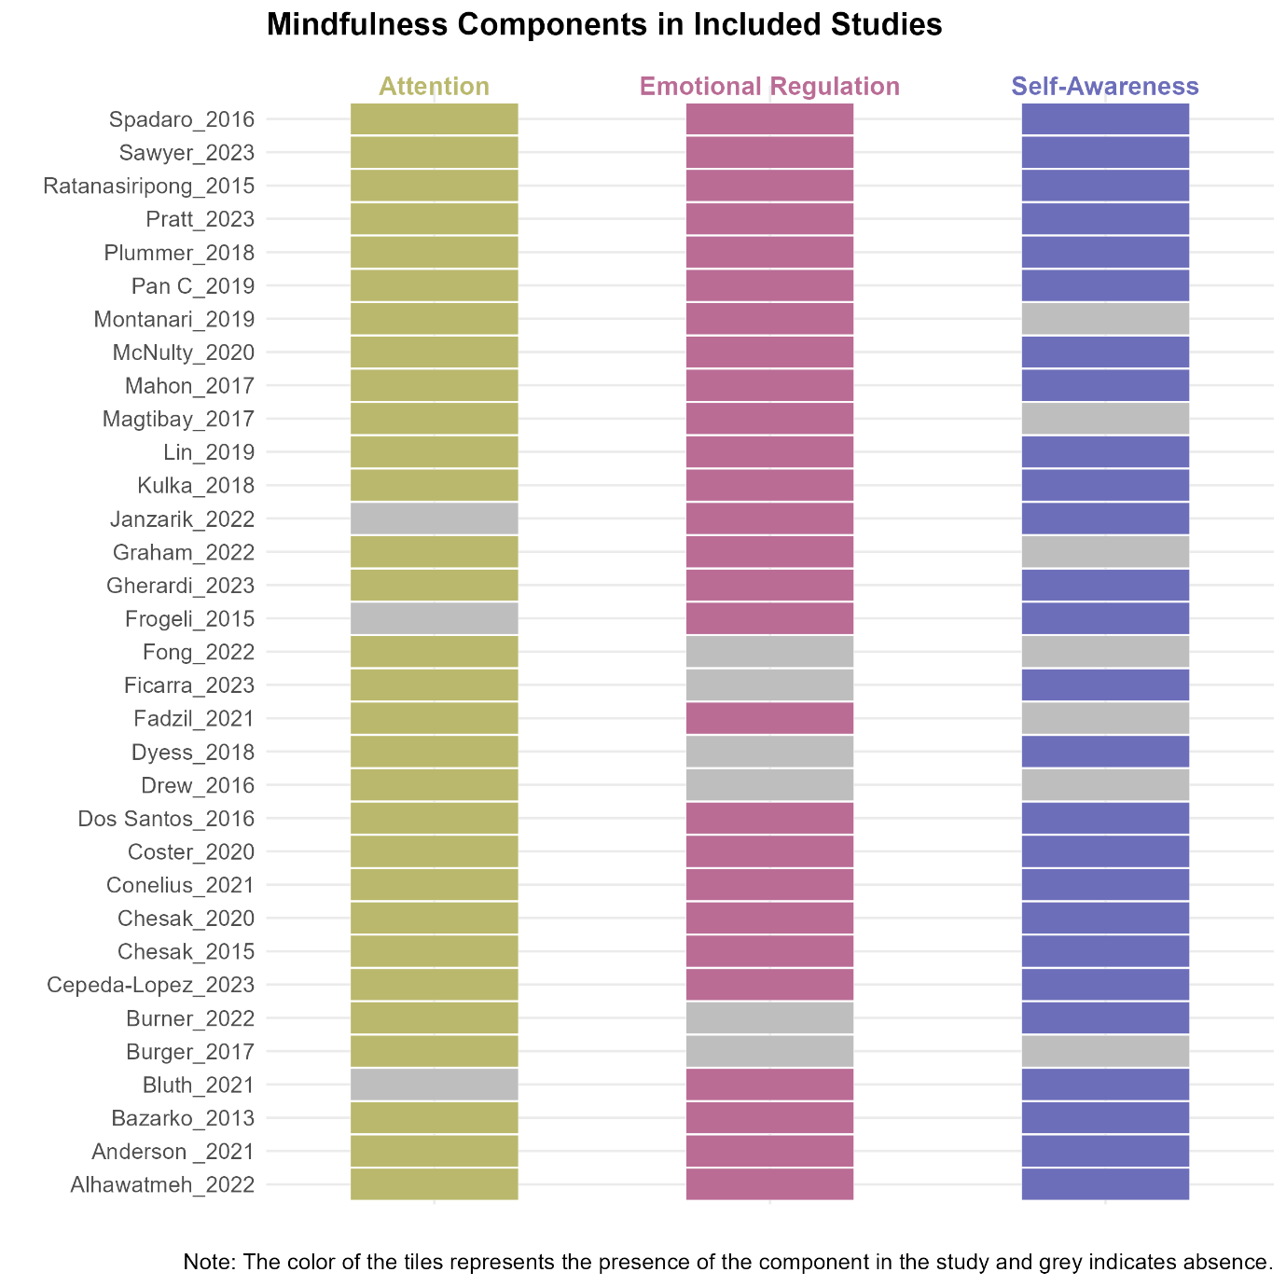
The figure illustrates the distribution of mindfulness intervention components (attention regulation, emotional regulation, and self-awareness) across the included studies. Each row represents an individual study, with colored tiles indicating the presence of the respective components and gray tiles denoting its absence. Studies are arranged chronologically, with the earliest studies at the bottom and the most recent at the top.

Supplementary Figure 2 a
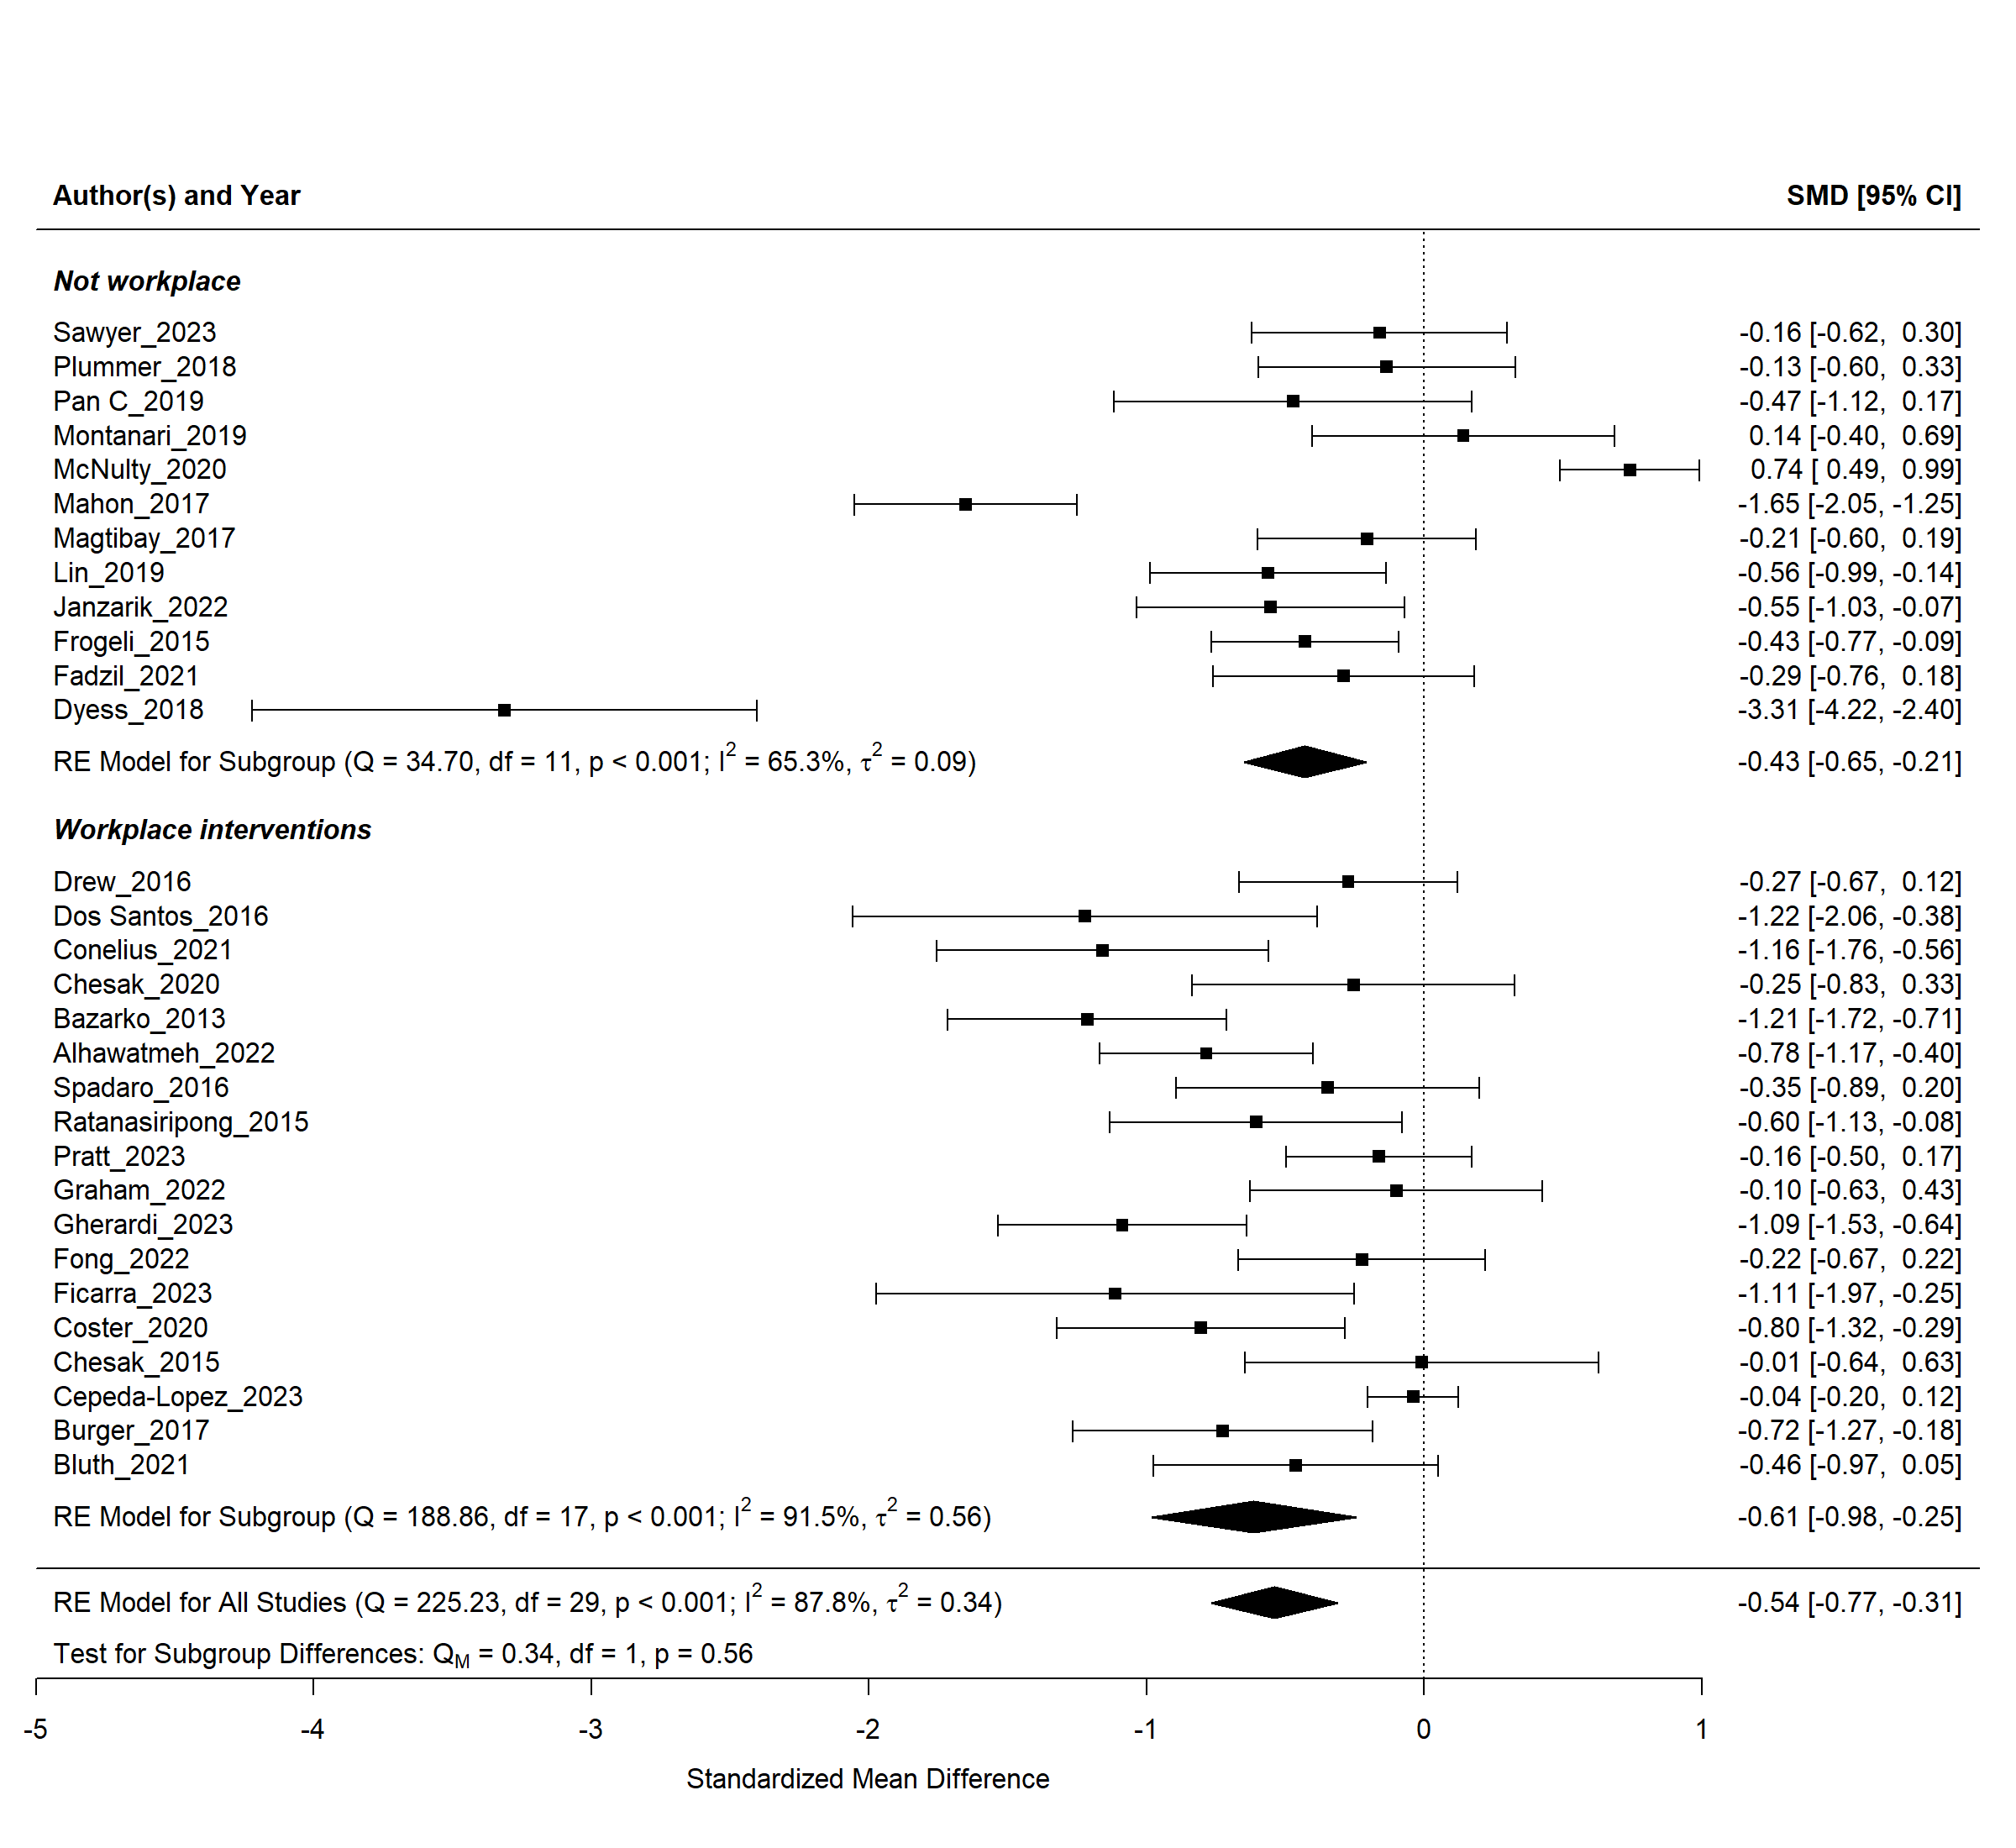
Subgroup analysis for workplace vs non-workplace interventions in one-sample pre-post studies design

Supplementary Figure 2 b
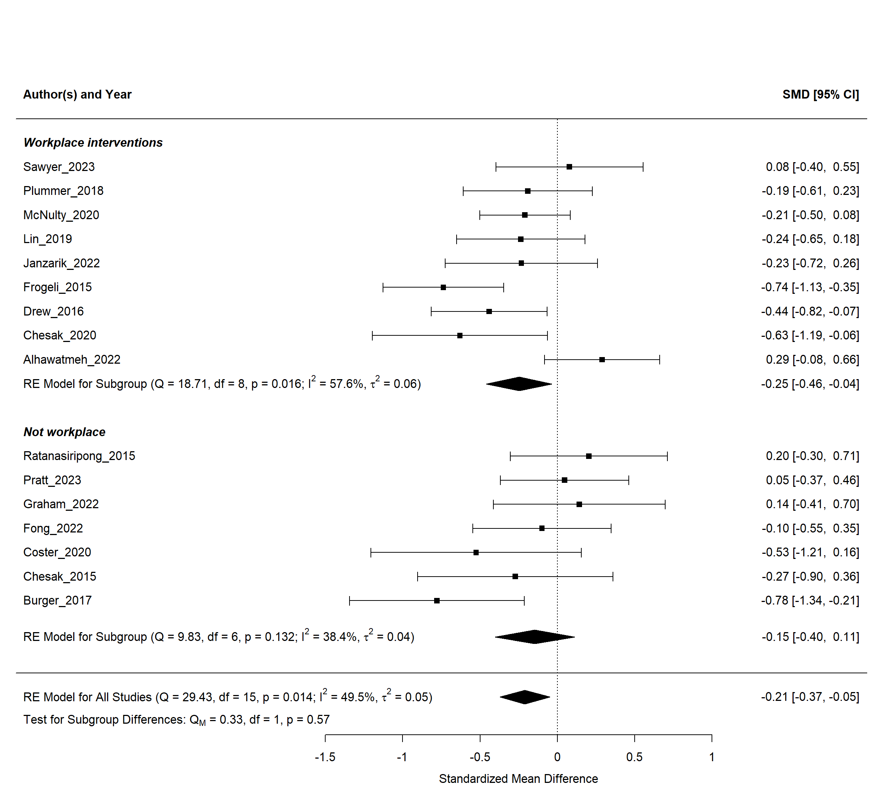
Subgroup analysis for workplace vs non-workplace interventions in control-intervention pre-post studies design

Supplementary Figure 3 a
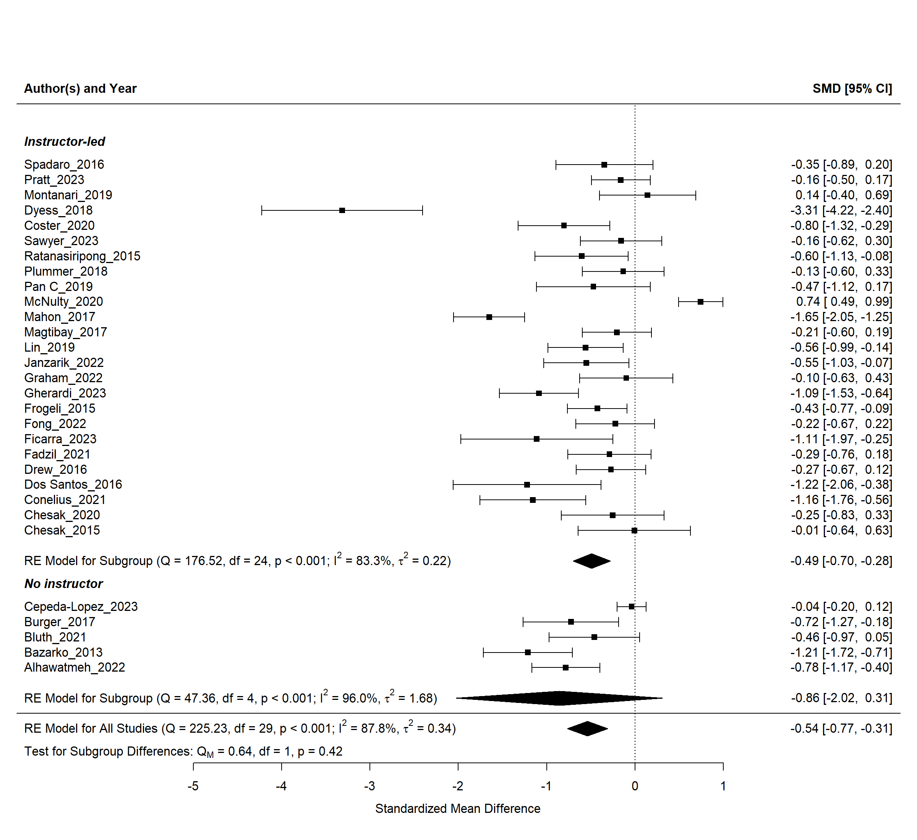
Subgroup analysis for instructor-led vs no instructor interventions in one-sample pre-post studies design

Supplementary Figure 3 b
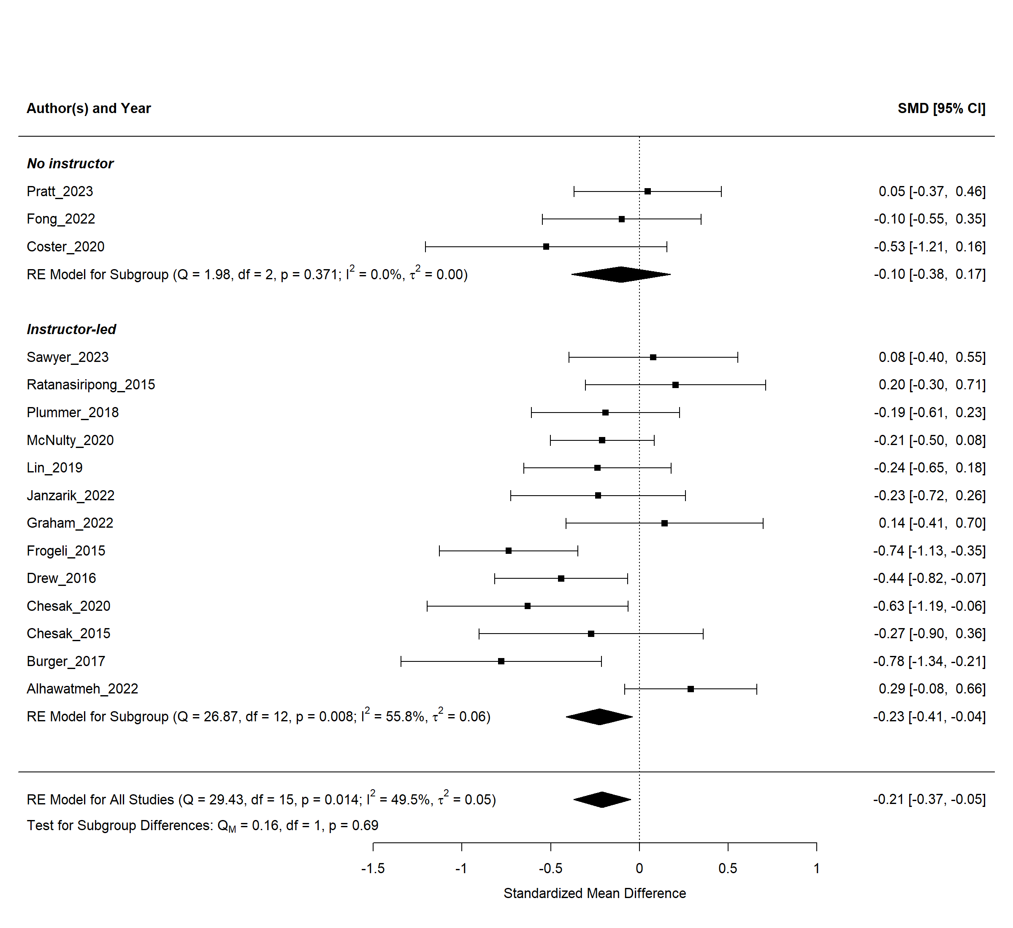
Subgroup analysis for instructor-led vs no instructor interventions in control-intervention pre-post studies design

Supplementary Figure 4a
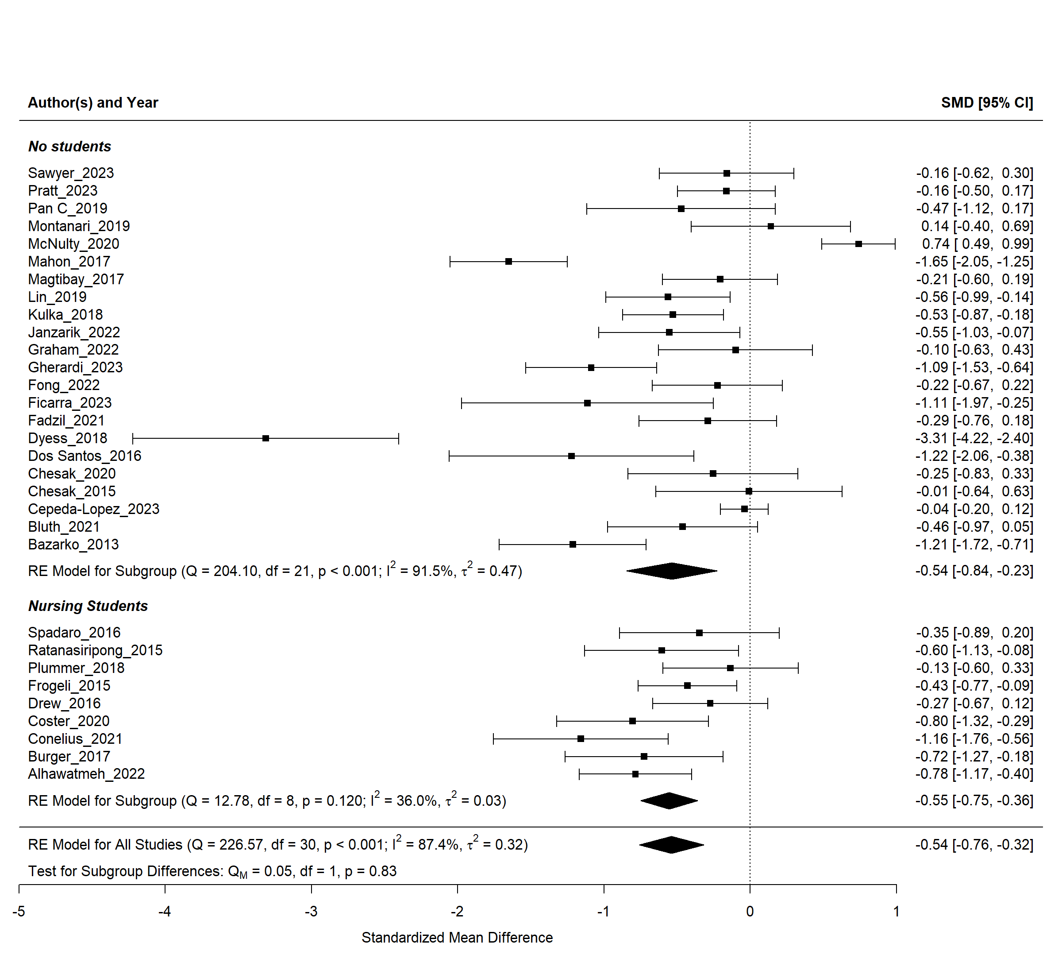
Subgroup analysis for nursing students vs clinical nurses in one-sample pre-post studies design

Supplementary Figure 4b
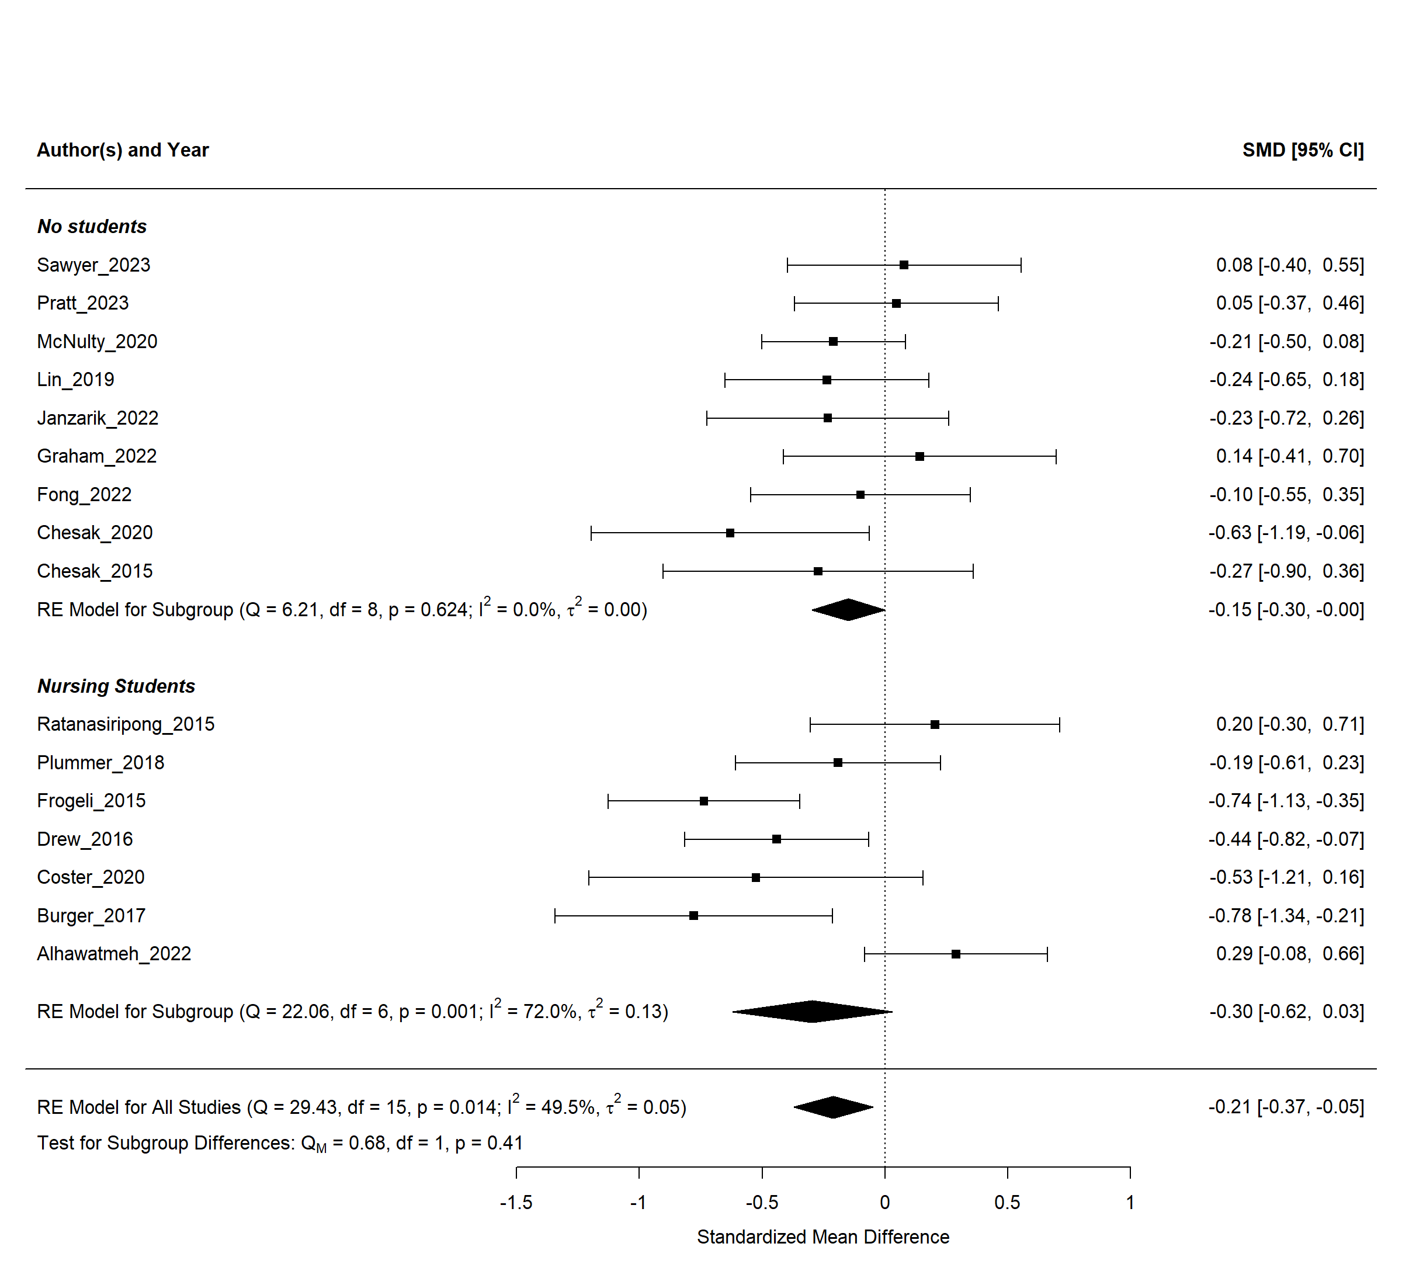
Subgroup analysis for interventions in nursing students vs clinical nurses among control-intervention pre-post studies design

Supplementary Figure 5
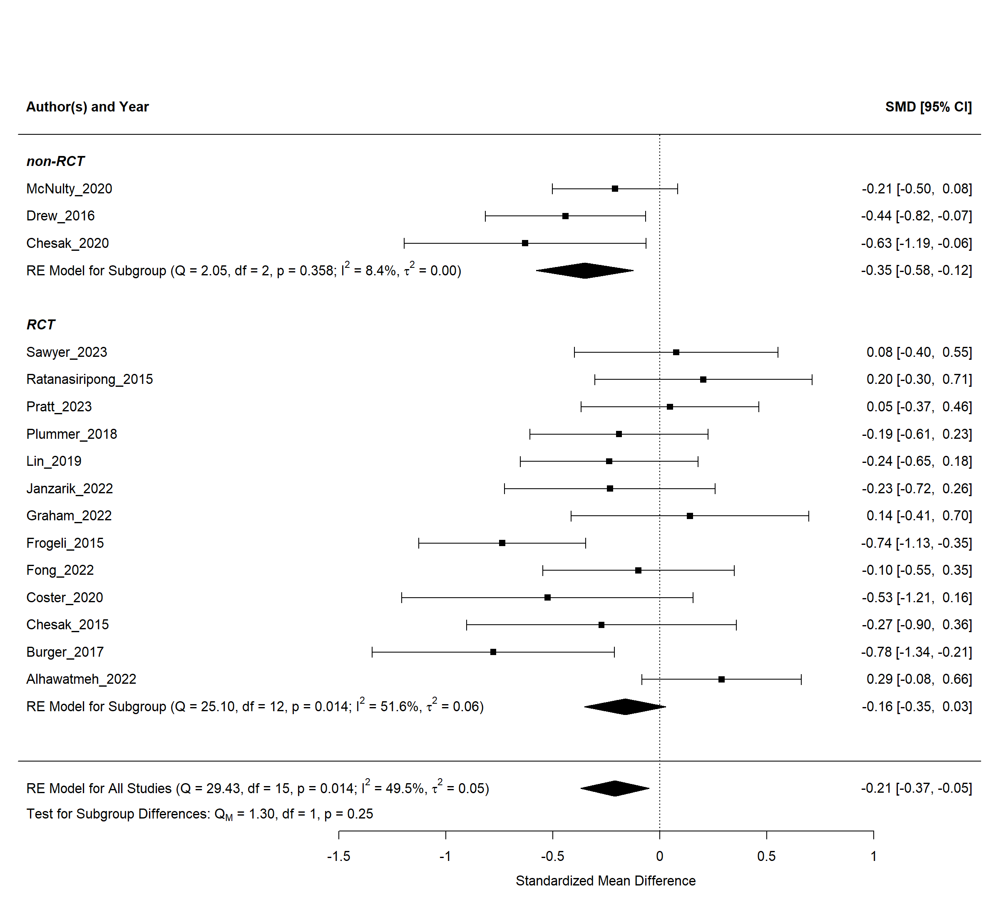
Subgroup analysis for RCT types in one-sample pre-post studies design

Supplementary Figure 6a
Sensitivity analysis for meta-analysis of one-sample pre-post studies
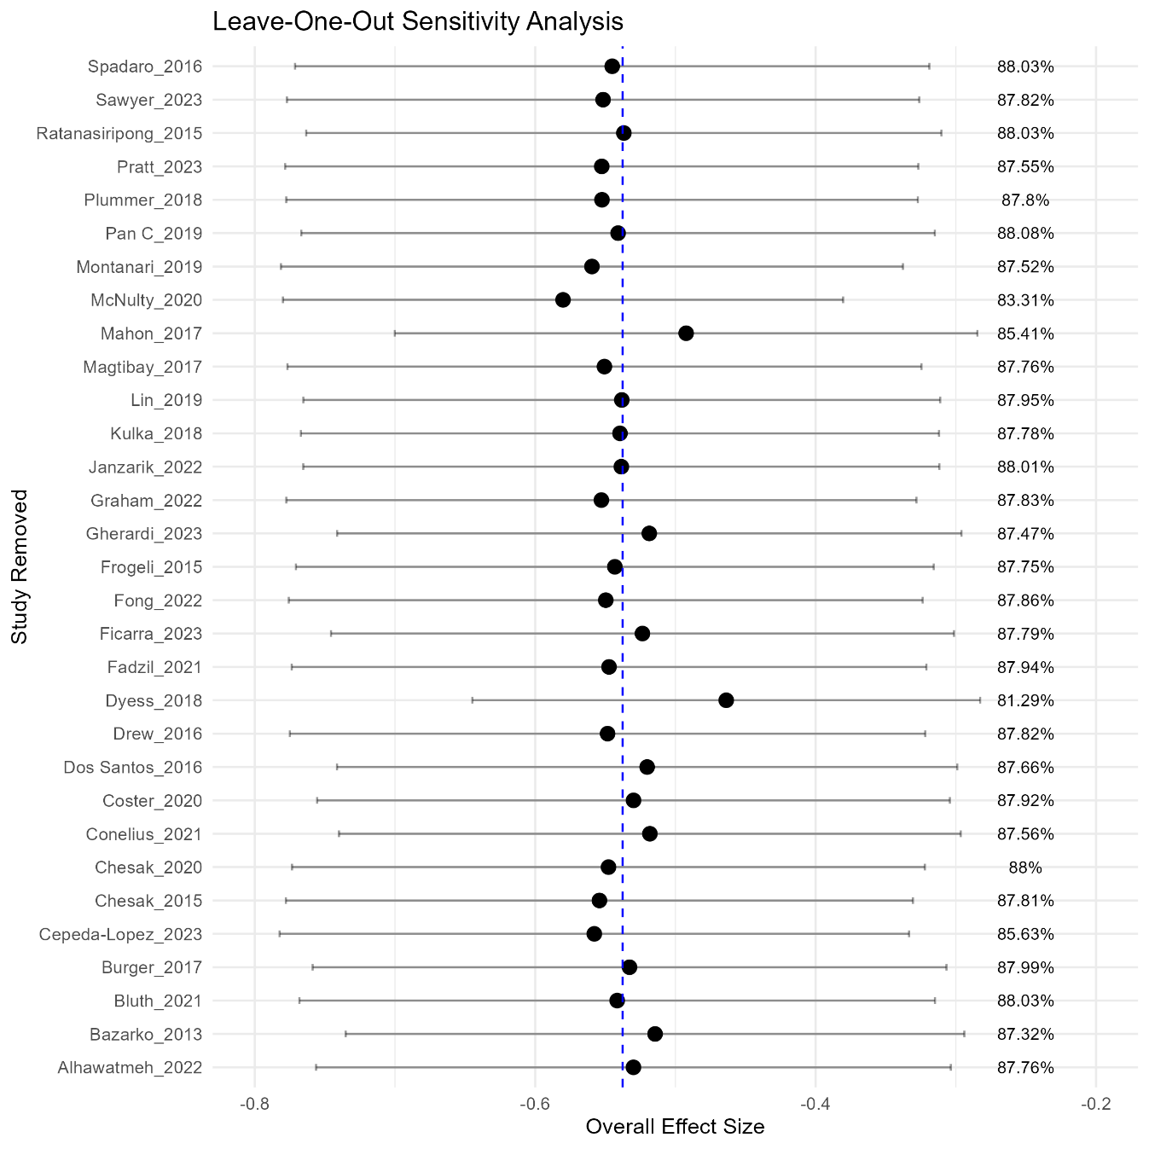
This figure illustrates the leave-one-out sensitivity analysis, where each point corresponds to the pooled effect size recalculated after omitting the respective study. The confidence intervals (CI) represent the 95% range for the recalculated effect size, providing an indication of the robustness of the overall findings. Minimal fluctuations in effect size and confidence intervals suggest that no single study disproportionately influenced the meta-analysis results. The blue dashed line represents the overall pooled estimate of the effect size when all studies are included in the analysis. This serves as a reference point to visually assess the impact of omitting each study on the total estimate.

Supplementary Figure 6b
Sensitivity Analysis: Exclusion of High-Influence Studies
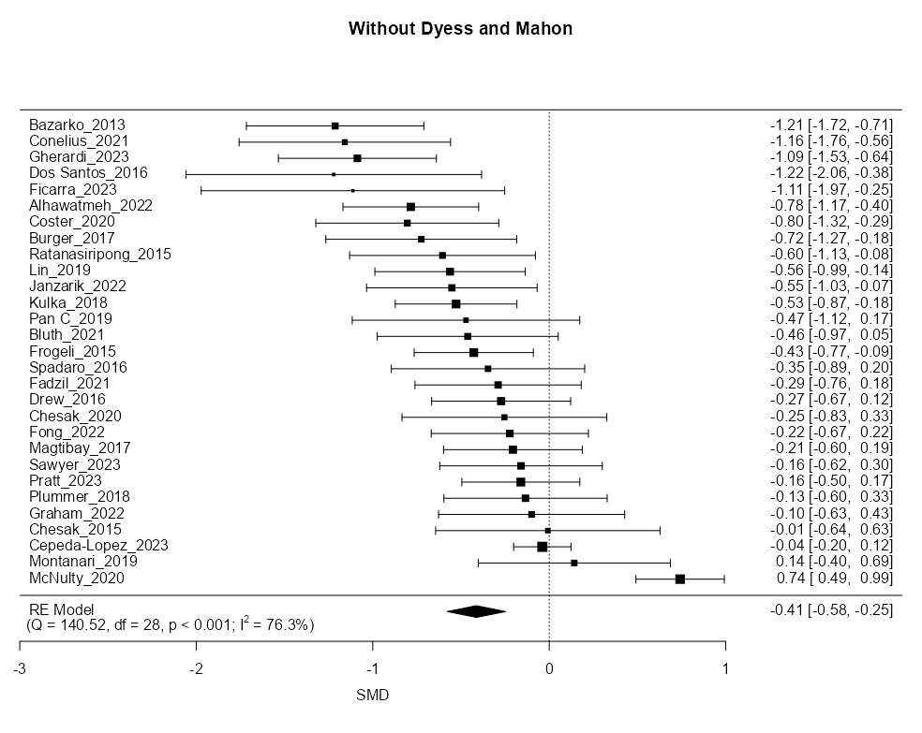

Forest plot of intervention-only studies excluding Dyess_2018 and Mahon_2017. This sensitivity analysis shows the standardized mean differences (SMDs) and 95% confidence intervals for each study. The pooled effect size using a random-effects model is –0.41 (95% CI: –0.58 to –0.25), with moderate-to-high heterogeneity (I² = 76.3%). Results remain statistically significant and directionally consistent, indicating that the overall findings are robust to the exclusion of outlier studies.

Supplementary Figure 6c
Sensitivity analysis for meta-analysis of control-intervention pre post studies
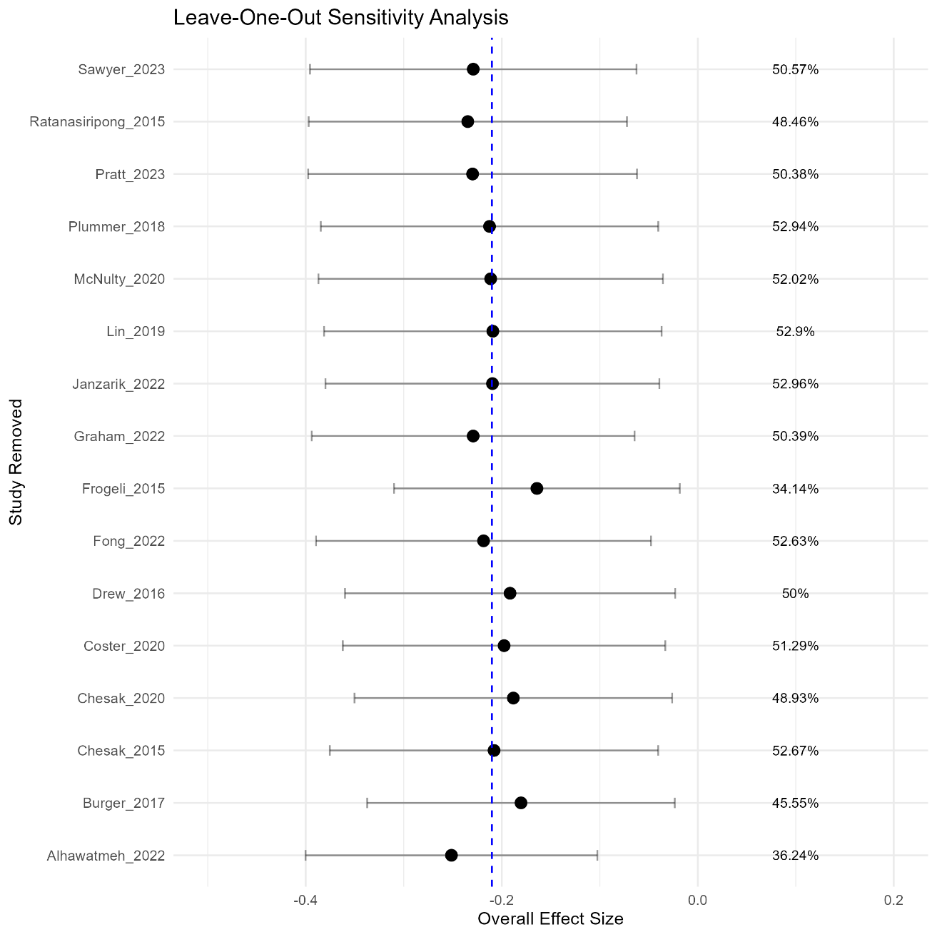
This figure illustrates the leave-one-out sensitivity analysis for controlled-intervention designs. Each point corresponds to the recalculated effect size when the respective study was excluded, with horizontal lines indicating 95% confidence intervals. The blue dashed line represents the pooled effect size when all studies were included.

