Supplementary Information
Table of Contents
Supplementary Tables
Supplementary Table 1 - GWAS Datasets and Quality Control Summary
Supplementary Table 2 - LD Score Regression Analysis Results
Supplementary Table 4 - Confirmatory Factor Analysis Results
- 4a. Model Fit Indices
- 4b. Factor Loadings and Model Parameters
Supplementary Table 5 - Genome-wide Association Summary Statistics for Neuroimmune Syndrome Factor
- 5a. Lead SNPs Associated with Neuroimmune Syndrome Construct (P < 5×10⁻¹²)
- 5b. Lead SNPs Associated with Neuroimmune Syndrome Construct (P < 5×10⁻¹⁶)
- 5c. Comparison with Previously Reported Associations (P < 5×10⁻¹²)
- 5d. Comparison with Previously Reported Associations (P < 5×10⁻¹⁶)
- 5e. FUMA Genomic Risk Loci
Supplementary Table 6 - Functional Annotation of Lead SNPs
Supplementary Table 7 - GWAS-by-Subtraction Analysis Results for Neuroimmune Syndrome
Supplementary Table 8 - Fine-mapping Analysis of High-confidence Causal Variants in Neuroimmune Syndrome
Supplementary Table 9 - High-confidence Gene Associations with Neuroimmune Syndrome Identified by TWAS and FOCUS Intersection Analysis
Supplementary Table 10 - MAGMA Gene-based Analysis Results for Neuroimmune Syndrome
Supplementary Table 11 - Gene Set Enrichment Analysis (GSEA) of Neuroimmune Syndrome-associated Genes
Supplementary Table 12 - Cell-type Enrichment Analysis of Neuroimmune Syndrome-associated Genetic Loci
Supplementary Table 13 - Heritability Enrichment Analysis Across Genomic Functional Regions for Neuroimmune Syndrome
Supplementary Table 14 - Mendelian Randomization Analysis of Plasma Proteins and Neuroimmune Syndrome Risk
Supplementary Table 15 - Mendelian Randomization Analysis of Candidate Therapeutic Targets and Neuroimmune Syndrome Risk
Supplementary Table 16 - Mendelian Randomization Analysis of Brain, Cerebrospinal Fluid, and Plasma Proteins Using Yang et al. pQTL Data
Supplementary Table 17 - Mendelian Randomization Analysis of Phenome-wide Associations with Neuroimmune Syndrome Risk

Supplementary Files
Supplementary File 3 - Exploratory Factor Analysis Results

Supplementary Figures
Supplementary Figure S11 - Chromosomal Contribution to Neuroimmune Syndrome Genetic Architecture
Supplementary Figure S12 - Relationship Between Effect Sizes and Variant Counts Across Chromosomes
Supplementary Figure S13 - Volcano Plot of Mendelian Randomization Results for Protein-Neuroimmune Syndrome Associations

Supplementary Table 1. GWAS Datasets and Quality Control Summary
Phenotype | Database | Sample Size | Cases/Controls | Population | Quality Control
Guillain-Barre syndrome  (GBS) | FinnGen R12 | 492,134 | 551 / 491,583 | Finnish | INFO > 0.8<br>MAF > 0.01<br>HWE P > 1×10⁻⁶
Myasthenia gravis  (MG) | FinnGen R12 | 492,134 | 560 / 495,667 | Finnish | INFO > 0.8<br>MAF > 0.01<br>HWE P > 1×10⁻⁶
Multiple Sclerosis  (MS) | FinnGen R12 | 498,857 | 2,926 / 495,931 | Finnish | INFO > 0.8<br>MAF > 0.01<br>HWE P > 1×10⁻⁶
Systemic Lupus Erythematosus  (SLE) | FinnGen R12 | 499,333 | 291 / 499,042 | Finnish | INFO > 0.8<br>MAF > 0.01<br>HWE P > 1×10⁻⁶
Systemic Connective Tissue Disorders(SCTD) | FinnGen R12 | 500,348 | 16,088 / 484,260 | Finnish | INFO > 0.8<br>MAF > 0.01<br>HWE P > 1×10⁻⁶
Notes: Note. INFO = imputation quality score; MAF = minor allele frequency; HWE = Hardy-Weinberg equilibrium; ICD = International Classification of Diseases. Quality control filters were applied consistently across all datasets to ensure data quality and comparability. FinnGen data represents Finnish population isolate with high genetic homogeneity, while UK Biobank represents broader European ancestry.

Supplementary Table 2. LD Score Regression Analysis Results
Note: Diagonal elements represent SNP-based heritability estimates. Off-diagonal elements show pairwise genetic correlations. Standard errors are shown in parentheses. GBS, Guillain-Barré syndrome; MG, myasthenia gravis; MS, multiple sclerosis; SLE, systemic lupus erythematosus; SCTD, systemic connective tissue disease.

Supplementary File 3. Exploratory Factor Analysis of Genetic Correlations Among Five Autoimmune and Neurological Disorders
Notes: Results from exploratory factor analysis (EFA) comparing 1-factor and 2-factor models using promax rotation. The genetic correlation matrix was smoothed using the nearPD function prior to analysis to ensure positive semi-definiteness. Factor loadings, communalities, and model fit statistics are presented.

Supplementary Table 4a.Model Fit Indices
Notes: AIC = Akaike Information Criterion; CFI = Comparative Fit Index; SRMR = Standardized Root Mean Square Residual.
Supplementary Table 4b.Factor Loadings and Model Parameters
Notes: F1 represents the common genetic factor. =~ indicates factor loadings; ~~ indicates residual variances. SE = standard error. All estimates derived from genomic structural equation modeling of GWAS summary statistics.

Supplementary Table 5. Genome-wide Association Summary Statistics for Neuroimmune Syndrome Factor
Description: Complete GWAS summary statistics from genomic structural equation modeling analysis of neuroimmune syndrome. This file contains association results for 7,170,712 single nucleotide polymorphisms (SNPs) with the latent neuroimmune syndrome factor derived from five neuroimmune-related disorders: Guillain-Barré syndrome (GBS), myasthenia gravis (MG), multiple sclerosis (MS), systemic lupus erythematosus (SLE), and systemic connective tissue diseases (SCTD).

Supplementary Table 5a. Lead SNPs Associated with Neuroimmune Syndrome Construct (P < 5×10⁻¹²)
Summary: 31 lead SNPs identified across 41 genomic loci.
Note: A1/A2 = effect/other allele; BP = base pair position (hg38); CHR = chromosome; MAF = minor allele frequency; SE = standard error; SNP = single nucleotide polymorphism.
Supplementary Table 5b. Lead SNPs Associated with Neuroimmune Syndrome Construct (P < 5×10⁻¹⁶)
Summary: 29 lead SNPs identified across 39 genomic loci at stringent threshold.
Note: A1/A2 = effect/other allele; BP = base pair position (hg38); CHR = chromosome; MAF = minor allele frequency; SE = standard error; SNP = single nucleotide polymorphism.

Supplementary Tables 5c and 5d. Comprehensive Identification Report of Neuroimmune Syndrome GWAS Variants
SNP ID | Chr:Position | Gene | Previously Reported | Key References (PMID) | Disease/Trait Context
rs76210604 | 17q25.1 | IKZF3 | Yes | 26502338 (Bentham et al. Nat Genet 2015) | Systemic lupus erythematosus, autoimmune diseases
rs55691991 | 9q34.2 | ABO | Yes | 27346686 (Astle et al. Cell 2016) | Blood cell traits, immune cell counts

Supplementary Table 5e. Genomic risk loci associated with neuroimmune syndrome construct identified by FUMA
Notes: A total of 36 independent genomic risk loci were identified at genome-wide significance (P < 5×10⁻⁸) through FUMA analysis. Fourteen loci (38.9%) demonstrated extremely significant association (P = 1×10⁻²⁰⁰), with additional loci showing P-values ranging from 1.08×10⁻⁴⁵ to 1.85×10⁻¹⁷³. The identified loci span 18 chromosomes, with highest concentrations observed on chromosomes 1 (5 loci), 4 (5 loci), 2 (4 loci), and 8 (4 loci). Key identified variants include rs148729815 (chr19), rs76210604 (chr17), and rs17098406 (chr14), which provide novel insights into the shared genetic architecture underlying neuroimmune syndrome pathophysiology.

Supplementary Table 6. Functional annotation and biological characterization of genomic risk loci associated with neuroimmune syndrome construct
Notes: Comprehensive functional annotation of 36 independent genomic risk loci identified through FUMA analysis. All loci represent novel associations in the neuroimmune syndrome context. The majority of variants are located within intronic regions (66.7%) with low minor allele frequencies (72.2% MAF < 0.05), suggesting enrichment for rare functional variants.

Supplementary Table 7. GWAS-by-Subtraction analysis results for neuroimmune syndrome
Notes: No GWAS subtraction loci were identified in this analysis. The GWAS-by-Subtraction method, which compares lead loci identified through genomic structural equations with those meeting genome-wide significance thresholds in single-input GWAS, did not reveal any loci that were specific to the latent neuroimmune syndrome factor while being absent from the individual component GWAS.
Supplementary Table 8. Fine-mapping analysis of high-confidence causal variants in neuroimmune syndrome construct
Notes: Fine-mapping analysis identified four major genomic association clusters with high posterior probabilities (mean > 0.95) of causal association with neuroimmune syndrome construct. The clusters are: chromosome 1 (6 variants including rs56332939 and rs76692181), chromosome 4 (7 variants including rs10029041 and rs7664257), chromosome 8 (4 variants including rs35642230 and rs72678550), and chromosome 11 (4 variants including rs34851197 and rs71482185).

Supplementary Table 9. TWAS and FOCUS intersection analysis results for neuroimmune syndrome-associated genes
Notes: Intersection analysis of TWAS and FOCUS fine-mapping results for neuroimmune syndrome construct. While TWAS analysis yielded no genome-wide significant genes, FOCUS identified 78 potential pathogenic genes. Intersection analysis revealed 15 high-confidence genes: seven with positive Z-scores (ISCA2, NPC2, PRSS8, ENDOD1, PNKD, GSAP, ATG101) indicating upregulation associates with increased risk, and eight with negative Z-scores (PGBD1, DNAJC24, LINC02980, TUBGCP5, LSM12P1, ATF6B, PFN1P2, MDC1) indicating downregulation associates with increased risk. These genes represent promising candidates for functional studies of neuroimmune syndrome mechanisms.

Supplementary Table 10. Gene-based association analysis using MAGMA for neuroimmune syndrome construct
Notes: MAGMA gene-based analysis identified 2 genes reaching genome-wide significance (P < 2.7×10⁻⁶, Bonferroni corrected P < 0.05). UNG (Uracil-DNA glycosylase) on chromosome 12 showed the strongest association (P = 4.50×10⁻¹⁵, P_bonferroni = 8.31×10⁻¹¹), followed by BCL10 (B-cell lymphoma/leukemia 10) on chromosome 1 (P = 9.00×10⁻⁷, P_bonferroni = 0.0166). Both genes have established roles in immune system regulation and DNA repair mechanisms, providing molecular insights into neuroimmune syndrome pathophysiology.

Supplementary Table 11. Gene set enrichment analysis (GSEA) of neuroimmune syndrome-associated genes
Notes: Gene set enrichment analysis of MAGMA-identified genes revealed regulatory-enriched genetic architecture rather than traditional pathway-based enrichment. While no gene sets achieved FDR significance, this pattern is consistent with the extensive regulatory element enrichment observed in LD Score Regression analysis. The results suggest that neuroimmune syndrome pathophysiology is primarily driven by transcriptional network dysregulation across multiple biological systems rather than disruption of specific metabolic or signaling pathways. This regulatory-centric genetic architecture provides a unified molecular framework for understanding the shared pathophysiology underlying diverse neuroimmune manifestations.

Supplementary Table 12. Cell-type-specific enrichment analysis of neuroimmune syndrome construct heritability
Notes: Cell types represent distinct cellular populations across tissues; Coefficient = effect size of cell-type-specific enrichment; FDR = false discovery rate corrected for multiple testing across all cell types. Analysis performed using cell-type-specific LD Score Regression with tissue-specific gene expression data.

Supplementary Table 13. Comprehensive LD Score Regression functional enrichment analysis for neuroimmune syndrome construct
Notes: Analysis of 53 functional genomic categories identified 25 significantly enriched annotations (FDR < 0.05), revealing extensive concentration of neuroimmune syndrome heritability in transcriptional regulatory elements. Transcription start sites show the highest enrichment (21.77×), followed by histone modification marks H3K4me3 (13.30×) and H3K9ac (12.08×). The broad enrichment across enhancers, promoters, and chromatin marks indicates that neuroimmune syndrome genetic architecture is fundamentally driven by transcriptional dysregulation. These findings provide a molecular framework for understanding shared pathophysiology and identifying therapeutic targets.

Supplementary Table 14. Mendelian Randomization Analysis of Plasma Proteins and Neuroimmune Syndrome Risk
Description: Results from two-sample Mendelian randomization analysis examining causal associations between circulating plasma protein levels and neuroimmune syndrome risk. This table contains analysis results for 4,907 plasma proteins from the deCODE genetics consortium, including odds ratios (OR), 95% confidence intervals (CI), P-values, and significance indicators. Eight proteins demonstrated significant associations (P < 0.05): seven risk-increasing proteins (BDH2, WFDC2, ALPL, LILRA2, PCDHA4, GRID2, RNASE6) and one protective protein (EPB41). Analysis was performed using genetic instruments from protein quantitative trait loci (pQTL) data and neuroimmune syndrome GWAS summary statistics from genomic structural equation modeling.

Supplementary Table 15. Mendelian Randomization Analysis of Candidate Therapeutic Targets and Neuroimmune Syndrome Risk
Description: Results from two-sample Mendelian randomization analysis examining causal associations between candidate therapeutic targets and neuroimmune syndrome risk. This table contains analysis results for drug targets, including odds ratios (OR), 95% confidence intervals (CI), and P-values. Five targets demonstrated significant associations: three with protective effects (CTLA4, TYK2, CCR5) and two with risk effects (LILRA2, BDH2). Analysis was performed using genetic instruments from drug target genes and neuroimmune syndrome GWAS summary statistics from genomic structural equation modeling.

Supplementary Table 16. Mendelian Randomization Analysis of Brain, Cerebrospinal Fluid, and Plasma Proteins Using Yang et al. pQTL Data
Description: Results from two-sample Mendelian randomization analysis examining causal associations between protein levels and neuroimmune syndrome risk using Yang et al. brain, cerebrospinal fluid, and plasma protein quantitative trait loci (pQTL) data. This table contains analysis results for proteins with significant associations (FDR < 0.05), identifying 529 proteins linked to neuroimmune syndrome risk. Key protein categories include complement components (C2, C5, C9), inflammatory mediators (TNF, IL1B), glial activation markers (GFAP), neuroprotective factors (GDNF, NGF), immune checkpoint molecules (CD274), and vascular markers (VCAM1). EPB41 showed consistent protective associations across both deCODE and Yang et al. analyses. Analysis was performed using genetic instruments from protein quantitative trait loci and neuroimmune syndrome GWAS summary statistics from genomic structural equation modeling.

Supplementary Table 17. Mendelian Randomization Analysis of Phenome-wide Associations with Neuroimmune Syndrome Risk
Description: Results from two-sample Mendelian randomization analysis examining causal associations between 50,033 phenotypes and neuroimmune syndrome risk. This table contains analysis results for traits with significant causal associations (FDR < 0.05), identifying 17 traits linked to neuroimmune syndrome risk. The strongest association was observed for thyroid problems (not cancer) (OR = 1.826, 95% CI: 1.494-2.232, P = 4.11×10⁻⁹, FDR = 9.43×10⁻⁵), followed by self-reported hypothyroidism (OR = 1.743, 95% CI: 1.393-2.180, P = 1.14×10⁻⁶) and rheumatoid arthritis (OR = 1.035, 95% CI: 1.022-1.047, P = 3.24×10⁻⁸). Sixteen traits showed risk-increasing effects, supporting shared autoimmune and endocrine mechanisms underlying neuroimmune syndrome susceptibility. Analysis was performed using genetic instruments from GWAS summary statistics and neuroimmune syndrome GWAS summary statistics from genomic structural equation modeling.

Supplementary Figure S11. Chromosomal contribution to neuroimmune syndrome genetic architecture.
Notes: Bar chart showing the relative contribution of each chromosome to the overall genetic architecture of neuroimmune syndrome based on polygenic risk score analysis. The y-axis represents the percentage contribution of each chromosome, with chromosome 4 showing the highest contribution (39.1%), followed by chromosome 14 (23.8%), chromosome 1 (12.0%), and other chromosomes contributing smaller proportions. The x-axis lists all autosomes from chromosome 1 to 22. This analysis reveals the non-uniform distribution of genetic variants across chromosomes, highlighting specific chromosomal regions that harbor the majority of causal variants for neuroimmune syndrome susceptibility.
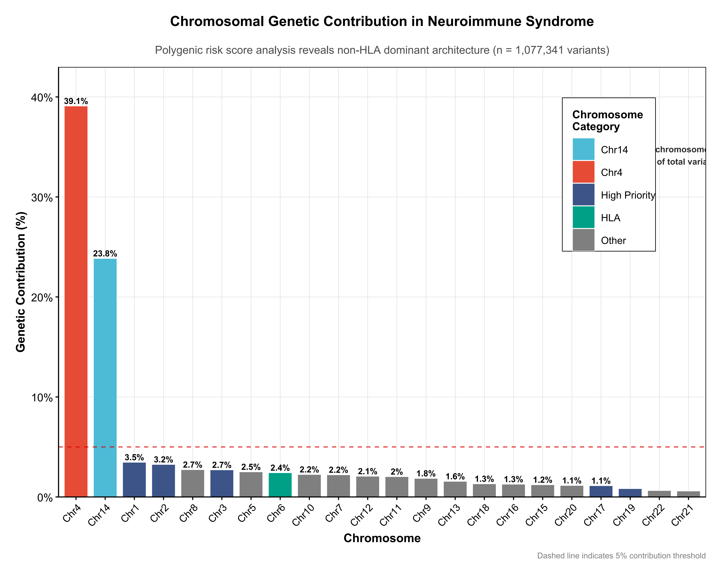

Supplementary Figure S12. Relationship between effect sizes and variant counts across chromosomes.
Notes: Scatter plot displaying the relationship between genetic effect sizes (y-axis) and the number of variants (x-axis) for each chromosome in neuroimmune syndrome GWAS. Each point represents a chromosome, with chromosome 4 showing the largest effect size despite having a moderate number of variants, indicating high-impact genetic loci. The plot demonstrates that chromosomal contribution to disease risk is not simply proportional to variant count, but rather depends on the cumulative effect sizes of variants within each chromosomal region. This analysis supports the identification of chromosome-specific genetic architectures underlying neuroimmune syndrome pathogenesis.

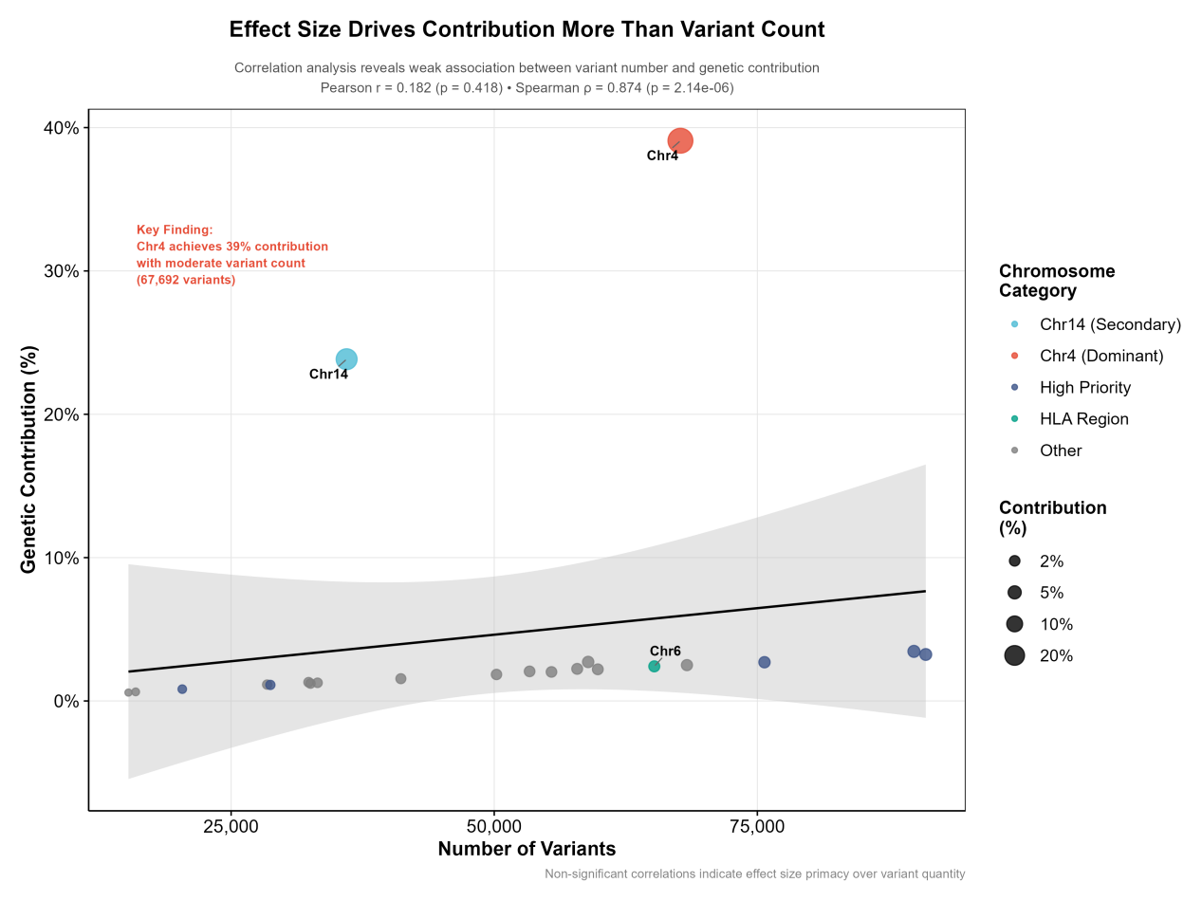

Supplementary Figure S13. Volcano plot of Mendelian randomization results for protein-neuroimmune syndrome associations.
Notes: Volcano plot displaying the relationship between effect sizes (x-axis, log odds ratio) and statistical significance (-log10 P-value, y-axis) for Mendelian randomization analysis of protein exposures and neuroimmune syndrome risk. The plot shows 104 ultra-significant results (P < 0.001) identified from the comprehensive analysis. Each point represents a protein, with significant associations labeled (including NME1 and other candidate proteins). The horizontal dashed line indicates the significance threshold (P = 0.001), while the vertical dashed lines may indicate effect size thresholds. Proteins in the upper left quadrant represent protective associations with large effect sizes, while those in the upper right represent risk-increasing associations. This genome-wide view complements the focused analyses in main Figures 7 and 8, providing comprehensive evidence for protein-mediated causal relationships in neuroimmune syndrome pathogenesis.
