Impact of Mixing Duration on Growth and Nutrient Removal Efficiency of Scenedesmus sp. in a Novel Raceway Pond System
Muhammad Umer Abbasª, Rashid Iftikhar^{a*},Sahar Saleem^{b} , Sarah Bader Alotaibi^{c}, Nadeem Ullahª, Mashael M. Alfgeh^{c}, Muhammad Ali Inam^{d}, Faras Ahmad Shahbazª and Ahmad Aakash^{e}
ª Institute of Environmental Sciences and Engineering (IESE), School of Civil and Environmental Engineering (SCEE), National University of Sciences and Technology (NUST), Islamabad, 44000, Pakistan.
^{b} Department of Sciences, School of Interdisciplinary Engineering & Science (SINES), National University of Science and Technology (NUST), Islamabad, Pakistan
^{c} Department of Teaching and Learning, College of Education and Human Development, Princess Nourah bint Abdulrahman University, Riyadh 11671, Saudi Arabia
^{d} Institute of Water Resources and Water Supply, Hamburg University of Technology (TUHH), Am Schwarzenberg-Campus 3, 21073, Hamburg, Germany
^{e} Department of Chemistry "Giacomo Ciamician", University of Bologna, Via Selmi 2, postal 40126 Bologna, Italy.
*Corresponding author
Dr. Rashid Iftikhar
Assistant Professor
Institute of Environmental Sciences and Engineering (IESE), School of Civil and Environmental Engineering (SCEE), National University of Sciences and Technology (NUST), Islamabad, 44000, Pakistan.
Email address: rashid.iftikhar@iese.nust.edu.pk; rashid.iftikhar@hotmail.com

Supplementary Material

Section S1: Materials and Methods
S1.1 Basal Bold Medium Recipe
The composition of Bold’s Basal Medium (BBM) includes (i) the macro-nutrients containing Sodium nitrate (250 mg/L), Dipotassium Phosphate (75 mg/L), Magnesium Sulfate Heptahydrate (75 mg/L), Calcium Chloride Dihydrate (25 mg/L), Sodium Chloride (25 mg/L), Ferrous Sulfate Heptahydrate (4.98 mg/L), Monopotassium Phosphate (175 mg/L), Ethylenediaminetetraacetic Acid (50 mg/L), Potassium Hydroxide (31 mg/L) (ii) the micro-nutrients containing Boric Acid (11.42 mg/L), Manganese(II) Chloride Tetrahydrate (0.44 mg/L), Zinc Sulphate Heptahydrate (8.82 mg/L), Copper Sulfate Pentahydrate (1.57 mg/L), Cobalt (II) Nitrate Hexahydrate (0.49 mg/L). The pH value of the prepared media was adjusted to 6.5 and 2 L of media was transferred to the raceway pond so as the working volume of the system is 6 L.
S1.2 Microscopic analysis of Scenedesmus sp. strain
The microscopic observations were performed before and after the experiment to observe the impact of submersible regime on cell structure using an Olympus microscope (Olympus CKX41) at 1000x magnification.
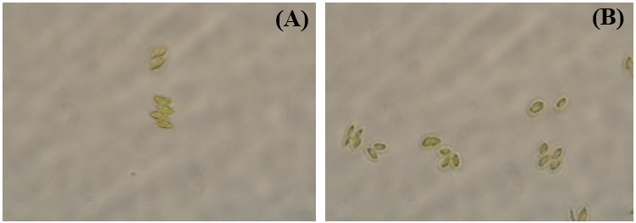
Fig S.1. The microscopic images of Scenedesmus sp. (A) before mixing duration experiment, (B) after experiment ends

Section S2: Results and Discussion
S2.1.1 Growth kinetics and biomass production of Scenedesmus sp.
Table S1. Biomass productivity and growth rate comparison for Scenedesmus sp. cultivated in raceway pond under different mixing duration systems
System | Specific growth rate | Doubling time (d) | Biomass productivity (g L⁻¹ d⁻¹) | Dry biomass Yield (g L⁻¹)
R1 | 0.1618 ± 0.0058 | 4.28 | 0.0813 | 1.013 ± 0.0117
R2 | 0.1493 ± 0.0040 | 4.64 | 0.0640 | 0.841 ± 0.0123
R3 | 0.1353 ± 0.0068 | 5.12 | 0.0482 | 0.683 ± 0.0099

S2.1.2 Change in pH, Dissolve Oxygen and Temperature
The change in pH during Scenedesmus sp. cultivation in BBM media is shown in Fig 2 (A). The initial pH level was 6.5 in all three mixing duration systems. At the end of the experiment, the R2 and R3 systems had 8.5 and 8.4 pH values, which were less than pH value of 8.9 observed for R1 system. Algal physiological activity is the primary factor influencing pH change such that the rate of CO₂ consumption by algae photosynthesis is significantly higher than the rate of CO₂ production by respiration, leading to a rise in the pH and CO₃ ²⁻ / HCO₃ – ratio (Ji et al., 2021). Continuous mixing in R1 might enhance the CO₂ uptake by Scenedesmus sp. and lower CO₂ level in culture leads to increase the pH level. In R2 and R3 systems, the mixing was stopped for a 4 and 8 hours per day, where lack of photosynthesis in these durations might help to build up the CO2 in culture and prevent rise in pH level. Also, Nitrogen absorption by microalgae influences the pH value as absorption of nitrate ions lead to increased pH (Gardner et al., 2011). The elevated 8.9 pH value in R1 system might result in dissolved CO₂ being converted into the carbonate and bicarbonates which remained unconsumed and slow down the growth of microalgae.
The Dissolved Oxygen (DO) level observed a slight increase in all three mixing duration systems as shown in Fig 2 (B). The initial DO was ranging between 5.5 to 6 mg L⁻¹ in all three mixing systems. The highest DO observed was 7.5 mg L⁻¹ in the R1 mixing duration system. The continuous mixing in the R1 system ensured maximum time for air to liquid interaction at the surface of the open raceway pond, leading to increase the transfer of atmospheric oxygen into the culture in open raceway pond (Jiménez et al., 2003). Additionally, the highest algal biomass was observed in the R1 system as compared to R2 and R3 system, leading to release more oxygen into the culture through the process of photosynthesis. Fig 2 (C) shows the temperature of the culture in open raceway pond fluctuating in the range of 24ºC to 27.5ºC for all three mixing duration systems (R1, R2 and R3). The average atmospheric temperature surrounding the open raceway pond was maintained at 25 ± 2 ºC. According to Whitton et al. (2012), most algal strains have optimum temperature ranging between 24 to 42 ºC. The temperature variations might be due to the evaporation of water vapors from the surface of open raceway pond due to heat transfer and variations of air circulation on the surface of the open raceway pond (Ryu et al., 2019).
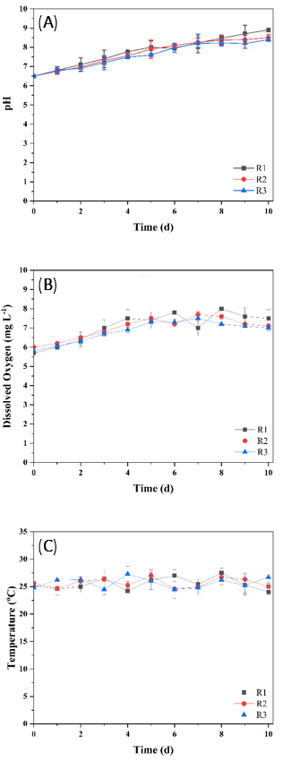
Fig S2. Temporal variations of Scenedesmus sp. grown under three different mixing duration systems. (A) pH, (B) Dissolved Oxygen, (C) Temperature in raceway systems
S2.2 Mixing error
Table S2. Identifying mixing uniformity in submersible raceway system through dry biomass comparison of Scenedesmus sp. at sequential heights of working volume
Symbols | Depths (cm) | Dry biomass (g L⁻¹)
D₁ | 4.75 | 0.2054
D₂ | 3 | 0.2054
D₃ | 1.5 | 0.2060
D₄ | 0 | 0.2061

D_{AVG} = (D₁ + D₂ + D₃ + D₄) / 4
MAE = (|D₁ – D_{AVG}| + |D₂ – D_{AVG}| + |D₃ – D_{AVG}| + |D₄ – D_{AVG}|) / 4
Where MAE is the mean absolute error (g/L) and D_{AVG} is the average of Scenedesmus sp. biomass at different depths (g/L).
S2.3 Energy Calculations

Net energy efficiency
η = W_{h} / W_{m} (S.1)
Where η is the net energy efficiency, W_{h} and W_{m} are the theoretical power and actual energy consumption for the submersible pump.
Theoretical power = W_{h} = 8 W
Actual power = W_{m} = 12.96 W (as measured through the power meter)

NER
NER = E_{out} / E_{in} (S.2)
E_{out} = (P_{E} + C_{E} + L_{E}) x 4.184 (S.3)
E_{in} = 600 x (E_{n} / C_{v}) (S.4)
Where,
Where NER is the net energy ratio of open raceway pond, E_{out} is the energy potential from the algae (MJ Kg⁻¹) and E_{in} is the energy requirement for the submersible pump operation (MJ Kg⁻¹) (Jorquera et al., 2010).
P_{E} = (% age composition of protein x P_{cv})
C_{E} = (% age composition of carbohydrate x C_{cv})
L_{E} = (% age composition of lipids x L_{cv})
En = energy of submersible pump (Kw d⁻¹),
C_{v} = dry biomass of Scenedesmus sp. in open raceway pond (g L⁻¹ d⁻¹).
The calorific values in kcal/g of protein, carbohydrate, and lipid were observed with a bomb calorimeter and verified with average caloric conversion factors (17, 23.50, and 39.31 KJ g⁻¹ for carbohydrate, protein, and lipid, respectively) mentioned in Cho et al. (1982).
Calculated values:
Energy of submersible pump = E_{n} = 0.2 KW d⁻¹
The dry biomass of micro-algae in an open raceway pond = C_{v} = 0.08 g d⁻¹
Calorific values of protein = P_{cv} = 5.65 Kcal g⁻¹
Calorific values of carbohydrate = C_{cv} = 4.1 Kcal g⁻¹
Calorific values of lipid = L_{cv} = 9.45 Kcal g⁻¹
Pump driven energy requirement
E_{R} = P_{A} / B_{D} (S.5)
Where E_{R} is the energy requirement for a submersible pump (MJ kg⁻¹), P_{A} is the power of one submersible pump (18 kW d⁻¹) and B_{D} is the dry biomass of Scenedesmus sp. per open raceway pond (kg d⁻¹).
Based on data available, the total dry biomass of Scenedesmus sp. for a 100 m² working area containing 6 open raceway ponds would be 1657.6 kg per year. A single raceway will be contributing 0.77 kg per day and the power required for a submersible pump would be 64.8 MJ per day, corresponding to an energy value (E_{in}) of 24.9 MJ. The NER can be calculated as the ratio of E_{out} to E_{in} resulting in an NER value of 0.23.

References
Cho, C. Y., Slinger, S. J., & Bayley, H. S. (1982). Bioenergetics of salmonid fishes: Energy intake, expenditure and productivity. Comparative Biochemistry and Physiology -- Part B: Biochemistry And, 73(1), 25–41. https://doi.org/10.1016/0305-0491(82)90198-5
Gardner, R., Peters, P., Peyton, B., & Cooksey, K. E. (2011). Medium pH and nitrate concentration effects on accumulation of triacylglycerol in two members of the chlorophyta. Journal of Applied Phycology, 23(6), 1005–1016. https://doi.org/10.1007/s10811-010-9633-4
Ji, L., Ge, Q., Li, Y., Gao, Y., & Xie, S. (2021). A comparative study of the growth and nutrient removal effects of five green microalgae in simulated domestic sewage. Water (Switzerland), 13(24). https://doi.org/10.3390/w13243613
Jiménez, C., Cossío, B. R., & Niell, F. X. (2003). Relationship between physicochemical variables and productivity in open ponds for the production of Spirulina: A predictive model of algal yield. Aquaculture, 221(1–4), 331–345. https://doi.org/10.1016/S0044-8486(03)00123-6
Jorquera, O., Kiperstok, A., Sales, E. A., Embiruçu, M., & Ghirardi, M. L. (2010). Comparative energy life-cycle analyses of microalgal biomass production in open ponds and photobioreactors. Bioresource Technology, 101(4), 1406–1413. https://doi.org/10.1016/j.biortech.2009.09.038
Ryu, K. H., Lee, J. Y., Heo, S., & Lee, J. H. (2019). Improved Microalgae Production by Using a Heat Supplied Open Raceway Pond. Industrial and Engineering Chemistry Research, 58(21), 9099–9108. https://doi.org/10.1021/acs.iecr.9b00986
Whitton, B. A. (2012). Ecology of cyanobacteria II: Their diversity in space and time. Ecology of Cyanobacteria II: Their Diversity in Space and Time, 9789400738, 1–760. https://doi.org/10.1007/978-94-007-3855-3

