Appendices
Appendix A. Study process table
 | Process step |  | Activities
Pilot intervention | Prior to the pilot intervention |  | - Co-construction of the intervention tasks and tests  - Informed consent procedure
Pilot intervention | Pilot intervention | Control group | - Pre-intervention assessment  - Post-intervention assessment
Pilot intervention |  | Intervention group | - Observation of a math lesson  - Pre-intervention assessment  - 3 in class and 2 homework intervention tasks  - Post-intervention assessment
Pilot intervention | After the pilot intervention |  | - Analysis of the effectiveness of the pilot intervention  - Feedback to the teachers  - Amendments to the intervention
The current study | Prior to the intervention |  | - Informed consent procedure for the intervention  - Preparing the intervention group teachers for the intervention
The current study | Intervention | Control group | - Pre-intervention assessment  - Post-intervention assessment  - Delayed post-intervention assessment
The current study |  | Intervention group | - Observation of practice lesson of functions  - Pre-intervention assessment  - 3 in class and 2 homework intervention tasks  - Observation of an intervention task lesson  - Post-intervention assessment  - Delayed post-intervention assessment
The current study | After the intervention |  | - Analysis of the effectiveness of the intervention  - Feedback to the teachers of the intervention

Appendix B. An English translation of the Estonian questionnaire regarding functions which was presented to the students during all assessments
Here are statements about learning functions. Mark how well each statement describes You. Choose an answer from the given scale, where 1 = completely disagree, 2 = somewhat disagree, 3 = do not agree or disagree, 4 = somewhat agree, 5 = completely agree.
1. Compared to my classmates I am doing well when it comes to solving tasks about functions. | 1 | 2 | 3 | 4 | 5
2. I understand function tasks well. | 1 | 2 | 3 | 4 | 5
3. Solving tasks about functions is difficult for me. | 1 | 2 | 3 | 4 | 5
4. I am doing well when it comes to solving tasks about functions. | 1 | 2 | 3 | 4 | 5
5. Knowing how to use functions is useful for me in other subjects. | 1 | 2 | 3 | 4 | 5
6. Knowing how to use functions is useful for me in the future. | 1 | 2 | 3 | 4 | 5
7. Knowing how to use functions is useful for me. | 1 | 2 | 3 | 4 | 5
8. Knowing how to use functions is useful for me in my everyday life. | 1 | 2 | 3 | 4 | 5

Appendix C. Open-ended utility answers coding guide
Coding category | Examples of answers
Not useful | „Functions are not useful.“  „There is no need for functions when we have calculators.“
Do not know | „I do not remember.“  „I do not know.“
Non-specific utility | „Knowing how to use functions is useful for brain development.“  „Knowing how to use functions is useful for getting into high school.“  „Functions are useful for the future.“  „Knowing how to use functions is useful for doing well in future math.“
Specific utility | „Functions are useful for construction workers/engineering.“
Specific function-related utility | „Functions provide a way to show data on a graph to give a better overview of results.“  „Functions can be used to understand how things relate to one another in a linear way.“

Appendix D. Example of an intervention task translated from Estonian to English
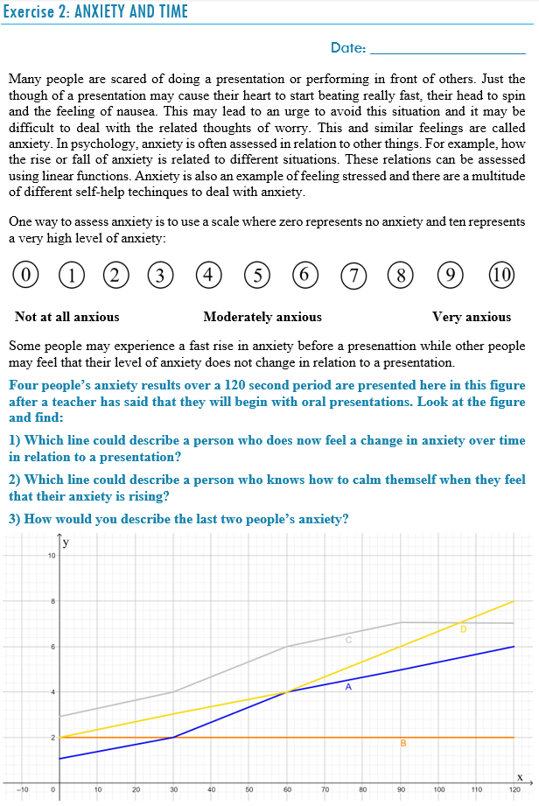
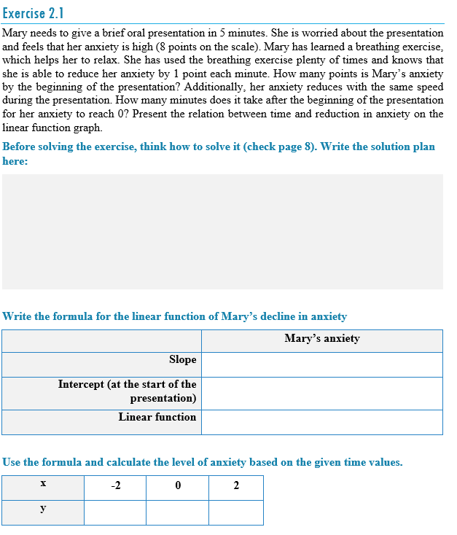
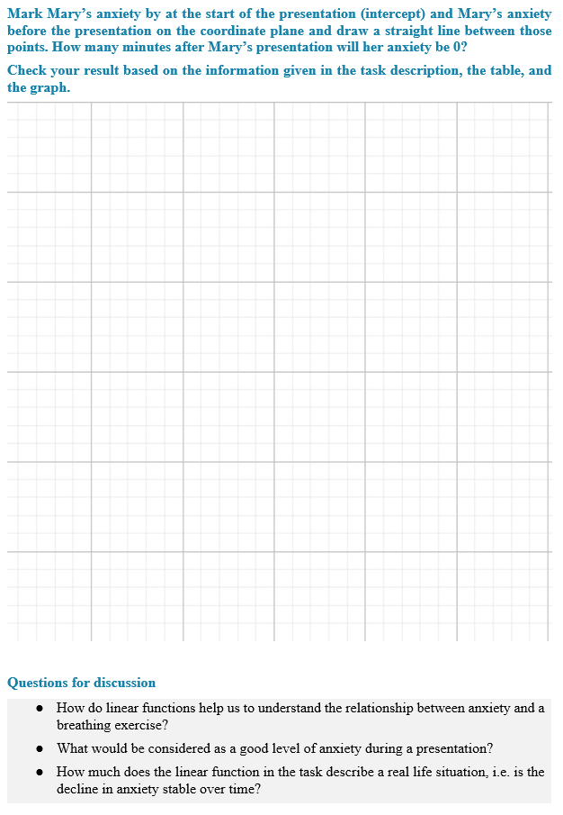
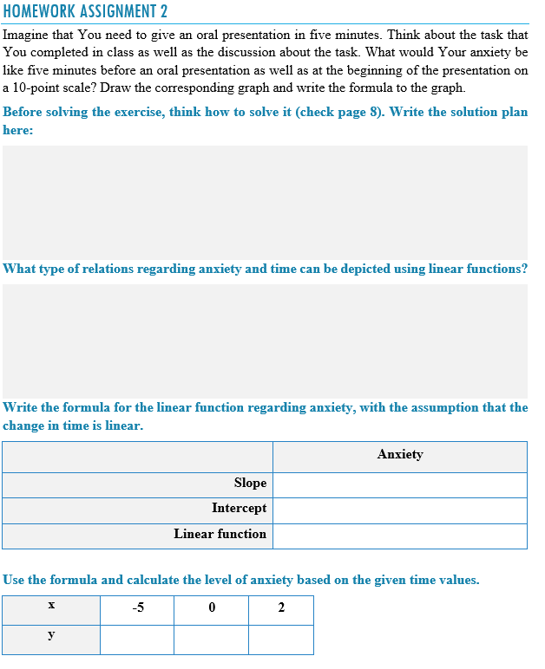
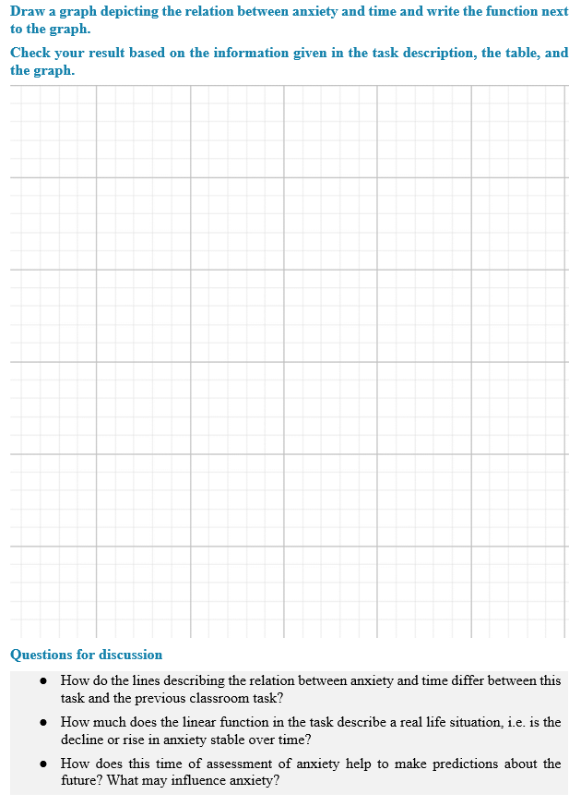

Appendix E.1 Correlations between all measures of analyses
 |  | 1. | 2. | 3. | 4. | 5. | 6. | 7. | 8. | 9. | 10. | 11. | 12. | 13. | 14. | 15.
Pre-intervention | 1. Textbook-type tasks | - | .342* | .413* | .080 | .124 | .556* | -.032 | .464* | .112 | -.013 | .625* | .079 | .260* | -.080 | -.249*
Pre-intervention | 2. Real-life tasks | .279* | - | .192 | .295* | .310* | .065 | .054 | .100 | .204 | .028 | .179 | .190 | .171 | .111 | .040
Pre-intervention | 3. Self-efficacy Q | .507* | .217 | - | .354* | .316* | .348* | -.032 | .387* | .226* | .119 | .236 | .059 | .321* | .180 | -.055
Pre-intervention | 4. Utility value Q | -.087 | -.085 | .172 | - | .350* | .224 | -.076 | .379* | .738* | .244* | .065 | -.050 | .277* | .595* | .188
Pre-intervention | 5. Utility value O | .314* | .034 | .231 | .024 | - | -.019 | -.157 | .261* | .115 | .150 | .202 | .026 | .168 | .149 | .232
Post-intervention | 6. Textbook-type tasks | .480* | .239 | .370* | -.167 | .204 | - | .066 | .457* | .195 | .005 | .398* | -.011 | .202 | .028 | -.093
Post-intervention | 7. Real-life tasks | -.001 | .248 | .039 | -.163 | .118 | .201 | - | .108 | -.078 | .048 | .268 | .349* | .010 | -.078 | -.100
Post-intervention | 8. Self-efficacy Q | .435* | .073 | .542* | -.071 | .298* | .507* | .340* | - | .364* | .328* | .366* | .166 | .611* | .338* | .188
Post-intervention | 9. Utility value Q | .196 | -.056 | .314* | .481* | .293* | .099 | .131 | .384* | - | .417* | .169 | .085 | .283* | .589* | .210
Post-intervention | 10. Utility value O | .246 | -.123 | .146 | .233 | .366* | -.013 | .209 | .138 | .289* | - | .162 | .033 | .394* | .254* | .611*
Delayed post-inter. | 11. Textbook-type tasks | .455* | .193 | .327* | -.081 | .226 | .676* | .312* | .494* | .126 | .306* | - | .185 | .297* | -.203 | -.169
Delayed post-inter. | 12. Real-life tasks | .168 | .153 | .283 | -.187 | .133 | .463* | .499* | .426* | -.095 | .006 | .443* | - | .059 | .008 | -.128
Delayed post-inter. | 13. Self-efficacy Q | .481* | .094 | .512* | -.177 | .304* | .574* | .145 | .738* | .194 | .130 | .617* | .368* | - | .445* | .283*
Delayed post-inter. | 14. Utility value Q | .228 | .235 | .166 | .468* | .275* | .203 | .061 | .052 | .470* | .315* | .044 | -.157 | .163 | - | .411*
Delayed post-inter. | 15. Utility value O | .474* | -.058 | .254 | .149 | .093 | .287 | .147 | .181 | .144 | .313* | .264 | .272 | .178 | .080 | -
Note. Results below the diagonal are for the intervention group, above the diagonal for the control group. Q – questionnaire, O – open-ended, * - p < .05.

Appendix F.1 Post-intervention first real-life task Configural Frequency Analysis
Group | Slope | Intercept | Formula | Graph | Task answer | Observed counts | Expected counts
Control | 0 | 0 | 0 | 0 | 0 | 4 | 0.04
Control | 0 | 0 | 0 | 1 | 0 | 1 | 0.05
Control | 0 | 1 | 0 | 0 | 0 | 4 | 0.37
Intervention | 0 | 1 | 0 | 0 | 0 | 8 | 1.07
Intervention | 1 | 1 | 1 | 1 | 1 | 21 | 5.7
Note. p < .05 for all results in the table.
Appendix F.2 Post-intervention second real-life task Configural Frequency Analysis
Group | Slope | Intercept | Formula | Graph | Task answer | Observed counts | Expected counts
Control | 0 | 0 | 0 | 0 | 0 | 3 | 0.004
Control | 0 | 0 | 0 | 1 | 1 | 1 | 0.02
Control | 1 | 1 | 1 | 0 | 0 | 6 | 1.60
Intervention | 0 | 0 | 0 | 0 | 0 | 2 | 0.01
Intervention | 0 | 1 | 0 | 0 | 0 | 2 | 0.08
Intervention | 1 | 1 | 1 | 1 | 1 | 35 | 15.46
Note. p < .05 for all results in the table.
Appendix F.3 Delayed post-intervention first real-life task Configural Frequency Analysis
Group | Slope | Intercept | Formula | Graph | Task answer | Observed | Expected
Control | 0 | 1 | 0 | 0 | 0 | 6 | 0.66
Control | 0 | 0 | 0 | 0 | 1 | 1 | 0.04
Control | 0 | 1 | 0 | 0 | 1 | 5 | 0.90
Intervention | 1 | 1 | 1 | 1 | 1 | 12 | 2.79
Note. p < .05 for all results in the table.
Appendix F.4 Delayed post-intervention second real-life task Configural Frequency Analysis
Group | Slope | Intercept | Formula | Graph | Task answer | Observed counts | Expected counts
Control | 0 | 0 | 0 | 0 | 0 | 2 | 0.03
Control | 1 | 0 | 0 | 0 | 0 | 2 | 0.11
Control | 0 | 0 | 0 | 0 | 1 | 1 | 0.03
Control | 0 | 1 | 1 | 0 | 0 | 3 | 0.56
Control | 1 | 1 | 1 | 0 | 0 | 8 | 2.33
Intervention | 0 | 0 | 0 | 0 | 0 | 1 | 0.05
Intervention | 1 | 0 | 0 | 0 | 0 | 2 | 0.21
Intervention | 0 | 0 | 0 | 0 | 1 | 1 | 0.06
Intervention | 1 | 1 | 1 | 1 | 1 | 23 | 5.75
Note. p < .05 for all results in the table.

