Supplementary Figures and Tables
eFigure 1: Histogram of Median Normalized Weights of SNPs in the Genetic Risk Score
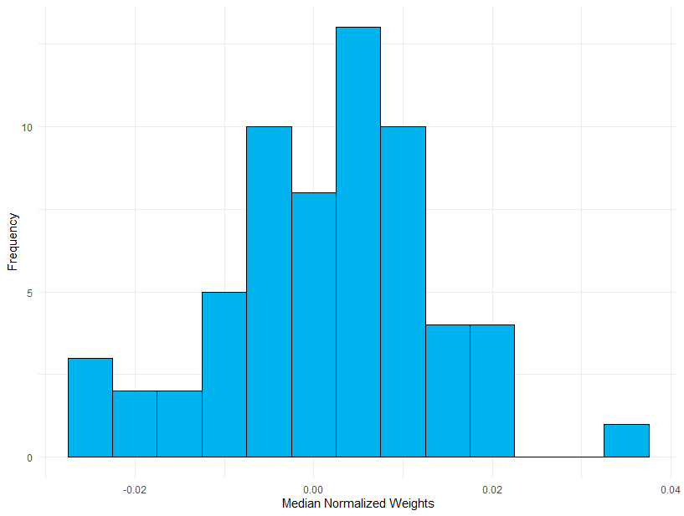

eFigure 2: Decorrelating Effect of Construction of Risk Scores
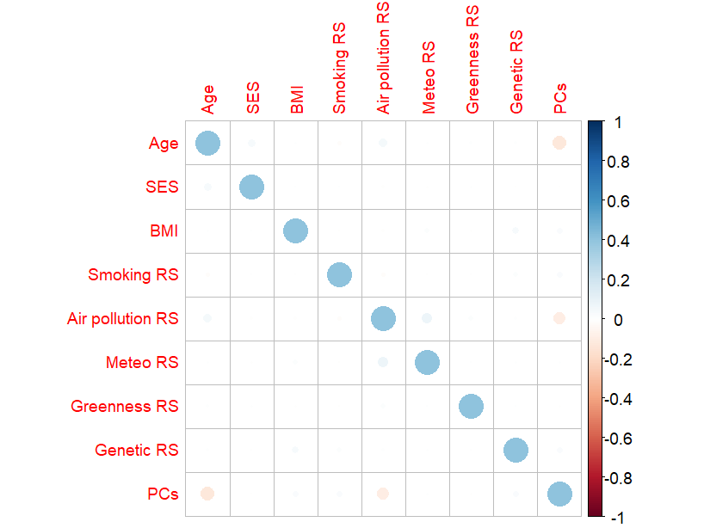

eFigure 3: Relative Contribution when GRS is excluded from the analysis
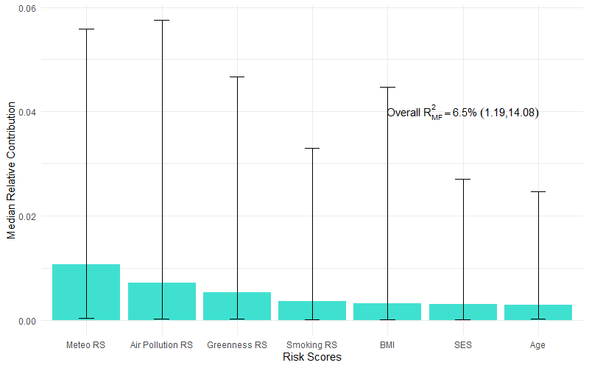
eFigure 4: Estimated Odds Ratios when GRS is excluded from the analysis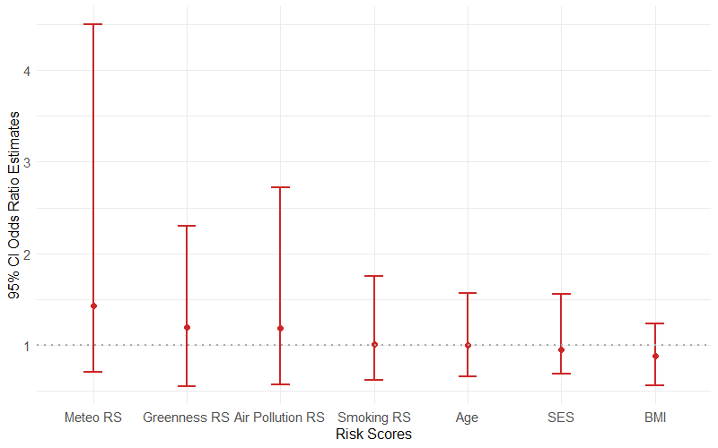

eTable 1. Cross Leverage Scores and Median Normalized Weights of 50 SNPs included in the GRS

SNP | Chromosome | Position | Normalized Weights | Rank by Normalized Weights | CLS | Rank by Absolute CLS
rs10759210 | 9 | 96731696 | 0.0220 | 5 | 6.31E-07 | 1
rs10788672 | 1 | 17460989 | -0.0062 | 32 | 5.41E-07 | 27
rs11108368 | 12 | 95992360 | -0.0089 | 36 | -5.40E-07 | 36
rs1156201 | 14 | 87292785 | -0.0134 | 41 | 5.49E-07 | 20
rs11951482 | 5 | 1.05E+08 | 0.0205 | 7 | 5.46E-07 | 23
rs12588718 | 14 | 1.01E+08 | -0.0115 | 38 | -5.74E-07 | 47
rs12638589 | 3 | 1.82E+08 | 0.0073 | 16 | 5.65E-07 | 11
rs12700261 | 7 | 21169448 | 0.0272 | 3 | 5.41E-07 | 26
rs13043054 | 20 | 43325757 | -0.0076 | 35 | -5.43E-07 | 41
rs1344740 | 2 | 82093530 | -0.0071 | 34 | 5.56E-07 | 14
rs1352437 | 4 | 83834043 | 0.0329 | 2 | 5.61E-07 | 13
rs138262316 | 18 | 71605320 | 0.0002 | 25 | -6.03E-07 | 50
rs17684937 | 8 | 2149971 | -0.0156 | 46 | 6.22E-07 | 2
rs1887319 | 20 | 10941498 | -0.0143 | 42 | -5.43E-07 | 40
rs2214576 | 16 | 74009285 | -0.0038 | 30 | -5.38E-07 | 33
rs2268057 | 1 | 71017190 | 0.0118 | 11 | -5.45E-07 | 42
rs2284786 | 11 | 1.29E+08 | 0.0056 | 19 | -5.47E-07 | 43
rs2780980 | 9 | 83619681 | 0.0552 | 1 | 5.63E-07 | 12
rs30101 | 5 | 53121469 | -0.0011 | 27 | -5.41E-07 | 38
rs3130274 | 6 | 33363123 | 0.0212 | 6 | -5.49E-07 | 44
rs34251 | 5 | 1.04E+08 | -0.0066 | 33 | 5.47E-07 | 22
rs3853729 | 3 | 1.69E+08 | 0.0164 | 9 | 5.35E-07 | 28
rs41523449 | 19 | 35046802 | 0.0062 | 18 | -5.70E-07 | 46
rs4340170 | 13 | 24920485 | 0.0115 | 12 | 5.54E-07 | 16
rs4536481 | 16 | 27909786 | -0.0133 | 40 | -5.42E-07 | 39
rs4556888 | 18 | 49548938 | 0.0011 | 24 | -5.98E-07 | 48
rs4732135 | 7 | 1.36E+08 | 0.0246 | 4 | 5.51E-07 | 18
rs4879657 | 9 | 33012467 | 0.0032 | 21 | 5.68E-07 | 9
rs532625 | 13 | 1.1E+08 | 0.0082 | 15 | -6.01E-07 | 49
rs56095271 | 15 | 79228562 | -0.0060 | 31 | 5.72E-07 | 8
rs57869271 | 20 | 48213585 | 0.0200 | 8 | 5.75E-07 | 6
rs6065705 | 20 | 44112474 | -0.0235 | 50 | 5.73E-07 | 7
rs62345028 | 4 | 1.85E+08 | -0.0156 | 45 | 5.44E-07 | 25
rs6502987 | 17 | 6914229 | 0.0022 | 22 | 5.34E-07 | 29
rs6570819 | 6 | 1.48E+08 | -0.0124 | 39 | 5.48E-07 | 21
rs6590783 | 11 | 1.35E+08 | 0.0107 | 13 | -5.39E-07 | 35
rs6749415 | 2 | 2.16E+08 | 0.0014 | 23 | 5.65E-07 | 10
rs6908376 | 6 | 19825074 | -0.0220 | 48 | -5.41E-07 | 37
rs7330704 | 13 | 22964548 | -0.0109 | 37 | 5.53E-07 | 17
rs7364985 | 1 | 1.1E+08 | -0.0146 | 43 | 5.32E-07 | 30
rs7586824 | 2 | 2.28E+08 | -0.0027 | 29 | 5.79E-07 | 4
rs766674 | 2 | 1.37E+08 | -0.0010 | 26 | -5.35E-07 | 32
rs782926 | 15 | 61112423 | -0.0155 | 44 | -5.39E-07 | 34
rs7926545 | 11 | 31928036 | -0.0231 | 49 | -5.59E-07 | 45
rs8069832 | 17 | 2027066 | 0.0105 | 14 | 5.50E-07 | 19
rs847441 | 7 | 16977934 | 0.0067 | 17 | 5.46E-07 | 24
rs9809154 | 3 | 1.09E+08 | 0.0133 | 10 | 5.77E-07 | 5
rs9834892 | 3 | 10947509 | 0.0039 | 20 | 5.55E-07 | 15
rs994741 | 8 | 95884286 | -0.0018 | 28 | 5.30E-07 | 31
rs9964759 | 18 | 12618423 | -0.0162 | 47 | 5.86E-07 | 3

eTable 2. Relative Contribution and Odds Ratios of Sensitivity Analysis with allergies defined with High IgE Levels
Variable | Relative Contribution (%) |  | Odds Ratio
GRS | 3.84% | (0.28, 11.81) | 2.04 | (1.19, 4.07)
Meteo RS | 0.94% | (0.05, 5.66) | 1.37 | (0.54, 4.74)
Air Pollution RS | 0.76% | (0.05, 5.20) | 1.23 | (0.54, 3.07)
Greenness RS | 0.55% | (0.01, 4.55) | 1.28 | (0.63, 2.28)
Smoking RS | 0.34% | (0.01, 2.67) | 1.00 | (0.63, 2.28)
SES | 0.31% | (0.01, 2.67) | 0.95 | (0.68, 1.50)
BMI | 0.31% | (0.01, 4.37) | 0.88 | (0.52, 1.22)
Age | 0.30% | (0.02, 2.85) | 0.97 | (0.60, 1.60)

