Supplementary Data

Unraveling the role of CACNA1F, RASAL1, GARIN4, and TRIM56 in common opioid side effects via transcriptomic analysis of differentiated neuron-like SH-SY5Y cells

Aly Abotaleb¹,²*, Nguyen Phan Khoi Le³,⁴, Sara Tucci¹, Martin J. Hug¹, Evelyn Lamy³,⁴, Stefan Günther²*
AUTHOR ADDRESS
¹ Pharmacy, Medical Center – University of Freiburg, Freiburg, Germany
² Institute of Pharmaceutical Sciences, Faculty of Chemistry and Pharmacy, University of Freiburg, Freiburg, Germany
³ Molecular Preventive Medicine, University Medical Center and Faculty of Medicine, University of Freiburg, Freiburg, Germany
⁴ Chair for Research of Environment-Related Mechanisms of Action on Health, Medical Faculty, University of Augsburg, Augsburg, Germany
⁵ Department of Microbiology and Immunology, Pasteur Institute in Ho Chi Minh City, Ho Chi Minh City, Vietnam

*Corresponding authors
Aly Abotaleb; aly.abotaleb@uniklinik-freiburg.de
Stefan Günther; stefan.guenther@pharmazie.uni-freiburg.de
Table of Contents
Figure S1. Per Sequence GC Content: 2
Figure S2. Sequence Count: 3
Figure S3. Per Sequence Quality Scores: 4
Figure S4. Mean Quality Score: 5
Table S1. Downregulated Genes After Opioid Treatment 6

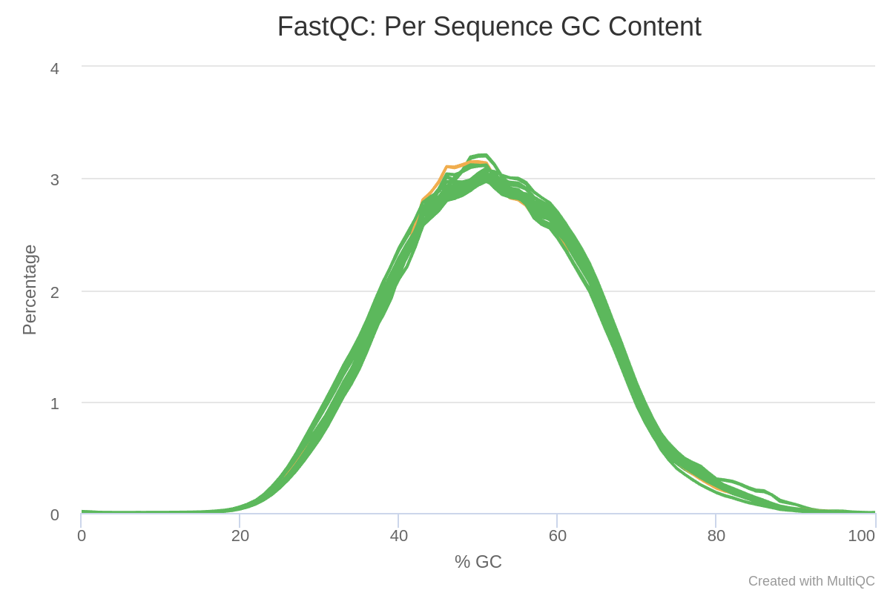

Figure S1. Per Sequence GC Content:
Displays the distribution of GC content across all sequences. A normal distribution suggests uniform GC content.

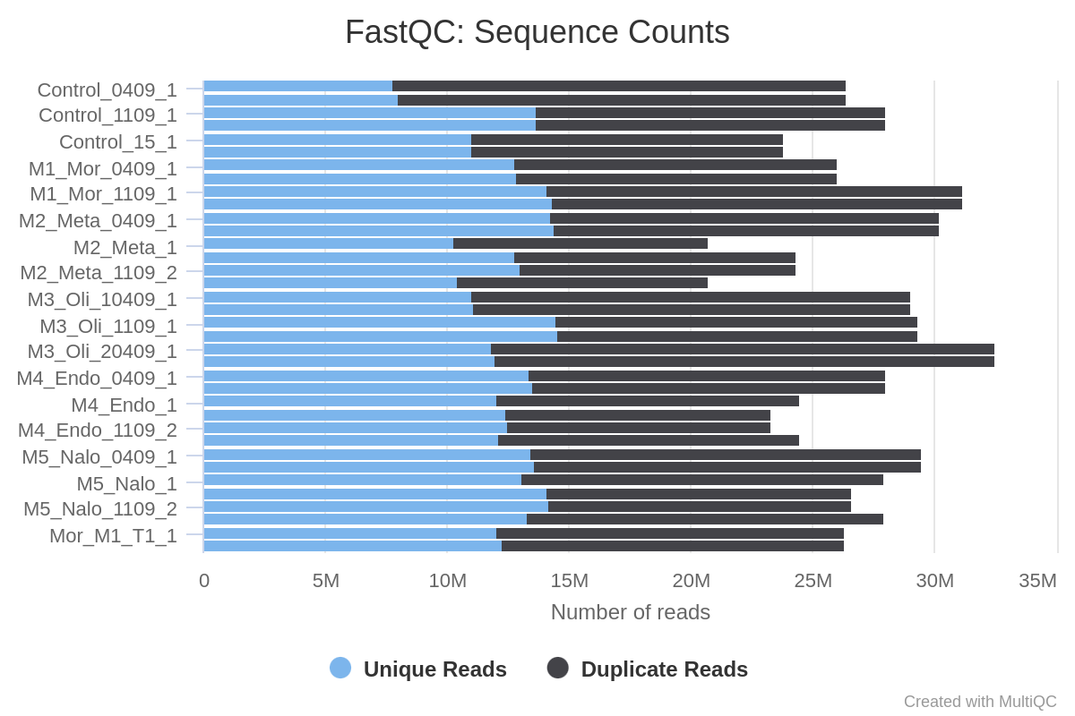

Figure S2. Sequence Count:
Indicates the total number of reads in the sequencing dataset. A higher read count improves transcriptome coverage and statistical robustness in downstream analysis.

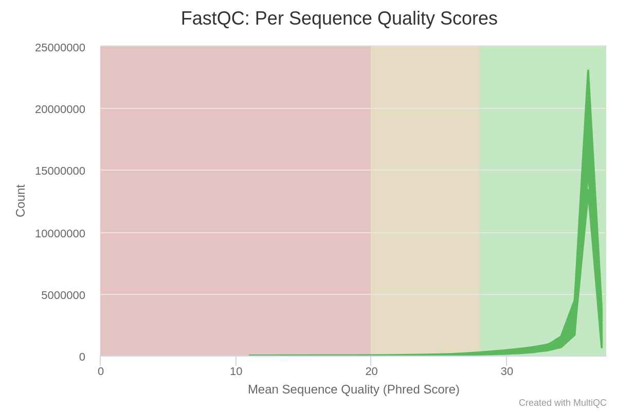

Figure S3. Per Sequence Quality Scores:
Shows the average quality score per read. Most reads are expected to have high Phred scores, indicating good base call accuracy

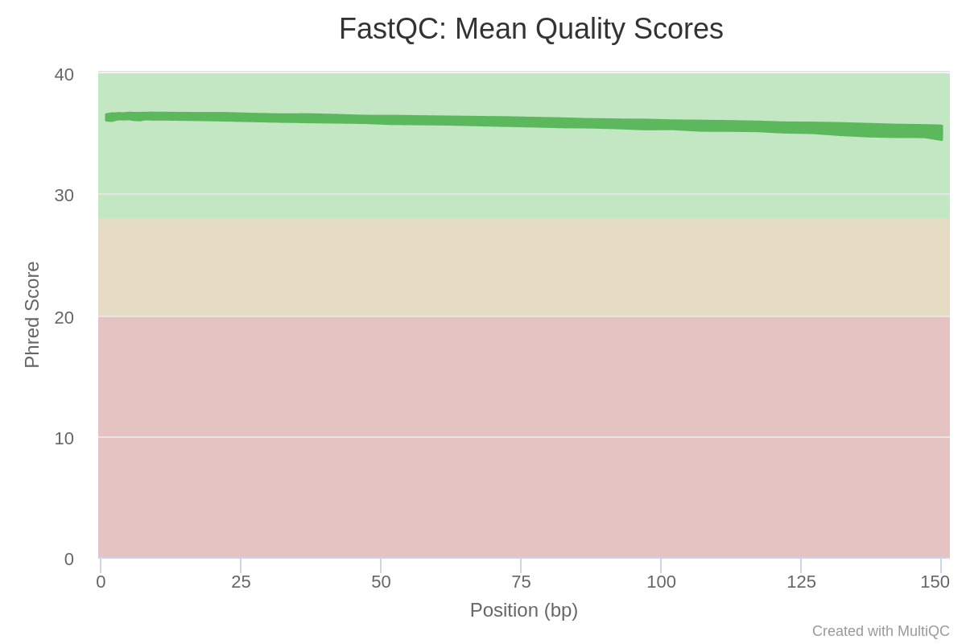

Figure S4. Mean Quality Score:
Represents the average Phred quality score across all bases and reads in the dataset. A high mean quality score reflects overall sequencing reliability.

Ensembl | baseMean | log2FoldChange | pvalue | padj | Gene Symbol | Gene Name
ENSG00000235862 | 4.28 | -4.33 | 2.34E-07 | 0.003
ENSG00000162771 | 4.21 | -4.48 | 6.69E-08 | 0.002 | Q8IYT1 | GARIN4
ENSG00000169871 | 11.45 | -3.97 | 1.02E-05 | 0.040 | Q9BRZ2 | TRIM56_HUMAN
ENSG00000102001 | 10.25 | -5.52 | 1.98E-06 | 0.011 | O60840 | CACNA1F
ENSG00000180210 | 5.97 | -3.16 | 1.95E-05 | 0.049 | P00734 | F2
ENSG00000111344 | 7.01 | -3.54 | 1.26E-05 | 0.043 | O95294 | RASAL1
ENSG00000274376 | 10.09 | -2.84 | 3.50E-06 | 0.016
ENSG00000167483 | 20.26 | -2.38 | 1.78E-05 | 0.049 | Q86XR2 | NIBAN3
ENSG00000279175 | 5.39 | -4.65 | 1.45E-05 | 0.044
ENSG00000280800 | 16.27 | -4.06 | 7.07E-07 | 0.005
ENSG00000281383 | 18.44 | -3.57 | 2.73E-07 | 0.003

Table S1. Downregulated Genes After Opioid Treatment
Table S1. List of significantly downregulated genes in SH-SY5Y cells treated with opioids for 15 minutes. The table includes Ensembl ID, base mean expression, log2 fold change, p-value, adjusted p-value (padj), gene symbol, and gene name.

