Supplemental Materials

Figures
Figure S1: The NLR spatiotemporal pattern representation for four randomly-selected patients from our study cohort.
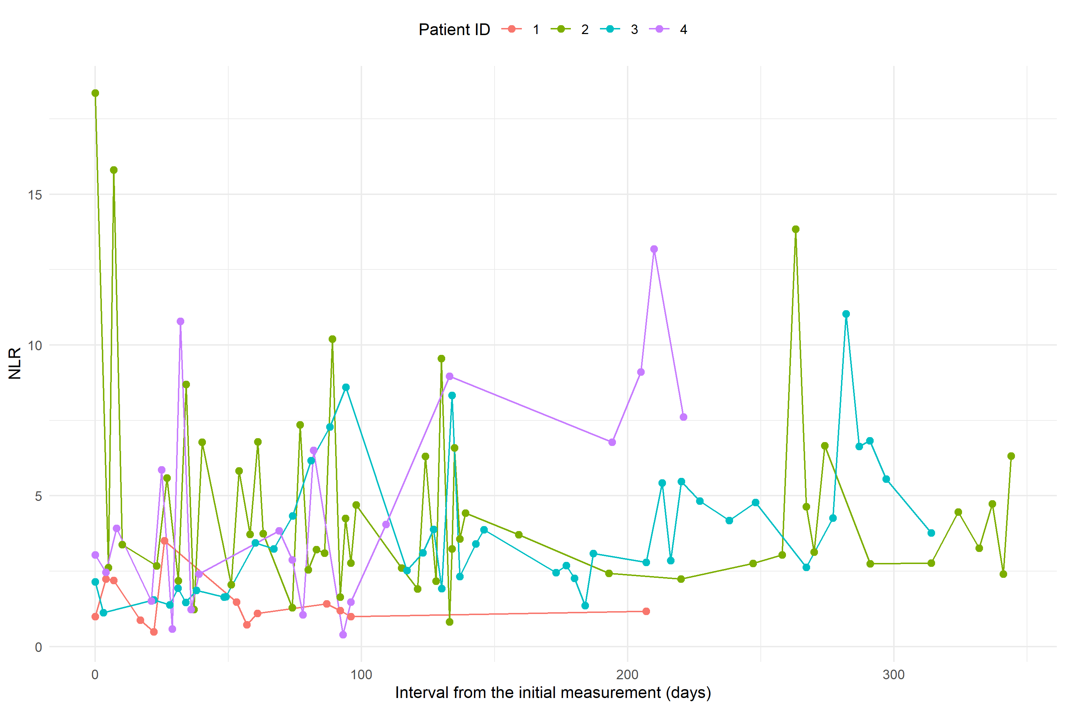
NLR: neutrophil to lymphocyte ratio.
Notes: Patient IDs were de-identified and converted to numerics (i.e., 1, 2, 3, 4).

Figure S2: Comparison of survival curves (end event: adverse cardiac events [ACEs]) in groups with different inflammation status.
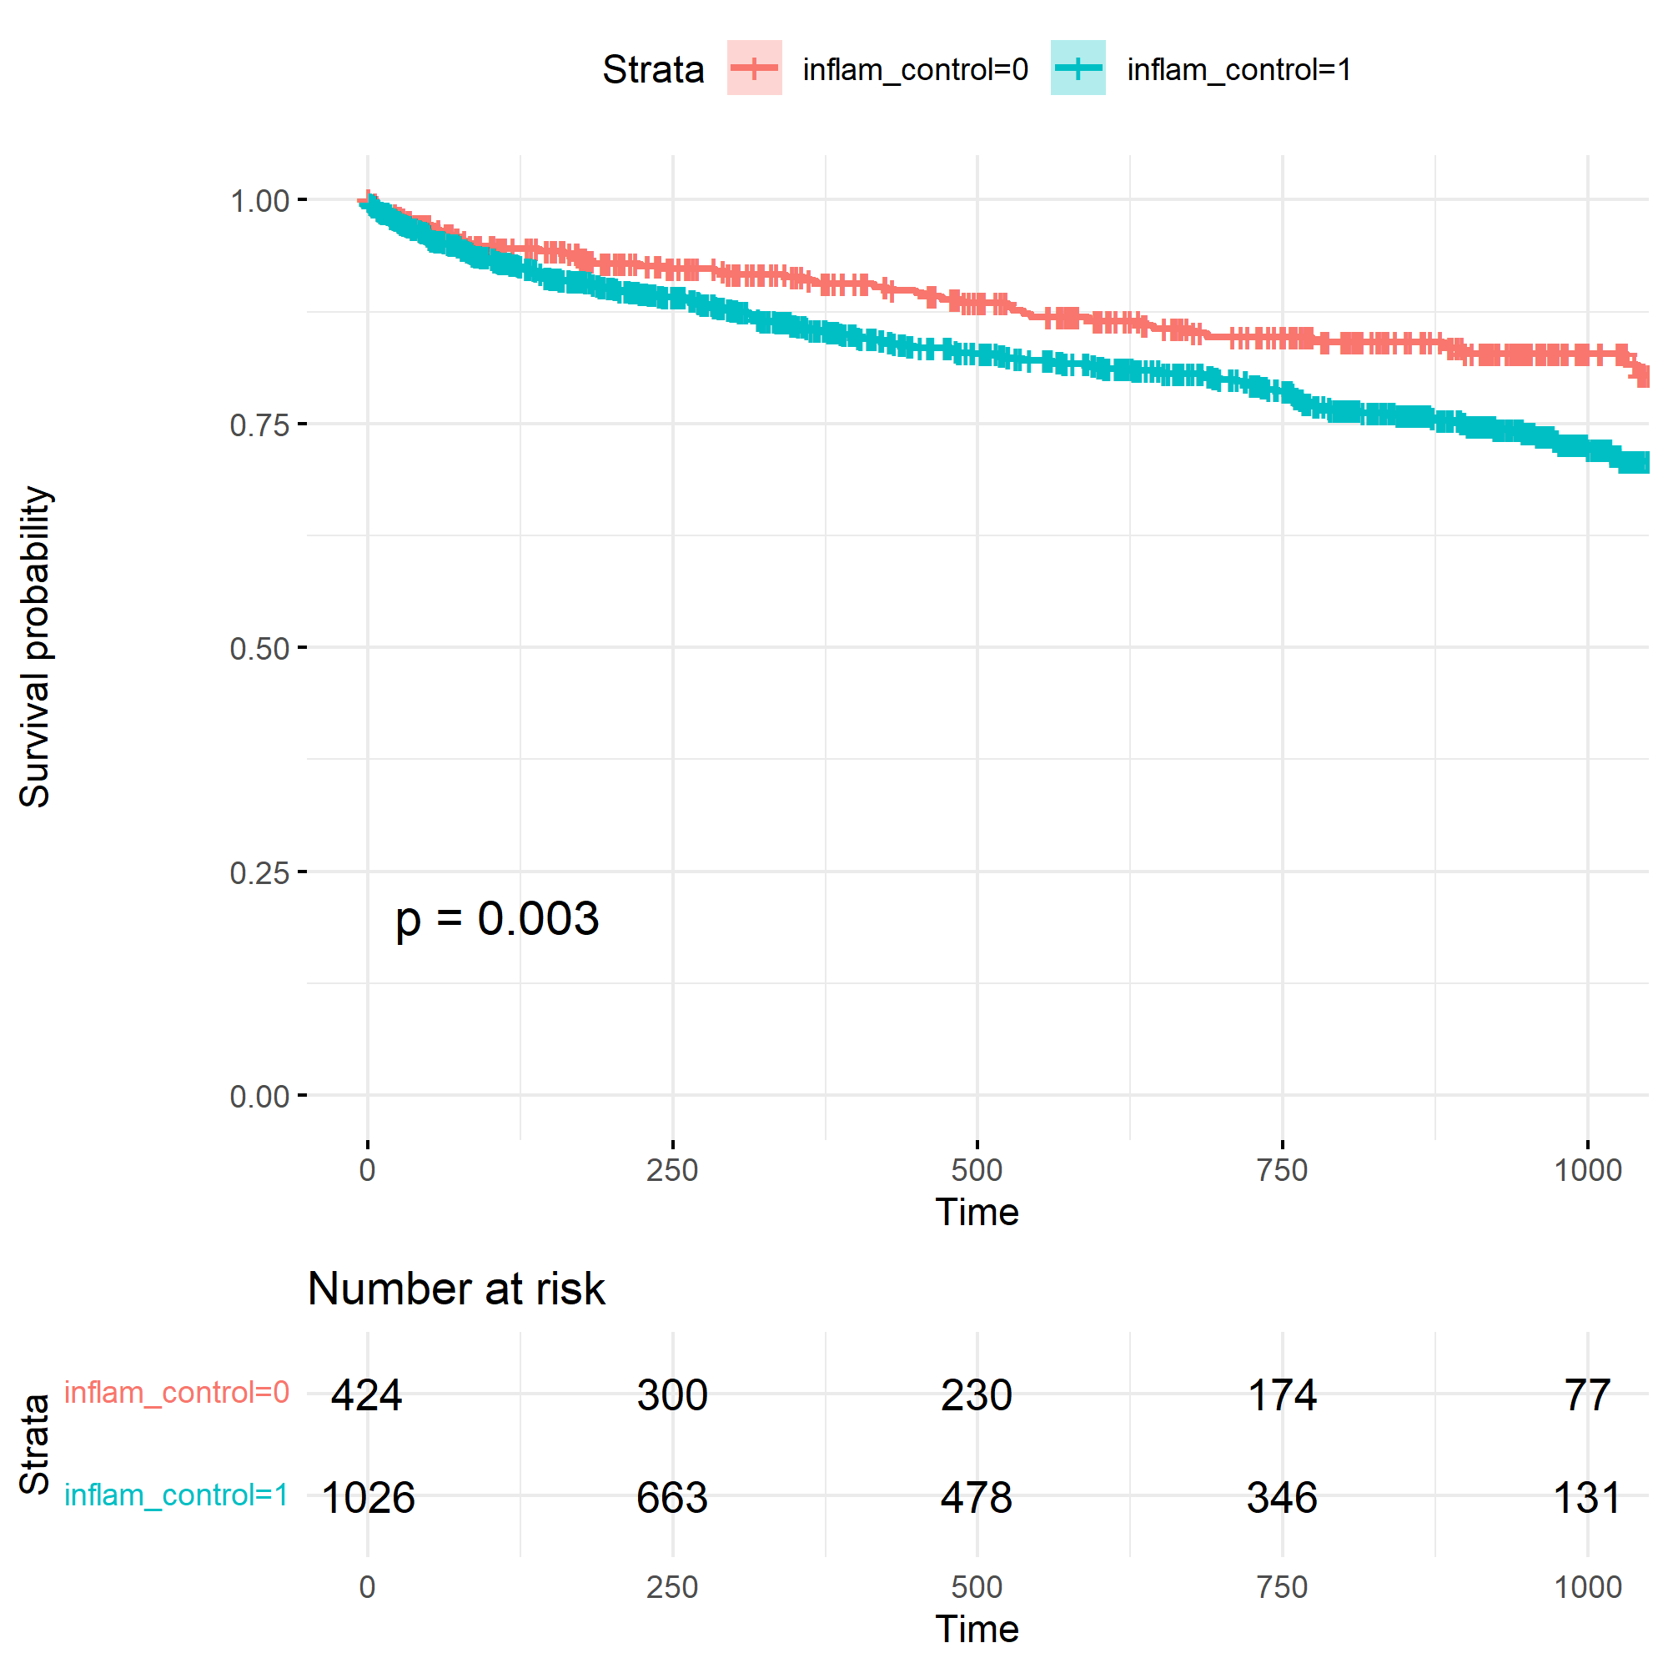
Inflam_control = 0 (well-controlled inflammation) vs. inflam_control = 1 (poorly controlled inflammation). End event: adverse cardiac events (ACEs).
*Survival curves start 1 year after the initial diagnosis of NSCLC.

Tables
Table S1: Distribution of the initial platinum-based compounds
NO | Drug Name | Frequency
1 | Oxaliplatin Mannitol | 5
2 | Oxaliplatin | 15
3 | Cisplatin | 536
4 | Carboplatin | 185
5 | Lobaplatin | 89
6 | Nedaplatin | 125
7 | total | 955

Table S2: List of adverse cardiac events.
NO | Chinese Name | English Name | ICD-10 Code
1 | 冠状动脉粥样硬化 | Coronary Artery Atherosclerosis | I25.1
2 | 冠心病 | Coronary Heart Disease (CHD) | I25.9
3 | 缺血性心肌病 | Ischemic Cardiomyopathy | I25.5
4 | 冠状动脉性心脏病 | Coronary Artery Heart Disease | I25.9
5 | 缺血性心肌病 | Ischemic Cardiomyopathy | I25.5
6 | 心房颤动 | Atrial Fibrillation (AF) | I48.0
7 | 心绞痛 | Angina Pectoris | I20.9
8 | 慢性心功能不全 | Chronic Heart Failure (CHF) | I50.9
9 | 心脏病 | Heart Disease | I25.9
10 | 心梗 | Myocardial Infarction (MI) | I21.9
11 | 心房恶性肿瘤 | Malignant Tumor of the Atria | C32.0*
12 | 心肌梗塞 | Myocardial Infarction (MI) | I21.9
13 | 心肌缺血 | Myocardial Ischemia | I25.2
14 | 心脏支架 | Cardiac Stent (Coronary Artery Stent) | Z95.5
*Atrial tumors, such as atrial myxomas, may be coded under this

Table S3: Sub-models of the causal mediation analysis
 | Dependent variable:
 | Max NLR | ACEs (0/1)
 | OLS  (model 1) | Logistic  (model 2)
Max NLR |  | 0.019***  (0.006)
plan | 2.445***  (0.614) | 0.392**  (0.163)
age | 0.024  (0.040) | 0.031***  (0.010)
sex | 0.413  (0.578) | 0.062  (0.148)
Baseline NLR | 0.062  (0.073) | -0.022  (0.021)
dm | 0.308  (0.902) | 0.371*  (0.208)
htn | -0.496  (0.697) | 0.024  (0.174)
Constant | 7.260***  (2.569) | -4.034***  (0.667)
Observations | 1,450 | 1,450
R² | 0.014
Adjusted R² | 0.010
Log Likelihood |  | -638.408
Akaike Inf. Crit. |  | 1,292.815
Residual Std. Error | 10.719 (df = 1443)
F Statistic | 3.484*** (df = 6; 1443)
Significance Levels:* p < 0.1, ** p < 0.05, *** p < 0.01

The standard errors are provided in parentheses below each coefficient.
Abbreviations: NLR, neutrophil-to-lymphocyte ratio; DM, diabetes mellitus; htn, hypertension
Note: chd is zero across all patients and was thus omitted from the modeling process.
Plan: 1, platinum-based chemotherapy; 0, no platinum-based chemotherapy
Model 1: Association between all covariates (X) and maximum NLR (y)
Model 2: Association between all covariates, maximum NLR (X), and risk of ACEs (y)

Table S4. Sensitivity analysis results
 | BMI Added  (N = 1188) |  | Smoking Added  (N = 920) |  | Smoking + BMI (Simultaneous Inclusion) (N = 920) |  | Well-Controlled vs. Not  (N = 1450) |  | Alternative Outcome Definition  (N = 1450)
 | Estimate | p-value | Estimate | p-value | Estimate | p-value | Estimate | p-value | Estimate | p-value
ACME (control) | 0.004917  (0.000800, 0.01) | 0.010 ** | 0.00441  (0.000065, 0.01) | 0.044 * | 0.00443  (0.000061, 0.01) | 0.044 * | 0.004869 (0.000353, 0.01) | 0.030 * | 0.00515 (0.00120, 0.01) | <2e-16 ***
ACME (treated) | 0.005996  (0.000923, 0.01) | 0.010 ** | 0.00532  (0.000071, 0.02) | 0.044 * | 0.00535  (0.000071, 0.02) | 0.044 * | 0.006312 (0.000400, 0.01) | 0.030 * | 0.00666 (0.00167, 0.02) | <2e-16 ***
ADE (control) | 0.038515  (-0.005313, 0.08) | 0.094 . | 0.0377  (-0.016, 0.08) | 0.166 | 0.0377  (-0.016, 0.08) | 0.166 | 0.049230 (0.009506, 0.09) | 0.018 * | 0.04946 (0.00791, 0.09) | 0.02 *
ADE (treated) | 0.039594  (-0.005590, 0.08) | 0.094 . | 0.0386  (-0.0166, 0.09) | 0.166 | 0.0386  (-0.0164, 0.09) | 0.166 | 0.050673 (0.009676, 0.09) | 0.018 * | 0.05097 (0.00816, 0.09) | 0.02 *
Total Effect | 0.044510  (-0.000660, 0.09) | 0.052 . | 0.043  (-0.00811, 0.09) | 0.106 | 0.043  (-0.0084, 0.09) | 0.106 | 0.055542 (0.013405, 0.10) | 0.010 ** | 0.05612 (0.01402, 0.10) | 0.01 **
Prop. Mediated (control) | 0.110462  (-0.107411, 0.80) | 0.062 . | 0.102  (-0.508, 1.13) | 0.150 | 0.103  (-0.515, 1.07) | 0.146 | 0.087660 (0.003862, 0.34) | 0.040 * | 0.09177 (0.02042, 0.39) | 0.01 **
Prop. Mediated (treated) | 0.134702  (-0.091885, 0.81) | 0.062 . | 0.124  (-0.461, 1.13) | 0.150 | 0.124  (-0.475, 1.07) | 0.146 | 0.113638 (0.005284, 0.37) | 0.040 * | 0.11875 (0.02933, 0.42) | 0.01 **
ACME (average) | 0.005456  (0.000877, 0.01) | 0.010 ** | 0.00486  (0.000068, 0.01) | 0.044 * | 0.00489  (0.000071, 0.01) | 0.044 * | 0.005590 (0.000376, 0.01) | 0.030 * | 0.00591 (0.00144, 0.01) | <2e-16 ***
ADE (average) | 0.039054  (-0.005451, 0.08) | 0.094 . | 0.0382  (-0.0162, 0.08) | 0.166 | 0.0382  (-0.0161, 0.08) | 0.166 | 0.049951 (0.009544, 0.09) | 0.018 * | 0.05022 (0.00804, 0.09) | 0.02 *
Prop. Mediated (average) | 0.122582  (-0.099648, 0.80) | 0.062 . | 0.113  (-0.484, 1.13) | 0.150 | 0.114  (-0.495, 1.07) | 0.146 | 0.100649 (0.004573, 0.35) | 0.040 * | 0.10526 (0.02492, 0.41) | 0.01 **

Signif. codes: 0 ‘***’ 0.001 ‘**’ 0.01 ‘*’ 0.05 ‘.’ 0.1 ‘ ’ 1
Notes: Alternative definition/subset of outcomes (strictly cardiac-specific events): Exclude pulmonary embolism (PE) and focus only on direct cardiac pathology.

