Table 1 Global incidence of BL in 1990 and 2021 and the corresponding average annual percent change (AAPC).
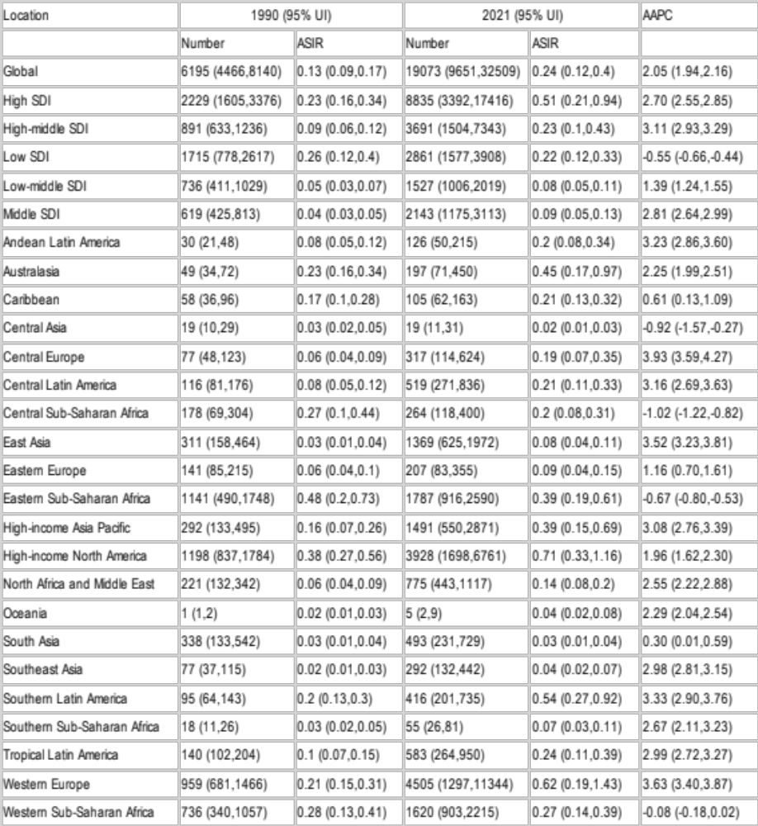
Table 2 Global prevalence of BL in 1990 and 2021 and the corresponding average annual percent change (AAPC).
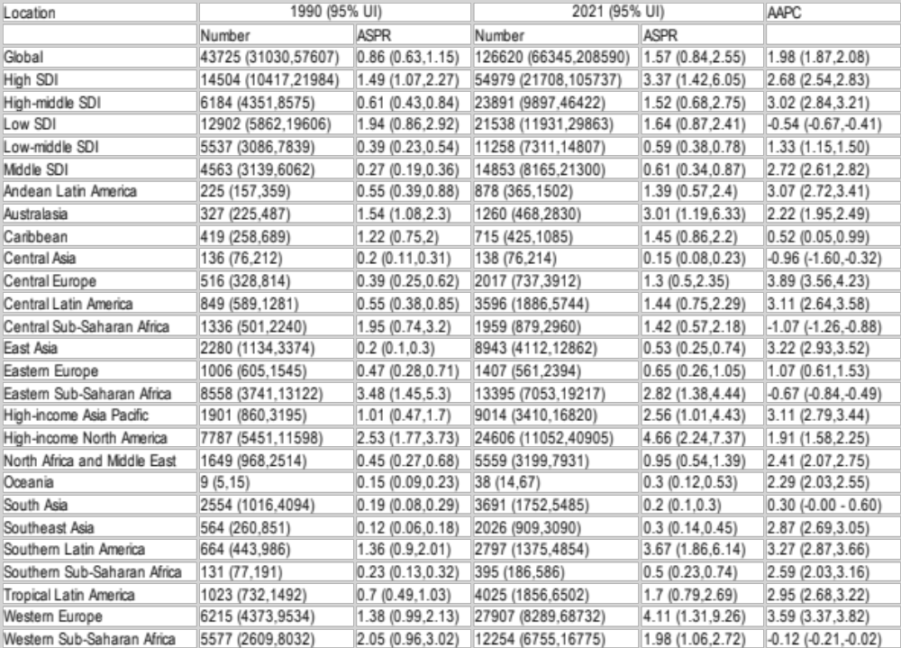
Table 3 Global mortality of BL in 1990 and 2021 and the corresponding average annual percent change (AAPC).
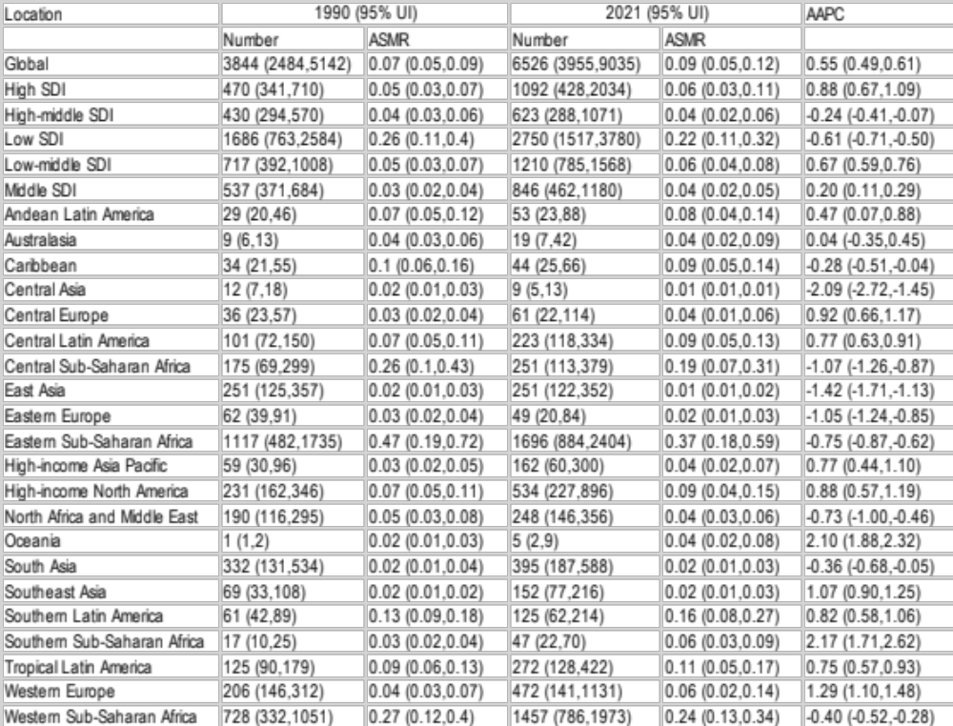
Table 4 Global disability-adjusted life years (DALYs) of BL in 1990 and 2021 and the corresponding average annual percent change (AAPC).
