Supplemental Figure 1A. Violin plots with MG-ADL score at admission and at discharge in both groups.
Statistical analysis of multiple comparisons was performed the False Discovery Rate (FDR) approach after one-way ANOVA.
The confidence line showed medians, and dot lines showed the 25th and 75th quantiles.
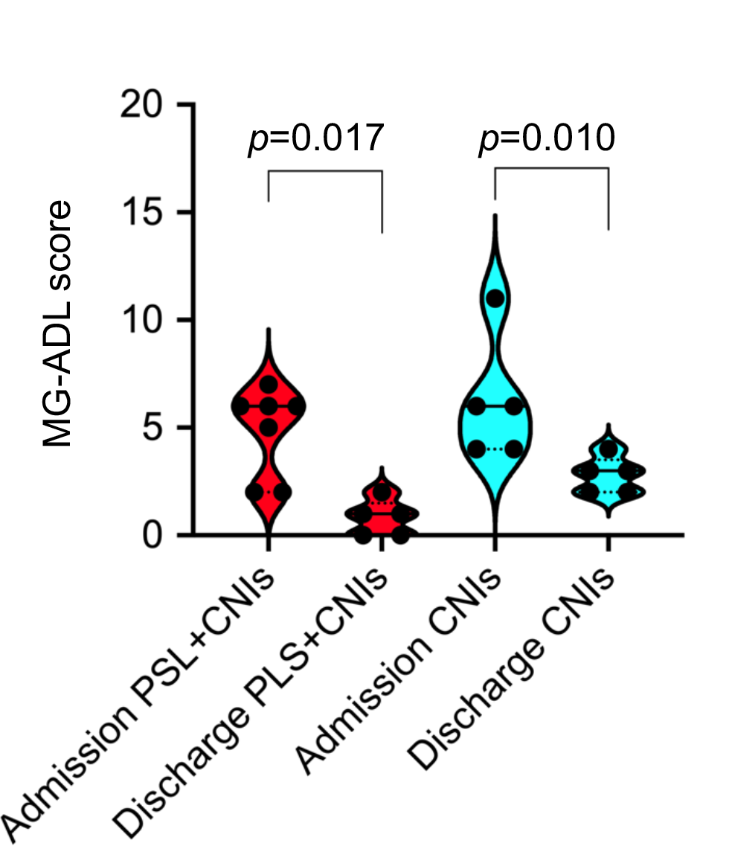

Supplemental Figure 1B. Violin plots with QMG score at admission and at discharge in both groups.
Statistical analysis of multiple comparisons was performed the False Discovery Rate (FDR) approach after one-way ANOVA.
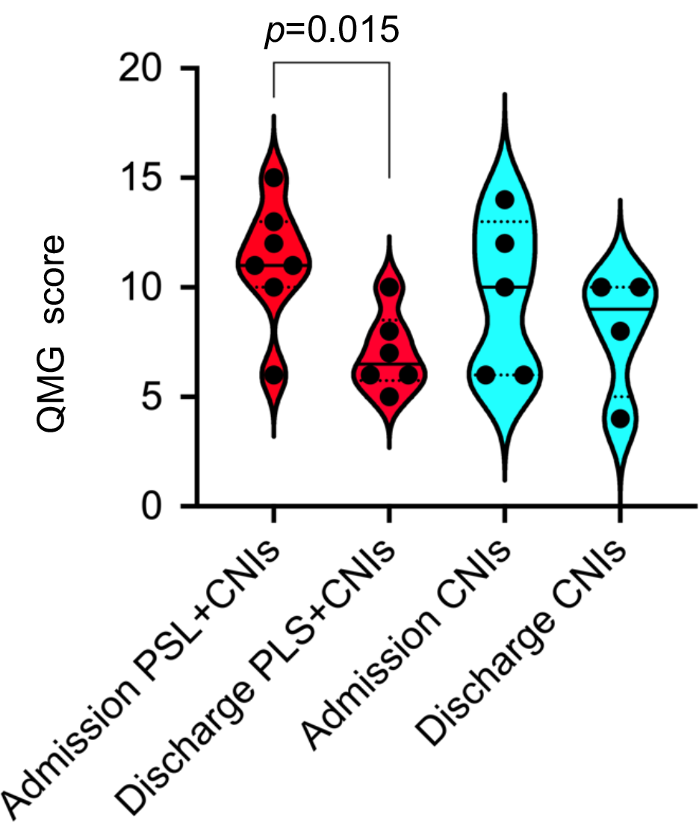
The middle line showed medians, and the dot lines showed the confidence of 25th and 75th quantiles.

