Tab.1 Block-Mean Visualization
Liang Kai (B1) | Muqi (C1)
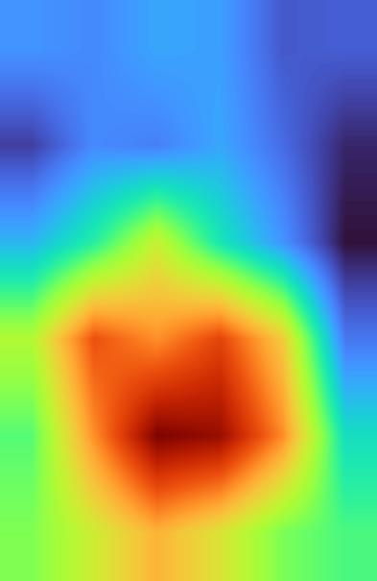 | 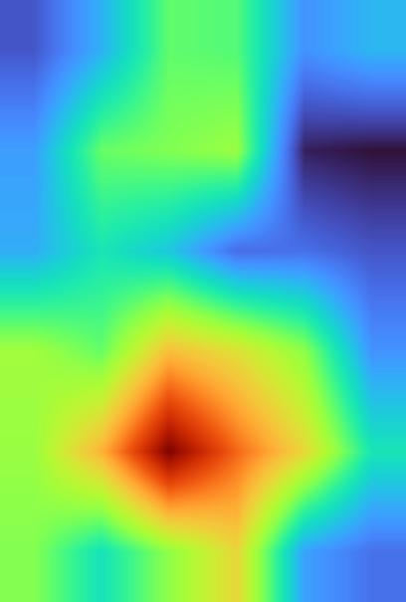

Tab.2 Research Samples
No. | Artist | Primary Pictorial Elements | Representative Exemplars of Hanging Scroll Figure Paintings
A1 | Sesshū Tōyō（14） | Figure | 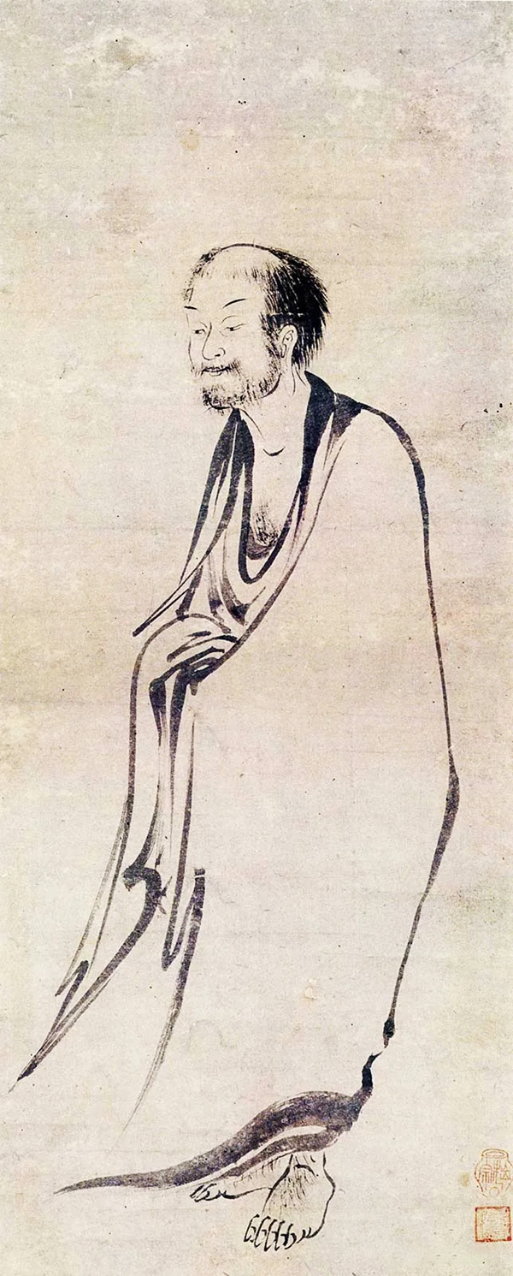
B1 | Liang Kai（21） | Figure | 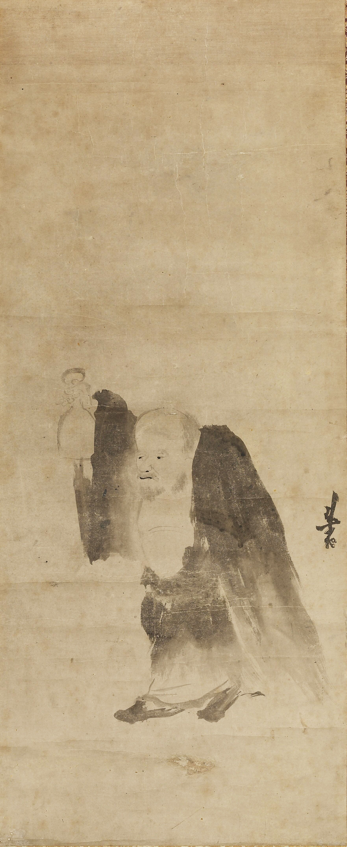
C1 | Muqi（14） | Tree, Figure | 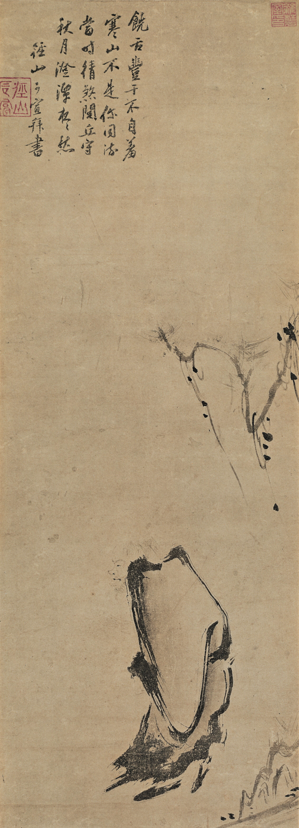

Tab.3 Grid Configuration Testing
Sample | 3*3 | 4*4 | 5*5 | 6*6
 | 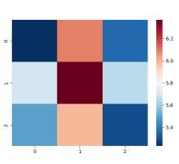 | 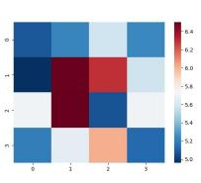 | 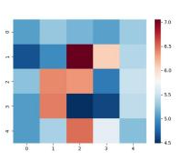 | 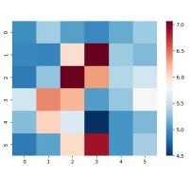
 | 7*7 | 8*8 | 9*9 | 10*10
 | 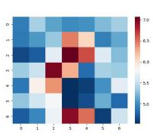 | 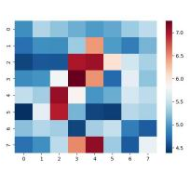 | 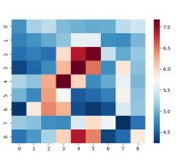 | 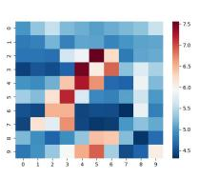

Tab.4 Block-Entropy Heatmap
Sesshū Tōyō's Hanging Scroll Exemplar | Heatmap | Liang Kai's Hanging Scroll Exemplar | Heatmap | Muqi's Hanging Scroll Exemplar | Heatmap
 | 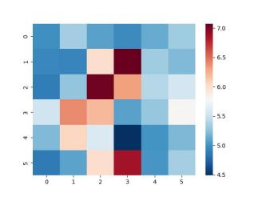 |  | 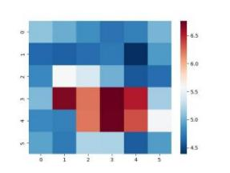 |  | 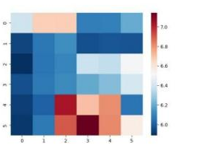

Tab.5 Block-Mean Values by Sample
(Subtitle: Yellow = high-entropy regions; Orange= peak entropy)
Sesshū Tōyō: Hanging Scroll Figure Painting (Cohort A1)
V | 1 | 2 | 3 | 4 | 5 | 6
1 | 5.330965 | 5.491103571 | 5.319365429 | 5.288063214 | 5.243429286 | 5.491784786
2 | 5.415453929 | 5.522857429 | 5.587036214 | 5.787634429 | 5.523223429 | 5.761788786
3 | 5.634409857 | 5.785595857 | 6.265779143 | 6.184218357 | 5.815292929 | 5.692836643
4 | 5.458724 | 6.056173429 | 6.289660857 | 6.134526786 | 6.300679857 | 5.845165786
5 | 6.0041205 | 6.303179857 | 6.5816925 | 6.232976 | 6.437443571 | 6.364609429
6 | 5.7755145 | 6.073829571 | 6.238960786 | 6.436237429 | 6.202503571 | 6.067524143
Liang Kai: Hanging Scroll Figure Painting (Cohort B1)
V | 1 | 2 | 3 | 4 | 5 | 6
1 | 5.538029952 | 5.519564524 | 5.563975381 | 5.55342619 | 5.449923143 | 5.45827419
2 | 5.413822905 | 5.522493286 | 5.505671905 | 5.565569667 | 5.477313524 | 5.38050181
3 | 5.586605571 | 5.704703762 | 5.88931619 | 5.679494762 | 5.538036429 | 5.353863476
4 | 5.858576619 | 6.139633048 | 6.056291095 | 6.159709667 | 5.967844667 | 5.493812048
5 | 5.756172905 | 6.058608333 | 6.315659238 | 6.284803238 | 6.062931571 | 5.661157905
6 | 5.795939714 | 5.899465095 | 6.00866719 | 5.919443143 | 5.791311857 | 5.743912
Muqi: Hanging Scroll Figure Painting (Cohort C1)
V | 1 | 2 | 3 | 4 | 5 | 6
1 | 5.807024429 | 5.921940786 | 6.082036071 | 6.071436786 | 5.882149 | 5.9294845
2 | 5.897281643 | 6.087619143 | 6.108795357 | 6.133173071 | 5.743580429 | 5.726617286
3 | 5.9166605 | 6.005331 | 5.9539795 | 5.833915643 | 5.838683143 | 5.805301929
4 | 6.140942857 | 6.086466643 | 6.274420429 | 6.219081929 | 6.120742 | 5.883303429
5 | 6.131446786 | 6.291227429 | 6.556164214 | 6.378352929 | 6.234733643 | 6.004654429
6 | 6.111548071 | 5.999055071 | 6.1227145 | 6.236287786 | 5.9027315 | 5.839388214

Tab.6 Quartile Distribution of Block Means
Cohort | Min | Q1 (25th Percentile) | Median (Q2) | Q3 (75th Percentile) | Max
A1 | 5.243429286 | 5.522857429 | 5.815292929 | 6.232976 | 6.5816925
B1 | 5.353863476 | 5.519564524 | 5.679494762 | 5.919443143 | 6.315659238
C1 | 5.726617286 | 5.883303429 | 6.005331 | 6.131446786 | 6.556164214

Tab.7 Block-Mean Visualizations
Sesshū Tōyō (A1) | Liang Kai (B1) | Muqi (C1)
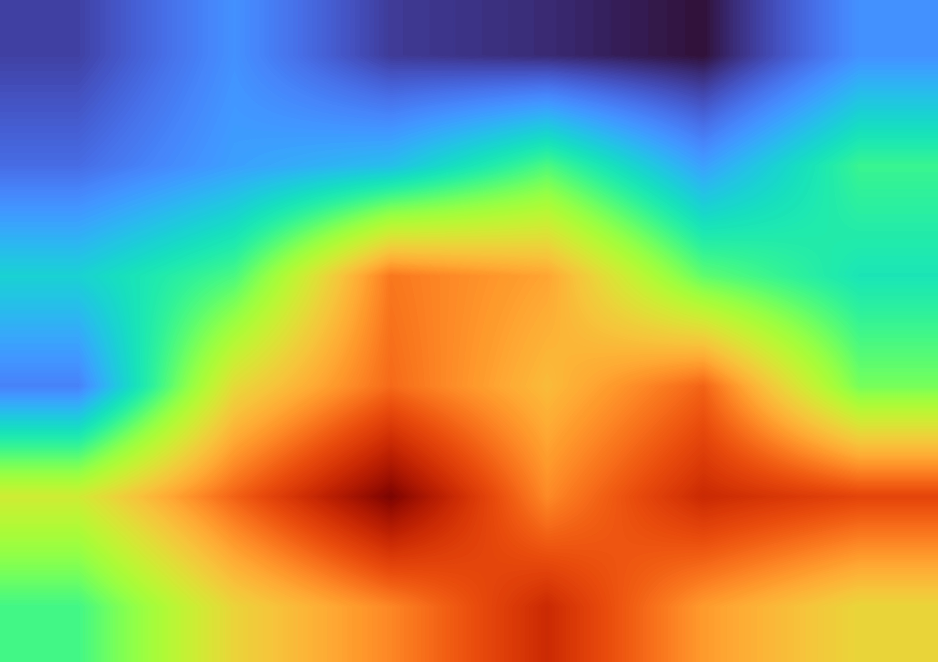

Table 8. Comparative Entropy Analysis: Sesshū Tōyō, Liang Kai, and Muqi
 | Sesshū Tōyō (A1) Analysis | Liang Kai (B1) Analysis | Muqi (C1) Analysis
Max block mean | 6.5816925 at V(3,5) | 6.315659238 at V(3,5) | 6.556164214 at V(3,5)
75th percentile | 6.232976 | 5.919443143 | 6.131446786
High-entropy range | 6.5816925–6.232976 | 6.315659238–5.919443143 | 6.556164214–6.131446786
High-entropy blocks | V(2,5), V(3,3)–V(3,6), V(4,5)–V(4,6), V(5,4)–V(5,5), V(6,5) | V(2,4)–V(2,5), V(3,4)–V(3,6), V(4,4)–V(4,6), V(5,4)–V(5,5) | V(1,4)–V(1,5), V(2,5), V(3,4)–V(3,5), V(4,2), V(4,4)–V(4,6), V(5,5)
Distribution pattern | ★ 79% high-entropy blocks in Row 5  ★ Central concentration > lateral zones  ★ Primary subjects cluster near bottom 1/3 region with central emphasis | ★ 62% high-entropy blocks in Rows 4–5  ★ Central dominance > lateral areas  ★ Subject concentration in bottom 1/2 region with central alignment | ★ 71% high-entropy blocks in Row 5  ★ Left-central prevalence > right zones  ★ Subject focus in bottom 1/2 region with left-central bias

Tab.9 Representative Artworks: Sesshū Tōyō, Liang Kai, and Muqi
A1  Sesshū Tōyō Exemplars | 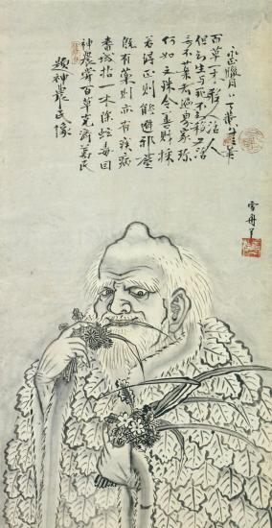《神农图》  Divine Farmer (Shennong)  (Cultural Note: Shennong, mythical inventor of agriculture) | 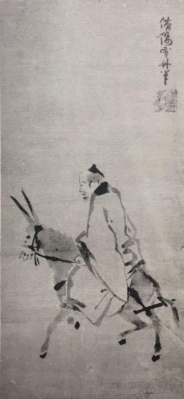《杜子美图》  Poet Du Fu  (Historical Context: Du Fu (712-770), Tang dynasty poet) | 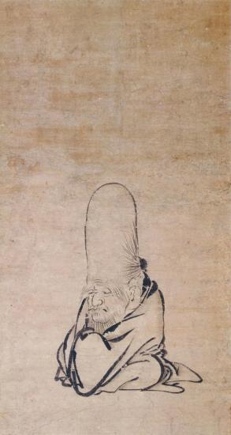《寿星图》  Longevity Deity (Shouxing)  (Iconography: Star God of Southern Polar Constellation)
B1  Liang Kai Exemplars | 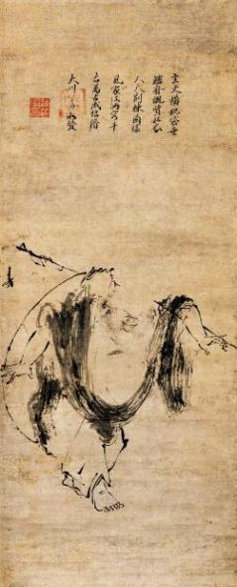  《布袋图》  Budai Monk  (Zen Significance: Laughing Buddha prototype) | 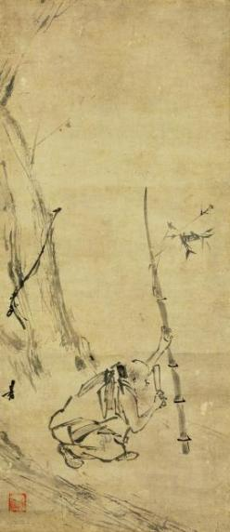  《六祖斫竹图》  Sixth Patriarch Cutting Bamboo  (Key Scene: Huineng demonstrating sudden enlightenment) | 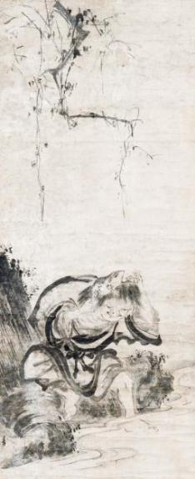  《刘海仙人图》  Immortal Liu Hai  (Daoist Tradition: Coin-dancing toad tamer)
C1  Muqi Exemplars | 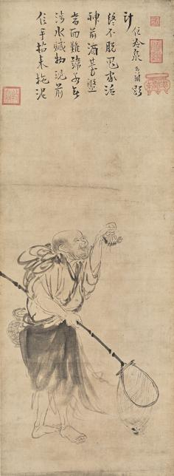  《蚬子和尚图》  Monk Xianzi (Clam Gatherer)  (Zen Folklore: Tang dynasty eccentric monk) | 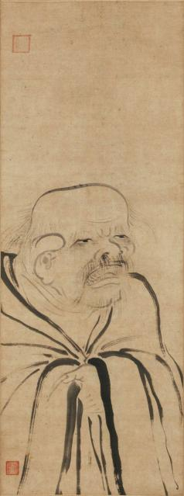  《老子图》  Laozi  (Philosophical Icon: Founder of Daoism) | 《丰干图》  Fenggan  (Zen Triad: Companion to Hanshan and Shide)

Tab.10 Comparative Cohort Sample
No. | Artist | Primary Pictorial Elements | Representative Exemplars of Hanging Scroll Figure Paintings
A1 | Sesshū Tōyō（14） | Figure
D1 | Liu Songnian（9） | Trees, Tables and chairs, Believers, Railings | 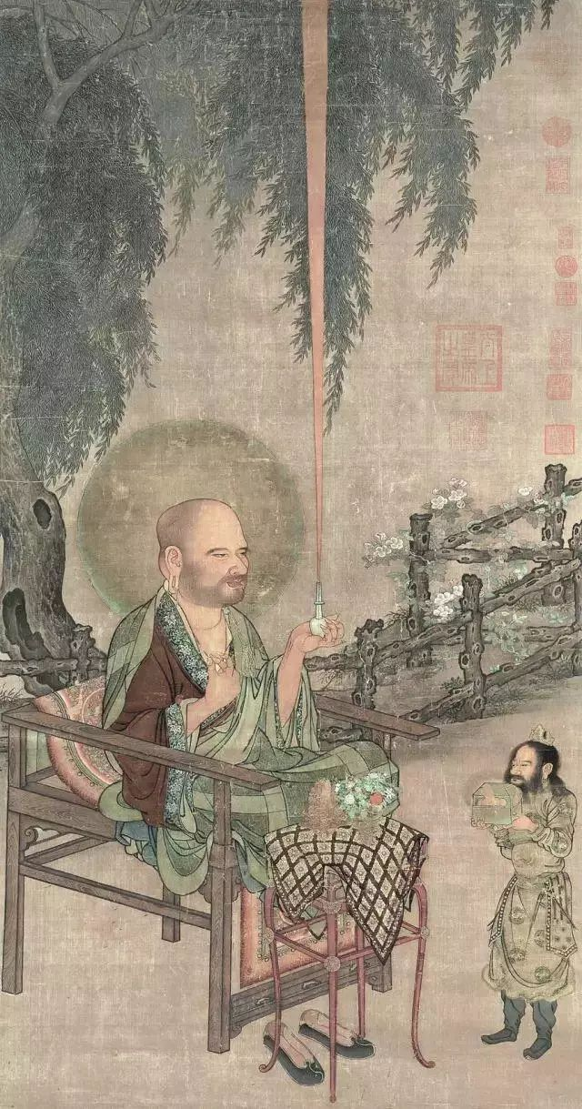

Tab.11 Block-Entropy Heatmap
Sesshū Tōyō's Hanging Scroll Exemplar | Heatmap | Liu Songnian's Hanging Scroll Exemplar | Heatmap
 |  |  | 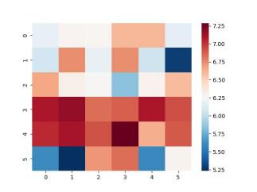

Tab.12 Block-Mean Values by Sample
(Subtitle: Yellow = high-entropy regions; Orange-red = peak entropy)
Sesshū Tōyō: Hanging Scroll Figure Painting (Cohort A1)
V | 1 | 2 | 3 | 4 | 5 | 6
1 | 5.330965 | 5.491103571 | 5.319365429 | 5.288063214 | 5.243429286 | 5.491784786
2 | 5.415453929 | 5.522857429 | 5.587036214 | 5.787634429 | 5.523223429 | 5.761788786
3 | 5.634409857 | 5.785595857 | 6.265779143 | 6.184218357 | 5.815292929 | 5.692836643
4 | 5.458724 | 6.056173429 | 6.289660857 | 6.134526786 | 6.300679857 | 5.845165786
5 | 6.0041205 | 6.303179857 | 6.5816925 | 6.232976 | 6.437443571 | 6.364609429
6 | 5.7755145 | 6.073829571 | 6.238960786 | 6.436237429 | 6.202503571 | 6.067524143
Liu Songnian: Hanging Scroll Figure Painting (Cohort D1)
V | 1 | 2 | 3 | 4 | 5 | 6
1 | 6.038226625 | 6.167855125 | 6.2625675 | 6.1602465 | 6.004294625 | 5.963239375
2 | 6.223475125 | 6.508425375 | 6.637757875 | 6.5992535 | 6.09680975 | 5.95185
3 | 6.734366 | 6.776007 | 6.729408 | 6.457457875 | 6.42862325 | 6.264632875
4 | 6.78943125 | 6.893999625 | 6.809143625 | 6.870757125 | 6.7688375 | 6.419301875
5 | 6.93195875 | 7.107636 | 6.93108225 | 6.927252625 | 7.021503375 | 6.52857175
6 | 6.419648125 | 6.728910625 | 6.657282 | 6.47498175 | 6.19893 | 6.040149875

Tab.13 Quartile Distribution of Block Means
Cohort | Min | Q1 (25th Percentile) | Median (Q2) | Q3 (75th Percentile) | Max
A1 | 5.243429286 | 5.522857429 | 5.815292929 | 6.232976 | 6.5816925
D1 | 5.95185 | 6.19893 | 6.508425375 | 6.776007 | 7.107636

Tab.14 Block-Mean Visualizations
Sesshū Tōyō (A1) | Liu Songnian (D1)
 | 