Demographic data

- Gender
- female
- male
- other
- How many years of clinical experience do you have?
- <1year
- 1 year
- 2 years
- 3 years
- 4 years
- >4 years
- How many years of clinical experience do you have in the field of orthopedics/traumatology?
- <1year
- 1 year
- 2 years
- 3 years
- 4 years
- >4 years
- Which medical specialty is your medium-term goal?
- Board certification in Orthopedics and Traumatology
- Board certification in General Surgery
- Board certification in Internal Medicine
- Other
- I had prior experience with augmented reality before this study.
5 point Likert scale:
1 no experience with AR - 5 a lot of experience with AR
- Study group
- Augmented Reality group
- Traditional Learning group

General Feedback

Learning Experience

- Did the learning experience help you understand the individual steps of the hip approach?
Scale: 1 = not at all - 10 Completely true
- The learning materials were sufficiently detailed, and I had all the necessary information at each step.
Scale: 1 = not at all - 10 Completely true
- The learning experience motivated me to learn more about surgery.
Scale: 1 = not at all - 10 Completely true
- I would recommend the learning materials for use in surgical training.
Scale: 1 = not at all - 10 Completely true

Usability

- How satisfied are you with the learning materials?
Scale: 1 = not at all - 10 Completely satisfied
- Were you able to successfully perform the surgical approach?
- yes
- no
- The learning method was a helpful guide for identifying key anatomical landmarks.
Scale: 1 = not at all - 10 Completely true
- Would you have hoped for additional support from the learning method?
- no
- difficult to tell
- yes
- I was able to orient myself within the surgical field at all times.
Scale: 1 = not at all - 10 Completely true
- If not applicable: During which steps were you unable to orient yourself?
open answer
- What bothered you while using the learning method?
open answer

General Assessments on Augmented Reality in Surgery

- Augmented Reality applications are the future of surgery.
Scale: 1 = not at all - 10 Completely true
- New technologies improve surgical teaching.
Scale: 1 = not at all - 10 Completely true

General Feedback

- Name three things you particularly liked about the learning method.
open answer
- Name three suggestions for improving the learning method.
open answer

NASA Task Load Index

- How mentally demanding was the task during the study?
20-point Likert scale:
Scale: 1 = not at all - 20 Very demanding
- How physically demanding was the task during the study?
20-point Likert scale:
1 not at all - 20 Very demanding
- How pressured did you feel regarding time while performing the task?
20-point Likert scale:
1 not at all - 20 very Pressured
- How successful were you in accomplishing the task?
20-point Likert scale:
1 not at all - 20 very successful
- How hard did you have to work to achieve your level of performance?
20-point Likert scale:
1 not at all - 20 very hard
- How uncertain, discouraged, irritated, stressed, or annoyed did you feel?
20-point Likert scale:
1 not at all - 20 very much

System Usability Scale (SUS)

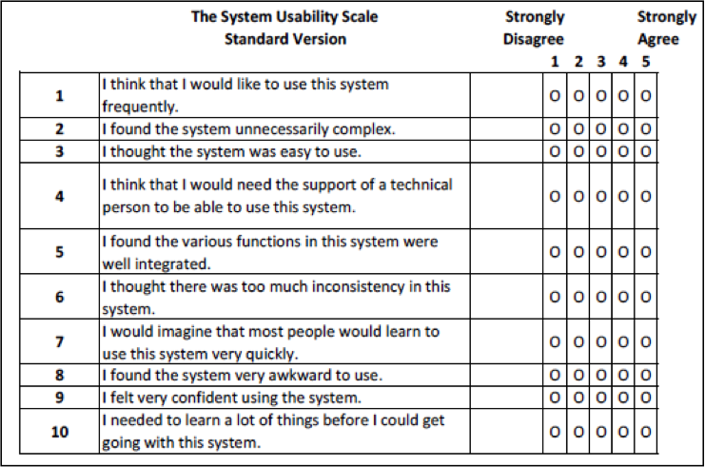

Augmented Reality Immersion (ARI) questionnaire

- I liked the activity because it was novel.
7 point Likert scale:
1 not at all - 7 very true
- I liked the type of the activity.
7 point Likert scale:
1 not at all - 7 very true
- I wanted to spend the time to complete the activity successfully.
7 point Likert scale:
1 not at all - 7 very true
- I wanted to spend time to participate in the activity.
7 point Likert scale:
1 not at all - 7 very true
- It was easy for me to use the AR application.
7 point Likert scale:
1 not at all - 7 very true
- I found the AR application confusing.
7 point Likert scale:
1 not at all - 7 very true
- The AR application was unnecessarily complex.
7 point Likert scale:
1 not at all - 7 very true
- I did not have difficulties in controlling the AR application.
7 point Likert scale:
1 not at all - 7 very true
- I was curious about how the activity would progress.
7 point Likert scale:
1 not at all - 7 very true
- I was often excited because I felt as being part of the activity.
7 point Likert scale:
1 not at all - 7 very true
- I often felt suspense by the activity.
7 point Likert scale:
1 not at all - 7 very true
- If interrupted, I looked forward to returning to the activity.
7 point Likert scale:
1 not at all - 7 very true
- Everyday thoughts and concerns faded out during the activity.
7 point Likert scale:
1 not at all - 7 very true
- I was more focused on the activity rather than on any external distractions.
7 point Likert scale:
1 not at all - 7 very true
- I didn’t have any irrelevant thoughts or external distractions during the activity.
7 point Likert scale:
1 not at all - 7 very true
- The activity became the unique and only thought occupying my mind.
7 point Likert scale:
1 not at all - 7 very true
- I lost track of time, as if everything just stopped, and the only thing that I could think about was the activity.
7 point Likert scale:
1 not at all - 7 very true

Technology Acceptance Model (TAM) questionnaire

- Assuming I had access to this AR learning method, I would intend to use it.
10 point likert scale:
1 not at all - 10 very true
- If I had access to this AR learning method, I predict I would use it.
10 point likert scale:
1 not at all - 10 very true
- Using the AR learning method would enhance my effectiveness in my job.
10 point likert scale:
1 not at all - 10 very true
- Using the AR learning method would improve my productivity.
10 point likert scale:
1 not at all - 10 very true
- Using the AR learning method would enhance my effectiveness in my job
10 point likert scale:
1 not at all - 10 very true
- I would find the AR learning method useful in my job.
10 point likert scale:
1 not at all - 10 very true
- Learning to operate the AR learning method would be easy for me.
10 point likert scale:
1 not at all - 10 very true
- I would find it easy to get the AR learning method to do what I want it to do.
10 point likert scale:
1 not at all - 10 very true
- I would find the AR learning method easy to use.
10 point likert scale:
1 not at all - 10 very true
- It would be easy for me to become skillful in the use of the technology.
10 point likert scale:
1 not at all - 10 very true

Objective Structured Assessment of Technical Skills (OSATS)
  - Completed by the attending surgeon

Part 1. Checklist

- Palpates the anterior superior iliac spine.
- yes
- no
- Places marking and skin incision in the correct location.
- yes
- no
- Performs hemostasis correctly.
- yes
- no
- Correctly exposes the tensor fascia.
- yes
- no
- Performs longitudinal incision of the tensor fascia in the correct location.
- yes
- no
- Mobilizes the tensor correctly with Langenbeck retractor.
- yes
- no
- Places retractor correctly.
- yes
- no
- Correctly exposes the deep muscle layer (rectus femoris visible).
- yes
- no
- Places deep retractor correctly.
- yes
- no
- Ligates arteries correctly.
- yes
- no
- Correctly exposes the joint capsule.
- yes
- no
- Incises the joint capsule correctly.
- yes
- no
- Uses appropriate surgical instruments for dissection and maintaining exposure.
- yes
- no
- Incisions are appropriate in depth and length.
- yes
- no
- Vulnerable structures such as nerves and blood vessels are properly protected, and no structures outside the surgical approach were injured.
- yes
- no

Part 2. Global rating Scale (GRS)

- Tissue Handling
5-point Likert scale
1 Frequently uses unnecessary force or causes damage due to incorrect instrument use.
3 Generally careful handling of tissue, but some unintentional damage.
5 Consistently good tissue handling with minimal damage.
- Time and Motion
5-point Likert scale
1 Many unnecessary movements
3 Generally efficient use of time and motion, but with some unnecessary movements
5 Good economy of movement with maximum efficiency.
- Instrument Handling
5-point Likert scale
1 Repeatedly clumsy or hesitant instrument use.
3 Competent use of instruments, though sometimes a bit stiff or awkward.
5 Smooth instrument use without clumsiness.
- Knowledge of Instruments
5-point Likert scale
1 Repeatedly asks for the wrong instruments or uses inappropriate tools.
3 Knows the names of most instruments and uses appropriate tools for the task.
5 Clearly familiar with instruments and their names.
- Use of Assistance
5-point Likert scale
1 Assistant's hands are consistently poorly placed.
3 Generally good use of the assistant.
5 Strategically and effectively uses assistance throughout.

Part 3. Overall Performance

- How often did the senior surgeon need to intervene?
open answer
- Duration of learning?
open answer rounded to minutes
- Duration of the operation?
open answer in minutes and seconds
- Did the participant successfully complete the task?
- yes
- no
- Assuming the anterior hip approach is an EPA (Entrustable Professional Activity), what level of supervision would the participant require after this study?
- Participant should only observe
- Direct supervision (Supervisor present in the room)
- Supervision on demand (Supervisor on call)
- No supervision needed
- Participant supervises others
- Any additional remarks?

