Lepr⁺ PDL Cells Are Functionally Compensated during Aging and Bone Repair

Satsuki Shidara^{1#}, Shinichirou Ito^{2, 3#}, Karishma Desai⁴, Akihide Tokuyama², Ran Leng¹, Mana Kawakami⁵, Satoru Matsunaga^{3, 6}, Toshihisa Komori⁷, Akihiro Hosoya⁸, Yasushi Nishii^{1, 3}, Toshihide Mizoguchi^{3, 4}*

¹Department of Orthodontics, Tokyo Dental College, 2-9-18 Kanda-Misakicyo, Chiyoda-ku, Tokyo 101-0061, Japan
²Department of Pharmacology, Tokyo Dental College, 2-9-18 Kanda-Misakicyo, Chiyoda-ku, Tokyo 101-0061, Japan
³Tokyo Dental College Research Well-being Project, Tokyo Dental College, 2-9-18 Kanda-Misakicyo, Chiyoda-ku, Tokyo 101-0061, Japan
⁴Oral Health Science Center, Tokyo Dental College, 2-9-18 Kanda-Misakicyo, Chiyoda-ku, Tokyo 101-0061, Japan
⁵Department of Oral Pathobiological Science and Surgery, Tokyo Dental College, 2-9-18 Kanda-Misakicyo, Chiyoda-ku, Tokyo 101-0061, Japan
⁶Department of Anatomy, Tokyo Dental College, 2-9-18 Kanda-Misakicyo, Chiyoda-ku, Tokyo 101-0061, Japan
⁷Department of Molecular Tumor Biology, Nagasaki University Graduate School of Biomedical Sciences, 1-7-1 Sakamoto, Nagasaki 852–8588, Japan
⁸Division of Histology, Department of Oral Growth and Development, School of Dentistry, Health Sciences University of Hokkaido, 1757 Kanazawa, Ishikari-Tobetsu, Hokkaido 061-0293, Japan

*Corresponding author:
Toshihide Mizoguchi, Ph.D.
Professor, Oral Health Science Center
Tokyo Dental College, Tokyo 101-0061, Japan
Phone: +81-36380 9114
Fax: +81-3-6380 9606
E-mail: tmizoguchi@tdc.ac.jp
# These two authors contributed equally this work

Appendix materials and methods

Experimental animals
C57BL/6 mice were purchased from Sankyo Labo Service Corporation (Tokyo, Japan). B6.129(Cg)-Lepr^{tm2(cre)Rck}/J (Lepr-Cre; JAX008320) (DeFalco et al. 2001) and B6.Cg-Gt(ROSA)26Sor^{tm14(CAG-tdTomato)Hze}/J (R26-tdTom; JAX007914) (Madisen et al. 2010) mice were purchased from the Jackson Laboratory (Bar Harbor, ME, USA). Runx2-GFP (Kawane et al. 2014) mice were generated in the laboratory of one of the authors (T.K., Nagasaki University, Nagasaki, Japan). ROSA26-SA-lsl-DTR-IRES-tdTomato (R26-DTR/tdTom) mice (Iwasaki et al. 2018) were a kind gift from Professor Yanagisawa Masashi (University of Tsukuba, Tsukuba Japan). To avoid nonspecific DNA recombination, when creating Cre reporter mice, the Cre gene was introduced into the male mouse of each breeding pair. Euthanasia was performed by cervical spine dislocation under isoflurane anesthesia (Pfizer, New York City, NY, USA). No adverse events were observed. All animals showed normal behavior and recovered uneventfully. No humane endpoints were set. Animals were monitored daily for health and recovery. Gender-matched paired groups were used for the statistical analyses. Male mice were used for micro-computed tomography–based quantification of bone tissue. The mice were fed a regular diet (MF; Oriental Yeast, Tokyo, Japan). No inclusion or exclusion criteria were pre-established; all animals and data points were included in the analysis. A total of 84 mice were used in this study. Group sizes are indicated in the figure legends. Groups were assigned based on genotype, without randomisation or control of potential confounders. Group information was concealed during evaluation and analysis. The maximum number of mice per cage was five. All mice were maintained under specific-pathogen-free conditions at 24 ± 2 °C, exposed to 50%–60% humidity with a 12-h light/dark cycle, and provided with sterile water and ad libitum access to food in animal facilities certified by the Animal Care and Use Committees of Tokyo Dental College (Tokyo, Japan). All experimental protocols were approved by the Animal Care Committee of the Tokyo Dental College. (No. DNA2205, 244102, 244103, and 244105). A study protocol was approved by the institutional animal ethics committee prior to the study but was not publicly registered. All methods were carried out in accordance with the guidelines of the Animal Care Committee of Tokyo Dental College. All methods are reported in accordance with ARRIVE guidelines.

Generation of Lepr-CreER knock-in mice
Lepr-CreER knock-in mice were generated with the Laboratory Animal Resource Center, University of Tsukuba (Appendix Fig. 2A). Briefly, we selected a sequence (5′-CAT GAC AGG CTC TAC TGG AA-3′) located downstream of the termination codon of Lepr as the CRISPR target. We purchased synthetic CRISPR RNA containing this target in a sequence from IDT (Coralville, Iowa, USA). For the pP2A-iCreERT2-WPRE-rGpA- sequence, we placed the P2A, iCreERT2, WPRE, and rGpA sequences between the 5′ and 3′ homology arms. The 5′ homology arm is the genomic region from 1,069 bp to 1 bp upstream of the Lepr termination codon, and the 3′ homology arm is the genomic region from 31 bp to 1,338 bp downstream of the Lepr termination codon.
The CRISPR-Cas9 ribonucleoprotein complex and pP2A-iCreERT2-WPRE-rGpA-Lepr donor DNA vector were microinjected into zygotes of C57BL/6J mice as described in our previous report (Tanimoto et al. 2022). Subsequently, microinjected zygotes were transferred into oviducts in pseudopregnant ICR female mice (Jackson Laboratory Japan) and newborns were obtained.

Induction of Cre-mediated recombination and R26-DTR/tdTom-mediated cell depletion
Two-week-old mice were intraperitoneally injected with 0.1 mg/g/body weight 4OH-tamoxifen (4OH-Tam) (Selleck Biotechnology, Kanagawa, Japan) daily for 3 consecutive days. For continuous Cre induction, we administered the CRF-1 chow diet (Oriental Yeast, Tokyo, Japan) containing tamoxifen (Sigma-Aldrich, St. Louis, MO, USA) at 400 mg/kg/food to mice from 3 weeks mice to 2 months old. For diphtheria toxin-mediated cell depletion, 25 μg/kg of diphtheria toxin (BioAcademia, Osaka, Japan) was injected intraperitoneally daily for 7 days.

Antibodies and reagents
The following antibodies for immunohistochemistry were used: goat anti-CD31 antibody coupled to Alexa Fluor (AF) 488 (R&D Systems, Minneapolis, MN, USA) (1:50). To enhance the green fluorescent protein (GFP) signal of Runx2-GFP mice, the tissue was incubated with an AF 488-conjugated anti-GFP antibody (Thermo Fisher Scientific, Waltham, MA, USA) (1:100). To enhance the tdTom fluorescent signal of Lepr-Cre; R26-DTR/tdTom mice, the tissues were incubated with goat anti-tdTom (SICGEN antibodies, Carcavelos, Portugal) (1:50), and further incubated with AF 555-conjugated donkey anti-goat IgG (H+L) cross-adsorbed secondary antibody (Thermo Fisher Scientific) (1:100). Primary antibody incubation was conducted at 24 ± 2 °C for 12 h, and secondary antibody incubation was performed at 24 ± 2 °C for 2 h. Nuclei were stained using Hoechst 33342 (Thermo Fisher Scientific).
The following antibodies for FACS were used: APC-conjugated rat anti-CD45 antibody (clone: 30-F 11, Thermo Fisher Scientific) (1:500) and APC-conjugated rat anti-Ter119 (clone: TER-119, Thermo Fisher Scientific) (1:500).

Preparation of PDLC suspensions and FACS analysis
All maxillary molars were extracted using hooked-end forceps under triple anesthesia (medetomidine hydrochloride 0.75 mg/kg [Domitol; Nippon Zenyaku Kogyo], midazolam 4.0 mg/kg [Dormicum; Sandoz K. K.], and butorphanol 5.0 mg/kg [Vetorphale, Meiji Seika Pharma]). After surgery, euthanasia was performed. The six extracted molars were incubated with 2 mL collagenase/protease/DNase mixed buffer (2 Wunsch units of Liberase™ [Roche, Mannheim, Germany], 0.5 mg/mL Pronase [Roche], 1:2,000 benzonase [Sigma-Aldrich], and 5 mM MgCl₂ [Sigma-Aldrich]; modified from a previous report by Matsushita et al. 2021) at 37 °C with shaking at 2,000 rpm for 1 h in a shaking incubator (ThermoMixer® C, Eppendorf, Hamburg, Germany). The incubation buffer was collected into a tube with a 35-μm filter cap (Falcon, Corning, Corning, NY, USA) containing 1 mL bone buffer (2% fetal bovine serum, 0.5 mM ethylenediaminetetraacetic acid [EDTA, Thermo Fisher Scientific], 25 μg/ml DNase [Worthington Biochemical Corporation, Lakewood, NJ, USA], and 5 mM MgCl₂ in phosphate-buffered saline), and centrifuged at 4 °C, 280 g for 10 min. The cell pellet was treated with a hemolysis buffer (ACK Lysing Buffer, Thermo Fisher Scientific) containing 1:2,000 benzonase (Sigma-Aldrich) and 5 mM MgCl₂ for 3 min on ice. The cells were treated with antibodies for 30 min on ice. Flow cytometry and cell sorting experiments were performed using a FACSMelody (BD Biosciences, San Jose, CA, USA) equipped with FACSChorus software (BD Biosciences). Dead cells and debris were excluded using FSC, SSC, and SYTOX Red Dead Cell Stain (Thermo Fisher Scientific) staining profiles. Data were analyzed using FlowJo v10 (BD Biosciences).

Histological analysis
To prepare cryosections, mouse maxillae were collected and fixed with 4% paraformaldehyde for 24 h at 4 °C. The tissue was decalcified with 0.5 mol/L EDTA (FUJIFILM Wako Pure Chemical Corporation, Tokyo, Japan) for 10 days at 4 °C and subsequently incubated with 10%, 20%, and 30% sucrose solutions for more than 2 h at 4 °C for cryoprotection. The samples were embedded in super-cryo-embedding medium (Section-lab, Hiroshima, Japan). Cryosections (16 µm thick) were cut in accordance with Kawamoto’s film method using Cryofilm type 4D (16UF) (Section-lab) and a tungsten carbide microtome (Section-lab). The sections were incubated with antibodies for 24 h at 24 ± 2 °C, mounted using 30% glycerol, covered with coverslips, and sealed with nail polish. Z-stacks of confocal images were obtained at 1 µm intervals between sections (16 µm thick). Fluorescence images were acquired using a laser scanning confocal microscope (LSM880) equipped with a Plan-APOCHROMAT (20×/0.8), ZEN 2.3 black edition, and ZEN 2.6 blue edition (all from Carl Zeiss, Oberkochen, Germany).
For counting of Lepr^{creER}-Tom⁺ PDLCs, osteocytes, and cementocytes in periodontal tissues, regions of interest (ROIs) were defined as shown in Fig. 3H. Lepr^{creER}-Tom⁺ PDLCs were counted within ROIs of 0.11–0.22 mm². The Lepr^{creER}-Tom⁺ osteocytes localized within three cell layers of the PDL in an ROI of 0.07–0.17 mm² were counted. The frequency of Lepr^{creER}-Tom⁺ cementocytes was calculated as a percentage of total cementocytes in the mesial root of the maxillary first molars. In the extraction socket, all Lepr^{creER}-Tom⁺ and Lepr^{creER}-Tom⁻ osteocytes in the regenerated bone (0.29–0.57 mm²) were counted, and the percentage of Lepr^{creER}-Tom⁺ osteocytes among total osteocytes was calculated. Dissection, sectioning, and staining for each experiment were consistently performed under the same conditions at the same time.

Tooth extraction
Maxillary first molars were extracted using hooked-end forceps under triple anesthesia (medetomidine hydrochloride 0.75 mg/kg [Domitol; Nippon Zenyaku Kogyo], midazolam 4.0 mg/kg [Dormicum; Sandoz K. K.], and butorphanol 5.0 mg/kg [Vetorphale, Meiji Seika Pharma]). After surgery, mice were injected with atipamezole 0.75 mg/kg (Antisedan, Nippon Zenyaku Kogyo) to antagonize the anesthesia effect. Tissues from the extraction sockets were collected at the indicated time points.

Micro-computed tomography analysis of regenerated bone in extraction cavity
Fixed samples were analyzed using a microCT 50 (Scanco Medical, Bruttisellen, Switzerland). Slice data were used to construct three-dimensional images via a volume-rendering technique using TRI/3D-BON analytical software (Ratoc System Engineering, Tokyo, Japan). The scanning parameters were as follows: 7.4 μm voxel size, 90 kV, and 44 μA.

Outcome measures
(1) single-cell characterization of Lepr⁺ PDLCs by scRNA-seq, to identify molecular markers and subpopulations (Fig. 1–2); (2) longitudinal analysis of Lepr^{creER}-Tom⁺ cell distribution in periodontal tissues, to assess their spatial and temporal dynamics (Fig. 3); and (3) evaluation of Lepr^{cre}-DTR/Tom⁺ cell depletion following DT administration, and its impact on bone regeneration, assessed by microCT (Fig. 4). Although the primary outcome was the change in bone volume assessed by microCT following Lepr⁺ cell depletion, a formal sample size calculation based on statistical power analysis was not performed. Instead, sample size was determined with reference to previous studies and ethical considerations.

scRNA-seq analysis
Single-cell suspensions were prepared according to the instructions provided by 10x Genomics and filtered through a cell strainer (40 μm). Isolated cells were prepared for single-cell suspensions using a 10x Chromium Controller (10x Genomics, Pleasanton, CA, USA). Single Cell 3′ Library Kit v3.1 was used for cDNA library preparation according to the protocol by 10x Genomics. The quality of the libraries was checked using a BioAnalyzer 2100 (Agilent, Santa Clara, CA, USA) and LabChip (PerkinElmer, Waltham, MA, USA). Sequencing (read 1: 28 bp, index: 8 bp, and read 2: 91 bp) was performed using NovaSeq 6000 (Illumina, San Diego, CA, USA).
The sequence reads were demultiplexed with Illumina bcl2fastq (Illumina Inc), mapped, and demultiplexed, then unique molecular identifiers (UMIs) were counted and filtered using Cell Ranger 5.0.1. The reference genome sequence was the GRCm38.p6.genome with the addition of the eGFP and tdTomato sequences, annotated using gencode.vM25.annotation.
Data analysis was performed on R (version 3.6) using Seurat (version 3.1.4). Genes expressed in fewer than three cells were excluded, and cells with fewer than 400 and more than 7,000 genes detected per cell and more than 50,000 UMIs were excluded. Cells with mitochondria-related gene content exceeding 10% were also excluded. UMI count data were normalized with SCTransform while correcting for the effects of S score, G2/M score, and mitochondria-related genes. After dimensionality reduction by principal component analysis (PCA), cells were clustered by the shared nearest neighbors method using 75 dimensions. The results were visualized in two dimensions by UMAP (Finak et al. 2015). After selecting specific clusters, we performed dimensionality reduction by PCA, and then re-clustered cells with the shared nearest neighbors method using 75 dimensions. Statistical determination of differentially expressed genes was performed using MAST (version 1.10.0) (Finak et al. 2015) with min.pct = 0.2.
Trajectory analysis was performed using Monocle 3 (version 0.2.0) (Cao et al. 2019) for selected clusters. After dimensionality reduction by PCA, clustering was performed using the Leiden algorithm (Traag et al. 2019) with 60 dimensions and visualized in two dimensions by UMAP. Trajectory analysis was performed using the “learn graph” function of Monocle 3, and the pseudotime of each cell was calculated with the “order cells” function.

References
Cao J, Spielmann M, Qiu X, Huang X, Ibrahim DM, Hill AJ, Zhang F, Mundlos S, Christiansen L, Steemers FJ et al. 2019. The single-cell transcriptional landscape of mammalian organogenesis. Nature. 566(7745):496–502.
Finak G, McDavid A, Yajima M, Deng J, Gersuk V, Shalek AK, Slichter CK, Miller HW, McElrath MJ, Prlic M et al. 2015. Mast: A flexible statistical framework for assessing transcriptional changes and characterizing heterogeneity in single-cell rna sequencing data. Genome Biol. 16:278.
Matsushita Y, Ono W, Ono N. 2021. Flow cytometry-based analysis of the mouse bone marrow stromal and perivascular compartment. Methods Mol Biol. 2308:83–94.
Tanimoto Y, Mikami N, Ishida M, Iki N, Kato K, Sugiyama F, Takahashi S, Mizuno S. 2022. Zygote microinjection for creating gene cassette knock-in and flox alleles in mice. J Vis Exp. (184).
Traag VA, Waltman L, van Eck NJ. 2019. From louvain to leiden: Guaranteeing well-connected communities. Sci Rep. 9(1):5233.

Appendix tables:
Appendix Table 1. Cell types and key genes in each cluster from Figure 1C
cluster | cell number | ratio | cell type | key genes
0 | 1,514 | 0.206 | PDLC-1 | Aspn, Igfbp3, Postn, GFP
1 | 1,242 | 0.169 | Basal keratinocyte-1 | Epcam, Krt5, Krt14
2 | 809 | 0.110 | Endothelial cell-1 | Pecam1, Flt1, Pecam1, tdTomato
3 | 718 | 0.097 | Stratified squamous epithelial cell-1 | Epcam, Krt5, Krt14, Krt4, Krt13
4 | 609 | 0.083 | Basal keratinocyte-2 | Epcam, Krt5, Krt14
5 | 554 | 0.075 | Stratified squamous epithelial cell-2 | Epcam, Krt5, Krt14, Krt4, Krt13
6 | 422 | 0.057 | Suprabasal keratinocyte | Epcam, Krt1, Krt10
7 | 284 | 0.039 | Basal keratinocyte-3 | Epcam, Krt5, Krt14
8 | 280 | 0.038 | PDLC-2 | Aspn, Postn, Gpx3, Bglap, GFP
9 | 213 | 0.029 | PDLC-3 | Aspn, Apod, Igf1, Igfbp3, tdTomato,  GFP (low)
10 | 173 | 0.023 | CB/OB | Dmp1, Ibsp, Bglap, Bglap2, Spp1, GFP
11 | 146 | 0.020 | Stratified squamous epithelial cell-3 | Epcam, Krt5, Krt14, Krt4, Krt13
12 | 140 | 0.019 | PDLC-4 | Aspn, Postn, Col1a1
13 | 133 | 0.018 | Lymphatic endothelial cell | Flt4, Lyve1, Mmrn1
14 | 55 | 0.007 | PDLC-5 | Aspn, Thy1, Mfap5, tdTomato
15 | 49 | 0.007 | Endothelial cell-2 | Pecam1, Flt1, Pecam1, Procr, Prom1
16 | 25 | 0.003 | Epithelial cell-8 | Epcam, Krt8, Krt18
Total | 7,366 | 1

Appendix Table 2. Cell types and key genes in each cluster from Figure 2A
cluster | cell number | ratio | cell type | key genes
0 | 830 | 0.349 | PDLC-1–like | Aspn, Igfbp3, Postn, GFP, Gpha2
1 | 648 | 0.273 | PDLC-1–like | Aspn, Igfbp3, Postn, GFP, Crlf1
2 | 319 | 0.134 | PDLC-2–like | Aspn, Postn, Gpx3, GFP, Mmp13
3 | 201 | 0.085 | PDLC-3–like | Aspn, Apod, Igf1, Igfbp3, tdTomato, GFP(low)
4 | 168 | 0.071 | CB/OB | Dmp1, Ibsp, Bglap, Bglap2, Spp1, GFP
5 | 154 | 0.065 | PDLC-4–like | Aspn, Postn, Lars2, Tagln
6 | 55 | 0.023 | PDLC-5–like | Aspn, Thy1, Mfap5, tdTomato
Total | 2,375 | 1

Appendix Figures:
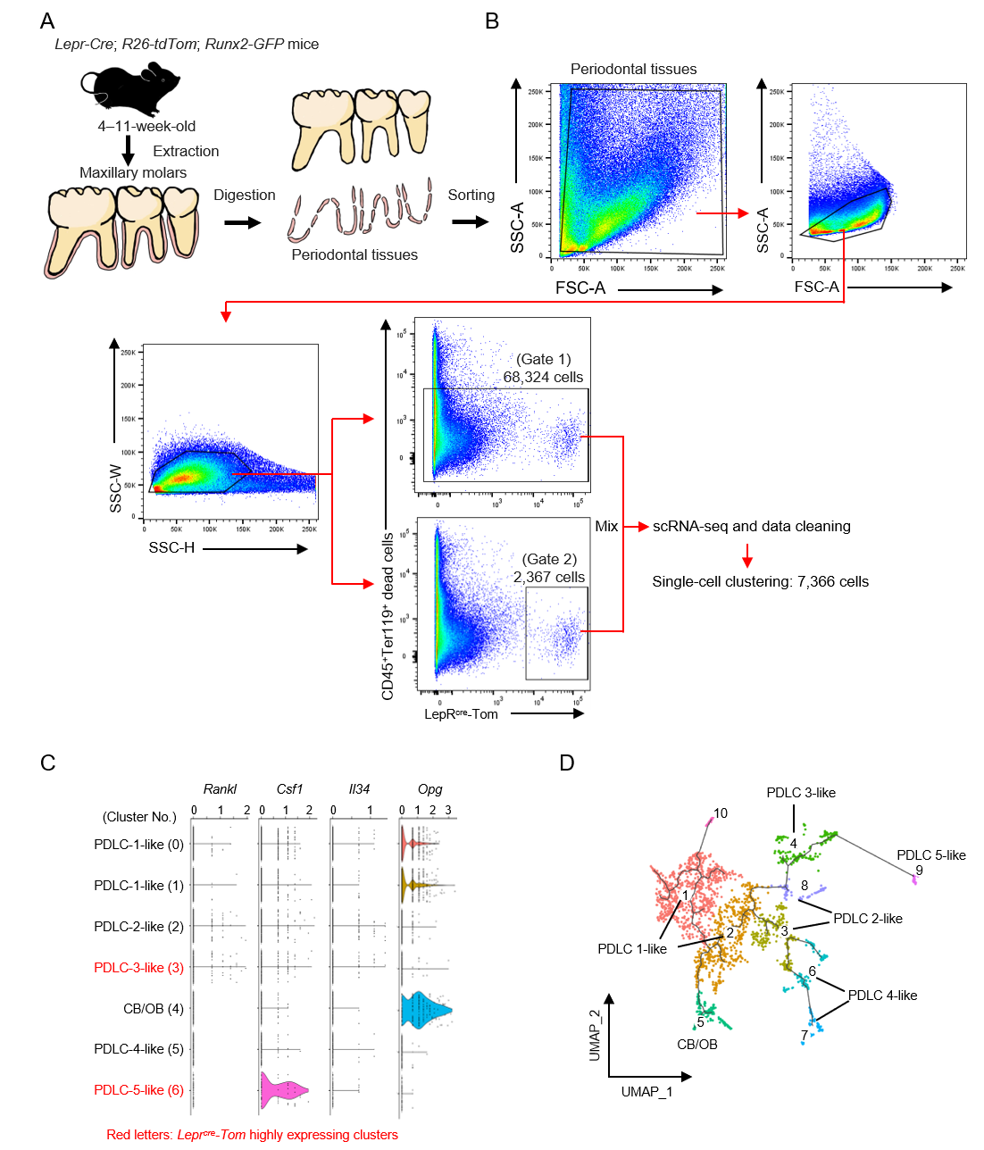
Appendix Fig.1

Appendix Fig. 1. scRNA-seq analysis of mouse periodontal tissues of maxillary first molars
A. Experimental procedure of scRNA-seq analysis of periodontal tissues of maxillary molars from Lepr-Cre; R26-tdTom; Runx2-GFP mice (male: n = 6, female: n = 12). B. Gating strategy used for scRNA-seq analysis. Representative flow cytometry plots showing the gating strategy for periodontal tissues. As the frequency of Lepr^{cre}-Tom⁺ cells in the sorted population was too low to perform gene profiling analysis, additional Lepr^{cre}-Tom⁺ cells (Gate 2: 2,367 cells) were added to the CD45–Ter119– living stromal population (Gate 1: 68,324 cells). C. Violin plots of the expression of selected osteoclast-regulating genes in each distinct subcluster. D. Re-clustered PDLC-like 1–5 and CB/OB clusters in Fig. 2A for single-cell trajectory analysis. The UMAP plot identified 10 distinct clusters. Cell-type annotation from Fig. 2A was applied to the UMAP, and trajectory analysis was performed.
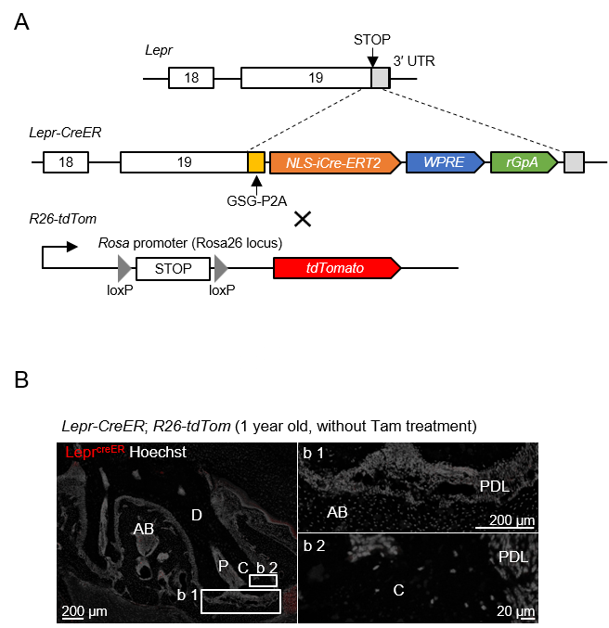
Appendix Fig.2

Appendix Fig. 2. Generation and verification of the Lepr-CreER knock-in mice used for cell labeling
A. Schematic diagram of the Lepr-CreER genomic construct. Lepr-CreER knock-in mice were crossed with R26-tdTomato (tdTom) mice to carry out labeling of Lepr⁺ cells. B. Spontaneous Cre activity was not observed in Lepr-CreER; R26-tdTom mice at 1 year old (n = 2). Nuclei were visualized using Hoechst.

