Supporting Information

Endogenous N-oleoylethanolamine Crystals loaded Liposomes with Enhanced Hydrophobic Drug Loading Capacity for Efficient Stroke Therapy

Shichao Wu#, Di Liao#, Xi Li, Zeyu Liu, Lin Zhang, Fanny Mo, Shuo Hu*, Jian Xia*, Xiangrui Yang*

Figure S1. The size distribution of OSDP LNPs.
Figure S2. The drug release of OEA, OEA-SPC NPs, and OSDP LNPs.

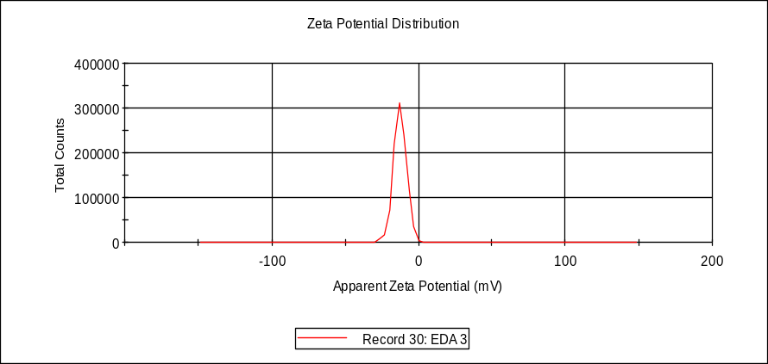
Figure S3. The Zeta potential of OSDP LNPs.

Figure S4. The size changes of OSDP LNPs and OEA-SPC NPs in an aqueous environment.
Figure S5. The size changes of redissolved dispersion of lyophilized OSDP LNPs and OEA-SPC NPs in 1 month.

Figure S6. The TTC-stained brain slices from the dead rats of the OSDP LNPs group.

