Characterization of Physicochemical, Biocompatible Properties and Investigation on Repair Mechanism of Three Typical ECM Meshes in Vitro and in Vivo

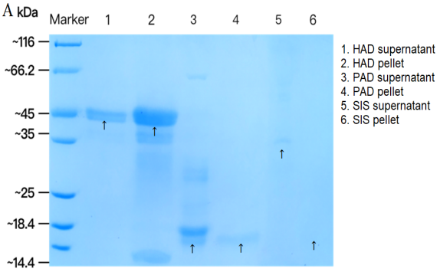
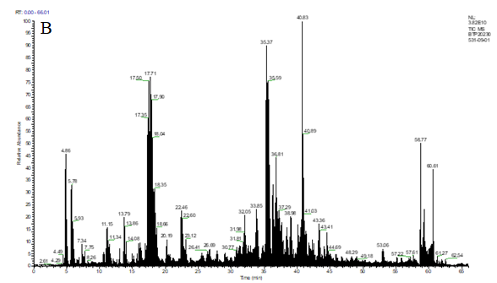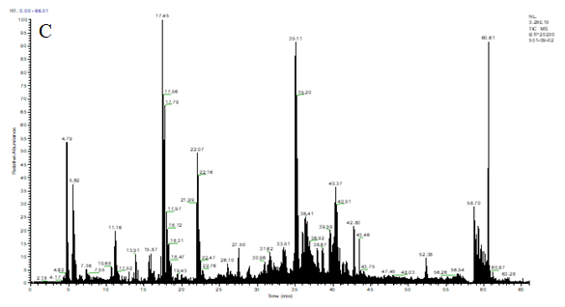
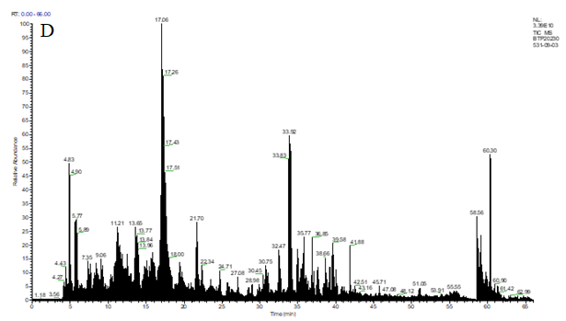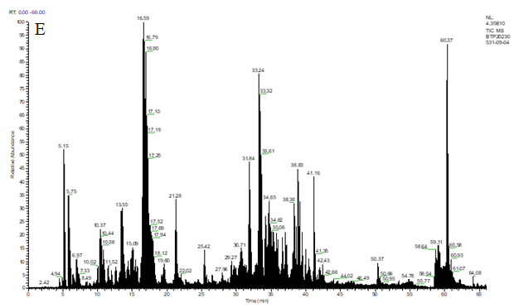
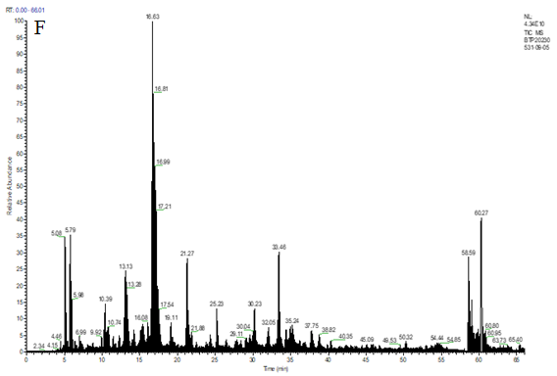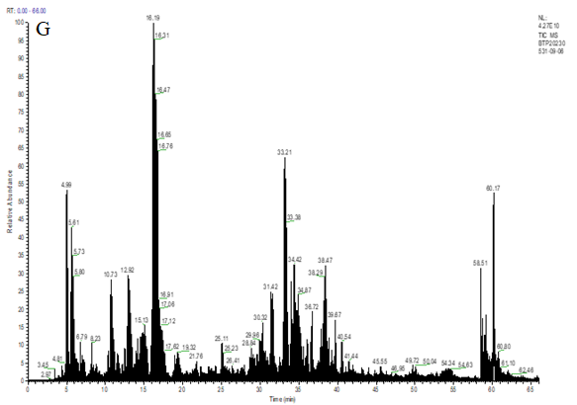
Figure S1. SDS-PAGE and LC-MS/MS total ion chromatogram. (A) SDS-PAGE for components of ECM meshes and use a UV spectrophotometer for detection. Choose the obvious electrophoretic bands to perform protein identification (↑). The possible proteins in HAD supernatant and pellet were: type I collagen α1 and α2 chain, respectively. The possible proteins in PAD supernatant and pellet were IF rod domain protein, keratin 17 and IF rod domain protein, type I collagen α1 chain, respectively. The possible proteins in SIS mesh supernatant and pellet were IF rod domain protein; (B) HAD supernatant, (C) HAD pellet, (D) PAD supernatant, (E) PAD pellet, (F) SIS supernatant, (G) SIS pellet.

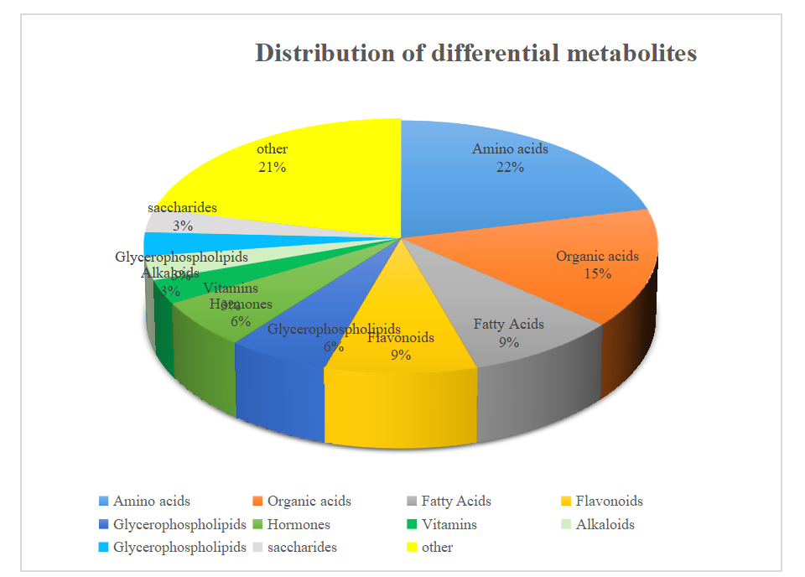
Figure S2. Yields 33 differential metabolites by qualitative matching analysis with secondary mass spectrometry. Amino acids, organic acids, fatty acids and flavonoids were the main differential metabolites.
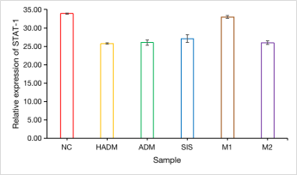
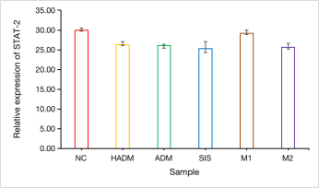
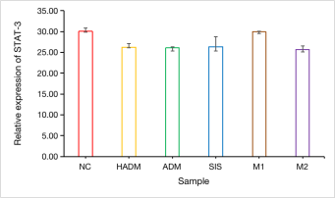
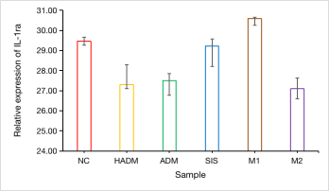
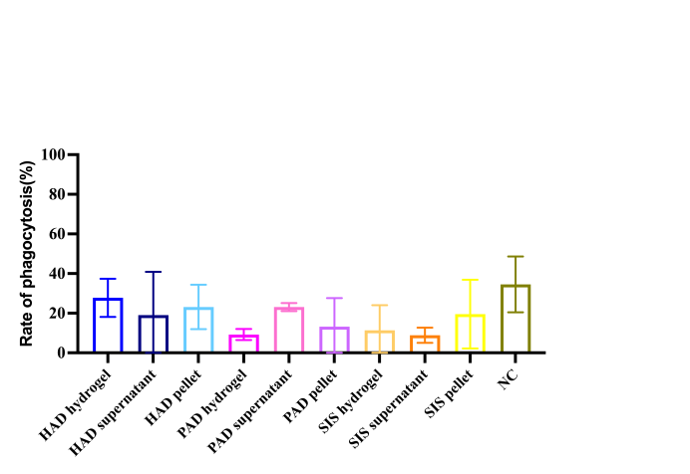

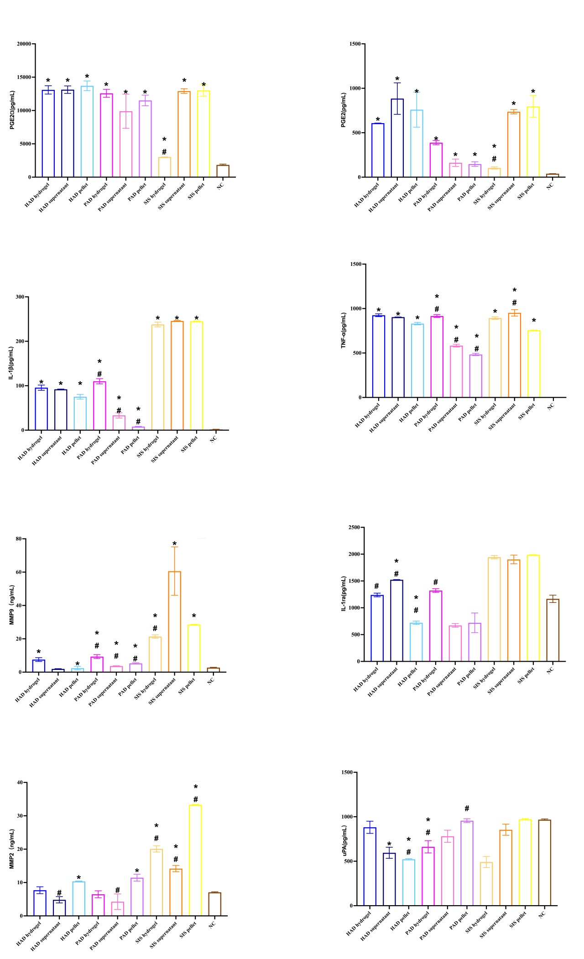
Figure S3. In vitro molecular mechanism of ECM mesh tissue repair.(A) THP-1 cells were treated with ECM mesh hydrogel, precipitation and supernatant samples for 48 h, and THP-1 cells engulfed fluorescent spheres were observed by laser confocal microscopy to calculate the phagocytic rate of THP-1 cells; (B) the expression levels of STAT 1, STAT 2, STAT 3 and IL-1ra were induced to differentiate into macrophages by RT-qPCR; (C) Effect of ECM mesh fraction on cytokine secretion by THP-1 cells. Note: *p <0.05 vs negative control, # p <0.05 vs different ECM test group.

Table. S1. Local tissue reaction and degradation of ECM meshes
mesh class | Implantation cycle（week） | Score | Tissue reactivity
PAD | 1 | 4.0 | Mild irritation
PAD | 4 | 8.3 | Mild irritation
PAD | 13 | 11.4 | Moderate stimulation
PAD | 26 | 9.3 | Moderate stimulation
HAD | 1 | 1.7 | No irritation or very mild irritation
HAD | 4 | 6.3 | Mild irritation
HAD | 13 | 2.4 | No irritation or very mild irritation
HAD | 26 | 3.7 | Mild irritation
SIS | 1 | 3.0 | Mild irritation
SIS | 4 | 7.0 | Mild irritation
SIS | 13 | 9.0 | Moderate stimulation
SIS | 26 | 10.0 | Moderate stimulation
Composite | 1 | 2.7 | No irritation or very mild irritation
Composite | 4 | 4.3 | Mild irritation
Composite | 13 | 8.3 | Mild irritation
Composite | 26 | 10.3 | Moderate stimulation

Table. S2. Scoring results of adhesion of different ECM meshes

Group |  | Male |  |  | Female
Group | Adhesion Strength | Adhesion area | Evaluation | Adhesion Strength | Adhesion area | Evaluation
HAD | 0.8±1.2 | 0.7±1.0 | Medium | 1.0±1.0 | 1.0±1.0 | Medium
PAD | 1.8±1.3 | 1.8±1.3 | Medium | 1.6±1.1 | 1.4±1.1 | Medium
SIS | 1.7±1.5 | 1.7±1.5 | Medium | 1.3±1.5 | 1.3±1.5 | Medium
Composite | 1.2±0.9 | 1.5±1.4 | Medium | 1.5±1.3 | 1.5±1.3 | Medium

Table. S3. Statistical assay of differential metabolites in serum samples in different groups

MS2 name | MEAN NC | MEAN T1 | MEAN T2 | MEAN T3 | MEAN T4 | P-VALUE
D-Phenylalanine | 2.15 | 2.05 | 1.86 | 1.87 | 1.88 | 0.03
Thiamine | 0.43 | 0.41 | 0.36 | 0.46 | 0.40 | 0.04
PC(16:0/16:0) | 5.56 | 7.84 | 6.16 | 7.51 | 7.93 | 0.05
Bis-Tris | 1.66 | 1.84 | 0.88 | 0.86 | 0.91 | 0.02
L-Tyrosine | 0.17 | 0.15 | 0.13 | 0.13 | 0.14 | 0.02
N-Acetyl-L-histidine (monohydrate) | 0.01 | 0.01 | 0.01 | 0.01 | 0.01 | 0.04
N-Methylsalsolinol | 0.28 | 0.27 | 0.28 | 0.31 | 0.27 | 0.00
Morusin | 0.05 | 0.08 | 0.05 | 0.03 | 0.07 | 0.03
Racemethionine | 0.58 | 0.56 | 0.48 | 0.52 | 0.50 | 0.02
Acrylodan | 0.31 | 0.42 | 0.23 | 0.53 | 0.40 | 0.04
(+/-)-1-Acetoxy-1-ethoxyethane | 0.35 | 0.46 | 0.39 | 0.24 | 0.42 | 0.01
D-Aspartic acid | 0.03 | 0.03 | 0.02 | 0.03 | 0.03 | 0.03
Calabaxanthone | 0.01 | 0.01 | 0.00 | 0.01 | 0.01 | 0.04
Isopropyl formate | 0.39 | 0.49 | 0.40 | 0.25 | 0.44 | 0.02
Propionic acid | 0.08 | 0.07 | 0.08 | 0.08 | 0.08 | 0.03
Coproporphyrin Ⅲ | 0.02 | 0.03 | 0.02 | 0.01 | 0.03 | 0.01
Arachidonic Acid (peroxide free) | 7.63 | 7.19 | 6.56 | 9.38 | 9.57 | 0.05
PC(20:2(11Z,14Z)/15:0) | 1.62 | 2.43 | 2.03 | 1.95 | 1.93 | 0.03
Glycolic acid | 0.02 | 0.03 | 0.02 | 0.02 | 0.02 | 0.04
9,10-Epoxyoctadecenoic acid | 0.38 | 0.69 | 0.47 | 0.39 | 0.49 | 0.01
2-(Ethylamino)-4,5-dihydroxybenzamide | 0.06 | 0.06 | 0.04 | 0.04 | 0.05 | 0.04
N1-(2-Methoxy-4-methylbenzyl)-n2-(2-(pyridin-2-yl) ethyl)oxalamide | 0.07 | 0.10 | 0.06 | 0.04 | 0.10 | 0.03
Cinnamyl phenylacetate | 0.88 | 1.29 | 0.99 | 0.58 | 1.20 | 0.02
Methylsyringin | 0.02 | 0.02 | 0.01 | 0.01 | 0.02 | 0.02
Dihydrocortisol | 0.01 | 0.03 | 0.02 | 0.02 | 0.03 | 0.01
Parakmerin A | 0.47 | 0.70 | 0.59 | 0.30 | 0.66 | 0.04
SN-38 | 0.01 | 0.01 | 0.00 | 0.00 | 0.01 | 0.03
12-Tridecene-4,6,8,10-tetraynal | 2.24 | 2.86 | 1.88 | 3.66 | 2.77 | 0.03
Kuwanon A | 0.03 | 0.04 | 0.01 | 0.02 | 0.03 | 0.00
Nervonic acid | 0.12 | 0.22 | 0.26 | 0.28 | 0.29 | 0.03
Monomethyl phthalate | 0.30 | 0.43 | 0.27 | 0.58 | 0.45 | 0.03
N-Acetyl-beta-alanine | 0.01 | 0.01 | 0.01 | 0.01 | 0.01 | 0.03
Cinnatriacetin A | 0.09 | 0.14 | 0.09 | 0.05 | 0.12 | 0.02

Table. S4. Pathways of differential metabolites between NC group and each ECM group

Group | Metabolites Pathway
NC VS Composite | Cysteine and methionine metabolism,  Glycine, serine and threonine metabolism, Aminoacyl-tRNA biosynthesis
NC VS PAD | Phenylalanine, tyrosine and tryptophan biosynthesis
NC VS HAD | Phenylalanine, tyrosine and tryptophan biosynthesis，  Phenylalanine metabolism

Table. S5. Pathways of differential metabolites between Composite group and each ECM group
Group | Metabolites Pathway
Composite vs PAD | Starch and sucrose metabolism  Synthesis and degradation metabolic pathways of ketone bodies
Composite vs HAD | Taurine and Hypotaurine Metabolic
Composite vs SIS | Sphingolipid metabolism

