Supplementary Table 1 Information on articles with established prognostic models for comparison
Authors | Genes | The PMID of Article
Chen_H et.al | NPY1R, CELSR2, STC2, SCUBE2, GIMAP2, HLA-DPB1, CXCL14 , KLRB1, BIRC3, IL18, PSMB8, CD1C, TNFAIP8, IRF1 | 37860187
Chen_QT et.al | ABCC9, PIGR, CXCL13, DOK7, CD24, IVL | 38665551
Chen_X et.al | APOA5, CHAC1, EMIDI, GOSR2, RGS20, RPH3A, SGCE, TCP1, TMEM167A, ZDHHC15 | 38300336
Chen_Y et.al | ELOVL2, IFNG, MAP2K6, MZBI, PCSK9, IGF2BPI, POPI | 38725284
Huang_BJ et.al | CACNA2D1, MAP3K4, PLCD1, PTPN7, TMBIM6, VHL, PARP3, FBXO6, APBB1IP, TNN, WNT10A | 37685980
Jiao_YC et.al | RAD51, CASP14, NEK10, PCP2, IDO1, CLSTN, IGHG | 38318076
Lei_CQ et.al | SERPINA1, SERPINF2, C1S, CFB, RASGRP1, TLN2 | 38751445
Li_Q et.al | TP63, IFNG, MT3, ANO6, FLT3, PTGS2, SLC1A4, JUN, SLC7A5, CHAC1, TF | 37643511
Li_Y et.al | SERPINA1, CD74, STX11 , ADAM9, CD24, NFKBIA, PGK1 | 34187256
Liu_Y et.al | CCT4, CXCL13, MTDH, PSMD2, RAB27A | 38795164
Ma_S et.al | FEZ1, ITGA5, F12, IGF2R, FLT3, IL16, IL1RN, CD79A | 38634039
Qiu_CR et.al | ALOX5B, CA9, CD24, CHEK1, FOXM1, HOTAIR, KCNJ11, NEDD9, PSME2 | 38561760
Su_HR et.al | ATP6AP1, SLC7A5, EPDR1, SDC1, PIGR | 38162504
Authors | Genes | The PMID of Article
Teng_X et.al | MDC1, PARP3, PSMB1, PSMB9, PSMD2, PSMD7, PSMD14 | 37350936
Wang_D et.al | ALOX15, CISD1, CS, GCLC, GPX4, SLC7A11, EMC2, G6PD, ACSF2 | 34059009
Wang_F et.al | SERPINA1, P2RX5, CAPN1, ITGA6, PFKP, VPS37B, TECPR1, FOXO3, PRKAG3 | 36856932
Wang_Y et.al | ACSL1, ALDH2 , MTHFD2, MRPL13, TP53AIP1, SLC1A1, ME3, BCL2A1 | 38310106
Wu_Q et.al | ZIC2, NFE2, FOXJ1, KLF15, POU3F2, SPIB | 37596527
Wu_ZZ et.al | IL18, MYD88, GLIPR1, TNN, BHLHE41, DNAJB5, FKBP14, XG | 38322675
Ye_YH et.al | ALOX15B, ERRFI1, ETS1, G6PD , MAP2K6 NDRG1, ZMAT3 | 37600707
Zhang_J et.al | FLT3, IL33, IL18, IL2RG, CXCL9, CCL5, MMP9, IDH2, EZR, CCR7, MAPK10 | 38438469
Zhang_L et.al | TP63, SQLE, SLC7A5, SLC7A11, PTGS2, PROM2, MT3, IL33, ANO6, ALOX15B | 38152394
Zhang_ZH et.al | LDHD, LYRM7, PNKD | 36171887

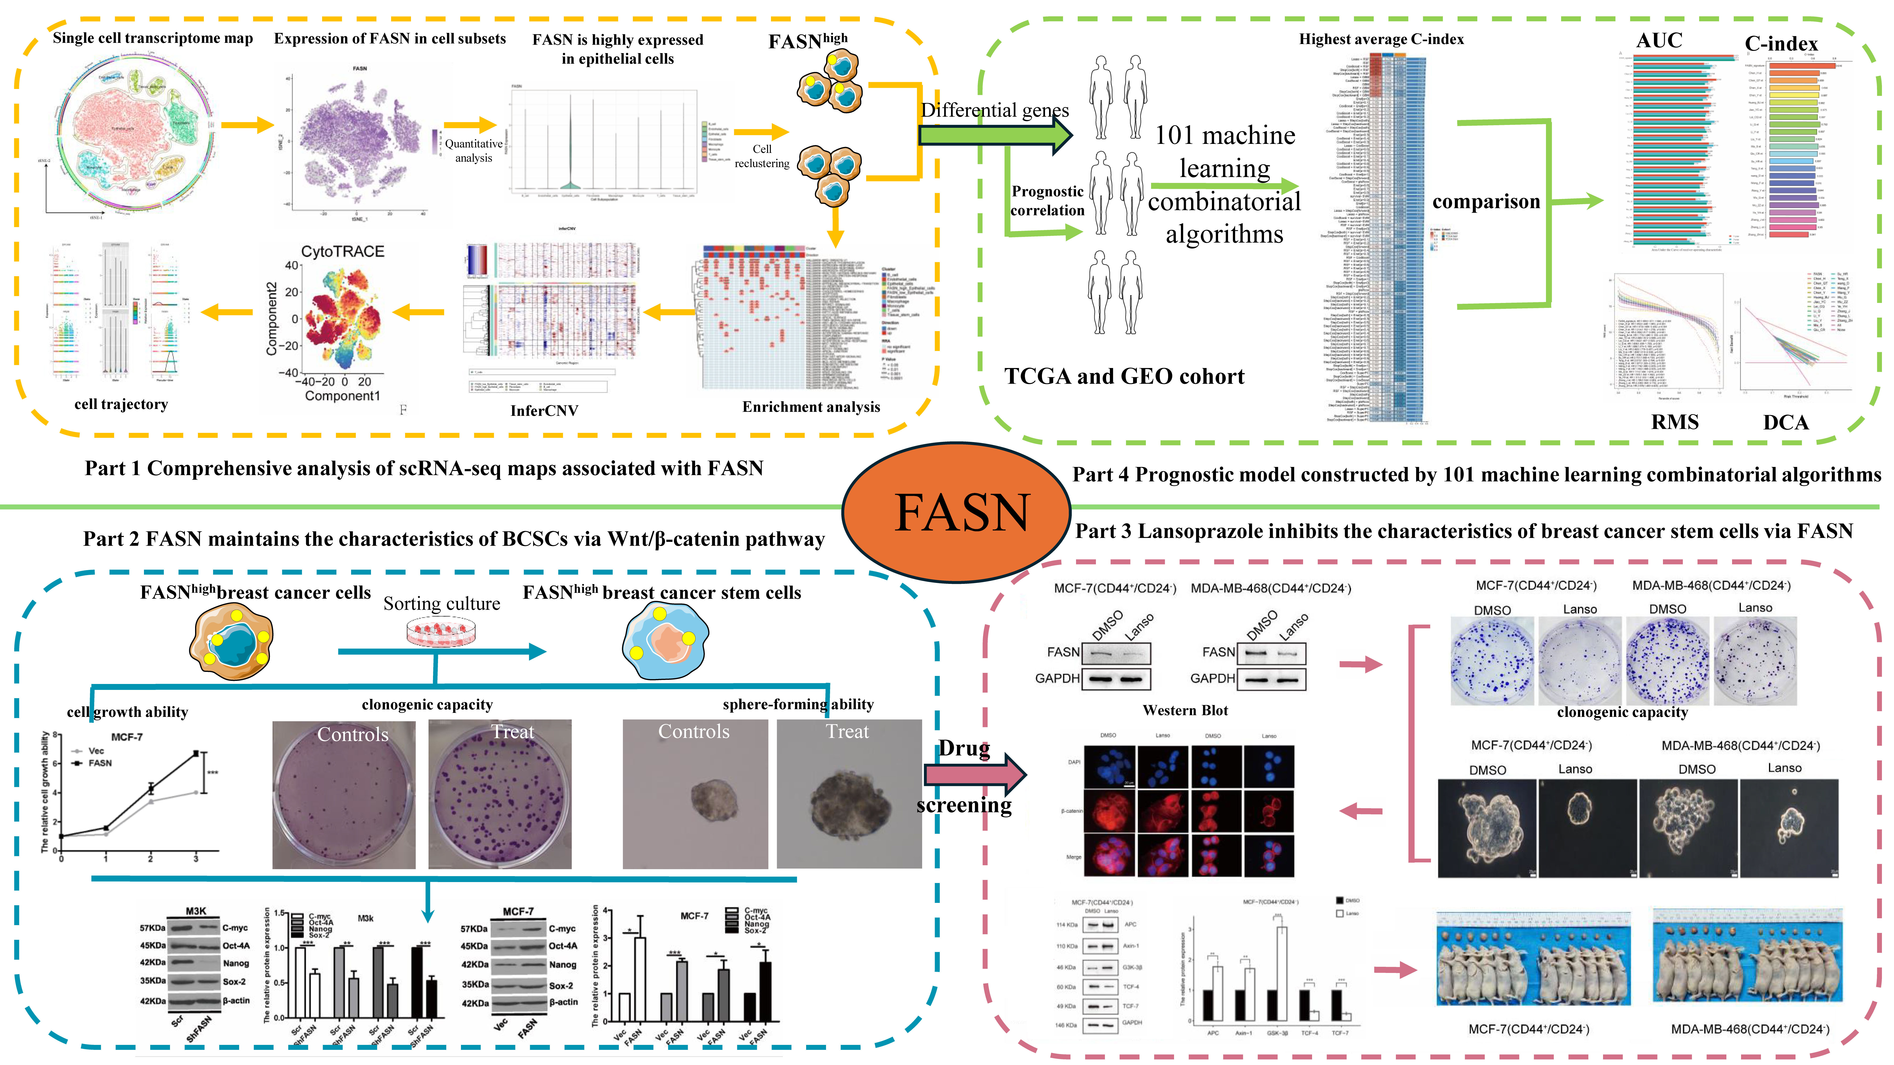
Supplementary Figure 1 The workflow of this article.

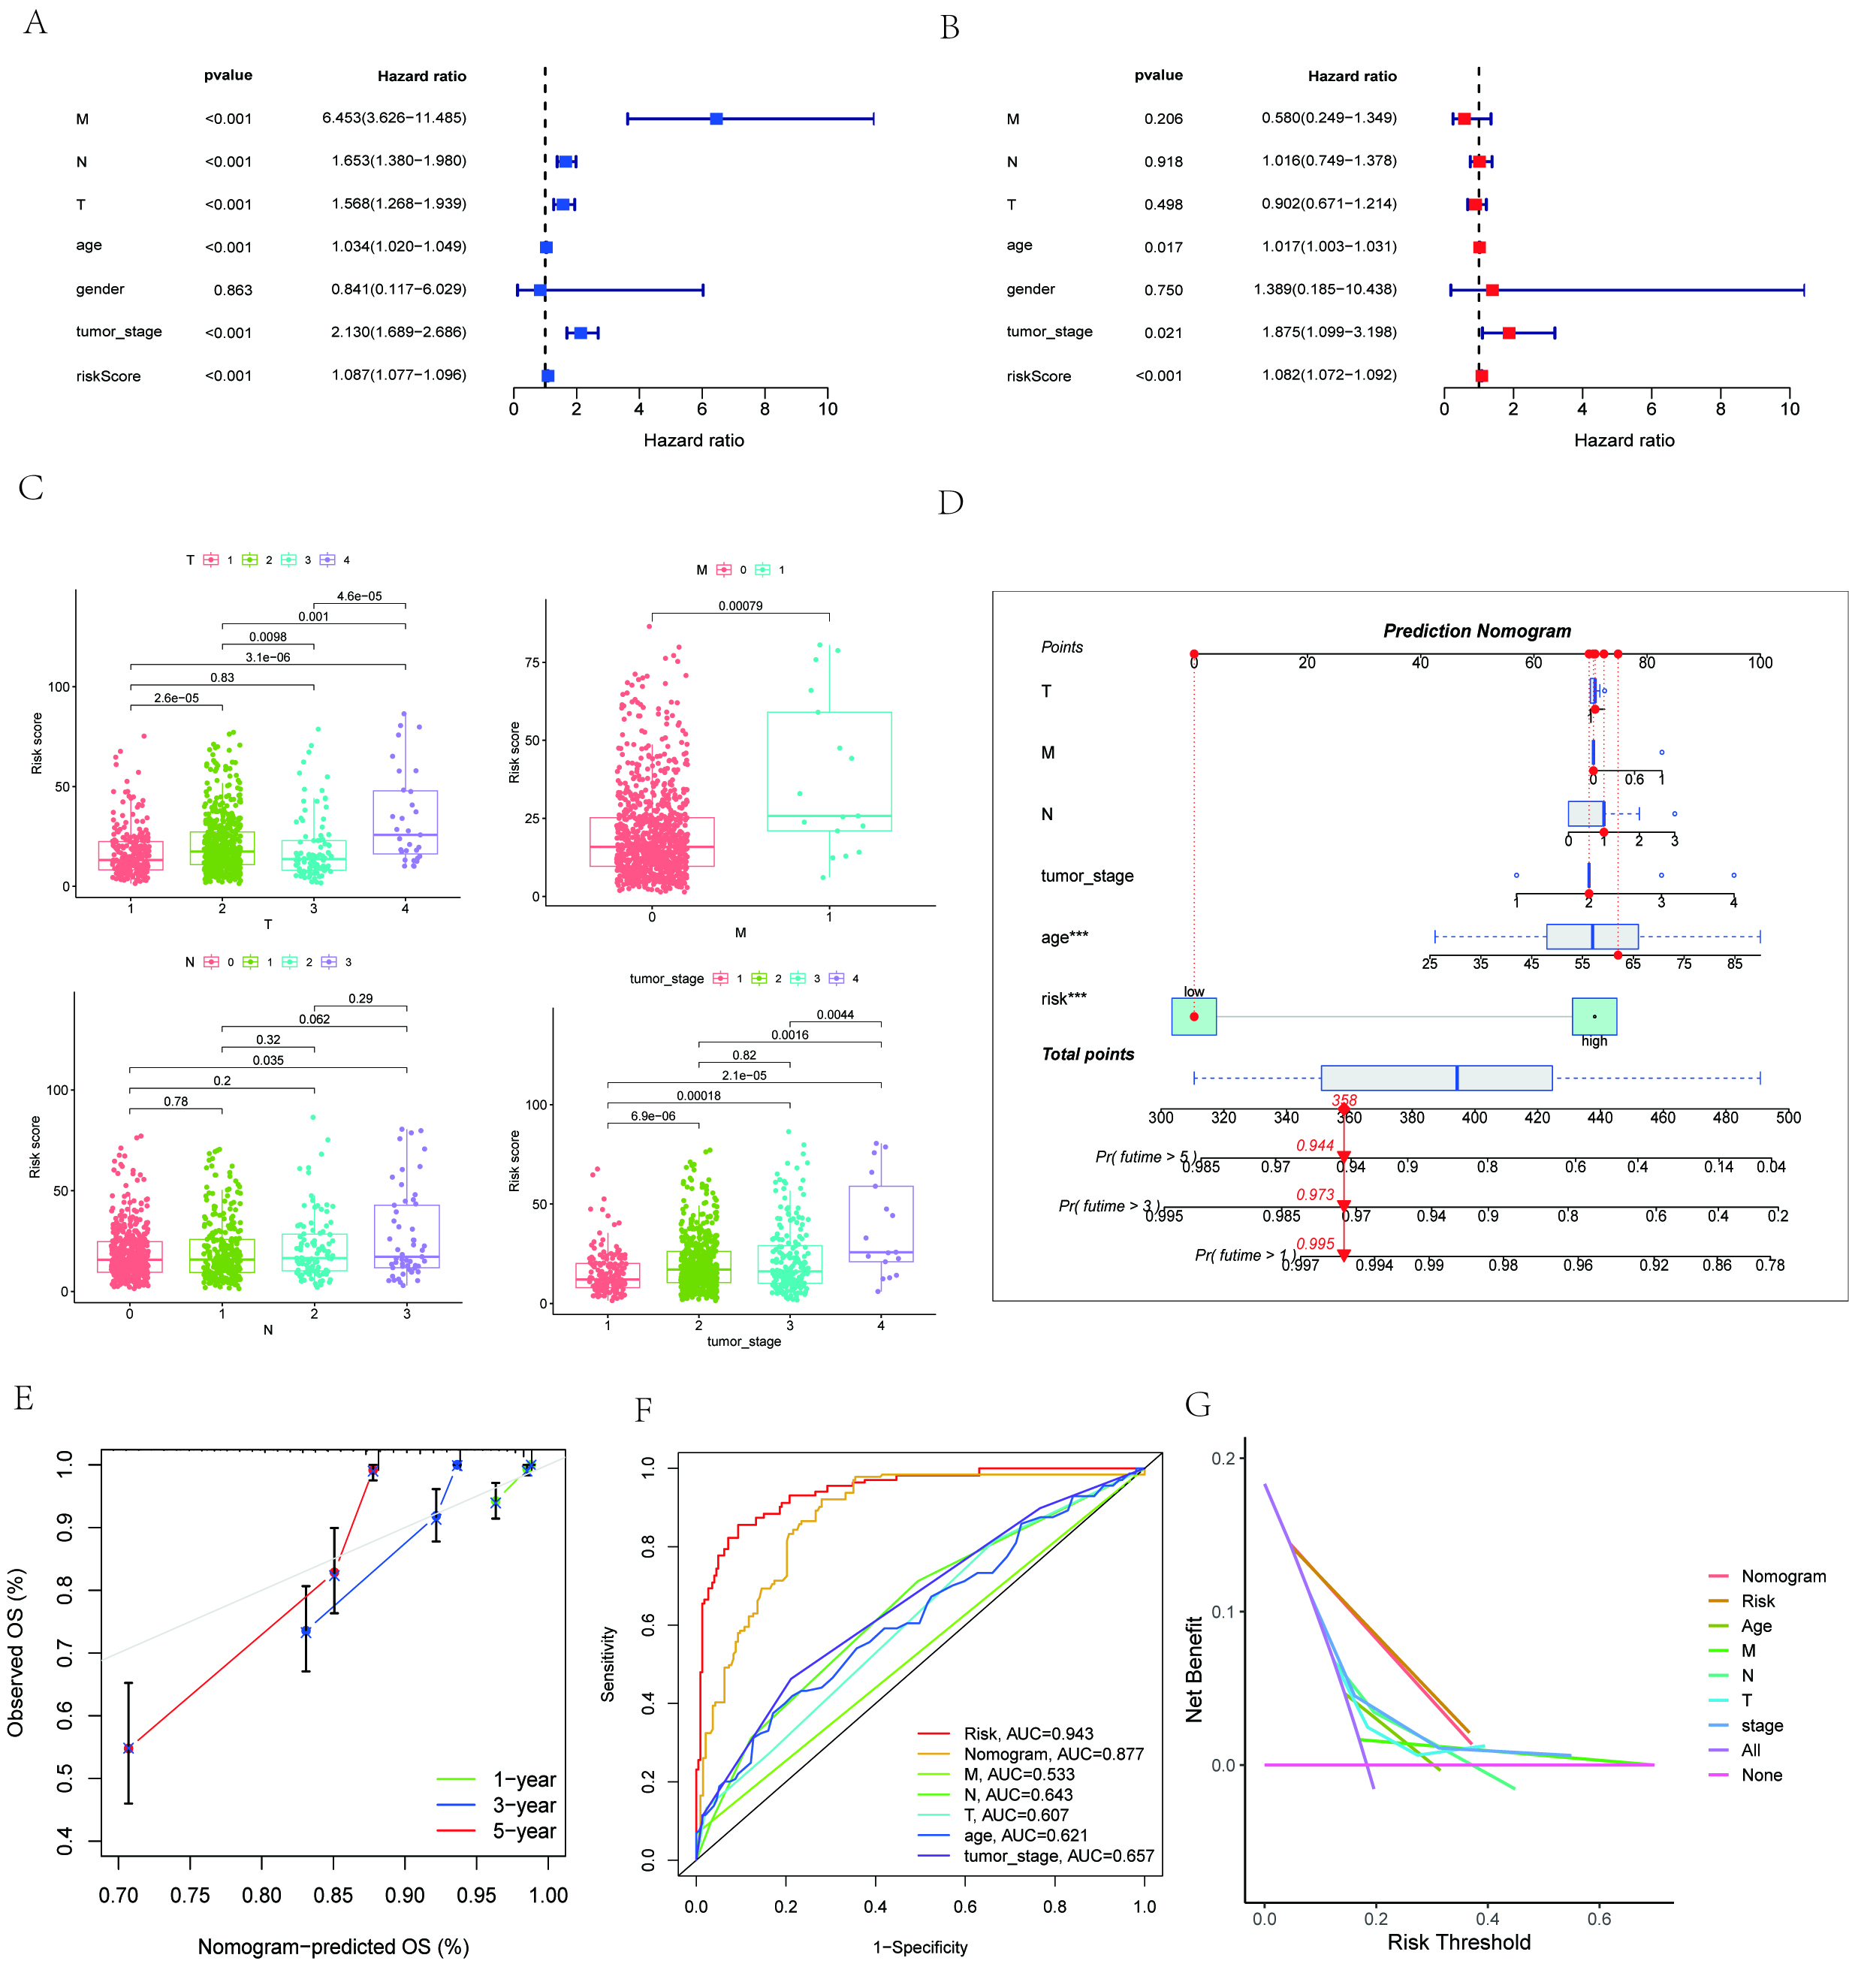
Supplementary Figure 2 Construction of a nomogram integrating clinical variables. (A-B) Univariate and multivariate Cox regression analysis of clinical factors and risk scores in breast cancer prognosis. (C) Association of risk scores with clinical variables in breast cancer patients. (D) Nomogram for Predicting Overall Survival in Breast Cancer Patients. (E) Calibration curve for the nomogram-predicted overall survival (OS). (F) Receiver Operating Characteristic (ROC) Curves for Predictive Performance. (G) Decision Curve Analysis (DCA) for the nomogram and individual clinical factors in predicting patient outcomes.

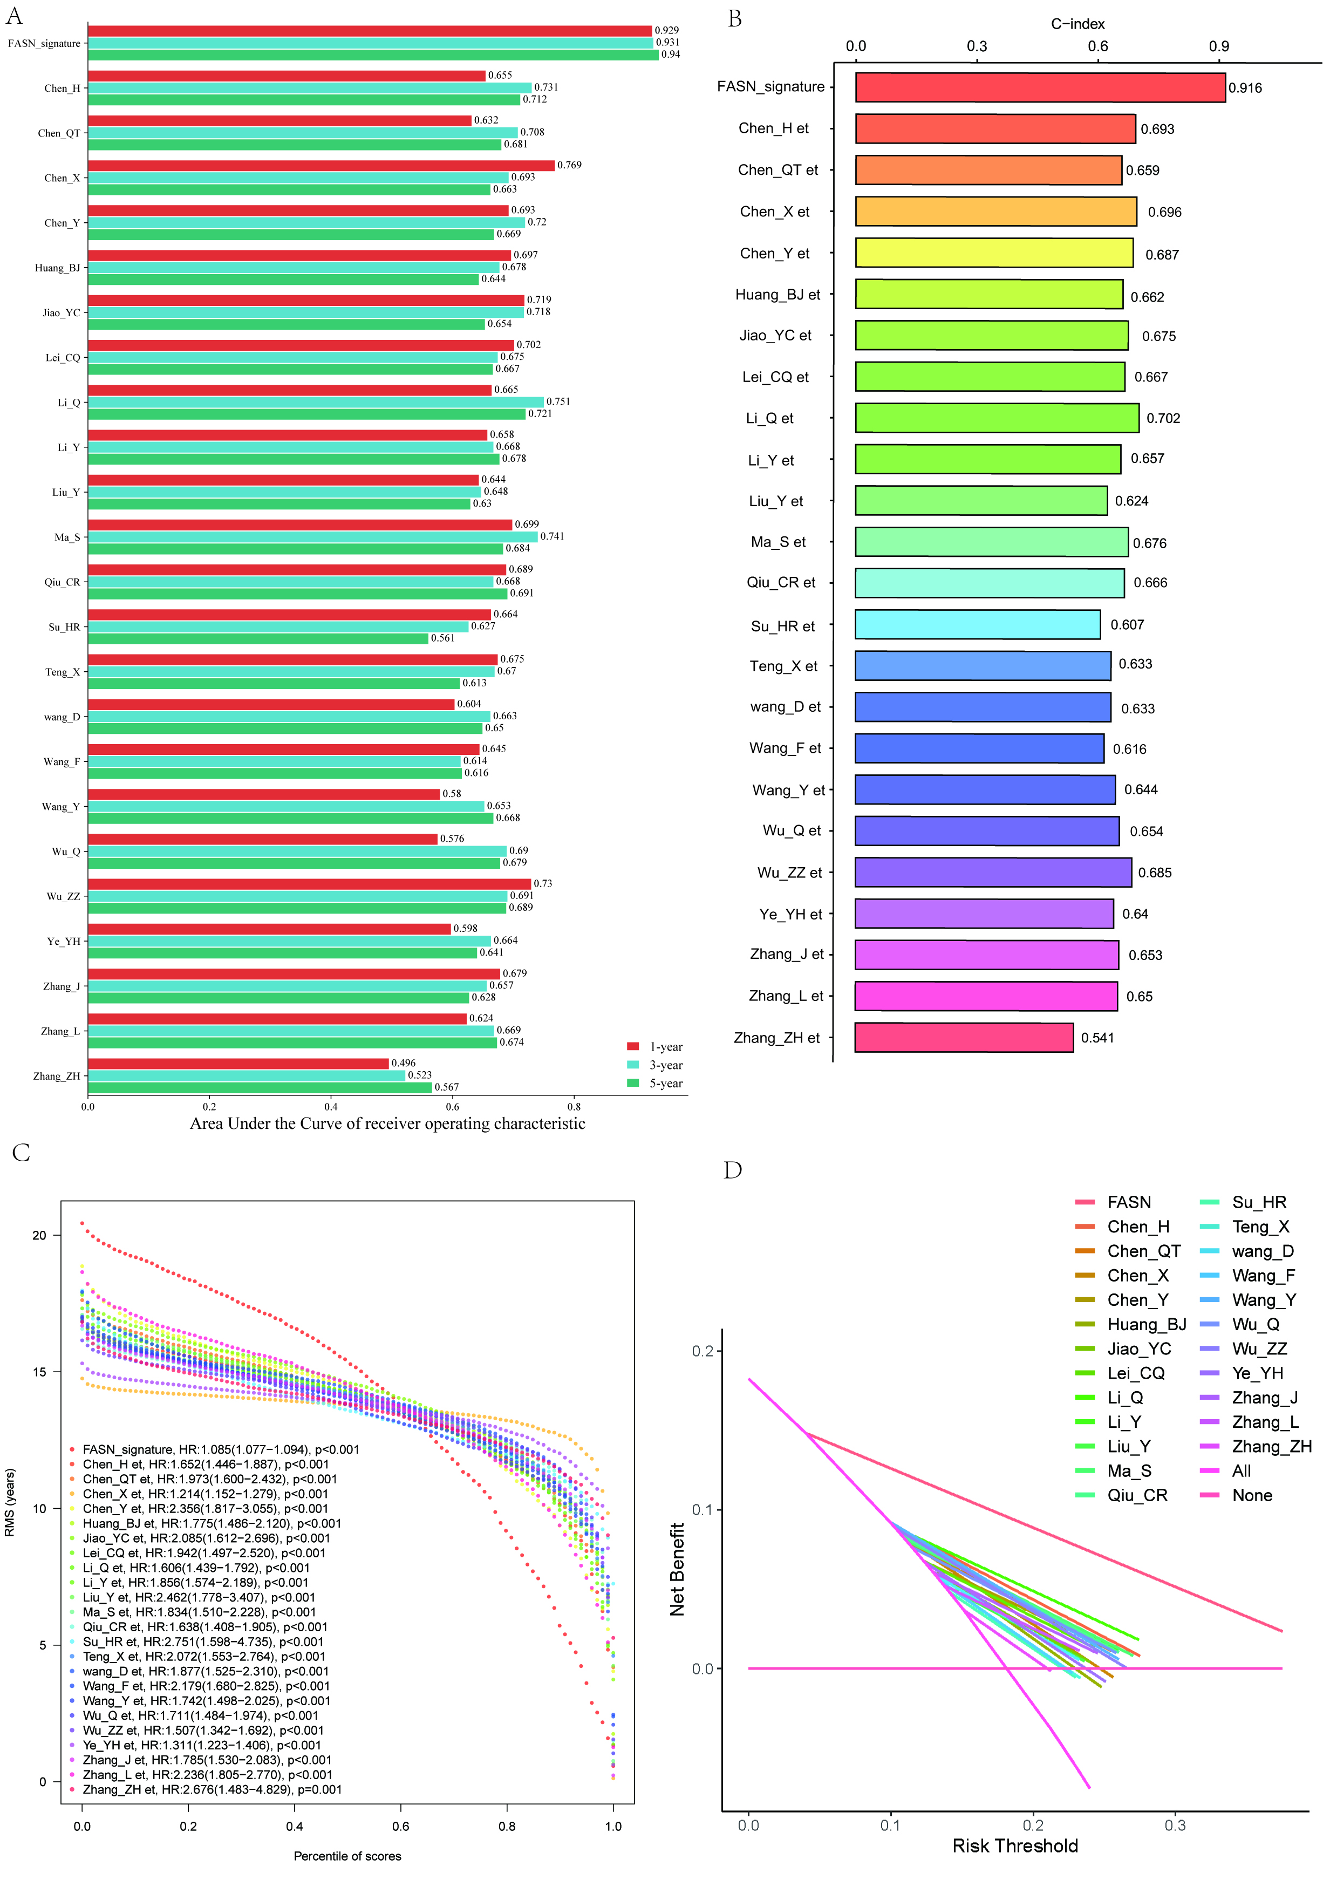
Supplementary Figure 3 Comparison of the prognostic performance of the FASN signature against various published breast cancer prognostic models. (A) Time-dependent Area Under the Curve (AUC) values at 1, 3, and 5 years, showing the predictive accuracy of the FASN signature and other models. (B) Concordance index (C-index) comparison of the FASN signature with other prognostic models for breast cancer patients. (C) Restricted Mean Survival (RMS) analysis comparing the prognostic significance of FASN-related signature with other models. (D) Decision Curve Analysis (DCA) showing the net benefit provided by the FASN-related signature compared to other models across various risk thresholds.

