SUPPLEMENT

Induction of CD73 prevents death after emergency open aortic surgery for a ruptured abdominal aortic aneurysm – a randomized, double-blind, placebo-controlled study

Harri Hakovirta MD, PhD^{1,2,3}; Juho Jalkanen MD, PhD⁴; Eija Saimanen MD, PhD⁵; Tiia Kukkonen MD, PhD⁶; Pekka Romsi MD, PhD⁷; Velipekka Suominen MD, PhD⁸; Leena Vikatmaa MD, PhD⁹, Mika Valtonen MD, PhD¹⁰; Matti K. Karvonen MD, PhD⁴; Maarit Venermo MD, PhD¹¹; and INFORAAA Study Group

Details from the Adverse Event Reports on two patients that were excluded from efficacy analyses

Patient 1
Patient 1, an 80-year-old male diagnosed with ruptured abdominal aortic aneurysm (RAAA),was randomised to blinded treatment with FP-1201-lyo/placebo. The patient was administered the first dose of study drug on 23 May 2017 and ended the treatment on 24 May 2017. The patient received 10 μg once daily (intravenously) of the blinded study drug for 1 day. His medical/surgical history included pulmonary arterial hypertension, coronary artery disease, hypercholesterolaemia, lymphoma, cerebrovascular accident, osteoarthritis, type 2 diabetes mellitus, arrhythmia supraventricular, sinus node dysfunction, benign prostatic hyperplasia, chronic renal insufficiency (from 2014) and cardiac insufficiency (hospitalized first time March 2014).

On 23 May 2017, the patient was hospitalised due to an aneurysm rupture and was operated
immediately. After the procedure, the patient was anuric, he also had severe hypotension and
needed high level noradrenaline support. On the first operative day the decision was to stop the intensive care treatment because of the poor prognosis due to the chronic renal insufficiency and severe cardiac insufficiency that the patient had already before the aneurysm rupture. The patient died on 24 May 2017 at 18:25 (Day 1 of the study). Ruptured abdominal aortic aneurysm was reported as a cause of death. An autopsy was not performed.
The investigator assessed the event of multiple organ dysfunction syndrome as not related to the study drug. The most likely cause of the event was concomitant disease. The sponsor agreed with the investigator’s causality assessment.

Patient 2
Patient 2, a 73-year-old male diagnosed with ruptured abdominal aortic aneurysm (RAAA),
was randomised to blinded treatment with FP-1201-lyo/placebo. The patient was administered the first dose of study drug on 04 Jun 2017 and ended the treatment prematurely on 05 Jun 2017. His medical/surgical history included type 2 diabetes mellitus, hypertension, acute myocardial infarction, cardiac arrest, ventricular fibrillation, sinus node dysfunction, hypercholesterolaemia, arrhythmia, cardiac failure congestive, ischaemic cardiomyopathy and hypothyroidism. On 04 Jun 2017, the patient sustained ruptured abdominal aortic aneurysm and was hospitalised. Emergency operation was carried out, bleeding during the operation was 12 litres. Postoperatively the patient was transferred to intensive care unit (ICU). He was anuric. Due to suspicion of bleeding and high intra-abdominal pressure, laparotomy and open abdomen treatment was initiated on 05 Jun 2017. Despite deliberation, the patient continued being anuric and hypotonic. Multi-organ failure was diagnosed considering its onset on 04 Jun 2017 at 18:30 (Day 0 of the study). The patient died on 05 Jun 2017 at 22:00 (Day 1 of the study). Ruptured abdominal aortic aneurysm was reported as the cause of death. An autopsy was not performed. The investigator assessed the event of multiple organ dysfunction syndrome as not related to the study drug. The most likely cause of the event was disease under treatment. The sponsor agreed with the investigator’s causality assessment.

Supplemental Table S1. Reason for using glucocorticoids with IFN beta-1a
Reported indication for glucocorticoid use | Number of patients | Start of treatment | Dose & regime
Emphysema | 1 | 1 day after surgery | Hydrocortisone start 200mg/day, used tappering down until day 15
Shock | 2 | From surgery | Hydrocortisone used for 2 days 200mg/day
Anesthesia | 1 | From surgery | Dexmethasone 9mg/day for 2 days
Baseline disease | 3 | Pre-existing | Methylprednisolon varying doses

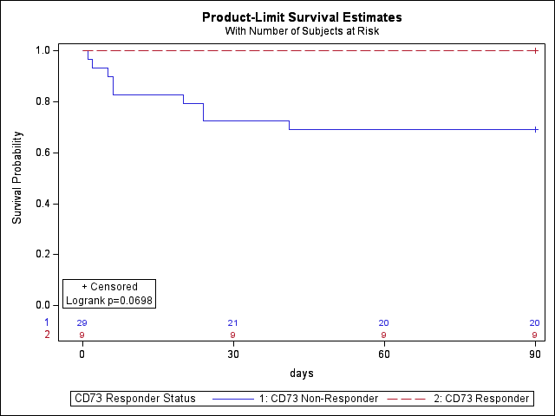
Supplemental Figure S1. D90 Kaplan-Meier Survival Curve for the entire study population divided into CD73 responders vs. non-responders.

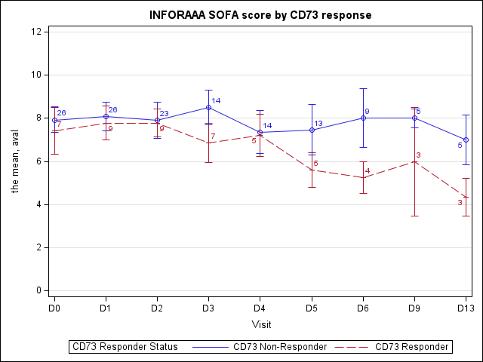
Supplemental Figure S2. SOFA score in the entire study population divided into CD73 responders vs. non-responders

IFN beta neutralizing antibodies (NABS) and MxA and CD73 responses
Methods
The study of anti-human IFN beta antibodies in human serum was carried out in the quality-assured environment of Wieslab’s ISO 17025 and GLP test facility in Malmö, Sweden. The study was performed and documented according to current written local standard operating procedures A detailed description of the method can be shared under confidentiality. The principle is a bridging immunoassay with electrochemiluminescence (ECL) as detection method where anti-drug antibodies form a bridge with labelled drug material. The ECL label emit light in response to an electrical current that is initiated at the electrodes at the bottom of the plate. The method consists of three tiers: 1) a screening assay, where anti-drug antibodies are detected. 2) a confirmatory assay, where anti-drug antibody specificity is confirmed and 3) a titer assay, where anti-drug antibodies are semi-quantitated. Assay sample output is reported qualitatively (tier 1/2) and semi quantitatively (tier 3).
- Tier 1: Samples with a response ≥ SCP were further tested in confirmatory assay
- Tier 2: Samples with a response ≥ CCP were reported as positive
- Tier 3: The titer result was determined as the lowest dilution/concentration of the diluted sample that was detected ≥ SCP and was reported as absolute titer with minimum required dilution factored in.
Blank pooled serum was used as negative control (NC). NCs were stored at -60°C to -90°C. Positive controls (low- and high-quality controls (QCs)) were prepared by spiking blank pooled serum with the positive control antibody. QCs were prepared frozen at approximately -60°C to -90°C at least 12 hours prior to analysis. These run qualifying controls were included in all assay tiers and runs in at least replicate n = 2x2 wells at each concentration level. Study serum samples were transferred and stored at -60°C to -90°C until analyses. Study samples were analysed as duplicates in each analytical run. The %CV for the duplicate determination must be ≤25%, If a study sample does not meet acceptance criteria it must be reanalysed according to Wieslab procedures.

Results
Determination of elevated levels of IFN beta neutralizing antibodies (NABS) was succesful except for one patient. In the baseline serum sample 45% of study patient had elevated levels of NABS. A multivariable Repeated Measurements Covariance (RM ANCOVA) model for both MxA and CD73 levels during the observation period from baseline to day 13, which explored what affects CD73 and MxA levels the most. The model included treatment (active vs. placebo), concomitant use of glucocorticoids (Y/N), presence of NABS (Y/N), duration of surgery, and transfusion. The most profound effect was with NABS, which reached statistical significance in the model (P = 0.04 for CD73 and P = 0.02 for MxA). Visualization of the effect NABS have on CD73 and MxA can be seen in Figures S3 and S4 below.
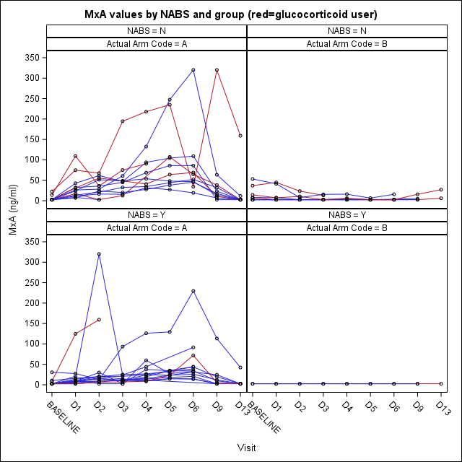
Supplemental Figure S3. MxA values in both treatment groups (A = IFN beta-1a group; B = placebo group) according to the presence of NABS (Y = yes, elevated levels; N = elevated levels not detected).

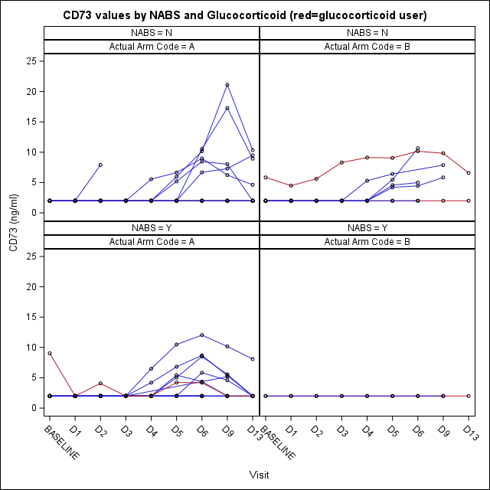
Supplemental Figure S4. CD73 values in both treatment groups (A = IFN beta-1a group; B = placebo group) according to the presence of NABS (Y = yes, elevated levels; N = elevated levels not detected).

