CNIH4 regulates metabolic adaptations to exercise through β-adrenergic receptor-mediated ECM remodeling

Xu Liu^{1*}, Zhihong Wang^{1*}, Tao Bo², Zhiwei Liu¹, Zhihao Jia^{1, ✉}, Yong Zhang^{1, ✉}

¹Jiangsu Key Laboratory of Drug Discovery and Translational Research for Brain Diseases, Cambridge-Suda Genomic Resource Center, The Fourth Affiliated Hospital, Suzhou Medical College, Soochow University, Suzhou, Jiangsu, China
²Key Laboratory of Endocrine Glucose & Lipids Metabolism and Brain Aging, Ministry of Education, Department of Endocrinology, Shandong Provincial Hospital Affiliated to Shandong First Medical University, Jinan, Shandong, China.

✉Corresponding author
Zhihao Jia, zhjia@suda.edu.cn
Yong Zhang, yong.zhang@suda.edu.cn

*Contributed equally to this work

Keywords: CNIH4; Skeletal muscle; Adipose tissue; β-adrenergic receptor; ECM

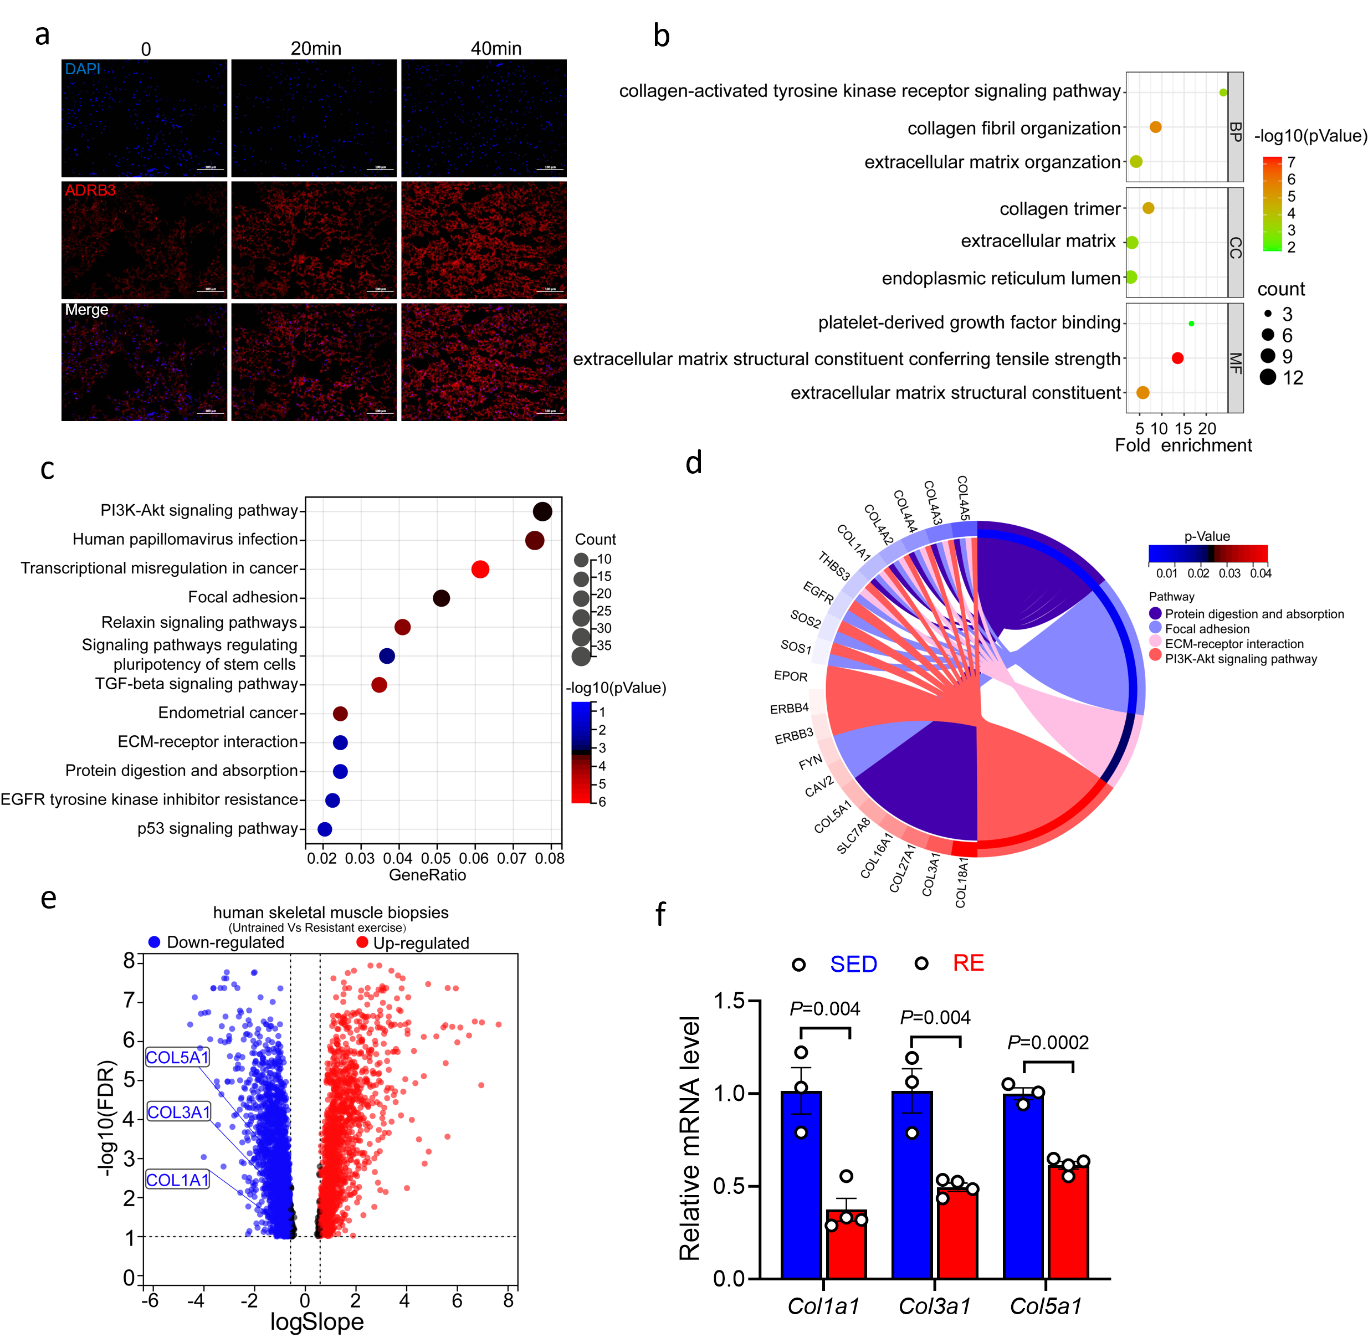
Fig S1. Transcriptome analysis of significant DEGs between SED and RE in human. (a) Representative immunofluorescence images of BAT cross-sections from mice subjected to sedentary conditions or acute treadmill exercise for 20 or 40 minutes. Sections were stained for DAPI (blue) and ADRB3 (red). Scale bar, 100 μm. (b) GO enrichment analysis, (c) KEGG pathway analysis and (d) Chord Diagram conducted on the 2285 differentially expressed proteins between SED and RE (FDR < 0.1) (e) Volcano plot of human vastus lateralis muscle in progressive resistant running. FDR < 0.1. (f) RT-qPCR analysis of TA muscle after mice resistant exercise 4 weeks. Data are expressed as the mean ± SEM. Statistical significance was assessed by unpaired two-sided Student’s test (f). The exact P values are shown in the figure or corresponding legends.

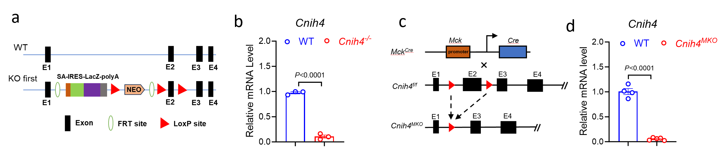
Fig S2. Generation and characterization of Cnih4-deficient mice. (a-b) Schematic diagram showing the construction strategy of Cnih4 global knockout mice (a) and validation of mouse knockout efficiency by RT-qPCR (b). (c-d) Schematic diagram showing the construction strategy of Cnih4^{MKO} mice(c) and validation of mouse knockout efficiency by RT-qPCR (d). Data are expressed as the mean ± SEM. Statistical significance was assessed by unpaired two-sided Student’s test (b, d). The exact P values are shown in the figure or corresponding legends.

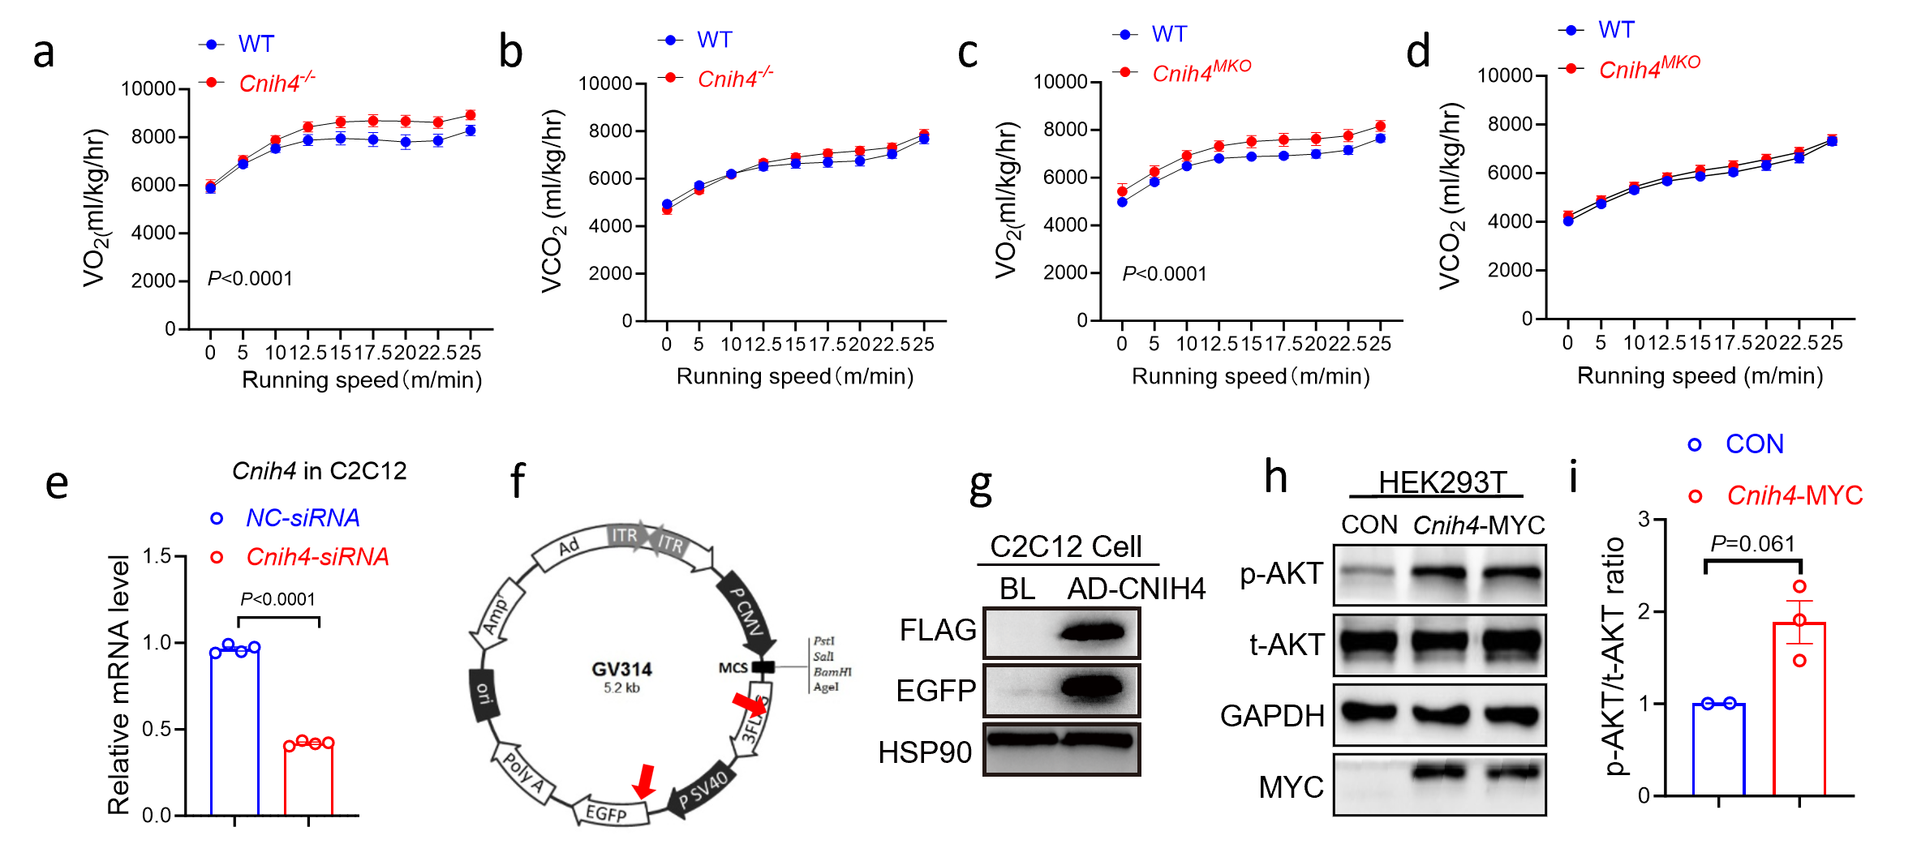
Fig S3. Knockdown efficiency and overexpression of CNIH4 in mammalian cells. (a-b) O₂ consumption (VO₂) and CO₂ (VCO₂) production of WT (n = 8) and Cnih4^{-/-} (n = 9) mice during exercise. (c-d) O₂ consumption and CO₂ production of WT (n = 8) and Cnih4^{MKO} (n = 8) mice during exercise. (e) Validation of Cnih4-siRNA knockdown efficiency in C2C12 cells. C2C12 cells were transfected with Cnih4-siRNA on day 1 of differentiation. Media was changed every two days, and cells were harvested on day 5 for qPCR analysis to confirm knockdown efficiency. (f-g) Construction (f) and validation (g) of CNIH4 adenovirus. Adenovirus for CNIH4 overexpression was constructed by cloning the CNIH4 coding sequence into an adenoviral vector. C2C12 cells were infected with the adenovirus, and overexpression was confirmed via western blotting. (h-i) Representative western blot images (h) and quantifications (i) of p-AKT level overexpressing CNIH4-MYC plasmid in HEK293T cells. Data are mean ± SEM of biologically independent samples. Statistical analysis was performed using two-tailed unpaired Student’s t-tests (e) (i), two-way-ANOVA (a) (c).

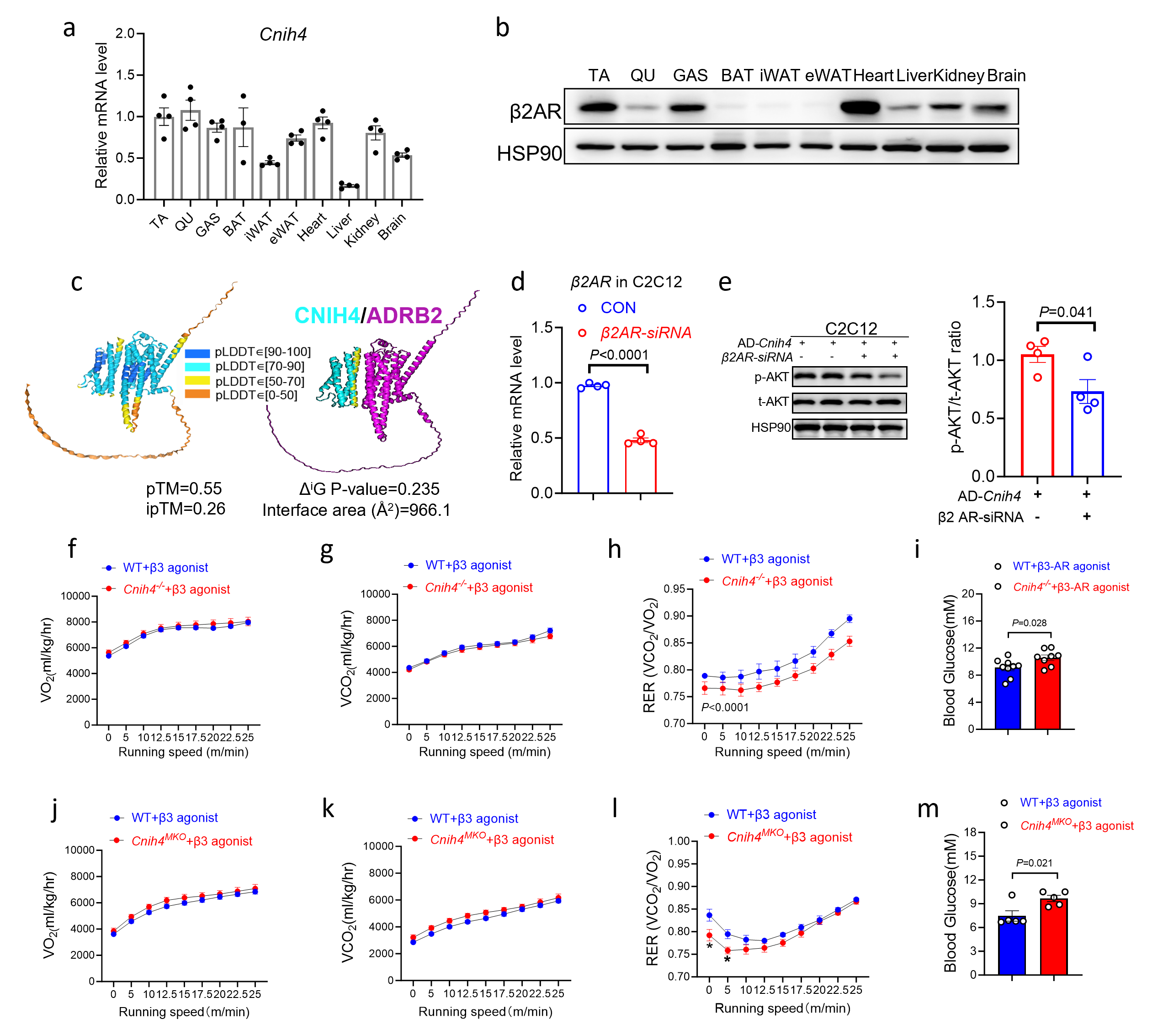
Fig S4. Structural and functional analysis of CNIH4 Interactions with β2AR in muscle and metabolic regulation. (a) RT-qPCR analysis of Cnih4 levels in TA, QU, GAS, BAT, iWAT, eWAT, Heart, Liver, Kidney and brain from WT (n = 4) mice. (b) Representative western blot of β2AR and HSP90 protein in TA, QU, GAS, eWAT, BAT, IWAT, heart, liver, kidney, and brain from WT mice. (c) Structure prediction of biomolecular interactions between CNIH4 and ADRB2 by using AlphaFold 3. pLDDT: a per-atom confidence estimates on a 0-100 scale where a higher value indicates higher confidence. Interface area in Å2, calculated as difference in total accessible surface areas of isolated and interfacing structures divided by two. ΔiG P-value indicates the P-value of the observed solvation free energy gain. (d-e) Representative Immunoblotting analysis and quantifications of p-AKT after transfecting β2AR-siRNA in C2C12 cells base on overexpressing CNIH4. When β2AR-siRNA knockdown efficiency was confirmed, infected with AD-Cnih4 and transfected with β2AR-siRNA, finally detected p-AKT by western blotting. (f-i) Changes of oxygen consumption (f; VO₂), carbon dioxide production (g; VCO₂), respiratory exchange ratio (h; RER) and blood glucose (i) during exercise after I.P. with β3AR agonist in WT (n = 9) and KO (n = 8) mice. (j-m) Changes of oxygen consumption (j; VO₂)，carbon dioxide production (k; VCO₂ ) , respiratory exchange ratio (l; RER ) and blood glucose (m) during exercise after i.p. with β3AR agonist in WT (n = 5) and MKO (n = 5) mice. Data are mean ± SEM of biologically independent samples. Statistical analysis was performed using two-tailed unpaired Student’s t-tests (d, e, i, m), two-way-ANOVA (h, l, r).
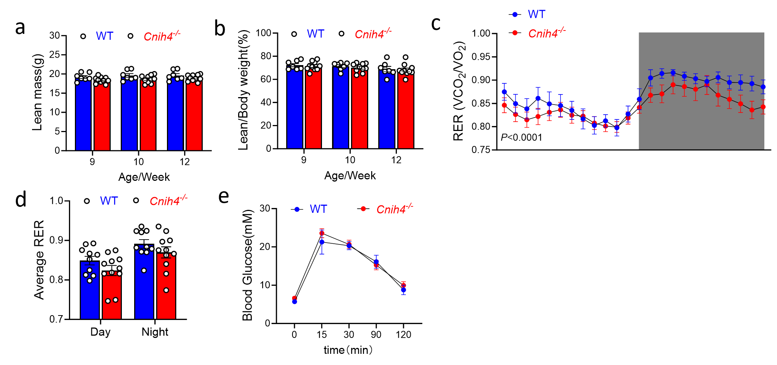
Fig S5. Metabolic parameters in Cnih4^{-/-} mice. (a-b) The analysis of lean mass (a) and lean ratio (b) were conducted in mice at 9, 10, and 12 weeks of age of WT (n = 7) and Cnih4^{-/-}(n = 10) mice. (c-d) Changes of RER (c) and quantification (d) of average RER during day and night in Cnih4^{-/-} (n = 11) and WT (n = 10) mice. (e) Intraperitoneal glucose tolerance test (GTT) of Cnih4^{-/-} (n = 7) and WT (n = 5) mice. Data in bar graphs are mean ± SEM with individual data points shown. Statistical analysis was performed two-way-ANOVA (c).

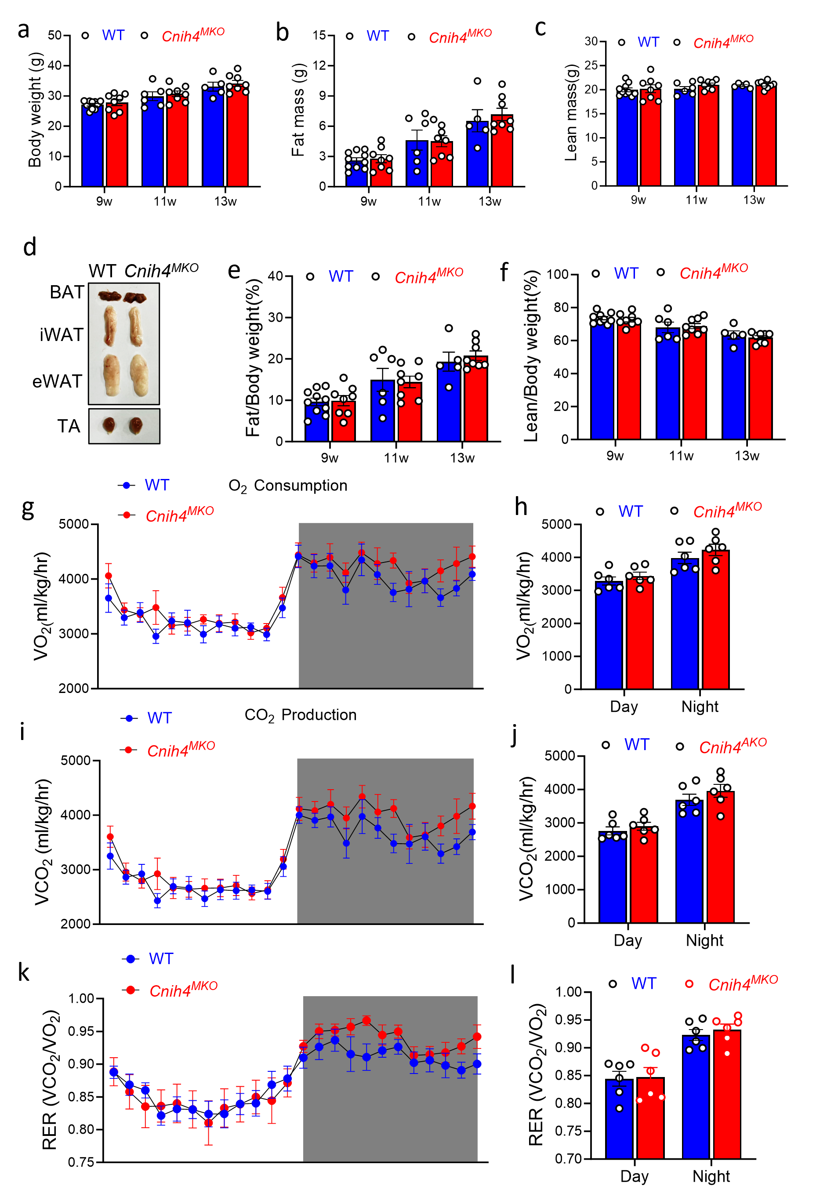
Fig S6. Body Composition and Metabolic Parameters in Cnih4^{MKO} Mice. (a-f) The analysis of body weight (a), fat mass (b), lean mass (c), fat ratio (e) and lean ratio (f) were conducted in mice at 9, 11, and 13 weeks of age of WT (n = 5-10) and Cnih4^{MKO} (n = 8) mice. In (d), Representative tissue images of WT and Cnih4^{MKO}mice. (g-k) Oxygen consumption (g-h; VO₂), carbon dioxide production (i-j; VCO₂) and respiratory exchange ratio (k-l; RER) of Cnih4^{MKO} (n = 6) and WT (n = 6) mice over 24 h (Light : Dark = 12:12). In (h) (j) (l), statistical quantifications of oxygen consumption, carbon dioxide production and RER between WT and Cnih4^{MKO} mice during day and night. Data in bar graphs are mean ± SEM with individual data points shown.

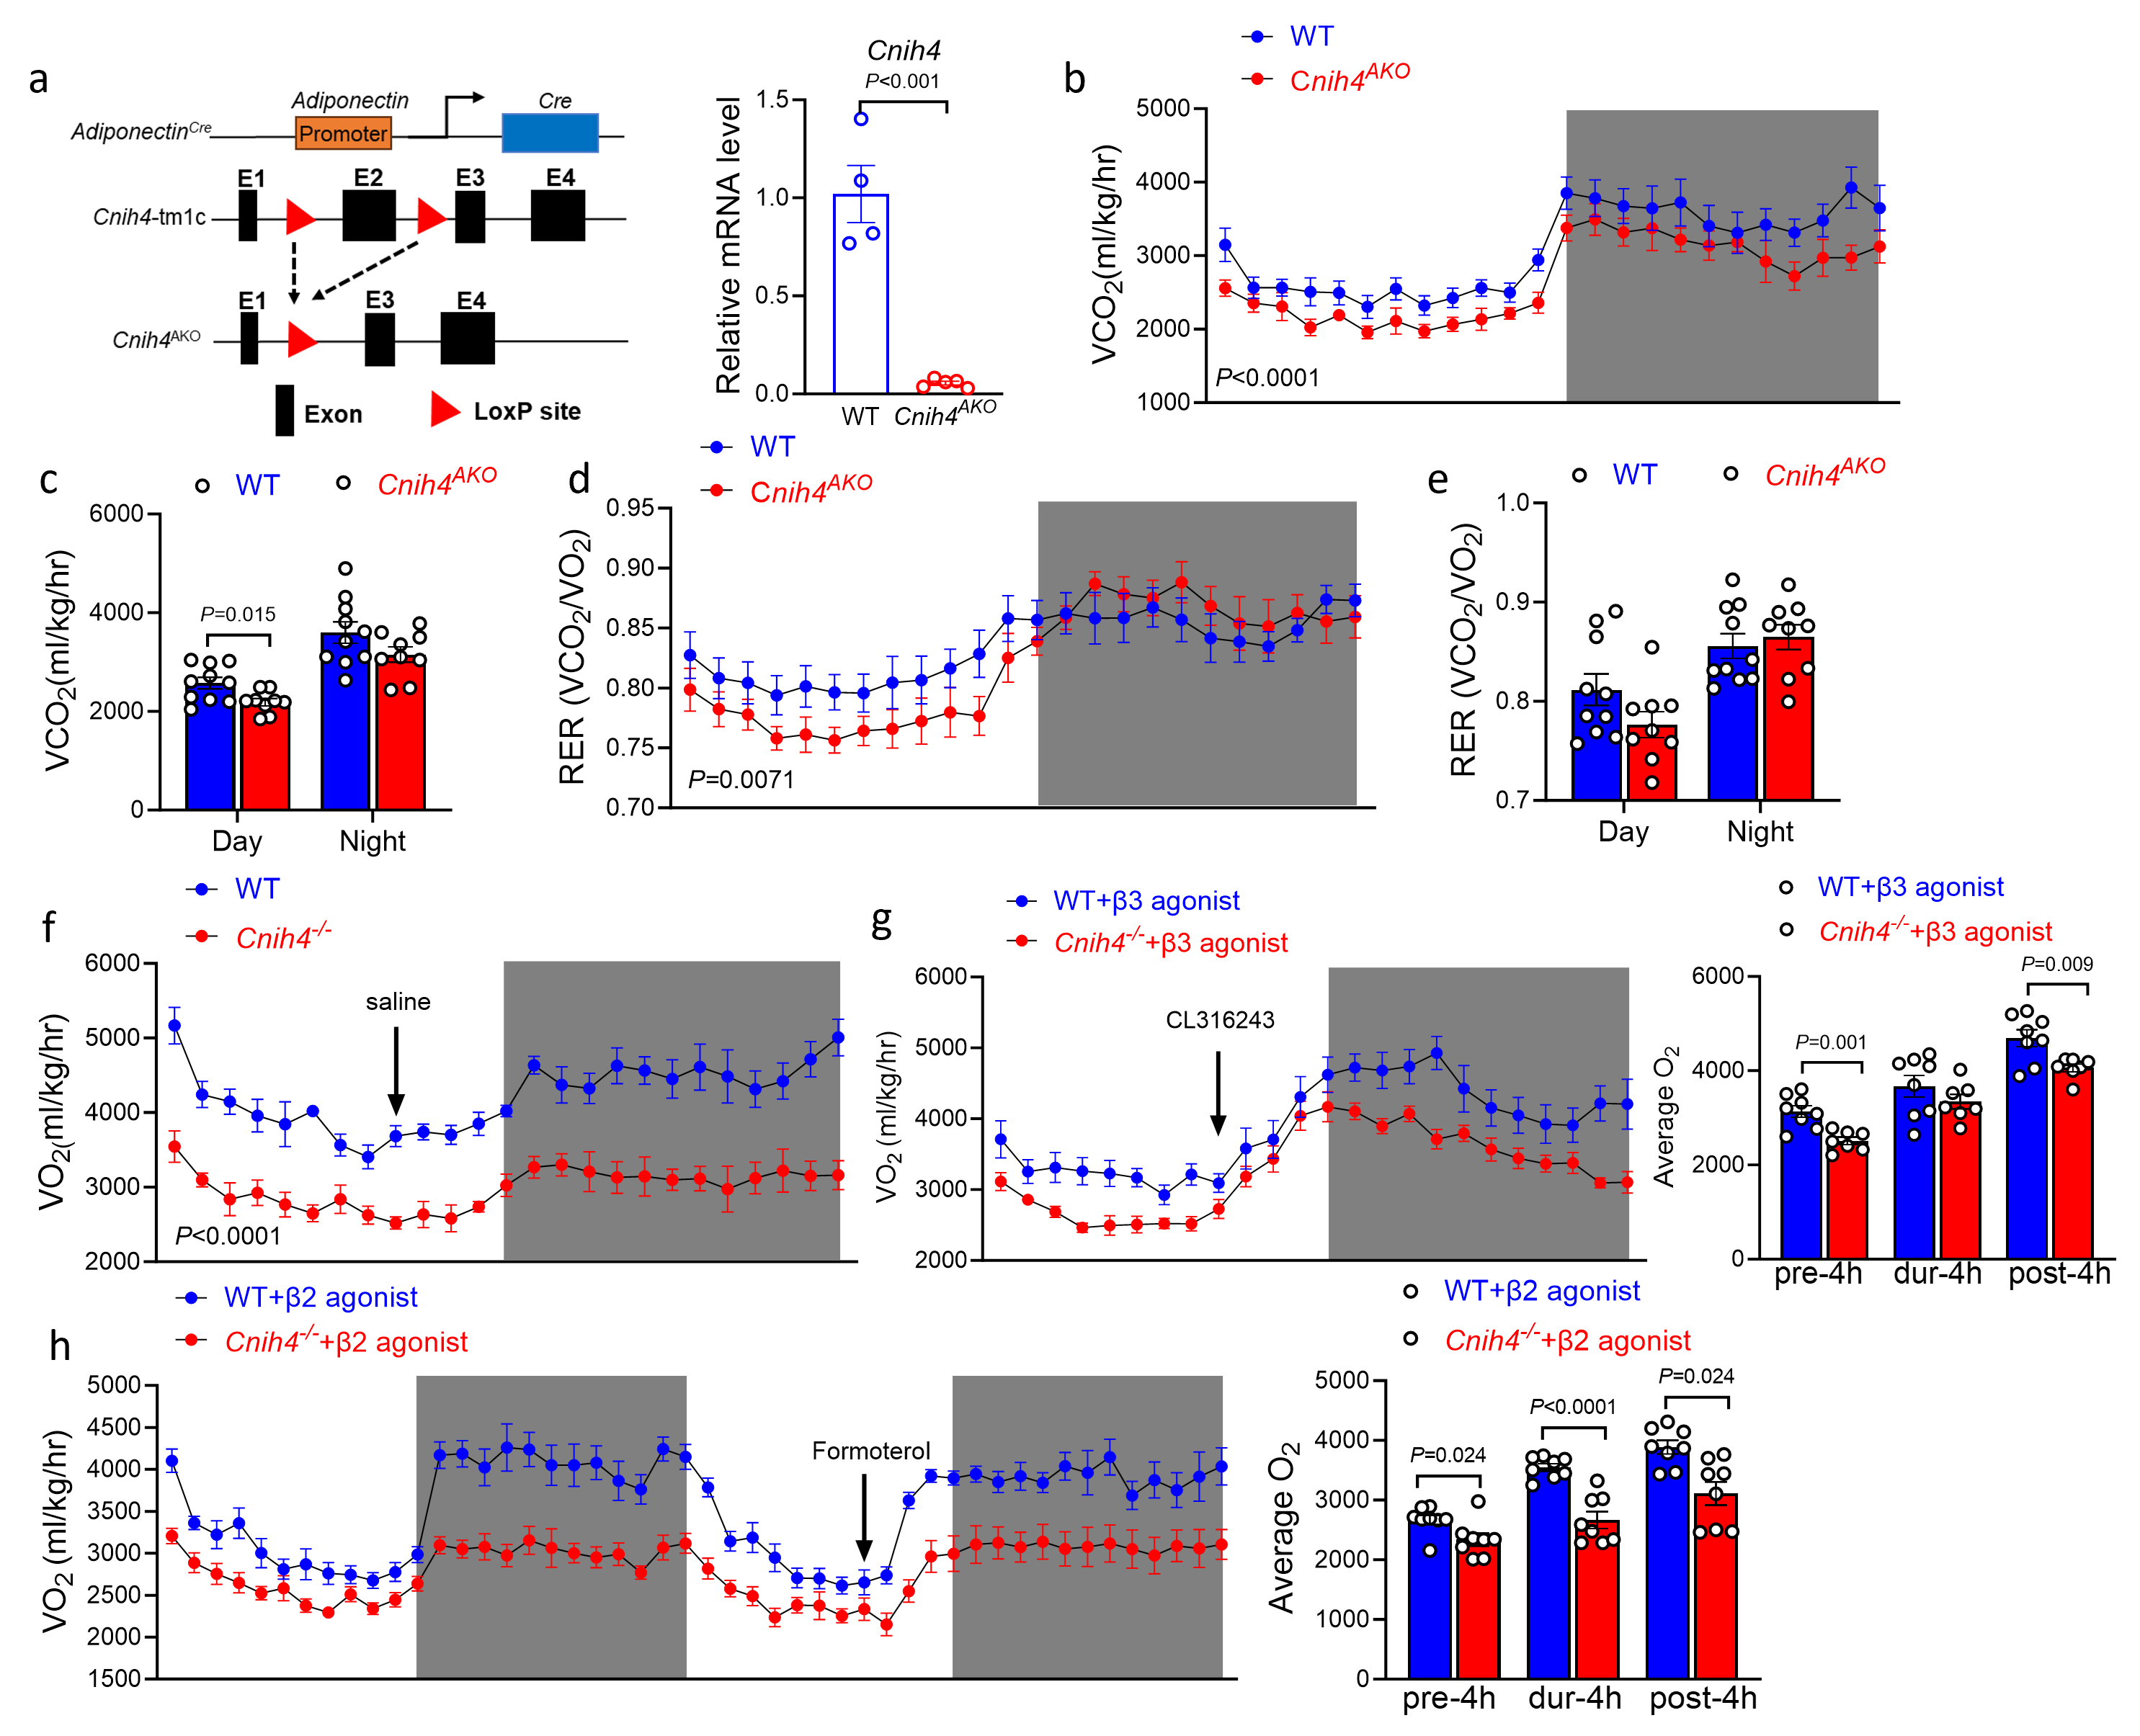
Fig S7. Metabolic Parameters in Cnih4^{AKO} Mice. (a) Schematic diagram showing the construction strategy of Cnih4^{AKO} mice and validation of mouse knockout efficiency by from WT (n = 4) and Cnih4^{AKO} (n = 5) mice. (b-c) Carbon dioxide production and quantifications (c) of carbon dioxide production RER between WT (n = 10) and Cnih4^{AKO} (n = 9) mice during day and night. (d-e) Respiratory exchange ratio (d) and quantifications (e) of RER between WT (n = 10) and Cnih4^{AKO} (n = 9) mice during day and night. (f) Oxygen consumption in male WT (n = 6) and Cnih4^{AKO} (n = 6) mice i.p. injected with saline over 24h. Injection was performed at 4:00 pm of the day. (g) Oxygen consumption in male WT (n = 8) and Cnih4 ^{-/-}(n = 7) mice i.p. injected with CL316,243 (ADRB3 agonist). Injection was performed at 4:00 pm of the day (left panel). Average Oxygen consumption pre-4h, duration-4h and post-4h injection of with CL316,243 (right panel). (h) Oxygen consumption in male WT (n = 8) and Cnih4^{AKO} (n = 8) mice i.p. injected with formoterol (ADRB2 agonist). Injection was performed at 4:00 pm of the day (left panel). Average Oxygen consumption pre-4h, duration-4h and post-4h injection of with Formoterol (right panel). Data in bar graphs are mean ± SEM with individual data points shown. Statistical significance was assessed by unpaired two-sided Student’s test (a, c, g, h) or two-way ANOVA (b, d, f). The exact P values are shown in the figure or corresponding legends.

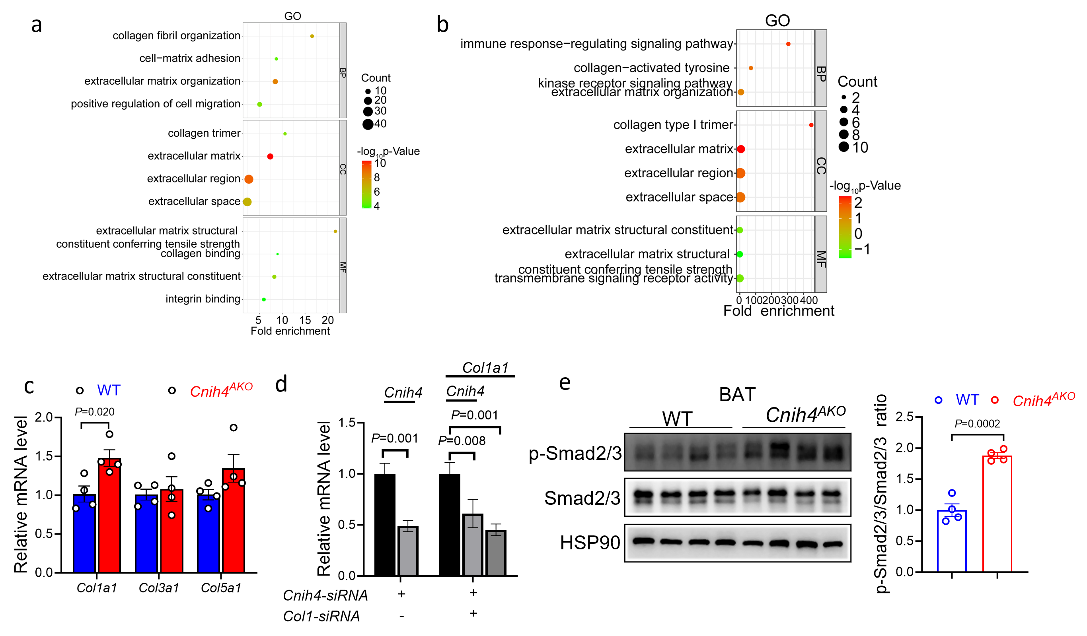Fig S8. CNIH4 regulates ECM genes and Smad2/3 signaling in BAT. (a) GO enrichment analysis conducted on the 1736 DEGs in BAT between HFD-fed WT and Cnih4^{-/-} mice. (b) GO enrichment analysis conducted on the 45 overlap DEGs. (c) RT-qPCR analysis of ECM genes (Col1a1, Col3a1 and Col5a1) levels in BAT from WT (n = 4) and Cnih4^{AKO} (n = 4) mice. (d) Knockdown efficiency of Co1la1-siRNA, Cnih4-siRNA or both. (e) Representative western blot images and quantifications of p-Smad2/3 level in BAT from WT (n = 4) and Cnih4^{AKO} (n = 4) mice. Total-Smad2/3 is used as a control for p-Smad2/3. Data are expressed as the mean ± SEM. Statistical significance was assessed by unpaired two-sided Student’s test (c, d, e). The exact P values are shown in the figure or corresponding legends.

