Supplementary data
______________________________________________________________________

Effects of enzymatically-synthesized sialylated oligosaccharides on the N- and O-glycosylation of etanercept in recombinant CHO cell culture

Tae-Ho Kim^{1,2,#}, Hoon-Min Lee^{1,3,#}, So-Hui Ryu^{1,4}, Hyun-Seung Kim^{1,3}, Seung Jin Koo^{1,3},
Mi-Jung Kang¹, Jungmok You^{2,4*}, and Yeon-Gu Kim^{1,3*}

¹Biotherapeutics Translational Research Center, Korea Research Institute of Bioscience and Biotechnology (KRIBB), 125 Gwahak-ro, Yuseong-gu, Daejeon, Korea

²Department of Convergent Biotechnology & Advanced Materials Science, Graduate School of Biotechnology, College of Life Science, Kyung Hee University, 1732 Deogyeong-daero, Giheung-gu, Yongin-si, Gyeonggi-do, Korea

³Department of Bioprocess Engineering, KRIBB School of Biotechnology, University of Science and Technology (UST), 217 Gajeong-ro, Yuseong-gu, Daejeon, Korea

⁴Department of Convergent Biotechnology & Advanced Materials Science, Graduate School of Green-Bio Science, College of Life Science, Kyung Hee University, 1732 Deogyeong-daero, Giheung-gu, Yongin-si, Gyeonggi-do, Korea

______________________________________________________________________
* Correspondence to Prof. Jungmok You
Tel: +82-31-201-2626; fax: +82-31-204-8117; e-mail: jmyou@khu.ac.kr
* Correspondence to Dr. Yeon-Gu Kim
Tel: +82-42-860-4196; fax: +82-42-860-4149; e-mail: ygkim@kribb.re.kr

#Tae-Ho Kim and Hoon-Min Lee contributed equally to this work.
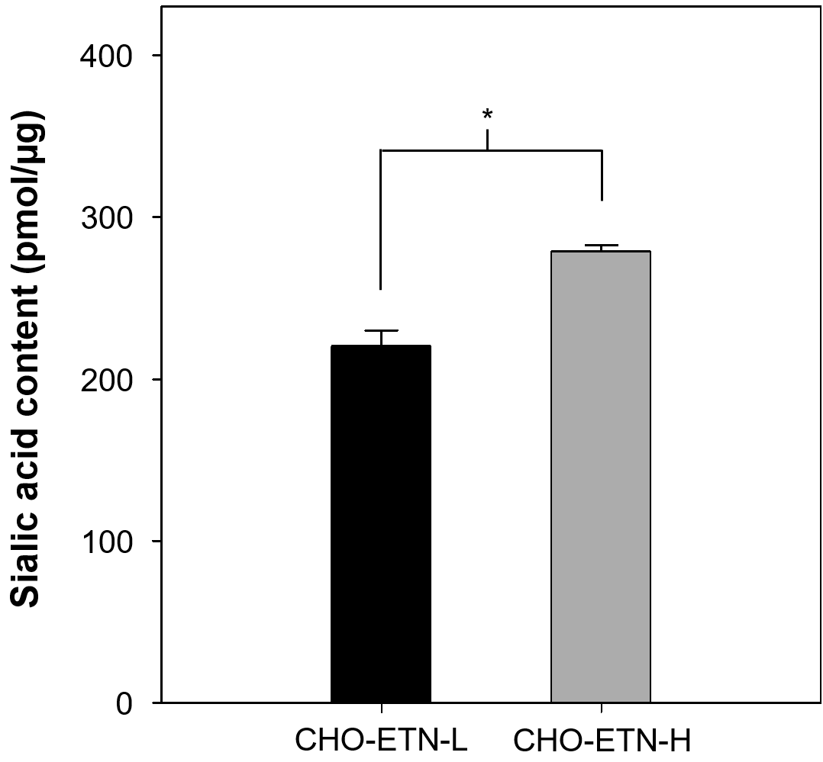

Fig. S1 The sialic acid (Neu5Ac) content of etanercept in the CHO-ETN-L clone (black) and the CHO-ETN-H clone (gray) without oligosaccharide supplementation on day 6. Error bars represent standard deviations calculated from triplicate experiments. *p ≤ 0.05
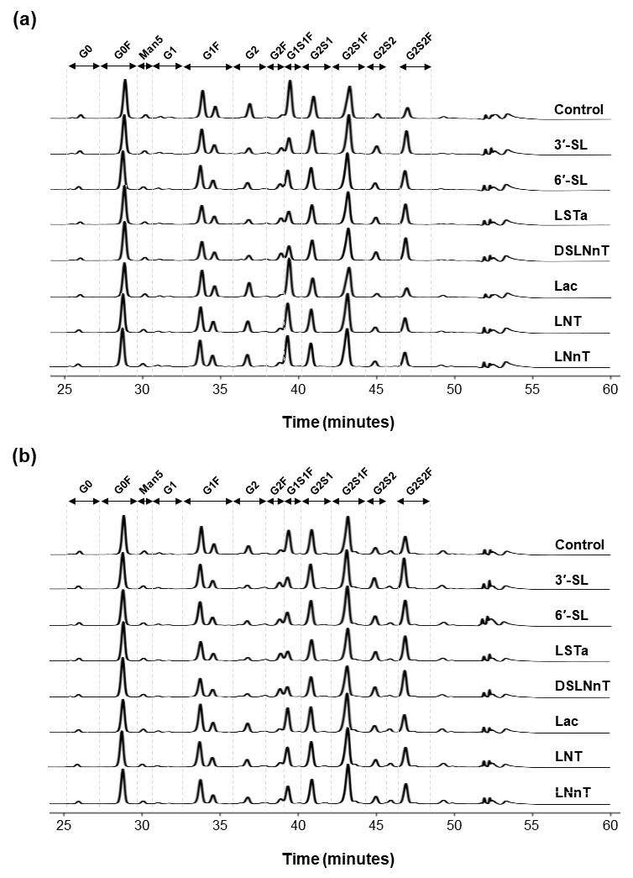

Fig. S2 Chromatograms of hydrophilic interaction UPLC analysis of N-glycan obtained from purified etanercept in the a CHO-ETN-L clone and b CHO-ETN-H clone on day 6
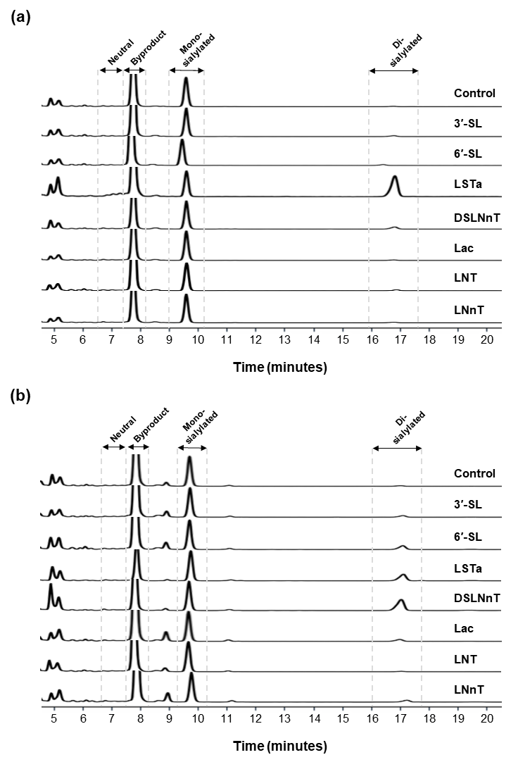

Fig. S3 Chromatograms of hydrophilic interaction UPLC analysis of O-glycan obtained from purified etanercept in the a CHO-ETN-L clone and b CHO-ETN-H clone on day 6

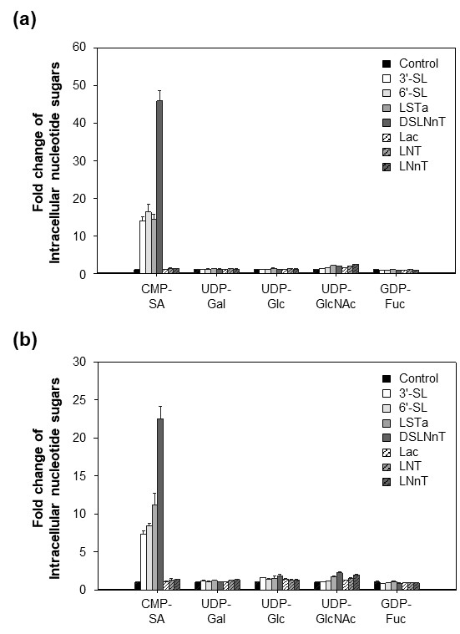

Fig. S4 Fold-change of the intracellular nucleotide sugars in the a CHO-ETN-L clone and b CHO-ETN-H clone on day 6. Without oligosaccharide (black), with 3′-SL (white), with 6′-SL (light gray), with LSTa (gray), with DSLNnT (dark gray), with lactose (white striped), with LNT (gray striped), and with LNnT (dark gray striped). Intracellular nucleotide sugars were extracted and quantified from cells taken on day 6 using ion-pair reversed-phase HPLC. The value of each oligosaccharide was normalized to the control cultures. Error bars represent standard deviations calculated from triplicate experiments
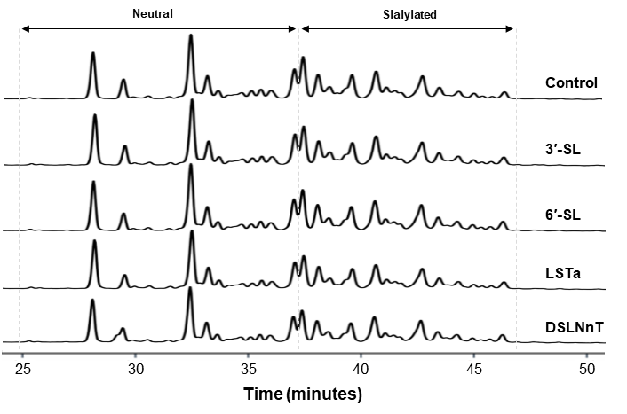

Fig. S5 Chromatograms of hydrophilic interaction UPLC analysis of N-glycan obtained for purified etanercept from the HEK293-ETN clone on day 6

