Supplemental Material:

Supplemental Table 1. Systemic Sclerosis and CVD-related crude number of deaths in the US population stratified by sex, race, region, age group, census region, and urbanization status in the United States.

Year | All SS deaths | SS+CVD deaths | Female | Male | NH Black or African American | NH White | Hispanics | Young (15-44) | Middle age (45-74) | Elderly (≥75) | Northeast | Midwest | South | West
1999 | 1938 | 1165 | 957 | 208 | 173 | 877 | 87 | 99 | 729 | 337 | 243 | 246 | 436 | 240
2000 | 1944 | 1046 | 816 | 230 | 171 | 783 | 67 | 83 | 615 | 348 | 241 | 226 | 379 | 200
2001 | 1973 | 1063 | 887 | 176 | 159 | 794 | 82 | 100 | 631 | 332 | 231 | 268 | 357 | 207
2002 | 1922 | 1017 | 809 | 208 | 165 | 743 | 77 | 80 | 600 | 337 | 218 | 219 | 347 | 233
2003 | 1943 | 1128 | 915 | 213 | 157 | 854 | 85 | 90 | 702 | 336 | 243 | 234 | 384 | 267
2004 | 1873 | 1117 | 914 | 203 | 165 | 833 | 87 | 83 | 660 | 374 | 242 | 272 | 387 | 216
2005 | 1961 | 1167 | 954 | 213 | 194 | 816 | 120 | 88 | 711 | 368 | 226 | 244 | 431 | 266
2006 | 1803 | 1087 | 888 | 199 | 159 | 815 | 88 | 75 | 662 | 350 | 235 | 253 | 366 | 233
2007 | 1836 | 1135 | 915 | 220 | 163 | 854 | 92 | 74 | 686 | 375 | 245 | 259 | 417 | 214
2008 | 1798 | 1081 | 891 | 190 | 161 | 793 | 87 | 89 | 627 | 365 | 218 | 251 | 373 | 239
2009 | 1807 | 1090 | 909 | 181 | 174 | 805 | 80 | 69 | 668 | 353 | 201 | 265 | 373 | 251
2010 | 1753 | 1098 | 895 | 203 | 189 | 785 | 94 | 77 | 667 | 354 | 223 | 266 | 385 | 224
2011 | 1732 | 1085 | 893 | 192 | 138 | 801 | 111 | 71 | 660 | 354 | 243 | 252 | 329 | 261
2012 | 1714 | 1014 | 818 | 196 | 152 | 710 | 114 | 60 | 611 | 343 | 209 | 215 | 343 | 247
2013 | 1807 | 1080 | 891 | 189 | 143 | 797 | 95 | 62 | 643 | 375 | 208 | 234 | 387 | 251
2014 | 1726 | 1021 | 832 | 189 | 160 | 708 | 112 | 66 | 632 | 323 | 208 | 218 | 345 | 250
2015 | 1702 | 1019 | 826 | 193 | 137 | 753 | 89 | 44 | 619 | 356 | 207 | 240 | 317 | 255
2016 | 1643 | 1023 | 832 | 191 | 172 | 705 | 107 | 49 | 660 | 314 | 222 | 224 | 342 | 235
2017 | 1681 | 1017 | 842 | 175 | 174 | 723 | 78 | 71 | 592 | 354 | 194 | 222 | 345 | 256
2018 | 1605 | 1007 | 816 | 191 | 168 | 672 | 116 | 61 | 609 | 337 | 203 | 220 | 345 | 239
2019 | 1635 | 1037 | 824 | 213 | 139 | 716 | 137 | 45 | 618 | 374 | 195 | 247 | 346 | 249
2020 | 1667 | 1095 | 890 | 205 | 168 | 762 | 110 | 66 | 631 | 398 | 211 | 250 | 394 | 240
2021 | 1748 | 1184 | 989 | 195 | 161 | 826 | 148 | 60 | 692 | 432 | 222 | 275 | 419 | 268
2022 | 1799 | 1189 | 951 | 238 | 161 | 826 | 145 | 53 | 663 | 473 | 220 | 265 | 403 | 301
Total | 43010 | 25965 | 21154 | 4811 | 3903 | 18751 | 2408 | 1715 | 15588 | 8662 | 5308 | 5865 | 8950 | 5842

Supplemental Table 2. Systemic Sclerosis and CVD-related mortality rates stratified by sex, race, and age in the United States.
Year | Overall (SS+CVD) | Women | Men | NH Black or African American | NH White | Hispanics | Young  (15-44) | Middle age (45-74) | Elderly (≥75)
1999 | 5.39 | 7.99 | 2.17 | 8.04 | 4.99 | 6.88 | 0.78 | 9.19 | 20.59
2000 | 4.79 | 6.71 | 2.39 | 7.79 | 4.37 | 4.86 | 0.67 | 7.66 | 20.95
2001 | 4.79 | 7.21 | 1.75 | 6.99 | 4.44 | 5.49 | 0.81 | 7.72 | 19.59
2002 | 4.51 | 6.45 | 2.01 | 7.37 | 4.07 | 5.12 | 0.67 | 7.17 | 19.68
2003 | 4.91 | 7.22 | 2.04 | 6.53 | 4.65 | 4.86 | 0.75 | 8.21 | 19.35
2004 | 4.77 | 7.08 | 1.87 | 6.84 | 4.45 | 4.84 | 0.68 | 7.5 | 21.38
2005 | 4.9 | 7.28 | 1.92 | 7.92 | 4.29 | 6.79 | 0.71 | 7.93 | 20.77
2006 | 4.49 | 6.67 | 1.8 | 6.37 | 4.23 | 4.49 | 0.64 | 7.16 | 19.57
2007 | 4.6 | 6.71 | 1.95 | 6.1 | 4.4 | 4.95 | 0.64 | 7.22 | 20.79
2008 | 4.34 | 6.48 | 1.62 | 6.12 | 4.01 | 3.97 | 0.78 | 6.45 | 20.03
2009 | 4.24 | 6.5 | 1.5 | 6.26 | 4.02 | 3.62 | 0.57 | 6.65 | 19.38
2010 | 4.21 | 6.25 | 1.65 | 6.73 | 3.86 | 3.97 | 0.67 | 6.5 | 18.97
2011 | 4.09 | 6.12 | 1.53 | 4.89 | 3.89 | 4.57 | 0.64 | 6.26 | 18.64
2012 | 3.72 | 5.48 | 1.54 | 5.13 | 3.36 | 4.59 | 0.52 | 5.58 | 17.99
2013 | 3.82 | 5.77 | 1.46 | 4.64 | 3.65 | 3.67 | 0.48 | 5.7 | 19.07
2014 | 3.59 | 5.37 | 1.43 | 5.33 | 3.21 | 4.12 | 0.57 | 5.5 | 16.34
2015 | 3.48 | 5.18 | 1.41 | 4.31 | 3.37 | 3.08 | 0.35 | 5.27 | 17.6
2016 | 3.43 | 5.17 | 1.34 | 5.19 | 3.12 | 3.41 | 0.42 | 5.5 | 15.31
2017 | 3.37 | 5.16 | 1.21 | 5.41 | 3.15 | 2.53 | 0.6 | 4.77 | 16.72
2018 | 3.24 | 4.84 | 1.28 | 5.23 | 2.87 | 3.57 | 0.5 | 4.83 | 15.53
2019 | 3.27 | 4.81 | 1.41 | 4.17 | 3.01 | 4.03 | 0.39 | 4.86 | 16.59
2020 | 3.41 | 5.08 | 1.41 | 4.99 | 3.17 | 3.22 | 0.52 | 4.9 | 17.25
2021 | 3.68 | 5.66 | 1.29 | 4.6 | 3.53 | 4.17 | 0.5 | 5.21 | 19.43
2022 | 3.58 | 5.27 | 1.58 | 4.71 | 3.4 | 3.97 | 0.43 | 4.98 | 19.68
Average APC | -1.54* (-2.09 to –1.21) | -1.46* (-2.07 to –1.07) | -1.74* (-2.42 to –1.19) | -2.44* (-3.07 to –1.82) | -1.42* (-2.09 to –1.00) | -1.74 (-3.53 to 0.12) | 2.42* (-3.35 to –1.60) | -2.33* (-3.15 to –1.77) | -0.30 (-1.07 to 0.17)

Supplemental Table 3. Systemic Sclerosis and CVD-related mortality rates stratified by census region and urbanization status in the United States.
Year | Northeast | Midwest | South | West | Urban | Rural
1999 | 5.47 | 4.88 | 5.68 | 5.47 | 5.51 | 4.87
2000 | 5.36 | 4.44 | 4.9 | 4.49 | 4.83 | 4.69
2001 | 5.11 | 5.2 | 4.51 | 4.5 | 4.88 | 4.46
2002 | 4.78 | 4.2 | 4.29 | 4.97 | 4.62 | 3.96
2003 | 5.25 | 4.45 | 4.62 | 5.55 | 4.96 | 4.61
2004 | 5.18 | 5.11 | 4.57 | 4.39 | 4.9 | 4.26
2005 | 4.81 | 4.48 | 4.96 | 5.32 | 5.05 | 4.28
2006 | 4.91 | 4.64 | 4.11 | 4.57 | 4.47 | 4.46
2007 | 5.09 | 4.61 | 4.59 | 4.04 | 4.67 | 4.32
2008 | 4.54 | 4.53 | 4.01 | 4.43 | 4.38 | 4.12
2009 | 4.1 | 4.64 | 3.96 | 4.5 | 4.29 | 4.16
2010 | 4.44 | 4.53 | 4 | 3.99 | 4.22 | 4.08
2011 | 4.78 | 4.29 | 3.32 | 4.5 | 4.16 | 3.8
2012 | 4.02 | 3.55 | 3.37 | 4.1 | 3.72 | 3.57
2013 | 3.9 | 3.74 | 3.76 | 4.07 | 3.83 | 3.91
2014 | 3.84 | 3.51 | 3.29 | 3.9 | 3.55 | 3.77
2015 | 3.78 | 3.74 | 2.95 | 3.91 | 3.51 | 3.39
2016 | 3.94 | 3.43 | 3.11 | 3.47 | 3.45 | 3.31
2017 | 3.45 | 3.4 | 3.13 | 3.76 | 3.43 | 3.26
2018 | 3.58 | 3.3 | 2.93 | 3.4 | 3.28 | 2.99
2019 | 3.28 | 3.7 | 2.91 | 3.48 | 3.23 | 3.53
2020 | 3.73 | 3.64 | 3.25 | 3.29 | 3.39 | 3.57
2021 | 3.82 | 4.02 | 3.43 | 3.67 | - | -
2022 | 3.6 | 3.8 | 3.22 | 3.97 | - | -
Average APC | -2.02* (-2.50 to -1.59) | -0.83* (-1.31 to -0.21) | -1.94* (-2.71 to -1.36) | -1.73* (-2.36 to -1.10) | -2.40* (-2.76 to -2.02) | -1.74* (-2.19 to -1.28)

Supplemental Table 4. Systemic Sclerosis and CVD-related change in AAMR at the state level in the United States.

State | AAMR 1999 - 2023
Alabama | 2.85
Arizona | 2.98
Arkansas | 3.11
California | 3.34
Colorado | 4.78
Connecticut | 4.60
Delaware | 4.58
District of Columbia | 4.35
Florida | 3.20
Georgia | 3.43
Hawaii | 3.78
Idaho | 3.25
Illinois | 3.46
Indiana | 3.67
Iowa | 3.41
Kansas | 4.39
Kentucky | 3.25
Louisiana | 2.70
Maine | 3.53
Maryland | 4.34
Massachusetts | 4.07
Michigan | 3.79
Minnesota | 4.61
Mississippi | 4.36
Missouri | 3.48
Montana | 4.12
Nebraska | 5.35
Nevada | 4.00
New Hampshire | 2.47
New Jersey | 3.72
New Mexico | 4.43
New York | 3.78
North Carolina | 4.32
North Dakota | 4.62
Ohio | 3.54
Oklahoma | 4.80
Oregon | 3.42
Pennsylvania | 4.00
Rhode Island | 4.73
South Carolina | 4.35
South Dakota | 4.84
Tennessee | 3.76
Texas | 3.75
Utah | 4.46
Vermont | 3.94
Virginia | 3.67
Washington | 4.12
West Virginia | 3.89
Wisconsin | 4.23
Wyoming | 3.68

Supplemental Table 5. Systemic Sclerosis-related death in the United States by CVD subcategories.
Year | Hypertensive diseases | Ischemic heart disease | Pulmonary heart disease and diseases of pulmonary circulation | Heart failure | All SSc-related deaths
1999 | 114 | 314 | 238 | 284 | 1938
2000 | 175 | 272 | 125 | 251 | 1944
2001 | 187 | 282 | 152 | 254 | 1973
2002 | 156 | 246 | 133 | 246 | 1922
2003 | 182 | 257 | 331 | 241 | 1943
2004 | 191 | 237 | 338 | 257 | 1873
2005 | 180 | 229 | 429 | 246 | 1961
2006 | 208 | 255 | 379 | 228 | 1803
2007 | 212 | 236 | 442 | 256 | 1836
2008 | 174 | 226 | 453 | 223 | 1798
2009 | 162 | 189 | 479 | 251 | 1807
2010 | 186 | 215 | 483 | 241 | 1753
2011 | 187 | 220 | 468 | 237 | 1732
2012 | 198 | 189 | 399 | 228 | 1714
2013 | 197 | 186 | 475 | 289 | 1807
2014 | 172 | 194 | 440 | 252 | 1726
2015 | 170 | 178 | 436 | 278 | 1702
2016 | 196 | 172 | 455 | 267 | 1643
2017 | 189 | 176 | 461 | 286 | 1681
2018 | 179 | 161 | 470 | 284 | 1605
2019 | 209 | 169 | 441 | 297 | 1635
2020 | 236 | 200 | 466 | 319 | 1667
2021 | 259 | 175 | 524 | 366 | 1748
2022 | 294 | 208 | 514 | 378 | 1799
Total | 4613 | 5186 | 9531 | 6459 | 43010
Percentage of all SSc deaths (%) | 10.73 | 12.06 | 22.16 | 15.02 | 100

Supplemental Figure 1. APC for overall and sex-stratified Systemic Sclerosis and CVD-related mortality rates in the adult population of the United States from 1999 to 2022. *Indicates the APC is significantly different from 0.
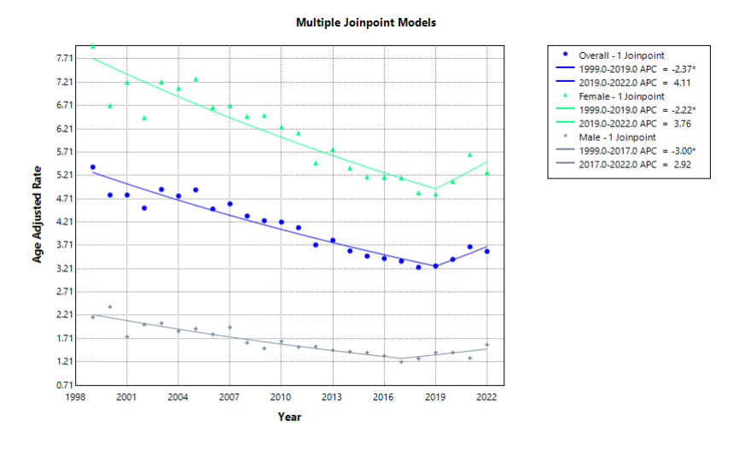
Supplemental Figure 2. APC for Race-stratified Systemic Sclerosis and CVD-related mortality rate in the adult population of the United States from 1999 to 2022. *Indicates the APC is significantly different from 0.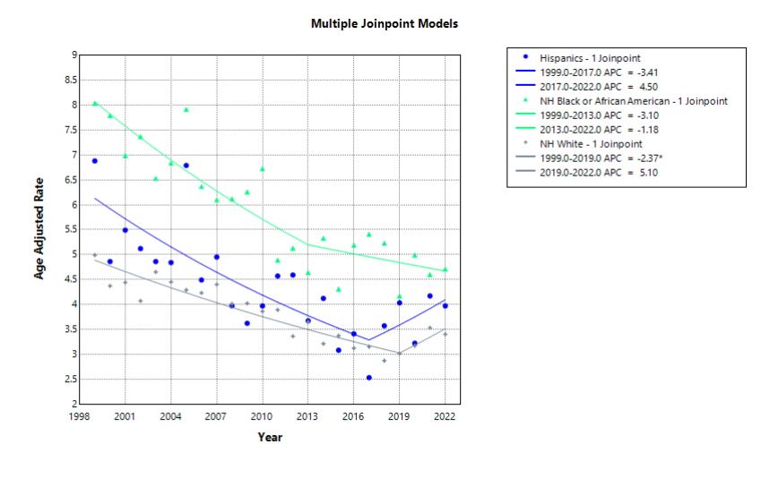

Supplemental Figure 3. APC for Age-stratified Systemic Sclerosis and CVD-related mortality rate in the adult population of the United States from 1999 to 2022. *Indicates the APC is significantly different from 0.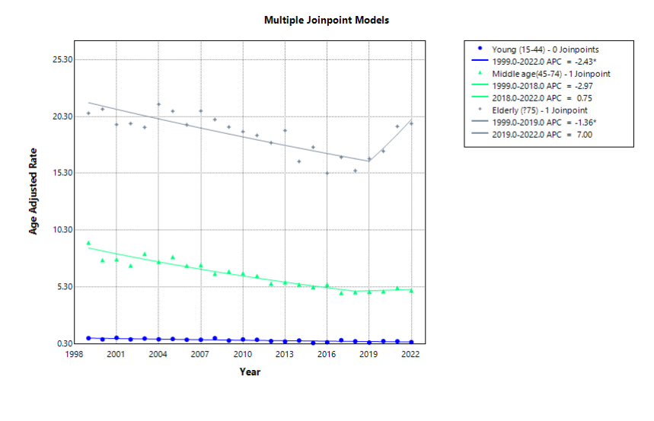

Supplemental Figure 4. APC for Census Region-stratified Systemic Sclerosis and CVD-related mortality rate in the adult population of the United States from 1999 to 2022. *Indicates the APC is significantly different from 0.