Supplemental information

Title: Competing valence-related roles of dopamine in the tail of the striatum

Authors: Ryota Tsuruga, Yu Tajika, Masabumi Minami, Iku Tsutsui-Kimura

Affiliation: Department of Pharmacology, Graduate School of Pharmaceutical Sciences, Hokkaido University.

Lead contact: Iku Tsutsui-Kimura, ikimura@pharm.hokudai.ac.jp

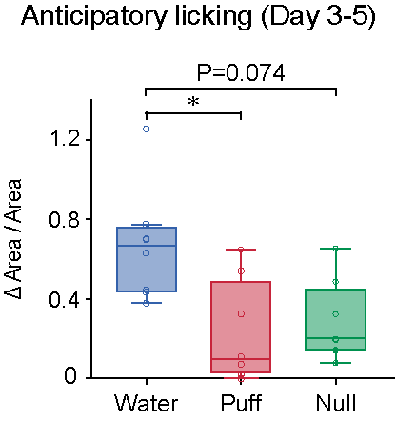
Figure S1. Increased anticipator licking in the later sessions
Mice discriminatively showed anticipatory licking in the later sessions of appetitive trials (p=3.0×10⁻³, F(2, 14)=8.8, repeated ANOVA; p=0.045, aversive vs appetitive, p=0.82, aversive vs null, p=0.074, appetitive vs null, Bonferroni’s test, n=8 animals for each). *p < 0.05.

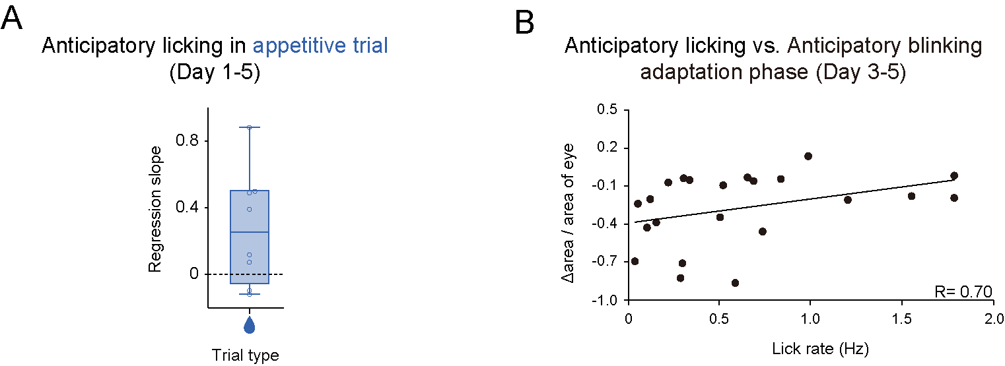
Figure S2. Two competing valence-induced learning in the 2-VCC task
A, No significant trend in regression coefficients of the rate of anticipatory licking with trial number in Day 1-5 for each animal (p=0.056, one-sampled t-test, n=8). B, Regression coefficients of intensities of anticipatory blinking with anticipatory licking were correlated in the adaptation phase (R=0.70, p=0.026, Pearson's correlation coefficient, n=22). Error bars, SEM. Center of box plot shows median; edges are 25th and 75th percentiles; and whiskers are the most extreme data points.

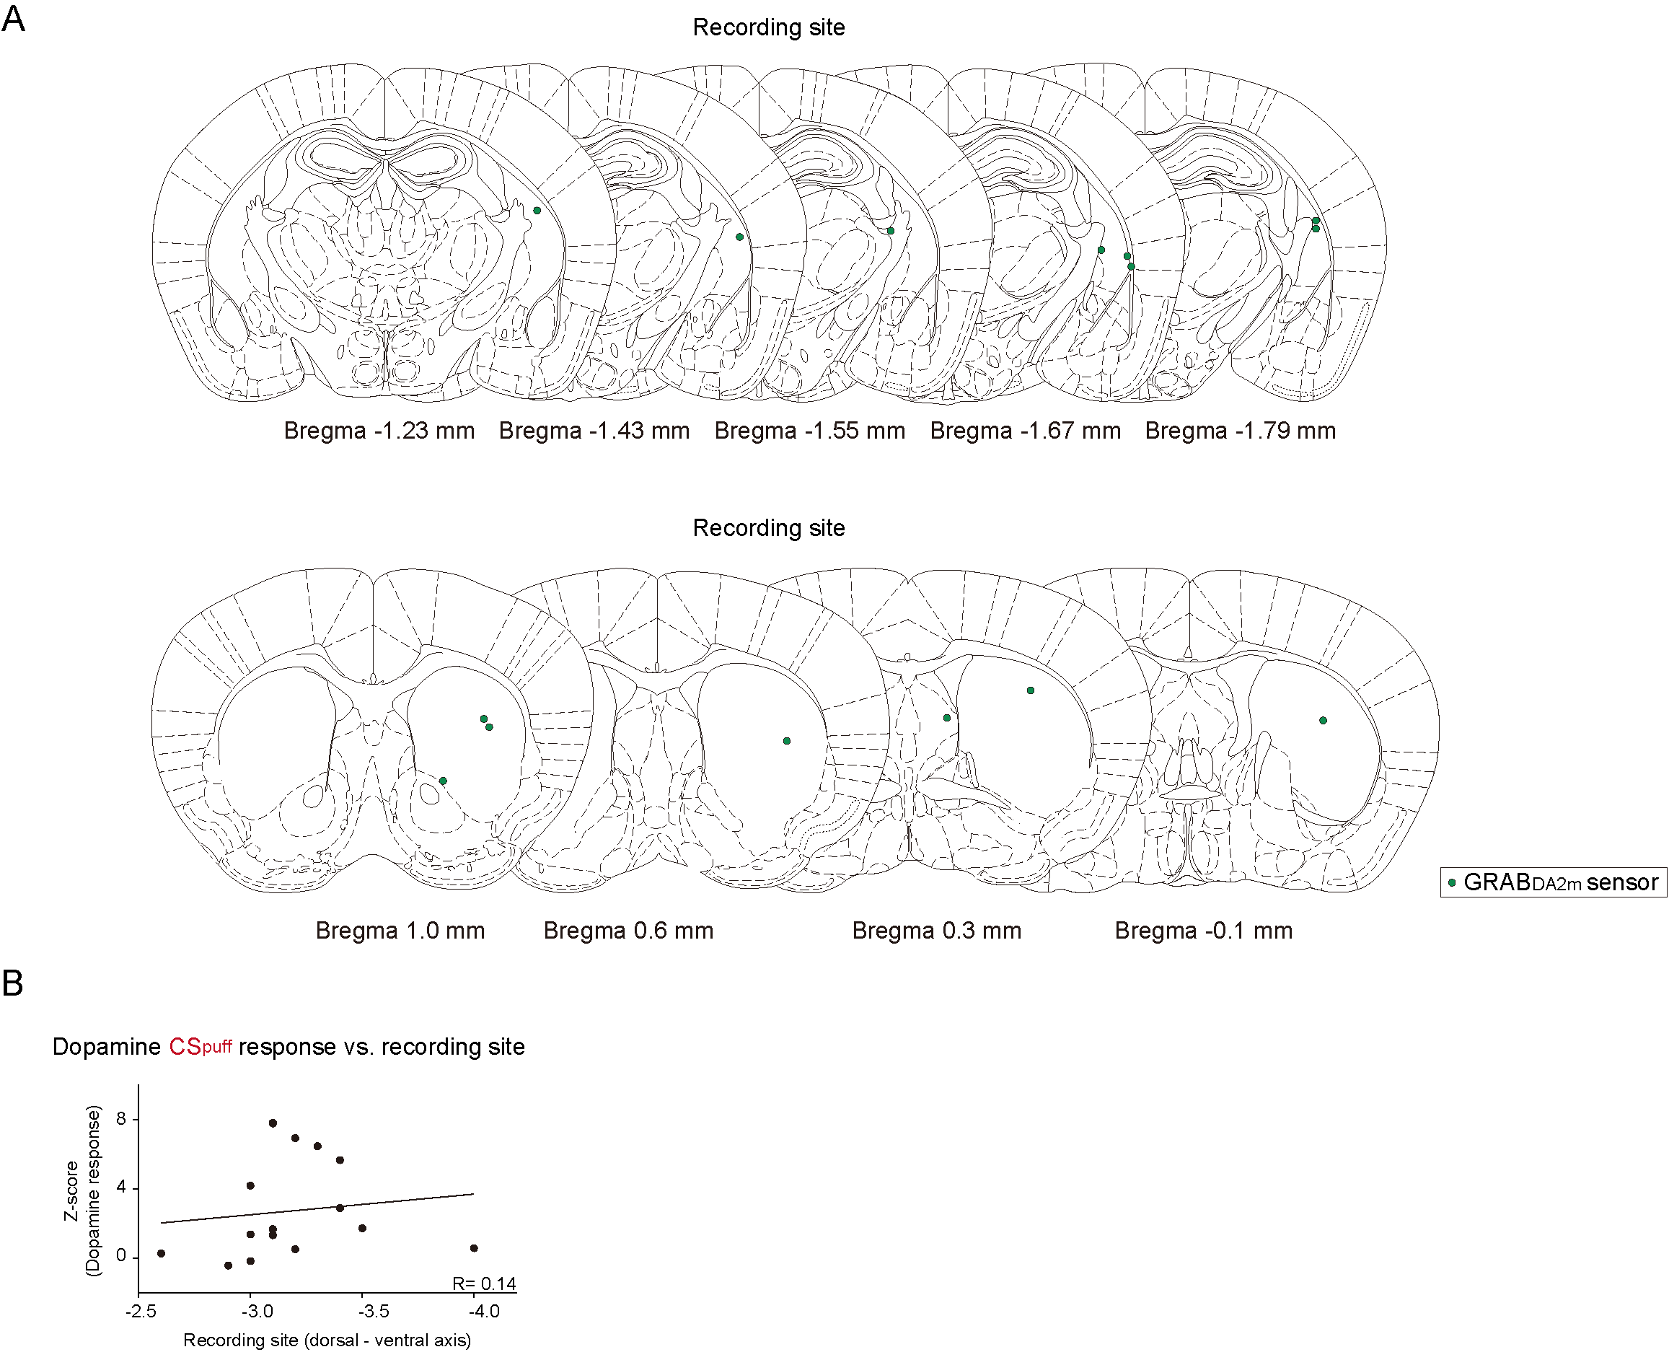
Figure S3. Striatal dopamine dynamics during the 2-VCC task
A, Location of optic fiber tips (marked with green circles) used to collect dopamine sensor signals in the striatum. B, Dopamine CSpuff response was not correlated with dorso-ventral axis of recording location (R=0.14, p=0.63, Pearson's correlation coefficients, n=15 animals).

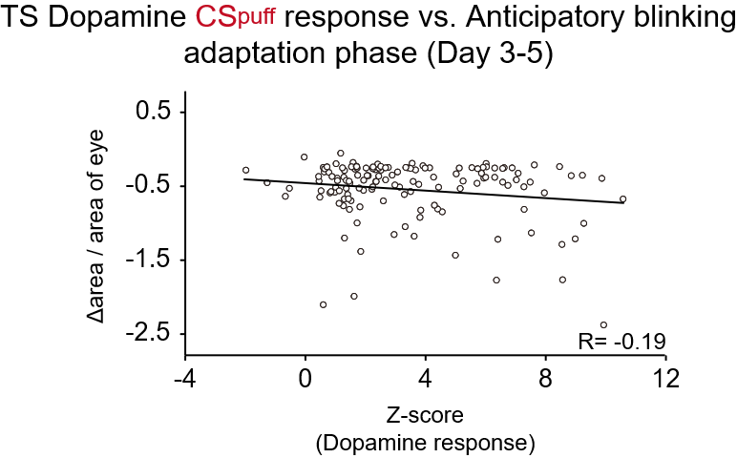
Figure S4. Correlation between CSpuff response and anticipatory blinking
Regression coefficients of intensities of anticipatory blinking with amplitude of TS dopamine CSpuff response were anti-correlated (R=-0.19, p=0.025, Pearson's correlation coefficient, n=140).

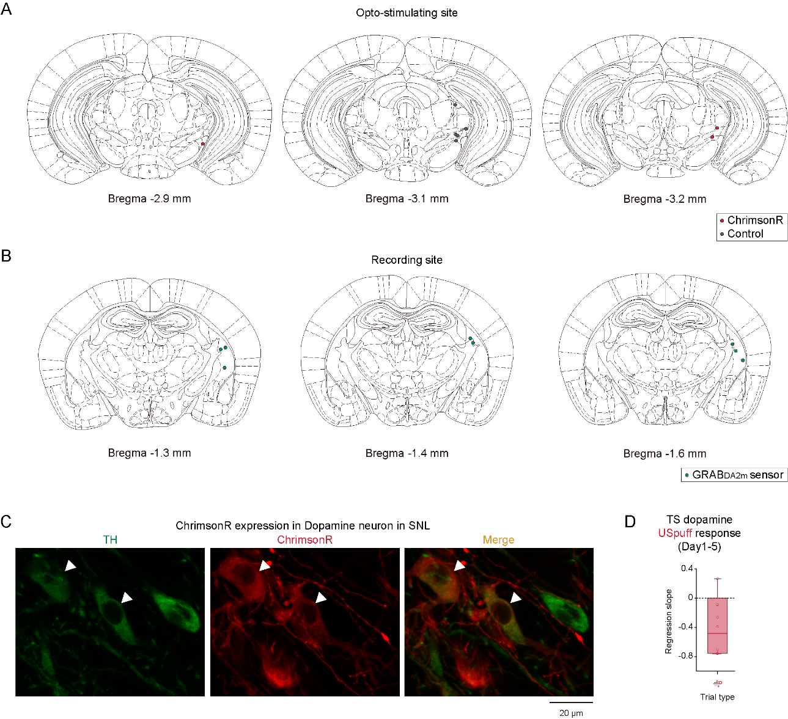
Figure S5. Validation for optogenetic manipulation of SNL dopamine neurons
A, Location of optic fiber tips (ChrimsonR group was marked with red circles while control group was marked with gray circles) used to opto-stimulate ChrimsonR in the SNL. B, Location of optic fiber tips (marked with green circles) used to collect dopamine sensor signals in the striatum. C, TH (green) and ChrimsonR (red) expression in DAT-cre mouse. White arrow heads indicate cells that express both. Scale bar, 20 μm. D, Regression coefficients of USpuff dopamine response with trial number in Day 1-5 for each animal were not significantly changed (p=0.077, one-sampled t-test, n=6). Error bars, SEM. Center of box plot shows median; edges are 25th and 75th percentiles; and whiskers are the most extreme data points.

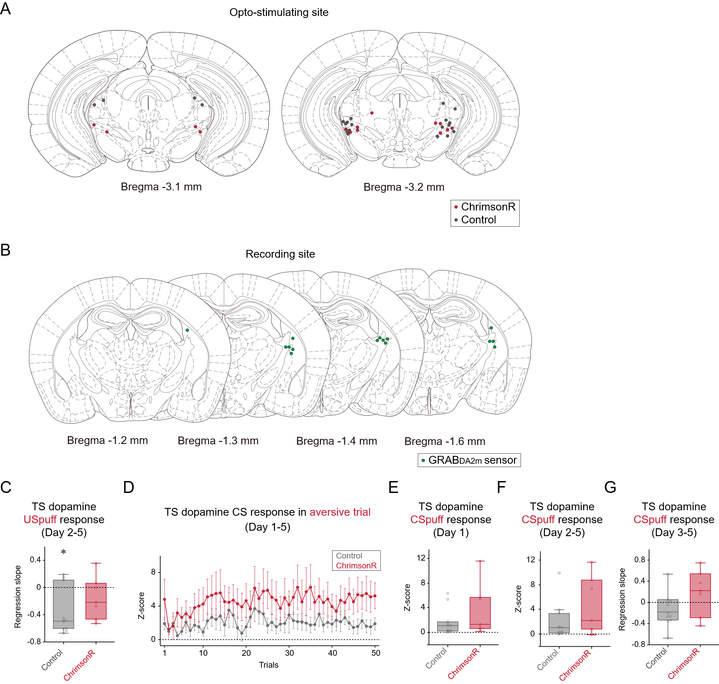
Figure S6. Optogenetic manipulation affected aversive and appetitive learning
A, Location of optic fiber tips (ChrimsonR group was marked with red circles while control group was marked with gray circles) used to opto-stimulate ChrimsonR in the SNL. B, Location of optic fiber tips (marked with green circles) used to collect dopamine sensor signals in the striatum. C, Regression coefficients of USpuff dopamine response with trial number in Day 2-5 for each animal were significantly negative in the control (p=5.1×10⁻³, one-sampled t-test, n=11) but not in ChrimsonR group (p=0.24, one-sampled t-test, n=7). D, Time-course of CSpuff dopamine response in the aversive trials. E, No difference in CSpuff response in control and ChrimsonR groups in Day 1 (p=0.21, two-sided t-test, control group, n=11, ChrimsonR group, n=7). F, CSpuff response was not changed by optogenetic stimulation (p=0.18, two-sided t-test, control group, n=11, ChrimsonR group, n=7). G, Regression coefficients of CSpuff dopamine response with trial number in Day 3-5 for each animal were relatively high in the ChrimsonR group (p=0.089, two-sided t-test, control group, n=11, ChrimsonR group, n=7). *p < 0.05.

