Blue-Green Infrastructure for Flood Management in Data-Scarce Regions: A Case Study from Colombia.
Laura Medina Rivera ^{1,} *, Madeleine Johnson ², and Robert Faggian ^{1,} *
¹ Centre for Regional and Rural Futures (CeRRF), School of Life and Environmental Sciences, Deakin University, 221 Burwood Highway, Burwood VIC 3125, Australia.
² Department of Energy, Environment and Climate Action. Madeleine.johnson@deeca.vic.gov.au
* Correspondence: lmedinarivera@deakin.edu.au (LMR); r.faggian@deakin.edu.au (RF)

ORCID ID
LMR: https://orcid.org/0009-0003-5594-878X
RF: https://orcid.org/0000-0001-8750-3062

Supplementary data.

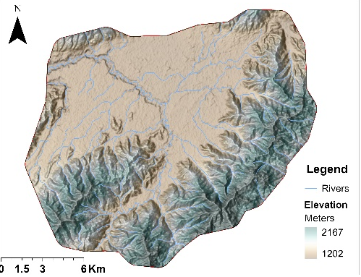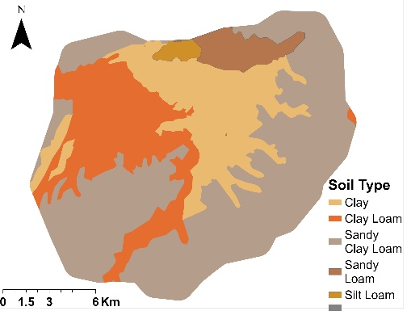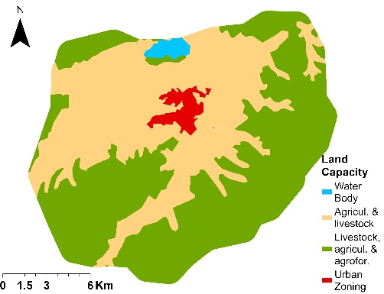
C
B
A
Figure S1. Features of the case study area which is in Guarapas river catchment: (a) Digital Elevation Model – DEM, (b) Soil type, and (c) land capacity.

Table S1 Summarizes the main data types, their sources, and purposes.
Data | Purpose | Data Source
Boundaries & Town | Case Study, catchment definition. | https://data.humdata.org/dataset/cod-ab-col | The Humanitarian Data Exchange. Colombia – Subnational Administrative Boundaries.
Landsat | Land use, definition of impervious and pervious area. | Private by request | “Corporación Autónoma del Alto Magdalena-CAM” (Regional Autonomous Corporation upper Magdalena – CAM)
Soil | Permeability Capacity | Private by request
Cartography | Rivers, creeks, definition catchment, subcatchments, conduits, junctions. | Private by request
DEM | Elevation, catchment definition, subcatchments. | Private by request
Rainfall | 10 Min: October-November 2021. | http://dhime.ideam.gov.co/atencionciudadano/ | “Datos Hidrologicos y Metereologicos-DHIME” (Hydrologic and Meteorologic Data) portal from IDEAM -Institute of Hydrology, Meteorology and Environmental Studies
Rainfall | Mm/24h: February 2021, July and October 2022, and June 2023. | http://dhime.ideam.gov.co/atencionciudadano/

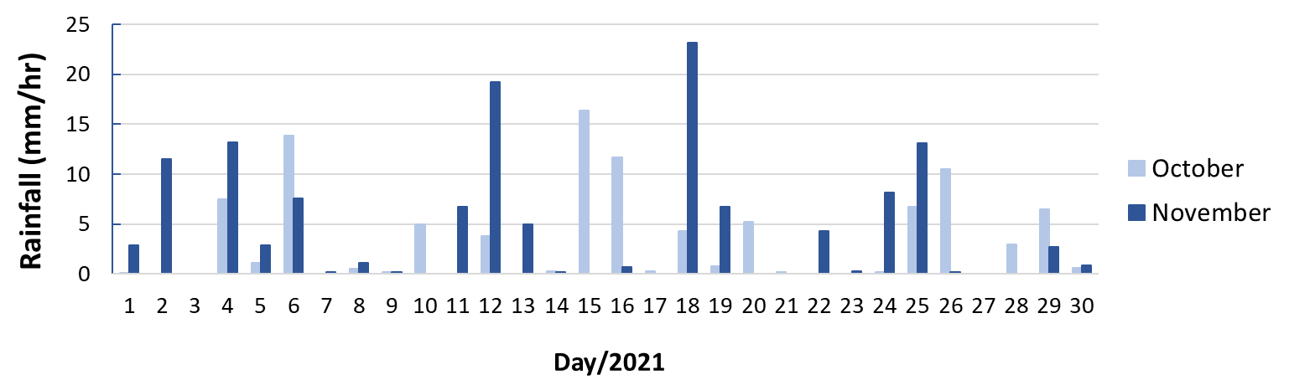

Figure S2. Case study rainfall data mm/10min for October and November 2021.

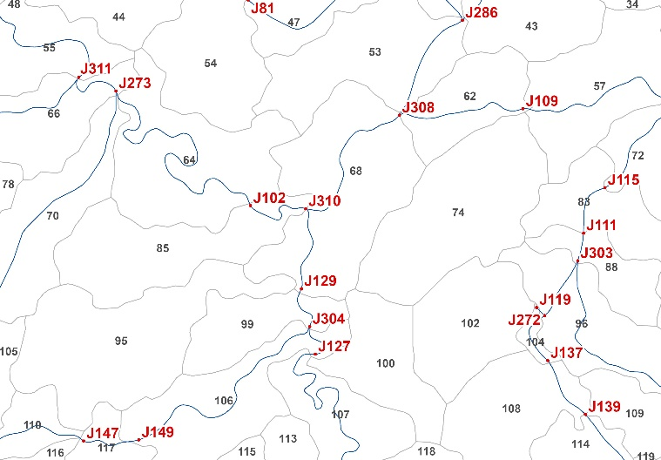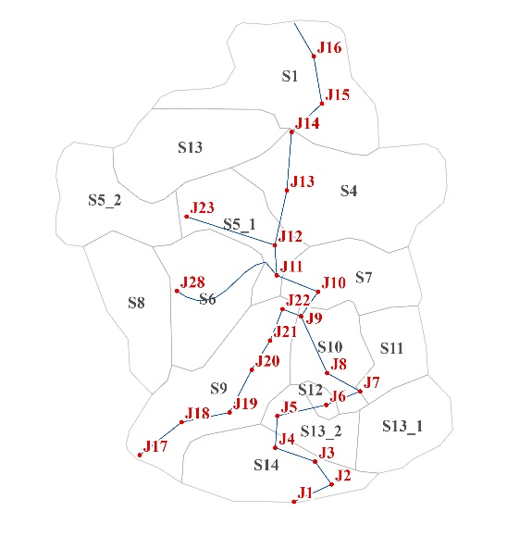
Figure S3. (Left) case study A: zoom in area within the whole Guarapas river catchment case study; (right) case study B: smaller area within the Guarapas river catchment and Pitalito.

Table S2. Summary of flood model validation using grey literature and social media sources for the town of Pitalito. The table lists observed flood events, affected areas, corresponding overflowed junctions identified by the model, and the associated data sources. This comparison supports the alignment between simulated outputs and real-world flood occurrences.
Case Study | Event | Observed data | Modelling Results | Source
 | February 2021 | Venecia | J119 and S102 | (Pitalito, 2021)
A | February 2021 | La Pradera Suburb | J127 and S100 | (Radio, 2021)
A | February 2021 | Portal del Oriente Suburb | J119 and S102 | (Radio, 2021)
A | October 2021 | Paraiso Suburb | J119 and S102 | (Moreno Ramirez, 2021)
A | July 2022 | Solarte Suburb (figure 10 – sky blue color border) | J102 and S85 | (Digital, 2022)
A | October 2022 | INPEC | J102 and S85 | (Huila, 2022; Villarreal Ruiz, 2022)
A | October 2022 | Las Gaviotas Suburb | J102 and S85 | (Huila, 2022; Villarreal Ruiz, 2022)
A | October 2022 | Red Cross | J127 and S100 | (Huila, 2022; Villarreal Ruiz, 2022)
A | October 2022 | Coliseum Sports | J129 and S99 | (Huila, 2022; Villarreal Ruiz, 2022)
A | October 2022 | San Antonio Hospital | J129 and S99 | (Huila, 2022; Villarreal Ruiz, 2022)
B | November 2021 | Libertador suburb | J15 and S1 | (SVC, 2021)
B | October 2022 | Street in from of ‘Drogas la rebaja’ (image below). Also, evidence of | J15 and S1 | (Villarreal Ruiz, 2022)
B | October 2022 | ‘ESE Manuel Castro, and | J11 and S6 | (Villarreal Ruiz, 2022)
B | October 2022 | San Antonio Hospital | J10 and S7 | (Villarreal Ruiz, 2022)
B | June 2023 | Libertador suburb and bridge in ‘carrera 6th’ | J15 and S1 | (Neiva Stereo, 2023)

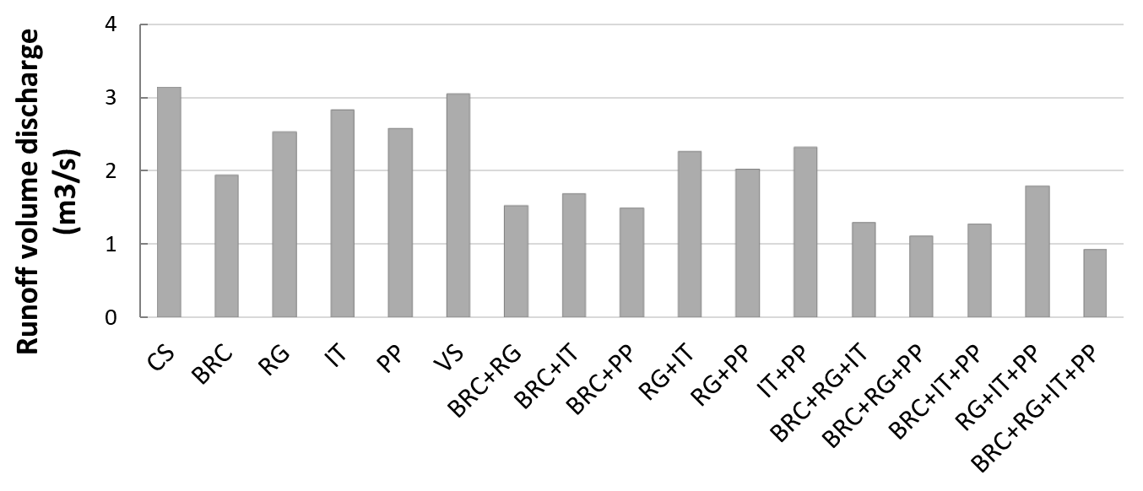
Figure S4. Total runoff volume for sixteen BGI scenarios compared to the current situation (baseline) in Case Study B, Pitalito, Huila, Colombia. Scenarios include five single-element cases (BRC, RG, PP, IT, and VS) and eleven combinations of two to four elements. Results highlight bioretention cells (BRC) as the most effective individual element, with increased performance observed in multi-element configurations.

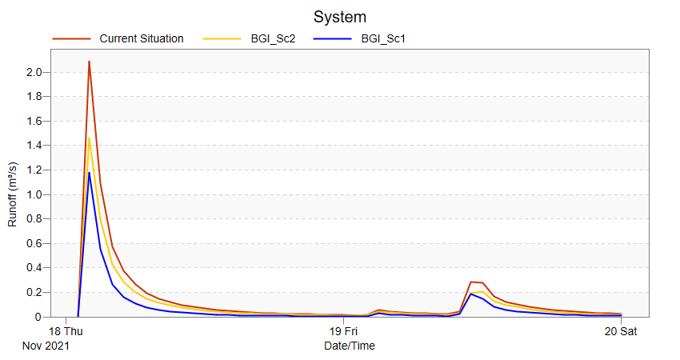
Figure S5. Comparison of simulated runoff for two BGI placement strategies using the Best-Case Scenario (BSc) in Case Study B, Pitalito, Huila, Colombia. The baseline scenario without BGI is shown in red; the targeted placement strategy (focused on key flood-prone sub-catchments) is shown in blue; and the diffuse placement strategy (across non-priority sub-catchments) is shown in yellow.

References
Digital, H. (2022). Inundaciones en vías principales de Pitalito te fuertes lluviasFacebook. https://www.facebook.com/elhuiladigital/videos/-inundaciones-en-v%C3%ADas-principales-de-pitalito-te-fuertes-lluvias/2401489926656483/
Huila, D. d. (2022). Fuertes lluvias generaron emergencias en Pitalito. Diario del Huila. Retrieved March from https://diariodelhuila.com/fuertes-lluvias-generaron-emergencias-en-pitalito/
Moreno Ramirez, J. (2021). El Huila en alerta por lluvias. Caracol Noticias. Retrieved September from https://caracol.com.co/emisora/2021/10/19/neiva/1634650333_834804.html
Neiva Stereo. (2023). Lluvias en Pitalito causan emergencias. Neiva Estereo. Retrieved February from https://neivaestereo.co/lluvias-en-pitalito-causan-emergencias/
Pitalito, T. N. (2021). Inundaciones en Pitalito tras fuertes lluvias https://www.facebook.com/tvnoticiaspitalito/videos/inundaciones-en-pitalito-tras-fuertes-lluvias/1157505828033700/
Radio, B. (2021). Varias viviendas afectadas y colapso en las vías tras las fuertes lluvias en Pitalito, Huila. Blu Radio Colombia. Retrieved March from https://www.bluradio.com/nacion/varias-viviendas-afectadas-y-colapso-en-las-vias-tras-las-fuertes-lluvias-en-pitalito-huila
SVC. (2021). Asi esta en Rio Guarapas en Pitalito. Youtube. Retrieved February from https://www.youtube.com/watch?v=CwAInnLBJHM
Villarreal Ruiz, F. (2022). 30 edificaciones resultaron afectadas por lluvias en Pitalito. Caracol Radio. Retrieved March from https://caracol.com.co/2022/10/28/30-edificaciones-resultaron-afectadas-por-lluvias-en-pitalito/

