Observation of single- and two-mode magnon thermal squeezing
Supplementary Information
T. Hioki^{1,2,3*}, K. Tojo^{1*}, M. Elyasi³, S. Horibe¹, H. Shimizu¹, K. Hoshi^{1,4}, T. Makiuchi²,
G. E. W. Bauer^{3,6,7} and E. Saitoh^{1,2,3,4,5}
1. Department of Applied Physics, The University of Tokyo, Tokyo 113-8656, Japan.
2. RIKEN Center for Emergent Matter Science, Riken, Wako 351-0198, Japan.
3. WPI Advanced Institute for Materials Research, Tohoku University, Sendai 980-8577, Japan.
4. Institute for AI and Beyond, The University of Tokyo, Tokyo 113-0032, Japan.
5. Quantum-Phase Electronics Centre, The University of Tokyo, Tokyo 113-8656, Japan.
6. Zernike Institute for Advanced Materials, University of Groningen, 9747 AG Groningen, Netherlands.
7. Kavli Institute for Theoretical Sciences, University of the Chinese Academy of Sciences, Beijing 10090, China.

CONTENTS
- Noise evaluation for single-mode thermal squeezing
- Evaluation of Duan-Simon criterion for two-mode thermal squeezing
- Magnetic field dependence of non-degenerate parametric oscillation
- Temperature dependence of two-mode thermal squeezing
- Time-resolved measurement of squeezed magnon’s Wigner function
- Effect of out-of-plane non-uniformity of AC magnetic field
- Numerical simulation of thermal squeezing
- Intuition behind thermal squeezing
References
- Noise evaluation for single-mode thermal squeezing
To establish thermal squeezing, it suffices to demonstrate that the fluctuation of either the $I$ or $Q$ quadrature components fall below the level expected in thermal equilibrium. In equilibrium, the equipartition principle dictates that fluctuations proportional to the magnon population are distributed evenly among the conjugate degrees of freedom. Accordingly, we define the reference thermal fluctuation level as $\left[{\left(ΔQ\right)}^{2}+{\left(ΔI\right)}^{2}\right]/2$, where ${\left(ΔI\right)}^{2}=⟨I^{2}⟩-⟨I⟩^{2}$ and ${\left(ΔQ\right)}^{2}=⟨Q^{2}⟩-⟨Q⟩^{2}$ are variances. $I$ and $Q$ components in our measurement correspond to the spin current injected perpendicular to the platinum (Pt) thin film through ac spin pumping. This spin current can be formulated as
$$J_{s}^{Y}=\frac{ℏ}{4πS_{0}^{2}}\left[Reg_{↑↓}\left(S_{Z}{\dot{S}}_{X}-S_{X}{\dot{S}}_{Z}\right)+Img_{↑↓}{\dot{S}}_{Y}S_{0}\right]$$
where ℏ,${ S}_{0}$, $S_{X,Y,Z}$, $g_{↑↓}$ denote the reduced Planck constant, the total spin magnitude, the $X,Y,Z$ components of the spin angular momentum, the spin-mixing conductance, respectively. In the present experiment, ${\dot{S}}_{Z}$ can be approximated as zero since the ellipticity of the magnetization precession is small. Moreover, at the Pt/YIG interface, the imaginary part of the spin-mixing conductance is much smaller than its real part. Consequently, since ${\dot{S}}_{X}∝iωS_{Y}$, $S_{Z}{\dot{S}}_{X}$ term dominates the signal contribution. Accordingly, since the detected voltage is proportional to the time variation of $S_{Y}$, the proportional relationship can be expressed using the magnon creation and annihilation operators $\hat{a}(t)$ and ${\hat{a}}^{†}(t)$ as follows
$$V_{ISHE}\left(t\right)∝S_{Y}=\frac{〈\hat{a}\left(t\right)-{\hat{a}}^{†}\left(t\right)〉}{\sqrt{2}i}.$$
When this signal is demodulated using a lock-in amplifier (IQ detection), the obtained in-phase $I$ and out-of-phase $Q$ components at the frequency $f$satisfy the following proportional relationships:
$$〈I\left(f\right)〉∝\frac{〈\hat{a}\left(f\right)-{\hat{a}}^{†}\left(f\right)〉}{\sqrt{2}i}=:〈M_{y}\left(f\right)〉, 〈Q\left(f\right)〉∝\frac{〈\hat{a}\left(f\right)+{\hat{a}}^{†}\left(f\right)〉}{\sqrt{2}}=:〈M_{x}(f)〉$$
Thus, the measured voltages $I$ and $Q$ are proportional to $M_{x}​$ and $M_{y}$​ in the rotating reference frame. In the case of elliptical precession, the diagonalized magnon operators are defined by the Bogoliubov transformation as $\hat{c}=μ\hat{a}+ν{\hat{a}}^{†}, {\hat{c}}^{†}=μ{\hat{a}}^{†}+ν\hat{a}$ because the precession involves mixing between the creation and annihilation operators. This yields:
$$〈I\left(f\right)〉=G\left(μ-ν\right)\frac{〈\hat{c}\left(f\right)-{\hat{c}}^{†}\left(f\right)〉}{\sqrt{2}i}, 〈Q\left(f\right)〉=G\left(μ-ν\right)\frac{〈\hat{c}\left(f\right)+{\hat{c}}^{†}\left(f\right)〉}{\sqrt{2}},$$
where $c=μa+νa^{†}, c^{†}=μa^{†}+νa, μ=cosh s, ν=\sinh{s},$with $e^{s}={\left(\frac{H_{ex}+NM_{s}}{H_{ex}}\right)}^{1/4}$. Here $H_{ex}, { M}_{s}, N, G$ are external magnetic field, saturation magnetization, demagnetizing factor and conversion factor for voltage detailed below. When $⟨Q^{2}⟩=0$ and $⟨I^{2}⟩=0$, we obtain
$$\frac{{\left(ΔQ\right)}^{2}+{\left(ΔI\right)}^{2}}{2}=G^{2}{\left(μ-ν\right)}^{2}\left(〈\hat{n}〉+\frac{1}{2}\right).$$
This quantity therefore represents the expected fluctuations of the $I$and $Q$components when the magnon population is $\hat{n}={\hat{c}}^{†}\left(f\right)\hat{c}\left(f\right)$in thermal equilibrium.
In our experiment, microwave-induced heating (described in Methods) increases the magnon temperature in a power-dependent manner, and thus increases the magnon population. Therefore, for each microwave power, we evaluate the corresponding magnon number and the thermal fluctuation level expected for that population. Figure S1b shows the comparison of ${\left(ΔQ\right)}^{2}$ and $\left[{\left(ΔQ\right)}^{2}+{\left(ΔI\right)}^{2}\right]/2$ as a function of microwave power. We find that ${\left(ΔQ\right)}^{2}$is consistently lower than $\left[{\left(ΔQ\right)}^{2}+{\left(ΔI\right)}^{2}\right]/2$, indicating that its fluctuation lies below the thermal equilibrium level.
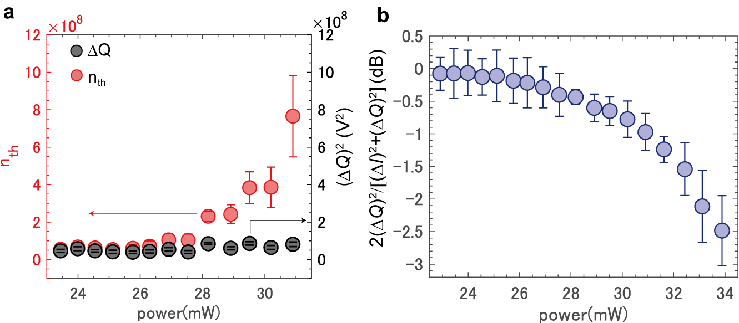
In Figs. S1a, we plot ${\left(ΔQ\right)}^{2}$ and magnon number as a function of microwave power. The constant ${\left(ΔQ\right)}^{2}$ despite heating, compared to the increased thermal magnon number, clearly demonstrates that the quadrature componet $Q$ is squeezed below the thermal level. Moreover, Fig. S1b shows the ratio of $2ΔQ/\left[{\left(ΔQ\right)}^{2}+{\left(ΔI\right)}^{2}\right]$, which compares the quadrature noise along $Q$ to the average thermal noise amplitude. At thermal equilibrium, we expect ${{\left(ΔQ\right)}^{2}∝\left(ΔM_{x}\right)}^{2}$ $≈ n_{th}+1/2$, so the normalized variance should approach unity in the large-magnon-number limit. However, the experiment clearly shows a power-dependent deviation from this expectation. The calculated squeezing level reaches −2.5 dB, indicating that ${\left(ΔQ\right)}^{2}$ is indeed suppressed below the thermal noise floor.
Fig. S1 a. Power dependence of the absolute variance of $Q$ and the thermal magnon number obtained at B = 31.75 mT, b. Power dependence of the variance of $Q$ normalized by the thermal noise level.
We can quantitatively compare magnon thermal noise and quadrature noise by scaling the horizontal and vertical axes of the scatter plots in Fig. 2e to$M_{x}$ and $M_{y}$. To scale horizontal and vertical axes, we evaluated the coefficient to convert $I$ and $Q$ to $M_{x}$ and $M_{y}$.The measured voltage signals induced by AC spin pumping $I$ and $Q$ are expressed as¹:
$$\begin{aligned}I=G\left[M_{x}cosϕ+M_{y}sinϕ\right]\#\left(1\right)\end{aligned}$$
$$\begin{aligned}Q=G\left[M_{y}cosϕ-M_{x}sinϕ\right]\#\left(2\right)\end{aligned}$$
where $G=\sqrt{2}ρw\tilde{e}\left|G_{p}\right|ω_{0}, ρ$ is the resistivity of Pt, $w$ is the electrode separation, $G_{p}$​ is the circuit gain, $ω_{0}$​ is the precession frequency, and $ϕ$ is the local oscillator phase. The coefficient $\tilde{e}=\frac{2e|g_{↑↓}| }{4π\sqrt{2S_{0}V}}Aα_{NF}$ incorporates the elementary charge $e$, spin mixing conductance $g_{↑↓}$, spin density $S_{0}$, volume $V$, spin Hall angle $α_{NF}$, and a backflow correction factor $A=\frac{λ_{N}}{d_{N}}tanh⁡(\frac{d_{N}}{2λ_{N}})$, where $λ_{N}$ and $d_{N}$ are the spin diffusion length and thickness of Pt. All the experimental parameters ($ρ, w, G_{p}, V,d_{N}$) were determined from the device design and measurement, while the material parameters ($α_{NF}, λ_{N},S_{0},\left|g_{↑↓}\right|$) were taken from literature. These values are listed in Table 1.
Table1: Material parameters used for magnon number estimation
Symbol | Physical amount | value | Unit
$$ρ$$ | Resistivity | 4.54$×$10⁻⁷ | $Ω$m
$$w$$ | Terminal distance | 80 | μm
$$G_{p}$$ | Gain of the circuit | 24 | -
$$g_{↑↓}$$ | Spin mixing conductance^{[1]} | 1.94$×$10¹⁸ | m⁻²
$$V$$ | Sample volume | 2.75$×$10⁻¹³ | m³
$$d_{N}$$ | Normal metal layer thickness | 10 | nm
$$λ_{N}$$ | Spin diffusion length of Pt^{[2]} | 8 | nm
$$α_{NF}$$ | Spin Hall angle of Pt^{[2]} | 0.03 | -
$$S_{0}$$ | Spin density^{[3]} | 6.44$×$10²⁷ | m⁻³

Note that in our measurement, the observed noise consists of two main contributions: magnetization dynamics and Johnson–Nyquist noise. Johnson–Nyquist noise is frequency-independent over the relevant bandwidth at the measurement temperature of 160 K, and can be treated as white noise. As a result, the noise observed away from the FMR frequency can be attributed primarily to Johnson–Nyquist noise. In our setup, the sample bridges the signal and ground lines of a coplanar waveguide, so the Johnson–Nyquist noise reflects both the sample resistance and the characteristic impedance of the transmission line. Under the measurement conditions used in this study, the power spectral density of the Johnson–Nyquist noise was estimated to be 5.1×10⁻¹⁶ V²/Hz, corresponding to –142.5 dBm/Hz.
By taking the Johnson–Nyquist noise of the detection circuit into account, we can isolate the magnon-induced noise contribution and the number of thermal magnons of $n_{th}$~2.2×10⁸.
Figs. S2a and b reveal that the fluctuations along the $M_{x}$-axis are smaller than that of the thermal equilibrium distribution, providing direct evidence for magnon thermal squeezing. In particular,${\left(ΔM_{X}\right)}^{2}=〈M_{x}^{2}〉-{〈M_{x}〉}^{2}$falls below the noise level expected for a thermal state, confirming that our experiment demonstrates thermally squeezed magnon fluctuations.

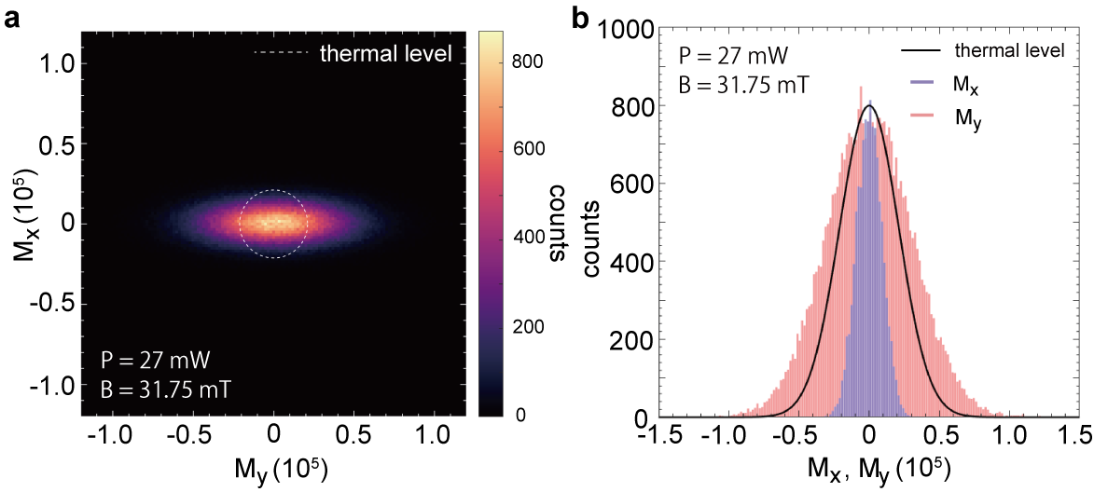
Fig.S2 a. Comparison between thermal noise and thermally squeezed magnon’s Wigner function measured at pumping microwave with $P$ = 27 mW and magnetic field of $B$ = 31.75 mT, b. Bar plot of magnon’s Wigner function as a function of $M_{x}$ (with $M_{y}=0$) and $M_{y}$ (with $M_{x}=0$). The black solid curve represents the separately measured equilibrium thermal noise.
- Evaluation of Duan-Simon criterion for two-mode thermal squeezing
Experimental studies often rely on the Duan–Simon criterion^{[4,5]} as a practical entanglement witness. This method evaluates, the sum of variances for the quadratures $x_{1}+x_{2}$ and $p_{1}-p_{2}$, or “separability”
$$σ_{sep}=Var(x_{1}​+x_{2}​)+Var(p_{1}​-p_{2}​),$$
which rigorously tests the correlations of Gaussian states also when the Wigner function remains positive. When for Gaussian states $σ_{sep}>$2 (in dimensionless units with $ℏ=1$), classical correlations are still present and characterized by the number, but genuine quantum entanglement is absent. Vice versa, when the sum of variances drops below 2 (in units where $ℏ=1$), the system is necessarily quantum-entangled. This criterion has been widely used in experiments, including several demonstrations of phonon entanglement ^{[6,7]}.
This criterion can be intuitively understood by reference to an ideal Einstein-Podolsky-Rosen state—in which $x_{1}+x_{2}$ and $p_{1}-p_{2}$ are simultaneously well-defined and variances vanish $σ_{sep}=0$. This number increases with reduced entanglement.
In our work, “two-mode thermal squeezing” refers to a decrease of the separability for a constant number of magnons, not to be confused with quantum entanglement at finite temperatures. $σ_{sep}$ measures classical correlations relative to thermal equilibrium and indicates the “distance” from genuine quantum entanglement at low temperatures.
Below we compare the observed separability and thermal magnon number over the experimentally relevant power range. We use Eqs. (1) and (2) to convert the observed $I\left(f_{1}\right), Q\left(f_{1}\right), I\left(f_{2}\right) and Q(f_{2})$ to $M_{1}^{x}, M_{1}^{y}, M_{2}^{x}, and M_{2}^{y}$ to compute the separability measure,
$$σ_{sep}^{exp} = Var(M_{1}^{x}+M_{2}^{x}) + Var\left(M_{1}^{y}-M_{2}^{y}\right).$$
The plot of $n_{th}$ and $σ_{sep}^{exp}$ in Fig.S3 indicates that between 35.2 mW and 35.4 mW, the separability significantly decreases despite of an increasing magnon number, clearly demonstrating a growth of the correlations between the two modes.
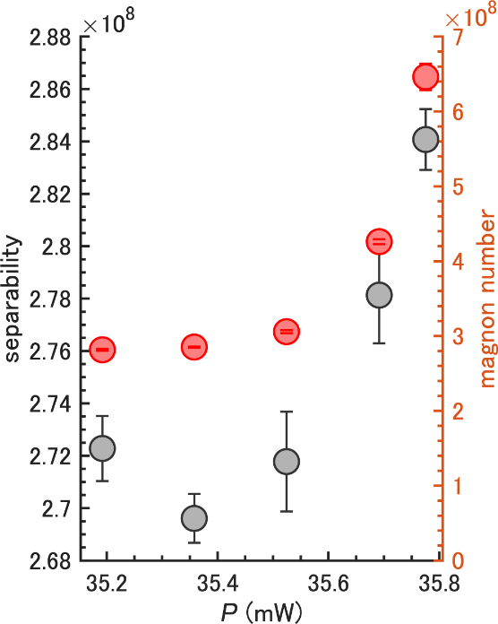
The separability in our data remains well above the quantum entanglement threshold of 2. Nevertheless, the decreasing separability reflects an increasing classical correlation that we refer to as thermal two-mode squeezing, i.e. classical correlations in a highly occupied (thermal) regime that is the precursor to a quantum entanglement at finite temperature.
Fig. S3 Power dependence of separability and magnon number measured at $B$ = 31.95 mT, $T$ = 160 K. While the magnon number increases from $P$ = 35.2 mW to 35.37 mW, the separability decreases. This decrease in separability without a corresponding decrease in the magnon number indicates an enhancement of correlation, which we refer to as thermal two-mode squeezing.
- Magnetic field dependence of non-degenerate parametric oscillation
Since we carry out the experiments at relatively low field strengths (~32 mT), the set and actual field values may differ slightly due to the residual magnetization in the yoke material of the electromagnet. To rigorously confirm the reversal of the peak amplitude under magnetic field inversion, we conducted systematic field-dependent measurements. The results are shown below.
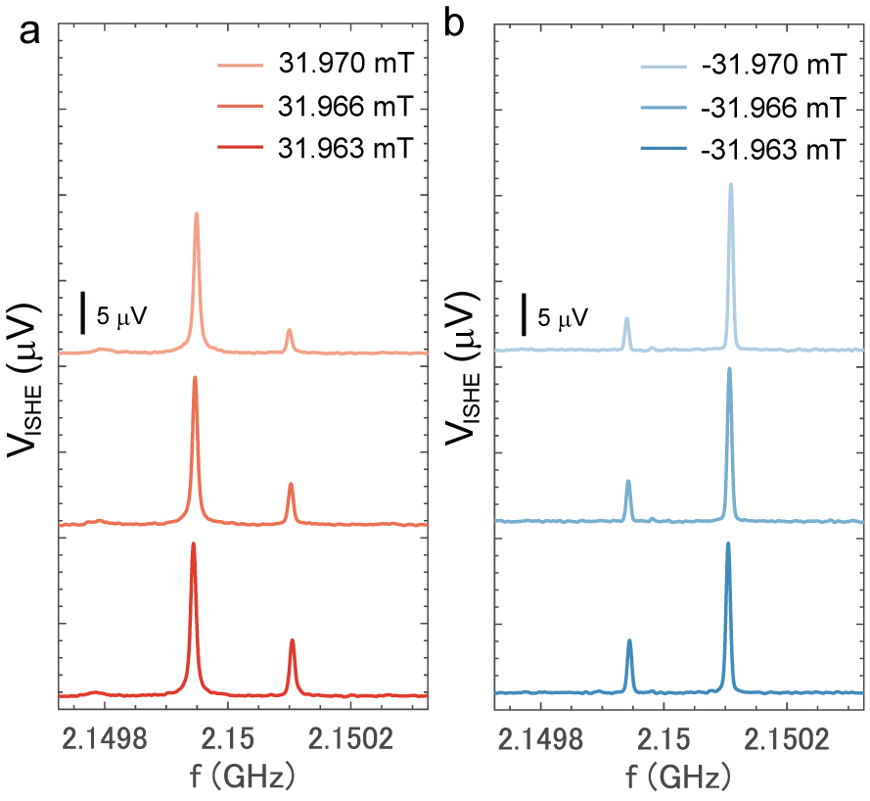
As demonstrated in Fig. S4, when we used a properly calibrated electromagnet, we observed that reversing the sign of the external magnetic field leads to a corresponding inversion in the relative amplitudes of the two peaks. Moreover, as the magnitude of the external magnetic field increases, one of the two peaks gradually diminishes in intensity for both field polarities, indicating stronger localization of the magnon mode on the surface of the sample due to the excitation of magnons with larger wavenumbers whose localization lengths are short.
Fig.S4 a. Magnetic field dependence of the peaks observed above the threshold for non-degenerate parametric pumping at P = 36 mW for positive magnetic field values, b. Magnetic field dependence of the peaks observed above the threshold for non-degenerate parametric pumping at P = 36 mW for negative magnetic field values.

- Temperature dependence of two-mode thermal squeezing
Two-mode thermal squeezing is induced by parametric excitation and therefore emerges universally near the threshold, independent of temperature. To demonstrate this, we measured two-mode thermal squeezing at three temperatures—300 K, 260 K, and 220 K—under magnetic fields of 29.84 mT, 30.00 mT, and 30.15 mT, respectively. We measured the Wigner functions at different fields because of the change in the resonance condition due to the change in the saturation magnetization and anisotropy as temperature decrease. In all cases, correlations were observed to develop near the threshold, confirming the universal nature of this phenomenon.
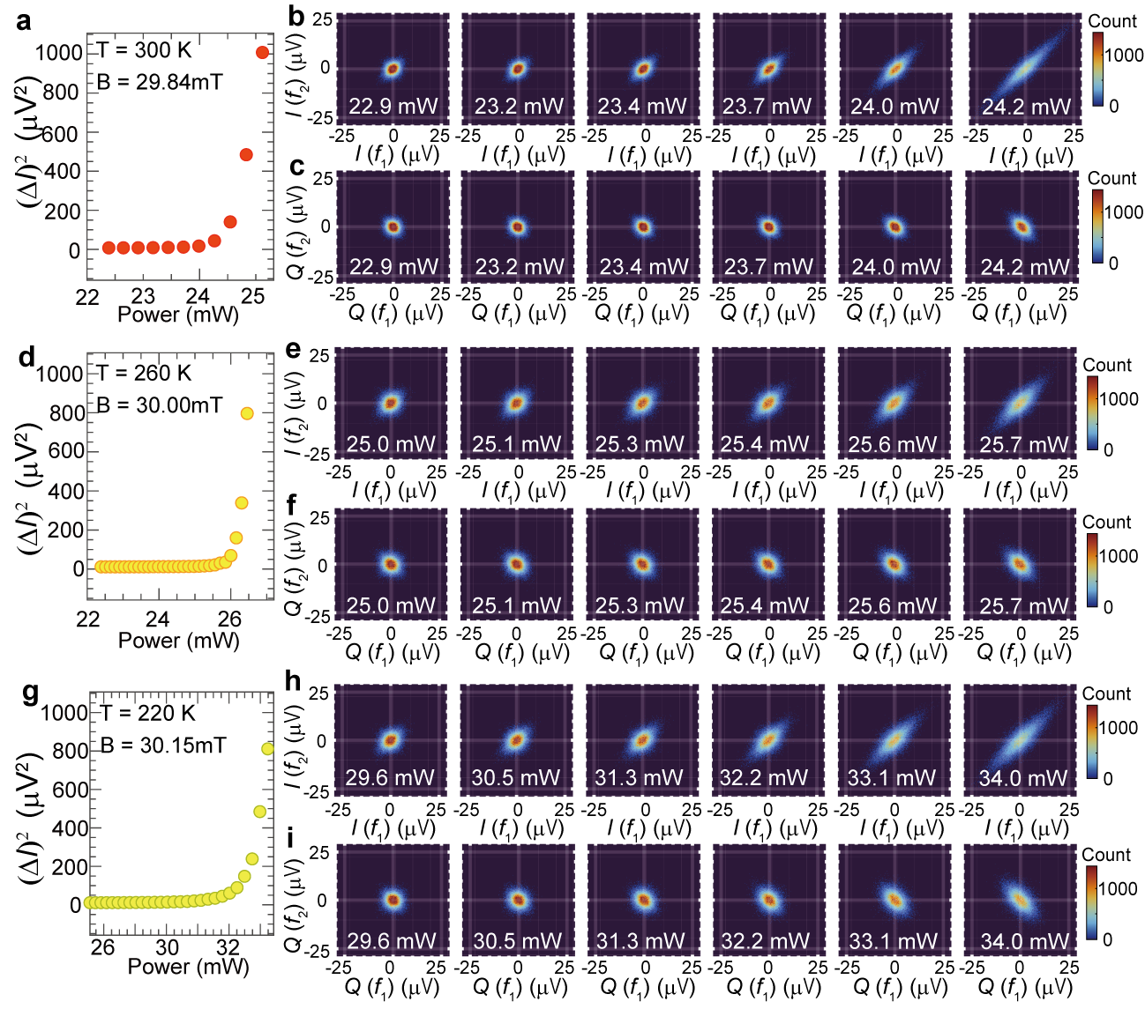
Fig. S5 a,d,g, Power dependence of noise intensity (bandwidth = 19 kHz) measured at 300 K (a), 260 K (d), and 220 K (g), b,e,h, Wigner functions representing correlations between the I (in-phase) components near the nondegenerate parametric excitation threshold at 300 K (b), 260 K (e), and 220 K (h), c,f,i, Wigner functions representing correlations between the Q (quadrature) components near the nondegenerate parametric excitation threshold at 300 K (c), 260 K (f), and 220 K (i).
- Time-resolved measurement of squeezed magnon’s Wigner function
To investigate how squeezing affects the relaxation time of magnons, we prepared a coherent squeezed state—a squeezed version of a coherent magnon state—and examined the relationship between its relaxation time constant and the damping coefficient obtained from conventional microwave absorption linewidth measurements by using time-resolved state tomography⁸.
In the experiment, we used a Holzworth 8990B microwave source with four output channels to generate microwaves at frequencies $f_{1}$= 2.15 GHz and $f_{2}$= 4.3 GHz. These signals were converted into pulses using an arbitrary waveform generator (Tektronix AFG31000) and a microwave switch (Mini-Circuits ZASWA-2-550DR+). The pulsed microwaves were passed through a band-pass filter (Mini-Circuits VHF-3000+) to extract only the high-frequency components, and then combined via a directional coupler (Krytar model 2620) with another pulsed $1f$ signal generated by another microwave output and the same type of switch. The superimposed microwave pulses is subsequently amplified by a NextecRF NBL00426 amplifier and filtered again using a band-pass filter (Mini-Circuits ZFHP-3800-S+) before being applied to the sample. The pulse durations were set to 1.5 μs for the $1f$ pulse and 2.0 μs for the $2f$ pulse, with the 1f pulse starting 500 ns earlier. The 1f pulse was used to generate a coherent magnon state with zero phase, and the 2f pulse squeeze the coherent magnon state to generate squeezed coherent state.
Time-dependent Wigner functions were measured after the $2f$ pulse was turned off, with $t = 0$ defined as the moment the $2f$pulse ceased. To ensure systematic analysis, measurements were performed at three temperatures: 300 K, 260 K, and 220 K. The signal from the sample was amplified by two low-noise amplifiers (LNA3035 and ZVA-183G-S+), mixed down to 500 MHz, and then recorded using a Zurich Instruments UHFLI lock-in amplifier. By employing the UHFLI’s boxcar integration function, 4096 time-domain accumulations were averaged to obtain the voltage distribution, from which the Wigner function was reconstructed.
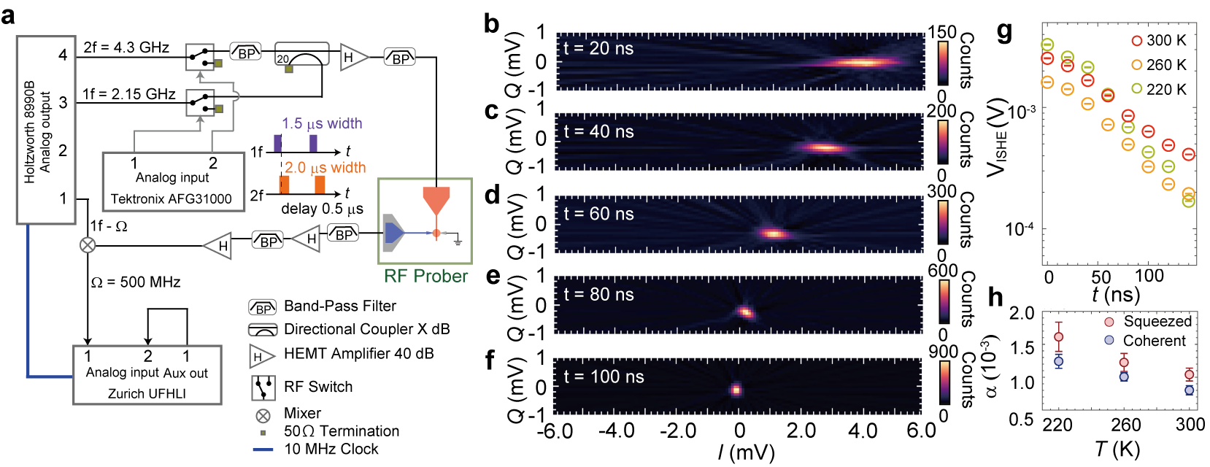
The centre of the Wigner function in Figs. S6b-f exhibited an exponential relaxation in time, reaching thermal equilibrium in approximately 100 ns. From this exponential decay, we extracted the relaxation time constant and calculated the corresponding damping coefficient. Comparison with the Gilbert damping parameter obtained from conventional VNA-FMR measurements without squeezing revealed that the squeezed state exhibited a slightly larger damping. This enhancement can be attributed to the fact that parametric excitation populates energetically degenerate modes, including magnons with finite wave vectors. These finite-wavenumber magnons interact with the uniform precession mode via four-magnon scattering processes, which are known to contribute to relaxation.
Fig. S6 a. Time-resolved tomographic measurement circuit used to determine the relaxation time constant of the squeezed coherent magnon state, b–f. Time evolution of the Wigner function after turning off the microwave for parametric excitation, g. Relaxation dynamics of the mean amplitude of the squeezed magnons, h. Comparison of the Gilbert damping between the coherent squeezed magnon state and the coherent magnon state.
- Effect of out-of-plane non-uniformity of AC magnetic field
In this experiment, magnetic excitation was performed using a coplanar waveguide (CPW), which raises a concern about possible inhomogeneity in the microwave magnetic field along the thickness direction of the sample due to the geometry of the waveguide. To evaluate this effect, we calculated the spatial distribution of the microwave alternating magnetic field on the CPW used in the experiment, simulated in COMSOL Multiphysics. A model reproducing the experimental CPW geometry was constructed, consisting of an 18-μm-thick Cu thin-film waveguide with a width of 100 μm deposited on a 1.6-mm thick dielectric substrate with a relative permittivity of 10.7. A microwave at 4 GHz frequency was applied to the model for numerical simulation. The results revealed that while the AC magnetic field amplitude along $x$ direction $b_{ac}^{x}$ decreases with increasing distance from the CPW surface, the variation within the 1.6 μm thickness of the sample is only about 0.13%. Therefore, the sample can be considered to be excited uniformly in the thickness direction within the experimental conditions. We also experimentally measured different samples with different thicknesses. Figs.S7c and d show the correlation values of $V_{ISHE}$ measured with samples of the thickness of 475 nm and 562 nm. The correlation values were similar, and the asymmetry between the correlations of the I and Q components remained the same as in the sample with a thickness of 1.6 μm, indicating no significant effect of thickness.
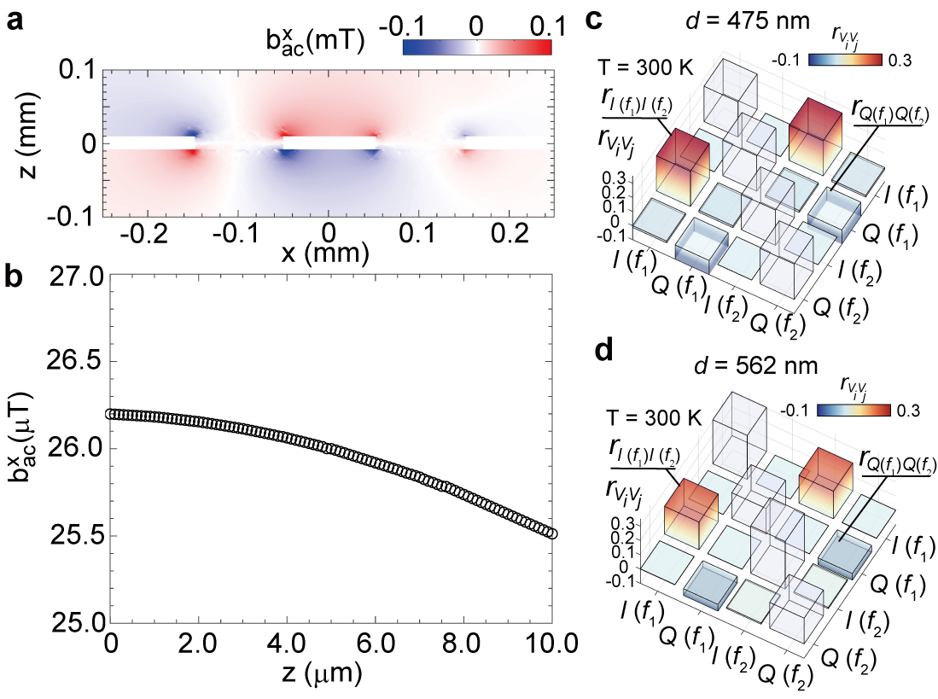
Fig. S7 a. Calculated spatial distribution of the AC magnetic field along the x-direction $b_{ac}^{x}$. The central white region corresponds to the signal line, while the white regions on both sides represent the ground electrodes, b. z dependence of $b_{ac}^{x}$ at the position $x$ = 0. c,d, Correlation observed by the samples with different thicknesses.
- Numerical simulation of thermal squeezing
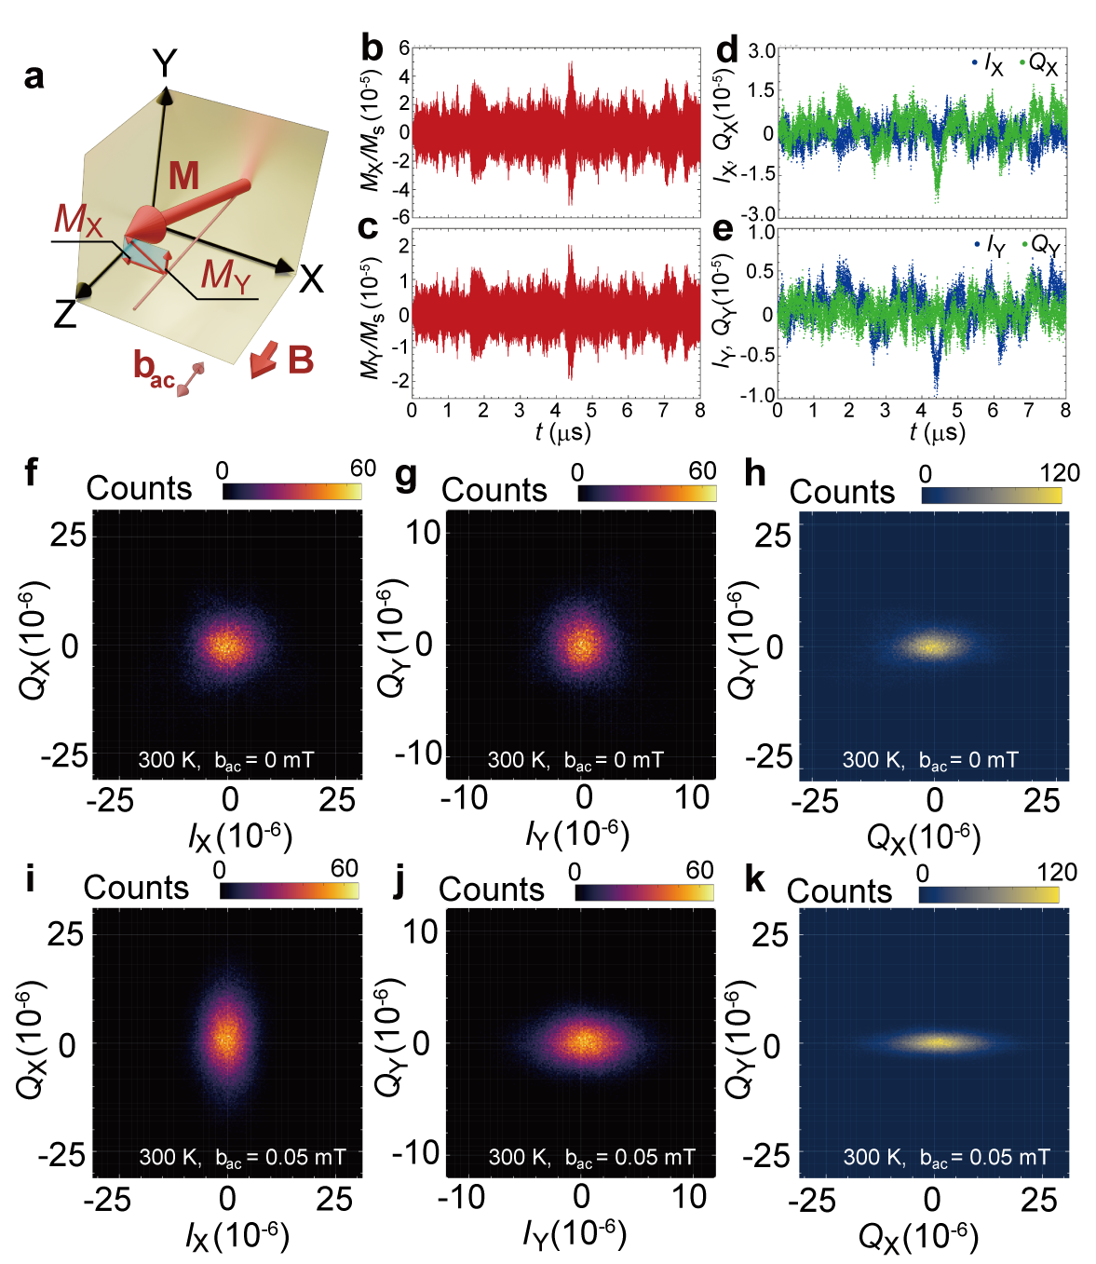
To clarify the correspondence between the thermally squeezed state of magnetization dynamics and the precessional motion of magnetization, we performed numerical calculations of the thermal squeezed state using micromagnetic simulations by using GPU-accelerated package MuMax3⁹. The simulation modeled a circular disk with a diameter of 100 μm and a thickness of 1.6 μm, using parameters ($K_{1}$= -44.4 $J/m^{3}$, ($K_{u}= -1707.6 J/m^{3}$), and a saturation magnetization ($μ_{0}M_{s} = 148.8 mT$).
Fig. S8 a. Coordinate systems of the micromagnetic simulations. b,c, Calculated $X$(b) and $Y$(c) components of the magnetization dynamics under an AC magnetic field of 0.05 mT and the frequency of 4.3 GHz, d,e, Calculated in-phase($I$) and quadrature ($Q$) component of $M_{X}$(d) and $M_{Y}$(e). Blue (green) plot represent $I (Q)$component, f,g, Wigner function of the magnetization dynamics calculated from $M_{X}$(f) and $M_{Y}$(g) at thermal equilibrium, h, Lab-frame fluctuation at the FMR frequency (2.15 GHz), i,j, Wigner function of magnetization dynamics calculated from $M_{X}$(i) and $M_{Y}$(j) under AC magnetic field of 0.05 mT, k, Lab-frame fluctuation at the FMR frequency (2.15 GHz) under AC magnetic field of 0.05 mT.

We focus on the spatially averaged magnetization dynamics of the in-plane and out-of-plane components $M_{X}$ and $M_{Y}$, respectively. By multiplying the sinusoidal wave at the ferromagnetic resonance frequency $f_{FMR}$ and filtering out $2f_{FMR}$ component, we obtained the DC in-phase ($I$) and quadrature ($Q$) components (Figs. S8d, e) at thermal equilibrium. $I_{X(Y)}$ and $Q_{X(Y)}$ correspond to $M_{X(Y)}.$ When plotting noise using the ($I_{X}$,$Q_{X}$) and ($I_{Y}$,$Q_{Y}$), the distributions are circular, as shown in Figs. S8f and g, respectively, because the stochastic thermal field is “white” and $I$ and $Q$ are not correlated. Only the relatively reduced amplitude of the isotropic distribution of ($I_{Y}$,$Q_{Y}$) in Fig. S8g, signals the ellipticity due to the demagnetizing field that suppresses the out-of-plane amplitude$.$
On the other hand, the joint distribution of$Q_{X}$ and $Q_{Y}$ in Fig.S8h, which corresponds to $M_{X}$and $M_{Y}$ in lab frame, visualizes the elliptical lab-frame fluctuations at equilibrium. A circular Wigner function therefore does not imply isotropic lab-frame fluctuations and vice versa.
Pumping the system with an AC magnetic field at twice the ferromagnetic resonance frequency and parallel to the external magnetic field, stretches the distribution of the $I_{X}-Q_{X}$ vertically (Fig. S8i) and $I_{Y}-Q_{Y}$ horizontally (Figs. S8j). Since $M_{X}$ and $M_{Y}$ are phase-shifted by 90° this result is consistent with the observed squeezing. When examining the lab-frame fluctuations in the squeezed state (i.e., plotting joint distribution of $Q_{X}$ and $Q_{Y}$ in Fig. S8k), we find that this aspect ratio becomes larger than that with $b_{ac}$ = 0 mT (Fig. S8h).

- Numerical simulation of magnon modes
To clarify the mode involved for thermal two-mode squeezing, we simulated a magnetic disk with a diameter of 500 μm and a thickness of 1.6 μm, discretized into $256×256$ in-plane cells and 64 cells along the thickness, using MuMax3⁹. A static magnetic field of 30 mT was applied along the $z$-axis. In addition, a square magnetic pulse with a width of 100 ps and an amplitude of 0.1 mT was applied along the $z$-axis, localized within a 100-μm-square region at the center of the disk. The resulting time-dependent magnetization dynamics were Fourier transformed to obtain the wavevector–frequency spectra. We set the analysis frequency 5.6 MHz below the simulated ferromagnetic resonance (2.17 GHz) that corresponds to the magnetic field shift for the non-degenerate experiment (31.95 mT) from the degenerate one (31.75 mT) which matches the resonance condition.
We analyze the magnetization dynamics on the surfaces by the Fourier spectra computed separately at the top and bottom of the disk. The resulting mode distributions (Figs. S9a,b) are very similar, but their difference $ΔF=F_{top}-F_{bottom}$ in Fig. S9c reveals that modes with positive $k_{x}$components are stronger at the top surface, whereas those with negative $k_{x}$components are stronger at the bottom, demonstrating nonreciprocal spin-wave propagation. Such nonreciprocal spin waves are typically observed above the ferromagnetic resonance frequency, so the nonreciprocity we observe below the resonance at first glance appears unconventional. However, this behavior is consistent with the nonreciprocity of volume modes reported by Hurben and Patton (J. Magn. Magn. Mater. 139, 263–291 (1995), Fig.6), that form “quasi-pinned” profiles along the thickness for wave vectors at finite angle with the magnetization. Here we observe nonreciprocity when the wave vector is tilted by 26.6 degrees with respect to the external field, matching the theoretical prediction of 25 degrees for YIG.
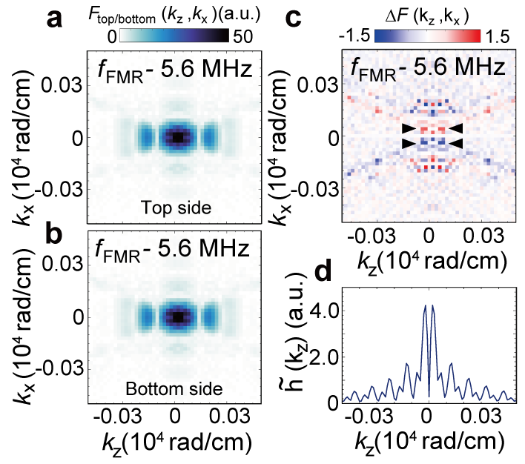
We therefore conclude that the modes contributing to the thermal squeezing are backward-volume–type magnons that propagate with a finite angle relative to the magnetization.
Fig.S9 a,b, Wave-vector-space spectra of magnons at a frequency 2.7 MHz below the FMR frequency for the top (a) and bottom (b) surfaces. c, Difference in the wave-vector-space spectral intensity between the top and bottom surfaces. The presence of obliquely propagating nonreciprocal modes is observed around the triangular eye-guide. d, Fourier intensity of AC magnetic field calculated from COMSOL simulation data plotted in VI. Effect of out-of-plane non-uniformity of AC magnetic field.

- Intuition behind thermal squeezing
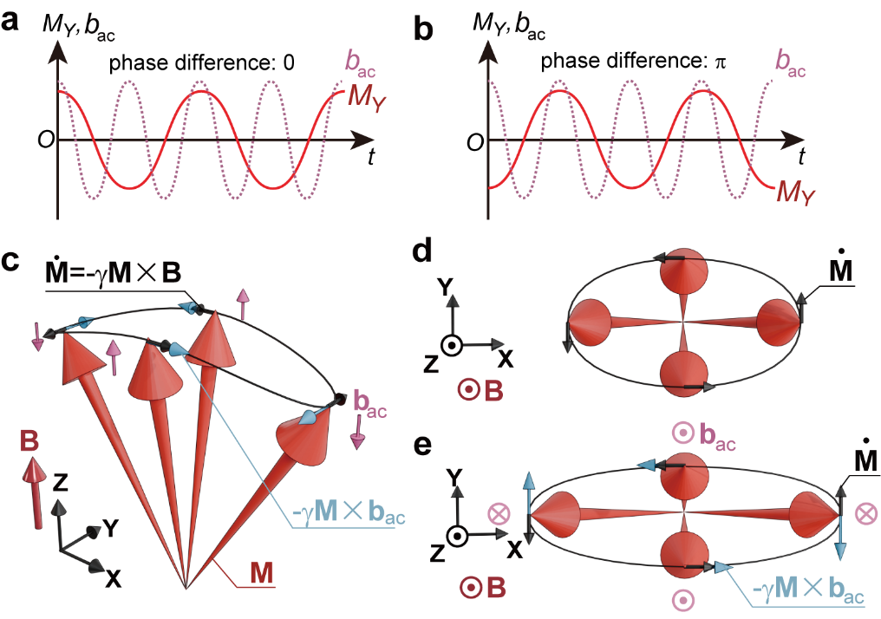
Thermal squeezing emerges under parametric excitation by the following mechanism. In thermal equilibrium, the magnetization in a thin magnetic film undergoes elliptical precession at its eigenfrequency—determined by the internal and external magnetic fields—while being randomly perturbed by thermal fluctuations. When an AC magnetic field with twice the frequency of the uniform precession mode is applied parallel to the external field, the magnetization experiences additional torques due to the AC field. Particularly at the phase matching condition of the parametric process with AC magnetic field phase in- or out-of-phase with $M_{Y}$, the torque due to AC magnetic field—given by the cross product of the magnetization and the AC magnetic field—accelerates the precession when the precession angle is small but motion is fast, while it decelerates the motion when the precession angle is large and magnetization moves slowly. This leads to suppression of fluctuations when the precession angle is large, thereby squeezing the thermal magnetization noise. At the same time, the torque due to AC magnetic field increases the ellipticity of the precession compared to that at thermal equilibrium.
Fig.S10 a,b, Schematics of magnetization precession component and AC magnetic field when phase-matching conditions are satisfied. c, Snapshots of the elliptical magnetization ($M$) precession under an AC magnetic field (b_{ac}, pink arrows) and its torque (light blue arrows) that enforce or suppress the torques by the dc magnetic field $-γM×B$ (black arrows). d, Top view of magnetization precession without AC magnetic field. e, Top view of magnetization precession under parametric pumping as in c. The torque arrow due to AC magnetic field (light blue) directs the same direction as ${\dot{M}}_{Y}$ when $M_{Y}$ takes maximum or minimum, while it directs the opposite when $M_{Y}=0$, leading to smaller noise along$M_{Y}$ and larger noise in $M_{X}$.

Thermal entanglement arises from the phase-sensitive nature of parametric excitation. When excited by microwave magnetic field at frequency $f_{p}$, the parametric process amplifies the magnetization dynamics when the longitudinal magnetization component oscillates at the same frequency. In the degenerate case the entire magnetization precesses at $f_{p}/2$, while in the non-degenerate case two modes at $f_{1}=f_{p}/2+Δ$ and $f_{2} =f_{p}/2-Δ$satisfy $f_{1}+f_{2}=f_{p}$. The two modes in the latter case may be spatially separated provided that the microwave field coherently overlaps with both (Fig.S11a). The magnetization in the overlap region then precesses at $(f_{1}+f_{2})/2$ with longitudinal component that oscillates at $f_{p}$ (Fig. S11b). In such case, the phase of the summed oscillation is determined from the mean value of the two phases $(ϕ_{1}+ϕ_{2})/2$. As in the degenerate case, the difference between this and the pumping phase $ϕ_{p}/2$ should be either 0 or $π$, leading to
$$ϕ_{1}+ϕ_{2}=ϕ_{p}$$
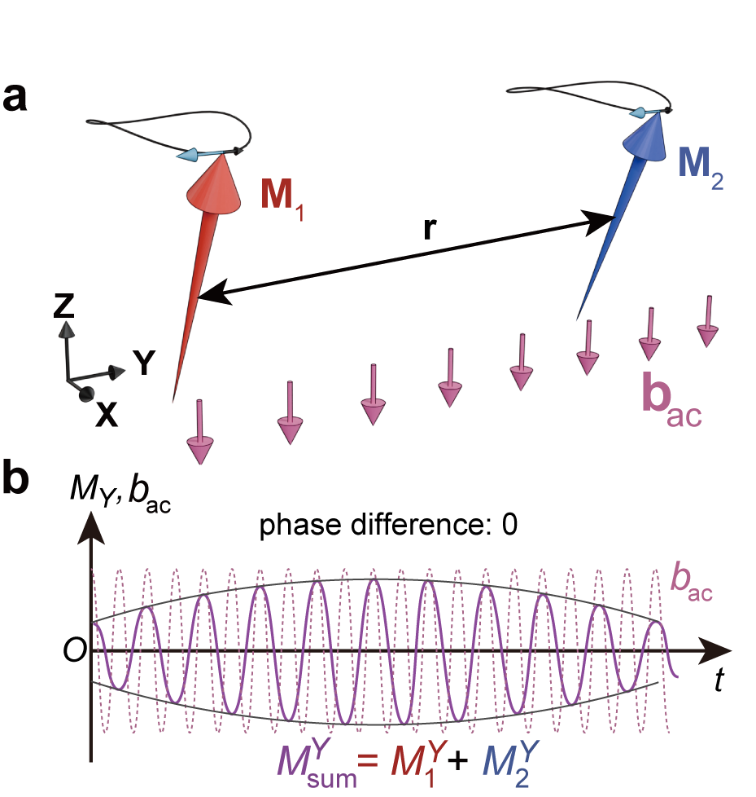
Hence, the magnons in the two modes oscillate with fixed relative phase, which generates the reported correlations, i.e., thermal two-mode squeezing. When we read out signals by means of a local oscillator that is in-phase with AC magnetic field, $ϕ_{p}$=0. $I_{Y1}$ and $I_{Y2}$ correlate positively since $I_{Y}$ is the cosine component with the same sign for $ϕ_{1}=-ϕ_{2}$, while $Q_{Y1}$ and $Q_{Y2}$ correlate negatively, as observed in Figs.3f,g.
Fig.S11 a, Magnetization precession vector components and AC magnetic field with matched phases. Spatially separated${\text{M}}_{1}=\text{M}(f_{1})$ and ${\text{M}}_{2}=\text{M}(f_{2})$ are parametrically excited by the same microwave magnetic field. b, Phase relation between summed precession component ${\text{M}}_{sum}^{Y}={\text{M}}_{1}^{Y}+{\text{M}}_{2}^{Y}$ and AC magnetic field. The envelop of the summed precession at $(f_{1}+f_{2})/2$ exhibits a beat at frequency $Δ$.

References
[1] T. Hioki, H. Shimizu, T. Makiuchi and E. Saitoh, Phys. Rev. B 104, L100419 (2021).
[2] X. Tao et al., Sci. Adv.4,eaat1670 (2018).
[3] V. Cherepanov, I. Kolokolov and V. L'vov, Phys. Rep., 229, 3, 81-144 (1993).
[4] L-M. Duan, G. Giedke, J. I. Cirac, and P. Zoller, Phys. Rev. Lett. 84, 2722 (2000).
[5] R. Simon, Phys. Rev. Lett, 84, 2726 (2000).
[6] S. Kotler et al., Science 372, 622-625 (2021).
[7] R. Sahu et al., Science 380, 718-721 (2023).
[8] H. Shimizu, T. Hioki, S. Takeda, and E. Saitoh, Phys. Rev. Lett. 135, 106701 (2025).
[9] A. Vansteenkiste, J. Leliaert, M. Dvornik, M. Helsen, F. Garcia-Sanchez, and B. V. Waeyeberge, AIP Advances 4, 107133 (2014).

