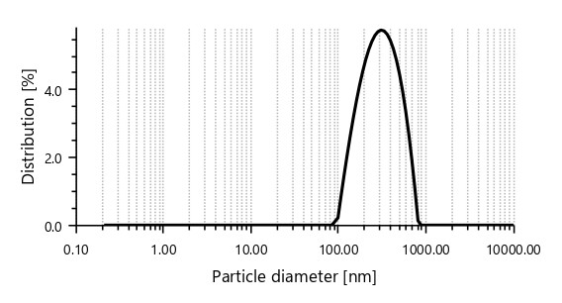
Fig. S1 Particle size distribution of tire wear nanoparticles (TWPs) analyzed by dynamic light scattering (DLS). The main peak at 327.2 nm (100% intensity) corresponds to the dominant nanoparticle fraction.

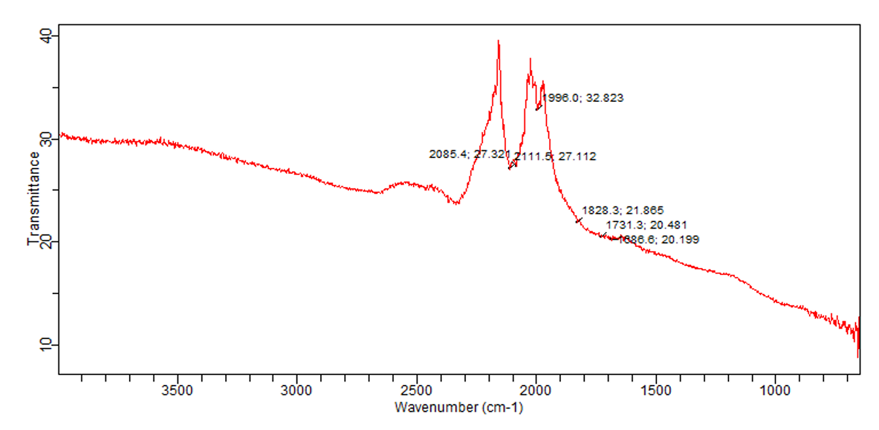

Fig. S2 Fourier Transform Infrared (FTIR) spectra of tire wear nanoparticles showing characteristic peaks of functional groups.

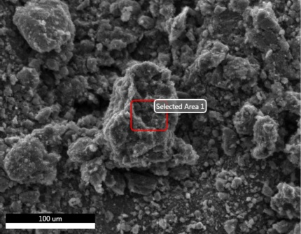
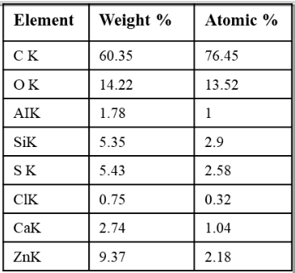
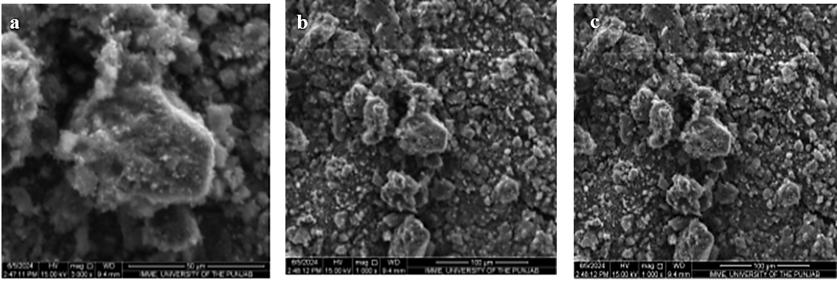
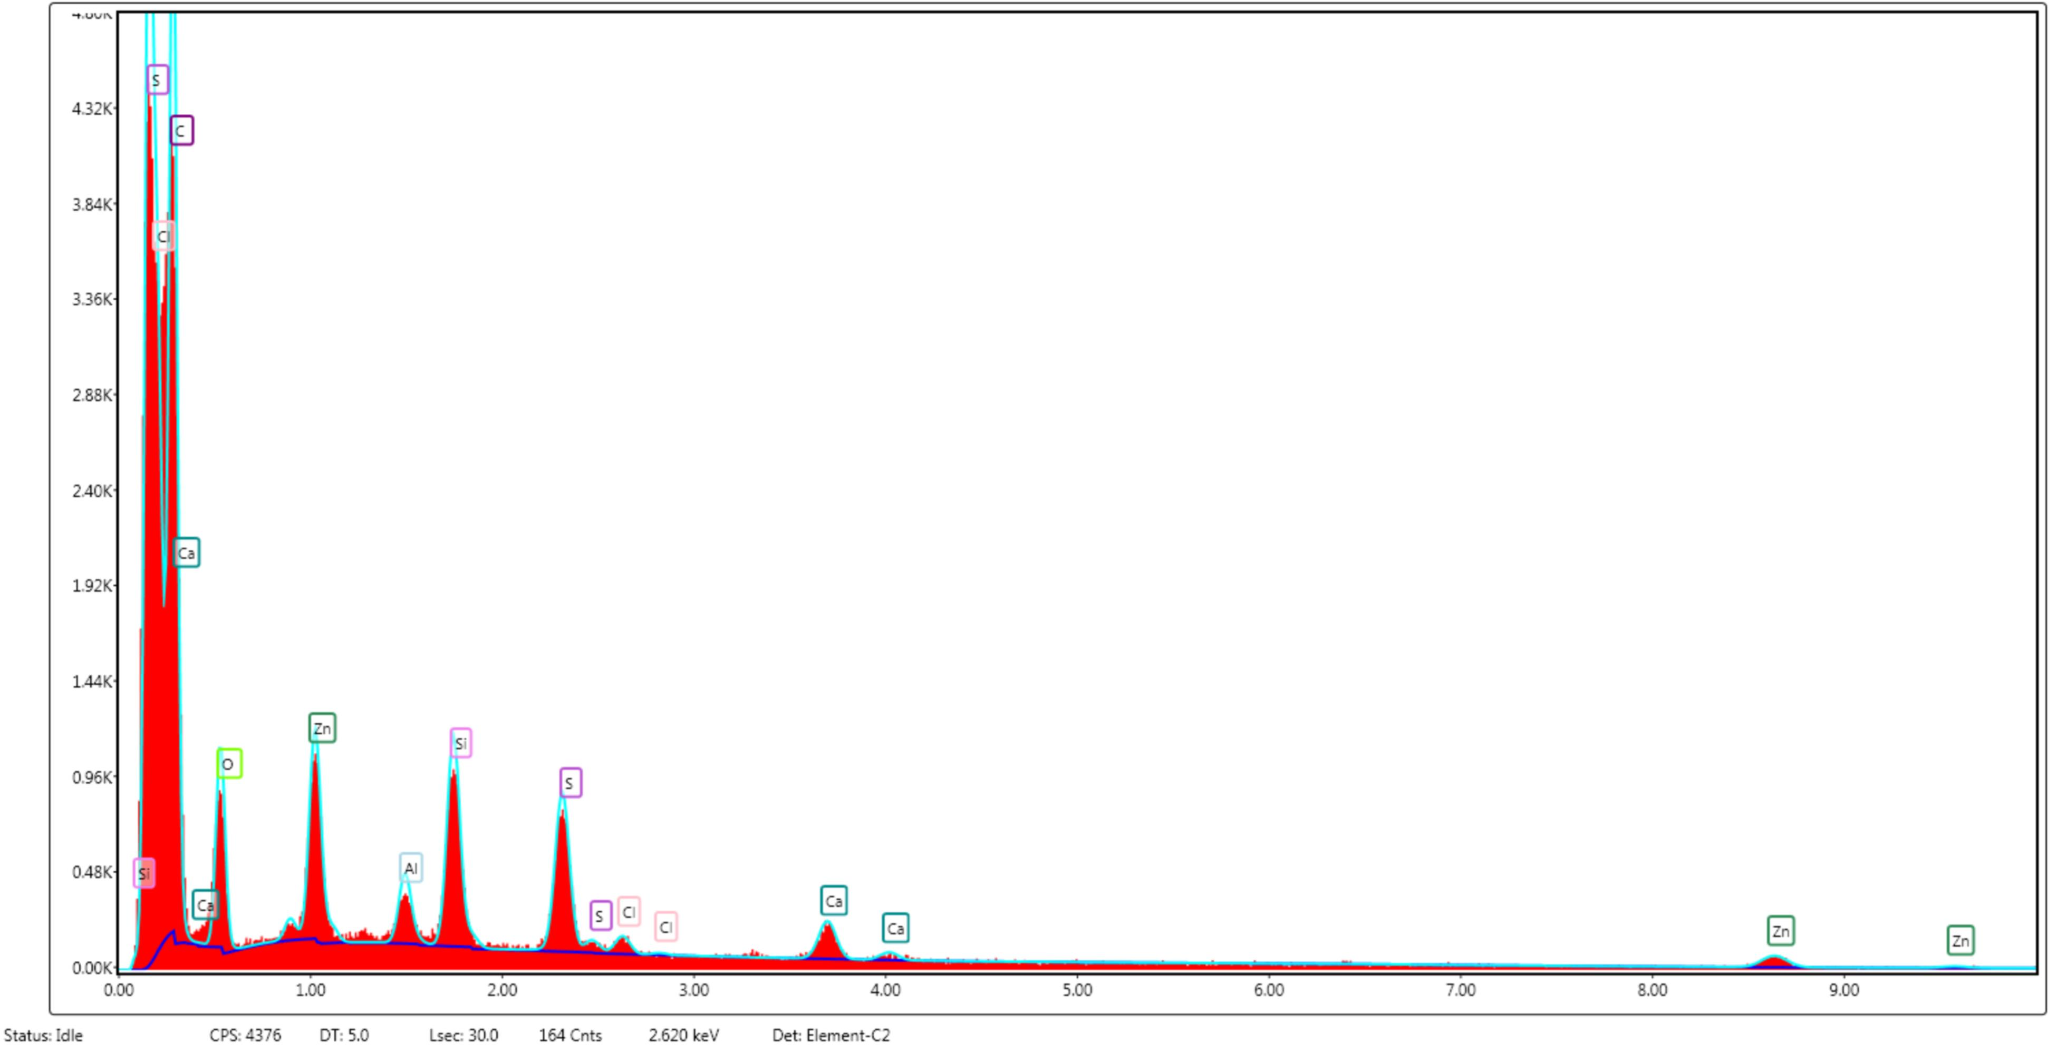
d

Fig. S3 (a-c) Scanning Electron Microscopy (SEM) images of tire wear nanoparticles at increasing magnifications (500x, 1000x, 4000x). (d) Energy-Dispersive X-ray (EDX) spectrum highlighting the elemental composition.

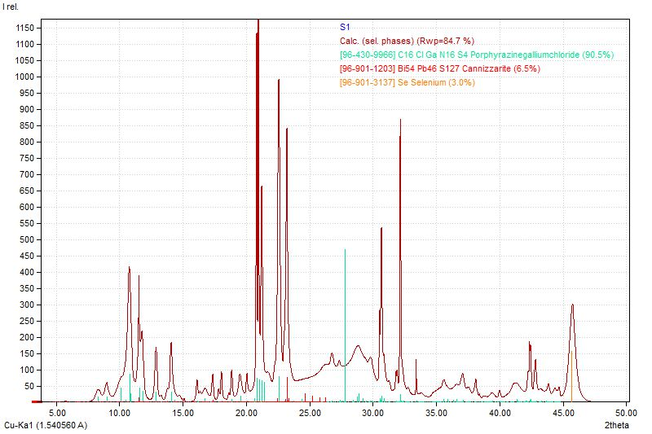

Fig. S4 X-ray diffraction (XRD) patterns of tire wear nanoparticles (TWPs) analyzed with Cu Kα radiation (λ = 1.5406 Å). The primary crystalline phase identified was porphyrazine gallium chloride (90.5%), with minor phases of cannizzarite (6.5%) and elemental selenium (3.0%), as indicated by the indexed diffraction peaks. The data highlights the complex mineral composition of TWPs, suggesting a mixture of organometallic and inorganic crystalline phases that may influence environmental persistence and bioavailability.

