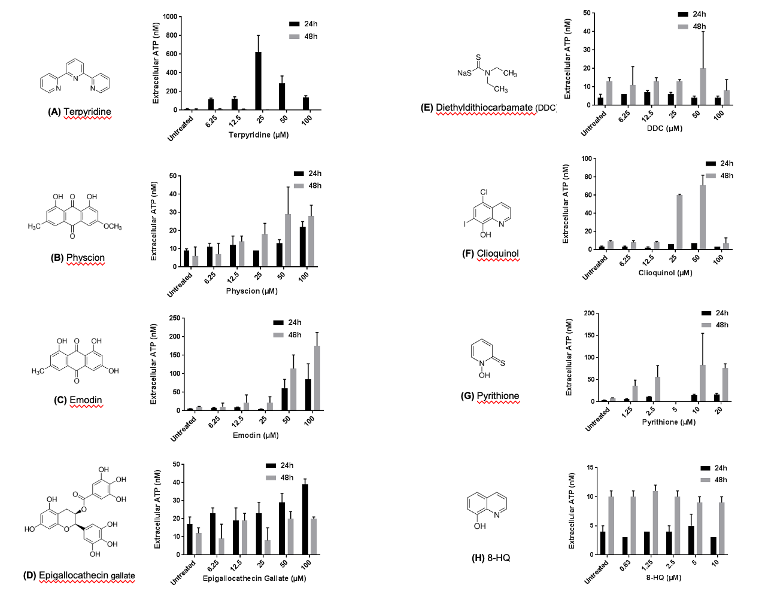
Supplementary Figure 1. Titration of tentative ICD inducers. Structures and ATP release profiles for eight compounds were assessed in vitro at 24 and 48 hours. Extracellular ATP concentrations were measured following treatment of CT26 cells with increasing doses of (A) Terpyridine, (B) Physcion, (C) Emodin, (D) Epigallocatechin gallate (EGCG), (E) Diethyldithiocarbamate (DDC), (F) Clioquinol, (G) Pyrithione, and (H) 8-hydroxyquinoline (8-HQ). Data represent mean ± SD of technical replicates from representative experiments.

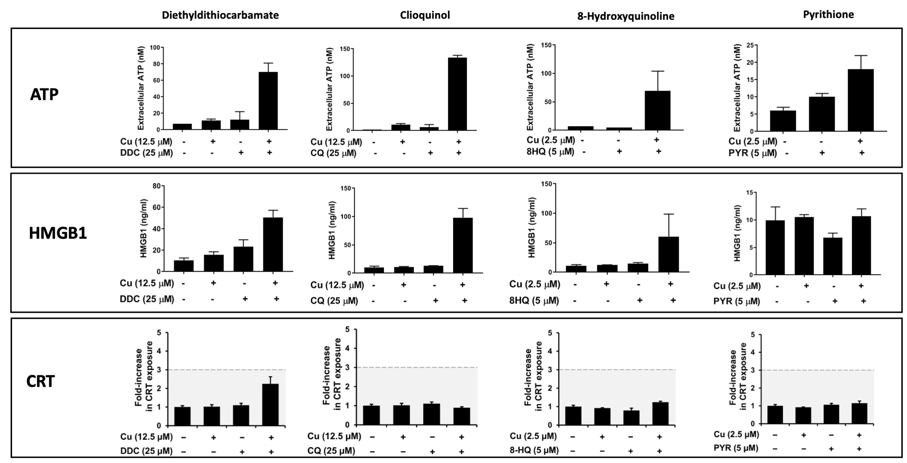
Supplementary Figure 2A. DAMP stimulation by classical copper ionophores.
Quantification of extracellular ATP, HMGB1 release, and cell surface calreticulin (CRT) in response to treatment with known copper ionophores (diethyldithiocarbamate, clioquinol, 8-hydroxyquinoline, and pyrithione) in the presence or absence of copper (Cu). These results are integrated into the DAMP heatmap in Figure 2.

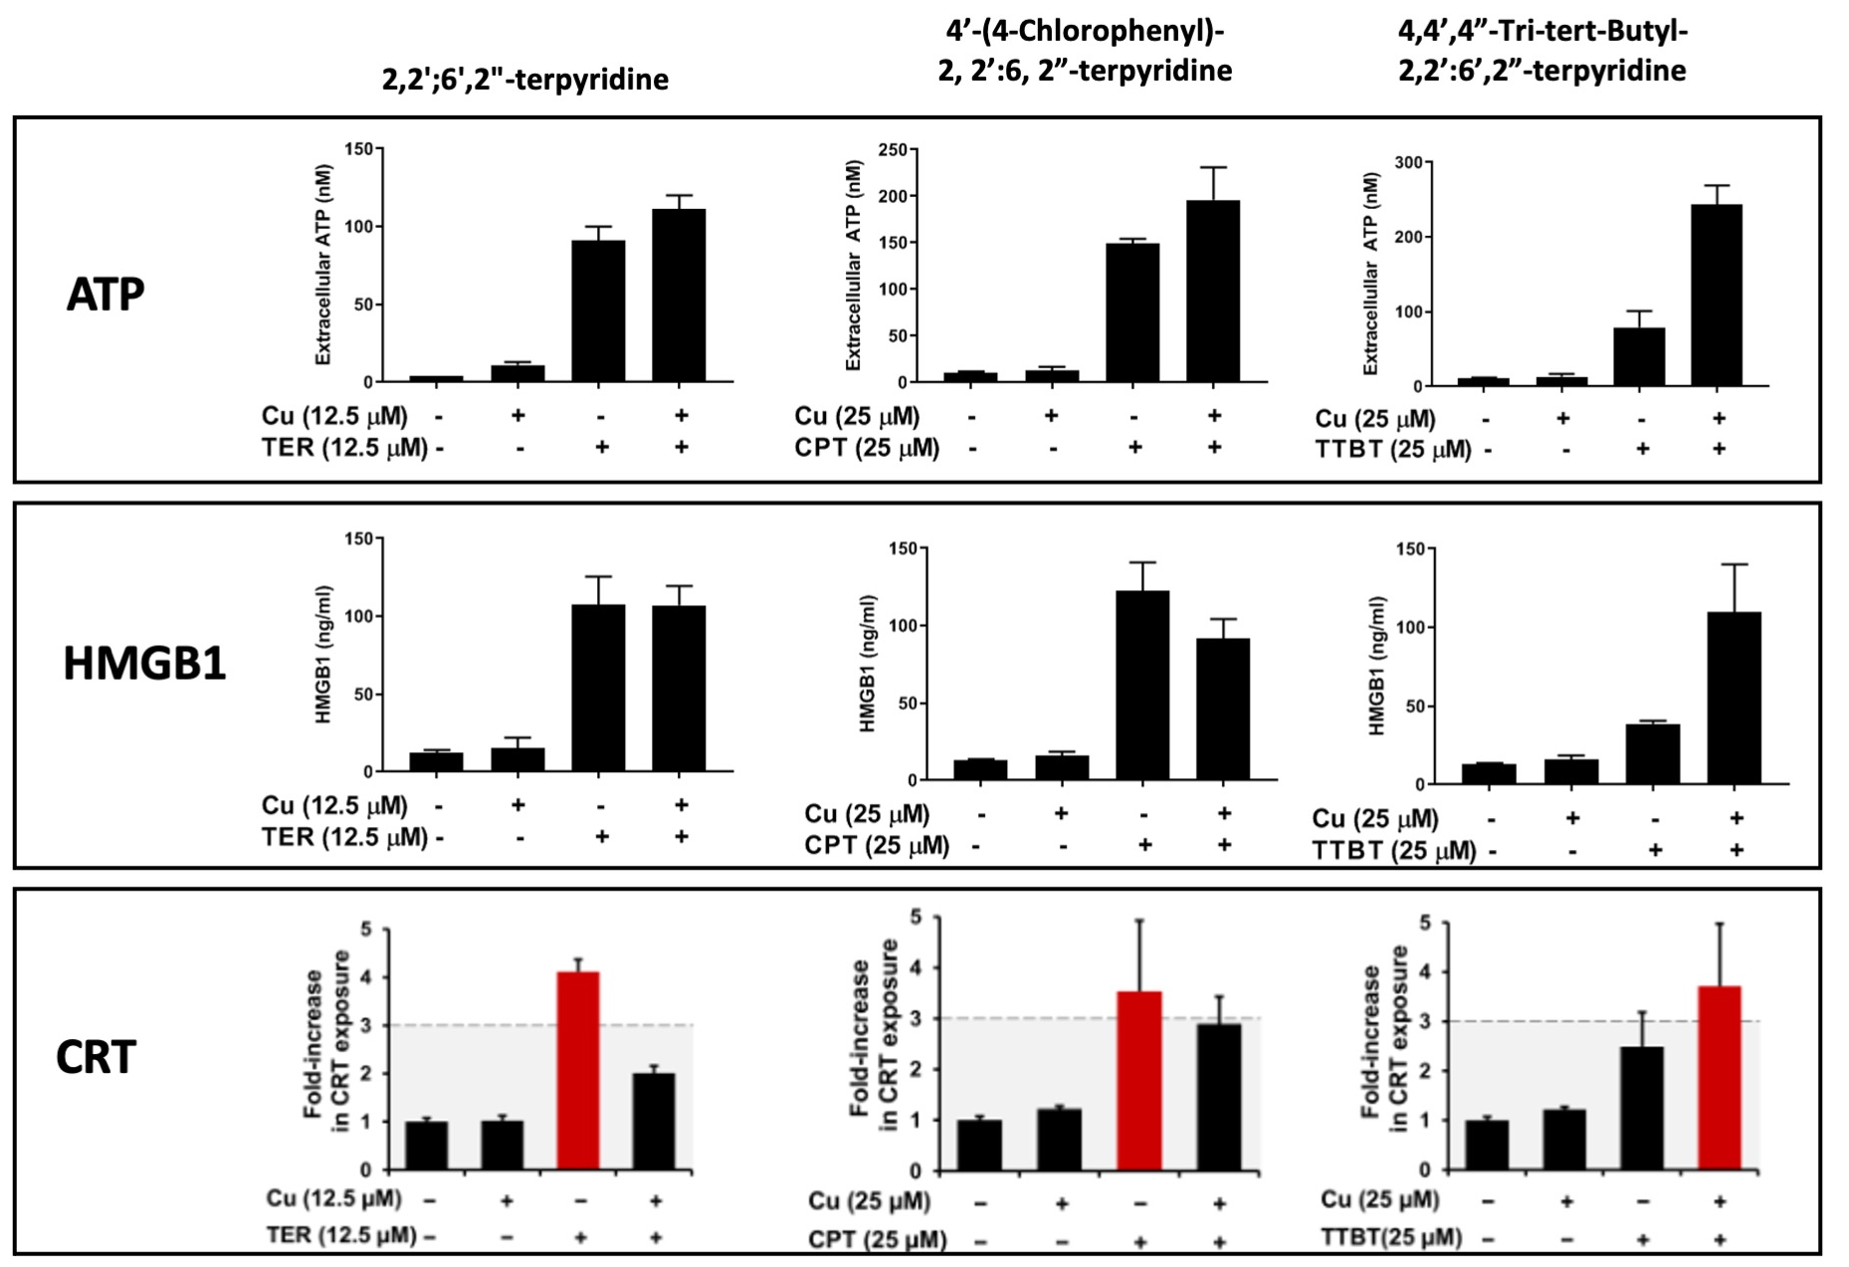
Supplementary Figure 2B. DAMP stimulation by terpyridine-based copper ionophores.
Quantification of extracellular ATP, HMGB1, and CRT in response to terpyridine and two structural analogs (CPT and TTBT) in the presence or absence of copper (Cu). These results are included in the DAMP heatmap in Figure 2.

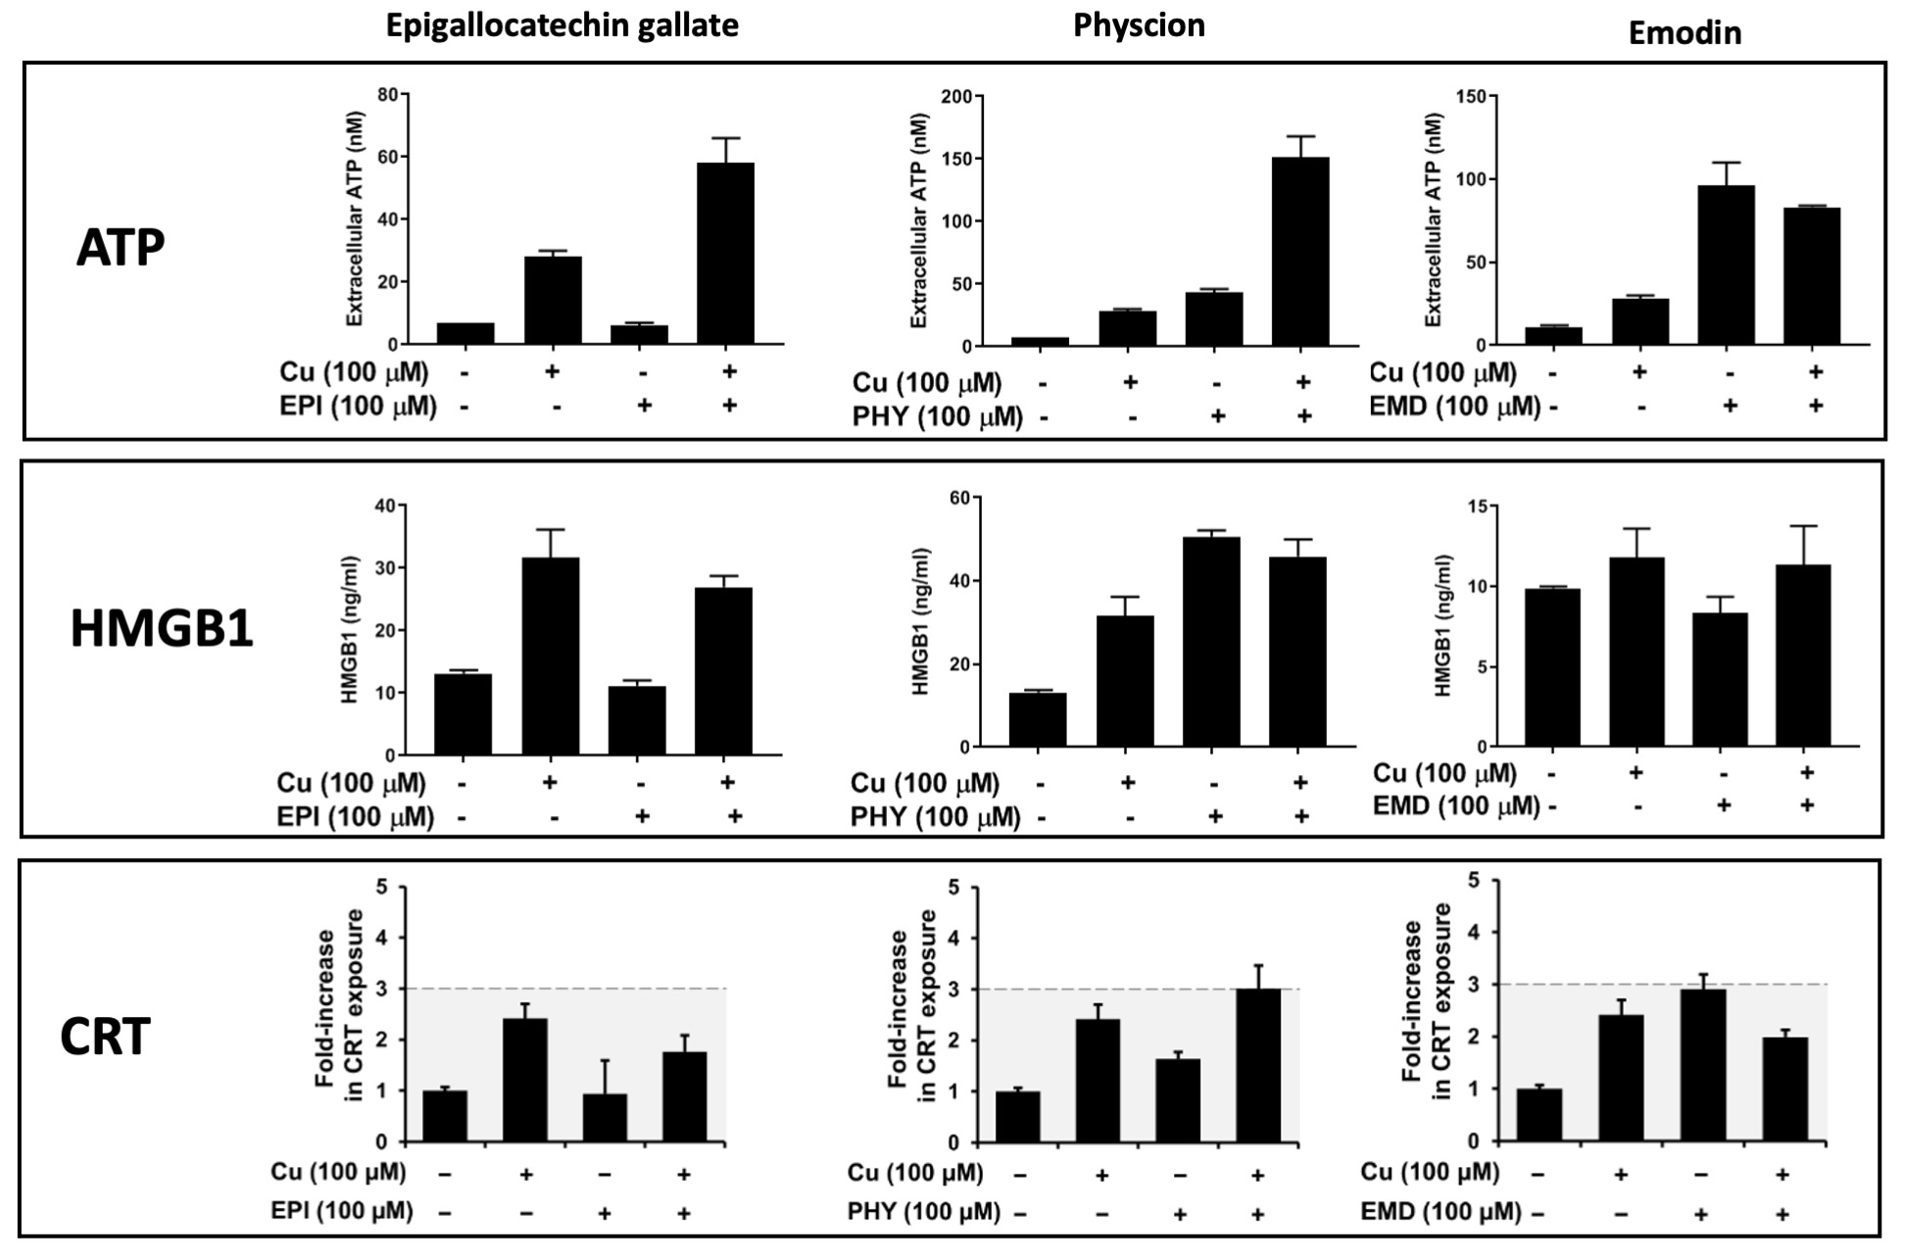
Supplementary Figure 2C. DAMP stimulation by polyphenol copper ionophores.
Extracellular ATP, HMGB1, and CRT levels following treatment with the polyphenols epigallocatechin gallate, physcion, and emodin, with or without Cu. These data are also integrated into the DAMP heatmap in Figure 2.

