SUPPLEMENT
Machine Learning-based Predictions of Healthcare Contacts Following Emergency Hospitalisation Using Electronic Health Records
Konstantin Georgiev¹, Dimitrios Doudesis¹, Joanne McPeake³, Nicholas L Mills¹, Susan D Shenkin², Jacques D Fleuriot⁴, Atul Anand¹

¹ Institute of Neuroscience and Cardiovascular Research, Queen's Medical Research Institute, University of Edinburgh, EH16 4TJ, UK
² Ageing and Health Research Group and Advanced Care Research Centre, Usher Institute, Edinburgh BioQuarter, University of Edinburgh, EH16 4UX, UK
³ The Healthcare Improvement Studies Institute, Department of Public Health and Primary Care, University of Cambridge, CB1 8RN, UK
⁴ Artificial Intelligence and its Applications Institute, School of Informatics, University of Edinburgh, EH8 9AB, UK

Correspondence to: Konstantin Georgiev, University of Edinburgh, Institute of Neuroscience and Cardiovascular Research, Chancellor’s Building, 49 Little France Crescent, Edinburgh, EH16 4SA, United Kingdom, Email: K.S.Georgiev@sms.ed.ac.uk

Table and Figure legends:
Supplementary Table 1. Feature definitions for prediction of hospital outcomes and healthcare need.
Supplementary Table 2. Summary of missingness across specialist health outcomes within the top-ranking predictors for in-hospital healthcare need.
Supplementary Table 3. Patient characteristics at baseline grouped by in-hospital death. Supplementary Table 4. Patient characteristics at baseline grouped by extended stay.
Supplementary Table 5. Patient characteristics at baseline grouped by home discharge. Supplementary Table 6. Patient characteristics at baseline grouped by admission to geriatric medicine services.
Supplementary Table 7. Summary of health provider contacts in hospital by each secondary outcome.
Supplementary Table 8. Performance comparison across different linear and non-linear regression estimators for predictions of healthcare need at point of ED attendance.
Supplementary Table 9. Summary of stratified training and validation set characteristics for healthcare need model at point of ED attendance.
Supplementary Table 10. Summary of fine-tuned model parameter across all outcomes at point of ED attendance.
Supplementary Table 11. Performance comparison using stratified 10-fold validation in predictions of healthcare need at point of ED attendance.

Supplementary Fig. 1. The annual distribution of secondary outcomes over the full data collection window.
Supplementary Fig. 2. Socio-demographic characteristics categorised by age and deprivation in patients with each secondary hospital outcome.
Supplementary Fig. 3. Box-plot showing the spread of log-transformed health contacts across patients with and without each secondary outcome.
Supplementary Fig. 4. Confusion Matrix summary showing the percentage of correctly captured and misclassified examples after quintile-based discretisation of healthcare need.
Supplementary Fig. 5. Performance trajectory curves for healthcare need prediction measured in all patients, stratified by age group.
Supplementary Fig. 6. Performance trajectory curves for healthcare need prediction measured in all patients, stratified by deprivation level.
Supplementary Fig. 7. Aalen-Johansen cumulative incidence function of in-hospital death stratified by healthcare frequency level, adjusted for non-home discharge outcomes.
Supplementary Fig. 8. Performance trajectory curves for healthcare need prediction measured in survivors to discharge.
Supplementary Fig. 9. Performance trajectory curves for healthcare need prediction measured in survivors to discharge, stratified by age group.
Supplementary Fig. 10. Performance trajectory curves for healthcare need prediction measured in survivors to discharge, stratified by deprivation level.

Supplementary Methods

Feature selection procedure summary
Correlated features were removed using Pearson’s correlation coefficient with a threshold $≥$0.9 determining significant linear relationships. We employed an additional cross-outcome feature selection procedure to filter meaningful predictor variables using the Boruta algorithm.¹ Boruta operates by generating random permutations called ‘shadow’ features, followed by training a Random Forest² model to highlight the original features that scored higher than the most prominent ‘shadow’ features. Those features will be retained and marked as ‘important’. This process was repeated for 100 iterations, generating one importance set per outcome, where the union across all sets was used as the target feature set for training. Features marked as ‘tentative’ (the Boruta algorithm did not converge to a decision) were included in the importance set if the detected ranking score was $≤$10 (among the top 10 tentative features for at least one outcome). The selected features used for model training are highlighted in Supplementary Table 1.

Overview of the Boruta algorithm for feature selection
The inner workings of Boruta are explained in Algorithm S1. The Boruta algorithm leverages the randomness introduced by shadow features and the ensemble nature of Random Forests to provide a robust feature selection method that considers feature interactions and non-linear relationships. For each feature $x_{i}$, the Random Forest algorithm calculates an importance score $I(x_{i})$ based on how much the feature contributes to the accuracy of predictions across all trees in the forest. The score itself is estimated via Mean Decrease Impurity (MDI, also known as Gini importance). In Boruta, this calculation is performed on both the original features and the ‘shadow’ features. Shadow features $x_{i}^{'}$ are artificially created reference points generated by simply randomly shuffling the values of each original feature in the dataset. In each iteration, a feature is considered to have a "hit" if its importance is higher than the maximum importance of all shadow features. Then, it uses a set of binomial tests to assess if the score remains consistently high or if it was elevated due to random chance.^{3,4} The maximum median importance of shadow features serves as a dynamic threshold for feature selection, which helps mitigate biases from correlated predictor variables. The final feature set contains all input healthcare variables labelled as ‘important’ to the target outcome after convergence (as shown in Supplementary Table 1).
Algorithm S1 Overview of the Boruta algorithm implementation.
Inputs: Original feature set: $X = \{x_{1}, x_{2}, …, x_{n}\}$;
Set of importance labels per feature: $L=\left\{l_{1},l_{2},…, l_{n}\right\};$
Number of binomial trials: $k$; Number of algorithm iterations: $t$;
Probability of feature being ranked as ‘important’ by chance (e.g. 0.5): $P=\left\{p_{1},p_{2},…, p_{n}\right\};$
- Create a ‘shadow’ feature set $X^{'}=\{x_{1}^{'}, x_{2}^{'},…, x_{n}^{'}\}$ by randomly shuffling the values of each feature in$X$.
- Form a combined dataset $Z = \{x_{1}, x_{2}, …, x_{n}, x_{1}^{'}, x_{2}^{'},…, x_{n}^{'}\}$ with the true and ‘shadow’ observations.
- Train a Random Forest model on $Z$ to obtain feature importance scores:
$I(Z) = \{I(x_{1}),I(x_{2}), …, I(x_{n}), I(x_{1}^{'}),I(x_{2}^{'}),…, I(x_{n}^{'})\}$;
- Calculate the maximum importance among shadow features:
$I_{sm}(Z) = max(\left\{I\left(x_{1}^{'}\right),I\left(x_{2}^{'}\right),…, I\left(x_{n}^{'}\right)\right\})$;
- Compare feature importances:
For each original feature $x_{i}$:
If $I\left(x_{i}\right)>I_{sm}(Z)$: Set $l_{i}$ as ‘important’;
If $I\left(x_{i}\right)<I_{sm}(Z)$: Set $l_{i}$ as ‘unimportant’;
- Statistical validation:
For each original feature $x_{i}$:
Estimate the set of binomial distributions: $p_{i}\left(x_{i}\right)=B(k,p)$;
- Feature Decision:
For each original feature $x_{i}$ and its distribution $p_{i}(x_{i})$:
If $p_{i}\left(x_{i}\right)<α$ (significance level, e.g. 0.05):
If $median\left(I\left(x_{i}\right)\right)>median(I_{sm}\left(Z\right))$: Keep $l_{i}$ as ‘important’;
If $median\left(I\left(x_{i}\right)\right)<median(I_{sm}\left(Z\right))$: Set $l_{i}$ as ‘unimportant’;
Else: Mark $l_{i}$ as ‘tentative’;
- Repeat steps 2-7 for $t$ iterations or until all features are confirmed or rejected.
- Set final feature set: $F=\{x_{i}|l_{i}='important^{'}\}$;
Outputs: Condensed feature set: $F = \{f_{1}, f_{2}, …, f_{n}\}$;

Modelling setup and training strategy
All XGBoost models were trained over a maximum of 20,000 rounds with up to 100 early stopping rounds (patience threshold for the target loss function indicating when the model should interrupt its training). Hyperparameter tuning was conducted using a grid search strategy over an exponentially spaced grid for the learning rate and a linear grid for the maximum tree depth and any additional regularisation parameters. All classification estimators were trained with an additional prevalence weighting parameter (scale_pos_weight) based on the absolute ratio of patients with the outcome. The objective for optimisation was minimising the logistic loss, due to its convex nature and subsequent ability to produce well-calibrated probabilities in the presence of imbalanced data. The regression estimator used an objective function for minimising the pseudo-huber error, which balanced the properties of MAE and RMSE. Compared to the standard Huber loss, this modified loss provides a smoother approximation in gradient-based functions, making it less sensitive to the outliers present in the health contacts variable.⁵
The preprocessed data for modelling included a stratified training set of 68,769 and hold-out validation set of 29,743 samples at the point of ED attendance (median age 73 [62, 81], 51% women and 16% at highest deprivation level in both sets). Using this model setup, the XGBoost regressor consistently outperformed other fine-tuned linear and non-linear estimators (see Supplementary Table 8). The training and validation sets were balanced by age, sex, SIMD, secondary outcome prevalence, total healthcare contacts, rehabilitation-specific contacts and number of healthcare disciplines involved during hospital stay (see Supplementary Table 9). The optimal model hyperparameters, identified using grid search are listed in Supplementary Table 10. For binary classification, a positive class weight was applied to account for class imbalance in rarer outcomes (see Supplementary Table 10).

Supplementary Tables and Figures

Supplementary Table 1. Feature definitions for prediction of hospital outcomes and healthcare need. Features were excluded from training after correlation either due to having strong linear correlation with another variable (PCC$>$0.9) or during cross-outcome feature selection using the Boruta algorithm, after being rejected as important across all outcomes. SIMD – Scottish Index for Multiple Deprivation, 4AT – 4 A’s Test for delirium screening, MUST – Malnutrition Universal Screening Tool for identifying adults at risk of undernutrition, COPD – Chronic Obstructive Pulmonary Disease. PCC – Pearson’s corrleation coefficient. HA – point of hospital admission; 24h PA, 48h PA, 72h PA – 24, 48 and 72 hours post-admission respectively.
Group | Data  type | Temporal sampling criteria | Variable thresholds | Selected for trainng  (Y/N) | Prediction timepoint
Demographics
Age | Continuous | At start of ED episode | / | Y | All models
Sex | Categorical | At start of ED episode | 1 [Female],  0 [Male] | Y | All models
SIMD (Quntiles) | Ordinal | At start of ED episode | / | Y | All models
ED information
Mode of arrival:  NHS Lothian Bus  Emergency Ambulance  Public Transport  Private Transport  GP Ambulance  Walked  Unknown  Other | Categorical | At start of ED episode | / | Y | All models
Triage code | Ordinal | At start of admission | / | Y | HA,  24h PA,  48h PA,  72h PA
Health questionnaires
4AT Score | Continuous | Within 24hrs of admission | / | Y | 24h PA,  48h PA,  72h PA
MUST Score | Continuous | Within 24hrs of admission | / | Y | 24h PA,  48h PA,  72h PA
Waterlow Score | Continuous | Within 24hrs of admission | / | Y | 24h PA,  48h PA,  72h PA
Bowel movement  Urinary catheterisation  Urinary incontinence  Dysuria  Movement >6 times per day  Nocturia >2 times per night  Faeces incontinence  Constipation  Diarrhoea  Blood in stool  Bowel movement medication | Categorical | Within 24hrs of admission | / | Y | 24h PA,  48h PA,  72h PA
Falls assessment  Clinical risk of falls  Fall within 6 months of admission | Categorical | Within 24hrs of admission | / | Y | 24h PA,  48h PA,  72h PA
Nutritional assessment  Swallowing difficulties  Food allergies | Categorical | Within 24hrs of admission | / | Y | 24h PA,  48h PA,  72h PA
MRSA-related  Infection prevention measures  Transfer with norovirus  Respiratory issues  Rash, fever or flu  Contact with infectious disease | Categorical | Within 24hrs of admission | / | Y | 24h PA,  48h PA,  72h PA
Rationale for use of bedrails  Nursing fall risk assessment  At risk of bed-related fall | Categorical | Within 24hrs of admission | / | Y | 24h PA,  48h PA,  72h PA
Mobility  Walking assistance  Bathing assistance  Toileting assistance  Bed rolling assistance  Moving up bed assistance  Out-of-bed assistance  Getting in bed assistance  Sit-stand-sit assistance  Lateral movement assistance  Floor-up assistance | Categorical | Within 24hrs of admission | Classified as independent, requiring assistance or not applicable due to bed rest | Y | 24h PA,  48h PA,  72h PA
Lab tests
eGFR (ml/min/1.73m²),  Potassium (mEq/L),  Creatinine (mg/dL),  Urea (mg/dL),  Sodium (mEq/L),  Calcium (mmol/L),  TCO2 (pH),  Chloride (mmol/L),  Lymphocyte count (x10⁹/L),  MCH (pg/cell),  Basophil count (x10⁹/L),  Haematocrit (L/L),  Monocyte count (x10⁹/L),  Eosinophil count (x10⁹/L),  Neutrophil count (x10⁹/L),  Red cell count (x10⁹/L),  MCV (μm3),  Platelet count (x10⁹/L),  White cell count (x10⁹/L),  Haemoglobin (g/dl),  MCHC (g/dl),  C-reactive protein (mg/L),  Lactate (mmol/L),  ESR (mm/hr),  Ferritin (μg/L),  Bilirubin (μmol/L),  Albumin (g/dL),  Alkaline Phoshpatase (U/L),  ALT (IU/L),  GGT (IU/L),  AST (IU/L),  Glucose (mmol/L),  HbA1c (IFCC, mmol/mol),  Creatine Kinase (IU/L),  NT-proBNP (pg/mL),  Procalcitonin (ng/mL),  HS troponin I (ng/L),  HS troponin T (ng/L) | Continuous (test value),  Categorical (abnormal-low, abnormal-high),  Temporal (mean and std within previous 365 days) | Any point prior to prediction stage | 0 [normal],  1 [above or below reference range] | Y  N  Y  Y  Y  Y  Y  N  Y  N  Y  Y  Y  Y  Y  Y  Y  Y  Y  Y  N  Y  Y  Y  Y  Y  Y  Y  Y  Y  Y  N  Y  Y  N  N  Y  Y | All models
Prescriptions
Bone metabolism related,  Antiplatelet drugs,  Diuretics,  Anti-hypertension,  Nitrates and CCBs,  Nausea and vertigo drugs,  Beta blockers,  Genito-urinary drugs,  Anticoagulants and protamine,  Parkinsonism-related,  Lipid regulators,  Anti-psychotics,  Anti-dementia drugs,  Antidepressants,  Total unique drug categories, | Continuous (# unique categories),  Continuous (# prescribed by drug group) | Any point prior to prediction stage | / | Y,  Y,  Y,  Y,  Y,  Y,  Y,  N,  Y,  Y,  Y,  Y,  Y,  Y,  Y | All models
Outpatient/inpatient attendances (by specialty)
General Medicine,  Cardiology,  Endocrinology,  Diabetes,  Gastroenterology,  Geriatric Medicine,  Medical Oncology,  Renal Medicine,  Neurology,  Palliative Medicine, Rehabilitation Medicine, Respiratory Medicine, Rheumatology,  General Surgery,  Non-vascular Surgery,  Vascular Surgery,  Anaesthetics,  Cardiac Surgery,  Thoracic Surgery,  Ear/nose/throat,  Neurosurgery,  Opthalmology,  Trauma/Orthopaedic Surgery,  Urology,  Oral Surgery,  Oral Medicine,  Clinical Oncology,  Haematology,  Infectious Diseases,  Dermatology,  Maxifollical Surgery,  Plastic Surgery,  Gynaecology,  General Psychiatry,  Psychiatry of Old Age,  Learning Disability,  Physiotherapy  Podiatry,  Dietetics,  Orthotics,  # attendances in last 365 days,  Days since last attendance | Continuous (# total attendances),  Continuous (# attendances by specialty),  Continuous (# failed attendances by specialty) | Any point prior to ED episode | / | Y  Y  Y  Y  Y  Y  Y  Y  Y  N  Y  Y  Y  Y  Y  N  Y  Y  N  Y  N  Y  Y  Y  N  Y  Y  N  N  N  N  Y  Y  Y  Y  N  Y  N  N  N  Y  Y | All models
Comorbidity history (SMR/GP READ coded)
Historical or Active cancer,  Liver disease,  Atrial fibrillation,  Chronic renal disease,  Obesity,  Hip fracture,  Bronchiectasis,  Diabetes,  COPD,  Chronic psychiatric disorder,  Progressive neurological disease†,  Inflammatory bowel disease,  Osteoporosis,  Aortic aneurysm,  Stroke,  Ischaemic heart disease,  Epilepsy,  Hypertension,  Spinal stenosis,  Heart failure,  Alcohol/substance misuse,  Arthritis/other arthropathy,  Asthma,  Depression,  Peripheral vascular disease,  Pulmonary fibrosis,  # long-term conditions,  # physical long-term conditions,  # mental long-term conditions  Physical-mental multimorbidity | Categorical ( Presence/absence of previous diagnosis),  Temporal (days since last diagnosis),  Continuous (unique physical/mental conditions) | Any point prior to ED episode | / | Y  Y  Y  Y  Y  Y  N  Y  Y  Y  Y  Y  Y  N  Y  Y  Y  Y  N  Y  Y  Y  Y  Y  Y  Y  Y  Y  Y  Y | All models
†Condition group includes diagnoses of dementia.
Supplementary Table 2. Summary of missingness across specialist health outcomes within the top-ranking predictors of in-hospital healthcare need. Values are displayed total and % missing measurements per patient across the study population.

 | All  (n=98,242) | Outcome
 | All  (n=98,242) | Geriatric Medicine services  (n=13,301) | Received rehabilitation*  (n=40,946)
SIMD | 970  (1%) | 61  (1%) | 294  (1%)
ED variables
Mode of arrival | 6,469  (7%) | 295  (2%) | 1,551  (4%)
Triage code | 5,242  (5%) | 216  (2%) | 1,208  (3%)
Nursing assessments
4AT Score | 43,633  (44%) | 5,160  (39%) | 17,098  (42%)
Waterlow Score | 20,314  (21%) | 901  (7%) | 5,086  (12%)
Bathing dependence | 54,885  (56%) | 5,705  (43%) | 19,736  (48%)
Floor-up moving assistance | 54,436  (55%) | 5,509  (41%) | 19,282  (47%)
Lab test values
Albumin (g/L) | 26,706  (27%) | 3,124  (24%) | 11,041  (27%)
Bilirubin (umol/L) | 7,821  (8%) | 1,389  (10%) | 4,276  (10%)
Urea (mmol/L) | 9,169  (9%) | 1,534  (12%) | 4,779  (12%)
Lymphocyte count | 7,430  (7%) | 1,363  (10%) | 4,185  (10%)
Basophil count | 7,632  (8%) | 1,416  (11%) | 4,305  (11%)
Eosinophil count | 8,628  (9%) | 1,648  (12%) | 4,833  (12%)
Neutrophil count | 7,429  (7%) | 1,362  (10%) | 4,184  (10%)
Erythrocyte Sedimentation Rate (mm/hr) | 59,455  (61%) | 7,816  (59%) | 23,695  (58%)
Alkaline Phosphatase (U/L) | 7,853  (8%) | 1,390  (11%) | 4,288  (11%)
Alanine Transaminase (U/L) | 7,853  (8%) | 1,394  (11%) | 4,290  (11%)
HS Troponin T (ng/L) | 92,508  (94%) | 13,007  (98%) | 39,569  (97%)
HS Troponin I (ng/L) | 76,455  (78%) | 11,723  (88%) | 34,986  (85%)
Creatine Kinase (U/L) | 84,524  (86%) | 10,006  (75%) | 33,392  (82%)
TCO2 (mmol/L) | 15,656  (16%) | 2,261  (17%) | 7,039  (17%)
C-reactive Protein (mg/L) | 18,697  (19%) | 2,410  (18%) | 8,429  (21%)
Gamma-Glutamyl Transferase (U/L) | 26,532  (27%) | 3,738  (28%) | 11,773  (29%)
Sodium (mmol/L) | 7,222  (7%) | 1,330  (10%) | 4,093  (10%)
*Defined as physiotherapy, occupational therapy or speech and language therapy.
SIMD – Scottish Index for Multiple Deprivation.

Supplementary Table 3. Patient characteristics at baseline grouped by in-hospital death. Values are displayed in patient counts (%) unless stated otherwise. Statistical testing: One-way analysis of variance (ANOVA) test in numerical data, Chi-squared test in categorical data. SIMD – Scottish Index for Multiple Deprivation, 4AT – 4 A’s Test for delirium screening, MUST – Malnutrition Universal Screening Tool for identifying adults at risk of undernutrition.
 | All  (n=98,242) | In-hospital death |  | p
 | All  (n=98,242) | Y  (n=6,093) | N  (n=92,149) | p
Age (mean, SD) | 72$±$12 | 78$±$11 | 71$±$12 | <0.001
Women | 50,214 (51%) | 3,017  (49%) | 47,197  (51%) | 0.01
SIMD in quintiles |  |  |  | 0.16
1 (most deprived) | 15,735 (16%) | 924  (15%) | 14,811  (16%)
2-4 | 57,608 (59%) | 3,597  (59%) | 54,011  (59%)
5 (least deprived) | 24,899 (25%) | 1,572  (26%) | 23,327  (25%)
Medical condition history
# Long-term conditions (median, IQR) | 3  [2, 5] | 4  [3, 6] | 3  [2, 5] | <0.001
Simple Multimorbidity ($≥$2 conditions) | 33,534  (34%) | 1,830  (30%) | 31,704  (34%) | <0.001
High-count Multimorbidity ($≥$4 conditions) | 48,655  (50%) | 3,707  (61%) | 44,948  (49%) | <0.001
Physical-mental Multimorbidity ($≥$1 physical and $≥$1 mental condition) | 36,096  (37%) | 2,016  (33%) | 34,080  (37%) | <0.001
Health questionnaire results
4AT Score ($≥$4, at risk) | 6,540  (7%) | 1,519  (25%) | 5,021  (5%) | <0.001
MUST Score ($≥$2, at high risk) | 5,911  (6%) | 1,150  (19%) | 4,761  (5%) | <0.001
Waterlow score ($≥$10, at risk) | 17,023  (17%) | 1,477  (24%) | 15,546  (17%) | <0.001
Fall event within 6 months of admission | 16,043  (16%) | 1,481  (24%) | 14,562  (16%) | <0.001
Walking dependence | 17,074  (21%) | 1,121  (18%) | 15,953  (17%) | <0.001
Bathing dependence | 20,160  (21%) | 2,086  (34%) | 18,074  (20%) | <0.001
Swallowing difficulties | 1,719  (2%) | 418  (7%) | 1,301  (1%) | <0.001

Supplementary Table 4. Patient characteristics at baseline grouped by extended stay. Values are displayed in patient counts (%) unless stated otherwise. Statistical testing: One-way analysis of variance (ANOVA) test in numerical data, Chi-squared test in categorical data. SIMD – Scottish Index for Multiple Deprivation, 4AT – 4 A’s Test for delirium screening, MUST – Malnutrition Universal Screening Tool for identifying adults at risk of undernutrition.
 | All  (n=98,242) | Extended stay ($≥$14 days) |  | p
 | All  (n=98,242) | Y  (n=19,040) | N  (n=79,202) | p
Age (mean, SD) | 72$±$12 | 78$±$11 | 70$±$12 | <0.001
Women | 50,214 (51%) | 10,624  (56%) | 39,590  (50%) | <0.001
SIMD in quintiles |  |  |  | <0.001
1 (most deprived) | 15,735 (16%) | 2,802  (15%) | 12,933  (16%)
2-4 | 57,608 (59%) | 10,931  (57%) | 46,677  (59%)
5 (least deprived) | 24,899 (25%) | 5,307  (28%) | 19,592  (25%)
Medical condition history
# Long-term conditions (median, IQR) | 3  [2, 5] | 4  [3, 6] | 3  [2, 5] | <0.001
Simple Multimorbidity ($≥$2 conditions) | 33,534  (34%) | 5,997  (32%) | 27,537  (35%) | <0.001
High-count Multimorbidity ($≥$4 conditions) | 48,655  (50%) | 11,056  (58%) | 37,599  (48%) | <0.001
Physical-mental Multimorbidity ($≥$1 physical and $≥$1 mental condition) | 36,096  (37%) | 6,709  (35%) | 29,387  (37%) | <0.001
Health questionnaire results
4AT Score ($≥$4, at risk) | 6,540  (7%) | 2,629  (14%) | 3,911  (5%) | <0.001
MUST Score ($≥$2, at high risk) | 5,911  (6%) | 2,635  (14%) | 3,276  (4%) | <0.001
Waterlow score ($≥$10, at risk) | 17,023  (17%) | 5,961  (31%) | 11,062  (14%) | <0.001
Fall event within 6 months of admission | 16,043  (16%) | 5,990  (31%) | 10,053  (13%) | <0.001
Walking dependence | 17,074  (21%) | 5,327  (28%) | 11,747  (15%) | <0.001
Bathing dependence | 20,160  (21%) | 7,867  (41%) | 12,293  (16%) | <0.001
Swallowing difficulties | 1,719  (2%) | 957  (5%) | 762  (1%) | <0.001

Supplementary Table 5. Patient characteristics at baseline grouped by home discharge. Values are displayed in patient counts (%) unless stated otherwise. Statistical testing: One-way analysis of variance (ANOVA) test in numerical data, Chi-squared test in categorical data. SIMD – Scottish Index for Multiple Deprivation, 4AT – 4 A’s Test for delirium screening, MUST – Malnutrition Universal Screening Tool for identifying adults at risk of undernutrition.
 | All  (n=98,242) | Home discharge |  | p
 | All  (n=98,242) | Y  (n=85,904) | N  (n=12,338) | p
Age (mean, SD) | 72$±$12 | 71$±$12 | 78$±$11 | <0.001
Women | 50,214 (51%) | 43,752  (51%) | 6,462  (52%) | 0.03
SIMD in quintiles |  |  |  | <0.001
1 (most deprived) | 15,735 (16%) | 13,910  (16%) | 1,825  (15%)
2-4 | 57,608 (59%) | 50,446  (59%) | 7,162  (58%)
5 (least deprived) | 24,899 (25%) | 21,548  (25%) | 3,351  (27%)
Medical condition history
# Long-term conditions (median, IQR) | 3  [2, 5] | 4  [3, 6] | 3  [2, 5] | <0.001
Simple Multimorbidity ($≥$2 conditions) | 33,534  (34%) | 3,798  (31%) | 29,736  (35%) | <0.001
High-count Multimorbidity ($≥$4 conditions) | 48,655  (50%) | 7,275  (59%) | 41,380  (48%) | <0.001
Physical-mental Multimorbidity ($≥$1 physical and $≥$1 mental condition) | 36,096  (37%) | 4,306  (35%) | 31,790  (37%) | <0.001
Health questionnaire results
4AT Score ($≥$4, at risk) | 6,540  (7%) | 3,563  (4%) | 2,977  (24%) | <0.001
MUST Score ($≥$2, at high risk) | 5,911  (6%) | 3,953  (5%) | 1,958  (16%) | <0.001
Waterlow score ($≥$10, at risk) | 17,023  (17%) | 13,873  (16%) | 3,150  (26%) | <0.001
Fall event within 6 months of admission | 16,043  (16%) | 12,461  (15%) | 3,582  (29%) | <0.001
Walking dependence | 17,074  (21%) | 14,375  (17%) | 2,699  (22%) | <0.001
Bathing dependence | 20,160  (21%) | 15,421  (18%) | 4,739  (38%) | <0.001
Swallowing difficulties | 1,719  (2%) | 943  (1%) | 776  (6%) | <0.001

Supplementary Table 6. Patient characteristics at baseline grouped by admission to geriatric medicine services. Values are displayed in patient counts (%) unless stated otherwise. Statistical testing: One-way analysis of variance (ANOVA) test in numerical data, Chi-squared test in categorical data. SIMD – Scottish Index for Multiple Deprivation, 4AT – 4 A’s Test for delirium screening, MUST – Malnutrition Universal Screening Tool for identifying adults at risk of undernutrition.
 | All  (n=98,242) | Admitted to Geriatric Medicine Services |  | p
 | All  (n=98,242) | Y  (n=13,301) | N  (n=84,941) | p
Age (mean, SD) | 72$±$12 | 83$±$8 | 70$±$12 | <0.001
Women | 50,214 (51%) | 8,167  (61%) | 42,047  (50%) | <0.001
SIMD in quintiles |  |  |  | <0.001
1 (most deprived) | 15,735 (16%) | 1,657  (13%) | 14,078  (17%)
2-4 | 57,608 (59%) | 7,409  (56%) | 50,199  (59%)
5 (least deprived) | 24,899 (25%) | 4,235  (32%) | 20,664  (24%)
Medical condition history⁺
# Long-term conditions (median, IQR) | 3  [2, 5] | 4  [3, 6] | 3  [2, 5] | <0.001
Simple Multimorbidity ($≥$2 conditions) | 33,534  (34%) | 3,934  (30%) | 29,600  (35%) | <0.001
High-count Multimorbidity ($≥$4 conditions) | 48,655  (50%) | 8,236  (62%) | 40,419  (48%) | <0.001
Physical-mental Multimorbidity ($≥$1 physical and $≥$1 mental condition) | 36,096  (37%) | 4,130  (31%) | 31,966  (38%) | <0.001
Health questionnaire results
4AT Score ($≥$4, at risk) | 6,540  (7%) | 2,523  (19%) | 4,017  (5%) | <0.001
MUST Score ($≥$2, at high risk) | 5,911  (6%) | 1,705  (13%) | 4,206  (5%) | <0.001
Waterlow score ($≥$10, at risk) | 17,023  (17%) | 4,433  (33%) | 12,590  (15%) | <0.001
Fall event within 6 months of admission | 16,043  (16%) | 5,375  (40%) | 10,668  (13%) | <0.001
Walking dependence | 17,074  (21%) | 4,485  (34%) | 12,589  (15%) | <0.001
Bathing dependence | 20,160  (21%) | 6,414  (48%) | 13,746  (16%) | <0.001
Swallowing difficulties | 1,719  (2%) | 506  (4%) | 1,213  (1%) | <0.001

Supplementary Table 7. Summary of health provider contacts in hospital by each secondary outcome. Values are displayed as median [IQR] unless stated otherwise. Statistical testing: One-way analysis of variance (ANOVA) test in numerical data reported as mean (SD), Kruskal-Wallis H test in numerical data reported as median [IQR], Chi-squared test in categorical data. INH-D – In-hospital death, EXT-ST – Extended stay ($≥$14 days), NHM-D – Non-home discharge, ADM-GM – Admitted to geriatric medicine services.

 | All  (n=98,242) | Secondary outcome (n, %)
 | All  (n=98,242) | INH-D  (n=6,093,  6%) | EXT-ST  (n=19,040,  19%) | NHM-D  (n=12,338,  13%) | ADM-GM  (n=13,301,  14%)
Overall
Health contacts per admission⁺ | 7  [3, 19] | 20  [8, 47] | 51  [30, 90] | 23  [8, 60] | 31  [11, 70]
Health contacts per admission day⁺ | 2  [2, 4] | 4  [2, 7] | 7  [4, 12] | 4  [2, 8] | 5  [3, 9]
Number of disciplines involved (mean, SD)⁺ | 2$±$1 | 2$±$1 | 3$±$1 | 2$±$1 | 3$±$1
Nursing
Nursing contacts per admission | 5  [2, 12] | 13  [6, 28] | 28  [13, 51] | 14  [5, 35] | 14  [5, 36]
Nursing contacts per admission day | 2  [1, 3] | 3  [2, 4] | 4  [2, 7] | 3  [2, 5] | 3  [2, 5]
Rehabilitation
Received any rehabilitation (n, %) | 40,946  (42%) | 3,796  (62%) | 17,210  (90%) | 8,299  (67%) | 11,897  (89%)
Rehabilitation contacts per admission* | 6  [2, 17] | 8  [3, 19] | 19  [9, 36] | 10  [4, 24] | 14  [5, 30]
Rehabilitation contacts per admission day* | 2  [2, 4] | 2  [2, 4] | 4  [2, 6] | 3  [2, 4] | 3  [2, 5]
Time to first rehabilitation contact (hours)* | 42  [19, 90] | 55  [22, 113] | 61  [23, 131] | 50  [22, 105] | 42  [20, 85]
⁺Includes nursing and rehabilitation disciplines.
*Rehabilitation data were calculated only for those who received at least one rehabilitation contact (defined as physiotherapy, occupational therapy or speech and language therapy).

Hyperparameters and performance summary | Model type
Hyperparameters and performance summary | OLSR | Ridge | Decision Tree | ElasticNet | Random Forest | XGBoost
Parameter grid | / | Fit intercept: {Y, N};  Solver: {‘auto’, ‘svd’} | splitter:  {‘best’, ‘random’};  criterion: {‘absolute error’, ‘Friedman MSE’, ‘Poisson’};  min samples per split:  {2, 3, 5, 10};  max features:  {sqrt, log2} | Fit intercept: {Y, N};  alpha:  {0.001, 0.01, 0.1, 1};  L1 ratio: {0.001, 0.1, 0.5, 1} | # estimators: {5, 10, 25, 20};  criterion: {‘absolute error’, ‘Friedman MSE’, ‘Poisson’};  min samples per split:  {2, 3, 5, 10};  max features:  {sqrt, log2} | Trained model setup from Supplementary Table 8
Evaluation results
RMSE | 1.21  [1.20, 1.22] | 1.21  [1.20, 1.22] | 1.50  [1.48, 1.51] | 1.21  [1.20, 1.22] | 1.19  [1.18, 1.20] | 1.18  [1.17, 1.19]
MAE | 0.96  [0.95, 0.97] | 0.96  [0.95, 0.97] | 1.18  [1.17, 1.19] | 0.96  [0.95, 0.97] | 0.95  [0.94, 0.96] | 0.94  [0.93, 0.95]
cMAPE (%) | 49.0%  [48.4%, 49.7%] | 49.0%  [48.4%, 49.7%] | 61.6%  [60.8%, 62.5%] | 49.0%  [48.5%, 49.7%] | 48.6%  [48.1%, 49.3%] | 46.9%  [46.3%, 47.5%]
Supplementary Table 8. Performance comparison across different linear and non-linear regression estimators for predictions of healthcare need at point of ED attendance. The models were fine-tuned based on a grid search strategy using the listed hyperparameters. Solver – automatically selected using scikit-learn or based on Singular Value Decomposition. L1 ratio – mixing parameter for ElasticNet indicating the balance between L1 and L2 penalties for coefficients. Alpha – constant that multiplies penalty terms. Splitter – whether to include randomisation within tree splits. Max features – subsample based on sqrt or log2 of feature size. Criterion – MSE, MSE with Friedman’s improvement score for potential splits or using reduction in the half mean Poisson deviance. RMSE – Root Mean Squared Error, MAE – Mean Absolute Error, cMAPE - conditional Mean Absolute Percentage Error with masked 0 values.
Supplementary Table 9. Summary of stratified training and validation set characteristics for healthcare need model at point of ED attendance. Values are in proportion of patients (%) unless stated otherwise. Statistical testing: Kruskal-Wallis H test in numerical data reported as median [IQR], Chi-squared test in categorical data. SIMD – Scottish Index for Multiple Deprivation.

Characteristic | All  (n=98,242) | Training  (n=68,769) | Validation  (n=29,743) | p
Age (median, IQR) | 73 (62, 81) | 73 (62, 81) | 73 (62, 81) | 0.91
Age group |  |  |  | 1.00
50-59 | 19,508 (20%) | 13,655 (20%) | 5,853 (20%) | ..
60-69 | 21,154 (22%) | 14,807 (22%) | 6,347 (22%) | ..
70-79 | 27,637 (28%) | 19,347 (28%) | 8,290 (28%) | ..
80-89 | 23,981 (24%) | 16,787 (24%) | 7,194 (24%) | ..
90+ | 5,962 (6%) | 4,173 (6%) | 1,789 (6%) | ..
Women | 50,214 (51%) | 35,151 (51%) | 15,063 (51%) | 0.99
SIMD in quintiles |  |  |  | 1.00
1 (most deprived) | 15,735 (16%) | 11,019 (16%) | 4,716 (16%) | ..
2-4 | 57,608 (59%) | 40,331 (59%) | 17,277 (59%) | ..
5 (least deprived) | 24,899 (25%) | 17,419 (25%) | 7,480 (25%) | ..
Health outcomes
In-hospital death | 6,093 (6%) | 4,283 (6%) | 1,810 (6%) | 0.62
Extended stay ($≥$14 days) | 19,040 (19%) | 13,344 (19%) | 5,696 (19%) | 0.78
Non-home discharge | 12,338 (13%) | 8,622 (13%) | 3,716 (13%) | 0.77
Admission to Geriatric Medicine services | 13,301 (14%) | 9,335 (14%) | 3,966 (13%) | 0.56
Received rehabilitation* | 40,946 (42%) | 28,663 (42%) | 12,283 (42%) | 0.99
Health provider contacts
Health contacts per admission⁺ | 4,334 (3%) | 3,034 (3%) | 1,300 (3%) | 0.91
Rehabilitation contacts per admission^{*+} | 8,899 (6%) | 6,230 (6%) | 2,669 (6%) | 0.49
Number of disciplines involved⁺ |  |  |  | 0.40
1 | 58,063 (59%) | 40,564 (59%) | 17,499 (59%) | ..
2 | 18,135 (19%) | 12,673 (18%) | 5,462 (19%) | ..
3+ | 22,044 (23%) | 15,532 (23%) | 6,512 (22%) | ..
⁺Includes nursing and rehabilitation disciplines.
*Rehabilitation data were calculated only for those who received at least one rehabilitation contact (defined as physiotherapy, occupational therapy or speech and language therapy).

Supplementary Table 10. Summary of fine-tuned model parameter across all outcomes at point of ED attendance. The huber loss combines the properties of the Mean Absolute Error (MAE) and Root Mean Squared Error (RMSE) during training. The pseudo-huber loss provides a smooth approximation to this error which is optimal for gradient-based learners, such as XGBoost. ‘scale_pos_weight’ is a constant scaling parameter applied during training to balance feature weights by outcome prevalence, estimated as the ratio:$\frac{ \# participants without outcome}{\# participants with outcome}$. CINT – Care Intensity prediction model, INH-D – in-hospital death model, EXT-ST – extended hospital stay model, NHM-D – non-home discharge model, ADM-GM – admission to geriatric medicine services model, REHAB – rehabilitation classification model.

XGBoost model hyperparameter | Outcome
XGBoost model hyperparameter | CINT | INH-D | EXT-ST | NHM-D | ADM-GM | REHAB
Training rounds | 20,000 | 20,000 | 20,000 | 20,000 | 20,000 | 20,000
Early stopping rounds | 50 | 100 | 100 | 100 | 50 | 100
Objective function | Pseudo-huber Error | Logistic  Loss | Logistic  Loss | Logistic Loss | Logistic Loss | Logistic  Loss
Max tree depth (max_depth) | 3 | 4 | 3 | 3 | 4 | 3
Learning rate (eta) | 0.01 | 0.1 | 0.01 | 0.01 | 0.001 | 0.01
Positive class weight (scale_pos_weight) | / | 10.0 | 4.2 | 6.9 | 6.4 | 1.4

Stratified K-fold evaluation | Fold #
Stratified K-fold evaluation | 1 | 2 | 3 | 4 | 5 | 6 | 7 | 8 | 9 | 10 | Mean
RMSE | 1.21  [1.20, 1.23] | 1.23  [1.21, 1.25] | 1.23  [1.21, 1.24] | 1.23  [1.22, 1.25] | 1.21  [1.20, 1.23] | 1.22  [1.20, 1.24] | 1.23  [1.21, 1.24] | 1.23  [1.21, 1.25] | 1.22  [1.20, 1.24] | 1.22  [1.20, 1.23] | 1.22±0.01
MAE | 0.96  [0.95, 0.98] | 0.97  [0.96, 0.99] | 0.97  [0.95, 0.98] | 0.98  [0.97, 0.99] | 0.97  [0.95, 0.98] | 0.97  [0.95, 0.98] | 0.97  [0.96, 0.99] | 0.98  [0.96, 0.99] | 0.97  [0.96, 0.99] | 0.97  [0.95, 0.98] | 0.97±0.01
cMAPE (%) | 48%  [47-49%] | 49%  [48-50%] | 49%  [48-50%] | 49%  [48-50%] | 49%  [48-50%] | 49%  [48-50%] | 48%  [47-50%] | 49%  [48-50%] | 49%  [48-50%] | 50%  [49-51%] | 49%±0.42
Supplementary Table 11. Performance comparison using stratified 10-fold validation in predictions of healthcare need at point of ED attendance. The model hyperparameter setup is provided in Supplementary Table 9. RMSE – Root Mean Squared Error, MAE – Mean Absolute Error, cMAPE - conditional Mean Absolute Percentage Error with masked 0 values.

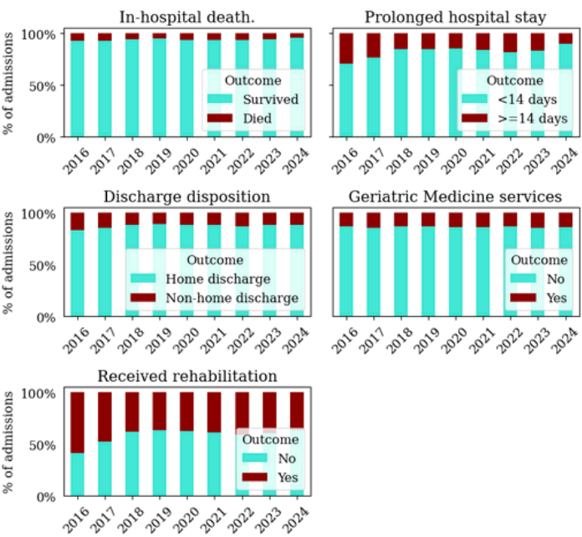
Supplementary Fig. 1. The annual distribution of secondary outcomes over the full data collection window.
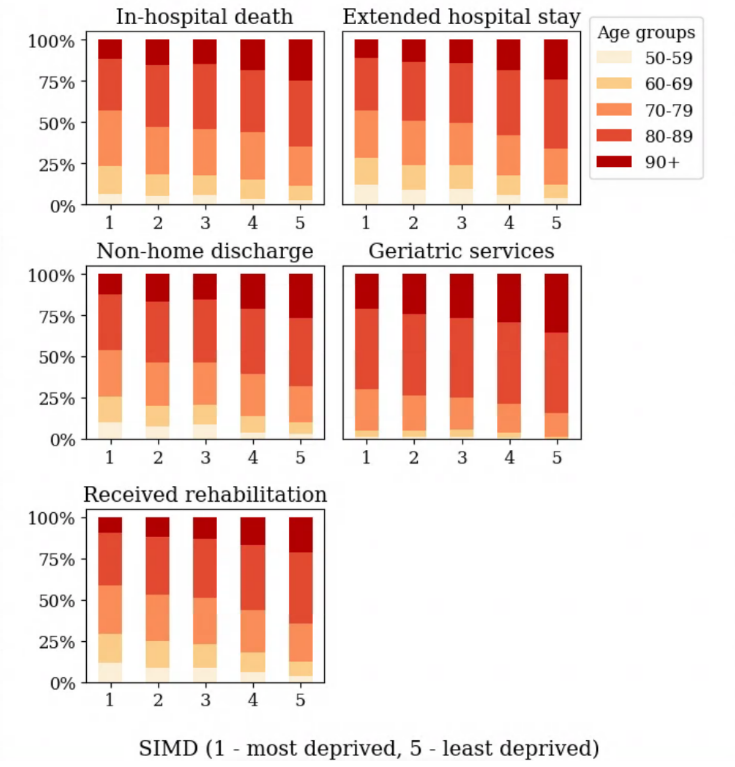
Supplementary Fig. 2. Socio-demographic characteristics categorised by age and deprivation in patients with each secondary hospital outcome. SIMD – Scottish Index for Multiple Deprivation (1 – most deprived, 5 – least deprived).
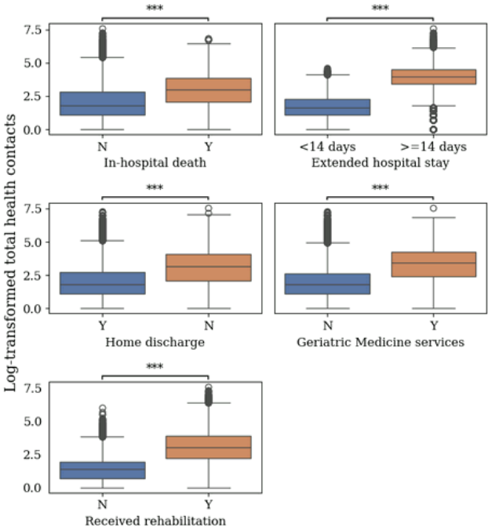
Supplementary Fig. 3. Box-plot showing the spread of log-transformed health contacts across patients with and without each secondary outcome. Statistical testing: Two-sided Mann-Whitney-Wilcoxon test with Bonferroni correction with significance measured at p<0.001. U statistic values: In-hospital death (U=1.65e+08), Extended stay (U=1.09e+08), Home discharge (U=7.79e+08), Geriatric Medicine services (U=2.42e+08), Received rehabilitation (U=3.43e+08).

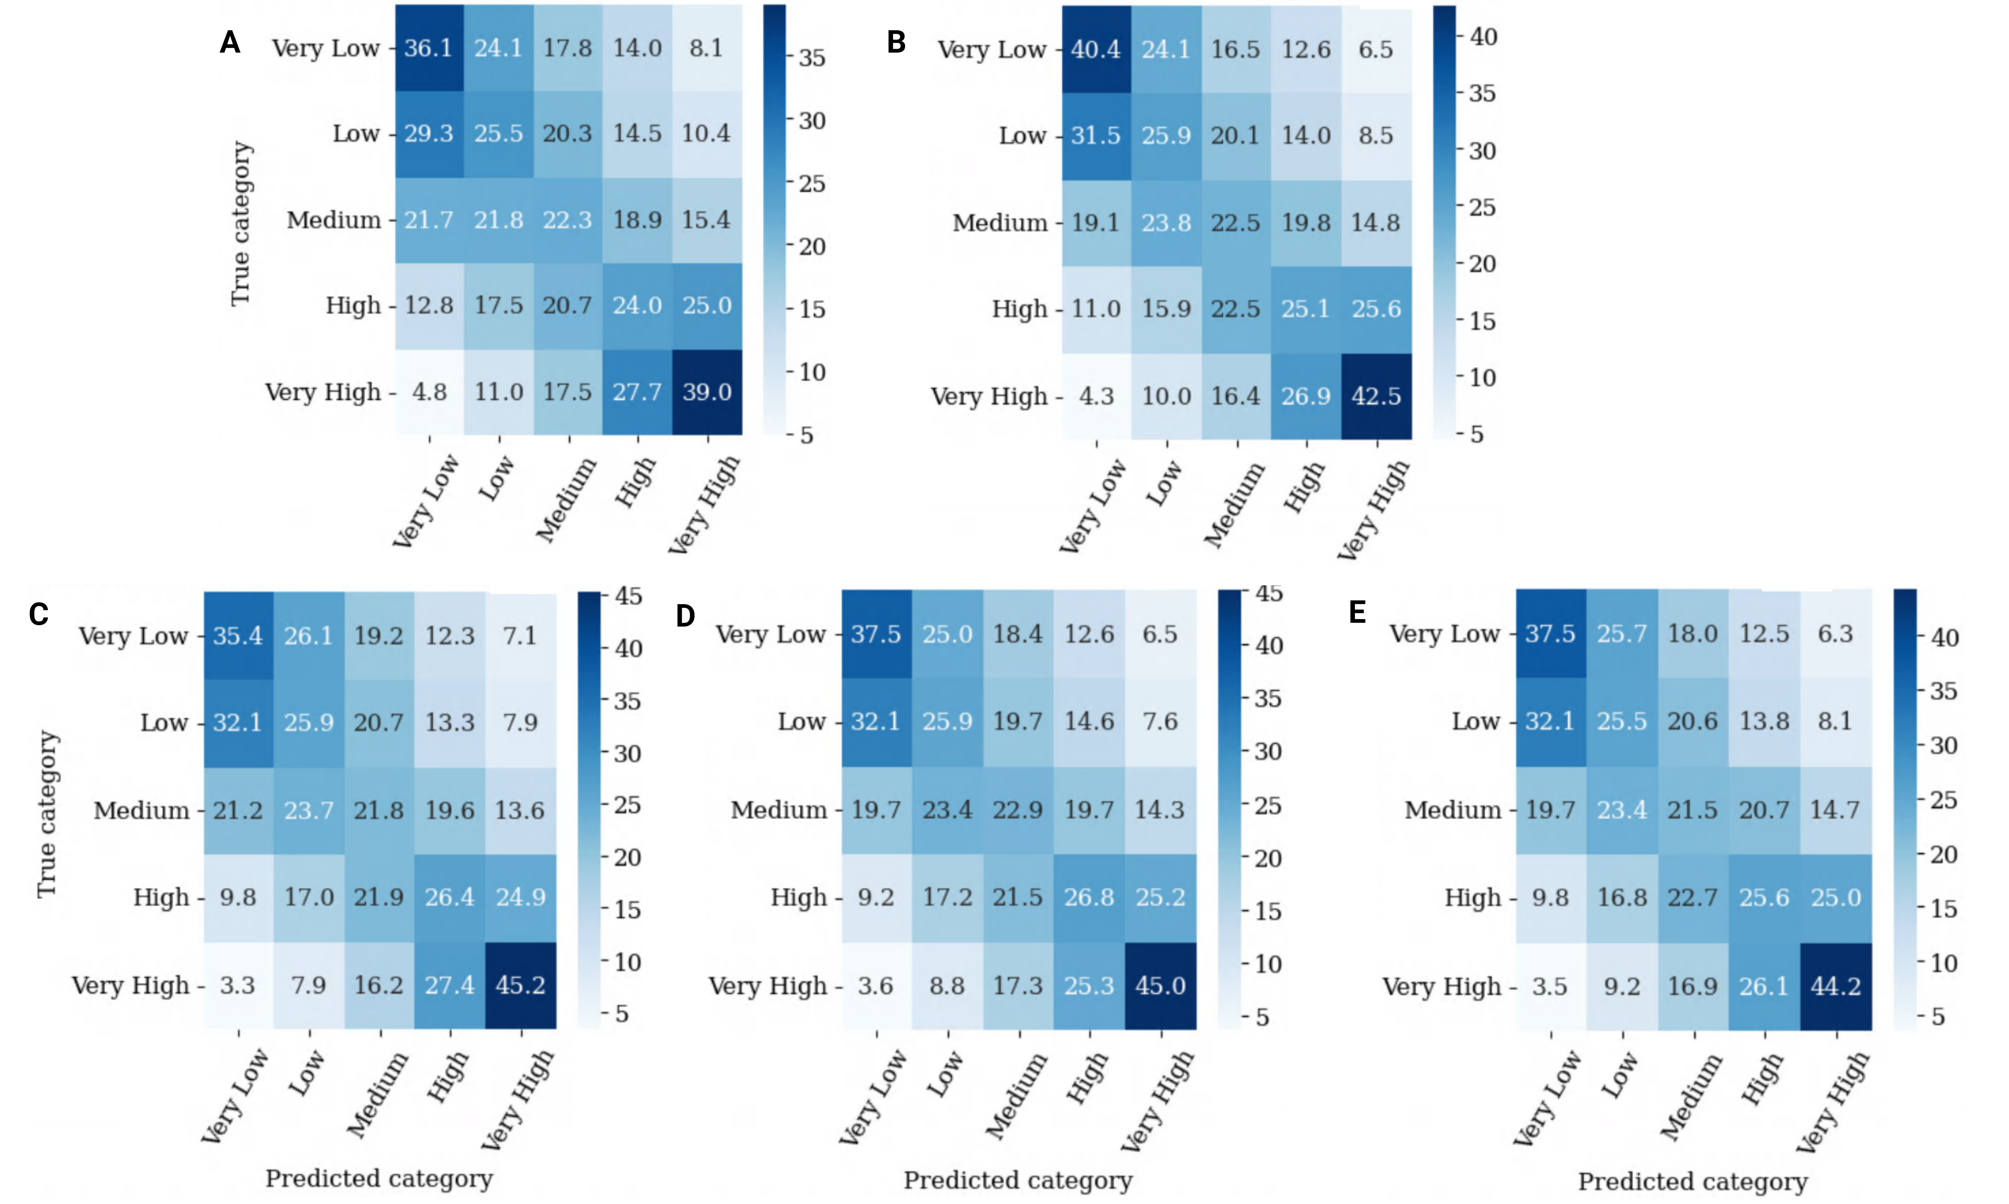
Supplementary Fig. 4. Confusion Matrix summary showing the percentage of correctly captured and misclassified examples after quintile-based discretisation of healthcare need. Categories shown on y-axis indicate true categories after binning the samples from the original data, while categories shown on x-axis indicate the binned samples of the predictions. (A)—Point of ED arrival, (B)—Point of hospital admission, (C)—24 hours post-admission, (D)—48 hours post-admission, (E)—72 hours post-admission.

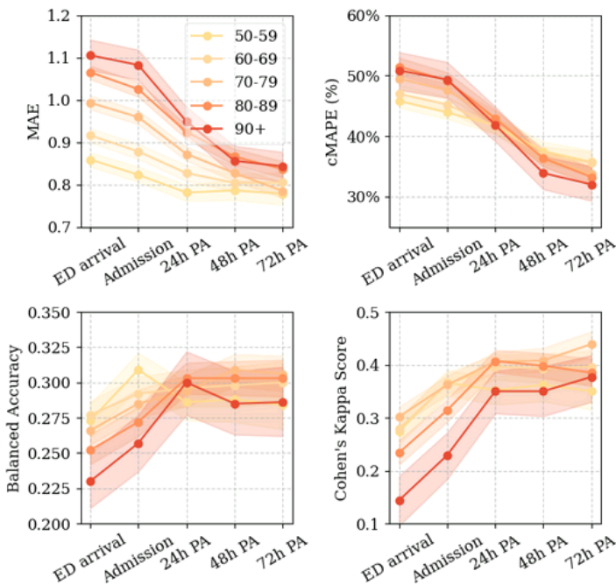
Supplementary Fig. 5. Performance trajectory curves for healthcare need prediction measured in all patients, stratified by age group. Reported with 95% confidence intervals across the five prediction timepoints. Balanced accuracy and Cohen’s Kappa Score were estimated after quintile-based discretisation of predictions into five frequency levels: ‘Very Low’, ‘Low’, ‘Medium’, ‘Medium-high’ and ‘High’. MAE – Mean Absolute Error, cMAPE – conditional Mean Absolute Percentage Error, estimated by masking 0 values (no linked contacts) from the estimation.

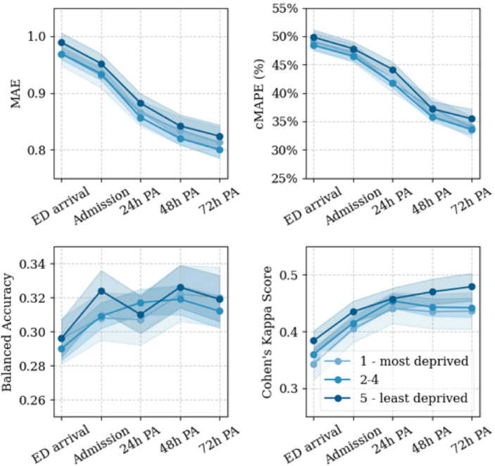
Supplementary Fig. 6. Performance trajectory curves for healthcare need prediction measured in all patients, stratified by deprivation level. Reported with 95% confidence intervals across the five prediction timepoints. Balanced accuracy and Cohen’s Kappa Score were estimated after quintile-based discretisation of predictions into five frequency levels: ‘Very Low’, ‘Low’, ‘Medium’, ‘Medium-high’ and ‘High’. MAE – Mean Absolute Error, cMAPE – conditional Mean Absolute Percentage Error, estimated by masking 0 values (no linked contacts) from the estimation. SIMD – Scottish Index of Multiple Deprivation.

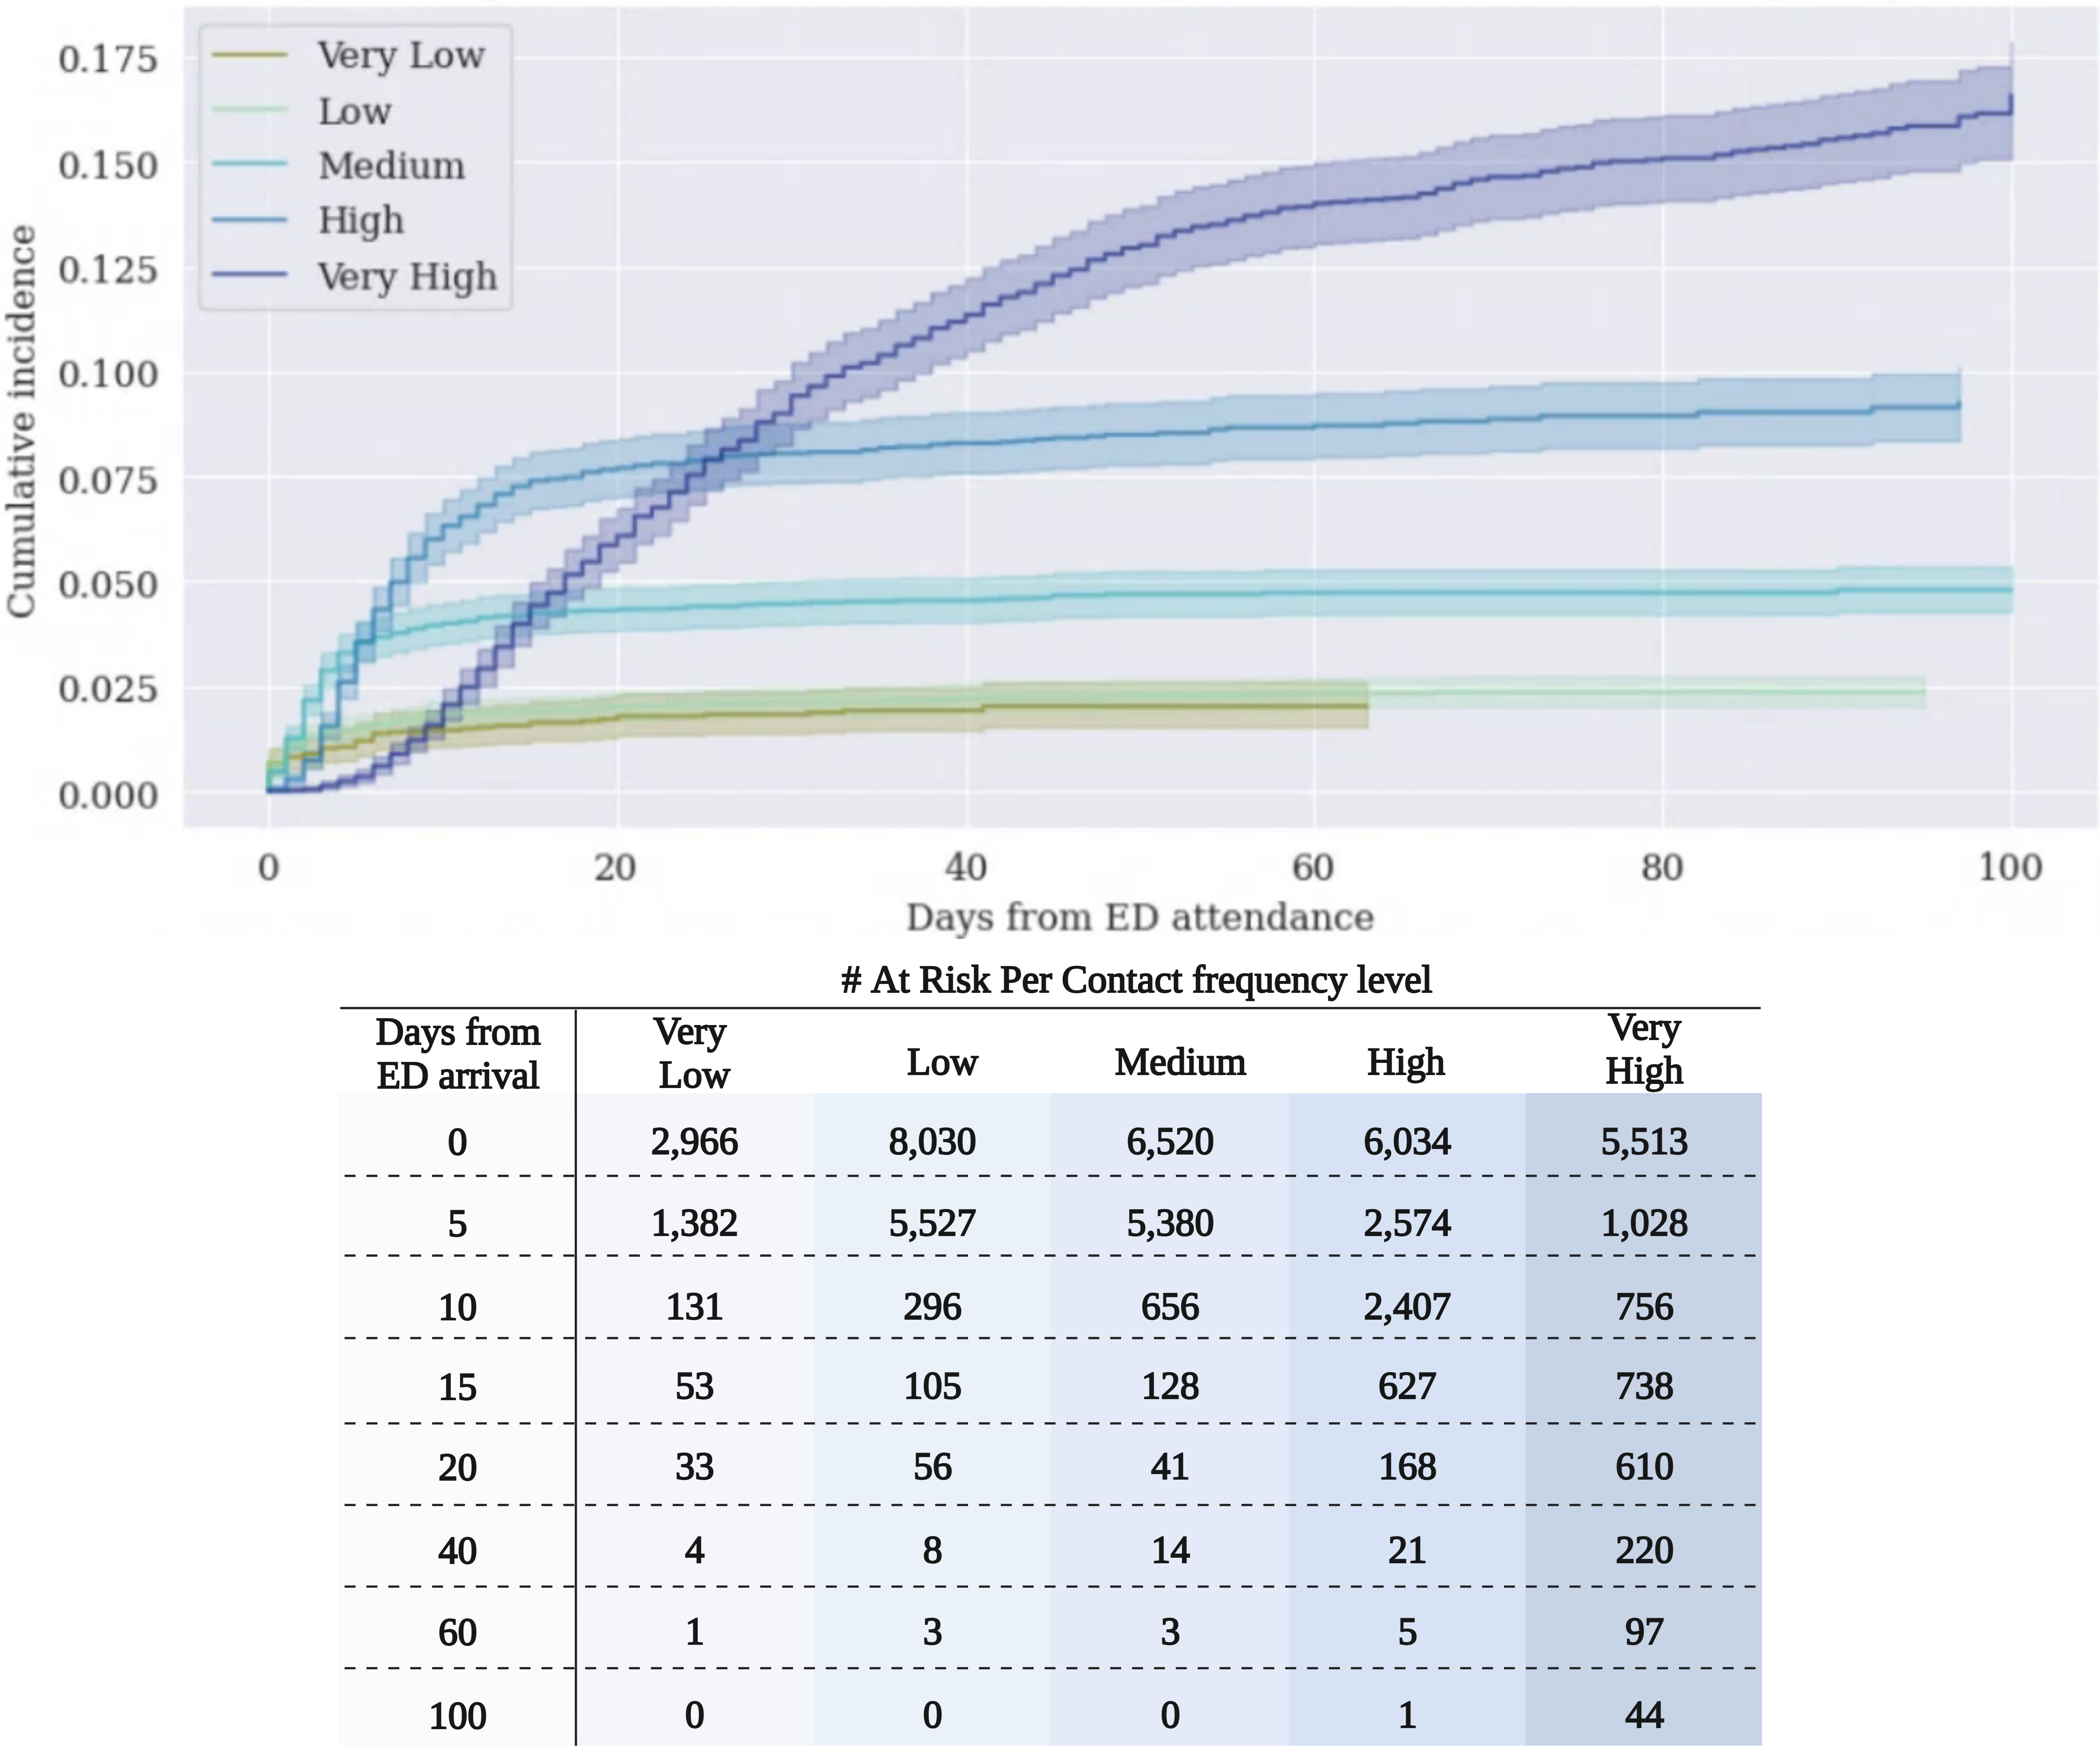
Supplementary Fig. 7. Aalen-Johansen cumulative incidence function of in-hospital death stratified by healthcare frequency level, adjusted for non-home discharge outcomes. The table indicates the number of patients at risk of in-hospital death (remaining in the study) over the validation set for the healthcare need prediction model at point of ED attendance.

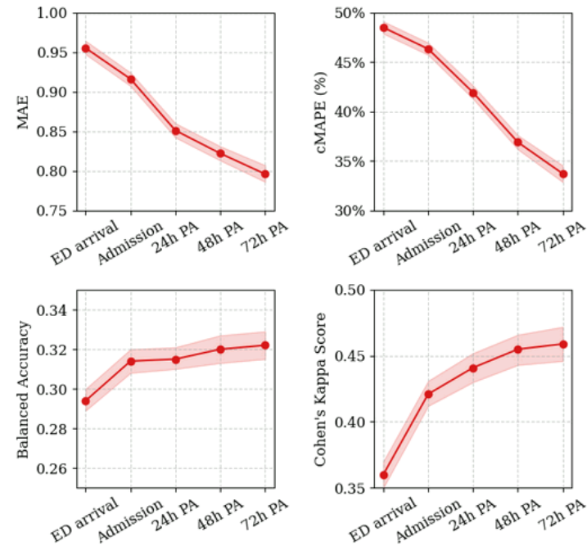
Supplementary Fig. 8. Performance trajectory curves for healthcare need prediction measured in survivors to discharge. Reported with 95% confidence intervals across the five prediction timepoints. Balanced accuracy and Cohen’s Kappa Score were estimated after quintile-based discretisation of predictions into five frequency levels: ‘Very Low’, ‘Low’, ‘Medium’, ‘Medium-high’ and ‘High’. MAE – Mean Absolute Error, cMAPE – conditional Mean Absolute Percentage Error, estimated by masking 0 values (no linked contacts) from the estimation.

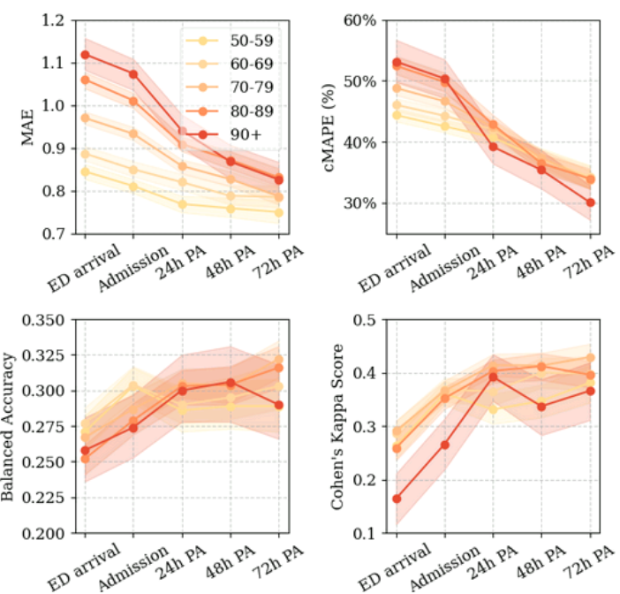
Supplementary Fig. 9. Performance trajectory curves for healthcare need prediction measured in survivors to discharge, stratified by age group. Reported with 95% confidence intervals across the five prediction timepoints. Balanced accuracy and Cohen’s Kappa Score were estimated after quintile-based discretisation of predictions into five frequency levels: ‘Very Low’, ‘Low’, ‘Medium’, ‘Medium-high’ and ‘High’. MAE – Mean Absolute Error, cMAPE – conditional Mean Absolute Percentage Error, estimated by masking 0 values (no linked contacts) from the estimation.

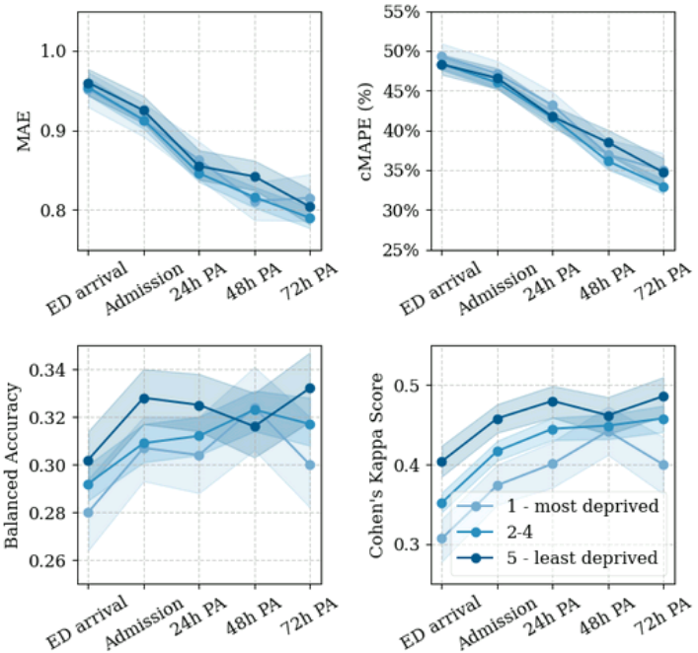
Supplementary Fig. 10. Performance trajectory curves for healthcare need prediction measured in survivors to discharge, stratified by deprivation level. Reported with 95% confidence intervals across the five prediction timepoints. Balanced accuracy and Cohen’s Kappa Score were estimated after quintile-based discretisation of predictions into five frequency levels: ‘Very Low’, ‘Low’, ‘Medium’, ‘Medium-high’ and ‘High’. MAE – Mean Absolute Error, cMAPE – conditional Mean Absolute Percentage Error, estimated by masking 0 values (no linked contacts) from the estimation. SIMD – Scottish Index of Multiple Deprivation.

Supplementary References

1. Kursa MB, Rudnicki WR. Feature Selection with the Boruta Package. Journal of Statistical Software. 2010;36:1-13. doi:10.18637/jss.v036.i11
2. Breiman L. Random Forests. Machine Learning. 2001;45(1):5-32. doi:10.1023/A:1010933404324
3. Rainio O, Teuho J, Klén R. Evaluation metrics and statistical tests for machine learning. Sci Rep. 2024;14(1):6086. doi:10.1038/s41598-024-56706-x
4. Santafe G, Inza I, Lozano JA. Dealing with the evaluation of supervised classification algorithms. Artif Intell Rev. 2015;44(4):467-508. doi:10.1007/s10462-015-9433-y
5. Khrapov A, Popov V, Sadekova T, Yermekova A, Kudinov M. Improving Diffusion Models’s Data-Corruption Resistance using Scheduled Pseudo-Huber Loss. Published online March 25, 2024. doi:10.48550/arXiv.2403.16728

