Deguelia duckeana in vitro establishment and triterpenes callus production
Priscila de Menezes Pinheiro* (ORCID https://orcid.org/0000-0001-5356-0499), Cristine Luciana de Souza Rescarolli* (ORCID https://orcid.org/0000-0003-1920-2502), Cecilia Veronica Nunez (ORCID https://orcid.org/0000-0003-3400-9508)

Supplemental Material

S1 ¹H NMR spectrum (300 MHz, CDCl₃ with TMS) of the compound 3β-hydroxy-20(29)-lupen-28-al (betulinaldehyde, I)
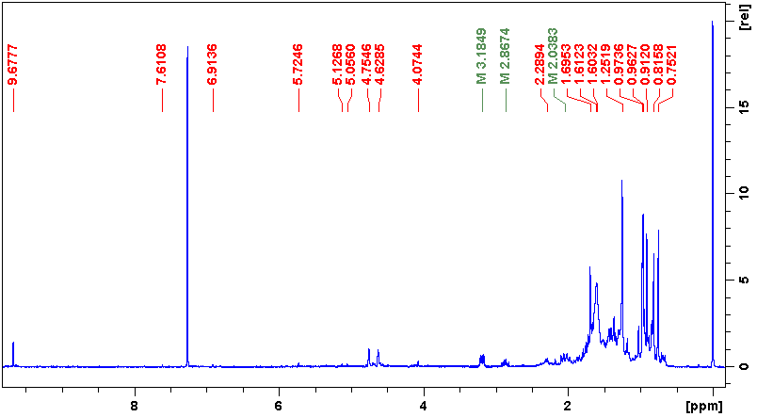

S2 Expanded region from δ_{H} 0 to 5 ppm of the ¹H NMR spectrum (300 MHz, CDCl₃ with TMS) of the compound 3β-hydroxy-20(29)-lupen-28-al (betulinaldehyde, I)
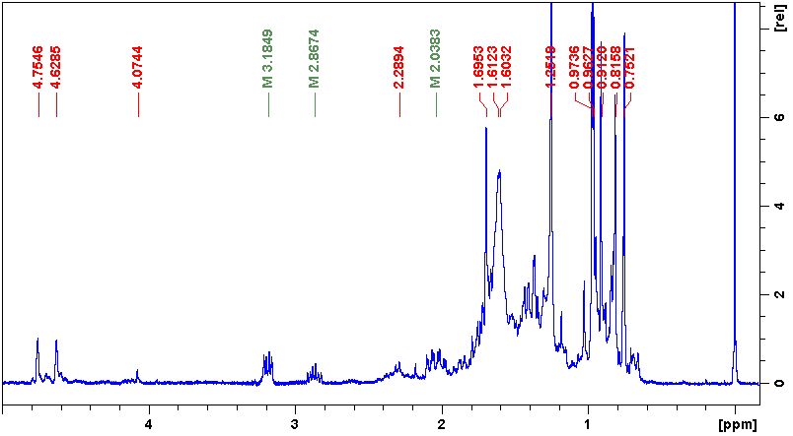

S3 Expanded HSQC contour plot of the compound 3β-hydroxy-20(29)-lupen-28-al (betulinaldehyde, I). A: Carbon 29 at δ_{C} 110.18 ppm coupled with protons at δ_{H} 4.61 and 4.74. B: C-28 at δ_{C} 206.77 coupled with δ_{H} 9.68, characteristic of an aldehyde group
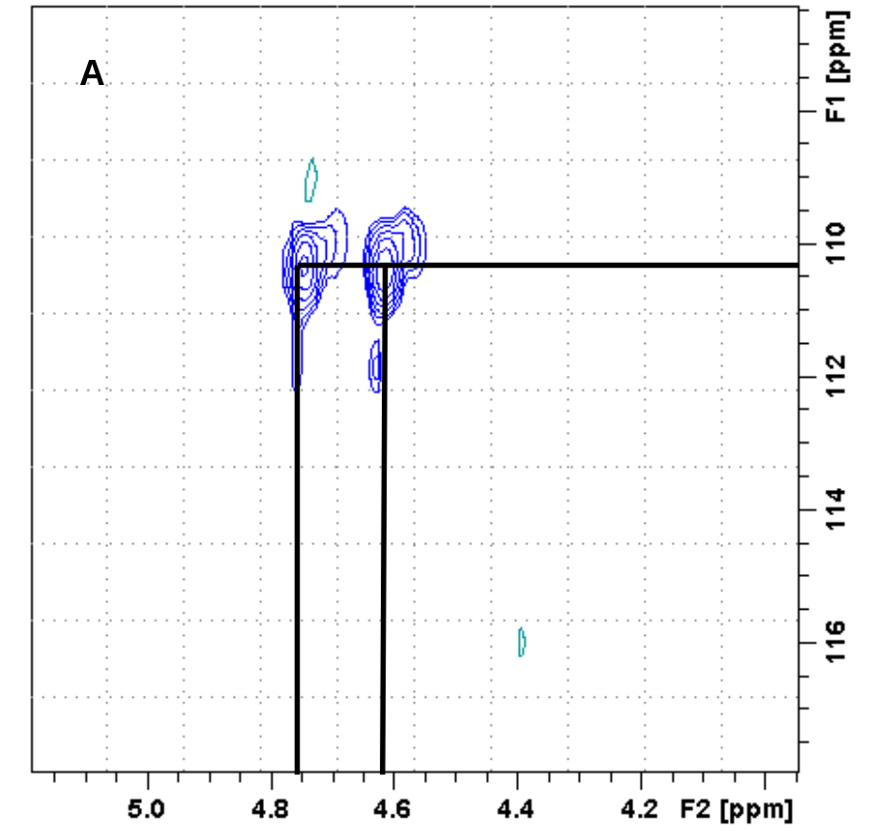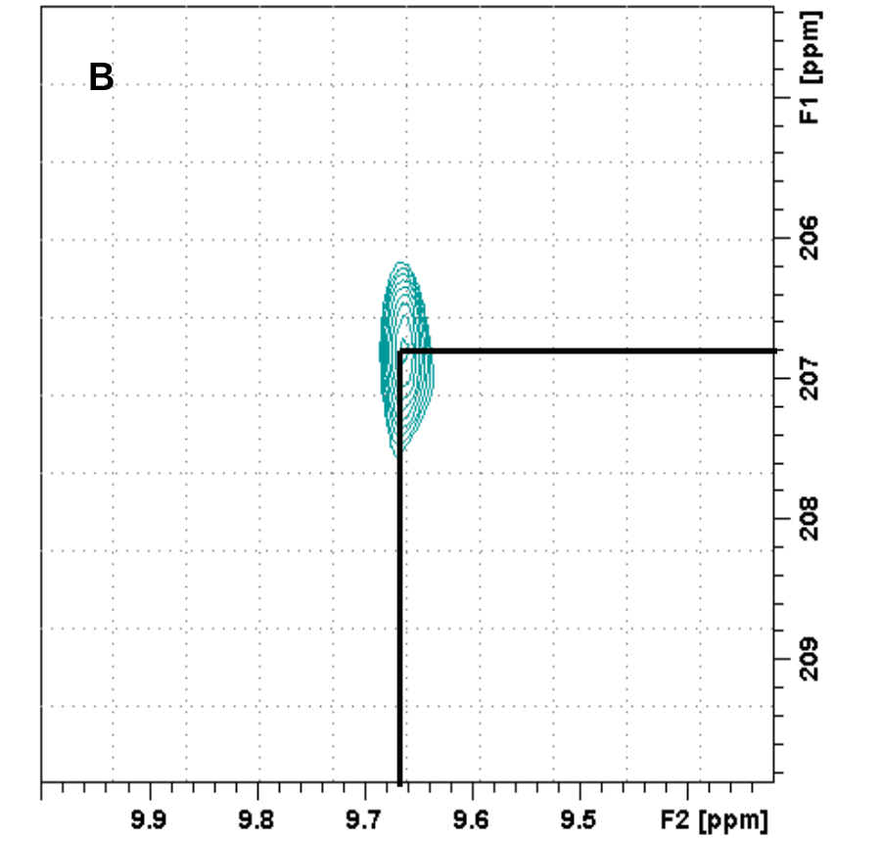

S4 ¹³C NMR spectrum (75 MHz, CDCl₃ with TMS) of the compound 3β-hydroxy-20(29)-lupen-28-al (betulinaldehyde, I)
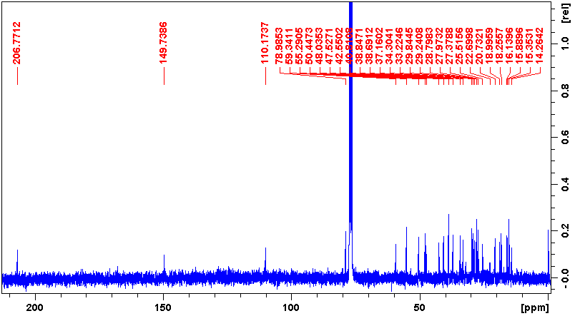
S5 Expanded region from δ_{C} 109 to 207 of the ¹³C NMR spectrum (75 MHz, CDCl₃ with TMS) of the compound 3β-hydroxy-20(29)-lupen-28-al (betulinaldehyde, I)
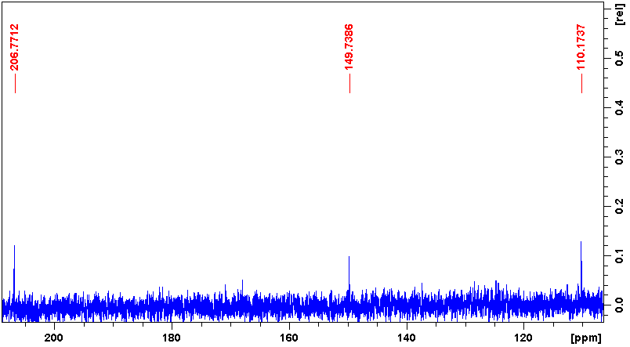
S6 COSY contour plot of the compound 3β-hydroxy-20(29)-lupen-28-al (betulinaldehyde, I) showing couplings between δ_{H} 1.70 and 4.75; δ_{H} 1.35 and 1.78; δ_{H} 1.44 and 2.08; δ_{H} 1.60 and 3.19
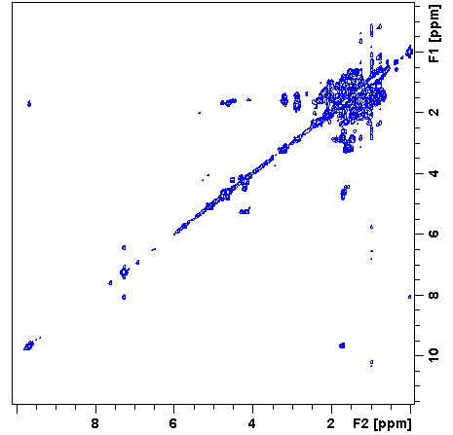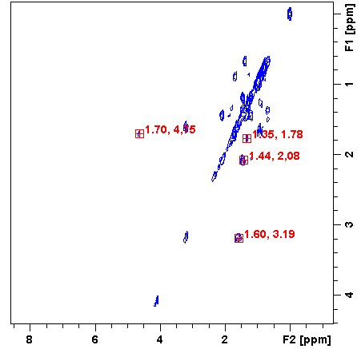

S7 ¹³C NMR spectrum (75 MHz, CDCl₃) of the compound lupeol (II) from fraction DDC2F11-12
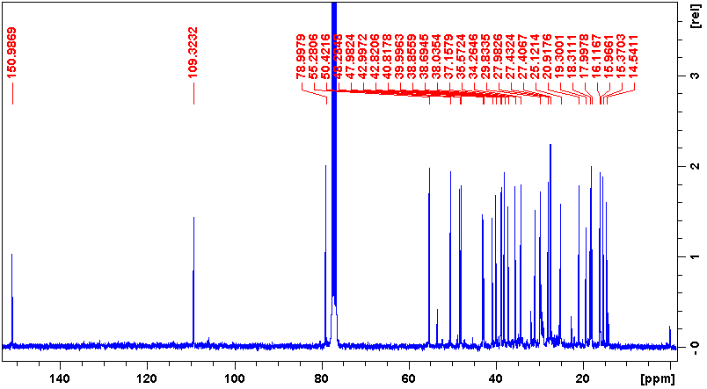

S8 ¹H NMR spectrum (300 MHz, CDCl₃) of the compound lupeol (II) from fraction DDC2F11-12
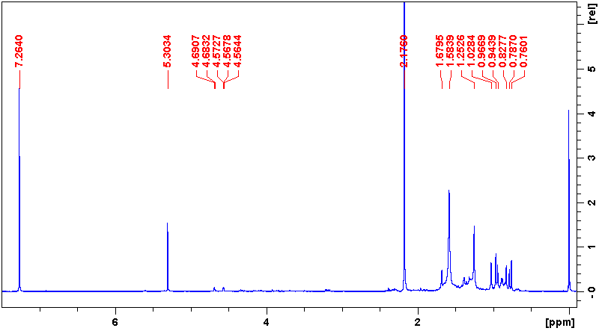

S9 ¹H NMR spectrum (300 MHz, DMSO-d₆ with TMS) of the compound betulinic acid (III)
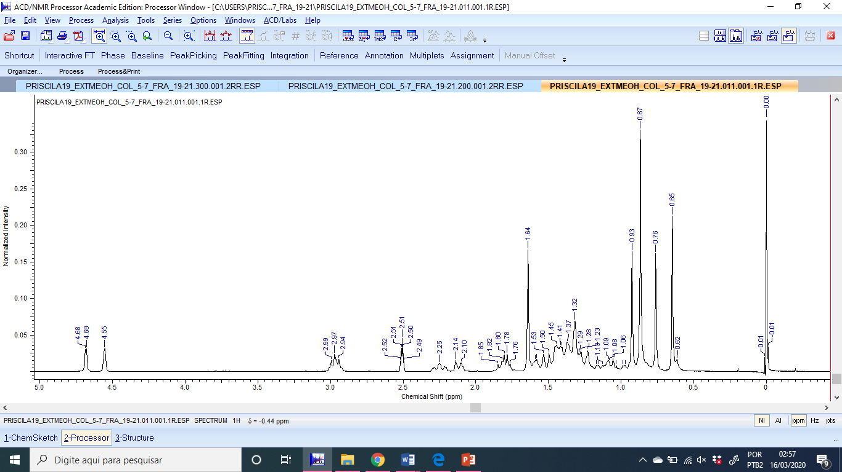

S10 HSQC contour plot of the compound betulinic acid (III)
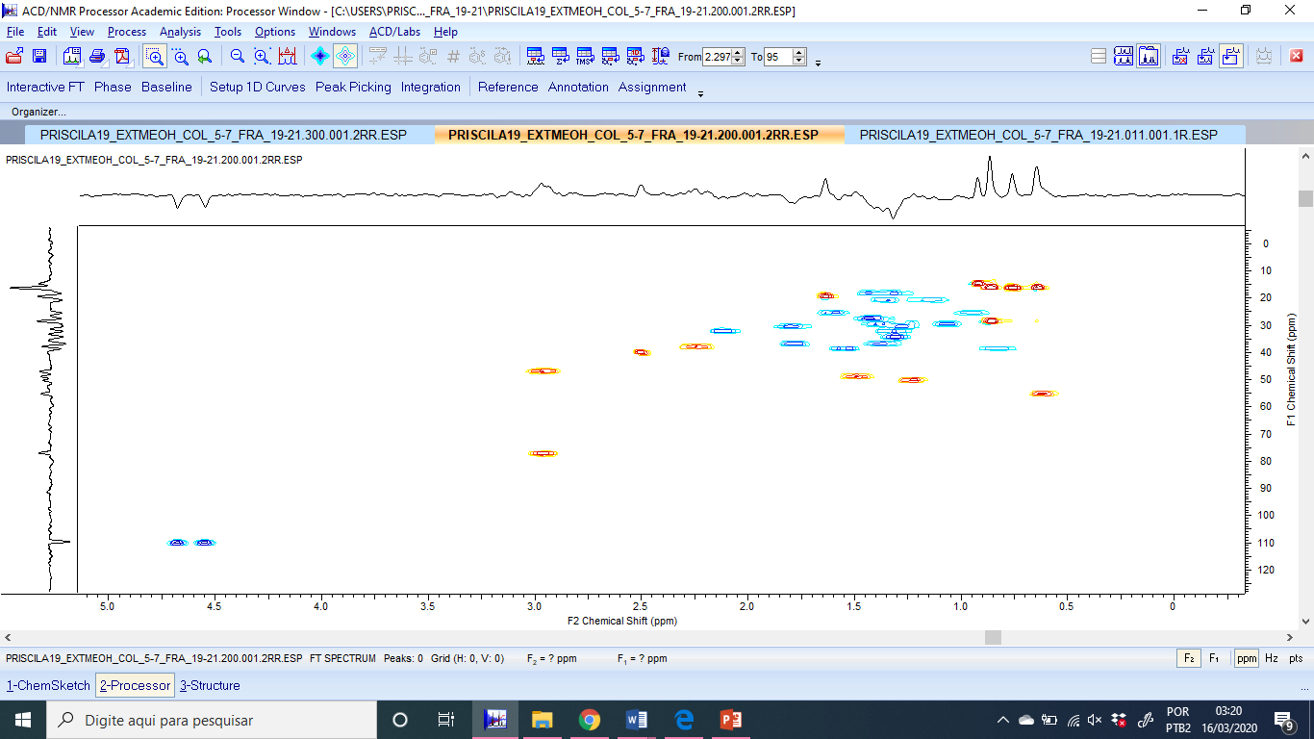

S11 HMBC contour plot of the compound betulinic acid (III)
