Exploring the binding interaction of rupatadine with bovine serum albumin using multi-spectroscopic and molecular modeling approaches

Heba Abo Shamiya¹, Heba Elmansi¹, Shahenda M. El-messery², Fathalla Belal¹
¹ Department of Pharmaceutical Analytical Chemistry, Faculty of Pharmacy, Mansoura University, 35516 Mansoura, Egypt
² Department of Pharmaceutical Organic Chemistry, Faculty of Pharmacy, Mansoura University, 35516 Mansoura, Egypt
Tel.: ++20502247496 Fax: ++20502247496 e-mail: boshamiyaheba@gmail.com

Supplementary Figures:
Figure S1: The Modified Stern–Volmer plot for BSA-RUPA at various temperatures.
Figure S2: Synchronous fluorescence of BSA-RUPA complex at ∆λ=15 (A) and ∆λ=60 (B) with increasing the concentration of RUPA (0.00-100µM) and 2µM of BSA at pH 7.4 at 303 K.
Figure S3: (a) Free BSA FTIR spectra at 303 K at pH 7.4.
(b) BSA-RUPA complex FTIR spectra at 303 K at pH 7.4.
Figure S4: Lowest energy conformer of compound Rupatadine with balls and cylinders rendering
Figure S5: (a) The 2D binding mode and residues involved in the recognition for Rupatadine
(b) 3D binding view of Rupatadine embedded into the surface mapping pocket. Pink: hydrogen bond, blue: mild polar, green: hydrophobic region.
Figure S6: Surface map for Rupatadine, Pink: hydrogen bond, blue: mild polar, green: hydrophobic region.

Figure S1

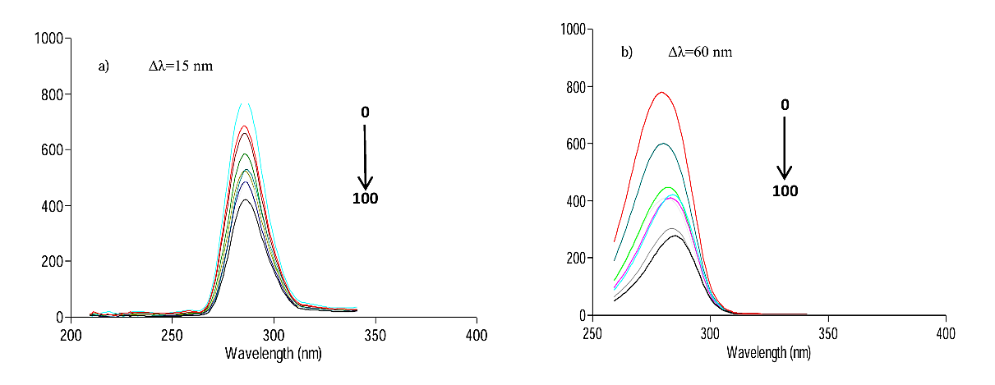
Fluorescence Intensity (a.u.)
Fluorescence Intensity (a.u.)

Figure S2

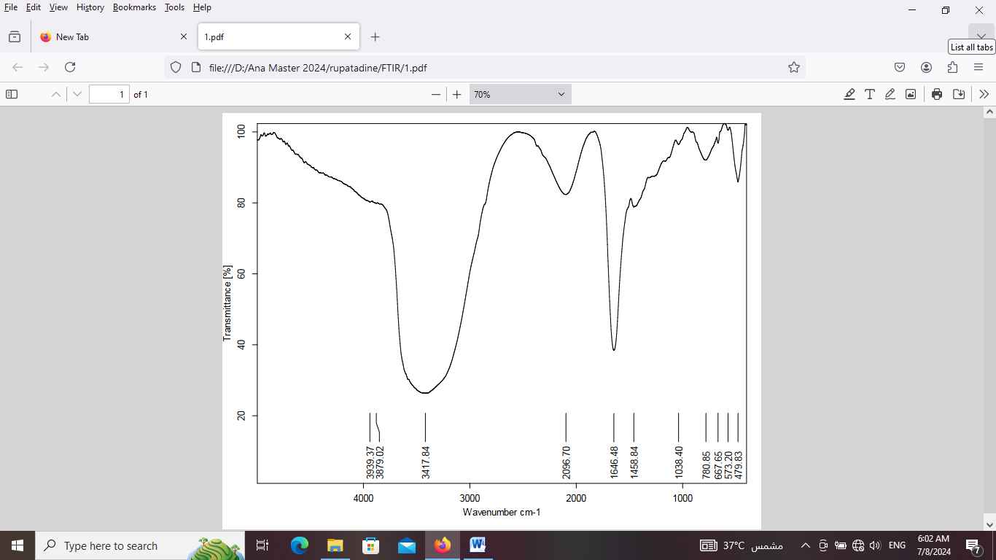
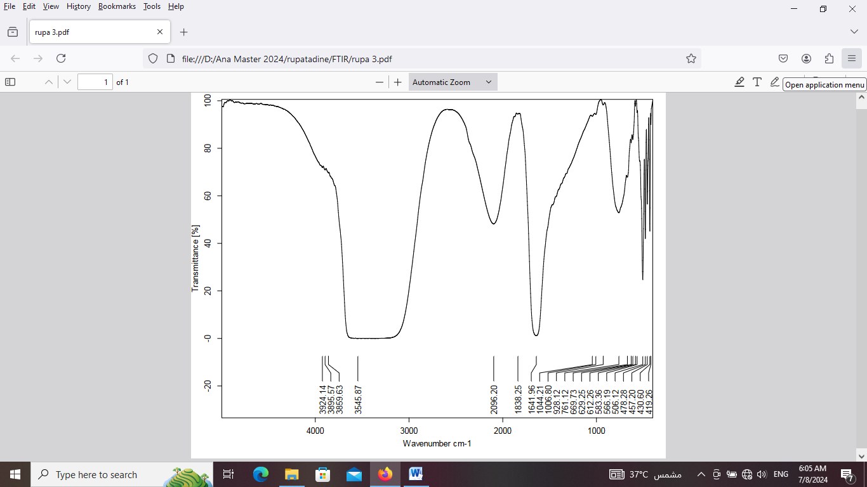
Figure S3

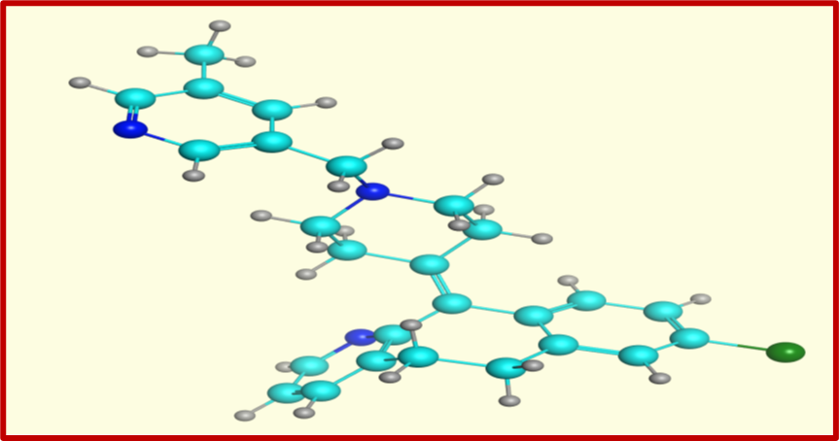

Figure S4

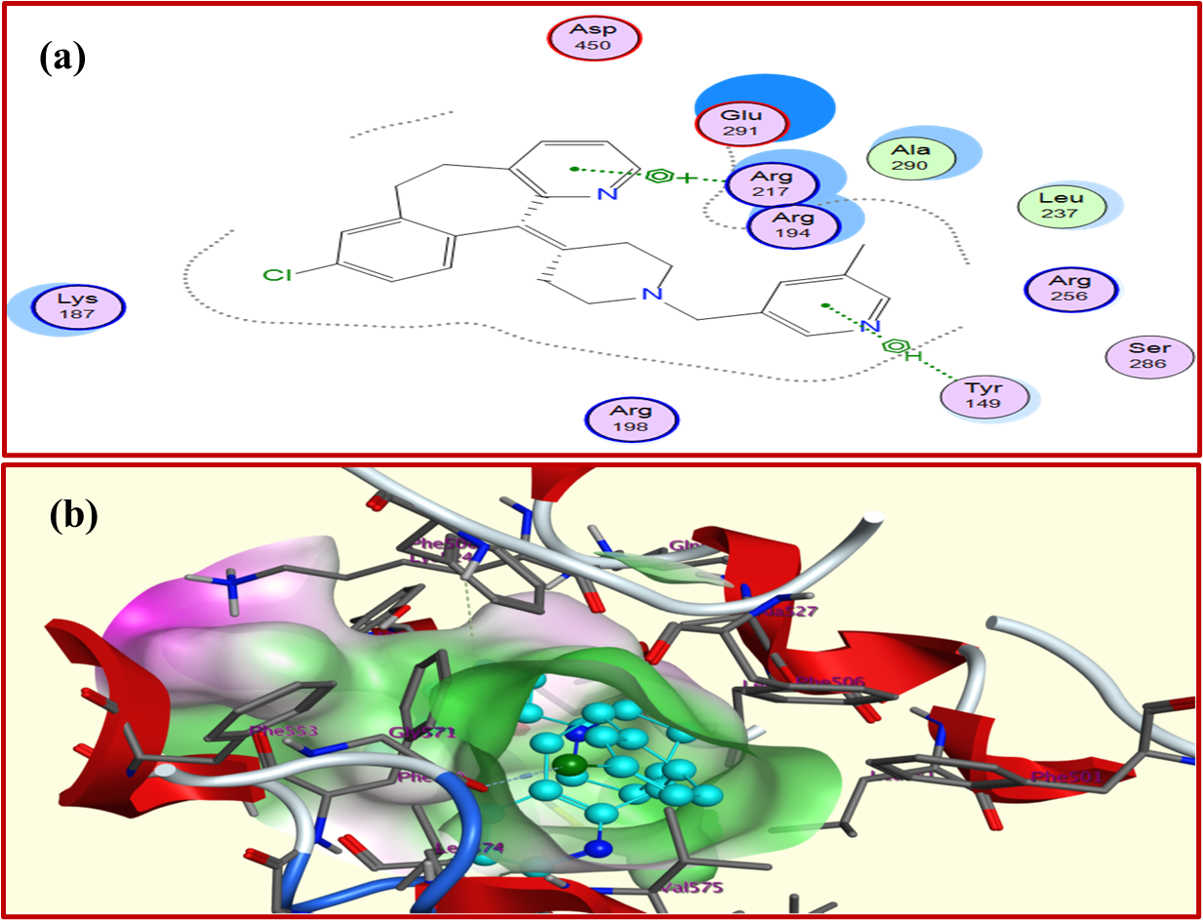
Figure S5

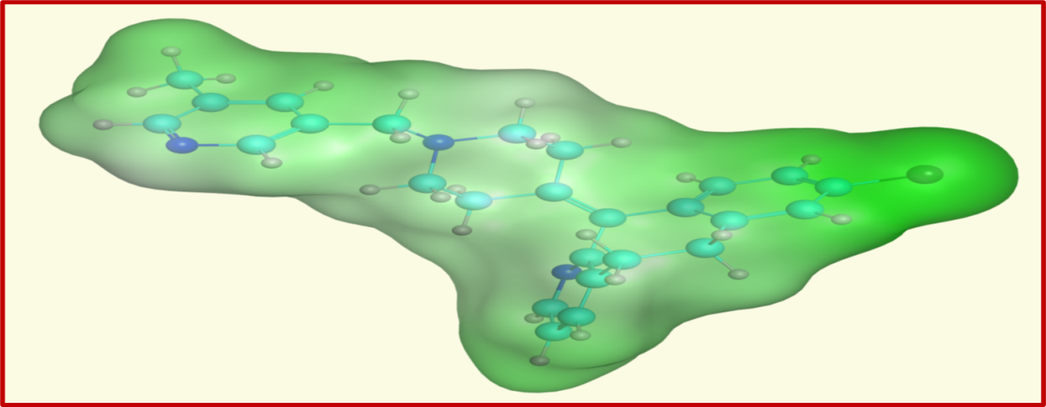

Figure S6

